

Croydon Main Street Revitalisation
Community Consultation Report
- 28 May to 24 June 2025
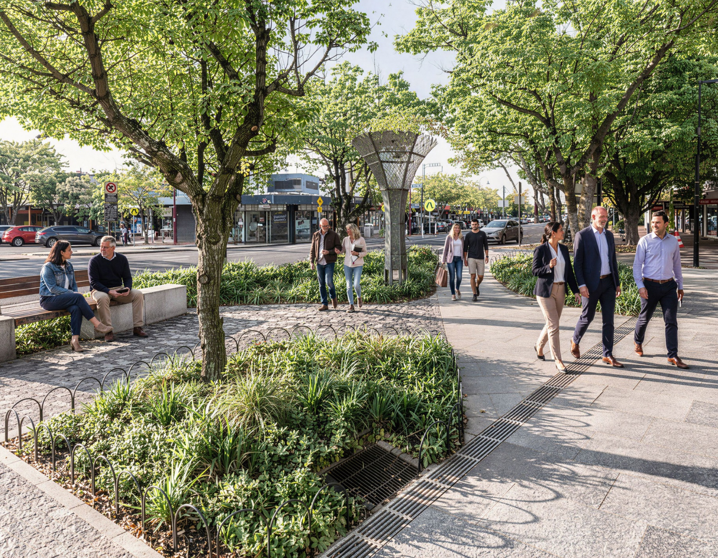
- 26 October to 28 November 2025

Contents

1. Background 3
2. Community consultation 3
Phase one 3
2.1 Shape the future of Croydon Main Street 3
2.2 Online submissions 4
2.3 Digital campaign 4
Phase two 5
2.4 Draft concept design plan exhibition 5
2.5 Online submissions 6
3 Conclusion 7
3.1 Two-phase consultation approach 7
3.2 Your Say project performance 7
3 Next steps 8
4.1 Project status 8

Background

Croydon Main Street is a well-loved and unique part of Maroondah, valued by residents, traders and visitors for its local character, pedestrian scale and role as a destination for shopping, dining and community connection.
Council was successful in securing funding through the Australian Government’s Thriving Suburbs Program for the $15 million Croydon Main Street Revitalisation project. The Australian Government will contribute $7.5 million, alongside Council’s own $7.5 million funding commitment.
The project aims to create a safer, greener and more vibrant Main Street precinct through improvements to pedestrian areas, paving, lighting, street furniture, landscaping, public art, outdoor dining opportunities and accessibility.
Community and trader feedback was sought across two distinct phases of consultation in 2025. Phase one, held from 27 May to 24 June 2025, invited traders, residents, visitors and community groups to share what Croydon Main Street means to them, how they use the precinct and what improvements they would like to see. Phase two, held from 27 October to 24 November 2025, invited feedback on the draft concept design plan developed following the first round of engagement.
This report summarises both phases of consultation, including the communications activities used to promote each phase, participation through the Your Say Maroondah page, in-person pop-up activities and feedback received through the online form.

Community consultation

Phase one

2.1 Shape the future of Croydon Main Street
The first phase of consultation ran from 27 May to 24 June 2025 and focused on early engagement to help inform the project design. The campaign asked the community to help shape the future of Croydon Main Street by sharing what the precinct means to them, what improvements they would like to see and how they currently visit and use the area.
The key message for phase one was “Shape the future of Croydon Main Street”. Community messaging highlighted that Council had received funding from the Australian Government to make important enhancements to Main Street and encouraged feedback on key elements including safety, accessibility, lighting, street furniture and landscaping.
Phase one target audiences included Councillors, the Croydon Main Street Traders Association, Main Street businesses, residents and visitors, advisory committees, Croydon Historical Society, Croydon Conservation Society and Croydon Partners in Safety.
Communications activities included the Your Say project page, targeted emails, Maroondah News, eDMs, organic and paid social media, website pop-up messaging, TV screens, A6 postcards, A4 flyers, A3 corflutes and a social media tile. A pop-up consultation event was also held on Thursday 29 May 2025 in Croydon Main Street, providing an in-person opportunity for community members and traders to speak with the project team.

Online submissions
The phase one online survey received 404 submissions from 402 engaged participants. During the reporting period, the Your Say Maroondah project page recorded 1.5k total visits, 1,238 aware participants, 664 informed participants and 402 engaged participants. The survey tool itself recorded 652 visitors.
When asked to identify the key issues impacting Main Street, safety was the most commonly selected issue, with 230 responses. This was followed by landscaping with 189 responses, lighting with 136 responses, accessibility with 131 responses, trees and shade with 128 responses, street furniture with 128 responses and other issues with 114 responses.
Pedestrian movement was also a strong theme. The condition of the existing brick surface was the most common challenge to navigating Main Street as a pedestrian, selected by 306 respondents. This was followed by crossing Main Street at other mid-block locations with 167 responses, crossing at existing zebra crossings with 136 responses, the location of street trading and activities with 107 responses, accessibility issues into shopfronts with 93 responses and other issues with 68 responses.
The survey results showed strong interest in greener, safer and more pedestrian-friendly streetscape improvements. Most respondents supported more greenery, including garden beds and low-level landscaping, with 331 respondents, or 81.9 per cent, selecting yes. A further 326 respondents, or 80.7 per cent, said they would feel safe walking along Main Street if the existing pedestrian fencing was replaced with garden beds.
There was also support for wider footpaths with outdoor dining and shopping, with 306 respondents, or 75.7 per cent, selecting yes, and for a reduced speed limit on Main Street, with 292 respondents, or 72.3 per cent, selecting yes. In contrast, 214 respondents, or 53 per cent, indicated there was not adequate lighting along Main Street and pedestrian laneways. Responses on the adequacy of street furniture were evenly split, with 202 respondents selecting yes and 202 selecting no.

Digital campaign
Traffic sources for the Croydon Main Street Revitalisation project page totalled 1.5k visits during phase one.
- Social media: 650
- QR code: 478
- eNews (MCC and Your Say): 285
- From MCC website: 63
- Google search: 41
- Referrals (links posted on other channels / directly sent from one device to another): 33

Phase two

2.4 Draft concept design plan exhibition
The second phase of consultation focused on the draft concept design plan. A range of communication channels were used to promote consultation opportunities, including the Your Say Maroondah project page, Council’s website, pop-up events, printed collateral, on-site promotional material, digital communications, eNews, social media, TV screens and targeted communications.
The phase two communications campaign aimed to encourage survey responses, invite previous respondents to provide feedback on the draft concept design plan, and reach traders, local residents and visitors who may not have engaged during the first round of consultation.
The phase two campaign theme was “Your Main Street, your voice”, with messaging focused on encouraging the community to review the draft concept design plan and provide feedback on the key elements that would help create a safer, greener and more vibrant Croydon Main Street.
Phase two target audiences included previous consultation respondents, Croydon Main Street traders, local residents and visitors to the area.
Two in-person pop-up consultation sessions were held at Croydon Square, opposite the corner of Main Street and Hewish Road, on Wednesday 29 October and Thursday 13 November 2025 from 10am to 12noon. These sessions provided an opportunity for community members to view the draft concept design plans in person, ask questions and provide feedback.
Promotional collateral included updated decals for existing corflutes, A4 flyers, A1 posters, A6 postcards for pop-up events, social media tiles and TV screen artwork. The campaign also used UTM tracking across print, web, eDM, social media and stakeholder communication channels to help evaluate traffic sources.
Council also promoted the consultation through scheduled organic social media posts, the Maroondah eNews, relevant eDMs, the Council website, web pop-ups, TV screens, the Maroondah Festival Café Consult tent and direct communications with stakeholders.
During the consultation period, the Croydon Main Street Revitalisation Your Say project page received 1,062 views, 918 visits and 734 visitors. A total of 52 contributions were received from 51 contributors, and the draft concept design plan was downloaded 406 times.

2.5 Online submissions
Respondents were asked to provide feedback on the following proposed key elements of the draft concept design plan:
- Safety and accessibility improvements
- Landscaping and green spaces
- Street furniture and public amenities
- Lighting and security
- Public art and cultural features
- Outdoor dining and activation zones
- Accessible parking changes
A total of 41 responses were received for the key element support questions.
Key element | Strongly support | Somewhat support | Summary
Safety and accessibility improvements | 73.08% | 7.69% | Strong support for smoother footpaths, improved crossings and safer pedestrian movement.
Landscaping and green spaces | 84.62% | 11.54% | Very strong support for new garden beds, street trees, shade and greenery.
Street furniture and public amenities | 71.15% | 21.15% | Strong support for modern seating, bike racks, bins and public amenities.
Lighting and security | 86.54% | 11.54% | Highest level of support, with feedback noting the importance of lighting, visibility and safety.
Public art and cultural features | 57.69% | 17.31% | Support for murals, sculptures, heritage elements and local character, with some neutral responses.
Outdoor dining and activation zones | 73.08% | 21.15% | Strong support for improved footpath areas, outdoor dining and flexible activation opportunities.
Accessible parking changes | 73.17% | 17.07% | Strong overall support for accessible parking changes, with feedback emphasising the importance of maintaining convenient accessible parking close to shopfronts and key services.

Conclusion
Council completed two phases of consultation for the Croydon Main Street Revitalisation project. Phase one identified community priorities and aspirations for Main Street, while phase two tested the draft concept design plan with the community. Both phases were supported by communications campaigns across online, print, on-site and in-person channels. Phase two feedback showed strong support for the proposed key elements, particularly lighting and security, landscaping and green spaces, safety and accessibility, and outdoor dining and activation opportunities.

3.1 Two-phase consultation approach
Phase one invited early feedback from traders, residents, visitors and community groups to help guide the project design. Phase two invited feedback on the draft concept design plan, with respondents asked to indicate their level of support for proposed key elements and provide comments on specific areas of interest.
Across the two phases, feedback themes included strong interest in safer and smoother footpaths, improved lighting, more greenery and shade, upgraded public spaces, better seating and street furniture, and opportunities to strengthen the look, feel and local character of Main Street. Some respondents also raised matters relating to traffic movement, parking, cycling access and the importance of retaining convenient access for shoppers and traders.
Following consideration of feedback received across both consultation phases, updated design plans are now available for the community to view. These design plans have been directly informed by feedback received from the community during consultation.
The consultation findings have helped ensure the revitalised Main Street reflects community needs and aspirations while supporting Council’s long-term vision for Croydon. Three artist renders have also been prepared to show projected before and after views of three different sections of Main Street.

3.2 Your Say project performance
The Your Say project page recorded 918 visits and 734 visitors during the reporting period. Campaign traffic was the main referral type, supported by direct, organic and referral traffic from channels including eNews, targeted emails, social media, web banners and other Council communications.
The draft concept design plan was the top downloaded file, with 406 downloads. This indicates strong interest in reviewing the design details before providing feedback.

4. Next steps
Council will continue to progress the Croydon Main Street Revitalisation project using the community feedback received through both phases of consultation. Updated design plans are now available to view, along with three artist renders showing projected before and after views of different sections of Main Street.
In response to specific community feedback regarding pedestrian safety, Council is proposing pedestrian safety improvements at the Devon Street and Main Street intersection. The works would combine the left and right southbound exit lanes at Main Street to reduce pedestrian crossing time and improve general safety and intersection operation.
A trial of the proposed safety improvements is planned for July 2026, using temporary delineation and signage. This will allow Council’s Traffic Engineers to review the works and any impacts before any permanent improvement works are undertaken at the intersection.
Main construction works are anticipated to commence in September 2026, following successful award of the construction contract. Further information will be made available to the community as construction planning progresses.

4.1 Project status
As of June 2026, updated design plans are available to view and have been informed by community feedback received during the 2025 consultation process.
The next project milestone is the proposed July 2026 trial of pedestrian safety improvements at the Devon Street and Main Street intersection, followed by anticipated commencement of main construction works in September 2026.
The community can view the updated design plans, before and after artist renders, and an image of the proposed safety improvement works. The Croydon Main Street Revitalisation project webpage will be updated with construction-specific information, including day-to-day construction impacts, while the Your Say project page will continue to provide updates on the consultation process.

