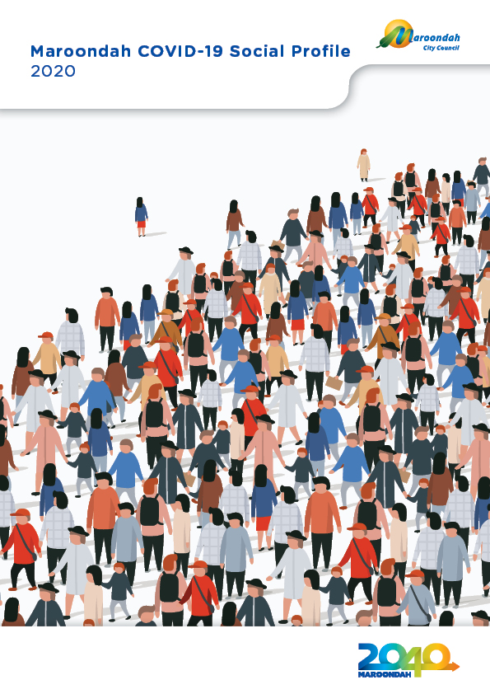

Contents

1. Introduction 3
2. Maroondah Population 3
3. Vulnerable Groups in Maroondah 6
4. Cultural Diversity 7
5. Languages Spoken 8
6. Social Isolation and Loneliness 9
7. Mental Health 10
8. Disabilities 11
9. Family or Partner Violence and Abuse 12
10. Financially Vulnerable Households 13
11. Economic Environment 14
12. Volunteering 16
13. Gambling 17
14. Alcohol Consumption and Drug Use 18

Introduction

In the disaster recovery context, social / community profiles are a valuable tool to support sustainable recovery outcomes and community resilience. They provide a sound understanding of the local community and their capacities and strengths, and include local data such as demographics, community-based services, structures and networks, and knowledge of existing social capital.

The following Social Profile data for Maroondah was compiled to inform Council’s COVID-19 relief and recovery planning.

Maroondah Population

Population size, distribution and growth

The Estimated Residential Population of the City of Maroondah for 2019 is 118,558.

At the 2016 census, Maroondah’s residents lived in approximately 44,502 households, with an average household size of 2.57 people.

The forecast distribution of the Maroondah population in 2020 across the municipality is shown in Figure 1.

The forecast change for the Maroondah population between 2020 and 2040 across the municipality is shown in Figure 2.

Figure 1: Maroondah forecast population distribution in 2020 (#)

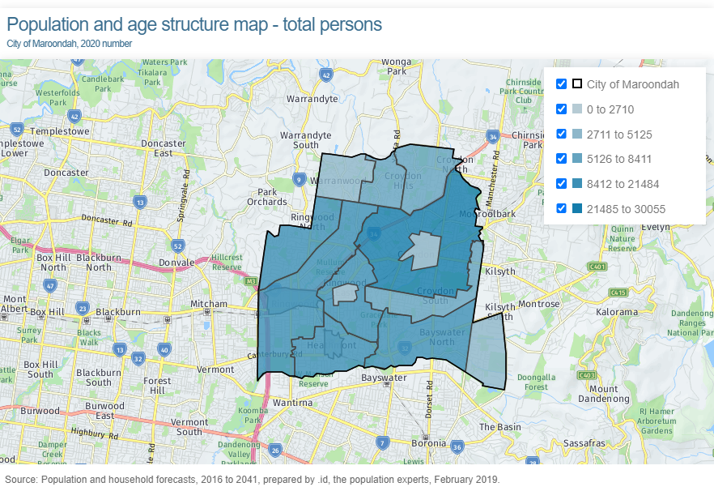

Figure 2: Maroondah forecast population change between 2020 and 2040 (%)

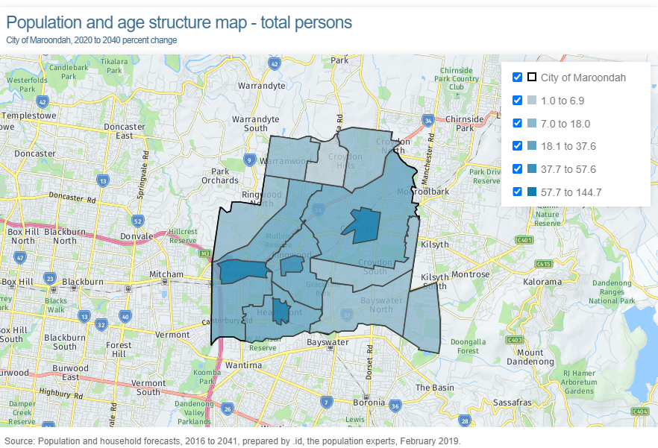

Age structure

The age structure of the Maroondah population in 2016 is shown in Figure 3.

The forecast changes in this age structure between 2016, 2020 and 2025 are shown in Figure 4.

Figure 3: Maroondah population age structure in 2016

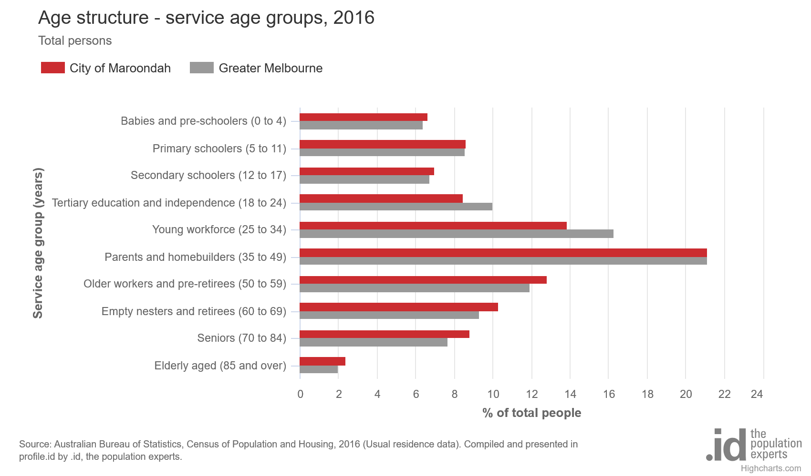

Figure 4: Maroondah population age structure in 2016

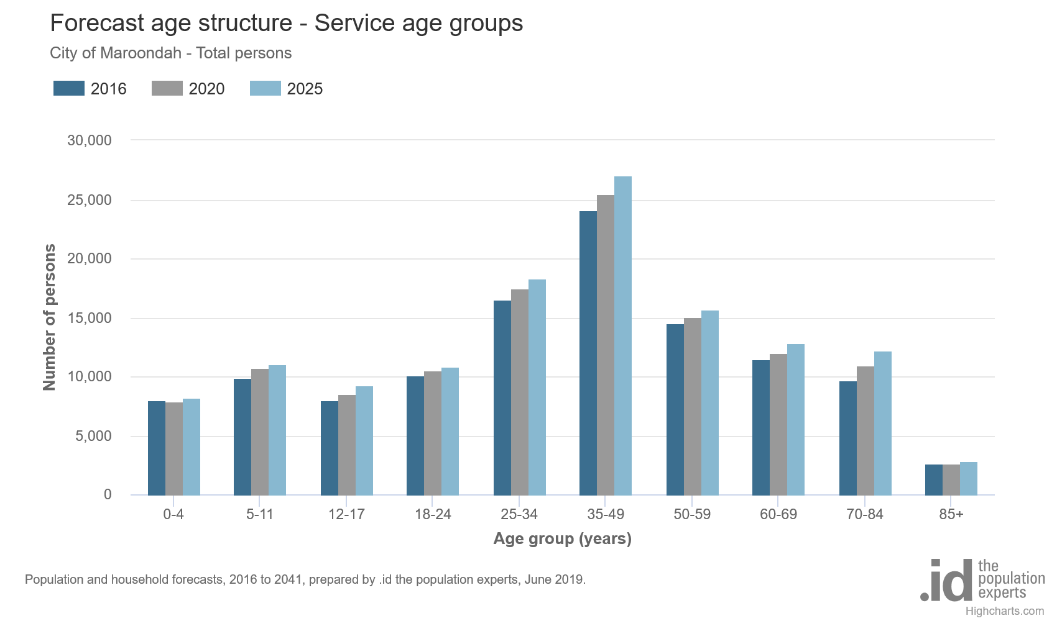

Vulnerable Groups in Maroondah

Early in 2020, .id used 2016 Census data to identify a series of demographic groups that would be vulnerable in the case of an emergency. Figure 5 is a chart of seven of the measures .id used to define ‘vulnerable people’ and shows the percentage of the population in Maroondah in 2016 that met each of the 7 criteria.

Figure 5: Vulnerable communities assessment for Maroondah

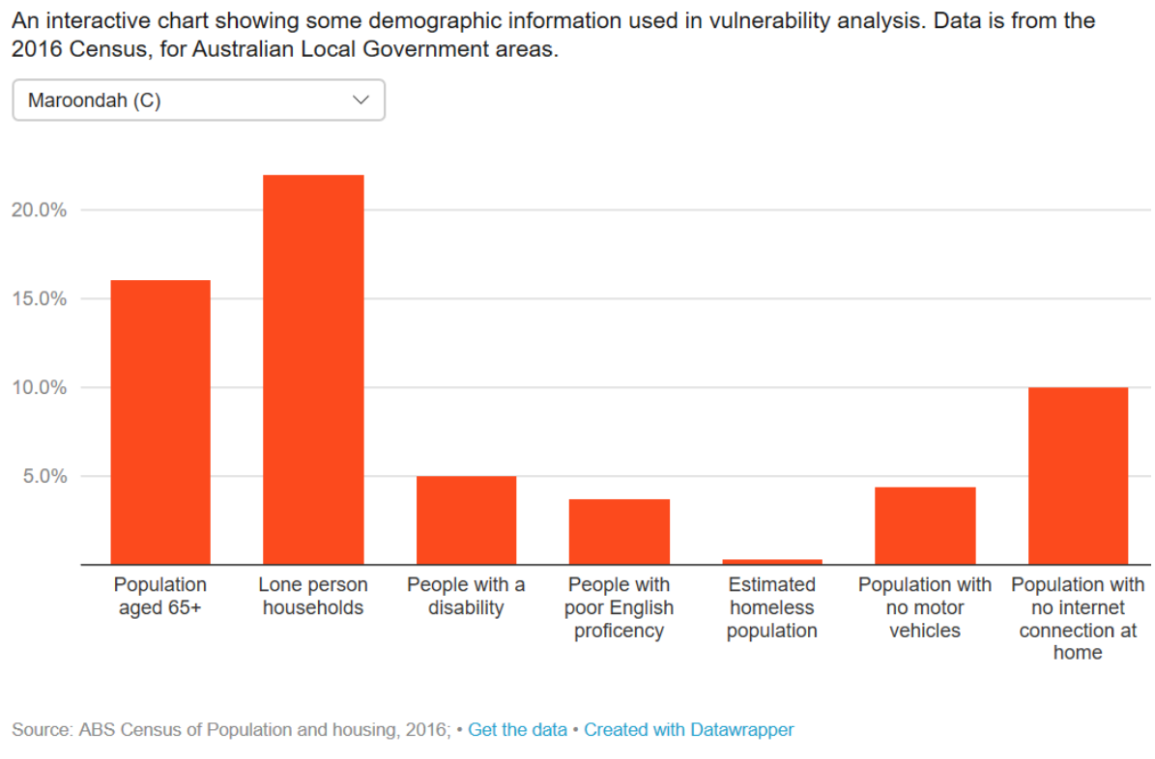

Cultural Diversity

Key statistics
Aboriginal and Torres Strait Islander people in Maroondah | 566 individuals or 0.5% of Maroondah population in 2016  Vs 0.4% for Eastern Metropolitan Region (EMR)
People in Maroondah that were born overseas | 25,545 individuals or 23.1% of Maroondah population in 2016  Vs. 33.2% for EMR | Of all the people living in Maroondah in 2016 that were born overseas, the top countries of birth were:  - United Kingdom  - China  - India  - Burma (Myanmar)  - New Zealand
People in Maroondah that are recent arrivals (i.e. born overseas and arrived in Australia between 2011 and 2016) | 4929 individuals or 19.3% of all people born overseas  Vs. 22.2% for EMR | Of the 435 new arrivals who settled in Maroondah in 2017-2018, the top countries of birth were:  - Myanmar (34%)  - China (18%)  - India (16%)  - Malaysia (5%)  - Iran (5%)
Humanitarian Visa arrivals in Maroondah | In 2017-2018, 60% (211) of Humanitarian Visa arrivals in the Outer East settled in the City of Maroondah – more than 3 times the next highest LGA (Yarra Ranges). The majority (69%) were born in Myanmar.

Languages Spoken

Key statistics | Percentage of population | Areas with highest proportions
People in Maroondah who speak a language other than English at home | 18,651 individuals or 16.9% of Maroondah population in 2016  NOTE: 42.7% increase since 2011  Vs. 30.1% for EMR | - Ringwood Metropolitan Activity Centre (RMAC) (39.5%)  - Ringwood (28.3%)  - Croydon Major Activity Centre (CMAC) (24.9%)
People in Maroondah not fluent in English | 4075 individuals or 3.7% of Maroondah population in 2016  Vs. 5.2% for EMR | - RMAC (9.6%)  - CMAC (8.7%)  - Ringwood (6.7%)
Languages spoken at home in Maroondah (ranked by size, excluding English) | In 2016:  - Mandarin (3.3% / 3601 persons)  - Cantonese (1.3% / 1398 persons)  - Chin Haka (1.0% / 1158 persons)  - Italian (0.7% / 825 persons)  - Hindi (0.6% / 631 persons)  - Greek (0.6% / 613 persons)  - Punjabi (0.5% / 589 persons)  - Persian / Dari (0.5% / 585 persons)  - German (0.5% / 515 persons)  - Spanish (0.5% / 467 persons) | Largest changes between 2011 and 2016:  - Mandarin (+2,033 persons)  - Chin Haka (+913 persons)  - Cantonese (+407 persons)  - Persian/Dari (+315 persons)

Social Isolation and Loneliness

Key statistics | Percentage of households | Areas with highest proportions
Lone person households in Maroondah | 9643 or 23.3% of households in Maroondah in 2016  Vs. 20.9% for EMR | - CMAC (39.9%)  - RMAC (34.4%)  - Kilsyth (30.1%)
Older lone person households in Maroondah where the lone person is aged 65+ years | 4165 or 10.1% of households in Maroondah in 2016  Vs 9.5% for EMR | - Kilsyth (15.7%)  - Croydon (13.4%)  - Ringwood (11.4%)
One parent families with dependent children aged under 15 years in Maroondah | 1850 or 4.5% of households in Maroondah in 2016  Vs. 3.8% for EMR | - CMAC (4.9%)  - Croydon (4.8%)  - Croydon South (4.7%)
Loneliness | - 1 in 4 Australian adults are lonely  - Older Australians (over 65 years) are least lonely  - Loneliness tends to be more common in young adults, males, those living alone and those with children, either singly or in a couple  - Unemployment, receiving income support and lack of satisfaction with financial situation are factors in the development of loneliness

Mental Health

Key statistics
Nationally in 2017-18 :
- One in five (20.1%) or 4.8 million Australians had a mental or behavioural condition, an increase from 4.0 million Australians (17.5%) in 2014-15
- 3.2 million Australians (13.1%) had an anxiety-related condition, an increase from 11.2% in 2014-15
- One in ten people (10.4%) had depression or feelings of depression, an increase from 8.9% in 2014-15

In Maroondah in 2017 :
- 26.2% of adults experienced anxiety or depression
- 18.3% of adults experienced high / very high psychological distress

Age differences:
- The prevalence of mental disorders declines with age from more than one in four (26.4%) in the youngest age group (16-24 years) to around one in twenty (5.9%) in the oldest age group (75-85 years)

Gender differences:
- Men on average are three times more likely (18.7%) to die by suicide compared to women (5.8%)
- Prevalence of anxiety and affective disorders (depression, anxiety, PTSD etc) is more widespread among women than men
- Men are less likely to seek help for mental health conditions than women

Disabilities

Key statistics
In 2018 there were 4.4 million Australians with disability (17.7% of the population), down from 18.3% in 2015.
5.7% of all Australians had a profound or severe disability.
The prevalence of disability increases with age, around 1 in 9 (11.6%) people aged under 65 have some level of disability, rising to 1 in 2 (49.6%) for those aged 65 and over.
Disability prevalence was similar for males (17.6%) and females (17.8%).
Of the 4.4 million Australians with disability in 2018:
- Over three-quarters (76.8%) reported a physical disorder as their main condition (the condition causing them the most problems), similar to 2015 (78.5%)
  - The most common physical disorder was a musculoskeletal disorder (29.6%), including arthritis and related disorders, and back problems
- Almost one-quarter (23.2%) reported a mental or behavioural disorder as their main condition, up from 21.5% in 2015
  - The most common mental and behavioural disorders were: psychoses and mood disorders (7.5%), intellectual and development disorders (6.5%), and neurotic, stress related and somatoform disorders (6.1%)
In Maroondah, 2016 Census data showed that 5% (5,482) of Maroondah’s population reported needing help in their day-to-day lives due to disability.
In 2016, the areas in Maroondah with the highest proportion of people in need of assistance due to disability were:
- Ringwood (6.1%)
- Bayswater North Community Renewal Area (6.1%)
- Ringwood East (5.9%)

Family or Partner Violence and Abuse

Key statistics
Children and young people | Nationally:  - About 1 in 6 women (16% or 1.5 million) and 1 in 10 men (11% or 991,600) aged 18 years and over had experienced physical and/or sexual abuse before the age of 15 by any adult (male or female) including the person’s parents  - Before the age of 15:  - 1 in 8 women and 1 in 10 men witnessed violence towards their mother by a partner;  - 1 in 20 women and 1 in 25 men witnessed violence towards their father by a partner  - Young women (18–24 years) experience significantly higher rates of physical and sexual violence than women in older age groups
Adults | Nationally:  - Approximately 1 in 4 women (23% or 2.2 million) and approximately 1 in 13 men (7.8% or 703,700) have experienced violence by an intimate partner (including non-residential partners) since the age of 15  In Maroondah:  - In 2018-19, 1156 family violence incidents in Maroondah were reported to Victoria Police, equating to a rate of 970.9 per 100,000 population (compared to 1,253.3 for Victoria)
Older people | Globally:  - Almost 1 in 6 of people aged 60 and over have been a victim of elder abuse
Homicide | Data sources referenced in the Australian Institute of Health and Welfare’s 2019 report ‘Family, domestic and sexual violence in Australia: continuing the national story’ show that nationally:  - 1 woman is killed every 9 days and 1 man is killed every 29 days by a partner  - 1 in 4 female victims held a current domestic violence order when murdered  - Most intimate partner homicides occur in the home  - Female victims are more likely to be killed during a period of intended or actual separation  - Almost half of all homicide victims were unemployed  - Emotional abuse is the most common form of abuse leading up to domestic violence homicide  - More than half of the people who killed an intimate partner were affected by alcohol, other drugs or both

Financially Vulnerable Households

Key statistics | Percentage of population | Areas with highest proportions
Low income households in Maroondah (i.e. combined gross income of less than $650 per week before tax) | 6427 or 16.0% of households in Maroondah in 2016  Vs. 16.2% for EMR | - RMAC (23.8%)  - Kilsyth (21.9%)  - CMAC (20.2%)  - Ringwood (19.6%)  - Croydon (18.8%)
Households in housing stress in Maroondah (re: home loan and rental payments) | 4210 or 10.2% of households in Maroondah in 2016  Vs. 10.2% for EMR | - RMAC (19.7%)  - CMAC (17.8%)  - Ringwood (13.2%)  - Bayswater North (11.8%)  - Croydon (11.5%)
Households without a car in Maroondah | 1934 or 4.7% of households in Maroondah in 2016  Vs. 5.7% for EMR | - RMAC (13.0%)  - CMAC (9.2%)  - Ringwood (7.6%)  - Ringwood East (6.0%)  - Croydon (5.9%)

Economic Environment

Key statistics
Pre-COVID:
- In the year ending June 2019, there were 52,428 jobs located in the City of Maroondah
- In 2016 the following industries were the top employers in Maroondah:
  - Retail Trade (15.1% of total employment)
  - Health Care and Social Assistance (15.0%) – top: hospitals (4.3%) and residential care services (3.4%)
  - Manufacturing (13.8%)
- Employment rates in March 2020:
- Unemployment rate in Maroondah - 3.7%
- National unemployment rate - 5.2%
- National youth unemployment rate - 11.6% (typically at least double the unemployment rate)
- National under-employment rate - 8.8%
Since COVID:
- Almost 2.3 million people (about 1 in 5 employed people) were affected by either losing their job between April and May 2020, or working reduced hours for economic reasons in May
- In May 2020 - female employment fell by 118,000, making up 52% of the jobs lost in the month of May; and
- youth employment fell by 103,000, making up 45% of those jobs lost in May
- Employment rates in June 2020:
- Unemployment rate in Maroondah - 4.4%
- National unemployment rate - 7.4%
- National youth unemployment rate - 16.4%
- National under-employment rate - 11.7%

JobSeeker and Youth Allowance

Recipients of JobSeeker and Youth Allowance in Maroondah | March 2019 | December 2019 | March 2020 | April 2020 | May 2020
City of Maroondah | 2,527 recipients or 3.3% of 15-64 age population  Vs. 3.4% for Greater Melbourne | 2,597 recipients  or 3.4% of 15-64 age population  Vs. 3.5% for Greater Melbourne | 2,853 recipients or 3.7% of 15-64 age population  Vs. 3.9% for Greater Melbourne | 4,780 recipients or 6.2% of 15-64 age population  Vs. 6.7% for Greater Melbourne | 5,928 recipients or 7.7% of 15-64 age population  Vs. 8.5% for Greater Melbourne
Areas (SA2) with highest % | - Croydon – East  - Ringwood  - Croydon South | - Ringwood  - Croydon – East  - Croydon South | - Ringwood  - Croydon – East  - Croydon South | - Ringwood  - Croydon – East  - Croydon – West | - Ringwood  - Croydon – East  - Bayswater North

Volunteering

Key statistics
Percentage of population volunteering | - 19.2% (931,544) of the Victorian population aged 15+ years participated in formal volunteering  - This was slightly higher in Outer East Melbourne with 20.8% (85,040) of the population participating in formal volunteering  - 9.5% (560,867) of the Victorian population aged 15+ years participated in informal volunteering (defined as volunteering for the common good outside of an organisational setting).
Gender | - 20.8% (518,547) of females aged 15 years and over  - 17.6% (413,006) of males aged 15 years and over
Disability | - 9.3% (25,780) of Victorians volunteered aged 15 years and over with a profound disability and needing help  - 21.2% (894,611) of Victorian aged 15 years or over who did not have a profound disability
Age | - Young people (aged 15-24) represent 16% (145,669) of the volunteering population  - Adults (aged 25-59) represent 59% (552,072) of the volunteering population  - Seniors (aged 60+) represent 25% (232,481) of the volunteering population
Frequency of volunteering | - 1 to 10 hours – 26.6%  - 11 to 49 hours – 39.1%  - 50 hours or more – 34.3%
Value of volunteering | - The economic value of volunteering in 2016 was projected at between $24-31 billion  - Volunteers are more likely to be involved in other aspects of community life than non-volunteers  - Volunteers are happier, healthier and sleep better than those who don’t volunteer  - Volunteering mediates the negative psychological effect of disadvantage, with volunteers from disadvantaged backgrounds having similar levels of psychological well-being as professional, educated non-volunteers
Trends | - More people are volunteering for less time than in the past  - ‘Virtual Volunteering’ has emerged in the last decade  - Stronger emphasis on volunteering with Young People as opposed to Sport and Recreation  - Full time and part time employees are more likely to volunteer than casual or unemployed persons

Gambling

Key statistics
Gambling in Maroondah is primarily comprised of electronic gaming machines or ‘pokies’ - there are 759 electronic gaming machines or ‘pokies’ in Maroondah.
Maroondah has the third highest pokies expenditure within the Eastern Metropolitan Region with a total loss of $62.9 million in 2018/19, with Monash ($110.2 million) and Knox ($73.9 million) being first and second respectively.
Gambling addiction has both economic and social impacts which are classified into six primary categories: financial, mental, physical, crime, community and service delivery.

Alcohol Consumption and Drug Use

Key statistics
Around 16% of Australians aged 18 years and over consumed more than two standard drinks per day on average in 2017/18, exceeding the lifetime risk guideline. More than one in five (23.7%) men and around one in eleven women (8.8%) exceeded the lifetime risk guideline.
Maroondah has 30 packaged liquor licenses, 16 of which are condensed in two suburbs: Ringwood (7 licenses) and Croydon (9 licenses).
Over the past decade, Maroondah has had significantly higher ambulance attendances due to alcohol than other local government areas within Eastern Metropolitan Region (EMR). Though still leading in the EMR, recent stats show a significant decline in Maroondah from 629.7 in 2017/18 to 528.5 in 2018/19.
Maroondah has also had the highest rates of ambulance attendances due to illicit drugs in the EMR over the last decade. However attendances for illicit drugs have declined significantly from 200.9 in 2017/18 to 151.5 2018/19.
Hospital admissions due to risky cannabis consumption has remained relatively high in Maroondah when compared to the EMR. In 2017/18 Maroondah had the highest hospital admissions in the EMR due to cannabis.

Australian Disaster Resilience Community Recovery Handbook; 2018; p 49, Australian Institute Disaster Resilience
Australian Bureau of Statistics, Regional Population Growth, Australia (3218.0). Compiled and presented in profile.id by .id , the population experts https://profile.id.com.au/maroondah/population-estimate
Australian Bureau of Statistics, Census of Population and Housing 2011 and 2016 (Enumerated). Compiled and presented in profile.id by .id , the population experts https://profile.id.com.au/maroondah/population
.id, Population and household forecasts, 2016 to 2041, prepared by .id, the population experts, February 2019 https://forecast.id.com.au/maroondah/population-age-structure-map?mYear1=2020&mYear3=2040&CustomAgeFrom=0&CustomAgeTo=85&themtype=Year1
.id, Population and household forecasts, 2016 to 2041, prepared by .id, the population experts, February 2019 https://forecast.id.com.au/maroondah/population-age-structure-map?mYear1=2020&mYear3=2040&CustomAgeFrom=0&CustomAgeTo=85&themtype=PerChangeY1Y3
Australian Bureau of Statistics, Census of Population and Housing, 2016 (Usual residence data). Compiled and presented in profile.id by .id, the population experts https://profile.id.com.au/maroondah/service-age-groups
Population and household forecasts, 2016 to 2041, prepared by .id the population experts, February 2019 https://forecast.id.com.au/maroondah/population-age-structure?Year1=2016&Year2=2020&Year3=2025&AgeTypeKey=3
.id, https://blog.id.com.au/2020/population/demographic-trends/interactive-chart-is-your-community-demographically-vulnerable/#chart
Australian Bureau of Statistics, Census of Population and Housing 2011 and 2016 (Usual residence). Compiled and presented in profile.id by .id , the population experts https://profile.id.com.au/maroondah/population
Australian Bureau of Statistics, Census of Population and Housing 2011 and 2016. Compiled and presented by .id , the population experts https://profile.id.com.au/maroondah/birthplace?BMID=35
Australian Bureau of Statistics, Census of Population and Housing 2016. Compiled and presented by .id , the population experts https://profile.id.com.au/maroondah/overseas-arrivals?BMID=35
Australian Government, Department of Social Services, as per Migrant Information Centre - Eastern Melbourne ‘City of Maroondah Settlement Data - July 2017 to June 2018’ https://miceastmelb.com.au/resources/demographics-of-the-eastern-region/city-of-maroondah-settlement-data-july-2017-to-june-2018/
Australian Government, Department of Social Services, as per Migrant Information Centre - Eastern Melbourne ‘Settlement Data in the Eastern Metropolitan Region - July 2017 to June 2018’ http://miceastmelb.com.au/resources/demographics-of-the-eastern-region/city-of-maroondah-settlement-data-july-2017-to-june-2018/
Australian Government, Department of Social Services, as per Migrant Information Centre - Eastern Melbourne ‘City of Maroondah Settlement Data - July 2017 to June 2018’ https://miceastmelb.com.au/resources/demographics-of-the-eastern-region/city-of-maroondah-settlement-data-july-2017-to-june-2018/
Australian Bureau of Statistics, Census of Population and Housing, 2016 (Usual residence data). Compiled and presented in atlas.id by .id, the population experts https://atlas.id.com.au/maroondah
Australian Bureau of Statistics, Census of Population and Housing, 2016 (Usual residence data). Compiled and presented in atlas.id by .id, the population experts https://atlas.id.com.au/maroondah
Australian Bureau of Statistics, Census of Population and Housing, 2011 and 2016 (Usual residence data). Compiled and presented in profile.id by .id, the population experts https://profile.id.com.au/maroondah/language?BMID=35
Australian Bureau of Statistics, Census of Population and Housing, 2016 (Enumerated data). Compiled and presented in atlas.id by .id, the population experts https://atlas.id.com.au/maroondah
Australian Bureau of Statistics, Census of Population and Housing, 2016 (Enumerated data). Compiled and presented in atlas.id by .id, the population experts https://atlas.id.com.au/maroondah
Australian Bureau of Statistics, Census of Population and Housing, 2016 (Enumerated data). Compiled and presented in atlas.id by .id, the population experts https://atlas.id.com.au/maroondah
Australian Psychological Society and Swinburne University of Technology, 2018, Australian Loneliness Report: A survey exploring the loneliness levels of Australians and the impact on their health and wellbeing https://psychweek.org.au/wp/wp-content/uploads/2018/11/Psychology-Week-2018-Australian-Loneliness-Report-1.pdf
Australian Psychological Society and Swinburne University of Technology, 2018, Australian Loneliness Report: A survey exploring the loneliness levels of Australians and the impact on their health and wellbeing https://psychweek.org.au/wp/wp-content/uploads/2018/11/Psychology-Week-2018-Australian-Loneliness-Report-1.pdf
Baker D, 2012, All the lonely people: loneliness in Australia, 2001–2009. Canberra: The Australia Institute, as per Australian Institute of Health and Welfare ‘Social isolation and loneliness’ snapshot https://www.aihw.gov.au/reports/australias-welfare/social-isolation-and-loneliness
Relationships Australia, 2018, Is Australia experiencing an epidemic of loneliness? Findings from 16 waves of the Household Income and Labour Dynamics of Australia Survey, Canberra: Relationships Australia, as per Australian Institute of Health and Welfare ‘Social isolation and loneliness’ snapshot https://www.aihw.gov.au/reports/australias-welfare/social-isolation-and-loneliness
Baker D, 2012, All the lonely people: loneliness in Australia, 2001–2009, Canberra: The Australia Institute, as per Australian Institute of Health and Welfare ‘Social isolation and loneliness’ snapshot https://www.aihw.gov.au/reports/australias-welfare/social-isolation-and-loneliness
Australian Bureau of Statistics, 2018, National Health Survey: First results, 2017-18 financial year https://www.abs.gov.au/statistics/health/health-conditions-and-risks/national-health-survey-first-results/2017-18
Victorian State Government, Victorian Population Health Survey 2017 https://www2.health.vic.gov.au/public-health/population-health-systems/health-status-of-victorians/survey-data-and-reports/victorian-population-health-survey/victorian-population-health-survey-2017
Australian Government, Department of Health, 2009, Prevalence of mental disorders in the Australian population (2007 National Survey of Mental Health and Wellbeing) https://www1.health.gov.au/internet/publications/publishing.nsf/Content/mental-pubs-m-mhaust2-toc~mental-pubs-m-mhaust2-hig~mental-pubs-m-mhaust2-hig-pre
Australian Bureau of Statistics, 2019, Causes of death, Australia, 2018 https://www.abs.gov.au/ausstats/abs@.nsf/Lookup/by%20Subject/3303.0~2018~Main%20Features~Intentional%20self-harm,%20key%20characteristics~3
Australian Bureau of Statistics, 2008, National Survey of Mental Health and Wellbeing: Summary of Results, 2007 https://www.abs.gov.au/AUSSTATS/abs@.nsf/Lookup/4326.0Main+Features32007?OpenDocument
Australian Bureau of Statistics, 2008, National Survey of Mental Health and Wellbeing: Summary of Results, 2007 https://www.abs.gov.au/AUSSTATS/abs@.nsf/Lookup/4326.0Main+Features32007?OpenDocument
Australian Bureau of Statistics, 2019, Disability, Ageing and Carers: Summary of Findings, 2018 https://www.abs.gov.au/statistics/health/disability/disability-ageing-and-carers-australia-summary-findings/2018
Australian Bureau of Statistics, 2019, Disability, Ageing and Carers: Summary of Findings, 2018 https://www.abs.gov.au/statistics/health/disability/disability-ageing-and-carers-australia-summary-findings/2018
Australian Bureau of Statistics, 2019, Disability, Ageing and Carers: Summary of Findings, 2018 https://www.abs.gov.au/statistics/health/disability/disability-ageing-and-carers-australia-summary-findings/2018
Australian Bureau of Statistics, 2019, Disability, Ageing and Carers: Summary of Findings, 2018 https://www.abs.gov.au/statistics/health/disability/disability-ageing-and-carers-australia-summary-findings/2018
Australian Bureau of Statistics, 2019, Disability, Ageing and Carers: Summary of Findings, 2018 https://www.abs.gov.au/statistics/health/disability/disability-ageing-and-carers-australia-summary-findings/2018
Australian Bureau of Statistics, 2019, Disability, Ageing and Carers: Summary of Findings, 2018 https://www.abs.gov.au/statistics/health/disability/disability-ageing-and-carers-australia-summary-findings/2018
Australian Bureau of Statistics, 2019, Disability, Ageing and Carers: Summary of Findings, 2018 https://www.abs.gov.au/statistics/health/disability/disability-ageing-and-carers-australia-summary-findings/2018
Australian Bureau of Statistics, 2019, Disability, Ageing and Carers: Summary of Findings, 2018 https://www.abs.gov.au/statistics/health/disability/disability-ageing-and-carers-australia-summary-findings/2018
Australian Bureau of Statistics, Census of Population and Housing 2011 and 2016. Compiled and presented by .id , the population experts https://profile.id.com.au/maroondah/assistance?BMID=35
Australian Bureau of Statistics, Census of Population and Housing, 2016 (Usual residence data). Compiled and presented in atlas.id by .id, the population experts https://atlas.id.com.au/maroondah
Australian Bureau of Statistics, 2017, Personal Safety Survey, Australia, 2016, ABS cat. no. 4906.0 https://www.abs.gov.au/ausstats/abs@.nsf/mf/4906.0
Australian Bureau of Statistics, 2017, Personal Safety Survey, Australia, 2016, ABS cat. no. 4906.0 https://www.abs.gov.au/ausstats/abs@.nsf/mf/4906.0
Australian Bureau of Statistics, 2017, Personal Safety Survey, Australia, 2016, ABS cat. no. 4906.0 https://www.abs.gov.au/ausstats/abs@.nsf/mf/4906.0
Australian Bureau of Statistics, 2017, Personal Safety Survey, Australia, 2016, ABS cat. no. 4906.0 https://www.abs.gov.au/ausstats/abs@.nsf/mf/4906.0
Crime Statistics Agency (2019). Data Tables – Victoria Police https://www.crimestatistics.vic.gov.au/family-violence-data-portal/download-data-tables
World Health Organisation, 2018, Elder Abuse fact sheet https://www.who.int/news-room/fact-sheets/detail/elder-abuse
As per Australian Institute of Health and Welfare, 2019, Family, domestic and sexual violence in Australia: continuing the national story https://www.aihw.gov.au/getmedia/b0037b2d-a651-4abf-9f7b-00a85e3de528/aihw-fdv3-FDSV-in-Australia-2019.pdf.aspx?inline=true
Australian Bureau of Statistics, Census of Population and Housing 2016. Compiled and presented in atlas.id by .id , the population experts https://atlas.id.com.au/maroondah
Australian Bureau of Statistics, Census of Population and Housing 2016. Compiled and presented in atlas.id by .id , the population experts https://atlas.id.com.au/maroondah
Australian Bureau of Statistics, Census of Population and Housing 2016. Compiled and presented in atlas.id by .id , the population experts https://atlas.id.com.au/maroondah
Australian Bureau of Statistics, Australian National Accounts: National Income, Expenditure and Product, catalogue number 5206.0; and the National Institute of Economic and Industry Research (NIEIR) ©2019. Compiled and presented in economy.id by .id the population experts https://economy.id.com.au/maroondah/local-jobs
Australian Bureau of Statistics, Census of Population and Housing, 2016. Compiled and presented in economy.id by .id, the population experts. .id the population experts https://economy.id.com.au/maroondah/employment-census
Australian Bureau of Statistics, Labour force survey catalogue number 6202.0; and Department of Employment, Small Area Labour Markets. Compiled and presented in economy.id by .id the population experts https://economy.id.com.au/maroondah/unemployment
Australian Bureau of Statistics, Labour force survey https://www.abs.gov.au/statistics/labour/employment-and-unemployment/labour-force-australia/latest-release#participation
Australia Bureau of Statistics, as per Trading Economics website https://tradingeconomics.com/australia/youth-unemployment-rate
Australian Bureau of Statistics, Labour force survey https://www.abs.gov.au/statistics/labour/employment-and-unemployment/labour-force-australia/latest-release#participation
Australian Bureau of Statistics, Labour force survey https://www.abs.gov.au/articles/people-who-lost-job-or-were-stood-down-flows-analysis-may-2020
Australian Bureau of Statistics, as per Josh Frydenberg MP, Treasurer at June 18 2020 press conference https://www.pm.gov.au/media/press-conference-australian-parliament-house-act-19
Australian Bureau of Statistics, Labour force survey catalogue number 6202.0; and Department of Employment, Small Area Labour Markets. Compiled and presented in economy.id by .id the population experts https://economy.id.com.au/maroondah/unemployment
Australian Bureau of Statistics, Labour force survey https://www.abs.gov.au/statistics/labour/employment-and-unemployment/labour-force-australia/latest-release#participation
Australia Bureau of Statistics, as per Trading Economics website https://tradingeconomics.com/australia/youth-unemployment-rate
Australian Bureau of Statistics, Labour force survey https://www.abs.gov.au/statistics/labour/employment-and-unemployment/labour-force-australia/latest-release#participation
Department of Social Services - JobSeeker and Youth Allowance recipients - monthly profile via data.gov.au. Compiled and presented by .id - the population experts https://profile.id.com.au/maroondah/job-seeker
Australian Bureau of Statistics, 2016 Census data as per Volunteering Victoria, 2018, “Key facts and statistics about volunteering in Victoria” http://volunteeringvictoria.com.au/wp-content/uploads/2019/05/Facts-Stats-10-Jan-2018.pdf
Victorian Responsible Gambling Foundation, 2019, Pokies across Victoria https://responsiblegambling.vic.gov.au/resources/gambling-victoria/pokies-across-victoria/maroondah/
Victorian Responsible Gambling Foundation, 2019, Pokies across Victoria https://responsiblegambling.vic.gov.au/resources/gambling-victoria/pokies-across-victoria/maroondah/
The Victorian Competition & Efficiency Commission, 2012, Counting the Cost: Inquiry into the costs of Problem Gambling: Final Report December 2012 https://www.dtf.vic.gov.au/sites/default/files/2018-02/counting-the-cost-inquiry-into-the-costs-of-problem-gambling.pdf
Australian Bureau of Statistics, 2018, National Health Survey: First results, 2017-18 financial year https://www.abs.gov.au/statistics/health/health-conditions-and-risks/national-health-survey-first-results/2017-18
Victorian Commission for Gambling and Liquor Regulation, Interactive map of Victoria’s liquor venues https://www.vcglr.vic.gov.au/interactive-map-victorias-liquor-venues
Turning Point, AODStats website https://www.aodstats.org.au/index.php
Turning Point, AODStats website https://www.aodstats.org.au/index.php
Turning Point, AODStats website https://www.aodstats.org.au/index.php

