Public Lighting Position Paper


Prepared for
Maroondah City Council
Version | Author | Date | Description of changes
V0a – 0n | Ross McKirdy, Keith Harwood | 14/07 – 20/9/2017 | Draft versions
V1a | Ross McKirdy, Keith Harwood | 21/9/2017 | First draft for Council comment
V2a | Nick Cody, Ross McKirdy | 17/11/2017 | Draft update following Council comment
V2b | Keith Harwood | 21/11/2017 | Draft update following Council comment
V2c | Ross McKirdy | 22/11/2017 | Second draft for Council comment
V2d | Nick Cody | 24/11/2017 | Minor revisions following Council comment
V2e | Hannah Snape, Ross McKirdy | 21/12/2017 | Final version following Council comment
V3a | Ross McKirdy | 23/5/2018 | Additional updates at request of Council

Prepared by
Ironbark Sustainability
Suite 8, 70-80 Wellington St, Collingwood 3066
ABN: 51 127 566 090
Ph: 1300 288 262 | info@realaction.com.au | www.realaction.com.au

© 2017 Ironbark Group Pty. Ltd.

The information contained in this document produced by Ironbark Group Pty. Ltd is solely for the use of the client identified on this page for the purpose for which it has been prepared and Ironbark Group Pty. Ironbark undertakes no duty to or accepts any responsibility to any third party who may rely upon this document. All rights reserved. No section or element of this document may be removed from this document, reproduced, electronically stored or transmitted in any form without the written permission of Ironbark Group Pty. Ltd.

About Ironbark Sustainability
Ironbark Sustainability is a specialist consultancy that works with government and business around Australia by assisting them to reduce energy and water usage through sustainable asset and data management and on-the-ground implementation.

Ironbark has been operating since 2005 and brings together a wealth of technical and financial analysis, maintenance and implementation experience in the areas of building energy and water efficiency, public lighting and data management. We pride ourselves on supporting our clients to achieve real action regarding the sustainable management of their operations.

Our Mission
Ironbark’s mission is to achieve real action on sustainability for councils and their communities.
Contents
1. Executive Summary 7
2. Introduction 12
3. Background 13
4. Context 15
4.1 Public Lighting Guidelines and Policy Scope 15
4.2 Ownership and Responsibility for Public Lighting 15
4.2.1 Vesting of Unmetered Lighting Assets 17
5. Approval Processes for New Assets 20
5.1 Unmetered Standard Street Lighting Assets 20
5.2 Unmetered Non-Standard Street Lighting Assets 21
5.3 Metered Lighting Assets 22
5.3.1 Special Consideration – Public Aesthetic Lighting 24
5.3.2 Special Consideration – Private Aesthetic Lighting 24
6. Maintenance and Repair Procedures 26
6.1 Unmetered Assets 26
6.2 Metered Assets 28
6.3 Public Lighting and Trees 30
7. Asset Replacement/Renewal Procedures 32
7.1 Unmetered Assets 32
7.2 Metered Assets 33
8. Asset Consistency 35
8.1 Unmetered Assets 36
8.1.1 Luminaire Technology 36
8.1.2 Standard and Non-Standard Fittings 37
8.2 Metered Assets 38
8.3 Key Precincts 40
9. Lighting Technology 42
9.1 Smart Cities Compatibility 42
9.2 Solar Lighting 45
10. Asset Registers 46
10.1 Unmetered Assets 46
10.2 Metered Assets 47
11. Complaints Procedures 50
11.1 Requests for New Street Lighting (Existing Lighting) 50
11.2 Requests for New Street Lighting (No Existing Lighting) 50
11.3 Requests for Removal of Lighting 51
11.4 Complaints About Overlighting or Light Spill 51
12. Where and When to Light 53
12.1 Special Considerations 61
13. Lighting Categories (Light Levels) 63
13.1 Assigning Lighting Categories Using the Standard 63
13.1.1 Car Parks 63
13.1.2 Public Activity Centres (excluding car parks) 64
13.1.3 Roadways, Pedestrian Paths and Laneways 65
13.2 Background to Assigning Lighting Categories Using the Standard 66
13.3 Exceptions 67
14. Lighting Quality 70
14.1 CCT and Blue Light 70
15. Waste Disposal at End of Life 72
16. Policy and Guidelines Review 74
17. Glossary 75
18. Appendix 1 – Strategic Cycling Corridors 77
19. Appendix 2 – Principle Pedestrian Network 78
20. Appendix 3 – Key Pedestrian Routes Around Train Stations and Maroondah Hospital 79
21. Appendix 4 – Road Classifications from Council’s Road Management Plan 84

Tables
Table 1: Summary of key positions and recommendations 7
Table 2: Current ownership and responsibility for public lighting 15
Table 3: Overview of repair and maintenance processes for unmetered asset types 26
Table 4: Comparison of LER of different luminaire technologies 36
Table 5: Recommended requirements for metered luminaire and poles 39
Table 6: Issues relating to lighting of key precincts 41
Table 7: Recommended guiding principles for installation of public lighting in Maroondah 54
Table 8: Recommended lighting requirements for specific types of locations in Maroondah 56
Table 9: Car park lighting categorisation system 64
Table 10: Lighting subcategory requirements for car parks 64
Table 11: Public activity centre lighting categorisation system 64
Table 12: Lighting subcategory requirements for public activity centres (excluding car parks) 65
Table 13: Roadway, pedestrian path and laneway categorisation table 65
Table 14: Lighting subcategory requirements for roadways, pedestrian paths and laneways 66
Table 15: Site-specific lighting category requirements identified by key Council staff 67
Table 16: Summary of typical components, materials and recycling requirements 72

Figures
Figure 1: Approval process for standard unmetered lighting assets 20
Figure 2: Approval process for non-standard unmetered lighting assets 22
Figure 3: Approval process for metered lighting assets 23
Figure 4: Examples of 'smart pole' features and functionality 44
Figure 5: Figure 2.1 from AS/NZS 1158.3.1 2005 63
Figure 6: Australian Highway Lighting Categories, reaction times improved by white light (Davis 1999, Arizona DoT, SLPC, from IPWEA SLSC Roadmap 2016) 70
Figure 7: 800m radius around Ringwood Station and Heatherdale Station 79
Figure 8: 800m radius around Croydon Station 80
Figure 9: 800m radius around Heathmont Station 81
Figure 10: 800m radius around Ringwood East Station 82
Figure 11: 800m radius around Maroondah Hospital 83

Executive Summary
This Public Lighting Position Paper has been developed to inform the management of Council’s public lighting assets. Consultation with key Council staff and the review of relevant Council policies within the context of best practice public lighting asset management has established a set of key positions and/or recommendations that should be addressed in Council’s Public Lighting Policy and Guidelines.

The key positions and/or recommendations are summarised in Table 1.

Table 1: Summary of key positions and recommendations
Section | Position/Recommendation
4.1 | The Guidelines and Policy will cover:  - road/street and footpath lighting  - Council car park lighting  - standalone car parks  - public facility or recreation reserve car parks  - park lights and other pole-mounted open space lights  - pedestrian path lighting  - off street bicycle path lighting  - wayfinding lighting (bollards and in-ground path markers)  - under-awning and shop window lighting  - aesthetic lighting  - building façade lighting  - tree up-lighting  - lighting related to sculptures and public art  - laneway lighting  - external building lighting  - perimeter lighting  - external entrance lighting  The Guidelines and Policy will not cover:  - internal building lighting  - sports ground lighting  - sports facility lighting
4.2.1 | Council to continue to monitor the vesting of new unmetered public lighting assets in Victoria
5.1 | Council to engage a third-party designer to review designs proposed by developers for all subdivisions where the road related assets will be vested to Council (for unmetered standard street lighting installations)
5.2 | Council to consider collecting key characteristic data for any new non-standard street lighting assets that are installed
5.3 | Council to consider the need to engage a third-party designer to review designs proposed by developers (for metered lighting assets)  Council to add all newly installed metered public lighting assets to an asset register
5.3.1 | Council to consider public aesthetic lighting in special circumstances
5.3.2 | Council’s Public Lighting Guidelines to specify private aesthetic lighting shall be considered. Private aesthetic lighting installations shall be considered where it:  - is not to be installed on public assets where maintenance of that asset might be affected  - is temporary  - does not impact negatively on existing functional lighting  - contributes to place making  - is to be installed, operated and maintained by the person/body making the request  - does not require the installation of any permanent supporting infrastructure
6.1 | Council will not stock decorative (non-standard) luminaires and poles for maintenance of unmetered public lighting  Council to consider commissioning third-party night time audits of unmetered minor road street lighting to collect data on faulty street lighting and subsequently submit them to AusNet for repair  Council to consider requesting a greater level of transparency from AusNet regarding bulk lamp and PE cell maintenance work
6.2 | Council to undertake proactive maintenance of metered public lighting assets, including:  - a 3-year cycle of cleaning visors  - either annual operation audits OR 3 to 4-year condition assessments  Council to install identification plates on all metered public lighting poles  Council will respond to faults (investigation, not action) within 10 days  Council will expand upon its existing asset register to create a comprehensive record of it metered lighting assets  Council will utilise its existing customer service system which has a street light module that can be refined/developed to access or align with any council public lighting asset register/database  Council will not to keep stock of metered luminaires or components, and instead will order in when required
6.3 | Council’s Public Lighting Guidelines to:  - specify design principles to apply to the design of new streetscapes  - specify to specify an onsite light level analysis and assessment against standards in response to complaints about trees
7.1 | Council to:  - continue the existing program to replace 50W and 80W unmetered standard mercury vapour street lights  - proactively explore potential renewal projects for unmetered street lighting that offer environmental and/or financial benefits  - consider replacement options for existing non-standard unmetered street lighting including their potential replacement with standard street lighting
7.2 | Council to consider:  - undertaking regular metered public lighting asset audits and reviews of maintenance works to better understand when an asset has reached the end of its life either via poor condition or escalating maintenance costs  - regular investigation of new technologies via feasibility studies that look into the financial and environmental costs and benefit of renewing metered public lighting assets before they reach the end of their life  - future metered public lighting requirements as part of any precinct or activity centre strategies
8.1.1 | Council’s Public Lighting Guidelines to specify a minimum luminaire efficacy ratio to effectively exclude the use of fluorescent, MV, HPS and MH luminaires for unmetered installations
8.1.2 | Council’s Public Lighting Guidelines to prohibit the use of non-standard unmetered fittings
8.2 | Council’s Public Lighting Guidelines to include a specification and checklist outlining minimum design and performance requirements for metered assets (poles and luminaires)
8.3 | Relating to public lighting in key precincts:  - Council’s Public Lighting Guidelines to identify key precincts  - Council’s Public Lighting Guidelines to specify the same design requirements as for metered public lighting, with limited variation permitted in surface finish and colour, and CCT  - Council’s Public Lighting Policy to specify that at the time of upgrade or renewal the following should be considered:  - transitioning from unmetered to metered supply  - transitioning from overhead to underground supply
9.1 | Council to develop a Smart Cities Policy/Strategy  Council’s Public Lighting Guidelines to specify the use of luminaires with a 7-pin NEMA base wired to a dimmable driver  Council to liaise with AusNet to ensure that all new unmetered luminaires are smart-enabled (featuring a 7-pin NEMA base wired to a dimmable driver)
9.2 | Council’s Public Lighting Guidelines to permit the use of solar lighting only where connection to the grid is not considered viable
10.1 | Council to consider collecting key characteristic data for any new non-standard unmetered street lighting assets that are installed  Council to continue to opportunistically collect locational data on existing non-standard unmetered street lighting assets during bulk upgrade works  Council to consider carrying out a more comprehensive audit of non-standard unmetered street lighting assets to collect data on paint colour, entry point and models
10.2 | Council to add all newly installed metered public lighting assets to an asset register  Council to collect the minimum data on each metered lighting asset (to be specified in Public Lighting Policy)  Council to install ID plates on each metered lighting asset to provide a cross reference between the physical asset and the book asset  Council to implement a clear internal process for the maintenance of the asset register  Council to audit all assets every 3 to 4 years to assess condition and capture any changes to assets that aren’t otherwise captured as part of the ongoing asset register maintenance process
11 | Council’s Public Lighting Guidelines to specify:  - best-practice process for responding to requests for new street lighting  - requests for street lighting on currently unlit streets will be assessed on a case-by-case basis  - requests for removal of street lighting will not be considered  - best-practice process for responding to complaints
12 | Council’s Public Lighting Guidelines to specify where and when to provide public lighting and what controls (dimming, switching, sensors) shall apply
12.1 | Council’s Public Lighting Policy to define the road reserve as:  - kerb-line to kerb-line where no footpaths exist;  - kerb-line to property boundary where only one footpath exists; or  - property boundary to property boundary where no footpaths or only one footpath exists within the Principle Pedestrian Network and pedestrians are expected to walk on nature strips
13 | Council’s Public Lighting Guidelines to specify the method for assigning lighting categories as per AS/NZS 1158, including any site-specific exceptions
15 | Council to include best-practice recycling and waste disposal requirements in any tender or RFQ documentation for public lighting works, including the requirement that evidence of appropriate recycling and/or disposal is provided
16 | Public Lighting Policy and Guidelines to be subject to review every 3-5 years

Introduction
This Public Lighting Position Paper has been developed by Ironbark Sustainability in collaboration with key Council staff to inform the development of Council’s Public Lighting Guidelines and Policy. The issues discussed in this Paper were identified during a series of two workshops and follow-up meetings with key Council staff. The Paper provides a description of each issue relating to public lighting, presents both best practice and Council-specific considerations, and makes recommendations for Council consideration and possible inclusion in the finalised Public Lighting Guidelines and/or Policy.
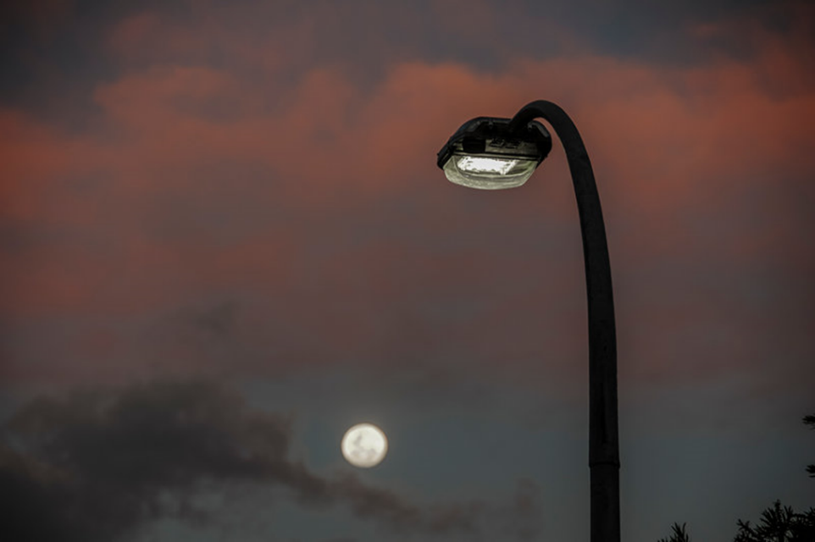

Background
From June to August 2017 a series of stakeholder workshops and internal meetings were conducted with key Council stakeholders. Council stakeholders included representatives from the following Council departments/areas:

- Transport & Traffic Engineering
- Development Engineering
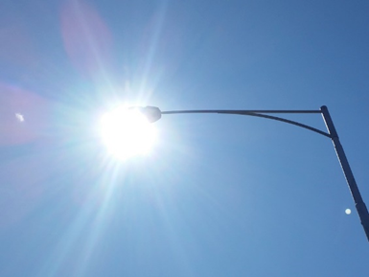
- Engineering Projects
- Facilities
- Asset Management
- Open Space
- Operations
- Built Environment
- Sustainability and Environment
- Business and Development
- Statutory Planning
- Contracts and Purchasing
- Waste and Special Projects
- Community Planning and Development
- Sport and Recreation
- Economic Development

The purpose of these discussions was to establish the guiding principles for the development, implementation and maintenance of public lighting schemes in the City Maroondah, with a focus on:

- best practice
- sustainability
- financial responsibility
- adherence to community expectations
- innovation
- asset management

Development of this Position Paper has also been informed by reference to the following documents:

- Ringwood Transit City Lighting Strategy November 2007
- Ringwood Urban Design Manual December 2014
- Road Management Plan 2013-2017
- Carbon Neutral Strategy & Action Plan 2014/15-2020/21

At present, Maroondah does not have any Council-wide guidelines or policies relating to public lighting. Recent projects have identified the need for an informed policy position on public lighting asset management, safety and public expectations, application of standards, sustainability and energy efficiency, and how to balance the often competing demands of the need to light public spaces while preserving neighbourhood character. The advent of “smart” lighting also presents challenges and opportunities which Council needs to consider.

This consultation represents the first step towards development of a set of Public Lighting Guidelines and ultimately a Public Lighting Policy. This Position Paper discusses the key issues that were identified during the Council stakeholder consultation process, and is intended to guide further discussion within Council in the context of what is considered best practice, and considerations that are specific to the City of Maroondah. Where relevant, recommendations for the content of Council’s Public Lighting Guidelines and Policy have been made.

While Council can exert significant influence on pedestrian lighting, it is also acknowledged that a wider range of stakeholders need to be consulted and collaborated with to achieve ideal outcomes. As such, Council may seek further targeted consultation with external stakeholders following the development including:

- AusNet Services
- Local Police
- Public Transport Victoria (PTV)
- VicTrack
- VicRoads
- Local business and community members (or community groups)

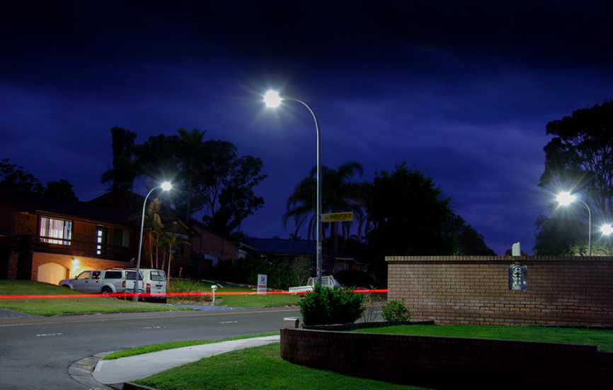

Context

Public Lighting Guidelines and Policy Scope
Following consultation with key Council stakeholders it was decided that the following types of lighting will be included in the scope of Council’s Public Lighting Guidelines and Policy.

The Guidelines and Policy will cover:

- road/street and footpath lighting
- Council car park lighting
  - standalone car parks
  - public facility or recreation reserve car parks
- park lights and other pole-mounted open space lights
  - pedestrian path lighting
  - off street bicycle path lighting
  - wayfinding lighting (bollards and in-ground path markers)
- under-awning and shop window lighting
- aesthetic lighting
  - building façade lighting
  - tree up-lighting
  - lighting related to sculptures and public art
- laneway lighting
- external building lighting
  - perimeter lighting
  - external entrance lighting

The Guidelines and Policy will not cover:
- internal building lighting
- sports ground lighting
- sports facility lighting

Ownership and Responsibility for Public Lighting
A summary of the current ownership and decision-making arrangements for all in-scope lighting is outlined in Table 2, and is based on discussion with key Council staff during the workshop process.

Table 2: Current ownership and responsibility for public lighting
Area | Strategic Planning | Operation and Maintenance | Asset Renewal | Capital Works | Pole & Light Ownership
Parks and Open Space lighting (generally metered lighting) | Traffic Engineering  Open Space  Leisure | Operations  Asset Management (when attached to a building) | Asset Management | Asset Management | Council or AusNet
Street lighting – standard unmetered (majority of lighting) | Traffic Engineering | AusNet | AusNet (maintenance) | Sustainability (bulk changeovers)  Traffic Engineering (ad-hoc replacements) | AusNet
Street lighting – non - standard unmetered | Traffic Engineering | AusNet | AusNet (maintenance) | Sustainability (bulk changeovers)  Traffic Engineering (ad-hoc replacements) | Council
Car park lighting (generally metered lighting) | Traffic Engineering | Operations | AusNet (maintenance) | Traffic Engineering  Open Space | Council or AusNet
External building lighting | Asset Management  Traffic Engineering | Asset Management  Facilities | Facilities | Facilities | Council
Aesthetic lighting | Site specific but may include:  Business development  Open space  Traffic Engineering  Arts and Cultural Development  Local businesses | Site specific but may be:  Operations  Local businesses | Site specific but may be:  Asset Management  Local businesses | Site specific but may be:  Asset Management  Local businesses | Site specific but may be:  Council  Local businesses
Lighting of shared public-private spaces (“quasi-private” e.g. Town Square) |  | Site-specific

Vesting of Unmetered Lighting Assets
Council’s standard unmetered street lights are owned and maintained by AusNet. At present, and as has been the case for Council’s recent bulk LED street light upgrades, the ownership of any new street lights installed by Council is “gifted” or vested back to AusNet. For over a decade, many councils around Australia have sought to retain ownership of new LED street lighting assets in residential streets, of which the vast majority of existing lights are owned by DNSPs. For this to occur, there generally needs to be an agreement between a council and the DNSP. In some states (such as Queensland and Tasmania) this arrangement whereby the new lights can be owned by the Council is integrated within existing contracts. In others, this is not available unless through negotiation.

In New South Wales, all LEDs have been vested or “gifted” back to the DNSP. Some councils attempted to retain ownership but inevitably the relevant DNSPs (there are three in NSW) have not been willing to sell back their assets.

In Victoria, a handful of councils have attempted to retain ownership of the new LEDs, most notably Moreland City Council who released an alternative maintenance tender in a process that began in 2007. In late 2013, it was announced that the preferred tenderer was Citelum Australia, a subsidiary of European energy, distribution network and nuclear giant EDF (Electricite de France). Citelum began negotiations with DNSP Jemena, to see if an agreement could be made around the transfer or sale of DNSP-owned assets from Jemena to Council, so they could be independently maintained. However, progress stalled with the Australian Energy Regulator confirming in 2014 that “unless a distributor agrees to give a third-party access to its network for maintenance services, it cannot be forced to. They’re not contestable if the distributor provides the services and continues to provide them”. The project was ultimately unsuccessful and in late October 2015 Council undertook a bulk changeover to LEDs with the assets vesting with Jemena.

In Queensland, there are at least three external providers who are interested in assisting councils to retain assets and engage a third party to manage and maintain their assets. Over the past few years a handful of councils have also been negotiating closely with DNSP Energex around a valuation and transfer of existing Energex-owned assets. In mid-2016, Energex developed guidelines under which the transfer of public lighting assets needs to comply. The next steps are to finalise the transfer documentation and develop access agreements, also known as a Facilities Access Agreement or FAA.

In Tasmania, Hobart and Glenorchy Councils retained ownership of the street lights after a change to LED lighting last year. They are currently negotiating an access agreement for councils to manage and maintain the newly installed LEDs. The relationship between councils and TasNetworks is collaborative and aimed at seeking mutually agreeable outcomes, with other councils (including Launceston and region) and the LGA of Tasmania playing a key role in ensuring these relationships are smooth and productive. If, as expected, these negotiations are successful, then Hobart and Glenorchy will be able to engage third parties to manage and maintain the new LEDs, or indeed deliver these services in-house.

In the Northern Territory, street lighting assets will be transferred from NT Power and Water Corporation to councils on 1st January 2018. This is for 22,000 lights across the territory and the negotiations for this transfer has been in motion for years. Negotiation has been in good faith and there are good existing relationships between all parties, noting that NT Power and Water Corporation are a government-owned corporation compared with the privately-owned SAPN.

In Western Australia, there has been no meaningful attempt to retain ownership of lights, noting that NT and WA are not part of the National Electricity Market and not regulated by the AER.

In South Australia, the DNSP SA Power Networks (SAPN) offers an "Energy Only" tariff where councils can retain ownership of the assets on council-owned infrastructure. However, for street lighting assets currently owned and operated by SAPN (i.e. the majority of lights in the state) it’s a bit more complicated. Thankfully the situation is changing and over the last year a group of 9 leading councils from across South Australia have been having regular, open and collaborative discussions with SAPN. This group has been able to facilitate discussions around SAPN approving LED technologies for use on the network and in improving the transparency of street lighting management. The group has been influential in developing a larger range of tariffs and undertaking negotiations that has led to downward revision of the tariffs for LEDs that are now being offered by SAPN. There are also discussions around "access agreements" that could allow councils to retain ownership of new LEDs.

Finally, in the Australian Capital Territory, where street lights are currently publicly owned and managed, the government planned on selling their street lights in 2015, however a tender process in November of that year was unsuccessful. The government is instead trying to find a third party to upgrade and manage their 79,000 lights.

There are potential risks and rewards for councils who do take over ownership and maintenance responsibility of unmetered lighting assets. In the event that ownership is transferred back to a council, the possible benefits include:

- reduced costs by opening up the market for street lighting maintenance service providers
- improved transparency regarding costs and maintenance procedures
- increased control over the costs of the council-owned components of the street lighting network (noting that there would likely still be DNSP-owned cost components e.g. supply cable wiring, the pole etc.).
- increased control over maintenance services such as the type and frequency of maintenance and management of lights.
- more control over smart city services

The key risk associated with any move to reclaim ownership of street lights is that it may never eventuate. While councils around Australia have attempted to seek more control over street lighting assets over the past decade, their success has been very limited. Quite simply, the challenge of “taking over” the assets of another party who do not wish to part with them represents a major obstacle. Other key risks include:

- undefined internal resourcing within Council and an internal lack of expertise in street lighting
- asset management, maintenance and replacement risks rest with Council which council does not currently have expertise in
- maintenance costs end up higher due to the inefficiencies of having multiple maintenance providers - for example, Council maintains the parts of the assets it owns and AusNet concurrently maintains their components (poles etc.) when it may be most efficient to have one provider maintaining the entire network
- legal challenges prevent the transfer of assets or costs blow out
- timeframes blow-out

To date, no council in the AusNet distribution area has sought to challenge or enter into negotiations with AusNet regarding the ownership of their street lights. In the event that a council does go down this path, it is likely that AusNet will refuse to relinquish control, in which case the state government would need to force them to through legislative change. There is currently no indication that this situation is likely to change in the near future.

Given the above, Ironbark would encourage Council to continue to monitor the state of play, especially in Victoria. If and when there is significant change (e.g. a Victorian council successfully takes ownership of their lights, or AusNet indicates they are open to a transfer of ownership) then Council should undertake detailed analysis to determine whether a benefit exists in pursuing ownership.

Recommendation:
- Council to continue to monitor the vesting of new unmetered public lighting assets in Victoria
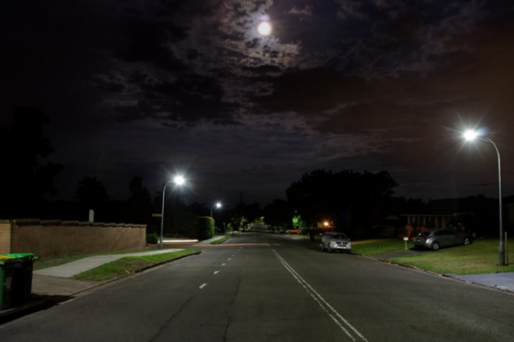

Approval Processes for New Assets
A well-defined and well-governed approval process for new pubic lighting assets is an important component of an overarching asset management system. Its main purpose is to provide a framework for Council to verify that key requirements relating to design, technology, efficiency and asset consistency are being met.

Unmetered Standard Street Lighting Assets
The approval process for new unmetered standard street lighting is relatively straightforward due to the constraints that exist in terms of which products can be used on the unmetered AusNet network.

Figure 1 describes the existing process whereby Council has oversight of the design/preparation phase and AusNet has control of the installation, commissioning and ongoing management of the asset. There are three steps within this process where Council needs to decide what level of control and oversight it wants to have.

Figure 1: Approval process for standard unmetered lighting assets

The first step is during the design phase and is related to the checklist that is provided to inform the proposed lighting scheme. This checklist can dictate minimum energy efficiency requirements, required levels of lighting and preferred product types. A checklist has been developed based on outcomes of the two workshops held with Council staff.

The second step is the Council review stage whereby Council staff verify that the requirements of the checklist and/or the Australian Standards are being met. The greater the complexity of the checklist, the more this stage becomes important to ensure that the desired outcomes are achieved and a consistent approach to new lighting assets is maintained. This stage is also important in terms of signing off on AS 1158 compliance and/or asset minimisation. Experience has shown that it is not always the case that minimum standards are met and/or the most efficient street lighting layout is used to minimise the number of poles and lights that are required. Whilst a third-party review for all proposed lighting schemes represents best practice, Council has indicated a preference for the following rule of thumb:

- when it is a capital works project involving metered lighting, or an unmetered intersection redesign, Council is happy to rely on the designer that they engage to do this
- when it is a developer proposing a design, then Council is will engage a third-party designer to check off on compliance and that the least number of poles/luminaires have been proposed for lighting designs relating to all subdivisions where the road related assets will be vested to Council, including key intersections within or connecting to the residential subdivisions. For smaller scale developments within a single street, Council will rely on the design submitted by the developer.

The third step is the asset register stage which is spoken about in more detail in Section 9. In short, however, AusNet is responsible for maintaining the asset register of unmetered street lighting assets in the City of Maroondah. Some councils choose to augment this asset register to address certain shortfalls in the data that AusNet maintains. At this stage, Council has indicated that it will only consider keeping a record of non-standard unmetered lighting assets (refer to Section 4.2).

Recommendation:
- engage a third-party designer to review designs proposed by developers for all subdivisions where the road related assets will be vested to Council

Unmetered Non-Standard Street Lighting Assets
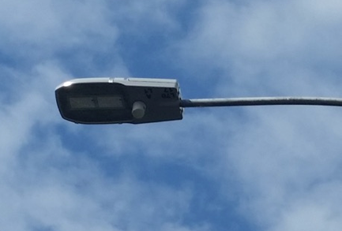
The existing approval process for new unmetered non-standard lighting is largely the same as the process outlined for unmetered standard street lighting (refer to Figure 2), and the same issues outlined in Section 4.1 need to be addressed. However, the following additional considerations (discussed in further details in the sections specified) are specific to non-standard street lighting and would need to be accommodated by a checklist and processes relating to asset registers:

- greater restrictions on the use of non-standard assets (refer to Section 7.1.2)
- limitations on non-standard asset data in the AusNet asset register (refer to Section 9.1)

In addition to the above considerations, the key difference that applies to non-standard unmetered assets (compared to standard) relates to ownership and maintenance responsibilities. AusNet have confirmed that the ownership of non-standard assets, in their view, remains with Council after installation (i.e. they are not vested to AusNet). In this context, the maintenance fee Council pays to AusNet only covers lamp and PE cell replacements and visor cleaning. Upon failure, replacement poles and luminaires must be provided to AusNet by Council. AusNet will then install the replacement materials at cost to Council.

Figure 2: Approval process for non-standard unmetered lighting assets

Recommendation:
- consider collecting key characteristic data for any new non-standard street lighting assets that are installed (refer to Section 7.1.2)

Metered Lighting Assets
Council is in full control of the approval process for new metered lighting assets, which is described in Figure 3.

The first step in the approval process occurs during the design phase and is related to the checklist used to inform the proposed lighting scheme, which is provided to whoever is carrying out the design for the new lighting scheme. This is usually a third-party lighting designer but can also sometimes be a developer or a Council staff member. This checklist can dictate minimum energy efficiency requirements, required levels of lighting and preferred product types. A checklist has been developed based on outcomes of the two workshops held with Council staff.

The second step is the Council review stage whereby Council staff verify that the requirements of the checklist and/or the Australian Standards are being met. The greater the complexity of the checklist, the more this stage becomes important to ensure that the desired outcomes are achieved and a consistent approach to new lighting assets is maintained. This stage is also important in terms of signing off on AS 1158 compliance and/or asset minimisation. Experience has shown that it is not always the case that minimum standards are met and/or the most efficient street lighting layout is used to minimise the number of poles and lights that are required. Whilst a third-party review for all proposed lighting schemes represents best practice, Council has indicated the following rule of thumb:

- When it is a capital works project involving metered lighting, or an unmetered intersection redesign, Council is happy to rely on the designer that they engage to do this.
- When it is a developer proposing a design, then Council is open to considering engaging a third-party designer to check off on compliance and that the least number of poles/luminaires where used.

Once the assets are installed as part of the third step, they should be immediately added to an asset register of Council’s metered lighting assets. Council’s has expressed a desire to achieve as close to best practice as possible whilst at the same time taking into consideration the resources required to maintain such an asset register versus it’s benefits. Further details of how Council will approach asset registers can be found in Section 9.2 of this document.

Figure 3: Approval process for metered lighting assets

Recommendations:
- consider the need to engage a third-party designer to review designs proposed by developers
- add all newly installed metered public lighting assets to an asset register

Special Consideration – Public Aesthetic Lighting
Special circumstances may dictate the need for Council to install aesthetic lighting (uplighting, feature lighting, façade lighting). This might include instances where public art (murals, sculptures, statues), memorials or heritage building facades warrant being illuminated from a place-making perspective. Whilst generally aesthetic in purpose, providing such lighting also has the advantage of reducing vandalism and damage, through enhanced security and surveillance. Other examples might include colour changing lighting along garden beds or atop existing path lighting where the purpose is purely aesthetic rather than functional.

Recommendation:
- consider public aesthetic lighting in special circumstances

Special Consideration – Private Aesthetic Lighting
Periodically, Council may be approached by a private body or local business seeking to install some kind of aesthetic or feature lighting (e.g. uplighting of, or bud lighting in trees, feature lighting of a building façade etc.). In such circumstances, the key issues Council needs to consider are:

- when to allow such lighting
- who will pay for the installation
- who will maintain the installation
- who will pay for the electricity consumption
- the potential impact of the installation

Providing local business groups and/or businesses with the opportunity to implement their own aesthetic or feature lighting elements in the public realm is an excellent way to promote the local economy with minimal investment from Council. Limitations, however, need to be applied in term of what can be illuminated, where the lighting is situated and when the lighting is on.

Typically, aesthetic or feature lighting implemented by local business groups and/or businesses are paid for and maintained by the local business groups and/or businesses that implemented them.

The lighting should not be installed on a public asset where Council maintenance activities might be affected. For example, bud lighting in trees will affect Council tree pruning activities. The lighting should also not be installed where it will have a negative impact on flora or fauna, for example upward lighting of trees into habitats of sensitive receptors.

Lighting should be temporary in nature and not form part of the permanent street scape so as to avoid neglect if local business groups and/or businesses are no longer able to fund ongoing maintenance. This precludes the installation of pole mounted lights as well as underground wiring and switchboard pillars located in the public realm.

Council’s considerations for instances where a private body or local business is seeking to install some kind of aesthetic or feature lighting largely aligns with what is currently best practice.

Council has indicated that it would allow lighting to be installed under the following circumstances:

- there is a clear communal place-making benefit
- there is little or no impact on the functional lighting of the area e.g. no bright lighting impacting on uniformity
- the proposed lighting fits into existing and future place-making strategies
- there is no involvement required from Council in terms of installation-related activities and costs
- there is no involvement required from Council in terms of maintenance-related activities and costs
- associated energy costs are paid for by the private body or local business installing the lighting
- the lighting is temporary in nature, allowing it to be removed or adapted as funding for ongoing operation and maintenance and/or place-making strategies change
- the lighting does not require any permanent elements such as poles, underground wiring or switchboards within the public realm

Bud lighting in trees has been specifically addressed due to its impact on tree pruning activities. Council has indicated that it would like to avoid any new bud lighting in trees and will actively seek to remove any existing bud lighting as trees are renewed.

Other methods to light trees include pole-mounted direction spot lights or ground-mounted up lighting. Both of these solutions would typically require Council to be responsible for implementation and maintenance.

Recommendations:
- Council’s Public Lighting Guidelines to specify aesthetic lighting shall be considered. Private aesthetic lighting installations shall be considered where it:
  - is not to be installed on public assets where maintenance of that asset might be affected
  - is temporary
  - does not impact negatively on existing functional lighting
  - contributes to place making
  - is to be installed, operated and maintained by the person/body making the request
  - does not require the installation of any permanent supporting infrastructure

Maintenance and Repair Procedures
Best practice asset maintenance and repair procedures not only assist in providing a high level of service to the public but also contribute to extending the serviceable life of an asset, thus lowering the capital required for asset renewal projects over time.

The following section provides a discussion on best practice asset maintenance and repair procedures, the options that exists for Council to pursue these procedures and the decisions that Council has made to date regarding committing to these procedures.

Unmetered Assets
Unmetered public lighting assets in Maroondah are maintained and repaired by AusNet. This is covered by an annual operation, maintenance and replacement (OMR) cost charged to Council by AusNet. The Victorian Essential Services Commission’s Public Lighting Code sets out that at a minimum, the distributor must (or must ensure that a person responsible to it must):

- operate a 24-hour call centre to receive public and public lighting customer reports of public lighting faults
- repair or replace standard fittings within 7 business days of a fault report and use best endeavours to repair or replace non-standard fittings within 7 business days of a fault report subject to the availability of fittings
- replace non-major road lamps at least every 4 years or otherwise as required by public lighting standards
- clean, inspect for damage and repair luminaires during any re-lamping
- replace photo-electric cells at least every 8 years or otherwise as required by public lighting standards
- routinely patrol major roads at night to inspect, replace or repair luminaires at least 3 times per year
- replace luminaires with appropriate new luminaires at the end of their economic life

Based on the above, different unmetered asset types fall under different processes for maintenance and repair. The most notable difference is that Council is required to source, pay for and supply replacement non-standard street lights and poles whereas AusNet’s OMR costs cover replacement standard street lights and poles.

Table 3: Overview of repair and maintenance processes for unmetered asset types
 | Minor Road Light (P-Category) | Major Road Light (V-Category)
Standard | - Faults are identified passively via reports from the public or Council  - Faulty lamps or PE cells are replaced under OMR costs  - Replacement luminaires and poles (due to fault or end-of-life) are replaced under OMR costs  - Lamps and PE cells upgraded at pre-defined cycles | - Faults are identified proactively via regular night time patrols  - Faulty lamps or PE cells are replaced under OMR costs  - Replacement luminaires and poles (due to fault or end-of-life) are replaced under OMR costs  - Lamps and PE cells are replaced only on failure.
Non-Standard | - Faults are identified passively via reports from the public or Council  - Faulty lamps or PE cells are replaced under OMR costs  - Replacement luminaires and poles must be paid for and supplied by Council  - Lamps and PE cells upgraded at pre-defined cycles | - Faults are identified proactively via regular night time patrols  - Faulty lamps or PE cells are replaced under OMR costs  - Replacement luminaires and poles must be paid for and supplied by Council  - Lamps and PE cells are replaced only on failure.

Council has limited scope to affect change to the maintenance and repair procedures of unmetered public lighting. Council’s options include:

- keeping stock of common decorative (non-standard) street lighting luminaires and poles to improve response times to faults (based on workshop discussions this option will not be pursued due to the limited number of non-standard lighting assets in Maroondah)
- commissioning annual third-party night time audits of minor road street lighting to collect data on faulty street lighting and subsequently submit them to AusNet for repair
- requesting a greater level of transparency from AusNet regarding bulk lamp and PE cell maintenance work (this would most likely be in the form of recording replacement dates)

The advent of smart lighting may present opportunities for Council, including in terms of maintenance and repair of public lighting (for broader discussion of the potential features and benefits of a smart lighting network, refer to Section 8.1).

AusNet does not currently have an explicit policy around incorporating smart lighting technology within their network, however there are informal discussions occurring between AusNet and various councils. In other distribution areas there are also regular discussions around smart technology being held at monthly “customer innovation forums” facilitated by Ironbark. These forums do not determine binding policies or official positions, however they are being used to inform the sector and ensure customers and DNSPs are discussing key issues and opportunities.

In practical terms, AusNet has recently approved LEDs that have a 7-pin NEMA PE cell base and a dimmable driver, which essentially means the LEDs are “future proofed” and ready for smart networks of the future.

Recommendations:
- Council will not stock decorative (non-standard) luminaires and poles for maintenance of unmetered public lighting
- Council to consider commissioning third-party night time audits of unmetered minor road street lighting to collect data on faulty street lighting and subsequently submit them to AusNet for repair
- Council to consider requesting a greater level of transparency from AusNet regarding bulk lamp and PE cell maintenance work

Metered Assets
Council has full control over the process and systems it puts in place to maintain and repair metered public lighting assets. Typically, there are large gaps between what a council actually does and what best practice is. For Maroondah, this is no different with a largely reactive process in place whereby faults or issues are identified either by members of the public or incidentally by Council staff or contractors working on or in the vicinity of metered public lighting assets.

For metered public lighting assets, best practice maintenance and repair procedures are based largely on a proactive approach. The following dot points provide a summary of what is considered best practice:

- Regular (every 6-12 months) audits to test for the operation of lighting assets followed by repairs to fix any assets that are not working.
- Regular (every 3 to 4 years) audits to assess the condition of lighting assets in order to identify structural faults (rust, pole lean etc.)
- Recording of all maintenance and repair work carried out in order to identify assets/sites with reoccurring issues and thus better inform asset renewal.
- The creation and upkeep of an asset register to record the location, characteristics, condition and maintenance history of each metered public lighting asset
- The installation of identification plates (with unique ID and Council phone number) on metered light poles to assist the public and Council in reporting and identifying faults.
- Holding stock of common pole and luminaire types as well as luminaire components in order to improve response times to faults.
- An overarching goal of asset consistency across the municipality to assist in product familiarity by maintenance staff and to simplify stock management of replacement components

Council made the following decisions in regard to how it would like to improve the way in which it maintains and repairs metered public lighting assets:

- As a general goal, Council will seek to implement proactive rather than reactive maintenance and repair processes.
- Council will seek to commit to a 3-year cycle of cleaning visors. Three years will align with the cycle that Council operates on for regular maintenance work.
- Council was not able to reach a clear decision on whether it wanted to implement annual operation audits or 3 to 4-year condition assessment.
- Council will seek to implement identification plates on all metered public lighting poles.
- Council will seek to respond to faults (investigation, not action) within 10 days. This aligns with Council’s current service requirements
- Council will seek to expand upon its existing asset register to create a comprehensive record of it metered lighting assets.
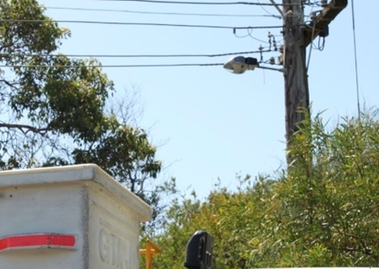
- Council will utilise its existing customer service system which has a street light module that can be refined/developed to access or align with any council public lighting asset register/database.
- Council will not to keep stock of luminaires or components, and instead will order in when required due to storage issues; lack of purchasing power for such small quantities; risk of equipment becoming obsolete

Recommendations:
- Council to undertake proactive maintenance of metered public lighting assets, including:
  - a 3-year cycle of cleaning visors
  - either annual operation audits OR 3 to 4-year condition assessments
- Council to install identification plates on all metered public lighting poles
- Council will respond to faults (investigation, not action) within 10 days
- Council will expand upon its existing asset register to create a comprehensive record of it metered lighting assets
- Council will utilise its existing customer service system which has a street light module that can be refined/developed to access or align with any council public lighting asset register/database
- Council will not to keep stock of metered luminaires or components, and instead will order in when required

Public Lighting and Trees
The interaction between trees and public lighting presents the challenge of balancing the need to provide adequate public lighting at night, and adequate shade and amenity during the day. This problem can occur with immature trees, and both small and larger species, with the primary issue being tree canopies shading luminaires resulting in lower light levels. How to best manage the relationship between trees and public lighting was a key issue raised during the workshop process.

Best-practice management of this issue can be separated into two parts:
- ensuring adequate separation of trees and lighting at the planning stage for new streetscapes
- establishing a clear and consistent approach for responding to complaints about existing trees and lighting

Wherever possible, street lighting, trees and other elements of the streetscape should be designed at the same time. The design process should consider the following principles:

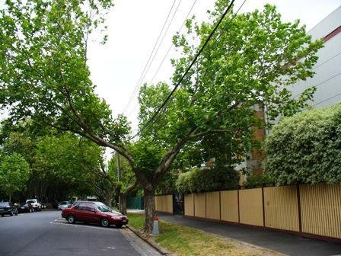
- the locations of street trees and light poles should be coordinated to minimise shading (shadowing)
- where street trees and poles are co-located, luminaires should be located below the canopy (if possible)
- where necessary, lighting may be placed nearer the centre of streets, out of reach of foliage
- supplementary lighting may be considered where street trees or verandahs would otherwise produce shadowing

A process for dealing with complaints about tree shading should involve a light level assessment and assessment against standards.

Current Council practice for new streetscapes is to require trees and public lighting to be separated by at least 2 metres. It was noted that tree species are also chosen to suit the local context on a case-by-case basis.

Current Council practice for existing trees and lighting involves pruning trees in response to complaints from the public. Following receipt of a complaint a day-time assessment of the proximity of the tree to the light is performed, and if a tree is confirmed to be blocking lighting, then it may be pruned if practical to do so.

It is therefore recommended that Councils Public Lighting Guidelines specify the design principles to be applied to the new streetscapes (as above).

Council has indicated a willingness to consider a best-practice approach to responding to complaints regarding existing trees and lighting. It is recommended this involve (refer also to the general complaints response procedures discussed in Section 10):

- an on-site analysis utilising a high-quality light meter to determine the existing levels of lighting 40 metres on either side of the tree
- a comparison of existing lighting levels against the requirements of the Australian Standards
- the development of a succinct report detailing the outcomes of the analysis including advice on whether tree pruning or tree/light relocation should be investigated further

The process described above is typically carried out by a suitably trained member of staff or a lighting designer/consultant.

Recommendations:
- Council’s Public Lighting Guidelines to:
  - specify design principles to apply to the design of new streetscapes
  - specify to specify an onsite light level analysis and assessment against standards in response to complaints about trees

Asset Replacement/Renewal Procedures
The typical drivers for the renewal of existing public lighting assets are:

- Environmental – the renewal of existing assets may present opportunities for energy savings as well as the elimination/minimisation of contaminants such as mercury.
- Financial – The renewal of existing assets may present opportunities to reduce maintenance and operation costs. This would typically be due to the use of a more reliable and energy efficient technology.
- End of Life – Luminaires are designed to last 20 years and poles for 35 years. In practice, however, where no other drivers exist, the end of life is typically based on the point in time at which maintenance and repair is no longer proving effective in addressing faults. At this time the individual asset or all assets of its type and age should be considered for replacement.
- Design (place-making) – Public spaces are periodically upgraded as part of Council place-making strategies. This typically involves public lighting as one of many elements that are upgraded.
- Design (change of purpose) – Urban environments and pedestrian and vehicular usage patterns evolve over time. This may necessitate a review of required lighting levels and the subsequent upgrade of lighting assets.

The following section provides a discussion on best practice asset renewal procedures, the options that exists for Council to pursue these procedures and the decisions that Council has made to date regarding committing to these procedures.

Unmetered Assets
It is extremely unlikely that an AusNet-initiated asset renewal program will occur on a scale large enough or time-frame short enough to present Council with any noticeable environmental of financial benefits. As such, Council-initiated projects are the only viable way to fast-track large-scale renewal projects involving unmetered public lighting assets.

Council has been pro-active with asset renewal in the recent past, having successfully replaced the majority of its existing standard unmetered 80W mercury vapour street lights with LED equivalents.

For unmetered public lighting assets, best practice renewal procedures as of August 2017 are:

- successful completion of a program to replace all 50W and 80W standard mercury vapour street lights with energy efficient (T5, CFL or LED) equivalents
- active exploration of replacement options for full-cost main road lighting (typically 150W and 250W high pressure sodium) via a cost-benefit analysis
- active exploration of the replacement options for non-standard street lights via a cost-benefit analysis including consideration for replacement with standard street lights to reduce capital and ongoing costs (see Section 5.1 Maintenance and Repair)

Council made the following decisions in regards to how it would like to approach the renewal of its unmetered public lighting assets:

- continue the existing program to replace 50W and 80W unmetered standard mercury vapour street lights
- proactively explore potential renewal projects for unmetered street lighting that offer environmental and/or financial benefits
- consider replacement options for existing non-standard unmetered street lighting including their potential replacement with standard street lighting

Recommendations:
- Council to:
  - continue the existing program to replace 50W and 80W unmetered standard mercury vapour street lights
  - proactively explore potential renewal projects for unmetered street lighting that offer environmental and/or financial benefits
  - consider replacement options for existing non-standard unmetered street lighting including their potential replacement with standard street lighting

Metered Assets
Proactive asset renewal processes that take into account environmental, financial and design considerations is a fundamental aspect of best practice asset management. Technology evolves over time to offer potentially lucrative cost savings and lower energy usage. Similarly, the function of a space will evolve over time and may require a redesigned lighting scheme to better serve current usage patterns. Lastly, place making is an increasingly important role of local government and lighting, either through the style of the hardware or the quality and type of light it delivers to a space, is an important element of most streetscape or open space upgrades.

Maroondah City Council has expressed a desire for a more proactive metered lighting asset renewal program. It is recommended that this includes:

- regular asset audits and reviews of maintenance works to better understand when an asset has reached the end of its life either via poor condition or escalating maintenance costs
- regular investigation of new technologies via feasibility studies that look into the financial and environmental costs and benefit of renewing assets before they reach the end of their life
- the consideration of future public lighting requirements as part of any precinct or activity centre strategies

Recommendations:
- Council to consider:
  - undertaking regular metered public lighting asset audits and reviews of maintenance works to better understand when an asset has reached the end of its life either via poor condition or escalating maintenance costs
  - regular investigation of new technologies via feasibility studies that look into the financial and environmental costs and benefit of renewing metered public lighting assets before they reach the end of their life
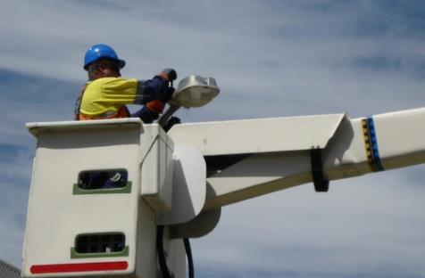
  - future metered public lighting requirements as part of any precinct or activity centre strategies

Asset Consistency
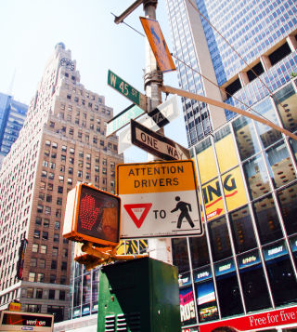
Asset consistency in public lighting asset management relates to the variety of pole and luminaire types that exist in Council’s public lighting asset base. The degree of variation has significant implications for ongoing management of public lighting assets, as well as impacting on the aesthetic or “feel” of public spaces throughout the municipality.

Best practice in public lighting asset management involves limiting the range of approved asset types, which may be achieved by specifying minimum design and performance requirements on poles and luminaires, or specifying particular products. The benefits of this best-practice approach include:

- simplified maintenance processes
- simplified design and procurement processes (including potential supply deals where large volumes are involved)
- continuity of style or aesthetic across Council

Typically, where no limits are placed on the range of accepted poles and luminaires, the public lighting asset base becomes increasingly complex and costly for a council to manage going forwards, with the main issues relating to:

- increasing demands on resources required for maintenance
- increasing difficulty in sourcing replacements
- inconsistency of style throughout the municipality

Council staff have indicated a desire to strive for consistency and reduce variation in its public lighting asset base by specifying minimum design and performance requirements for luminaires and poles in relation to the following:

- luminaire system efficacy (refer also to discussion in Section 7.1.1)
- pole height
- paint type and colour or finish
- offsets from paths (for pathway lighting)

Council staff have also expressed interest in investigating the possibility of banning completely the use of non-standard (decorative) poles and luminaires, but acknowledge the potential political sensitivity of such a move. There is also consensus that some flexibility (from general requirements) should be allowed for key precincts (e.g. the Ringwood MAC), where public lighting often contributes to a unique sense of place and identity (different to that which exists elsewhere in the municipality).

While the approach for unmetered and metered assets differs slightly, many of the underlying principles are the same. The following sections discuss in further detail key issues relating to unmetered and metered assets, as well as lighting in key precincts.

Unmetered Assets
For unmetered street lighting assets Council is limited to choosing from the list of AusNet-approved poles and luminaires, however within this list there still exists choice for any given application. For example, AusNet’s list of approved poles and luminaires includes:

- LED, fluorescent, high pressure sodium (HPS) and metal halide (MH) luminaires
- standard and non-standard (decorative) luminaires and poles

The following sections provide background and guidance on each of the above options.

Luminaire Technology
For lower output luminaires (typically of less than 500W), the use of LED technology is now established best practice, achieving a superior luminaire efficacy rating (LER). For existing luminaires of greater than 500 watts, traditional HID options (e.g. MH, HPS) may still compete with LED technology in terms of LER in certain applications. However, with continual upgrades and improvements, LEDs are also expected to become the preferred technology choice at these higher light output levels.

Table 4 presents a comparison of the LER of various technologies. As can be seen, specifying a minimum LER of 100 lm/w would effectively exclude the use of MV, fluorescent and HPS technologies.

Table 4: Comparison of LER of different luminaire technologies
Luminaire | Efficacy (lm/w)
MV80 | 28
HPS150 | 65
HPS250 | 75
T5 2x14W | 76
HPS400 | 88
LED 275W | 116
LED 17W | 120
LED 70W | 129
LED 155W | 132

When assessing the life-cycle impacts of HID or fluorescent versus LED technology the materials used in manufacturing should also be considered. Fluorescent and HID lamp technologies typically contain significant levels of mercury, whereas LED light sources do not.

It is therefore recommended that Council specify a minimum LER such that MV, fluorescent, HPS and MH technologies are effectively excluded. This approach is preferred to the blanket specification of LED (without a minimum LER) to avoid the risk of approving LEDs with poor efficacy. The specified minimum LER should be regularly reviewed to ensure alignment with improvements in technology.

Recommendation:
- Council’s Public Lighting Guidelines to specify a minimum luminaire efficacy ratio to effectively exclude the use of fluorescent, MV, HPS and MH luminaires for unmetered installations

Standard and Non-Standard Fittings
AusNet has approved standard and non-standard (decorative) luminaires and poles on their network. Standard luminaires and poles are items that AusNet keeps in stock, and will install and maintain without the need for procurement from Council. In contrast, non-standard luminaires and poles are not kept in stock by AusNet. When a non-standard fitting requires maintenance or repair (with the exception of standard components such as the lamp, PE cell or supply cable) any replacement materials must be sourced by Council. The suite of AusNet-approved standard fittings is more limited (in number and style e.g. finish/colour) than the suite of non-standard fittings.

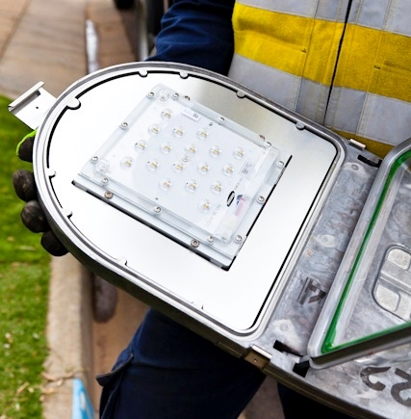
Generally speaking, the photometric performance of standard luminaires is superior to the equivalent non-standard luminaire that would be used in the same context, enabling greater pole spacings and therefore reduced energy consumption of the overall installation.

With a view to limiting the ongoing resource and cost burden placed on councils, best practice involves restricting the use of non-standard fittings. For some councils, typically those located on the metropolitan urban fringe, and where the number and type of non-standard fittings has historically been high, this involves banning non-standard fittings completely. In support of such a policy position it may be argued that the purpose of unmetered public lighting is to provide the base level of functional lighting required in the most cost-effective and consistent manner possible. Complementing this, non-standard fittings may be installed to differentiate or highlight key sites or features of the public realm, but only at specific locations, and only at metered supply points (refer to Section 7.2).

For other councils, a common approach is to permit limited use of non-standard fittings through one or a combination of the following:

- specifying a shortlist of approved fittings (from the AusNet approved list)
- specifying limits on:
  - colour and/or finish (e.g. grey, black or green, or galvanized only)
  - entry type (e.g. side-entry only)
  - minimum pole height (e.g. 5.5m)
- specifying the locations where non-standard fittings are permitted (e.g. along a foreshore)

It is recommended that Council bans completely the use of non-standard fittings for unmetered connections in line with the best-practice approach described above. Doing so would reduce costs and increase the uniformity of unmetered public lighting throughout Council. However, should such a policy position be deemed too restrictive or politically sensitive, then options 1 to 3 above should be considered.

Recommendation:
- Council’s Public Lighting Guidelines to prohibit the use of non-standard unmetered fittings

Metered Assets
In contrast to unmetered assets, Council has complete control over the selection, installation and maintenance of metered luminaires and poles. As a result, Council may in practice select any available luminaire or pole currently on the market. This freedom comes with the increased risk that the range of metered assets may become too large and costly to easily manage, and that poor-quality products will be installed.

To address this risk, best practice typically involves limiting the available choice via the use of a specification (or checklist) with which approved products must comply, and/or specifying any key precincts where exceptions to the specification will be permitted (note that the treatment of key precincts is discussed further in Section 7.3). Specifying design and performance requirements is preferred to specifying particular products given the risks of relying on a single supplier.

Council staff have highlighted the following as design and/or performance aspects over which Council would like to exert some control:

- luminaire technology (LED preferred)
- minimum pole height
- minimum offset of poles from pathways (preferred offset of 1m, minimum offset of 0.5m)
- luminaire/pole finish (preferred galvanised, or black if painted)
- “Smart City” compatibility

Council staff have also expressed a desire to limit the use of bollard lighting due to its limitations in assisting with the identification of facial features from people approaching as well as its susceptibility to vandalism.

Based on the above it is recommended that Council develop a specification for metered poles and luminaires. Table 5 outlines a recommended list of design and/or performance features that should be addressed by a specification, including a brief discussion of specific requirements.

Table 5: Recommended requirements for metered luminaire and poles
Feature | Recommended requirement
Luminaires
Luminaire design | Consider using a general statement such as “The luminaire design should be contemporary, with clean, minimalist lines and no decorative detailing”. Such a requirement will assist with reducing variation in styles, and support the objective of achieving a coherent style or aesthetic across Council.
Surface finish | A galvanised finish is considered lowest maintenance with paint finishes prone to fading, wear and tear over time. If a paint finish is preferred, then this should:  - be limited to a single paint colour (e.g. black or grey) with reference to a colour standard (e.g. AS 2700 or Dulux colour chart)  - use a durable method of coating (e.g. a heavy-duty zinc protective coating or two pack adhesion promoting primer over a sand blasted, galvanised steel pole to prevent corrosion, followed by two coats of two pack aliphatic polyurethane)
Protection against dust/water ingress and mechanical impact | Minimum IP65 (ingress) and IK06 (mechanical impact) ratings are standard for outdoor public lighting and recommended.
Energy efficiency | Specification of a minimum LER is recommended such that non-LED technologies are effectively excluded (e.g. 100 lm/w). Refer to discussion in Section 7.1.1.
Upward Waste Light Ratio | Upward waste light ratio (UWLR) is a measure of the amount of light emitted by a luminaire in directions above the horizontal. By limiting UWLR, urban sky glow from public lighting will be reduced.  New lights should have a maximum UWLR of less than 1%.
Correlated colour temperature (CCT) | The Australian Standard for street lighting (SA SNZ TS 1158.6:2015) does not specify CCTs for all available technology types, but does note concerns regarding the impacts of blue-rich spectral content from LED luminaires and therefore recommends the use of “intermediate” CCTs, stating that 4000K is “preferred” for LED street lights. LEDs above 4000K produce more blue light which is generally seen as undesirable in the night-time environment, while LEDs below 4000K will produce light with a “warmer” tone but are less efficient in terms of light output per unit of energy consumed.  4000K is also a more desirable colour temperature for facial recognition in CCTV camera footage.  Refer also to discussion in Section 13.1.
Colour rendering index (CRI) | SA SNZ TS 1158.6:2015 does not specify a minimum CRI for all available technology types, but does specify a minimum of 70 for LED luminaires. A higher CRI (e.g. white lights) is generally considered better in terms of safety, with a lower CRI (e.g. yellow lights) being less effective at reducing accidents. A higher CRI is also preferred where CCTV is in use.
Entry type | It is recommended that entry type be restricted to side entry only.
Compliance with relevant standards | Requiring compliance with SA/SNZ TS 1158.6 is recommended.
“Smart City” compatibility | Luminaires should feature a 7-pin NEMA base wired as per the requirements of ANSI C136.41-2013 to a variable output control gear (for dimming/brightening). Consideration should also be given to the dimming protocol with which the control gear is compatible (options include 0-10V or DALI).  Refer also to discussion in Section 8.1.
Design life | Minimum 20-year life is recommended. This is standard for outdoor street lighting.
Poles
Pole design | Consider using a general statement such as “The pole design should be contemporary, with clean, minimalist lines and no decorative detailing”.
Surface finish | Paint colour consistency (e.g. black or grey). Type of paint.
Compliance with relevant standards | Requiring compliance with AS 4100 is recommended.
Entry type | It is recommended that entry type be restricted to side entry only.
Mounting height | The luminaire mounting height of any pole should be of an appropriate scale for the space it is in, with a minimum height of 5.5m.
Offset from pathways | Where the purpose of lighting is to illuminate a pathway, the minimum offset of the pole from the pathway shall be 0.5m, with a preferred offset of 1m.
Design life | Minimum 35-year life is recommended. This is standard for street lighting columns.

The specification should take the form of a checklist to be included in Council’s Public Lighting Guidelines, with the checklist to be completed for any proposed metered installation (e.g. by a lighting designer or developer). Assessment of compliance with the specification may be undertaken by Council staff or a third-party (discussed further in Section 4).

Recommendation:
- Council’s Public Lighting Guidelines to include a specification and checklist outlining minimum design and performance requirements for metered assets (poles and luminaires)

Key Precincts
Key Council staff have indicated a preference for allowing some variation from the requirements of a standard Council specification for poles and luminaires (refer to Section 8.2) when lighting key sites or precincts (e.g. the Ringwood MAC, or select suburban shopping strips). This acknowledges that lighting can be an effective way to highlight particular spaces and provide contrast to the surrounding “standard” lighting in such a way as to enhance the night-time experience and attract pedestrian activity. This approach also aligns with the broader Council objective of enhancing the night time economy.

Best practice would involve specifying the sites at which such variation is permitted by explicitly listing areas and/or mapping them in Council’s Public Lighting Guidelines. It is also recommended that certain general, minimum design and performance requirements still apply. For example, the following requirements (refer to Table 5 for further detail on particular items) are still recommended:

- minimum luminaire IP and IK rating, LER and CRI
- SA/SNZ TS 1158.6 compliance (for luminaires)
- AS 4100 compliance (for poles)
- side entry only
- “smart city” compatibility
- minimum design life
- minimum mounting height (poles)

Limited variation in the following areas may be permitted:

- Design – Although variation may be desirable, consideration should be given to the risk that a particular product line may be discontinued and therefore replacements cannot be sourced for maintenance purposes. To mitigate this, it is recommended that the same broad design guidelines apply to luminaires and poles as recommended for metered assets (refer to Table 5).
- Finish/colour – The method of finish or coating application should be as for metered assets (refer to Table 5), with greater colour variation permitted to suit the particular site.
- CCT – A CCT of less than 4000K (neutral white) may be considered appropriate for certain precincts (e.g. areas where outdoor dining occurs), however the issues raised in Section 14.1 should be considered, the choice of CCT should be consistent with Council’s CCTV Policy, and the CCT used should be consistent throughout a given space.

When considering the lighting of key sites or precincts, key Council staff also raised specific issues which are summarised in Table 6. For each issue a recommended policy/design response is provided in line with best practice.

Table 6: Issues relating to lighting of key precincts
Issues | Recommended response
Council can’t always afford to replace/upgrade all street lights in a given area at one time. Instead upgrades are staged incrementally over time. With this approach comes the risk that different products are used (due to availability, changes to approvals) for different stages within the same precinct, thereby undermining the objective of achieving a consistent style or aesthetic. | Enforce the same broad design requirements on poles and luminaires as specified in Table 5 for metered sites.
Where existing connections are unmetered, past Council best practice has involved the conversion to metered supply whenever a major upgrade takes place. This gives Council more control over ongoing operation and maintenance. | Specify in Public Lighting Policy that at key sites or precincts, transitioning from unmetered to metered supply should be considered at the time of upgrade or renewal.
Where existing supply is overhead, past Council best practice has involved the conversion to underground supply whenever a major upgrade takes place. This contributes to decluttering of the streetscape, and more flexibility in the choice of pole and luminaire. | Specify in Public Lighting Policy that at key sites or precincts, transitioning from overhead to underground supply should be considered at the time of upgrade or renewal.

Recommendations:
- Relating to public lighting in key precincts:
  - Council’s Public Lighting Guidelines to identify key precincts
  - Council’s Public Lighting Guidelines to specify the same design requirements as for metered public lighting, with limited variation permitted in surface finish and colour, and CCT
  - Council’s Public Lighting Policy to specify that at the time of upgrade or renewal the following should be considered:
    - transitioning from unmetered to metered supply
    - transitioning from overhead to underground supply

Lighting Technology
Many of the key considerations around technology choice have already been discussed and are addressed by the recommendations of Section 7.1.1. In brief, current best practice in terms of luminaire technology choice for the types of applications to be covered by the scope of Council’s Public Lighting Guidelines and Policy is LED. At this point in time, there may still be some sports lighting applications where the business case for use of traditional HID technologies competes with LED, however the market trend is increasingly showing a shift toward LED technology even in this context.

During the workshop process the other issues raised which relate to technology choice were:
- ‘smart’ lighting and ‘smart cities’ compatibility
- solar lighting

Each of these issues is discussed below.

Smart Cities Compatibility

The term ‘smart cities’ has emerged in recent years to describe the transformative effect modern technology is having on the way urban infrastructure is used, operated and managed.
As a concept, smart cities is inherently ambiguous owing both to the broad range of asset and infrastructure types within an urban environment and the seemingly endless ways in which technology can be integrated into the application, operation and management of assets and infrastructure. This ambiguity is leading many local governments in Australia to seek to better define what the concept of smart cities means for them.

For Maroondah, public lighting has the potential to be both directly enhanced by smart city technology as well as playing a central role in a broader smart city network.
The ability to control and monitor public lighting via remote switching, dimming and fault reporting are ways in which smart city technology can beneficially augment public lighting. In addition, the ubiquity, existing power supply and presence above ground level allows public lighting and poles to act as the hubs and nodes of a smart cities network.

When talking about public lighting within the context of smart city infrastructure there are two elements to consider:

- how smart city infrastructure can be used to augment public lighting; and
- how public lighting infrastructure can be used as a central element with in a broader smart city network

The first element is relatively simple in that it relates to controlling (switching, dimming, colour changing) and monitoring (faults reporting, energy usage) public lighting assets via a smart city network. The benefits of implementing dimming or switching controls include the maximisation of energy savings, and the appropriate targeting of light levels in different places at different times. Importantly they can also give Council the ability to increase light levels, either temporarily (e.g. for public events or in emergency situations) or on a longer-term basis (because of the changing use of a space) without the need to install new infrastructure. Remote adjustment of the colour temperature of lights may be desirable in some key precincts. Remote fault reporting and energy monitoring have obvious benefits in terms of improved service levels and reporting.

The second element is more complex in that it relates to using public lighting infrastructure as the backbone of a smart city network as well as a key connection point (either physically or as a wireless node) for other smart city technologies such as sensors and input/output devices. Standard street lights connected to a smart grid system can assist in establishing a smart grid system in a given location and ensuring effective coverage. In addition, smart (or multifunction) poles can be located in certain areas to achieve specific smart city outcomes.

Smart poles are one of the more obvious solutions for leveraging public lighting infrastructure to create a smart city network. They are generally modular in design and easily adaptable to current and future smart city needs. This allows them to incorporate smart city technologies such as telecommunications, Wi-Fi, community messaging, parking management, data capture, surveillance, people counting, and electric vehicle car charging as well as traditional pole functions (signage and lighting) into a single uncluttered solution. Smart poles may also be designed to include features that contribute the aesthetic of the public space, such as audio art forms. Figure 4 provides an example of a smart pole and possible features and functionality.

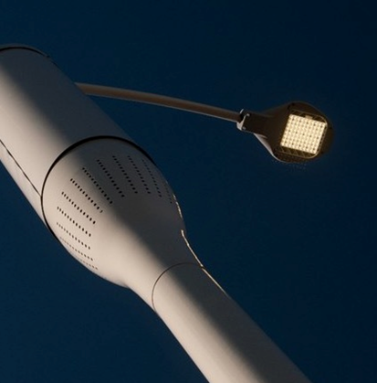
Smart poles would potentially allow Council and others to consider more innovative business models to on-sell the location of the pole for advertising, to telecommunication carriers and others.
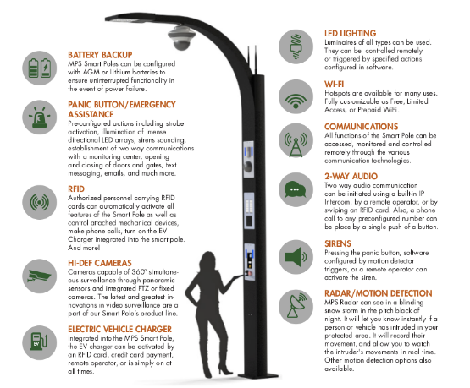
Figure 4: Examples of 'smart pole' features and functionality

It should be noted that the development of a smart city network and activation of smart controls (e.g. dimming, switching, colour changing etc.) using metered public lighting (Council-owned) is possible now. In contrast, the dimming, switching or other remote control of unmetered public lighting (DNSP-owned) would require further negotiation with AusNet (re governance arrangements, access etc.) before being implemented.

Council has indicated a desire work towards deployment of a smart cities network including smart poles, given the potential benefits outlined above. As part of the workshop discussions, the difficulties of installing CCTV devices on third-party infrastructure (i.e. not Council-owned) were noted.

It was also noted that Council already has demonstrated, practical experience of implementing smart lighting solutions with the successful deployment of a system whereby sports ground lighting is linked to a sports facility security system, allowing emergency services to activate lighting after hours (to assist landing of an air ambulance).

Due to the complex nature of the smart cities concept, and its relatively recent development, it is recommended that the issue be managed with a separate, targeted strategy or policy. However, as an immediate next step, Council’s Public Lighting Guidelines should specify the use of smart controls in public lighting applications, and aim to future proof any infrastructure for potential smart cities applications.

It is therefore recommended that all new lights be “future-proofed” for compatibility with a smart city network, both unmetered and metered, by specifying the use of luminaires with 7-pin NEMA PE cell base connected to a variable output control gear (as specified in Section 7.2). The use of smart poles may be considered for metered lighting locations in key precincts.

Recommendations:
- Council to develop a Smart Cities Policy/Strategy
- Council’s Public Lighting Guidelines to specify the use of luminaires with a 7-pin NEMA base wired to a dimmable driver (refer to Section 7.2)
- Council to liaise with AusNet to ensure that all new unmetered luminaires are smart-enabled (featuring a 7-pin NEMA base wired to a dimmable driver)

Solar Lighting
Solar lighting is generally not recommended due to high capital costs and high maintenance costs for panels and batteries. However, where the cost to install grid-connected electricity is high, solar (or other localised renewable energy) may be considered.

Because the need for trenching is normally eliminated when installing solar lighting, it may also be considered in instances where minimal ground and surface interference is required

Recommendation:
- Council’s Public Lighting Guidelines to permit the use of solar lighting only where connection to the grid is not considered viable
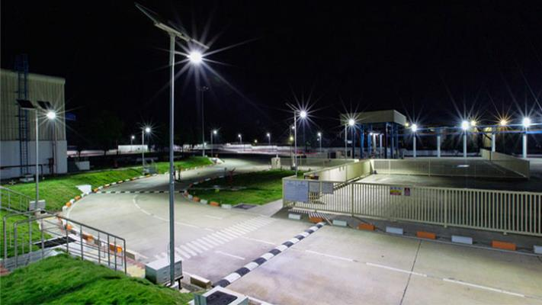

Asset Registers
An asset register is an essential element of best practice public lighting asset management. It provides a framework to log and store information on assets including condition, location, age, characteristics and maintenance history.

Unmetered Assets
For unmetered street lighting assets, AusNet Services maintains an asset register that includes a range of information such as location, lamp wattage, lamp type, pole ID and commission date.

Council is provided with access to an online portal through which it can download up to date asset registers at any time.

Existing limitations to the portal and the AusNet asset register do, however, exist. These include:

- no pole ID included in the data downloaded via the portal making it difficult to cross reference street lights in the field
- luminaire type is not recorded making the management of non-standard lighting potentially difficult
- non-standard pole types and their paint colour are not recorded, which adds to the difficulty of managing of non-standard street lighting assets
- lamp replacement dates are not recorded often making dealing with resident complaints regarding under or over-lighting difficult to manage
- inaccuracies in data fields such as lamp type and lamp wattage as well as the location and even existence of the asset

In Victoria, best practice in terms of an unmetered street lighting asset register typically involves the augmentation of AusNet’s asset register by Council to address the above limitations. This includes:

- Council-run audits of street lighting to identify the location, type and paint colour of non-standard assets
- Council-run audits of street lighting to identify any major data issues such as incorrect wattage and lamp types and importantly to identify lights that do not exist in the field
- ongoing maintenance of the assets register so that the location, type and paint colour of non-standard assets are added as they are commissioned

For Maroondah, who do not have large numbers of non-standard street lighting assets, it may not be considered vital to identify their location, type and paint colour as the management of replacement stock can be carried out reactively. However, the issues in identifying appropriate lights to replace during the recent bulk replacement program demonstrates that an understanding of where non-standard street lighting assets exists and also has benefits from a planning perspective.

Council is using the bulk replacement program to opportunistically identify the location of non-standard street lighting and it has indicated that it may consider a follow up audit to identify luminaire type and paint colour. Beyond this, Council has indicated that it will not actively pursue the best practice approach of augmenting AusNet’s asset Register.

Recommendations:
- Council to consider collecting key characteristic data for any new non-standard unmetered street lighting assets that are installed
- Council to continue to opportunistically collect locational data on existing non-standard unmetered street lighting assets during bulk upgrade works
- Council to consider carrying out a more comprehensive audit of non-standard unmetered street lighting assets to collect data on paint colour, entry point and models

Metered Assets
For metered assets, Council has full responsibility for the creation and upkeep of an asset register. The process of creating a comprehensive asset register typically begins with an on-site mapping and condition audit. This provides Council with a snapshot in time of the metered street lighting assets under its control including their location, characteristics and condition.

Common pieces of data to collect during an audit includes but is not limited to:

- Luminaire type and manufacturer  - Luminaire colour  - Luminaire condition rating  - Luminaire faults  - Lamp type  - Lamp wattage  - Pole type and manufacturer  - Pole material  - Pole colour  - Pole condition rating | - Pole faults  - Pole base type  - Pole base condition rating  - Pole base faults  - Overview photo  - Location (GPS co-ordinates)  - Mounting Height  - Switching (PE cell, timer etc)  - Timer settings  - ID number  - Site Name
The creation of an asset register via an audit is in many respects the easiest part of the process. The more difficult part and arguably the more important part of the process is the maintenance of the asset register. This includes the population of the asset register with valuable information relating to asset maintenance works, inputting information on new assets and updating existing asset data as changes are implemented (lamp upgrades, luminaire upgrades etc.).

The difficulty that exists in the maintenance of an asset register is largely related to the “buy in” that is required from multiple staff across multiple departments and the associated time and resources that need to be allocated.

Best practice processes for the maintenance of an asset register includes, but is not necessarily limited to:

- The logging of maintenance work carried out on an asset such as dates on which components (lamps, drivers, PE cells) were replaced
- The input of new assets into the asset register on or near to their commission date
- The gradual linking of lighting assets to their corresponding electricity meter and subsequently their corresponding electricity bill
- The logging of any opportunistic information relating to an asset by asset management staff during site meetings

Council currently has a park lighting register but it has been acknowledged that this was based on a once-off audit with a narrow scope in terms of which metered public lighting assets were audit and the data that was collected about each asset.

Council’s has expressed a desire to achieve as close to best practice as possible whilst at the same time taking into consideration the resources required to maintain such an asset register versus it’s benefits. It is recommended that Council collects the data listed above on each lighting asset at a minimum.

It is also recommended that Council installs accompanying ID plates on each lighting asset to provide a cross reference between the physical asset and the book asset and to also improve resident fault reporting processes.

It is understood that Council’s current asset register framework is fully customizable and can thus accommodate any changes in terms of data fields and data collection processes.

Council has also indicated that it would like link electricity meter details to each lighting asset.

It is recommended that clear internal processes are implemented for the maintenance of the asset register including the roll out of a mobile data capture system to minimise double handling of data and the risk that information is never digitised.

In terms of wholesale updates to the asset register it is recommended that all assets are audited every 3 to 4 years to assess condition and capture any changes to assets that weren’t otherwise captured as part of the ongoing asset register maintenance process.

The advent of smart lighting has potential benefits in relation to achieving the above outcomes. Smart lighting that is DALI-compatible introduces the capacity to have lighting assets that automatically communicate with an asset register. That is, the driver in the luminaire can be pre-programmed by the manufacturer with asset information (e.g. make, model, wattage, colour etc.) that can be automatically populated to Council’s asset register.
Recommendations:
- Council to add all newly installed metered public lighting assets to an asset register
- Council to collect the minimum data on each metered lighting asset (to be specified in Public Lighting Policy)
- Council to install ID plates on each metered lighting asset to provide a cross reference between the physical asset and the book asset
- Council to implement a clear internal process for the maintenance of the asset register
- Council to audit all assets every 3 to 4 years to assess condition and capture any changes to assets that aren’t otherwise captured as part of the ongoing asset register maintenance process

Complaints Procedures

Requests for New Street Lighting (Existing Lighting)
Periodically, Council may receive requests for the installation of additional street lighting in areas where some street lighting already exists. Requests are typically based on subjective opinions of the quality of existing lighting levels or increased concern for safety due to changes to traffic volumes or crime rates.

A consistently applied empirical process to assess the merits of any request for additional street lighting represents best practice. Typically, this would include the following steps:

- an on-site analysis utilising a high-quality light meter to determine the existing levels of lighting
- a comparison of existing lighting levels against the requirements of the Australian Standards (refer also to Section 12)
- the development of a succinct report detailing the outcomes of the analysis including advice on whether additional lighting is or isn’t required

The process described above is typically carried out by a suitably trained member of staff or a lighting designer/consultant.

Where additional lighting is deemed necessary, Council would then liaise with a lighting designer and AusNet to determine the most suitable location for the new lighting to be installed. A request for additional lighting would then be sent through to AusNet to implement.

Council indicated through the workshop process that it would like to achieve best practice, given that current responses use an inconsistent approach.

It is therefore recommended that Council follows the best practice approach described above.

Requests for New Street Lighting (No Existing Lighting)
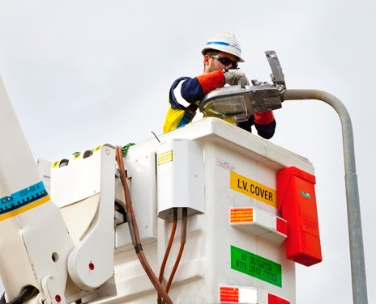
Periodically Council may receive requests for the installation of street lighting on roads where there is currently no street lighting.

Common practice would involve only addressing unlit streets when a complaint or request is received (i.e. reactively) as opposed to the proactive identification of locations. Also, the provision of lighting should only be considered where it is viable to do so (i.e. there are existing poles on to which lights can be installed, or the provision of poles and connection to supply is not prohibitively expensive), or where there is a legitimate need identified (e.g. public safety concern). Where considered viable, new installation shall light the street to the appropriate standard (refer to Section 12).

It is therefore recommended that Council’s Public Lighting Guidelines specify that requests for street lighting on currently unlit streets will be assessed on a case-by-case basis.

Requests for Removal of Lighting
Although rare, Council may receive requests for the removal of street lighting along parts or all of a street (usually relating to more isolated and/or rural locations).

Some Councils accept that residents living in semi-rural areas desire a decrease in light pollution/ambient light and therefore allow submissions from residents for the removal of lights in a street/area. This is typically assessed on an as needs basis and depends on a number of factors including gaining consensus from all resident affected by the proposed removal and ensuring that the area where the removal is being proposed does not serve as a thoroughfare.

In general, however, the existence of processes to allow the removal of street lighting is very rare amongst local government, which is reflective of a number of limiting factors including:

- the fact that consensus amongst those affected by the removal is extremely unlikely
- the fact that street lighting is generally installed in residential areas to provide illumination for not only residents but also those visiting the residents and those travelling through the area
- the fact that whilst existing residents may not want street lighting, future residents may end up requesting that the removed street lights are re-instated

During the workshop process, key Council staff indicated a preference for Council’s public policy position (i.e. that specified in the Public Lighting Guidelines) to be that Council will not remove existing lighting. However, if special circumstances apply (e.g. the request represents the consensus of all residents in a street), then lights will only be removed following formal approval by Council (involving submission of a report detailing the specifics of the request and why Council’s formal policy position should not apply in that instance).

Complaints About Overlighting or Light Spill
Periodically, Council may receive complaints about over lighting or light spill into properties from existing street lighting, park lighting or sports lighting. Complaints typically stem from the ingress of lighting into a dwelling but may also relate to light spill into front and back yards.

AS 4282 Control of the Obtrusive Effects of Outdoor Lighting provides guidance on the acceptable levels of light spill into habitable dwellings. Although the Standard specifically states that it does not apply to public lighting, best practice Councils tend to adopt the following requirements:

- limiting light spill to no greater that 1.0 lux on the window of a habitable room in a dwelling on a residential side street with P-Category street lights
- limiting light spill to no greater that 2.0 lux on the window of a habitable room in a dwelling on a road with V-Category street lights
- limiting light spill to no greater that 4.0 lux on the window of a habitable room in a dwelling on within a commercial area or at the boundary of a commercial area
- limiting light spill to no greater that 1.0 lux on the window of a habitable room in a dwelling adjacent to a park with metered path lighting

In order to assess whether light spill is in breach of the above requirements, a consistently applied empirical process to assess the merits of any request for additional street lighting represents best practice. Typically, this would include the following steps:

- an on-site analysis utilising a high-quality light meter to determine the existing levels of lighting on the window of a habitable room in a dwelling
- a comparison of existing lighting levels against the requirements of the Australian Standards
- the development of a succinct report detailing the outcomes of the analysis including advice on whether light spill control is or isn’t required

The process described above is typically carried out by a suitably trained member of staff or a lighting designer/consultant.

Where light spill control is deemed necessary, Council would then liaise with a lighting designer and AusNet to determine the most suitable solutions. This might include:

- installing shielding on or within the luminaire
- installing a different luminaire (lower output or more directional photometrics)
- relocating the luminaire
- dimming the luminaire
- recommending a new window treatment e.g. block out blinds

Council indicated through the workshop process that it would like to achieve best practice, given that current responses use an inconsistent approach.

It is therefore recommended that Council follows the best practice approach described above.

Recommendations:
- Council’s Public Lighting Guidelines to specify:
  - best-practice process for responding to requests for new street lighting
  - requests for street lighting on currently unlit streets will be assessed on a case-by-case basis
  - requests for removal of street lighting will not be considered
  - best-practice process for responding to complaints

Where and When to Light
To ensure that public lighting is installed in a consistent and appropriate manner throughout Maroondah City Council, best practice involves the development of a step-by-step decision-making process to determine if, when, where, and how lighting should be installed.

It is recommended the decision-making process include the following basic steps:

- establish the need for lighting
- determine site type and site-specific considerations
- determine the appropriate lighting category

Steps 1 and 2 are discussed further in this section, while step 3 is discussed further in Section 13.

Typically, where such a decision-making process is absent or lacking, decisions around where and when to light and to what level is left to the discretion of a Council officer or a lighting designer, with over-lighting often the result. The process described here is intended to strike a balance between being too prescriptive (whereby Council can be forced to install lighting where it’s in fact not appropriate) and allowing too much flexibility, resulting in the situation outlined above.

At various points throughout this Section, the possibility of remote dimming and/or switching is discussed. It should be noted that at this point in time, while technically possible with the installation of LED street lights with dimmable drivers, remote dimming or switching is not possible for unmetered connections points. In contrast, remote dimming and switching are possible for metered connections right now.

At a high level, the decision-making process should be framed by a set of high-level guiding principles, such as those outlined in Table 7.

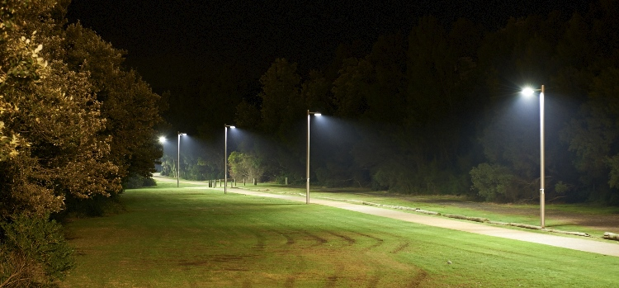

Table 7: Recommended guiding principles for installation of public lighting in Maroondah
Making better use of open space
Most people use public space during the day and early evenings. Lighting should support positive evening use and selective all-night lighting should be provided only where required
Assisting walking, cycling, public transport and safe driving
Appropriate lighting will allow for higher visibility and encourage people in Maroondah to walk, cycle and take public transport.
Improving safety
Council will avoid creating a false sense of security by not installing lighting in remote or poorly surveyed locations. Lighting will be discouraged in sites where it promotes inappropriate behaviour after hours in accordance with principles of the Crime Prevention through Environmental Design Guidelines.
Ensuring economically sustainable assets are installed and managed
At the scoping stage, a high-level business case analysis should be conducted to ensure that only lighting assets that are easy to install, have low maintenance requirements and are cost effective over the life of the asset are deployed.
Protecting habitat value areas
In some cases lighting (or some types of lighting) can be harmful to biodiversity (in particular insects and nocturnal animals).
Showcasing urban features in an effective way
When people are visiting Maroondah, they should see and enjoy our urban features; for example, monuments, signs, and public art. Lighting can be an effective way of doing this in key locations at selective times.

Step 1 of the decision-making process should first establish the actual need for new lighting.

Reasons that new lighting may not be needed include:

- adequate lighting is already available from an alternate source such as street, public transport zone, car park, building or any other adjacent lighting (in some locations this can reduce the number of new lights installed)
- the area is one where lighting is not recommended (as identified in Table 8)
- Council has identified the lighting purpose as not recommended (e.g. up-lighting, feature lighting, and daytime recreation areas)

There may also be safety reasons that new lighting is not needed. Whilst this may seem contradictory, it is important to not light spaces that may be inherently dangerous with or without lighting. Reasons include:

- an area does not have sufficient natural (passive) surveillance looking into the space from houses facing the space or passing vehicular and pedestrian traffic
- an areas/pathway leads to a dead end or otherwise unsafe area with little natural (passive) surveillance

Key Council staff have indicated that new lighting should also only be considered if one or a combination of the following apply:

- there is a pedestrian path that provides a legitimate shortcut or thoroughfare
- there is a ‘critical link’ as per Council’s Bicycle Strategy and/or Pedestrian Strategy
- new lighting will increase outdoor activity
- the site allows for passive security

Other consideration should include an assessment of whether:

- activity or traffic will be all night or only for a portion of the night
- a new metered supply will be required

Step 2 of the decision-making process should determine the site type and any site-specific considerations such as:

- the aim of lighting in the area: for example, aesthetic, to create atmosphere, for safety or to guide preferred usage patterns
- whether the area is a ‘high risk’ security area, or vandalism risk area, based on evidence
- the type of users and usage function, as well as usage patterns for the area, as this may indicate particular lighting controls that can be applied

Table 8 provides a summary of best practice and Council-specific considerations based on feedback from key Council stakeholders. A similar table may be reproduced in Council’s Guidelines to guide decision making.

Table 8: Recommended lighting requirements for specific types of locations in Maroondah
Site/Application | Best Practice and Council-specific Considerations | Controls (e.g. dimming, switching, sensors)
Large Parks | Best practice:  - lighting only paths and thoroughfares through parks, not lawns  - avoid lighting dead-ended paths, unless the path provides access to a facility within the park that is used during night time hours  Additional Council-specific considerations:  - Lighting should only be considered for large parks under the following circumstances:  - if there is a thoroughfare for pedestrians/ cyclists  - if it promotes night time physical activity (e.g. running track)  - public benefit or demand exists (e.g. for a dog park) | Use dimming and timers to turn lights off or down when usage levels drop off or no longer exist, or where activity is no longer desired after certain hours.  Switch off/dim: between 11pm and 1am  Switch on/brighten: 5am
Small local “pocket” parks | Best practice:  - Generally, lighting should not be considered for local “pocket” parks.  - Lighting should only be considered if there is a thoroughfare for pedestrians and/or cyclists. | If lighting is installed, use dimming and timers to turn lights off or down when usage levels drop off or no longer exist, or where activity is no longer desired after certain hours.
Nature reserves | Best practice:  - Generally, lighting should not be considered for nature reserves as it may disrupt local flora and fauna.  Additional Council-specific considerations:  - Lighting should only be considered if there is a ‘critical link’ as per Council’s Bicycle Strategy and/or Pedestrian Strategy.  - Where lighting is installed, consider (in order of preference):  - lights with site-specific optics (to minimise light spill) and dimming or switching after hours of use  - use of a lower CCT (lower impact on local fauna)  - solar path markers  - Reference should also be made to Council’s Habitat Corridor Strategy. | If lighting is installed, use dimming and timers to turn lights off or down when usage levels drop off or no longer exist, or where activity is no longer desired after certain hours.  Switch off/dim: between 11pm and 1am  Switch on/brighten: 5am
Recreation areas | Best practice:  - Lighting should only be installed with timers.  Additional Council-specific considerations:  - Basketball courts – no. Unless used for organized competitive sporting activities.  - Skate Parks – lighting shall be considered on an as needs basis.  - BBQs, gazebos etc. - lighting shall be considered on an as needs basis. | Lighting shall be switched off no later than 10 pm, and shall be dimmed over short shoulder period (e.g. 15 min) to allow safe departure from the area.
Playgrounds | Best practice:  - Lighting is not appropriate as playground activity is better suited to daylight hours.
Train stations | Best practice:  - Lights may be installed with timers and/or dimmers linked to operating hours of public transport.  Council-specific considerations:  - Defined areas or routes around or leading to train stations shall be lit to higher than the surrounding area. Council to define areas/routes around train stations. | At present switching is via PE cell control. Dimming, while technically possible (with new LEDs), is not possible for unmetered loads.
Bus routes/stops | Best practice:  - Lights may be installed with timers and/or dimmers linked to operating hours of public transport  Council-specific considerations:  - Lighting should be installed on every pole along bus routes (refer to Council’s Principal Pedestrian Network/Pedestrian Strategy) | At present switching is via PE cell control. Dimming, while technically possible (for new LED installations), is not yet possible for unmetered loads
Bike paths (off road) | Best practice:  - Lights may be installed on popular commuter routes  Council-specific considerations:  - Popular commuter routes should be identified by reference to the Strategic Cycling Corridors identified by VicRoads (refer to Appendix 1) | Lights may be installed with timers and/or dimmers  Switch off/dim: between 11pm and 1am  Switch on/brighten: 5am
Bike paths (underpass) | Best practice:  - Lights may be installed on popular commuter routes  Council-specific considerations:  - Underpasses may be lit throughout the whole day and during part of the night to minimise the effects of daytime dark/light transitions. | Lights may be installed with timer controls and/or dimmers  Switch off/dim: between 11pm and 1am  Switch on/brighten: 5am
External building lighting | External building lighting may be considered if the building is adjacent to and/or within:  - a Council car park (e.g. lighting on the building provides light for the car park)  - a Council reserve (e.g. lighting on the building provides light for the reserve)  - a Council footpath or shared path, including a path to a Council building (e.g. lighting on the building provides light for the path that leads to the building entry or lighting on the building provides light for shared path that runs adjacent to the building)  - a Council public art project  For the above scenarios the following arrangements would occur:  - any existing lighting on a building shall be included as part of any existing lighting condition assessment (i.e. the external building lighting is contributing to the public lighting)  - the external building walls may be used to support lighting as part of a new lighting design/scheme for a metered lighting supply  - external building lighting should be included in the assets register (refer to Section 9.2) | Controls to be applied depending on the nature of the adjacent public space (e.g. car park). Refer to relevant section of this table for controls to be applied.
Car parks | If lighting a car park, consideration should also be given to lighting any pedestrian linkages to the facility that the car park services | Lights may be installed with timers set to the hours of operation of the associated site or building or dimmers set to the usage levels of the car park over the course of the night
Laneways | Best practice:  - Lights may be installed where the laneway provides a logical shortcut for pedestrians or if it is a key thoroughfare for pedestrians and/or cyclists  Council-specific considerations:  - Lighting should be avoided wherever there is poor passive surveillance  - Where lighting is installed, the design process should consider the need for light spill control (i.e. the use of glare shields/baffles) and/or site-specific optics  - Consider space constraints such as: the ability to install and protect infrastructure whilst maintaining a trafficable laneway, the ability to supply power to this infrastructure, operational and maintenance issues due to the infrastructure being located in the laneway and excessive light spill within the rear properties that are adjacent to the laneway  - If a suitable alternative pedestrian path that requires minimal additional travel time and distance exists, then pedestrians should be encouraged to walk on the existing footpath network where there is sufficient existing street lighting available | For unmetered connection points, at present switching is via PE cell control. Dimming, while technically possible (with new LEDs), is not possible for unmetered loads  For metered connection points, dimming/switching is encouraged where usage patterns allow, or where activity is not desired after certain hours  Switch off/dim: between 11pm and 1am  Switch on/brighten: 5am
Shopping strip lighting schemes – additional lighting to street lighting | Best practice:  - Generally, lighting is not considered appropriate if unmetered street lighting already exists. Lighting may be considered if AusNet agrees to remove existing public lighting  - Additional lighting may be considered in some circumstances if the existing street lighting scheme is not deemed appropriate for the level of pedestrian traffic/crime/prestige in an area  Council-specific considerations:  - Where place-making/urban renewal is planned for a shopping strip, Council will explore options to remove existing unmetered street lighting and install metered lighting | For unmetered connection points, at present switching is via PE cell control. Dimming, while technically possible (with new LEDs), is not possible for unmetered loads  For metered connection points, dimming is encouraged where usage patterns allow, or where activity is not desired after certain hours. Switching is not recommended for shopping strip lighting
Uplighting/feature lighting of signs, trees, buildings, monuments, art | Best practice:  - Lights may be installed with timers based on a needs assessment  Council-specific considerations:  - The installation of a lit artwork (contributing modest illumination to the public space) may be considered as a means of addressing public perceptions of safety in places where there is no other justification for lighting  - Refer also to Section 4 which describes the approval process for new lighting assets | Timers installed linked to operation hours of the associated site or building
High risk areas - this includes entertainment precincts (e.g. the Ringwood MAC) | Best practice:  - Lighting should be provided all night in these locations at an appropriate standard  Council-specific considerations:  - Some areas, such as Ringwood Night Club precinct, only require this lighting at specific times. | Lights are to be installed in these locations.  Where risk is specific to hours of operation of a specific site or building, timers installed and linked to these hours of operation.
Areas of high vandalism | Best practice:  - Lights may be installed, subject to trial in the following order:  - turning lighting off to deter vandalism  - using motion sensors  - CCTV cameras  - increase lighting in accordance with the Crime Prevention through Environmental Design Guidelines

Following completion of steps 1 and 2 above, the required light levels should be determined, which are discussed further in Section 13.

Recommendations:
- Council’s Public Lighting Guidelines to specify where and when to provide public lighting and what controls (dimming, switching, sensors) shall apply

Special Considerations
With regard to the lighting of roads, the Australian Standards for Lighting for Roads and Public Spaces focuses on the need to illuminate the road reserve width in order to achieve compliance. The reserve width is defined as the width of the entire way, between property lines, devoted to public travel. This leaves scope for interpretation when dealing with roads that have no footpaths (only nature strips) or a footpath on only one side of the road.

The simplest interpretation is to treat the road reserve width as kerb-line to kerb-line where no footpaths exist and as kerb-line to property boundary where only one footpath exists. This, however, does not reflect the fact that nature strips may be used in lieu of a footpath.

Council has expressed a desire to follow the above approach as a general rule but to have an exception for situations where no footpaths or only one footpath exists with the Principle Pedestrian Network. In these instances, where pedestrians would be expected to walk on nature strips, the road reserve width should be treated as property boundary to property boundary.

Recommendations:
- Council’s Public Lighting Policy to define the road reserve as:
  - kerb-line to kerb-line where no footpaths exist;
  - kerb-line to property boundary where only one footpath exists; or
  - property boundary to property boundary where no footpaths or only one footpath exists within the Principle Pedestrian Network and pedestrians are expected to walk on nature strips

Lighting Categories (Light Levels)
Once the need to light and any site-specific requirements have been established (refer to Section 11) a best-practice approach would then assign the appropriate lighting category (light level). A framework for selecting the appropriate lighting category for a given type of open space or road is provided in the Australian and New Zealand Standard Lighting for Roads and Public Spaces (AS/NZS 1158). Best practice would involve deferring in large part to AS/NZS 1158 (see Sections 12.1 and 12.2 below) and to specify any exceptions where a different lighting category may be preferred by Council (refer to Section 12.3).

Assigning Lighting Categories Using the Standard
Figure 2.1 from AS/NZS 1158.3.1 (see Figure 5) summarises what categories may apply to different space types.

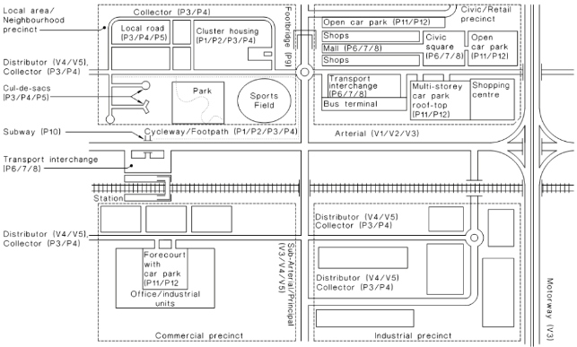
Figure 5: Figure 2.1 from AS/NZS 1158.3.1 2005

Different sections of the Standard apply to car parks, road ways and public activity centres as described in the following sections.

Car Parks
There are three lighting subcategories for outdoor car park lighting as outlined in AS/NZS 1158.3 Pedestrian Area (Category P) Lighting. Table 9 provides an overview of these three categories and the associated rates of pedestrian and vehicle traffic, night time occupancy and risk of crime.

Table 9: Car park lighting categorisation system
Type of area | Night time vehicle or pedestrian movements | Night time occupancy rates | Risk of crime | Applicable lighting subcategory
Parking spaces, aisles & circulation roadways | High | Greater than 75% | High | P11a
Parking spaces, aisles & circulation roadways | Medium | 25% - 75% | Medium | P11b
Parking spaces, aisles & circulation roadways | Low | Less than 25% | Low | P11c

Each of these three sub-categories has lighting level requirements for any given individual point in the assessment area, the average horizontal illuminance across the entire assessment area and the overall lighting uniformity. For the P11a category the required horizontal illuminance at any given point is 3 lux, while the required average for the whole car park is 14 lux. Table 10 provides an overview of the lighting level requirements for each of the three car park sub-categories.

Table 10: Lighting subcategory requirements for car parks
Lighting subcategory | Average horizontal illuminance (lux) | Point horizontal illuminance (lux) | Point vertical illuminance (lux) | Illuminance uniformity
P11a | 14 | 3 | 3 | ≤10
P11b | 7 | 1.5 | 1.5 | ≤10
P11c | 3.5 | 0.7 | - | ≤10
P12 | - | Greater than 14 |  | -

Public Activity Centres (excluding car parks)
There are three lighting subcategories for public activity centres as outlined in AS/NZS 1158.3 Pedestrian Area (Category P) Lighting. Table 11 provides an overview of these three categories and the associated rates of pedestrian and vehicle traffic, risk of crime and need to enhance prestige.

Table 11: Public activity centre lighting categorisation system
Type of area | Night time vehicle movement | Risk of crime | Need to enhance prestige | Applicable lighting subcategory
Areas primarily for pedestrian use e.g. outdoor shopping precincts, malls, open arcades, town squares | N/A | High | High | P6
 | Medium | Medium | Medium | P7
 | Low | Low | N/A | P8
Transport terminals and interchanges | High | High | High | P6
Transport terminals and interchanges | Medium | Medium | Medium | P7
Transport terminals and interchanges | Low | Low | N/A | P8

Table 12 outlines the lighting level requirements for the three public activity area subcategories. The requirements for these categories again include a minimum average horizontal illuminance, minimum point horizontal and vertical illuminance and maximum illuminance uniformity. As shown in Table 12, P6 requires the highest lighting levels of the three categories whilst P8 is the lowest.

Table 12: Lighting subcategory requirements for public activity centres (excluding car parks)
Lighting subcategory | Average horizontal illuminance (lux) | Point horizontal illuminance (lux) | Point vertical illuminance (lux) | Illuminance uniformity
P6 | 21 | 7 | 7 | 10
P7 | 14 | 4 | 4 | 10
P8 | 7 | 2 | 2 | 10

Roadways, Pedestrian Paths and Laneways
There are five lighting subcategories for roadways, pedestrian paths and laneways as outlined in AS/NZS 1158.3 Pedestrian Area (Category P) Lighting. Table 13 provides an overview of these five subcategories and the associated rates of pedestrian and bicycle traffic, risk of crime and need to enhance prestige.

Table 13: Roadway, pedestrian path and laneway categorisation table
Type of area | Pedestrian/cycle activity | Risk of crime | Need to enhance prestige | Applicable lighting subcategory
Collector roads or non-arterial roads | N/A | High | N/A | P1
Collector roads or non-arterial roads | High | Medium | High | P2
Collector roads or non-arterial roads | Medium | Low | Medium | P3
Collector roads or non-arterial roads | Low | Low | N/A | P4
Local roads or streets | N/A | High | N/A | P1
Local roads or streets | High | Medium | High | P2
Local roads or streets | Medium | Medium | Medium | P3
Local roads or streets | Low | Low | N/A | P4
Local roads or streets | Low | Low | N/A | P5

Table 14 outlines the lighting level requirements for the five subcategories for roadways, pedestrian paths and laneways. The requirements for these categories again include a minimum average horizontal illuminance, minimum point horizontal and vertical illuminance and maximum illuminance uniformity

Table 14: Lighting subcategory requirements for roadways, pedestrian paths and laneways
Lighting subcategory | Average horizontal illuminance (lux) | Point horizontal illuminance (lux) | Point vertical illuminance (lux) | Illuminance uniformity
P1 | 7 | 2 | 2 | 10
P2 | 3.5 | 0.7 | 0.7 | 10
P3 | 1.75 | 0.3 | 0.3 | 10
P4 | 0.85 | 0.14 | N/A | 10
P5 | 0.5 | 0.07 | N/A | 10

Background to Assigning Lighting Categories Using the Standard
AS/NZS 1158 provides guidance on assigning appropriate lighting categories and subcategories to various outdoor land uses and roads (refer to Section 12.1). Typical operating characteristics for each sub-category, defined largely via relative terms (low, moderate, high), are provided to assist in determining the most suitable subcategory. The Standard’s use of relative terms makes the task of assigning subcategories a subjective one. That is, one person’s opinion of what represents a “moderate” level of traffic volume or a “high” crime level will invariably differ from the next person.

The Australian Standard, in Section 2.4 of Part 1.1, acknowledges this issue, explaining that:

The concept of using relative terms is employed since it would be both unrealistic and impractical to apply one numerical set of values, for each of the selection criteria, to the lighting level hierarchy to accommodate the relevant requirements of each town, city etc. across both Australia and New Zealand.

The terms mixed, low, medium, high, very high and moderate are provided to enable individual road controlling authorities to develop their own specific lighting hierarchy.

The appropriate lighting subcategory for a particular road should be a matter for determination in consultation with the client…

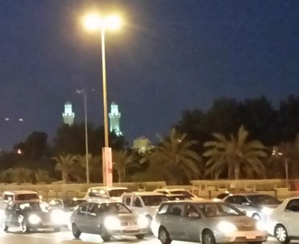
There is therefore inherent ambiguity in the relative terms used in the Standard, unless there is a clearly quantified definition of what is meant by low, moderate and high. This definition would typically be provided within a council Policy or Guidelines document, and would then require traffic counts and crime statistics to be sourced for each site before assigning a suitable lighting category or subcategory.

Only a limited number of road controlling authorities have a clearly quantified definition of what is meant by low, moderate and high in relation to traffic volumes and crime rates. For councils without a quantified definition of the relative terms used in the Standard – which includes Maroondah – the following process to assign desired categories or subcategories to a space or road is recommended:

- Define the function and busy-ness of the road/space via consultation with relevant Council staff;
- Match the definition of the road/space with the guidance provided by:
  - Public Lighting Policy and Guidelines documents
  - The Australian Standard (AS/NZS 1158)
  - Lighting schemes in similar roads/spaces in other local government areas
- Assign the most appropriate lighting subcategory to the road/space

In addition to assessing activity/occupancy levels and risk of crime, for road ways and public activity centres, application of the Standard involves an assessment of the “need to enhance prestige” or the required aesthetic appeal of a space. As an example, the Ringwood MAC may be considered an area where the required aesthetic appeal is higher than other areas.

Exceptions
The site types or specific locations presented in Table 15 have been identified by key Council staff as areas where lighting categories other than those that may be specified by strict application of the Standard are recommended.

Note that the option of installing a light on every pole (as opposed to meeting the specified lighting category) is suggested for most scenarios in Table 15 given the likelihood it will not be possible to meet the specified lighting category in all areas using existing pole infrastructure (i.e. existing mounting heights and spacings). For some locations, achieving the target (P3 or P4) would require the installation of new poles which adds significantly to the cost of any renewal or upgrade. Nevertheless, a cost benefit analysis of each individual site should be undertaken to determine if the installation of new poles is required (e.g. for high-profile or high-risk sites where meeting the target lighting classification is consider absolutely necessary).

Table 15: Site-specific lighting category requirements identified by key Council staff
Site/Application | Council’s preferred lighting category | Comment/Recommendation
Bus routes | Light to P4 category (or a light on every pole) | - The future possibility of dimming lighting along bus routes outside of public transport operating hours (e.g. from P4 to P5) via remote dimming should be considered in Council’s Public Lighting Policy.  - For PTV bus routes refer to: https://www.ptv.vic.gov.au/getting-around/local-areas/view/29
Taxi ranks | Refer to guidance in ATIA Taxi Rank Design Specification (April 2012) | - ATIA Taxi Rank Industry Specification, Table 7.19.3, provides illumination specifications for taxi ranks.
Principal Pedestrian Network (PPN) | Light to P3 (or light on every pole) | - Refer to map in Appendix 2  - Given the extensive coverage of the PPN it is not recommended that the entire network be lit to P3. Instead, it is recommended that P3 be targeted to key routes. For example, overlaying activity centres and other key sites may identify key routes.
Key pedestrian routes around train stations | Light to P3 (or light on every pole) | - Refer to maps in Appendix 3  - Council has identified what it considers to be the key pedestrian routes surrounding train stations (refer to Appendix 3). It is recommended that selection of key routes should be based on a clear understanding of current pedestrian patterns and usage. If possible, Council should encourage the concentration of pedestrian activity along particular routes to reduce lighting costs.
Key pedestrian routes around Maroondah Hospital | Light to P3 (or light on every pole) | - Refer to map in Appendix 3  - Council has identified what it considers to be the key pedestrian routes surrounding the Hospital (refer to Appendix 3). It is recommended that selection of key routes should be based on a clear understanding of current pedestrian patterns and usage. If possible, Council should encourage the concentration of pedestrian activity along particular routes to reduce lighting costs.
Higher order roads | Light to P3 (or a light on every pole) | - Based on consultation with key staff, applicable “higher order roads” include:  - Blue “link” roads as per Schedule 4 of Council’s Road Management Plan (refer to Appendix 4)  - Roads classified as “major” and “collector” roads by Melways  - To avoid confusion, it is recommended that Council ensure any road classifications/definitions are used are consistent with those used in Council’s roads asset database.
Ringwood MAC and night club precinct | Assign lighting categories using AS/NZS 1158 | It is recommended that lighting categories be assigned to specific space types within the Ringwood MAC by application of the Standard (as described in Sections 12.1 and 12.2).  Council’s Ringwood Transit City Lighting Strategy (2007) specifies nominal lighting classifications for key roads and space types within the Ringwood MAC area, which appears to be based on a high-level assessment against the Standard. Therefore, a more detailed assessment, as per the procedure described in Sections 12.1 and 12.2, would be consistent with the RTC Lighting Strategy.

Recommendations:
- Council’s Public Lighting Guidelines to specify the method for assigning lighting categories as per AS/NZS 1158, including any site-specific exceptions

Lighting Quality
Lighting quality considerations (e.g. CCT, colour rendering etc.) were discussed in detail during the workshop process and are generally catered for by the recommendations of other sections of this report (especially Section 7). However, further background discussion of the issue of blue light (and how it relates to CCT) is provided below given this is a topic of considerable discussion in the public lighting sector at present.

CCT and Blue Light
There is an increasing amount of public discourse around the potential negative effect of public lighting on human health due to too much “blue light”. In June 2016, a report by the American Medical Association (AMA) adopted guidance for USA communities on selecting among LED lighting options to minimise potential harmful human and environmental effects. While the report is based on the experience in the USA, it reinforces what could be considered as “best practice public lighting” which dictates that lighting should be designed and managed by professionals and with concern for broader environment, health and social factors.
The AMA also blames high colour temperatures and recommends a colour temperature of 3000K or lower for LED street lighting to limit the amount of blue light.

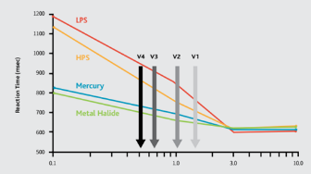
Unfortunately, many 3000K lights can have high blue light content and Figure 6 shows that the warmer colour temperatures (LPS and HPS at 3000K or lower) result in slower driver reaction times and have direct road safety implications.

Figure 6: Australian Highway Lighting Categories, reaction times improved by white light (Davis 1999, Arizona DoT, SLPC, from IPWEA SLSC Roadmap 2016)

According to the Institute of Public Works Engineering Australasia (IPWEA) Street Lighting and Smart Controls Roadmap (2016) “in practical terms, this means that at a vehicle speed of 50km/hr, the stopping distance might be reduced by 4.2m” when using a higher colour temperature compared to the warmer colours.

From an Australian point of view, SA/SNZ TS 1158.6 states a "recommended" colour temperature of 4000K for street lighting, which is the colour temperature of the current 80W MV as well as the majority of new LEDs installed throughout Australia. Four thousand degrees Kelvin is generally seen as an appropriate compromise between those arguing against too much light from the blue end of the spectrum and those arguing for better colour rendering, safety and efficiency of lighting.

It’s important to note that much of the public discourse around “over lighting” and too much “blue white” is based on experiences in the USA and Europe. While still important, it is of less relevance to Australia because Australian street lighting levels are relatively low by international standards. In the UK, the minimum lighting levels are up to seven times higher than the minimum levels in Australia. What’s more, the “old” lights in USA and Europe are commonly HPS lights which generally have a lower colour temperature than the MV lights in Australia.

In the absence of any conclusive research or evidence, the potential risks of blue lighting can be managed by good design. For example, lighting to the levels required (not higher), reducing light spill through well-designed luminaires and lighting schemes and the use of glare shields where appropriate. These issues and actions are generally discussed and decided with Ironbark’s support during the Design and Preparation Stage of a lighting project.

Waste Disposal at End of Life
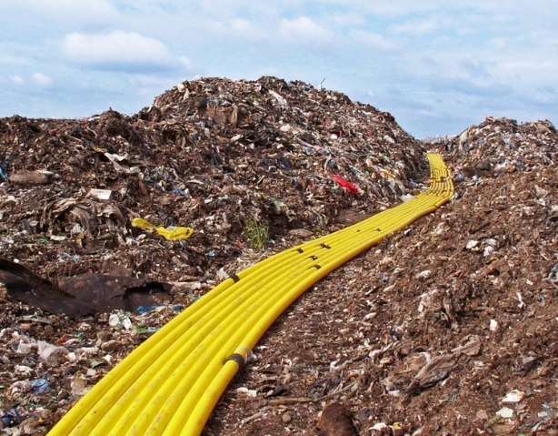
Waste materials arising from the removal and/or installation of public lighting assets can include toxic materials and therefore should be handled in an environmentally sensitive way, while the amount of material recycled should be maximised.

The vast majority of materials produced by the replacement of public lighting assets can be recycled, however some components require (e.g. mixed plastics) cannot. Table 16 summarises the best-practice approach to recycling of materials arising from public lighting.

Table 16: Summary of typical components, materials and recycling requirements
Component | Typical Materials | Best-Practice Disposal Method
Lamps (including mercury vapour, high pressure sodium, fluorescent, metal halide) | Glass, mercury, phosphorous, copper, plastic, aluminium | Processed to separate the glass, aluminium, phosphor powder (which contains the mercury) and argon gas  Glass and aluminium recycled  Mercury and phosphorous distilled and reused
Plastic visor | Acrylic | Recycled (for example, granulated to produce pellets to be used as raw material for producing new plastic products)
Plastic backing | High density polyethylene (HDPE) | Recycled (for example, granulated to produce pellets to be used as raw material for producing new plastic products)
Luminaire body | Aluminium | Recycled
Miscellaneous components attached to luminaire body (including components such as capacitors, lanyards, clips, terminal blocks, grommets etc.) | Plastic, copper, rubber, steel | Copper and steel components recycled
Photoelectric (PE) cell | Plastic, copper and steel.  Some PE cells may contain cadmium | Disposed of or recycled in line with EPA regulations  PE cells containing cadmium should only be accepted by an approved waste acceptor
Control gear/ballast | Iron exterior (older luminaires with iron core ballasts)  E-waste (newer luminaires with electronic control gears) | Iron core ballasts - Iron components must be recycled  Electronic ballasts – recycled as e-waste
Lamp holder | Ceramic, plastic, copper and steel | Copper and steel components recycled
Steel screws | Steel | Recycled
Copper wires | Plastic and copper | All insulated copper wire can be separated and the copper component recycled
Poles/columns | Steel | Recycled
Packaging | Cardboard, paper, soft plastics | Recycled

The measures outlined in Table 16 should be implemented to ensure compliance with the Environment Protection (Industrial Waste Resource) Regulations 2009 and the following:

- Planning and Environment Act 1987 (Vic)
- Environmental Protection Act 1970 (Vic)

Note that the objectives of the Environment Protection (Industrial Waste Resource) Regulations 2009 are to consolidate subordinate legislation and also assist industry to implement the principle of wastes hierarchy as set out in the original Environment Protection Act 1970 which is the primary legislation.

It is recommended that compliance with the Environment Protection (Industrial Waste Resource) Regulations 2009 and specific disposal of wastes (as per Table 16) be detailed clearly in any installation tender or RFQ process, with evidence of compliance sought from contractors in the form of recycling receipts or similar.

Recommendation:
- Council to include best-practice recycling and waste disposal requirements in any tender or RFQ documentation for public lighting works, including the requirement that evidence of appropriate recycling and/or disposal is provided

Policy and Guidelines Review
Any Policy or Guidelines should be subject to Council’s standard review procedures. This is especially relevant to public lighting given the rapid changes and improvements in lighting technology, and frequent updates to associated standards. As such, it is recommended that Council’s Public Lighting Policy and Guidelines be reviewed every 2 to 3 years with particular concern for:

- new technology options
- updates to AS/NZS 1158
- changes in the nature or use of particular spaces that may necessitate changes to public lighting

Recommendation:
- Public Lighting Policy and Guidelines to be subject to review every 3-5 years
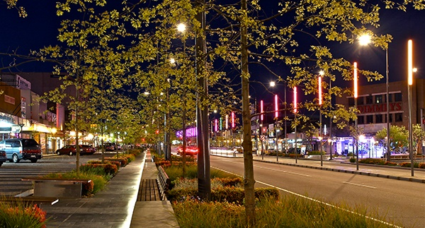

Glossary
Term | Definition
HID | High-intensity discharge lamps or luminaires
Luminaire efficacy rating (LER) | A measure of the efficiency with which a luminaire converts electrical energy into light, measured in lumens per watt
Category P | Pedestrian category roads
Category V | Vehicle category roads
CCT | Correlated colour temperature describes the colour of a light source, and is measured in degrees Kelvin (K). Blue-white lamps have a high colour temperature (e.g. 4000K). Yellow lamps have a low colour temperature, (e.g. 2000K)
Colour Rendering Index (CRI) | Colour rendering describes the degree to which natural colours can be perceived under different kinds of artificial light. It is measured on a colour rendering index (CRI). A CRI of 100 indicates that colours are depicted accurately. A CRI of less than 30 indicates colours are distorted and difficult to recognise. A CRI of 80 or above provides an acceptable standard for outdoor lighting.
DALI | Digital Addressable Lighting Interface. A type of standard lighting control system.
Decorative | Refer to ‘non-standard’
DNSP | Distribution Network Service Provider, also known as Energy Distribution Business (EDB) also known as distributors.
GHG | Greenhouse gas
HPS | High pressure sodium lamps or luminaires
IK rating | Measure of protection against mechanical impact (vandalism)
IP rating | Measure of protection against ingress by water and solid objects
IPWEA | Institute of Public Works Engineering Australasia
Lamp | The light bulb in a luminaire
LED | Light emitting diode
LPS | Low pressure sodium lamps or luminaires
Luminaire | The light source (lamp or LED module), fitting and control gear of the light
MAC | Metropolitan Activity Centre
MH | Metal halide lamps or luminaires
Non-standard lighting | Lighting that is typically not held in stock by DNSPs, sometimes also referred to as ‘decorative’ (typically found in URD areas)
OMR | Operation, maintenance and replacement (OMR) costs are charged by a DNSP to a public lighting customer (e.g. Council)
PPN | Principal Pedestrian Network
Standard lighting | Lighting that is typically held in stock by DNSPs, and is found on their list of products approved for use
Street lighting | Street lighting found in residential streets and main roads
URD | Underground Residential Developments

Appendix 1 – Strategic Cycling Corridors
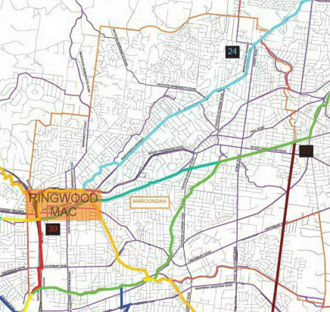

Appendix 2 – Principle Pedestrian Network
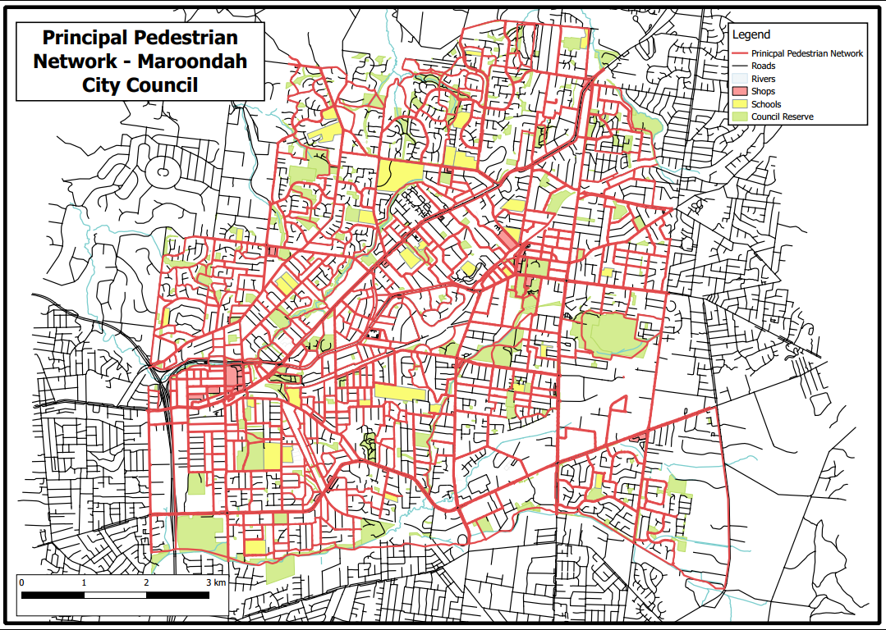

Appendix 3 – Key Pedestrian Routes Around Train Stations and Maroondah Hospital
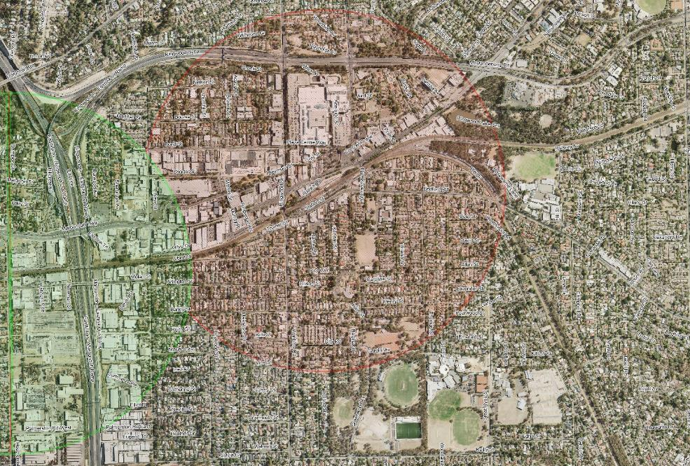
Figure 7: 800m radius around Ringwood Station and Heatherdale Station

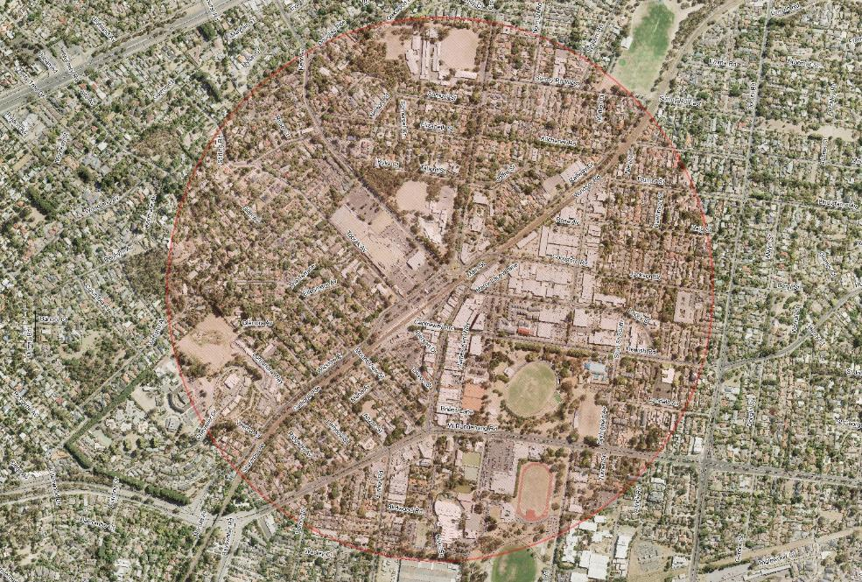
Figure 8: 800m radius around Croydon Station

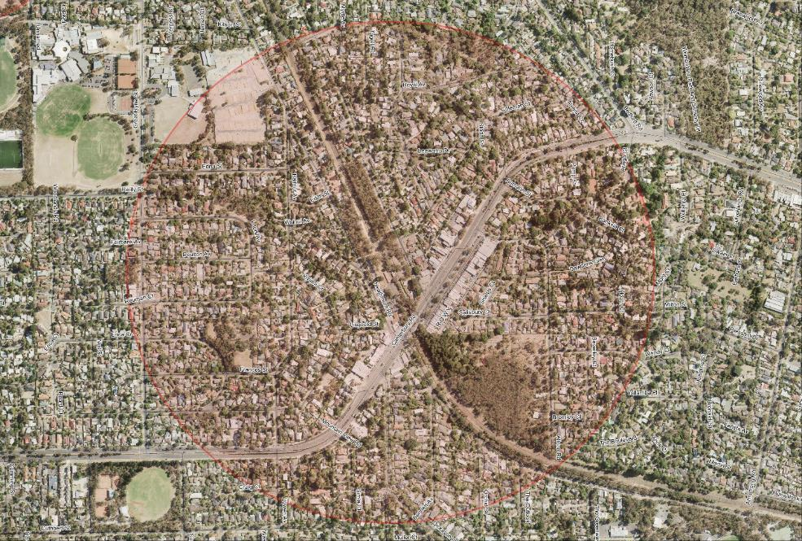
Figure 9: 800m radius around Heathmont Station

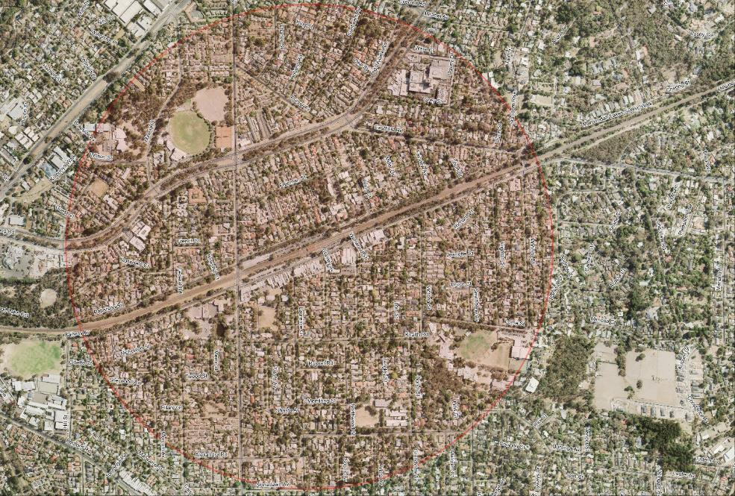
Figure 10: 800m radius around Ringwood East Station

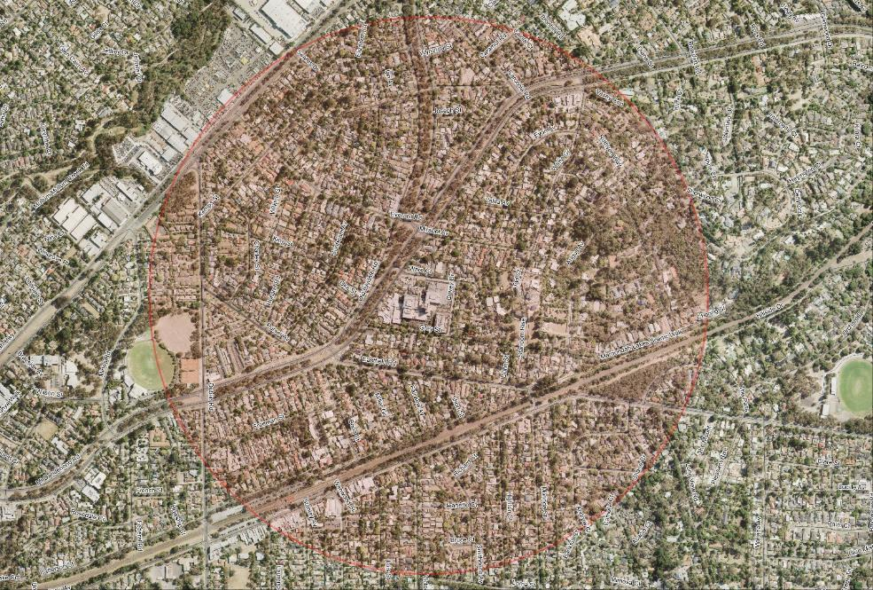
Figure 11: 800m radius around Maroondah Hospital

Appendix 4 – Road Classifications from Council’s Road Management Plan
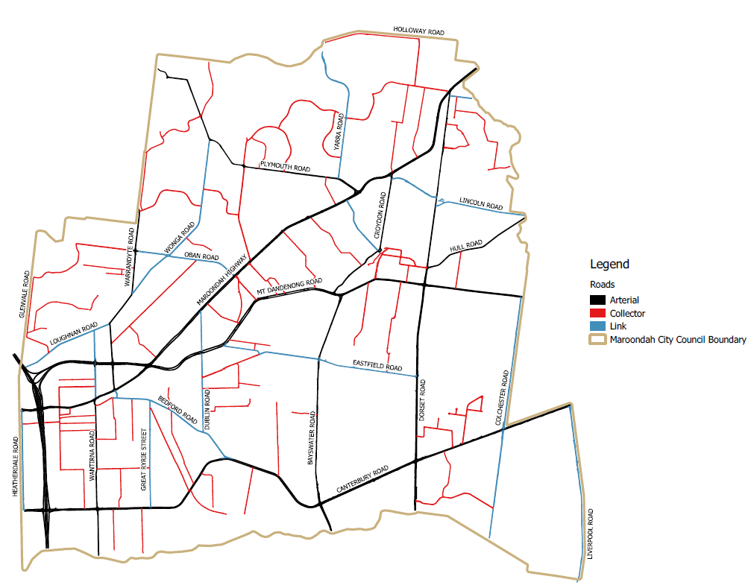

Limited (and decreasing) in number.
Maintenance is limited to lamp (if applicable) and PE cell replacements, and cleaning. Upon failure, replacement luminaire and/or pole must be provided by Council.
Limited (and decreasing) in number.
Where controls such as dimming or switching are implemented, consideration should be given to the need for public signage alerting the public to when lights will be turned off or dimmed.
Note that lighting of bus shelters/stops is the responsibility of PTV, and the lighting of bus interchanges and hubs is the responsibility of VicTrack.

