Planning and Environment Act 1987
MAROONDAH PLANNING SCHEME
AMENDMENT C128maro
EXPLANATORY REPORT
Who is the planning authority?
This amendment has been prepared by Maroondah City Council which is the planning authority for this amendment.
The Amendment has been made at the request of Maroondah City Council.
Land affected by the Amendment

The Amendment applies to part of 1 Wonga Road and to the entire property at 3-5 Wonga Road, Ringwood North.

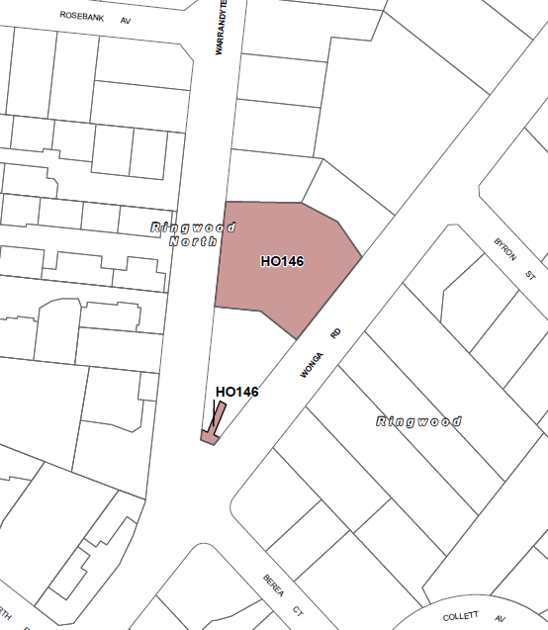
Figure 1- Proposed Heritage Overlay application to part 1 Wonga Road and entire 3-5 Wonga Road, Ringwood North.

The site is 4000 square metres in size. The site is zoned General Residential Zone (GRZ1) and Schedule 4 to the Significant Landscape Overlay – Landscape Canopy Protection (SLO1) applies to the site.

The Heritage Overlay (HO) – HO146 applies to 3-5 Wonga Road, Ringwood North on an interim basis.

What the amendment does

The Amendment applies heritage protection to 1 Wonga Road, Ringwood North and replaces the interim heritage protection with permanent heritage protection to 3-5 Wonga Road, Ringwood North.

Specifically, the Amendment:
- Amends Planning Scheme Map No.1 to apply HO146 to 1 Wonga Road and to 3-5 Wonga Road, Ringwood North on a permanent basis.
- Amends Schedule to Clause 43.01 Heritage Overlay – HO146, to delete reference to the interim control and replace the document ‘3-5 Wonga Road, Ringwood North Statement of Significance, 22 June 2018’ with ‘Statement of Significance HO146, 3-5 Wonga Road and 1 Wonga Road, Ringwood North, 22 June 2019’.
- Amends the Schedule to Clause 72.04 - Documents Incorporated in this Planning Scheme to replace the existing document ‘3-5 Wonga Road, Ringwood North State of Significance, 22 June 2018’ with document ‘Statement of Significance HO146, 3-5 Wonga Road and 1 Wonga Road, Ringwood North, 22 June 2019’.

It is relevant to note that the Statement of Significance differs from the Gazettal document as part of C127 as it includes reference to 1 Wonga Road and it deletes reference to the stone retaining wall along the Warrandyte Road public footpath adjacent to the sites of 1 and 3-5 Wonga Road. In accordance with Council’s Heritage Advisor assessment it identifies that the rock wall along Warrandyte Road, dating from the 1960s, is of interest as homage to the earlier stone driveway wall and gateposts and for some landmark qualities in its own right.
Strategic assessment of the Amendment

Why is the Amendment required?
The Amendment is required to protect local heritage significance at 1 Wonga Road, Ringwood North and 3-5 Wonga Road, Ringwood North.
A heritage assessment of the site/s has concluded the site/s as having local heritage significance worthy of its inclusion in the Schedule to the HO. The site/s are of architectural, aesthetic and historical significance to the Maroondah municipality.
Specifically, the heritage significance of 3-5 Wonga Road includes:
- The former “Thalloo” early modern house, completed in 1942; and
- Trees numbered 10, 14, 16, 17, 22 and 23 shown in Figure 2.

The heritage significant of 1 Wonga Road includes:
- The “Thalloo” stone gateposts with wrought iron name plate and gate at the entrance of 1 Wonga Road and the 13-meter-long stone walled driveway.

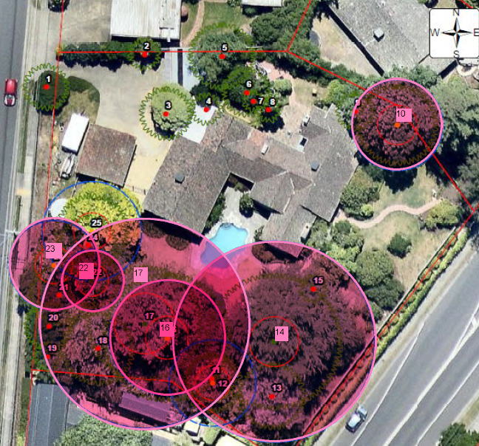
Figure 2- Significant trees at 3-5 Wonga Road, Ringwood North.
Interim protection
Amendment C127 was gazetted on 16 May 2019 and applied heritage protection to 3-5 Wonga Road, Ringwood North on an interim basis. The interim protection is set to expire on 31 March 2020.
Amendment C127 was pursued after Council received a planning permit application (application number M/2018/496) to use and develop the land at 3-5 Wonga Road, Ringwood North for a childcare centre, removal of vegetation, alteration of access to a Road Zone category 1 and the erection of business identification signage in 2018.
Council issued A Notice of Decision to Refuse to Grant a Permit in December 2018 on the basis that the planning application did not respond to local and state planning policy.
Amendment C128maro will ensure permanent heritage protection to the local heritage significant elements on these sites.

How does the Amendment implement the objectives of planning in Victoria?

The Amendment implements the objectives of planning in Victoria, the objective outlined in section 4(1)(d) of the Planning and Environment Act 1987 being:

(d) to conserve and enhance those buildings, areas or other places which are of scientific, aesthetic, architectural or historical interest, or otherwise of special cultural value;

The Amendment is consistent with these objectives on the following grounds:

- Ensuring that the subject property has appropriate controls applied to facilitate their conservation on an on-going basis.
How does the Amendment address any environmental, social and economic effects?
The Amendment will ensure that the building and garden at 3-5 Wonga Road Ringwood North identified as having local heritage significance will be protected and that any future redevelopment will have regard to the significant heritage aspects of the site. It will also ensure that the heritage elements at 1 Wonga Road namely the “Thalloo” gateway and drive at 1 Wonga Road, are protected.
The Amendment will not have significant adverse effects on the environment. The likely long-term social effects of the amendment will be positive as the aim of the amendment is to conserve buildings that are of local social and historical significance and to provide guidance in decision making as to Council’s position in relation to heritage of this site.
Does the Amendment address relevant bushfire risk?
The subject site is located within an established urban environment and has not been identified as at risk from bushfire. It is considered that general bushfire risk in the State Planning Policy Framework is addressed through the planning scheme.
Does the Amendment comply with the requirements of any Minister’s Direction applicable to the amendment?

The Amendment is consistent with the following Ministerial Directions:

- Ministerial Direction on the Form and Content of Planning Schemes under section 7(5) of the Planning and Environment Act 1987.

- Ministerial Direction No. 9 – Metropolitan Strategy (Plan Melbourne 2017-2050: Metropolitan Planning Strategy (Department of Environment, Land, Water and Planning, 2017). The Amendment will help to conserve a part of Maroondah’s and Melbourne’s heritage, and it aims to protect the heritage place distinctiveness and build on Maroondah’ heritage legacy.

- The Amendment is consistent with the Ministerial Direction No 11 – Strategic Assessments of Amendments.
How does the Amendment support or implement the State Planning Policy Framework and any adopted State policy?

The Amendment is consistent with the following Planning Policy Framework (PPF) and supports its objectives as follows:

The Amendment supports Clause 15 - Built Environment and Heritage with the objective to ‘protect places and sites with significant heritage, architectural, aesthetic, scientific and cultural value’. The Amendment identifies and documents a place of heritage significance, providing its protection through the Maroondah Planning Scheme.

The Amendment supports Clause 15.03-1S Heritage Conservation with the objective being to ensure the conservation of places of heritage significance.

The Amendment is consistent with The Victorian Planning Provisions Practice Note 1 Applying the Heritage Overlay August 2018.
How does the Amendment support or implement the Local Planning Policy Framework, and specifically the Municipal Strategic Statement?

The Amendment is consistent with the Municipal Strategic Statement (MSS) and supports its objectives as follows:

The Amendment supports Clause 21.04 that the recognises Maroondah’s heritage is crucial to the development of a vibrant and confident community.
Does the Amendment make proper use of the Victoria Planning Provisions?

The Amendment makes proper use of the Victorian Planning Provisions by applying the HO to the site. The HO identifies places of heritage significance with a recognised heritage citation.

In accordance with this Practice Note the heritage assessment clearly justifies the significance of the place. The documents for this heritage place include a statement of significance that establishes the importance of a place and addresses the heritage criteria; i.e. HERCON Criteria- Heritage Council of Victoria criteria.
How does the Amendment address the views of any relevant agency?

The views of relevant agencies will be sought as part of the exhibition process for the permanent controls.
Does the Amendment address relevant requirements of the Transport Integration Act 2010?

The Amendment is not expected to impact on the transport system as the proposed controls are intended to protect the significant neighbourhood character of the area.

Resource and administrative costs
• What impact will the new planning provisions have on the resource and administrative costs of the responsible authority?

Any additional work created by the additional heritage control can be resourced with current staff levels.
Where you may inspect this Amendment
The Amendment is available for public inspection, free of charge, during office hours at the following places:
Maroondah City Council:
- City Offices Service Centre, Braeside Avenue, Ringwood
- Realm, Ringwood Town Square, 179 Maroondah Highway, Ringwood
- Civic Square Service Centre, Civic Square, Croydon
- Croydon Library, Civic Square, Croydon
The Amendment can also be inspected free of charge at the Department of Environment, Land, Water and Planning website at www.delwp.vic.gov.au/publicinspection .
Submissions

Any person who may be affected by the amendment may make a submission to the planning authority. Submissions about the amendment must be received by
8 August 2019.

A submission must be sent to Mr Phil Turner, Director Strategy and Community, Maroondah City Council, PO Box 156, Ringwood 3134 or via email at maroondah@maroondah.vic.gov.au.
Panel hearing dates
In accordance with clause 4(2) of Ministerial Direction No.15 the following panel hearing dates have been set for this amendment:
• directions hearing: week commencing 28 October 2019
• panel hearing: week commencing 9 December 2019.

ATTACHMENT 1 - Mapping reference table

Location | Land /Area Affected | Mapping Reference
3-5 Wonga Road Ringwood North and 1 Wonga Road Ringwood North | 3-5 Wonga Road Ringwood North  1 Wonga Road Ringwood North | Maroondah C128maro 001ho Map 1 Exhibition

