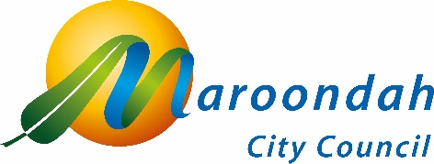

Asset Plan 2025-35

Community Consultation Report

June 2025

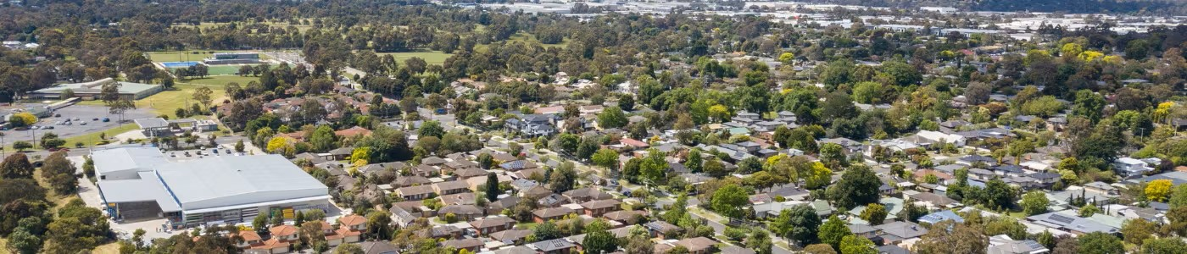

Contents

Asset Plan 2025-35 1
Community Consultation Report 1
June 2025 1
Contents 2
1. Background 3
2. Community consultation 3
2.1 Communication channels 3
2.2 Consultation tools 5
3. Community feedback - key themes 7
3.1 Online submissions - Your Say Maroondah 7
Conclusion 9
Next Steps 9

Background

Section 92 of the Local Government Act 2020 mandates Council create and adopt a public facing 10-year Asset Plan. This is to be undertaken using deliberative engagement practices by 31 October in the year following a Council election.

The Asset Plan is an important part of Council's integrated planning framework. Feedback collected as part of the Maroondah 2050 and Council Plan consultations helped inform the new plan. Council’s key Asset Management Plans were also referenced to develop the document.
The revised Asset Plan 2025-35 has been developed in accordance with section 92 of the Local Government Act 2020 and Council’s community engagement policy. The plan contains key information on the asset lifecycle (acquisition, maintenance, operations, renewal, upgrade, expansion and disposal) and projected expenditure for the next 10 years.

Community consultation

In accordance with Council’s community engagement policy, the draft plan was made available for community consultation from Wednesday 23 April to Wednesday 21 May 2025.

2.1 Communication channels

A range of communications channels were used to promote the consultation opportunities. This consultation was run together with the Council Plan, Financial Plan & Budget, and Rating and Revenue Plan. The below statistics represent the consultation as a whole, not the Asset Plan consultation individually.

Communications Channel | Reach Statistics
Your Say Maroondah website | Total page visits: 41  Document downloads: 59  Engaged visitors (no. of survey submissions): 7  22 engaged visitors  Survey  6 contributors  7 submissions  The above summary figures are based on the three types of activity on the Your Say Maroondah website.  Aware: Participants have viewed the project page and are aware that the project exists. This is the result of promotional activities.  Informed: Participants have viewed various elements within the project page and are well informed about a subject and take time to think before participating.  Engaged: Participants have provided feedback and contributions to a consultation.

Community engagement for the development of Council’s Asset Plan 2025-2035 was undertaken between August 2023 and May 2024 in conjunction with the engagement for the Maroondah 2050 Vision and Council Plan 2025 -2029.
This included:
- Broad community and stakeholder engagement surveys
- Deliberative engagement workshops/community panel
- Targeted engagement with hard to reach and under-represented community groups
- Engagement with Maroondah’s Advisory Committees, Councillors and Management

Council’s Asset Plan 2025-2035 was then created using:
- Council current Asset Plan
- Community engagement 2023/24 outcomes
- Local Government Act 2020 / Victoria - Asset Plan Guidance 2022
- Local Government Sector Benchmarking
- Maroondah internal Asset Management Plans and;
- Maroondah Asset Management maturity.

2.2 Consultation tools

The revised Asset Plan 2025-2035 was then made available for final community engagement between 23 April 2025 and 21 May 2025.
Following the conclusion of the engagement period, no formal submissions were received regarding the draft. However, there were 7 responses of a general nature, primarily focusing on planting more flowers and oak trees to support local habitat, and prioritising new footpath constructions.
Consultation tools | Description | Outcomes
Online | Your Say Maroondah | Specific to Asset Plan survey:  7 responses of a general nature, primarily focusing on planting more flowers and oak trees to support local habitat, and prioritising new footpath constructions
Online | Maroondah Website | All website traffic:  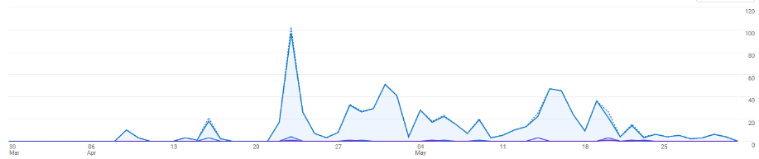  Time span of stats below - 30 March to 31 May 2025:  - Total views - 795  - Peak views: Wednesday 23 April, 102 views  - 13 views on the pop-up on Council’s website and one click through.  Top 5 traffic sources:  - 287 direct (Your Say)  - 133 Maroondah eNews  - 131 Your Say eNews  - 53 Google / organic  - 38 referrals from Cr Jones website  Learnings:  Most website referrals came from people directly searching for the page with a total 36% of all referrals.  Cr Chris Jones’ website had 38 referrals. Something to consider in future is further promotion via Councillors.  Maroondah eNews had 24 referrals and the monthly print edition of Maroondah news had 19 referrals.
Social Media | Facebook:  There were four Facebook posts over the consultation period.  - Facebook post engagement on average between the 4 posts was: 4.32%  - Most successful post was on 19/5 (first post on FB) which had a 6.26% engagement rate per impression.  Instagram:  There were four posts on Instagram over the engagement period.  - Instagram post engagement on average between the four posts was 0.82%.  Good engagement rates are 2% to 5%

Community feedback - key themes

3.1 Online submissions - Your Say Maroondah
Community engagement for the development of Council’s Asset Plan 2025-2035 was undertaken between August 2023 and May 2024 in conjunction with the engagement for the Maroondah 2050 Vision and Council Plan 2025 -2029 (i.e. titled ‘Council's future strategic plans | Your Say Maroondah)
The below tables provide a summary of the engagement outcomes specifically focused on the Asset Plan.
Widget Type | Engagement Tool Name | Visitors | Downloads/Views
Document | Draft Asset Plan 2025-35 | 41 | 59

Tool Type | Engagement Tool Name | Tool Status | Visitors | Contributors
 |  |  |  | Registered | Unverified | Anonymous
Survey Tool | Asset Plan feedback form | Archived | 22 | 1 | 0 | 5

The above summary figures are based on the three types of activity with the project on the Your Say Maroondah engagement website:
- Aware: Participants that have viewed the project page and are aware that the project exists. This is the result of your promotional activities.
- Informed: Participants that have viewed various elements within the project page and are well informed about a subject and take time to think before participating.
- Engaged: And, finally, participants who provide feedback and contributions to a consultation.

Visitors to the project page Council's future strategic plans | Your Say Maroondah were asked to complete a survey with the following responses to questions provided.

Following feedback received from Council’s Maroondah 2050 Community Vision consultation that has informed this draft Asset Plan, Council has determined the following opportunities for focus in relation to assets and infrastructure.
- Name
- Email address
- What suburb do you live in? (please type the name of the suburb and select from the drop-down options)
- Age group
- What do you identify as?

- Roads (To what extent do you support these priorities/actions? 1 = most important to 5. least important)
- Traffic lights and pedestrian crossing upgrades
- Local road renewals and reconstructions
- Kerb and channel replacements
- Car park improvements

- Drainage (To what extent do you support these priorities/actions? 1 = most important to 5. least important)
- Waterway improvements
- Stormwater drainage renewal and upgrades

- Buildings (To what extent do you support these priorities/actions? 1 = most important to 5. least important)
- Facilities improvements and replacements
- Public toilet improvements
- Funding for community groups
- Access and inclusion for community facilities

- Pathways (To what extent do you support these priorities/actions? 1 = most important to 5. least important)
- Shared (bike) path improvements
- Footpath replacements
- New footpath construction
- Footbridge and boardwalk improvements

- Open space assets (To what extent do you support these priorities/actions? 1 = most important to 7. least important)
- Play space improvements
- New tree planting
- Open space and open space lighting improvements
- Sports fields and golf course improvements
- Bushland improvements

- Do you have any other feedback on the draft Asset Plan?
- Better disabled toilets: This feedback suggests a need for improved accessibility and facilities for individuals with disabilities.
- Provide footpaths on at least one side of the roadway if there are no existing footpaths. Replacement of existing footpaths should be a lower priority: This feedback highlights the importance of pedestrian infrastructure and suggests prioritizing the installation of footpaths where they are lacking.
- Plant more flowers for bees and local animals. Stop planting easy-to-maintain plants. Fill the parks with Sheoak trees: This feedback emphasizes the importance of biodiversity and creating habitats for local wildlife within public spaces.
- Build a footpath on Heatherdale Road: This feedback specifically calls for the construction of a footpath on a particular road to improve pedestrian safety and accessibility.

Conclusion
In accordance with Council’s Community Engagement Policy, the revised Asset Plan was made available for community consultation from 23 April 2025 and 21 May 2025. Following the conclusion of the engagement period, no formal submissions were received regarding the draft. However, there were 7 responses of a general nature, primarily focusing on planting more flowers and oak trees to support local habitat, and prioritising new footpath constructions.
Following community consultation an update was prepared for CMT and Councillors with final feedback invited ahead of the proposed document adoption date 30 June 2025.

Next Steps
Having followed the prescribed processes in accordance with the Act and Council's community engagement policy, the Asset Plan 2025-2035 will be formally adopted at the 30 June 2025 Council meeting.

