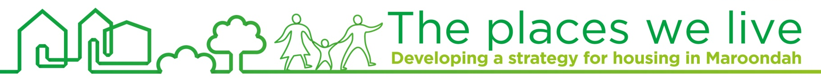
To contact Council
phone 1300 88 22 33 or (03) 9298 4598
visit: www.maroondah.vic.gov.au
email: maroondah@maroondah.vic.gov.au
Translating & Interpreter Service: 13 14 50
National Relay Service (NRS): 13 36 77
 MaroondahCityCouncil
@CityofMaroondah
 CityofMaroondah
 Maroondah City Council

Factsheet #9
November 2015

Community views on local

Find out more
Further details are available on the project website via:
www.maroondah.vic.gov.au
infrastructure and services
The Maroondah community has indicated strong support for walkable neighbourhoods with a desire to have close proximity between their home and a range of amenities such as transport options, local shopping strips, small parks and shared trails.  Council provides a vast and diverse range of facilities and services that are aimed at meeting the needs and aspirations of the Maroondah community. Council has recently undertaken an engagement activity to help understand community preferences and population needs relating to local amenities. Information from this activity will assist Council in identifying future directions for local infrastructure, service delivery and advocacy.  Consistent with the Victorian Government’s metropolitan planning strategy, Plan Melbourne, Maroondah City Council devised an engagement activity to seek the community’s input on which facilities and services are most important to them. The activity was based on the idea of creating ‘20 minute neighborhoods’, a key direction outlined in Plan Melbourne and also our community vision Maroondah 2040: Our future together.  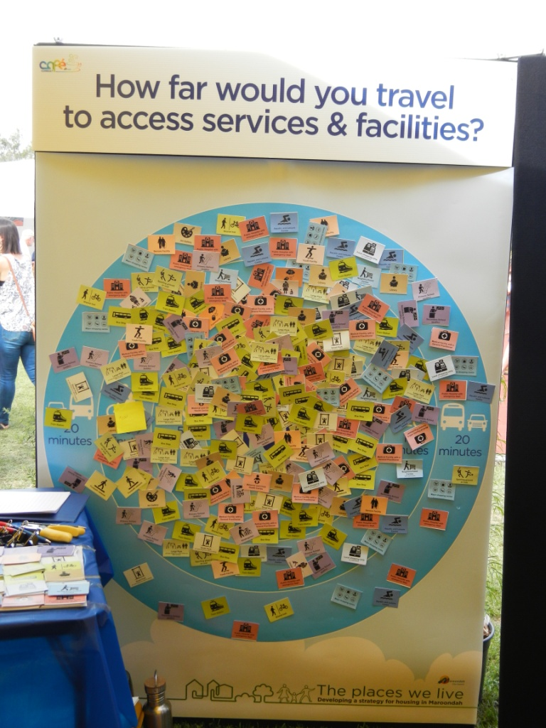  Open house engagement events were run in Croydon at the Maroondah Festival in early November 2015 and in the Ringwood Town Square over a weekend in mid November 2015. For this activity, participants were asked how far would they prefer to travel from home to access services and facilities. Participants were asked to select their top three services or facilities from a list of 24 options. Participants were then given an opportunity to categorise these selected services and facilities according how far they would travel to access or utilise them (5 minutes, 10 minutes, 20 minutes).  A total of 271 community members participated in this activity. 45% of participants were aged between 25 and 49, 83% lived in a detached house and 43% were couples with children.  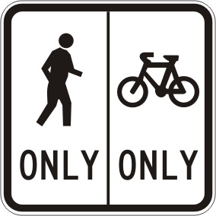  #1 - Transport and Accessibility  Shared trail, Footpath network,  Train Station, Bus Stop  Transport and accessibility services and facilities were identified as the highest priority with most participants selecting at least one option in this category. Most respondents wanted these amenities to be within a 5-10 minute travel distance from their home. The majority of respondents would like Shared Trails, Footpath Networks and Bus Stops to be within 5 minutes of their home. Over half of survey participants were willing to travel either 10 or 20 minutes to a Train Station.  COMMUNITY PRIORITIES AND NEEDS RELATING TO LOCAL SERVICES, FACILITIES AND AMENITIES |   Get in touch  1300 88 22 33  housing@maroondah.vic.gov.au
 | 
Healthcare facilities and services received the fourth highest number of responses. The considerable majority of participants preferred a travel time of between 5 and 10 minutes to access a Medical Facility with a GP. In contrast, most participants were willing to travel between 10 and 20 minutes to access a Public Hospital with an Emergency Department. Very few responses were received for Maternal and Child Health Centres.

Sporting and Leisure facilities and services received the third highest number of responses. Respondents were more willing to travel further to access Large Parks compared with Small Parks. The majority of participants were willing to travel between 10-20 minutes to access Aquatic and Leisure Centres.

Retail amenities received the second highest number of responses. The survey showed most participants were willing to travel 20 minutes or more to access Major Shopping Centres and Lifestyle/Homemaker Retail Centres.
A considerable majority of respondents preferred to live within 10 minutes of Local Shopping Strips and Neighbourhood Centres.

Community facilities received the fifth highest number of responses. A Library was the most popular facility in this category with a majority preferring to live within 10 minutes travel distance of this facility. The majority of respondents were willing to travel 10-20 minutes to access an Art Gallery. Mixed travel distances were identified for access to Youth Facilities, Seniors Facilities and Community Houses.

Education facilities received the sixth highest number of responses. Primary Schools (public) were identified as a higher community priority in comparison to Secondary Schools (public). The considerable majority of respondents preferred to live within 10 minutes of a Primary School (public) but most were willing to travel between 10 and 20 minutes to access a Secondary School (public).

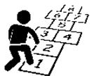

#6 – Education

Kindergarten, Childcare Centre, Primary
School (public), Secondary School (public)

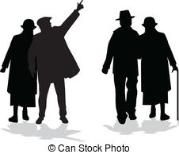

#5 – Community facilities

Youth Facility, Seniors Facility, Library, Community house, Art Gallery



#4 – Healthcare

Maternal Child and Health Centre, Medical Facility with GP, Public hospital with an
emergency department



#2 - Retail

Local Shopping Strip, Neighbourhood
Centre, Major shopping centre, Lifestyle/Homemaker Retail Centre



#3 – Sporting and Leisure

Small Park, Large Park, Aquatic and
Leisure Centre, Sporting ground or oval

