

MUNICIPAL
EMERGENCY
MANAGEMENT
PLAN
2020 - 2023

Disclaimer:

No reader should act on the basis of any matter contained in this publication without appreciating that it may be the subject of amendment or revocation from time to time without notice.

The Councillors of Maroondah City Council expressly disclaim all and any liability (including liability in negligence) to any person or body in respect of anything and of the consequences of anything done or omitted to be done by any such person or body in reliance, whether total or partial, upon the whole or any part of this publication.

Version 1.0
August 2019

TABLE OF CONTENTS
PART 1. INTRODUCTION 1-1
1.1 MUNICIPAL ENDORSEMENT 1-1
1.2 STATEMENT OF AUDIT 1-2
1.3 AIM 1-3
1.4 OBJECTIVES 1-3
1.5 ACTIVATION OF PLAN 1-3
PART 2. BACKGROUND 2-1
2.1 CONTEXT 2-1
2.2 AREA CHARACTERISTICS 2-1
2.2.1 Municipal location map 2-2
2.2.2 Topography 2-2
2.2.3 Demography 2-2
2.2.4 Vulnerable Persons 2-3
2.3 COUNCIL DATA AND INFORMATION 2-4
2.3.1 Council Asset Registers (IPS & GIS) 2-4
2.3.2 Council Property Registers and Database (Pathway & GIS) 2-5
2.3.3 Drainage Information 2-5
2.4 History of Emergencies 2-5
PART 3. PLANNING ARRANGEMENTS 3-1
3.1 MUNICIPAL EMERGENCY MANAGEMENT PLANNING COMMITTEE (MEMPC) 3-1
3.1.1 Terms of Reference 3-1
3.1.2 Membership of the Committee 3-1
3.1.3 Meeting frequency 3-2
3.1.4 Special Sub Committees 3-2
3.2 MAINTENANCE OF THE MUNICIPAL EMERGENCY MANAGEMENT PLAN 3-2
3.2.1 Audit 3-2
3.3 Key functional roles 3-2
PART 4. PREVENTION/ MITIGATION ARRANGEMENTS 4-1
4.1 BACKGROUND/ INTRODUCTION 4-1
4.2 RISK ASSESSMENT PROCESS 4-1
4.2.1 Community Emergency Risk Assessment (CERA) 4-1
4.2.2 CERA Dashboard 4-3
4.3 OPERATIONAL MANAGEMENT OPERATIONS 4-5
4.3.1 Sub Plans & Standard Operating Procedures (SOPs) 4-5
4.4 COMMUNITY AWARENESS 4-6
4.5 Climate Change and Emergency Management 4-6
4.6 Business Continuity Planning 4-7
4.7 EMERGENCY SUPPORT STAFF 4-7
4.8 EMERGENCY EXERCISING 4-7
PART 5. RESPONSE ARRANGEMENTS 5-1
5.1 Introduction 5-1
5.1.1 Definitions of Emergencies 5-1
5.2 Command, Control Coordination, Consequence, Communication and Community Connection 5-2
5.2.1 Command 5-2
5.2.2 Control 5-2
5.2.3 Coordination 5-2
5.2.4 Consequence 5-3
5.2.5 Communication 5-3
5.2.6 Community Connection 5-3
5.2.7 Emergency Management Teams 5-3
5.3 Emergency Management Group (EMG) activation 5-4
5.4 LOCAL RESPONSE ARRANGEMENTS AND RESPONSIBLE AGENCIES 5-5
5.5 Process for sourCIng additional resources 5-6
5.6 MUNICIPAL EMERGENCY COORDINATION ACTIVATION PROCEDURE 5-6
5.6.1 Level 1 - Small scale incidents (less than 24hr impact) 5-6
5.6.2 Level 2 - Medium scale incident 5-6
5.6.3 Level 3 - Large scale event 5-7
5.7 Municipal Emergency Coordination Centre 5-7
5.7.1 Council resources list 5-7
5.7.2 Crisisworks 5-7
5.7.3 Staging Area/ Marshalling Point 5-7
5.8 Incident control centres 5-8
5.9 FINANCIAL CONSIDERATIONS 5-8
5.10 EVACUATION 5-8
5.10.1 Traffic Management 5-9
5.11 PUBLIC INFORMATION AND WARNINGS 5-9
5.11.1 Warnings 5-10
5.11.2 Community Information 5-10
5.11.3 Community Information Guides 5-11
5.11.4 Local Flood Guides 5-11
5.12 Neighbourhood Safer PLACES and fire refuges 5-11
5.13 Planning for cross boundary events 5-11
5.14 inter council resource sharing 5-12
5.15 REGIONAL COLLABORATION 5-12
5.16 Regional Emergency Management Team (REMT) 5-12
5.17. Debriefing Arrangements 5-13
5.18 Response/recovery transition 5-13
PART 6. RELIEF AND RECOVERY ARRANGEMENTS 6-1
6.1 INTRODUCTION 6-1
6.2 Municipal relief arrangements 6-1
6.2.1 Management structure 6-1
6.2.2 Emergency Relief Centre (ERC) activation and Operations 6-1
6.2.3 Escalation and Regional Capacity Arrangements 6-2
6.2.4 Stand Down and Debriefing of ERC Operations 6-3
6.3 Municipal Recovery Arrangements 6-3
6.3.1 Objectives of Recovery 6-4
6.3.2 Community Recovery Committee 6-5
6.3.3 Community Recovery Committee Membership 6-5
6.3.4 Terms of Reference 6-5
6.3.5 Community Recovery Committee Functions 6-5
6.3.6 Implementation 6-6
6.3.7 Role of Department of Health and Human Services in relief/recovery 6-6
6.3.8 Escalation of Relief and Recovery Services 6-6
6.3.9 Government Funding 6-6
6.3.10 Memorandum of Understanding 6-7
6.4 Impact Assessment Guidelines 6-7
6.4.1 Initial Impact Assessments 6-8
6.4.2 Secondary Impact Assessment 6-8
6.4.3 Post Emergency Needs Assessment 6-8
PART 7. APPENDICES 7-1
7.1 AMENDMENT HISTORY 7-1
7.2 ACRONYMS 7-2
7.3. DISTRIBUTION LIST 7-3
7.4. EXERCISE rECORD 7-4
7.5 COMMUNICATION PLAN 7-6
7.6 SPECIAL PLANS AND ARRANGEMENTS 7-8
7.7 CONTACT DIRECTORY FOR mempc 7-10
7.8 CONTACT DIRECTORY 7-11
7.9 community directory 7-12

INTRODUCTION
Emergency management contributes to community safety through the reduction of the impact of emergency related events. The Maroondah Emergency Management Plan (“Plan”) has been developed to assist the community to prepare for, respond to, and recover from emergency events. This Plan is consistent with State and regional emergency management objectives. Maroondah City Council works collaboratively with emergency services, agencies, departments, industry, businesses, communities, all levels of government and neighbouring local government areas ensure outcomes are meaningful and community-focused.

This Plan has been developed by members of the Maroondah Municipal Emergency Management Planning Committee (MEMPC) in accordance with the requirements of Part 4 of the Emergency Management Act 1986.and 2013 detailed in the Emergency Management Manual Victoria (EMMV).

1.1 MUNICIPAL ENDORSEMENT

This plan has been produced by and with the authority of Maroondah City Council pursuant to Section 20(1) of the Emergency Management Act 1986.

Maroondah City Council understands and accepts its roles and responsibilities as described in Part 4 of the Emergency Management Act 1986.

This Plan addresses the prevention of, response to and recovery from emergencies within Maroondah. It is the result of the cooperative efforts of the Municipal Emergency Management Planning Committee (MEMPC) and incorporated audit advice from Victoria State Emergency Service.

This Plan is a result of the co-operative efforts of the Municipal Emergency Management Planning Committee after consultation with those agencies and organisations identified therein.

This Plan was endorsed by the Municipal Emergency Management Planning Committee on……. and has been adopted by Council at their meeting on…………...

SIGNATURE ON FILE
Signed: _________________________________ Date: __________

Steve Kozlowski
CEO, Maroondah City Council

SIGNATURE ON FILE
Signed: _________________________________ Date: ___________

Kirsten Jenkins
Chair, Municipal Emergency Management Planning Committee

1.2 STATEMENT OF AUDIT

1.3 AIM
The aim of this Plan is to detail the agreed arrangements for the prevention of, the response to and the recovery from emergencies that could occur in the municipality of Maroondah as identified in Part 4 of the Emergency Management Act, 1986 and EMMV Part 6.

1.4 OBJECTIVES
The broad objectives of this Plan are to:
- Implement measures to prevent or reduce the causes and/or effects of emergencies.
- Manage arrangements for the use and implementation of municipal resources in response to emergencies.
- Manage support that may be provided to or from adjoining municipalities.
- Assist the affected communities to recover following an emergency.
- Compliment other local, regional and State planning arrangements.

1.5 ACTIVATION OF PLAN
In the event of an emergency within the City of Maroondah the Municipal Emergency Management Plan will be activated in consultation with the Officer in Charge at Ringwood Police Station (Municipal Emergency Response Coordinator), the Municipal Resource Officer (MERO) or deputies and the Municipal Recovery Manager (MRM) or deputies.

BACKGROUND

2.1 CONTEXT
This Plan, prepared by the Maroondah Municipal Emergency Management Planning Committee (MEMPC), reflects the shared responsibilities of government, emergency management agencies and communities for the actions they will take to prepare for, respond to and recover from emergencies. It is important for community resilience that community, emergency services and relief and recovery agencies work together. The contents of this plan represent an integrated approach to managing all types of emergencies in Maroondah.

This Plan is the overarching document for the management of emergencies in the Maroondah municipal area. This Plan is supported by a range of hazard plans as determined by a risk identification process and a number of response based plans to ensure smooth coordination of service delivery in emergencies.

Emergency management agencies, departments, industries, businesses, schools, groups, families and individuals should have their own plans, procedures and guidelines that support their planning and decision making processes before during and after emergencies.

This Plan is supported by a variety of information, including:

    - Management arrangements that contain general information about emergency planning, response and recovery arrangements, and roles and responsibilities of people and organisations involved in emergency management.
    - Sub Plans, including hazard specific sub plans and Standard Operating Procedures (SOP) which are to be used during actual emergency events and are designed to be used as standalone operational documents.
    - Appendices that contain ancillary information including a contact directory that lists contact details for all persons and organisations that have a role in this plan, administration details and a glossary.

2.2 AREA CHARACTERISTICS
The City of Maroondah is located in the middle of the outer eastern region of metropolitan Melbourne. The City of Maroondah includes the suburbs of Bayswater North, Croydon, Croydon Hills, Croydon North, Croydon South, Heathmont, Kilsyth South, Ringwood, Ringwood East, Ringwood North and Warranwood with more than 117,00 residents living in 11 suburbs. Maroondah is an Aboriginal word meaning "leaf".

2.2.1 Municipal location map
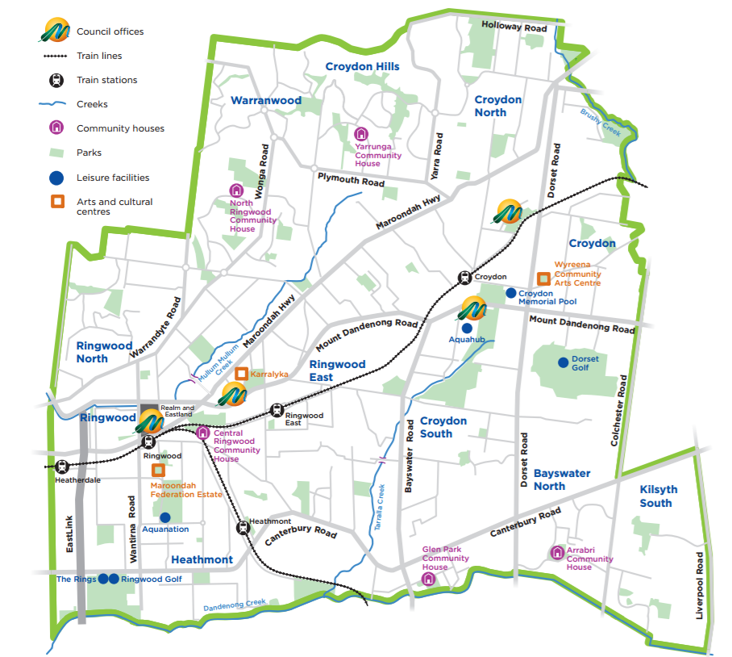

2.2.2 Topography
The City of Maroondah is a predominantly residential area, with some commercial, industrial and semi-rural areas and substantial parklands. Maroondah has the strategic advantage of being located at the north-eastern junction of the Eastern Freeway-East Link corridor. There are two train lines and a large number of bus routes linking the City to other regions. The City of Maroondah covers a land area of 61.4 square kilometres in Melbourne’s outer east, 22 kilometres from the central business district. There are three main waterways that flow through Maroondah - Brushy Creek along the north eastern boundary, Mullum Mullum Creek in the west and Dandenong Creek along the southern boundary.

The City of Maroondah hosts a regional health precinct including a major public hospital and a large private hospital, educational facilities that cater from early childhood learning to tertiary level, two libraries, arts and cultural centres, an art gallery and a range of community centres. Maroondah is also home to a range of world-class sporting facilities including Aquanation, a regional recreation and leisure facility incorporating the State Diving Centre.

Further information can be found on Maroondah’s website.

2.2.3 Demography
The population of Maroondah is 117,498 as at 20 June 2018, an increase of 1,177 persons compared with the previous year. In summary, between 2011 and 2016 census the largest changes in were:
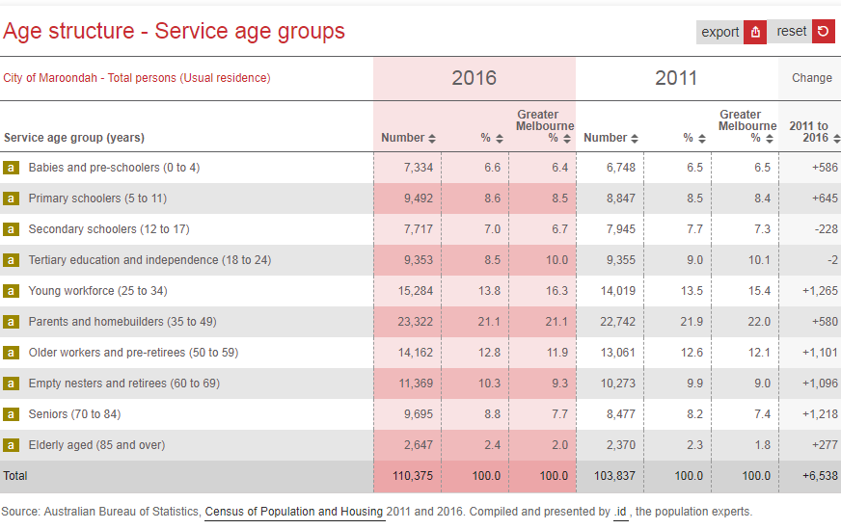

At the time of the 2016 census, the medium age of residents is 38, with 48.4% males and 51.9% females.

Culturally and Linguistically Diverse (CALD) communities.
As the 2016 census, Maroondah has a culturally diverse population with 23.1% overseas born people living in Maroondah born overseas with 17% of our residents speak a language at home other than English.
- 4.9% born in China
- 2.7% born in India
- 1.6% born in Burma
- 1.2% born in New Zealand
- 0.9% born in Malaysia
- 0.7& born in South Africa
- 0.6% born in German and Sri Lanka
- 0.5% born in Netherlands

For further demographic information can be found on Councils website or Profile ID

2.2.4 Vulnerable Persons
Within the Maroondah municipal area there are several vulnerable groups:
- Lower socio economic groups. In 2016, Maroondah scored 1,045 on the SEIFA index of disadvantage.
- Senior citizens and residential care facilities. There are 11 residential aged care facilities and a further 7 supported residential service facilities within the Maroondah municipal area, there are also a number of older person independent living complexes and retirement villages. An emerging trend is for older people to remain living in their own homes and have care services delivered at home.
- Hospitals. There are two hospitals within the Maroondah municipal area, one public (Maroondah Hospital) and one private (Ringwood Private Hospital).
- Children and young people. Nearly 17,000 children in the area are under 11. There are 26 schools in the Maroondah municipal area, both public and private, one specialist school and one tertiary institution.
- Special assistance. In the 2016 census there were 5,482 people with a need for assistance living in Maroondah. These were defined as people who need assistance in their day to day lives with any or all of the following activities; self-care, body movements or communication.

Vulnerable Persons Register (VPR)
The VPR was developed and implemented based on a recommendation from the Black Saturday Bushfire Royal Commission. The VPR is managed by DHHS and hosted in Councils emergency operating system Crisisworks. Residents clients are added or removed from the register based on an assessment by a funded agency. The agency will assess clients based on a defined criteria and add them to the register if eligible. The register is designed to have only the most extreme vulnerable listed so generally each council will have less than 10 people listed. Council acts as the VPR coordinator and manages agency users, not vulnerable people.

During an emergency, the Police have access to the Register and can make a decision as to whether they will try to evacuate a person during an emergency. Each person is advised before being put on the register that there is no guarantee they will be evacuated during an emergency

Vulnerable Facilities List
The Vulnerable Facilities List is maintained by Maroondah City Council and identifies buildings were people are likely to be situated including aged care facilities, hospitals, schools, disability group homes and child care centres. This list is reviewed and updated annually. A copy is kept by Victoria Police and available on Councils emergency operating system Crisisworks and Councils EClip.

2.3 COUNCIL DATA AND INFORMATION
Council has a variety of asset and property information as identified below. The below systems would be used to ascertain critical data in an event of an emergency.

2.3.1 Council Asset Registers (IPS & GIS)
Maroondah City Council uses IPS to record asset related information that Council manages and or owns in a centralised asset register. Council currently records a wide variety of assets inclusive of but not limited to buildings, roads, footpaths, storm water drainage, reserves, parks and road inventory assets of which varying levels of information is recorded such as ownership, maintenance and management responsibilities, dimensions, material and asset descriptions for example.

In addition to the asset registers, Council has spatial representation of these assets as points, lines or polygons depending on the type of asset. This information is available through the corporate GIS viewer IntraMaps which has linkages to IPS to display the respective asset information within this system for the selected asset. Basic asset register information is generally shown in IntraMaps however the user can open the asset in IPS to view additional details as to the condition, inspection records and historic works undertaken against that asset. In an emergency situation IntraMaps and IPS can be accessed remotely via a Citrix connection and utilised on a variety of devices (PC, tablet or mobile). Contact should be made with the Manager Assets to initiate discussion and access to more detailed information as required.

2.3.2 Council Property Registers and Database (Pathway & GIS)
Maroondah City Council uses Pathway to record private assets and property owner information. The database also allows recording of customer service requests property information, revenue, and regulatory management such as planning and building permits. The information is available through the corporate GIS viewer IntraMaps which has link to Pathway to display the property information within this system for the selected property.

In an emergency IntraMaps and Pathway can be accessed remotely via a Citrix connection and utilised on a variety of devices (PC, tablet or mobile). These systems will be used for reconciling emergency impact information and planning for response and recovery, including communicating with those in the affected area.

2.3.3 Drainage Information
In recent times, the City of Maroondah has experienced several intense major storm events, which caused localised flooding in parts of Croydon and Bayswater North. As a result of these significant storms, Council initiated a flood modelling study of the entire municipality. This has been recently completed and with this information, Council has identified where the critical areas of inundation are in Maroondah and where the development of works are needed to address these issues.

2.4 History of Emergencies
Bushfires
Over the years there have been many threats of bushfire to the municipality.

January 1913 - a fire burnt between Warrandyte and Ringwood and several houses were damaged.

1927 - bushfires crossed Maroondah Highway and threatened homes on the southern side of the highway down to the railway line, Croydon.

1962 - fires that circled around Croydon and Ringwood townships. To our knowledge there was no reported damage to buildings during this fire.

November 1967 to March 1968 - there were major fires through the State. Bushfires encircled Croydon and Ringwood.

February 2009 - bushfires impacted many areas of Victoria resulting in many lives lost. Maroondah, though not affected directly by the fires did provide resources to Councils affected.

Storm Events
Typically, the City of Maroondah would expect to be impacted by 2 large storm events per year. These storms generally result in flash flooding, wind and hail damage, and quite often a combination of three. Below is a summary of notable major storms and the resulting impact to the City of Maroondah.

Flooding
1972 - Brushy Creek in Croydon North flooded and it was recorded that during heavy rainfall, water was nearly two feet deep. Council took steps to overcome this problem by effecting major works on the culvert.

1975 - this area was again subject to flooding and Council received a grant for a flood mitigation scheme, which included a nine-foot barrel culvert beneath Maroondah Highway and a retarding basin upstream of the Highway. The problem was alleviated after these works were completed.

November 2004 - storms resulting in major flooding and tree damage to all areas of Maroondah.

1 December 2010, 4 February 2011 and 9 November 2011 - Maroondah experienced significant flash flooding throughout many areas of the municipality. The heaviest impact occurred around Civic Square in Croydon with several properties significantly inundated. Subsequent flood mitigation works in the precinct have provided protection to residential properties from above floor level flooding.

29 December 2016 - A major storm on the afternoon of caused widespread flash flooding through Maroondah and most of metropolitan Melbourne.

Wind/Hail
1982 - an unusual weather pattern caused severe winds and a hailstorm to batter parts of Ringwood, Croydon and Mooroolbark. Extensive damage was caused to property, including damage to Council buildings; private homes, buildings and left many trees uprooted.

1998 - A mini cyclone/windstorm around the Liverpool Road area caused damage to street trees and houses. Damage also included road closures and loss of power to many households in the area.

2 & 3 February 2005 - most of the Melbourne area sustained extensive damage to property and infrastructure as a result of a severe storm with rainfall exceeding 130mm along with strong winds.

27 January 2006 - Maroondah experienced another severe storm, with reports of a mini tornado at Gracedale Park, Ringwood East.

6 & 7 March 2010 - a severe hail event impacted Victoria on causing widespread damage to much of metropolitan Melbourne. As this occurred on Labour Day long-weekend, a large number of people were not home at the time and returned to their properties to find them significantly damaged from not just the hail storm but also the significant rain event that followed the hail.

17 October 2013 - a mini wind storm on caused extensive tree damage and damage to property in parts of Maroondah.

21 August, 2009, 5 February and 5 September 2012, 8 September 2014 - similar storms also occurred.

Heatwaves
27 – 31 January 2009 - The Victorian Heatwave in January 2009 was a period during which the state experienced the most extreme temperatures. Over the 5 days, maximum temperatures were 12 to 15 degrees above normal over much of Victoria with an additional 374 deaths recorded compared to the previous years. During this period, it was necessary for Council to activate the Business Continuity Plans across service delivery areas.

January 2014 - there was 5 consecutive days above 40 degrees resulting in Council activating its heatwave plan and emergency management staff placed on standby for severe fire danger.

PLANNING ARRANGEMENTS

This section details the planning arrangements for the management of emergencies which affect the community of the Maroondah municipal area.

This section identifies specific emergency management roles and responsibilities. All emergency positions and arrangements are put in place to meet the needs of an emergency affected community, with some of these positions required under the Emergency Management Act 1986.

3.1 MUNICIPAL EMERGENCY MANAGEMENT PLANNING COMMITTEE (MEMPC)
This Committee is formed under Section 21 (3) and (4) of the Emergency Management Act 1986, to formulate a plan for the Council’s consideration in relation to the prevention of, response to and the recovery from emergencies within the municipality of Maroondah.

3.1.1 Terms of Reference

The Terms of Reference for the Planning Committee were endorsed by the MEMPC on 15 November 2018. The purpose of the committee is outlined under section 3.1 of this plan. A copy is located in EClip.

3.1.2 Membership of the Committee
The Committee consists of:

Maroondah Council members | Response and recovery agencies/organisations | Local businesses/community representatives
Municipal Emergency Manager (Chairperson) | Victoria Police - Municipal Emergency Response Coordinator (MERC) | Eastlink
Emergency Management Officer | Country Fire Authority(CFA) | Eastland
Municipal Emergency Resource Officer (MERO) | Department Health & Human Services | Eastern FM 98.1
Municipal Fire Prevention Officer (MFPO) | Department of Education and Training | Centrelink
Municipal Recovery Manager (MRM) | Ambulance Victoria | Maroondah Hospital
Communications and Engagement | Victoria State Emergency Service
Risk, Information and Integrity | Red Cross
Community Health | Department of Defence
Community Development | Yarra Valley Water
 | Metro Trains
 | St John Ambulance
 | VicRoads
 | Metropolitan Fire Brigade (MFB)

Membership of the Committee can be reviewed at any MEMPC meeting. New members may be invited dependant on changes in legislation, changes of agency contact person, risk identification or interest from a new agency/ community group.

A full list of MEMPC members can be found within the MEMPC Contact Directory which is an appendix to this plan and available on Councils emergency management operating system Crisisworks.

3.1.3 Meeting frequency
The Maroondah MEMPC meetings are held quarterly (February, May, August and November). Should a significant incident occur within the municipality, the Committee will call an extraordinary meeting to discuss, review and evaluate the response to the event. A risk assessment will be undertaken to review key priorities of emergency management planning. Legislative or policy changes impacting local governments’ response to emergency management operations may also generate the need for an extraordinary meeting. Out of session communication may also be distributed via email.

3.1.4 Special Sub Committees
The MEMPC may form, or contribute to, special sub committees to plan for the management of hazard specific identified risks or functions which require an additional level of planning. Examples of these include: Municipal Fire Management, Flood and Storms, Risk Management and Municipal Relief and Recovery.

3.2 MAINTENANCE OF THE MUNICIPAL EMERGENCY MANAGEMENT PLAN
The content of this Plan is reviewed annually or after an organisational or legislative change or after an emergency on the direction of the Municipal Emergency Manager (MEM). The MEM, with support from the Executive Officer, is responsible for the ongoing maintenance of the plan, the updating of information and the distribution to MEMPC members. The Plan is required to be signed off by the MEMPC after consultation and agreement.

The MEMPC will consider elements of the plan that require testing or exercising annually. This includes conducting one exercise per year which could include participation in regional exercises and when invited, participation in other neighbouring Councils or agency exercises. Any procedural anomalies or shortfalls encountered are addressed and rectified and any changes to the plan are tabled at the MEMPC Committee. All exercise planning and documentation will be recorded and saved into relevant EClip Council files and learnings and improvements shared with EMV - Elearning Lessons Learnt.

3.2.1 Audit
Maroondah City Council pursuant to Part 4, Section 21(a) of the Emergency Management Act 1986 shall submit the MEMP to VicSES for audit. This audit will assess whether the Plan complies with guidelines issued by the VicSES Chief Officer and audit requirements outlined in the EMMV Part 6. The Plan will be submitted for audit at least once every three years. The MEMP provided for audit must be the most recent version endorsed by the MEMPC and adopted by Council. This plan will then be lodged with State Library on the ‘public document register’.

VicSES will formally notify Council in writing of the outcome of the audit and issue a Statement of Audit Certification for inclusion in this Plan.

3.3 Key functional roles
Maroondah City Council is responsible for the provision, management, and coordination of municipal resources in support of the response to and recovery from emergencies. Municipal resources include those owned by Council and those under its control (including contracted resources). Council builds community resilience by supporting the prevention/ mitigation of emergencies as well as ensuring the Council and community are as well prepared for any emergency as possible. Council is also responsible for the coordination of community resources in recovery from emergencies.

Municipal Emergency Resource Officer (MERO)
The MERO is legislated position under the Emergency Management Act 1986. This position is responsible for the coordination of municipal resources including personnel and equipment to be used in emergency response, relief, and recovery operations. This positon is also responsible for authorising relevant expenditure in accordance with Council delegations.

Municipal Recovery Manager (MRM)
The MRM is responsible for ensuring the coordinated allocation of resources and delivery of relief and recovery activities undertaken by Council and relief and recovery agencies in support of impacted individuals and communities. The MRM works closely with the MERO and other agencies in an integrated approach to the resolution of an emergency and its effects on the community. In situations where recovery activities are likely to be extended into the medium and longer term, the MRM may undertake strategic recovery planning to meet the needs of impacted communities in partnership with recovery agencies. The MRM is responsible for. authorising relevant expenditure in accordance with Council delegations

Municipal Emergency Manager (MEM)
The MEM provides a strategic emergency management advice during an incident and ensures Council is responding effectively according to their responsibility. The MEM is also responsible for communication with Council senior management and the Chief Executive Officer with respect to emergency management activities when activated.

Municipal Emergency Response Coordinator (MERC)
The MERC is a legislated position under the Emergency Management Act 2013 and is responsible for the effective coordination of emergency response within the municipality. The role is detailed in EMMV Part 3. In Maroondah the appointed MERC is the Senior Sergeant, Ringwood Police Station.
Municipal Fire Prevention Officer (MFPO)
Maroondah City Council under the CFA Act 1958 and Metropolitan Fire Brigades Act 1958 is required to appoint a MFPO to undertake and regularly review Council’s fire prevention planning and plans. The role will maintain, update and document Councils Fire Hazard Inspection and Enforcement Program and provide regular reporting to the Municipal Emergency Management Planning Committee (MEMPC).
Emergency Management Liaison Officer (EMLO)
Council’s EMLO is a representative of Council that is typically located at the Incident Control Centre (ICC) as part of the Incident Emergency Management Team (IEMT). The primary role of the EMLO is to provide a communication link between key agencies and the Council (MERO and/or MRM). The EMLO must pro-actively seek situational awareness and intelligence to inform relief and recovery requirements, community information, council operations and secondary impact assessment.
Figure 1 show the Councils Operational Management structure

Figure 1: Council Emergency Operational Management structure

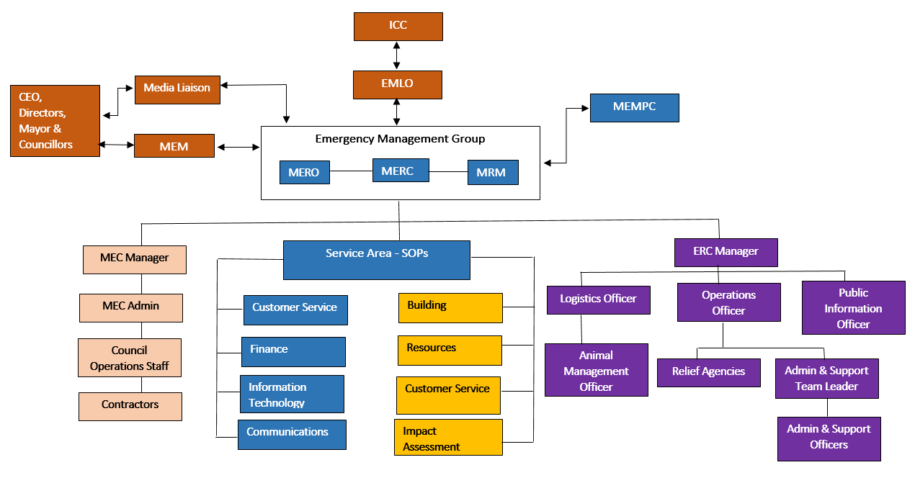

PREVENTION/ MITIGATION ARRANGEMENTS

4.1 BACKGROUND/ INTRODUCTION
Maroondah City Council recognises its key role in prevention and mitigation activities. Council’s policies relating to land management and building codes ensure that all measures are addressed to reduce the likelihood and impact of emergencies.

The Municipal Emergency Management Planning Committee (MEMPC) plays a key role in prevention via the identification of potential hazards and their associated risks and consequences. These identified risks and consequence are then considered and specifically planned for during the development and implementation of plans, policies and procedures.

The ability of a community to respond to an emergency situation and in turn recover from the effects of an emergency will depend greatly on the level of resilience the people affected inherently have. The municipality, through its MEMPC, and its sub-committees, will promote and support appropriate prevention and awareness programs.

Prevention is defined as the development and implementation of strategies and associated measures to reduce the occurrence of and mitigate the consequences of identified emergency risks on the community and environment.

Preparedness focuses on ensuring the risks and management strategies identified in prevention planning are utilised to assist and facilitate the local community to be aware of their risks and the potential consequences of a resulting emergency event, to inform and equip them with tools to implement resilience strategies for their own homes and families.

4.2 RISK ASSESSMENT PROCESS
This Plan identifies and prioritises emergency risks that may potentially affect the Maroondah community and environment. The mitigation and awareness of these risks aims to minimise the effects and consequences of an emergency event on the community.

4.2.1 Community Emergency Risk Assessment (CERA)
The CERA process is designed to systematically identify hazards, determine risks and prioritise actions to reduce the likelihood and effects of an emergency.

A working group of the MEMPC including Council staff and key stakeholders from the major emergency service/support organisations have identified the top eight risks in the municipal area.

The group considered emergency risk within the following context using the International Standard ISO 31000:
- Whole of community perspective
- Responsibility for the whole municipality
- Consideration of events which require multi-agency responses
- Consideration and acknowledgement of existing controls
- Mitigation activities and their effectiveness, and
- Subsequent level of risk.

Risks were assessed and rated according to consequence and likelihood scales and risk matrices in the CERA tool kit. Below is a copy of the Dashboard and Heat map for the CERA.

The 8 highest risks in the municipality area:

- Extreme temperatures - heatwave
- Flood Storm and Extreme Weather
- Bushfire - Large/small
- Road Transport Incident - Large commercial vehicle
- Disturbance, Shooting, Seige
- Service Disruption - Gas and Electricity >12 hours
- Fire - Residential
- Human Epidemic/ Pandemic

A detailed copy of the CERA workbook is available as an appendix to this plan and via Councils emergency management operating system Crisisworks.

4.2.2 CERA Dashboard
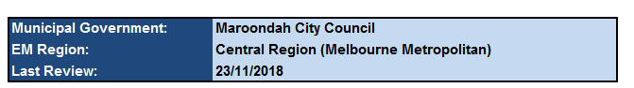

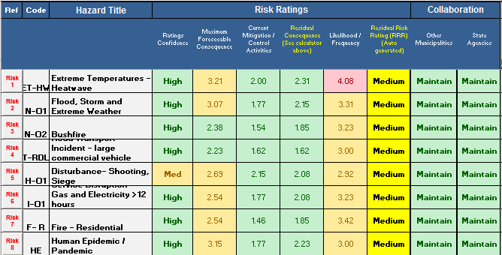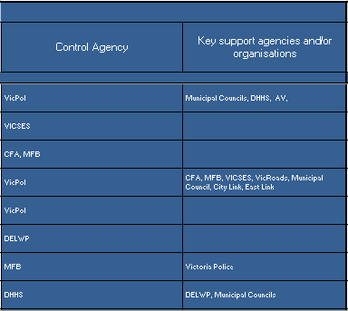

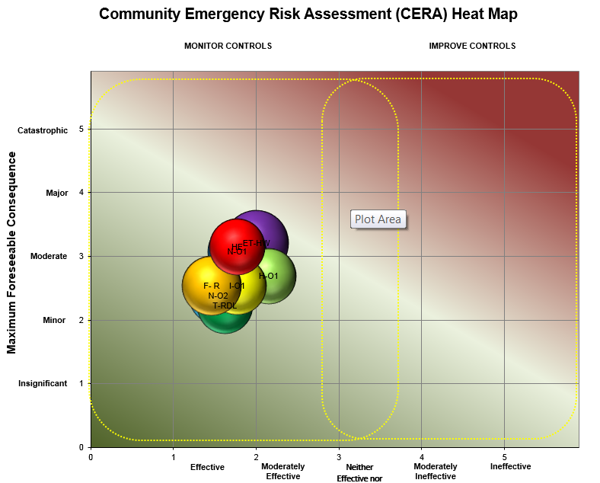
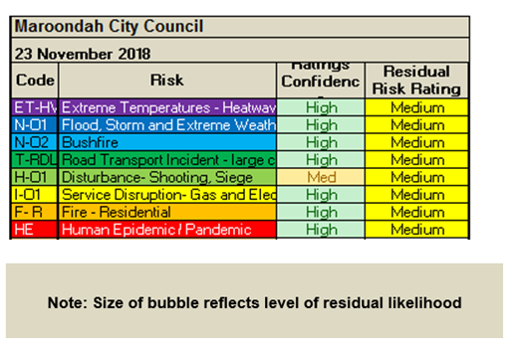

4.3 OPERATIONAL MANAGEMENT OPERATIONS

4.3.1 Sub Plans & Standard Operating Procedures (SOPs)
To ensure appropriate planning and mitigation strategies are in place for the leading risks identified, hazard specific plans have been developed and adopted as sub Plans of this Plan. Additional plans detailing relief and recovery considerations, arrangements and planning have also been developed as sub plans. A number of sub Plans have been written to detail specific emergency arrangements. These plans are available via Councils emergency management operating system Crisisworks, Councils intranet and EClip. The Municipal Fire Management Plan is also available via Councils website and the Flood and Storm Plan is available via the SES website.
Municipal Sub Plans include:
    - Municipal Fire Management Plan
    - Municipal Relief Plan
    - Municipal Recovery Plan
    - Heatwave Plan
    - Influenza Pandemic Plan
    - Flood and Storm Plan
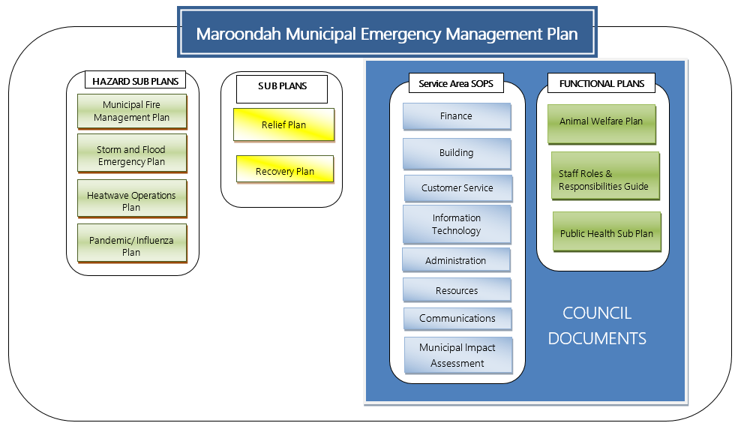
There are currently 8 Service Area Standard Operating Procedures (SOPs) that Maroondah City Council officers use to perform the activities associated with emergency management and an appendix to this plan. These procedures can also be found via EClip or via Councils emergency management operating system Crisisworks
Standard Operating Procedures include:
- Municipal Impact Assessment
      - Administration
      - Building
      - Communications and Engagement
      - Customer Service
      - Finance
      - Information Technology
      - Resources
The maintenance of the sub plans is the responsibility of the MEMPC, Councils Emergency Management Group (EMG) and the maintenance of the SOPs is the responsibility of the Emergency Management Group and various Council departments.

The CERA was conducted in a manner that did not intend to exclude any form of emergency, with the document adopting a flexible "all hazards approach". The MEMPC is responsible for reviewing the CERA process at least once every three years prior to audit.

There have also been a number of regional plans and sub plans developed as part of the Eastern Metro Councils Emergency Management Partnership (EMCEMP). These include:

      - Eastern Metro Emergency Relief Centre sub Plan
      - Eastern Metro Municipal Emergency Coordination sub Plan
      - Eastern Metro Emergency Animal Welfare Plan
      - Eastern Region Extreme Heat Plan
      - Eastern Region lnfluenza Pandemic Plan

These are available via Councils emergency management operating system Crisisworks and Councils Intranet and EClip.

4.4 COMMUNITY AWARENESS
One increasing challenge facing the emergency management sector is balancing community expectation while promoting and building community resilience when dealing with, or preparing for emergencies. Raising awareness within the community about emergency risks and their potential consequences is the responsibility of all agencies including Council. There are a number of strategies used in education, awareness and resilience building programs to ensure a broad spectrum of the community are engaged.

Strategies currently utilised include:
    - Hosting information on public websites
    - Social media
    - Council publications
    - Local newspapers
    - Distribution of brochures/ print media
    - Mail outs
    - Displays at festivals, shopping centres and within the community.

Further information is located in Appendix 8.5 – Communication Plan.

4.5 Climate Change and Emergency Management
Projected changes in the climate include temperature increases on land and at sea, sea-level rise, melting of glaciers and ice caps, and changing and irregular rainfall patterns. These changes affect almost every aspect of human life and the ecosystems on which it depends. Climate change may result in increases in the frequency and intensity of extreme weather events, as well as significant impacts from more gradual changes.

Efforts to reduce the impacts of climate change are known as climate change adaptation. Emergency risk reduction and climate change adaptation share a common space of concern: reducing the vulnerability of communities and achieving sustainable development. Maroondah City Council is currently undertaking Climate change adaptation planning.

To address this Council also adopts an all hazards approach to emergency management in the phases of preparedness, response and recovery through its emergency management plan. This approach is built on a coordinated and cooperative approach both within Council and with emergencies agencies through agreed service provision and planning. This is a holistic approach is based on education, planning, risk management and response capabilities to ensure that Maroondah City Council has the process, resources and capabilities to be able to respond to and recover from scalable extreme weather events.

4.6 Business Continuity Planning
Business continuity planning (BCP) forms part of Maroondah City Councils broader resilience approach, it incorporates the foundations of risk management and compliments planning for emergencies, evacuation and crisis.
Maroondah City Council Business Continuity Plan (BCP) is a collection of policies, procedure, protocols and information that has been developed, compiled and maintained in readiness for a business disruption. Our BCP outlines the steps we will take to quickly resume service delivery or how we will prioritise service delivery options in the response and recovery phases on an emergency. It also allows Council to proactively and formally address a number of “what if” scenarios whilst being able to have a plan on how we will continue to operate during and after emergencies.

4.7 EMERGENCY SUPPORT STAFF
In most emergencies, there will be a need to recruit personnel to support the activities of Council and other agencies. In the first instance appropriate staff will be sourced from within Council. Maroondah has a comprehensive list of trained staff that do not have a substantive position in emergency management, who have offered their skills to support Council in emergencies. Maroondah is also a signatory to the Eastern Metro Councils Emergency Management Partnership (EMCEMP) MOU enabling the capabilities of parties to plan and prepare together and share resources as well as a signatory to the MAV Protocol for inter-Council emergency management resource sharing protocol.

4.8 EMERGENCY EXERCISING
Maroondah identifies the need to be an active member in emergency management within the municipal, emergency management and local community environments. Maroondah is actively involved in a number of areas to test preparedness and to assist in creating community resilience to emergency situations.

Maroondah is an active member of the Eastern Metro Councils Emergency Management Partnership (EMCEMP) and participates in the annual Regional Emergency Exercise East. Maroondah also participates in other multi-agency events and exercises.

The Exercise Record in located in Part 7.4 of this plan.

RESPONSE ARRANGEMENTS

5.1 Introduction
Emergency response is the action taken immediately before, during and in the first period after an emergency to reduce the effect and consequences of emergencies on people, their livelihoods and wellbeing, property and the environment and to meet basic human needs. This includes the provision for requests for physical assistance from regional, state and commonwealth levels of government when municipal resources are exhausted. EMMV Part 3 outlines the State level arrangements for response in Victoria.

Emergency response operations are managed via three operational tiers which include state, regional and incident levels. Emergency response management is based on the functions of coordination, control command, and more recently consequence, communication and community connection (known as the six c’s).

5.1.1 Definitions of Emergencies
Emergencies are classified into three classes according to the Emergency Management Manual Victoria (EMMV).

“Class 1 emergency” means a major fire or any other major emergency for which the Metropolitan Fire and Emergency Services Board (MFB), the Country Fire Authority (CFA) or the Victoria State Emergency Service Authority (SES) is the control agency under the state emergency response plan.

“Class 2 emergency” means a major emergency which is not a Class 1 emergency or a warlike act or act of terrorism, whether directed at Victoria or as part of any other state or territory or Commonwealth, or a hi-jack or riot.

“Class 3 emergency” (also known as security emergencies) are classified as a warlike act or act of terrorism, where directed at Victoria or any other State or Territory or the Commonwealth or a hi-jack, siege or riot.

5.2 Command, Control Coordination, Consequence, Communication and Community Connection

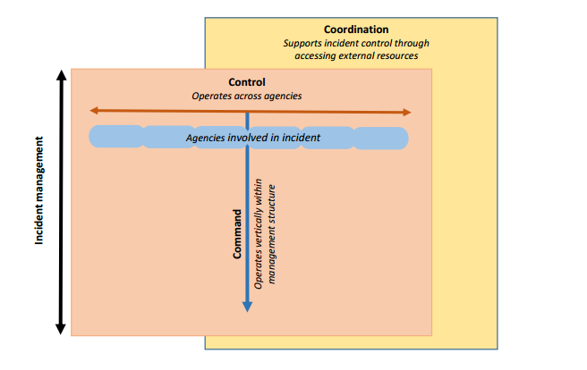

Figure 2 – Victoria’s Emergency Management Arrangements, demonstrating Command, Control and Coordination and the Emergency Management Team

Victoria bases its emergency response arrangement on the management functions of control, command, coordination, consequence and community connection, broadly described as follows:

5.2.1 Command
Commands the internal direction of personnel and resources of an agency, operating vertically within the agency. Each agency has a ‘chain of command which is the agency’s organisational hierarchy that identifies the link between each individual and their supervisor.

5.2.2 Control
Control is the overall direction of response activities in an emergency, operating horizontally across agencies. In Victoria, authority for control is established in the EMMV Part 3 State Emergency Response Plan with the agency responsible for control of emergency response (known as the ‘Control Agency’) being specified in EMMV Part 7 – Emergency Agency Roles.

5.2.3 Coordination
Coordination is the bringing together of agencies and resources to ensure effective response to and recover from emergencies.

Emergency response coordinators bring together agencies and resources to support the response to emergencies.

Emergency recovery coordinators/managers bring together agencies and resources to support the provision of relief and recovery from emergencies.

5.2.4 Consequence
Consequence management involves the coordination of the activities of the agencies with a role in delivering of services to the community, with the aim of minimising the adverse consequences of emergencies on the community. During a major emergency, all agencies may need to activate their business continuity arrangements to manage the adverse consequences of the emergency on their area of responsibility.

Consequence management informs and is the precursor to relief and recovery activities. The Emergency Management Commission is responsible for consequence management for major emergencies but will be supported by the relevant Control Agency.

5.2.5 Communication
Communication relates to communicating to the public, reporting to government and communicating with stakeholder agencies during emergencies. The Emergency Management Commission is responsible for the communication function for major emergencies but will be supported by the relevant Control Agency.

5.2.6 Community Connection
Safer and more resilient communities are always the aim of any emergency management planning. Community connection is around the understanding of and connecting with trusted networks, trusted leaders an all municipal communities to support resilience and decision making

5.2.7 Emergency Management Teams
The three tiers of control, scalable as required from incident through to regional and onto state support of the six C’s of Coordination, Control, Command, Consequence, Communication and Community Connections.

The EMMV Part 3 details the three tiers of emergency events and the required associated activation levels. The priorities are, but not limited to:
- Protection and preservation of life is paramount − this includes:
  - Safety of emergency services personnel; and
  - Safety of community members, including vulnerable community members and visitors/tourists located within the incident area
- Issuing of community information and community warnings detailing incident information that is timely, relevant and tailored to assist community members make informed decisions about their safety
- Protection of critical infrastructure and community assets that support community resilience
- Protection of residential property as a place of primary residence
- Protection of assets supporting individual livelihoods and economic production that supports individual and community financial sustainability
- Protection of environmental and conservation assets that considers the cultural, biodiversity and social values of the environment

Response agencies may formulate a strategic statement of intent based on the control priorities and local factors

Incident Emergency Management Team (IEMT)
The IEMT supports the incident controller. Their focus is on managing the effect and consequences of the emergency. Council may assign an EMLO to assist the Incident Controller as a member of the IEMT.

Regional Emergency Management Team (REMT)
The REMT supports the RERC and those exercising control at a regional level (Regional Controllers). Their focus is to raise awareness of the emergency across the whole of government, identify and manage strategic tasks and consequences and develop a regional strategic plan outlining high level actions of all agencies. The Eastern Region assigns a Local Government REMT Representative who acts on behalf of all Councils in the Eastern Region to assist the Regional Controller as a member of the REMT. Maroondah Council provides officers to perform the REMT Representative role on an agreed roster basis.

State Emergency Management Team (SEMT)
The SEMT is usually located at the State Control Centre or other location determined by the control agency.

If an emergency requires activation of the state tier response the SEMT is formed comprising of representatives from response, recovery, support agencies and departments. The role of the SEMT is to develop consistent situational awareness, identify strategic state risks and consequences and to develop a strategic plan with high level of all agency actions.

5.3 Emergency Management Group (EMG) activation
Maroondah City Council accepts responsibility for management of municipal resources and the coordination of community support to counter the effects of an emergency during both the response to and recovery from emergencies. To carry out these management functions, Maroondah City Council will form an Emergency Management Group.

This group may consist of:
- Municipal Emergency Manager (MEM)
- Municipal Emergency Resource Officer (MERO)
- Municipal Recovery Manager (MRM)
- Municipal Emergency Management Officer
- Chief Executive Officer (CEO)
- Municipal Emergency Response Coordinator (MERC)
- Service Area Standard Operating Procedures Leaders
- Environmental Health Officer (EHO)
- Agency representatives and others co-opted as required

The emergency management group or part thereof will convene when the scale of the emergency dictates the requirement for the provision of any of the functions outlined above. Members of the emergency management group will liaise to determine what level of activation is required such as Alert, Standby, Action and Standown. Where appropriate, the functions of the emergency management group will be carried out in consultation with:
- The MERC, with respect to the coordination and provision of resources.
- The relevant Control Agency.

5.4 LOCAL RESPONSE ARRANGEMENTS AND RESPONSIBLE AGENCIES
EMMV Part 7 details a ‘control agency’ and ‘support agencies’ for a range of emergencies. It is the control agencies responsibility to plan for the relevant emergency and ensure that adequate resources are in place. Maroondah Council is not a control agency but is a support agency for a range of emergencies.

Where there is any doubt as to who is the control agency, the Emergency Management Commissioner, RERC, MERC or Incident Emergency Response Coordinator (IERC) will determine who will exercise control.

Local Incident Response is coordinated at a municipal level by the MERO. The request usually comes from the coordinator of the response agency who is at the incident. The MERO attends to the requests received. The MERO may direct and authorise the use of physical resources in response to the local incident. Following the direction of the incident controller, the MERO may direct the establishment of a MECC or a municipal relief centre to be placed on standby. The escalation of Council’s response is to advise the MRM.

The objective of the response phase of this plan is to minimise the effects of an emergency on affected persons and property within the Maroondah municipality. This is achieved by coordinating municipal resources to assist responding emergency service authorities, and in providing community support, as requested, or as the situation requires.

The basic functions at a local level can include all or any of the following:
- Provision of resources as available and needed by the community and response agencies.
- Establishment of Municipal Emergency Coordination – facilities and staffing.
- Under the direction of the control agency facilitate the delivery of warnings to the community.
- Guided by the control agency provision of information to public and media.
- Coordination of the provision and operation of emergency relief centres and emergency shelters.
- Clearance of blocked drains and reinstatement of local roads, including tree removal and other physical works as deemed appropriate and where possible.
- Support to Victoria Police for partial/full road closures and determination of alternative routes.
- Repairing or replacing damaged public utilities, services and assets.

5.5 Process for sourCIng additional resources
Where additional resources are beyond the original control agency, the Incident Controller should:
- Seek response agency resources directly through the response agency commanders.
- Seek supplementary resources, other than those of the responding agencies, through the Incident Emergency Response Coordinator (IERC) or MERC.
- Seek relief or recovery resources through the Municipal Recovery Manager, ensuring the IERC or MERC is aware of the request.

Following a request:
- The IERC or MERC will seek resources within the local area (through the MECC) and the MERC will escalate unfulfilled resource requests to the RERC.
- Regional Emergency Response Coordinator (RERCs) will seek resources within their region and escalate unfulfilled resource requests to the Emergency Management Commissioner.
- The Emergency Management Commissioner will seek resources from across the state, interstate or internationally, where necessary.

Depending on the scale of the incident the MECC may be requested to be established by the IERC or MERC in consultation with the MERO, MRM or MEM.

Maroondah City Council is a signatory to the MAV Protocol for Inter-Council Emergency Management Resource Sharing.

5.6 MUNICIPAL EMERGENCY COORDINATION ACTIVATION PROCEDURE
In the first instance, the control agency will notify the MERC that there is a requirement for additional resources. The MERC will contact Council (MEM, MERO or MRM). At the municipal level, resources owned or under the control of Council may be used to supplement those of the control and support agencies.

Maroondah Council’s 24-hour number 1300 882 233 also provides access to the Councils Emergency Management duty officers to initiate MEMP response arrangements as required. The activation level is dependent upon the scale of the emergency and is determined by the (MERC, MEM, MERO or MRM).

5.6.1 Level 1 - Small scale incidents (less than 24hr impact)
A small scale emergency that can be resolved through the use of local or initial response resources. The MECC might not necessarily be activated with the MERC and MERO in close communication at all times. Consequently the MERC and MERO will undertake the planning and logistics functions concurrently and will activate the MRM as required to provide relief and recovery support if required (virtual MECC). They will also monitor the emergency and its impact on the area, the community, the weather, and other elements/variables that might lead to a higher level of activation.

5.6.2 Level 2 - Medium scale incident
A medium scale emergency is more complex in size, resources or risk. The MECC will be activated with the function being the deployment of resources beyond initial response, and multi-agency representation in the MECC. The emergency may potentially require forward planning to address response issues, and for recovery during the response phase.

5.6.3 Level 3 - Large scale event
A large scale emergency is characterised by levels of complexity that require the activation and establishment of all municipal emergency coordination functions plus an Emergency Call Centre (if required). This level of emergency will require forward planning as the emergency continues and will specifically require recovery planning during the early stages of the response phase of the emergency.

These descriptions are in line with the Australasian Inter Service Incident Management System (AlIMs) Classification of incidents. Further information on accessing supplementary supplies can found in Practice Note - Sourcing Supplementary Emergency Response Resources from Municipal Councils.

5.7 Municipal Emergency Coordination Centre
The purpose of the MECC is to provide a location for the coordination of Council and community resources in support of the response to emergencies. It is not the control centre for an emergency. An Incident Control Centre may be established by the control agency if the emergency is significant enough to warrant it.
The MECC will be activated only to the level of activity necessary in providing support to the emergency. In minor events this might involve only a few staff, through to a major emergency requiring significant resources over a long period.
The function of municipal emergency coordination for Council can be undertaken easily from a variety of locations which provide flexible options including operating on site or at ICC if required.

5.7.1 Council resources list
A list of resources owned by Council is located in the Operations Standard Operating Procedure (SOP) which is an Appendix to this plan. This list also includes a range of contractors where non-Council owned resources can be obtained.

5.7.2 Crisisworks
With the introduction of new mobile technology and Crisisworks the function of emergency coordination for municipal Councils can be undertaken easily from a variety of locations which provides flexible options including operating on site or at RCC or ICC if required.

Crisisworks is used to record the following information and can be used by Council and Agency staff:
- Communications between agencies in the ICC, MECC and ERC
- Requests for assistance
- A full account of assigned tasks given to Council and agencies
- Telephone logs
- Emergency management documentation

5.7.3 Staging Area/ Marshalling Point
This is a strategically place area where support response personnel, vehicles and other equipment can be held in readiness for use during an emergency. This is predominately managed by Victoria Police but may be shared with other agencies. Maroondah’s pre planning marshalling point is located at Quambee Reserve, Wonga Road, Ringwood North.

5.8 Incident control centres
The Control Agency Incident Controller will establish an Incident Control Centre (ICC) from which to initiate incident response command and control functions. The decision as to if and when the ICC should be activated rests with the Control Agency. Pre-determined Incident Control Centre locations are:
- Sunshine
- Dandenong
- Ferntree Gully
- Woori Yallock

Maroondah will provide and Emergency Management Liaison Officer (EMLO) as required as well as other staff and/ or resources identified as being necessary within the capacity of the organisation.

5.9 FINANCIAL CONSIDERATIONS
Financial accounting for Municipal resources utilised in emergencies must be authorised by the MEM, MERO or the MRM and shall be in accordance with the normal financial arrangements of Maroondah City Council.

A requesting agency will be responsible for all associated costs for the provision of resources to support the response to an emergency event. Council is able to keep track of resources distributed by recording their provision in Councils emergency management operating system Crisisworks.

Municipal Councils are responsible for the cost of emergency relief services and provisions however depending on the magnitude of the emergency some financial assistance may be available for prevention, response or recovery activities. For further information, see refer to the Finance Standard Operating Procedure (SOP), an appendix of this Plan.

5.10 EVACUATION
Evacuation is the planned relocation of persons from dangerous or potentially dangerous areas to safer areas and their eventual return. The decision to evacuate rests with the control agency in conjunction with police and available expert advice, unless time constraints prevent this consultation. Evacuation may be undertaken by individuals, families and households on their own volition and independent of any advice, or it may be after an assessment of information provided by a Control agency.

Examples of events that may require immediate evacuation include fire, floods, hazardous materials accidents/incidents, air crash or earthquake. In some life threatening circumstances, and in an effort to preserve life, this decision to evacuate may be made by any agency representative and in these circumstances, the Incident Controller must be notified of this decision as soon as possible. Once the decision to evacuate has been made the MERC the Council representatives (MEM, MERO and MRM) should be contacted to assist.

The MERO/MRM will assist the MERC by:
- Arranging a suitable assembly area if the pre-determined locations are not appropriate
- Providing transport resources and the determination of the location to which evacuees will be asked to attend.
- Establishing and activating emergency relief centres - including consideration of which location is the most appropriate in the circumstances
- Providing advice on local area information to assist with the traffic flow of evacuated persons out of the area and emergency services into the area.
- Providing vulnerable person/facility information and advice for relocation and other relief services.

In Victoria evacuation is largely voluntary. The Incident Controller makes a recommendation to evacuate and it is the choice of individuals as to how they respond to this recommendation. However in particular circumstances legislation provides some emergency service personnel with authority to remove people from areas or prohibit their entry.

Emergency Management Act 1986 Section 36A makes provision for the declaration by Police of an emergency area if normal community activities and freedom of movement must be restricted because of the size, nature or location of an emergency, and when the extreme powers available under a declared state of disaster are not needed or would take too long to implement. People and vehicles may be prevented from remaining in or entering the emergency area. This power is limited when a person claims pecuniary interest in a property or goods or valuables in a property within the emergency area. If the person claiming pecuniary interest is not on that property, they can be directed to leave or prevented from entering the emergency area if they are located on the property then they cannot be required to leave.

By exception, the Terrorism (Community Protection) Act 2003 (Sections 16, 18 & 21) provides that a senior officer of Police, if suspecting that an area has, or people in that area may have been exposed to such contamination by a terrorist act, may authorise a member of the force to direct a person or groups of persons to enter, not to enter, or to leave, any particular premises or area. Police may use reasonable and necessary force to ensure compliance with any authorised direction.

When the possibility of an evacuation is being considered, Victoria Police will identify a member to take the role of Evacuation Manager (EMMV Part 8 Appendix 9 Evacuation Guidelines). The Evacuation Manager should be co-located with the Incident Controller at the ICC, or if no ICC exists, at the location where control is exercised.

5.10.1 Traffic Management
Victoria Police are also the agency responsible for coordination of traffic management during times of emergency and will coordinate local resources as required during an emergency event to manage traffic in the affected area(s).

5.11 PUBLIC INFORMATION AND WARNINGS
Emergency warning systems have been established to warn individuals and communities in the event of a major emergency. Although these systems aim to improve the ability to warn communities about emergencies, individuals and communities still need to prepare themselves in case of an emergency.

It is important to ensure that public information and warnings are maintained at an optimum level for specific circumstances where community action is necessary, primarily to protect lives, and also for the protection of property and environment. The localised arrangements for warnings and information come from the State Emergency Response Plan.

The Incident Controller is responsible for issuing warnings and community information. Where an extreme and imminent threat to life exists and authorisation from the Incident Controller is not practicable in the circumstances, warnings may be issued by any response agency personnel with notification to the Incident Controller as soon as possible.

Methods of dissemination
All methods of dissemination information will be considered but are not limited to:
  - Vic Emergency website and hotline
  - Emergency service organisation websites
  - Radio and television
  - Councils website
  - Voice and SMS phone messaging through the use of Emergency Alert (EA)
  - Emails
  - Verbal messages
  - Social media and/or social networking web sites
  - Public meetings/door knocks.

The Regional Municipal Emergency Coordination sub plan outlines the roles and accountability in the municipal context. A copy of this sub plan is available on Councils emergency management operating system Crisisworks and Councils intranet and EClip.

Further information can be found within Communications and Engagement SOP, an appendix to this plan.

5.11.1 Warnings
Warnings should be used under specific circumstances where community action is necessary primarily to protect lives, and also for the protection of property or the environment. The warning arrangements are set out in the EMV Victorian Warning Protocol.

Sections 42 and 43 of the Emergency Management Act 2013 provide for warnings and information in relation to fires in Victoria. The provision of these warnings and information must be consistent with any guidelines, procedures and protocols developed by the Emergency Management Commissioner.

For all other emergencies the control agency should issue warnings and provide information to the community.

5.11.2 Community Information
Maroondah City Council has a range of activities and publications that have been designed and put in place to promote and support community awareness. Maroondah City Council is a NO BURN area. Burning however can be conducted with a permit, which is available from Resident Services.

Fire Danger Period Advisory Signs: These signs are placed generally on the boundaries of the municipality and at other strategic locations. These signs are provided by Council to inform the general community of the declared ‘Fire Danger Period’ and resultant restrictions on the use of fire throughout the area. These signs are erected on the advice of the CFA.

Information Signs: These signs have been installed at the same locations as the fire danger signs to assist residents in identifying which radio station to tune to for emergency information.

An emergency management Communication Plan has been developed by Communications and Engagement in consultation with relevant Council officers. A copy is located in Appendix 8.5 of this plan.

5.11.3 Community Information Guides
Community Information Guides are produced by the CFA and provide community information, township factors and fire prevention information to the emergency services and the community for townships where bushfire has the potential to impact. These guides address the specific needs of the town’s residents, property, assets, environment and economy. Guides for Maroondah for the suburbs of the greater Warrandyte area (including Croydon Hills, Croydon North and Wonga Park) have been developed. Guides are available at:
http://www.cfa.vic.gov.au/plan-prepare/community-information-guides/

5.11.4 Local Flood Guides
Local Flood Guides are produced by VicSES to provide the local community with information on local flood risks, warning systems, preparatory advice, recovery information and general contact information to obtain further information relating to local flood and storm risks. The Maroondah Local Flood Guide provides this information for identified risk areas including the locations of Bayswater North, Croydon, Kilsyth South, Croydon, Ringwood, Ringwood East and Heathmont. This guide is available at
https://www.ses.vic.gov.au/get-ready/your-local-flood-information/maroondah-city-council

5.12 Neighbourhood Safer PLACES and fire refuges
Neighborhood safer places (NSPs) and community fire refuges can be provided for community as last resort survival options. They do not replace having a well thought out and practiced survival plan.

Based on the relatively low risk of bushfire and following recommendation from the MEMPC, Maroondah’s municipal area does not have any designated Neighbourhood Safer Places or fire refuges.

5.13 Planning for cross boundary events
Planning for both response and recovery at the regional level is always necessary as emergencies respect no boundaries and will often traverse multiple municipal boundaries. Further, planning for cross boundary events is necessary as often services provided by State government agencies are administered and delivered at a regional level.

Maroondah has participated in a number of cross Council, multi-agency training exercises to better prepare for emergencies which have the potential to affect numerous Council boundaries. Maroondah is a member of the Eastern Metropolitan Councils Emergency Management Partnership (EMCEMP) and is represented on a number of regional working groups helping to build regional relationships and support to strengthen Council’s ability to support each other in emergencies.

5.14 inter council resource sharing
Maroondah City Council is a signatory to the ‘Protocol for Inter-Council Emergency Management Resource Sharing’ coordinated by the Municipal Association of Victoria (MAV). The Protocol provides an agreed position between Councils for the provision of inter-Council assistance for response and recovery activities during an emergency. A copy of the Protocol is located at www.mav.asn.au/policy-services/emergency-management/Pages/resource-sharing-protocol.aspx. This Protocol is most commonly enacted for emergency support staff requests to fulfill MECC and ERC shifts. Requests for resources from another Council should be made through the CEO or nominated person from Councils Emergency Management Group.

5.15 REGIONAL COLLABORATION
Representatives from Councils Emergency Management Unit as well as MRMs and MEROs sit on a number of regional collaboration committees. Membership and participation on these committees allows for relationship building and sharing of documentation and ideas which will benefit emergency management is conducted at Council. Council commonly collaborates with Emergency Management Victoria (EMV), Municipal Association Victoria (MAV), Local Government Victoria (LGV) and emergency service agencies.

Council Officers are involved with the following committees:
- Municipal Emergency Management Enhancement Group (MEMEG)
- Regional Emergency Management Planning Committee
- Eastern Metropolitan Regional Strategic Fire Management Planning Committee
- Working Groups/Committees as required to represent the Eastern Metro Councils Emergency Management Partnership (EMCEMP)

5.16 Regional Emergency Management Team (REMT)

The Eastern Metropolitan Councils Emergency Management Partnership (EMCEMP) has an REMT Local Government Area (LGA) representative roster arrangement in place that operates all year. All member Councils have nominated representatives on the roster that includes MRM’s, MERO’s, Emergency Management Coordinators and other emergency management related staff.

The REMT roster operates on a monthly rotation throughout the year and changes over to a weekly rotation from December to April inclusive to largely coincide with the CFA declared Fire Danger Period (FDP).

The representative (on roster) is responsible for representing local government responsibilities and the EMCEMP arrangements to deliver on those responsibilities on behalf of all the partner Councils. This assists all member Councils to contribute to the situational overview, provide intelligence that informs regional control strategies and the regional strategic plan and allows for early pre-positioning so the (EMCEMP) partners are ready to help when called upon.

During times of readiness the REMT representative will receive emails and SMS relating to regional control arrangements and municipal level status reports. The REMT representative will send to all member Councils all predictions/forecasts and other information provided/requested to be distributed by the Regional Commander/ Controller.

During an emergency event, the REMT representative will receive updates from regional control via email and/or SMS, MEC situation reports and other event related documentation/updates. This information will be forwarded to all member Councils to inform their readiness and/or response and relief activities. This information will reference minutes of REMT teleconferences, predictions/forecasts, regional plans, and situation reports and may also require phone calls to affected councils to gather intelligence and inform situational awareness for the region.

5.17. Debriefing Arrangements
For local level emergencies, the MERC is responsible for ensuring the control agency for the emergency organises an operational debrief with participating agencies as soon as practicable after the cessation of response activities. The aim of the debrief is to assess the adequacy of the response activities and recommend any changes to relevant agency plan(s) and future operational response activities. The Regional Emergency Response Coordinator (RERC) holds these responsibilities for regional level events, which must include local response agency participation.

Where MECC has been activated during an emergency all emergency support staff that undertook their allocated MECC roles will be debriefed by the MERO as soon as practicable following the cessation of MECC operations. The debrief will be delivered with an aim to assess the adequacy of the MECC operations and to identify and make recommendations to future planning and operations relation to the MECC. Psychological debriefing will also be made available as required.

Where an Incident Control Centre has been activated and is represented by a council Emergency Management Liaison Officer (EMLO) this role participates in debrief organised by the control agency.

5.18 Response/recovery transition
Transition requirements to effectively transfer control and coordination responsibilities from response agencies to relief/recovery agencies is required for all major incidents (Class 1 and 2) and may also be required for local level incidents that have resulted in significant impacts on the local community requiring continued provision of relief and/or recovery services.
The MERO, MRM and MERC will start planning for the transition from response to relief / recovery, as soon as possible following the initial impact of an emergency.
Relief typically commences at the same time as response activities, and therefore formalised transition from the response (during) phase to relief and recovery (after) is deemed to be at the point when the control activities associated with the emergency have ceased and the provision for relief and/or early recovery services continue to be required by the affected community.
A number of considerations that informed the timing of transition of coordination from response (during) to relief and recovery (after) include:
- The scale, complexity and capacity and the level recovery requires coordination.
- The nature of the emergency and what specialist resources are required.
- Whether a recurring threat is likely to occur compounding the impact on the community.
- The extent of the impact on communities, as this may determine the length of the transition period.
- The level of loss/damage and the extent to which this has been validated (the stage of impact assessment reached e.g. if phasing into secondary/post impact stages may indicate transition requirements).
- The extent to which the community required emergency relief services.
- The resources required for the activation of recovery arrangements; and
- When requested, a transition agreement will be developed at the appropriate level between the response agency Incident Controller, MERC, MERO, MRM and the recovery agency coordinator (typically DHHS).

RELIEF AND RECOVERY ARRANGEMENTS

6.1 INTRODUCTION
Relief is the provision of essential needs to individuals, families and communities in the immediate aftermath of an emergency. Relief services could be provided at the site of an emergency, a dedicated relief centre, places of community gathering, isolated communities, transit sites or other safe locations as appropriate. Relief is the first stage of recovery and must be seamlessly integrated with all other early recovery activities.

Recovery is assisting individuals and communities affected by emergencies to achieve an effective level of functioning. Recovery planning must ensure that there is a clear understanding of the community context (prior to the emergency) and is based on continuing assessment of impacts and needs.

The provision of relief and early recovery services occurs at the same time as the response to an emergency event.

6.2 Municipal relief arrangements
Emergency relief is the provision of immediate shelter, life support, and personal needs of people affected by, or responding to an emergency. It includes the establishment, management and provision of services to emergency relief/recovery centres.

Council is responsible for the local relief arrangements such as the establishment and management of emergency relief centres. The MRM is responsible for the coordination of relief and recovery services for the affected community. Further details relating specifically to the delivery of relief services are located in the Regional ERC Sub Plan. This document is available on Councils Intranet and Councils emergency management operating system Crisisworks and EClip.

6.2.1 Management structure
A request may come from an Incident Controller to open an Emergency Relief Centre (ERC) to support an emergency, the selection of an ERC will be determined by the Municipal Emergency Resource Officer (MERO), in consultation with the Municipal Emergency Response Coordinator (MERC) and the Municipal Recovery Manager (MRM).

6.2.2 Emergency Relief Centre (ERC) activation and Operations
An ERC is a building or place established to provide (temporary) support and essential needs to persons affected by or involved in the management of an emergency. The Centre will provide for basic needs only including shelter, food and water. Emergency relief agencies may also set up at the centre to provide emergency affected people with grants, material aid, Register Find Reunite, first aid, accommodation, and psychosocial support. Further details on the roles and responsibilities of government and community organisations involved in the provision of relief services are detailed in the Regional ERC Sub Plan Councils Intranet and Councils emergency management operating system Crisisworks and EClip.

The ERC is managed by a range of trained ERC staff and supported by Council’s emergency support staff as required. Maroondah City Council is a member of the Eastern Metropolitan Councils Emergency Management Partnership (EMCEMP) and has arrangements in place for trained staff to support the operation of ERC services when local resources are overwhelmed. There may be occasions when Maroondah will set up a relief centre, locally in support of an emergency in another Council.

Maroondah City Council has 2 ERC’s, (listed below) details of these Centre’s including roles and responsibilities, standby arrangements, activation, set up and deactivation, copies of Facility Plans including traffic management plans are available on Councils EClip and Councils Intranet and Councils emergency management operating system Crisisworks.

No | Location | Melways
1 | The Rings | 63 F1
2 | Karralyka Centre | 50 A6

6.2.3 Escalation and Regional Capacity Arrangements

Relief coordination is escalated from local to regional level:
- When requested, because capacity is or will be exceeded;
- Where an emergency has affected multiple municipalities within the region;
- The emergency is expected to run beyond known local government capacity;
- Complex needs of the community e.g. cultural needs, vulnerable groups; exceed the capacity of local arrangements, infrastructure or utilities lost at a significant scale; and
- Forward planned shifts for ERC operations are not able to be filed by locally available resources.

The above triggers will be monitored and considered by the MRM in consultation with DHHS and other relief organisations throughout. Escalation to regional capacity arrangements will be activated by the MRM via advice to both DHHS and the Regional Emergency Management Team representative for the Eastern Region Collaboration. The Regional Recovery Coordinator will consider the relevant components of the EMR Regional Relief and Recovery Plan in addition to this plan, during discussions with the MRM. Additional information can also be found in the Regional ERC Sub Plan available on Councils Intranet and Councils emergency management operating system Crisisworks and EClip.

There are arrangements in place to supplement municipal resources during the relief phase of an emergency. A Memorandum of Understanding exists between the Eastern Metropolitan Councils Emergency Management Partnership (EMCEMP) to support the medium to longer term delivery of emergency relief services when an emergency is affected one or more of the eastern region Councils.

DHHS coordinates a range of assistance available from the Victorian Government and the not-for-profit sector. In the event of an emergency, support and assistance is available to affected people, households, businesses and community organisations.

This support includes:
- Coordination of interim accommodation provision.
- Financial support (through provision of Personal Hardship Assistance Program) and material aid.
- Environmental health and wellbeing advice (Department of Health).
- Provide resource support to local relief and recovery efforts when requested

6.2.4 Stand Down and Debriefing of ERC Operations
For local level emergencies, the MRM in conjunction with DHHS is responsible for ensuring an operational debrief with participating agencies occurs as soon as practicable after the cessation of relief activities. The aim of the debrief is to assess the adequacy of the relief activities and recommend any changes to relevant agency plan(s) and future relief service provision activities. DHHS holds these responsibilities for regional level events, which must include local relief agency participation and coordination with the MRM.

Where an ERC has been activated, all emergency support staff that undertook their allocated ERC role will be debriefed as soon as practicable following the cessation of ERC operations. This debrief will be delivered with an aim to assess the adequacy of the ERC operations and to identify and make recommendations for future planning and operations related to the ERC.

6.3 Municipal Recovery Arrangements
Section 46 of the Emergency Management Act 2013 appoints the Emergency Management Commissioner with the responsibility for the coordination of agencies in line with the State Emergency Relief and Recovery Plan. Municipal Councils take the lead in delivering on the ground relief and recovery services, because they are closest to an affected community. The Victorian government supports municipalities to fulfil these local responsibilities.
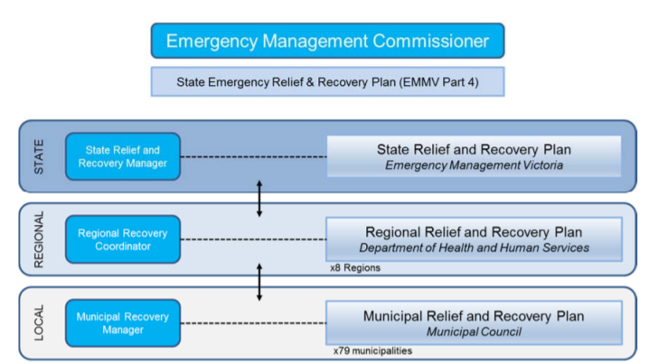

Figure 3 describes the 3 levels of relief and recovery coordination in Victoria (EMMV Part 4)

EMMV Part 4 outlines municipal responsibilities for relief and recovery. The requirements include:
- Development and implementation of the Municipal Emergency Management Plan (MEMP).
- Forming and convening of the Municipal Emergency Management Planning Committee (MEMPC).
- Appointment of a Municipal Recovery Manager (MRM).
- The aligned responsibilities of the Municipal Emergency Resource Officer (MERO) for notification to the MRM for relief and recovery needs during emergencies.
- Leading the provision of local public information to affected individuals in relief and recovery.
- Participation in local relief and recovery impact assessments – sharing any information gathered with Victorian Government agencies, as requested; and
- Development and maintenance of a Relief and Recovery Plan that is aligned with the requirements specified in EMMV Part 4 Appendix 7.

The MERO, MERC and MRM will consider the recovery needs of the community and activate the appropriate service providers and Council service units based on the four functional environments; social, built, economic and natural.

6.3.1 Objectives of Recovery
Recovery at all levels of government is implemented in alignment with the nationally recognised disaster recovery principles, to ensure successful recovery is delivered to affected communities. These principles are:
- Understanding the context
- Recognising complexity
- Using community-led approaches
- Coordinating all activities
- Communicating effectively
- Recognising and building capacity

Recovery requires collaboration between individuals, communities, all levels of government, non-government organisations and businesses across four inter-related recovery environments:
- Social environment – the emotional, social, spiritual, financial and physical wellbeing of affected individuals and communities;
- Built environment – the restoration of essential and community infrastructure;
- Economic environment - the revitalisation of the affected economy; and
- Natural environment – the rehabilitation of the affected environment.
Recovery initiatives may address specific elements of one or multiple aspects of the above recovery environments.

The functional areas of recovery; social, built, economic and natural environments; will lead the recovery planning process at the municipal level. The implementation of recovery requirements in each of the functional environments will be coordinated by the MRM. Further information can be located in Part 11 of the Municipal Recovery Plan via councils EClip Intranet or Councils emergency management operating system Crisisworks.

6.3.2 Community Recovery Committee
Where the scope, impact or magnitude of the event requires community input into the recovery process, one or more Community Recovery Committees may be established within the affected area.

6.3.3 Community Recovery Committee Membership
The composition of the committee will vary depending on the affected area. The membership of the committee should include community leaders and representatives of:
- Municipal Recovery Manager
- Functional Area Coordinators
- Council Officers
- Councillors
- Relevant community groups
- Affected persons
- Department of Health and Human Services and other Government agencies
- Non-Government Agencies

6.3.4 Terms of Reference
Terms of Reference will be developed and adopted as and when a Community Recovery Committee is convened and will be:
- Event focused on the life of recovery phase.
- Dependent on the needs of the community and could be short or long term.
- Supported by Council.
- Relevant groups must participate willingly.
- Council will activate and deactivate the Committee as required in consultation with the community.

6.3.5 Community Recovery Committee Functions
The Community Recovery Committee (CRC) may carry out a variety of functions which includes:
- Identifying community needs and resource requirements establish priorities and make recommendations to appropriate recovery agencies, municipalities and recovery managers.
- Coordinate information, resources and services in support of the affected community.
- Liaise, consult and negotiate on behalf of the affected area with the recovery agencies, government departments and municipalities.
- Monitor the overall progress of the recovery process in the affected community.
- Liaise with the DHHS as Coordinator through the designated DHHS Regional Director or delegate.
- Undertake recovery activities as determined by the circumstances and the Committee.
- Inform the overall planning and prioritising of recovery activities.
- Make recommendations as to appropriate time and strategy to withdraw recovery services allowing return to normal every day functioning for the community.

6.3.6 Implementation
- The MRM or a person delegated by him/her is to initiate recovery activities as documented in this section of the Plan as soon as possible after an emergency occurs, as directed by the MERO.
- The MRM shall convene a meeting of the Municipal Recovery Planning Group as soon as is practical where the emergency is of a magnitude to require co-ordinated community input.
- A range of recovery activities may be required during and after an emergency.
- The MRM will provide a CRC progress report to the MEMPC.

Please refer to the Municipal Recovery Plan for further information located in via councils EClip Intranet or Councils Crisisworks operating system.

6.3.7 Role of Department of Health and Human Services in relief/recovery
Emergency Management Victoria (EMV) is responsible for state-level relief and recovery coordination. Relief and recovery coordination arrangements at the regional levels are the responsibility of DHHS and municipal Councils have the responsibility at the local level.

6.3.8 Escalation of Relief and Recovery Services
The Municipality and other recovery agencies shall obtain and pay for goods/services through their own supply systems.

When the Municipality or participating agencies, cannot provide goods/services, the DHHS via the Recovery Coordinator will obtain the goods/services necessary. If it becomes apparent that an emergency will exceed the capacity of a municipal Council to perform emergency relief or recovery functions, the municipal Council may request the relevant Regional Recovery Coordinator (DHHS) to coordinate emergency relief or recovery at the regional level. This does not replace the requirement for the Regional Recovery Coordinator (DHHS) to monitor the emergency relief and recovery situation and activate the DHHS EMR Regional Emergency Relief and Recovery Plan. Further escalation to the State level of management may be necessary in respect of certain service needs in very large or complex events. The Australian Government may also provide Commonwealth resources to deliver particular services.

Importantly, escalation of coordination builds upon the layers of responsibility to contribute and coordinate, so additional levels are provided but none are replaced or relieved of their own responsibility. Further information is also available in EMMV Part 4 – State Emergency Relief and Recovery Plan.

6.3.9 Government Funding
The Victorian Government provides funding through Disaster Recovery Funding Arrangements (DRFA) to assist the Victorian community through natural disaster relief and recovery payments and infrastructure restoration. Further information can be found on the Finance Standard Operating Procedure an Appendix to this plan, Councils EClip and Councils Councils emergency management operating system Crisisworks. Alternatively information can be located the Department of Treasury and Finance website

6.3.10 Memorandum of Understanding
A Memorandum of Understanding (MOU) is in place between the following Councils:-
- Boroondara City Council
- Knox City Council
- Manningham City Council
- Maroondah City Council
- Monash City Council
- Nillumbik Shire Council
- Whitehorse City Council
- Yarra Ranges Council
The purpose of this MOU is to formalise a working relationship for operational arrangements in the delivery of emergency relief services within the municipalities. The MOU aims to enhance the capability of the parties by enabling Councils to request extra resources for the provision of relief services, mindful of differing Council capacities to respond. A copy of this MOU is available via the on EClip Councils Emergency Operating system Crisisworks.

The parties to this MOU are either signatories to, or principal stakeholders in the Municipal Emergency Plan for their respective Municipalities, made in accordance with Councils’ obligations under the Emergency Management Act 1986. Each party desires to promote the objectives of the Act and in so doing to minimize the risk to the respective municipalities. The parties to this MOU are also signatories to the MAV Protocol for Inter-Council Emergency Management Resource Sharing.

6.4 Impact Assessment Guidelines
Impact assessments are used to gather and analyse information following an emergency event. Impact assessment encompasses three stages. Impact assessment is conducted after an emergency to assess the impact to the community and inform government of immediate and longer-term recovery needs. Impact assessment must be community focused to ensure the data/information will assist decision making on how to best support impacted communities.

The EMV Impact Assessment Guidelines are written for class 1 emergencies. These guidelines are primarily for government and emergency responders with a responsibility for impact assessment in Victoria. Although specific to Class 1 emergencies, some of the principles and processes within these guidelines can also be applied to other emergencies. However, these guidelines will be re-evaluated as part of the comprehensive review to be undertaken as per the Victorian Emergency Management Strategic Action Plan 2017-2020 (SAP), identified as part of Priority G – Strategic Action 6:

“Implement a comprehensive impact assessment model across all hazards and all phases of emergency management, taking into consideration the National Impact Assessment Model. This model will include a process to collect, analyse and communicate impact information to better inform response processes, and relief and recovery planning and activities.”

6.4.1 Initial Impact Assessments
As soon as is practicable following the impact of an emergency, the control agency will coordinate the gathering of raw data on the loss and damage resulting from the emergency. This data will be broad in nature and is designed to provide some initial data as to the magnitude of an event, and may include extents of property and infrastructure damage, human and stock casualty numbers and other information that can assist in informing the response, and initial relief and recovery planning. This data also informs the planning and implementation of secondary and post impact assessment. Initial impacts on essential infrastructure and services will be coordinated at the local level by Council or relevant agency and undertaken as soon as practical.

6.4.2 Secondary Impact Assessment
Local government has the responsibility for gathering and processing information to determine of the needs of affected communities and recovery services required. It does this through the secondary impact assessment process. All departments and agencies involved in the collection of secondary impact assessment should liaise with the nominated Recovery Manager/Coordinator to ensure information is coordinated and shared. Secondary Impact Assessments are intended to further clarify the raw data gathered during the initial impact assessment phase. A standard operating procedure for Impact Assessments is located in Appendix 8.6 of this plan and available on councils EClip and Council’s Councils emergency management operating system Crisisworks.

6.4.3 Post Emergency Needs Assessment
The final level of impact assessment is post emergency needs assessment. These assessments occur during recovery phase of an emergency event. The data collected during initial and secondary impact assessment is utilised to inform the medium to longer term recovery process.

This is the most detailed phase of impact assessment, where assessments are undertaken on a per residence level. Specific data on impact incurred in alignment with the four recovery environments is collected and reported back to the municipality and coordinating agency(s) to further inform planning and implementation of recovery activities.

A generic format and approach for both secondary and post impacts assessments is currently available in the Councils emergency management operating system Crisisworks Impact Assessment tool located under the People and Property tab.

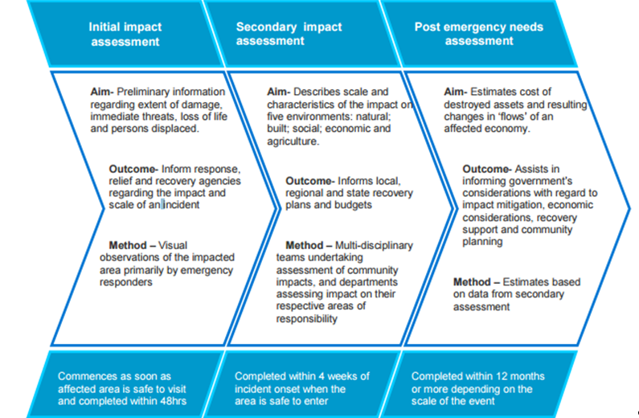

Figure 4 - Description of Impact Assessments Process - Impact Assessment Guidelines

APPENDICES

7.1 AMENDMENT HISTORY

Version | Date | Section Changes | Author
1.0 | 1/3/2019 | Major revision and formatting changes in readiness for 2020 audit by VicSES - replacing previous document | Executive Officer
 | 24/6/2019 | Minor rewording to Introduction, Objectives and Audit and format update CERA graph | Executive Officer
 | 20/8/2019 | Minor rewording to Part 6 from feedback from MEMPC and update Figure 3 | Executive Officer
 | 19/09/2019 | Minor changes to Part 7.5 Communications Plan | Executive Officer

7.2 ACRONYMS

CEO | Chief Executive Officer
CERA | Community Emergency Risk Assessment
CFA | Country Fire Authority
DHHS | Department of Health and Human Services
DRFA | Disaster Recovery Funding Arrangements
ECLIP | Electronic document and records management system
EMLO | Emergency Management Liaison Officer
EMC | Emergency Management Commissioner
EMCEMP | Eastern Metropolitan Councils Emergency Management Partnership
EMMV | Emergency Management Manual Victoria
EMV | Emergency Management Victoria
EMCEMP | Eastern Metro Councils Emergency Management Partnership
ERC | Emergency Relief Centre
FDP | Fire Danger Period
ICC | Incident Control Centre
IEMT | Incident Emergency Management Team
IERC | Incident Emergency Response Coordinator
IIA | Initial Impact Assessment
LGV | Local Government Victoria
MAV | Municipal Association Victoria
MEC | Municipal Emergency Coordination
MECC | Municipal Emergency Coordination Centre
MEM | Municipal Emergency Manager
MEMP | Municipal Emergency Management Plan
MEMPC | Municipal Emergency Management Planning Committee
MERC | Municipal Emergency Response Coordinator (Victoria Police)
MERO | Municipal Emergency Resource Officer
MFB | Metropolitan Fire Brigade
MFMPC | Municipal Fire Management Planning Committee
MIA | Municipal Impact Assessment
MFPO | Municipal Fire Prevention Officer
MOU | Memorandum of Understanding
MRM | Municipal Recovery Manager
NSP | Neighbourhood Safer Place
PENA | Post Emergency Needs Assessment
REMT | Regional Emergency Management Team
RERC | Regional Emergency Response Coordinator
SEMT | State Emergency Management Team
SIA | Secondary Impact Assessment
SOP | Standard Operating Procedure
VicSES | Victoria State Emergency Service
VicPol | Victoria Police
VFRR | Victorian Fire Risk Register
VPR | Vulnerable Persons Register

7.3. DISTRIBUTION LIST

This Plan is made available to the community at www.maroondah.vic.gov.au.

Members of the Municipal Emergency Management Planning Committee (MEMPC) may also access this Plan via the Library Tab in Councils emergency management operating system Crisisworks.

As required by the EMMV, a hard copy has been sent to the State Library of Victoria, 328 Swanston St, Melbourne VIC 3000

7.4. EXERCISE rECORD

Date | Exercise | Description
10 December 2013 | Exercise Stopwatch | Assess MEMP contact list  Evaluate the ‘stand up’ times for agencies to attend MECC  Evaluate procedures for contacting stakeholder agencies in an emergency event
2 April 2014 | ERC Walk through | The ERC at Karralyka was set up to check and update facility plan set-up. This included set up of animal management.
22 May 2014 | Exercise East | Eastern regional ERC Exercise. activated 2 ERCs to exercise ERC staff and support agencies and test hosting Councils facilities
25 October 2014 | Working in a MECC Exercise | Test MECC systems and processes and provide staff with an understanding of their role in MECC operations
7 May 2015 | Exercise East | Eastern regional ERC Exercise activated 2 ERCs at to exercise Council ERC staff and support agencies and test facilities.
15 April 2015 | ERC Walk through | The ERC at ‘The Rings” was set up to check and update facility plan set up.
31 October 2015 | Exercise Trilogy | A joint exercise with 3 regional Councils to evaluate cross agency and municipality communications in a MECC environment in response to a multi-agency incident.
5 November 2015 | Exercise Rolling Stone | RCT/REMT Regional Strategic Plan joint exercise.
3 August 2016 | Walk Through ERC Exercise | The ERC at “Karralyka” was set up, changes identified, role clarification, agency, and animal management arrangements.
26 October 2016 | Eastland Active Shooter | A joint tabletop exercise responding to and recovering from an active shooter incident.
21 November 2016 | Eastlink Exercise | A joint tabletop exercise based a Pandemic event.
19 June 2017 | Active Armed Offender | Regional exercise to identify roles, responsibilities, and actions in the recovery phase of this type of incident.
27 October 2017 | Exercise East | A regional exercise to test and review municipal emergency coordination standard operating procedures.
Date | Exercise | Description
29 May 2018 | Walk Through ERC Exercise | The ERC at “The Rings” was set up to check and update facility plan set-up. This included set up of animal management.
19 October 2018 | Exercise East | Regional exercise to develop capability of Council EMLO, and functions of municipal, regional and incident emergency management team
16 November 2018 | Class 2 Biodiversity Exercise | Regional agency exercise based on a biodiversity event
16 November 2018 | Eastlink Hermes Exercise | Desktop exercise major traffic hazmat incident
19 August 2019 | Walk Through ERC Exercise | The ERC at Karralyka was set up to check and update facility plan set-up. This included set up of animal management.
14 November 2019 | Exercise East | Reginal exercise consisting of a range of masterclasses for staff involved in an ERC.

7.5 COMMUNICATION PLAN

Subject | Topic | Media | Timing
Swimming Pool Safety | Gates and fences | Building Commission Brochures (available at service centres) | Ongoing
 |  | Media release | September/October/December  January/February  Incident generated (ie: prosecution for fencing failure – message reinforced)
 |  | Web | Ongoing  Front page articles during peak seasons
 |  | Focus community newsletter | December
 |  | Community Information Bulletin (available at service centres) | Ongoing
StormSafe | Storm preparation | SES Brochures (available at service centres) | Ongoing
 |  | Media articles  Council’s Fire Preparation brochure available at service centres | July  February/March  Incident generated – message reinforced
 |  | Web | Ongoing
 |  | Focus community newsletter | February (space dependent)
Bushfires | Fire restrictions | Web (links to CFA) | Ongoing – updated on advice from CFA usually October and April
 |  | Community Information Bulletins (available at service centres) | Ongoing – updated on advice from CFA approximately October and April
 |  | Media article | October  April
 | Fire season preparation | Web (links to CFA) | Ongoing
 |  | Community Information Bulletins | Ongoing
 |  | Focus community newsletter | December (if needed)
 |  | Media article | October, December, April  Other as needed  Incident generated – message reinforced
 | Bushfire (all material exists ready to release as needed) | Web (links to CFA and other agencies as needed) | As needed
 |  | Community Information Bulletins | As needed
 |  | Media article | As needed
 |  | Internal communication | As needed
Heatwave | General and declared days  (all material exists for declared days ready to release as needed) | Web | Ongoing  Updated on notification of declared days
 |  | Community Information Bulletins | Ongoing  As needed following notification of declared days
 |  | Media release  Media article | October/November  As needed where timely following notification of declared days
 |  | DHHS Brochure (available at service centres) | Ongoing
 |  | Focus community newsletter | December

7.6 SPECIAL PLANS AND ARRANGEMENTS
Hazard Risk Sub Plans
Fire Management Plan
Storm and Flood Plan
Heatwave Operations Plan
Pandemic Plan

Municipal Sub Plans
Relief Plan
Recovery Plan
Roles and Responsibilities Guide
Animal Welfare Plan
Public Health Sub Plan

Standard Operating Procedures
Administration
Resources
Building
Communications and Engagement
Customer Service
Finance
Information Technology
Municipal Impact Assessment
Non Major Emergencies

Eastern Councils Regional Plans
Eastern Metro ERC Sub Plan
Eastern Metro Heatwave Plan
Eastern Metro Influenza Pandemic Plan
Eastern Metro Municipal Coordination Sub Plan
Eastern Metro Animal Welfare Plan

Arrangements and other documents
Maroondah Business Continuity Plan
Maroondah MEMPC Committee Terms of Reference
Emergency Relief Centre Facility Plans
Maroondah Event Planning handbook
Maroondah 2040 - Our future together
Maroondah Childrens Plan
Maroondah Health and Wellbeing Plan
Regional Relief and Recovery Plan
Emergency Management Manual Victoria
Victorian Emergency Management Strategic Plan
Protocol for Inter-Council Emergency Management Resource Sharing
EMV Recovery Toolkit for Local Government
Emergency Relief Handbook – A Planning Guide

* All the above documents (except those that are hyperlinked) are available on Councils emergency management operating system Crisisworks and linked where mentioned throughout the plan or on Councils EClip system.
Eastlink Operational Plans

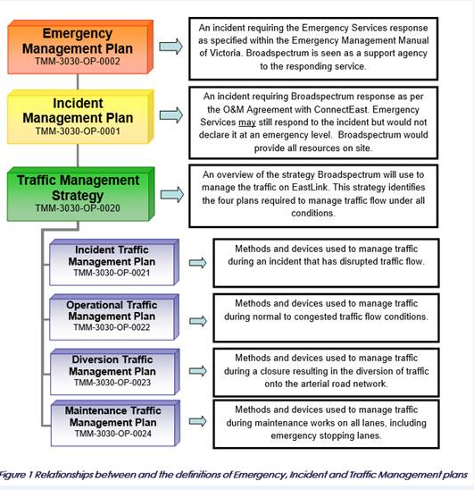

Eastland Operational Plans

- Emergency Response Procedures (for tenants)
- Major Incident and Emergency Procedures Manual (for duty managers)
- Security Escalation Plan
- Business Continuity Plan

7.7 CONTACT DIRECTORY FOR mempc
Not for public distribution

Process for updating the Municipal Emergency Management Planning Committee (MEMPC) contact list
1 week prior to MEMPC Meeting an electronic copy of the list is forwarded to all members requesting any changes, following meeting electronic changes received are matched with details listed in MEMPC meeting attendance sheet, once confirmed all changes are made to electronic copy of MEMPC contact list, then forwarded electronically to all members to enter onto their copy of the contact list prior to each meeting.

7.8 CONTACT DIRECTORY

Not for public distribution

Process for updating MEMP Contact Directory
All contacts are checked by phone and updated by the MEMPC Executive Officer annually or as required and changes transferred into MEMP contact list.

7.9 community directory

A copy of the Maroondah Community Directory can be found via the Maroondah Website at www.maroondah.vic.gov.au or at all customer service centre outlets.

Both the Emergency Management Act 1986 and the Emergency Management Act 2013 are to be read and construed as one Act, until such time as the 1986 Act is repealed.

