MAROONDAH Planning Scheme

Statement of Significance

Heritage Place:  ELLISON STREET PRECINCT (EXTENSION) |  | PS ref no: | HO 98

Prepared by: Context

Address: 4-18 Ellison Street, Ringwood | Survey Date: August 2016
Name: Ellison Street Precinct | Architect:
Place Type: Residential House | Builder: Harry Peake
Grading: Significant | Construction Date: 1923-27
Extent of Overlay: Refer to Precinct Map
Architectural Style: Interwar Period (c.1919-c.1940)

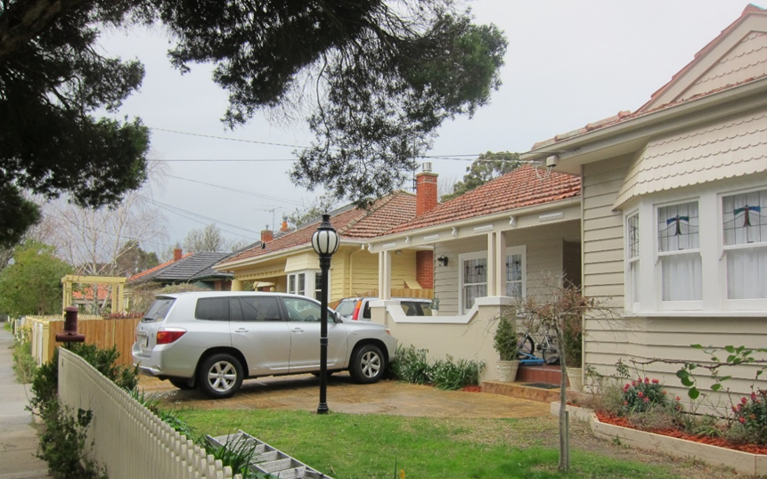

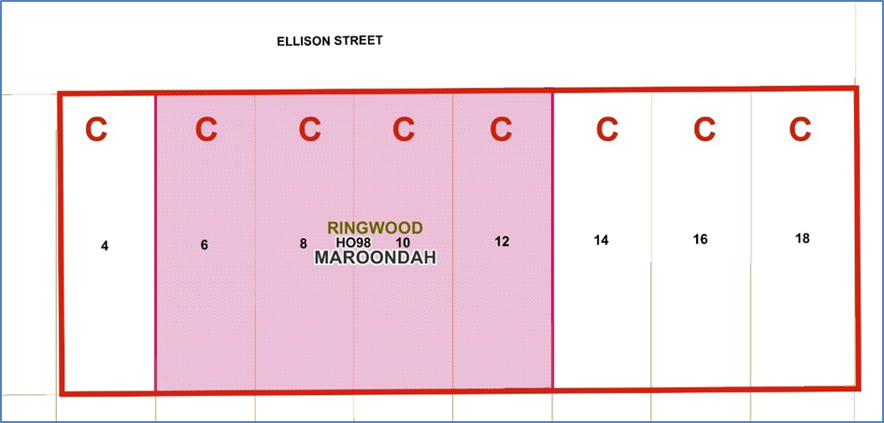
What is significant?
The Ellison Street precinct comprising numbers 4,6,8,10,12,14,16 and18 Ellison Street, Ringwood is significant.

The modern carports and garages, rear extensions and front fences are not significant.

How is it significant?

The Ellison Street precinct is of local historic, architectural and aesthetic significance to the City of Maroondah.

Why is it significant?
The Ellison Street precinct is of historic significance in demonstrating the rapid residential development that occurred in Ringwood, particularly around the trainlines in the early interwar years, following arrival of the electrified rail line to the area and the ready supply of fresh water available from the newly completed O’Shannassy Dam. (Criterion A)

The Ellison Street precinct is of aesthetic significance as a good representative example of a residential precinct from the interwar period in Ringwood. There is a consistency in building form, materiality and detailing that contributes to the homogenous character of the precinct. The precinct is largely intact, with consistent setbacks, garden settings, homogenous building forms and material consistency – forming a characteristic interwar suburban streetscape with some visible additions, such as added carports or garages. The properties within the precinct have a similar style, scale form and materiality where the original designs are clearly distinguishable, but with some alterations evident. The consistency in the row of houses at 6-12 Ellison Street forms the core of the precinct and strengthens the aesthetic value. (Criteria D and E).

The dominant building style in the precinct is the Californian Bungalow, mostly in timber with one brick example. Roofs are typically transverse from with a projecting wing to the front, clad in Marseilles patterned terracotta tiles. Windows are double hung sash windows, sometimes with small panes to the upper sashes. Number 6 has leadlight to the upper sashes. A number of houses have double timber entry doors. Verandah detailing includes of various combinations and squared timber posts and masonry pillars to front verandahs, with the distinctive splayed pillars on number 4 being a notable example. Timber shingles feature over the bay window on numbers 6-12, and on the front gable of number 18..
Number 10 is notable for the relatively elaborate detailing of the original brick façade, fenestration and verandah. (Criteria D and E)

Gradings and Planning Control Recommendations

Recommended for inclusion in the Schedule to the Heritage Overlay of the Maroondah Planning Scheme as a Precinct. Gradings are specified in the precinct Schedule of Gradings below.

Primary source
Jubilee Park Heritage and Neighbourhood Character Study, Context. Final Report February 2018

PRECINCT GRADINGS SCHEDULE

Name | Number | Street | Grading | Built Date
 | 4 | Ellison Street | Contributory | < c.1924
 | 6 | Ellison Street | Contributory | 1923-24
 | 8 | Ellison Street | Contributory | 1923
 | 10 | Ellison Street | Contributory | c.1927
 | 12 | Ellison Street | Contributory | 1924
 | 14 | Ellison Street | Contributory | 1923
 | 16 | Ellison Street | Contributory | c.1924
 | 18 | Ellison Street | Contributory | c.1924

Recommendations for the Schedule to the Heritage Overlay (Clause 43.01) in the Maroondah Planning Scheme:

External Paint Colours  Is a permit required to paint an already painted surface? | No
Internal Alteration Controls  Is a permit required for internal alterations? | No
Tree Controls  Is a permit required to remove a tree? | No
Victorian Heritage Register  Is the place included on the Victorian Heritage Register? | No
Incorporated Plan  Does an Incorporated Plan apply to the site? | No
Outbuildings and fences exemptions  Are there outbuildings and fences which are not exempt from notice and review? | No
Prohibited uses may be permitted  Can a permit be granted to use the place for a use which would otherwise be prohibited? | No
Aboriginal Heritage Place  Is the place an Aboriginal heritage place which is subject to the requirements of the Aboriginal Heritage Act 2006? | No

This document is an incorporated document in the Maroondah Planning Scheme pursuant to section 6(2)(j) of the Planning and Environment Act 1987

MAROONDAH Planning Scheme

Statement of Significance

Heritage Place: HAIG STREET PRECINCT |  | PS ref no: | HO 140

Prepared by: Context

Address: 3-31 and 2-34 Haig Street, Ringwood | Survey Date: August 2016
Name: Haig Street Precinct | Architect:
Place Type: Residential House | Builder:
Grading: Significant | Construction Date: 1920s-1950s
Extent of Overlay: Refer to Precinct Map
Architectural Style: Interwar Period (c.1919-c.1940)

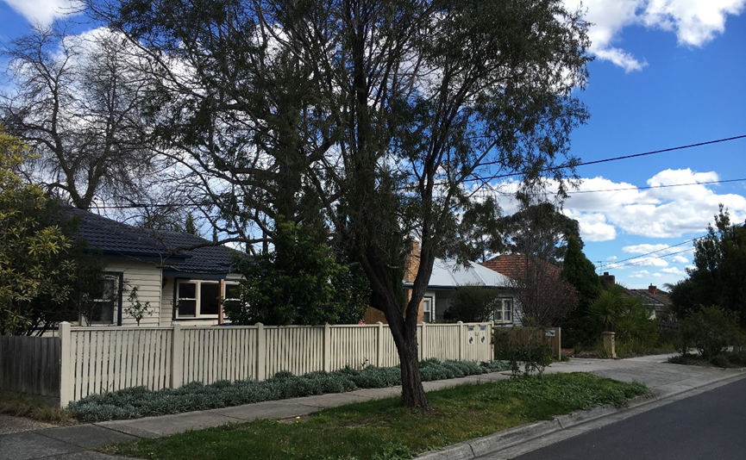

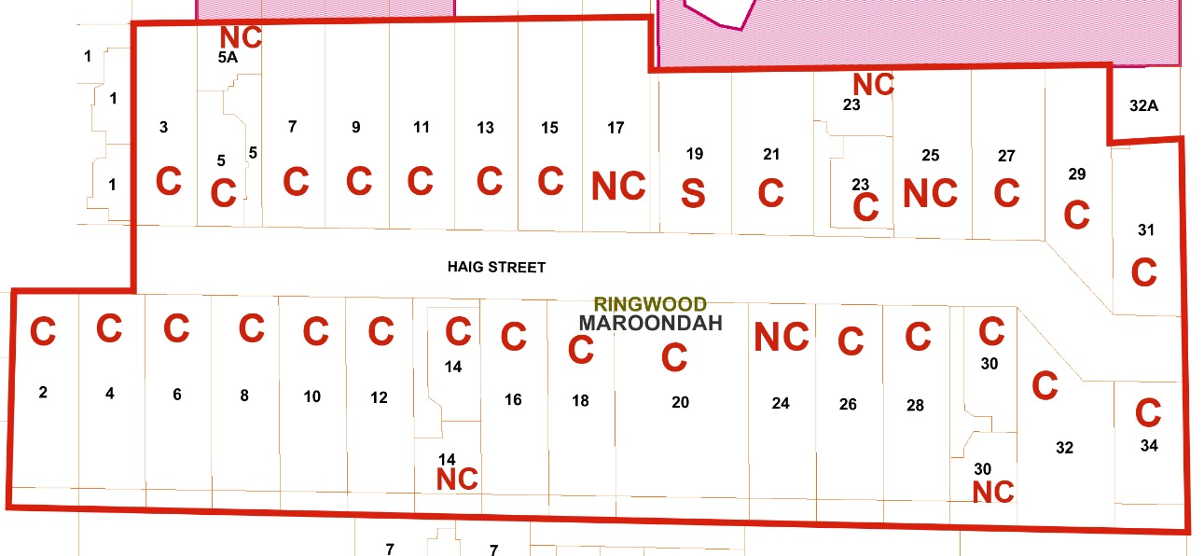
Figure 1 Map of the Haig Street precinct – red line denotes proposed precinct boundary. ‘C’ = contributory to the precinct, ‘NC’ = non-contributory to the precinct.

What is significant?
The Haig Street Precinct, comprising 3-31 and 2-34 Haig Street, Ringwood, is significant.

Number 19 Haig Street is significant within the precinct.

Front fences, carports and garages within the precinct are not significant.

How is it significant?
The Haig Street precinct in Ringwood is of local historic, architectural and aesthetic significance to the City of Maroondah.

Why is it significant?
The Haig Street precinct is of historic significance in demonstrating the rapid residential development that occurred in Ringwood, particularly around the trainlines in the interwar and early post war years, following first, the arrival of the electrified rail line to the area and the ready supply of fresh water available from the newly completed O’Shannassy Dam, and later, the popularisation of the suburbs .(Criterion A)

The Haig Street precinct is of further historic significance for its association with the Great War. As was common in new subdivisions in Melbourne in the 1920s, the street name selected had an association with the Great War. Haig Street was named after the British army officer, General Douglas Haig who had commanded the British forces on the Western Front during World War I. (Criterion A)

The Haig Street precinct is a good representative example of a residential precinct from the interwar/early post World War 2 period. While demonstrating a consistent building type - the single storey, detached bungalow, the precinct is notable for demonstrating the range of styles applied to the bungalows in the interwar and early post World War 2 years. Visual cohesion is achieved in the precinct by the use of consistent front setbacks, material palette, and garden settings. The wide streets, nature strips and established streets (majority replanted) contribute to the aesthetic appeal of the precinct. The cohesive suburban streetscape retains its integrity despite, such as added carports, upper storey additions and garages through the similar style, scale form and materiality where the original designs are clearly distinguishable, but with some alterations evident. (Criterion D and E)

19 Haig Street is an example of a bungalow built in the Moderne style. It features a semi-circular entry porch with rendered walls which are trimmed with tapestry brick. A rectangular opening on the curved edge has a wrought iron grilled in a diamond pattern. Soldier courses of tapestry brick feature around the window openings and across the façade. Two brick and render chimneys have stepped bases which protrude through the roof. The house is an excellent example of the Moderne style adapted to suit the modest housing of the area. (Criterion E)

Gradings and Planning Control Recommendations

Recommended for inclusion in the Schedule to the Heritage Overlay of the Maroondah Planning Scheme as a Precinct. Gradings are specified in the precinct Schedule of Gradings below.

Primary source

Jubilee Park Heritage and Neighbourhood Character Study, Context. Final Report February 2018

PRECINCT GRADINGS SCHEDULE

Name | Number | Street | Grading | Built Date
 | 2 | Haig Street | Contributory | 1935-38
 | 3 | Haig Street | Contributory | 1930s
 | 4 | Haig Street | Contributory | 1926-28
 | 5 | Haig Street | Contributory | 1920s
 | 5A | Haig Street | Non-contributory
 | 6 | Haig Street | Contributory | 1935-38
 | 7 | Haig Street | Contributory | 1935-38
 | 8 | Haig Street | Contributory | 1949
 | 9 | Haig Street | Contributory | 1935-38
 | 10 | Haig Street | Contributory | By 1954
 | 11 | Haig Street | Contributory | 1935-38
 | 12 | Haig Street | Contributory | 1950-55
 | 13 | Haig Street | Contributory | 1920-24
 | 14 | Haig Street | Contributory | By 1954
 | 2/14 | Haig Street | Non-contributory
 | 15 | Haig Street | Contributory | By 1924
 | 16 | Haig Street | Contributory | 1950-55
 | 17 | Haig Street | Non-contributory
 | 18 | Haig Street | Contributory | 1950-55
 | 19 | Haig Street | Individually Significant | 1940
 | 20-22 | Haig Street | Contributory | By 1954
 | 21 | Haig Street | Contributory | 1935-38
 | 23 | Haig Street | Contributory | 1941-42
 | 2/23 | Haig Street | Non-contributory
 | 24 | Haig Street | Non-Contributory
 | 25 | Haig Street | Non-Contributory
 | 26 | Haig Street | Contributory | 1920-24
 | 27 | Haig Street | Contributory | 1935-38
 | 28 | Haig Street | Contributory | 1920-24
 | 29 | Haig Street | Contributory | 1935-38
 | 30 | Haig Street | Contributory | 1948
 | 2/30 | Haig Street | Non-Contributory
 | 31 | Haig Street | Contributory | 1935-37
 | 32 | Haig Street | Contributory | By 1924
 | 34 | Haig Street | Contributory | 1941

Recommendations for the Schedule to the Heritage Overlay (Clause 43.01) in the Maroondah Planning Scheme:

External Paint Colours  Is a permit required to paint an already painted surface? | No
Internal Alteration Controls  Is a permit required for internal alterations? | No
Tree Controls  Is a permit required to remove a tree? | No
Victorian Heritage Register  Is the place included on the Victorian Heritage Register? | No
Incorporated Plan  Does an Incorporated Plan apply to the site? | No
Outbuildings and fences exemptions  Are there outbuildings and fences which are not exempt from notice and review? | No
Prohibited uses may be permitted  Can a permit be granted to use the place for a use which would otherwise be prohibited? | No
Aboriginal Heritage Place  Is the place an Aboriginal heritage place which is subject to the requirements of the Aboriginal Heritage Act 2006? | No

This document is an incorporated document in the Maroondah Planning Scheme pursuant to section 6(2)(j) of the Planning and Environment Act 1987

MAROONDAH Planning Scheme

Statement of Significance

Heritage Place:  Kendall Street Precinct |  | PS ref no: | HO 141

Prepared by: Context

Address: 20-32 and 21-35 Kendall Street, Ringwood | Survey Date: August 2016
Name: Kendall Street Precinct | Architect:
Place Type: Residential TerraceResidential Terrace | Builder:
Grading: Significant | Construction Date: 1915 – early 1950s
Extent of Overlay: Refer to Precinct Map
Architectural Style: Interwar Period (c.1919-c.1940)Interwar Period (c.1919-c.1940)

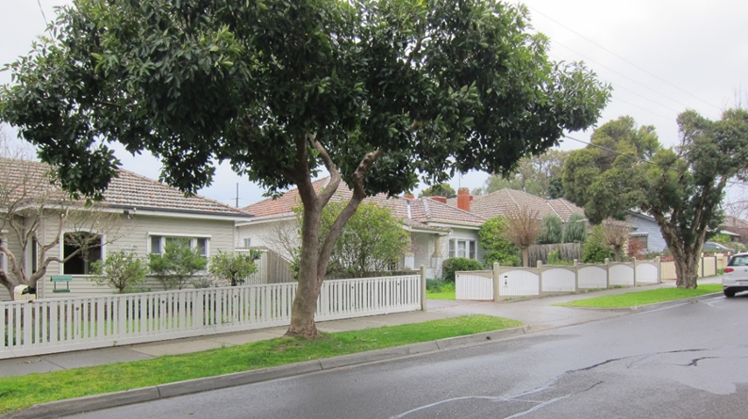

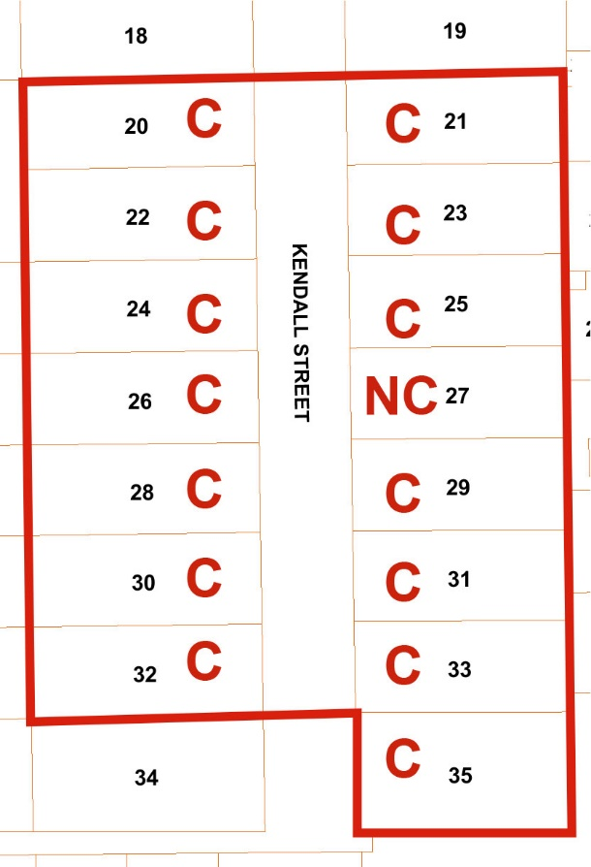
Figure 1 Map of Kendall Street Precinct. Red line shows precinct boundary. C = Contributory to the precinct

What is significant?
The Kendall Street precinct, comprising 20-32 and 21-35 Kendall Street, Ringwood is significant.

How is it significant?
The Kendall Street precinct in Ringwood is of local historic, architectural and aesthetic significance to the City of Maroondah.

Why is it significant?
The Kendall Street precinct is of historic significance as evidence of the residential development that occurred in Ringwood in the interwar years, following the electrification of the railway line and the supply of fresh water from the newly completed O’Shannassy Dam. (Criterion A)

The Kendall Street precinct is a representative example of a residential precinct from the interwar period. There is a consistency in building form, materiality and detailing that contributes to the homogenous character of the precinct. The precinct is comprised of modest timber bungalows, mostly from the 1930-40s. Groups of similar houses occur, suggesting they were built by one builder or to a standardised design. The primary architectural character of the precinct is the single storey, detached bungalow with a projecting wing to one side, a central entry porch and a tiled hipped roof. Timber is the dominant material with one example in brick. Windows typically are tripartite timber framed double sash windows. Number 22 has leadlight to the upper sashes. Primary aesthetic interest is derived from detailing of the entry porch of each house. Detailing varies between each dwelling and includes motifs and elements from the various interwar styles including: gabled parapets, pointed arched openings, columns and pillars, and tapestry brick motifs and edging (Criterion D)

The interwar suburban streetscape is intact within the precinct, with garden settings, nature strips and street plantings of Melaleuca, with a row of three mature Liquidambar on the west side; the latter appear to date from the 1930s-50s. (Criterion DandE)

Gradings and Planning Control Recommendations

Recommended for inclusion in the Schedule to the Heritage Overlay of the Maroondah Planning Scheme as a Precinct. Gradings are specified in the precinct Schedule of Gradings below.

Primary source
Jubilee Park Heritage and Neighbourhood Character Study, Context. Final Report February 2018

PRECINCT GRADINGS SCHEDULE

Name | Number | Street | Grading | Built Date
 | 20 | Kendall Street | Contributory | 1930s
 | 21 | Kendall Street | Contributory | 1942?
 | 22 | Kendall Street | Contributory | 1930s
 | 23 | Kendall Street | Contributory | 1940
 | 24 | Kendall Street | Contributory | Post-1950
 | 25 | Kendall Street | Contributory | 1940
 | 26 | Kendall Street | Contributory | 1940
 | 27 | Kendall Street | Contributory | By 1922
 | 28 | Kendall Street | Contributory | 1939
 | 29 | Kendall Street | Contributory | 1939
 | 30 | Kendall Street | Contributory | Around 1915
 | 31 | Kendall Street | Contributory | 1941
 | 32 | Kendall Street | Contributory | 1930s
 | 33 | Kendall Street | Contributory | c.1940
 | 35 | Kendall Street | Contributory | 1941

Recommendations for the Schedule to the Heritage Overlay (Clause 43.01) in the Maroondah Planning Scheme:

External Paint Colours  Is a permit required to paint an already painted surface? | No
Internal Alteration Controls  Is a permit required for internal alterations? | No
Tree Controls  Is a permit required to remove a tree? | No
Victorian Heritage Register  Is the place included on the Victorian Heritage Register? | No
Incorporated Plan  Does an Incorporated Plan apply to the site? | No
Outbuildings and fences exemptions  Are there outbuildings and fences which are not exempt from notice and review? | No
Prohibited uses may be permitted  Can a permit be granted to use the place for a use which would otherwise be prohibited? | No
Aboriginal Heritage Place  Is the place an Aboriginal heritage place which is subject to the requirements of the Aboriginal Heritage Act 2006? | No

This document is an incorporated document in the Maroondah Planning Scheme pursuant to section 6(2)(j) of the Planning and Environment Act 1987

MAROONDAH Planning Scheme

Statement of Significance

Heritage Place:  HOUSE 5 – Caroline Street Ringwood |  | PS ref no: | HO 142

Prepared by: Context

Address: 5 Caroline Street, Ringwood | Survey Date: August 2016
Name: | Architect:
Place Type: Residential House | Builder:
Grading: Significant | Construction Date: 1925-26
Extent of Overlay: To title boundaries
Architectural Style: Interwar Period (c.1919-c.1940)

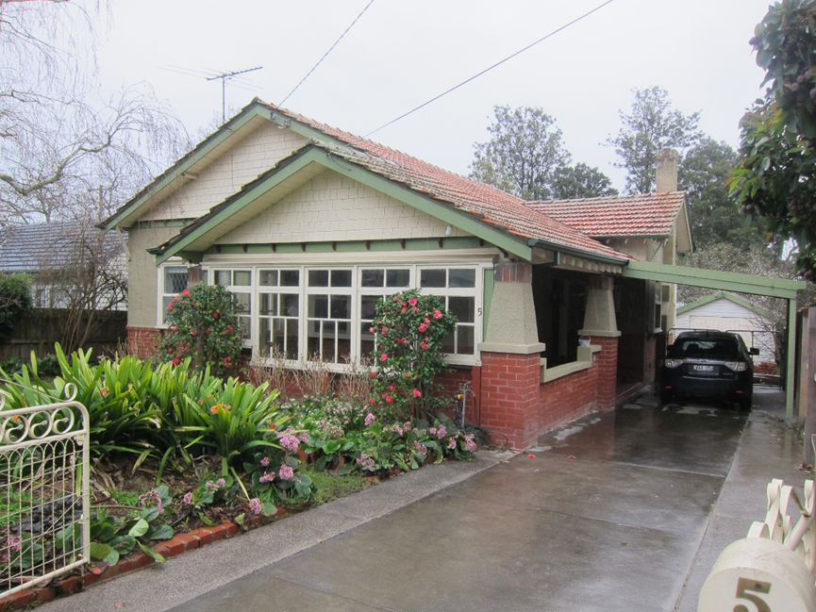

What is significant?
The house at 5 Caroline Street, Ringwood, built in 1925-26, is significant.
The modern additions of glazed panels in porch wall, carport and front fence are not significant.

How is it significant?
The house at 5 Caroline Street, Ringwood is of local architectural significance to the City of Maroondah.

Why is it significant?
The house at 5 Caroline Street, Ringwood exhibits a number of characteristics typical of the Californian Bungalow style. The style was popular in Ringwood and surrounding suburbs during the Interwar years when a number of housing estates were developed in Ringwood and in the Maroondah area more generally. (Criterion D)

Characteristics associated with the Californian Bungalow style include: a low pitched gabled roof form, with a secondary gabled roof over a projecting front porch; Marseille patterned roof tiles, with wide eaves and exposed rafter ends; timber brackets below the shingled gable; half brick porch/verandah piers with tapered rendered sections above, and soldier brickwork to the upper edges; a combination of natural materials arranged to provide visual interest including timber shingles to the gables, and half brick walls with rough cast rendered sections above; boxed double-hung sash windows with diamond patterned leadlight to the upper sashes; two square rendered chimneys with a brick soldier course to the upper edge. (Criterion D)

Primary source
Jubilee Park Heritage and Neighbourhood Character Study, Context. Final Report February 2018

Planning Control Recommendations

Recommendations for the Schedule to the Heritage Overlay (Clause 43.01) in the Maroondah Planning Scheme:

External Paint Colours  Is a permit required to paint an already painted surface? | No
Internal Alteration Controls  Is a permit required for internal alterations? | No
Tree Controls  Is a permit required to remove a tree? | No
Victorian Heritage Register  Is the place included on the Victorian Heritage Register? | No
Incorporated Plan  Does an Incorporated Plan apply to the site? | No
Outbuildings and fences exemptions  Are there outbuildings and fences which are not exempt from notice and review? | No
Prohibited uses may be permitted  Can a permit be granted to use the place for a use which would otherwise be prohibited? | No
Aboriginal Heritage Place  Is the place an Aboriginal heritage place which is subject to the requirements of the Aboriginal Heritage Act 2006? | No

This document is an incorporated document in the Maroondah Planning Scheme pursuant to section 6(2)(j) of the Planning and Environment Act 1987

MAROONDAH Planning Scheme

Statement of Significance

Heritage Place:  CARISBROOK 20 Caroline Street Ringwood |  | PS ref no: | HO 143

Prepared by: Context

Address: 20 Caroline Street, Ringwood | Survey Date: August 2016
Name: Carisbrook | Architect:
Place Type: Residential House | Builder:
Grading: Significant | Construction Date: 1939-40
Extent of Overlay: To title boundaries
Architectural Style: Interwar Period (c.1919-c.1940)

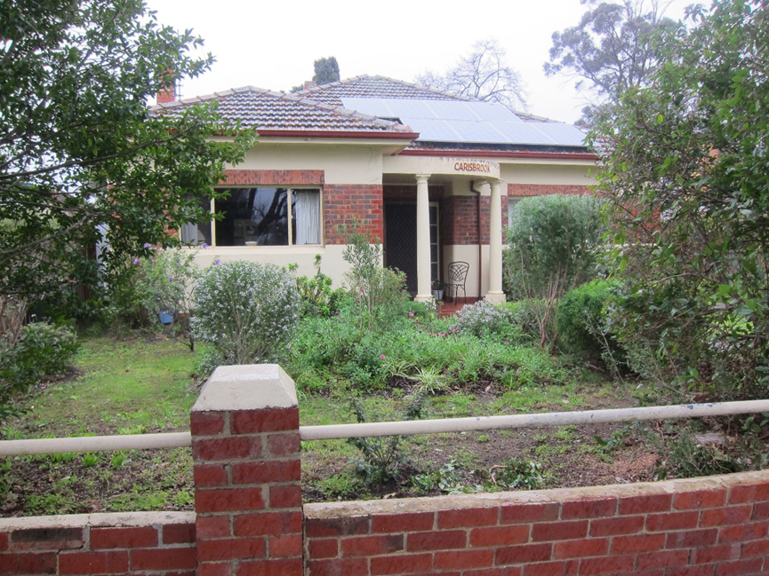

What is significant?
The house and front fence at 20 Caroline Street, built 1939-40, is significant.

How is it significant?
The house and front fence at 20 Caroline Street, Ringwood are of local architectural significance to the City of Maroondah .

Why is it significant?
The house at 20 Caroline Street, Ringwood exhibits characteristics typical of a the ‘Moderne’ style in a domestic building from the interwar period, including a strong horizontal emphasis with a deep band of face tapestry brick running between rendered bands to the upper and lower façade; two identical tri-partite steel casement windows are set into the brick band, on either side of the entry porch; a soldier course of tapestry bricks runs across the upper edge of each window opening; a central entry door has steel sidelight windows. The low brick front fence has simple brick piers with tapered rendered tops and a steel pipe rail running between the piers. (Criterion D)

Primary source
Jubilee Park Heritage and Neighbourhood Character Study, Context. Final Report February 2018

Planning Control Recommendations

Recommendations for the Schedule to the Heritage Overlay (Clause 43.01) in the Maroondah Planning Scheme:

External Paint Colours  Is a permit required to paint an already painted surface? | No
Internal Alteration Controls  Is a permit required for internal alterations? | No
Tree Controls  Is a permit required to remove a tree? | No
Victorian Heritage Register  Is the place included on the Victorian Heritage Register? | No
Incorporated Plan  Does an Incorporated Plan apply to the site? | No
Outbuildings and fences exemptions  Are there outbuildings and fences which are not exempt from notice and review? | Yes – brick and steel pipe front fence.
Prohibited uses may be permitted  Can a permit be granted to use the place for a use which would otherwise be prohibited? | No
Aboriginal Heritage Place  Is the place an Aboriginal heritage place which is subject to the requirements of the Aboriginal Heritage Act 2006? | No

This document is an incorporated document in the Maroondah Planning Scheme pursuant to section 6(2)(j) of the Planning and Environment Act 1987

MAROONDAH Planning Scheme

Statement of Significance

Heritage Place:  18 James Street Ringwood |  | PS ref no: | HO 144

Prepared by: Context

Address: 18 James Street, Ringwood | Survey Date: August 2016
Name: House and garage | Architect:
Place Type: Residential House | Builder:
Grading: Significant | Construction Date: 1927-28
Extent of Overlay: To title boundaries
Architectural Style: Interwar Period (c.1919-c.1940)

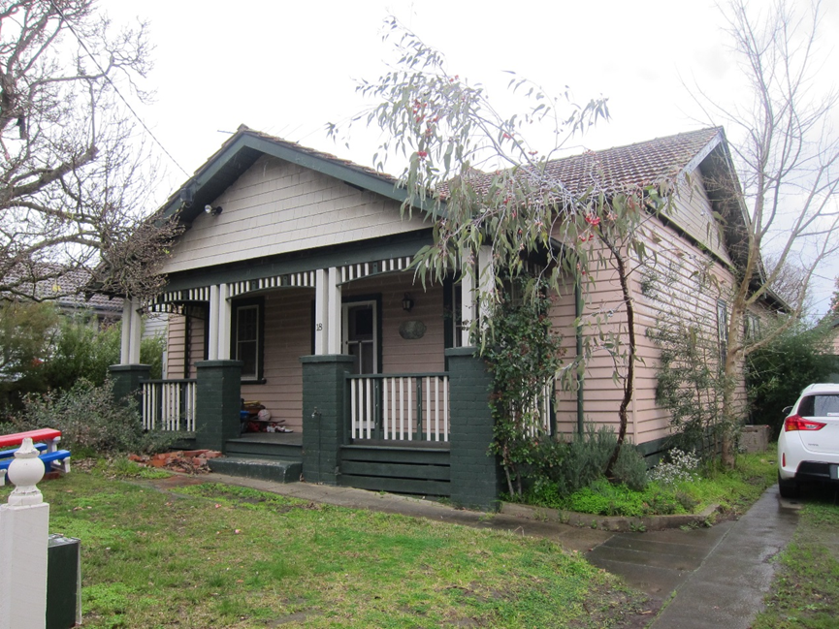

What is significant?
18 James Street, Ringwood, built 1927-28, is significant. The timber garage is also significant.

How is it significant?
18 James Street, Ringwood is of local architectural significance to the City of Maroondah.

Why is it significant?
The house at 18 James Street, Ringwood exhibits a number of characteristics typical of the Californian Bungalow style. The style was popular in Ringwood and surrounding suburbs during the interwar years when a number of housing estates were developed in Ringwood and in the Maroondah area more generally. The addition of the ‘matching’ garage, from a later, but contemporary period enhances the significance. Characteristics associated with the Californian Bungalow style include: a simple transverse form enclosed by a low pitched gabled roof, clad in patterned Marseilles tiles; wide eaves and exposed rafter ends; a generous front porch located across the front of the house, and enclosed by a separate wide gabled roof form which faces the street; verandah details including paired timber posts over brick piers, an arched timber ladder frieze, and a simple timber balustrade; timber shingles to the front facing gable; two squared brick chimneys are located either side of the roof ridge on the southern side of the house; identical timber double hung sash windows with six panes to the upper sashes, located on either side of the entry; and paired timber entry doors located centrally across the façade. (Criterion D)

Primary source
Jubilee Park Heritage and Neighbourhood Character Study, Context. Final Report February 2018

Planning Control Recommendations

Recommendations for the Schedule to the Heritage Overlay (Clause 43.01) in the Maroondah Planning Scheme:

External Paint Colours  Is a permit required to paint an already painted surface? | No
Internal Alteration Controls  Is a permit required for internal alterations? | No
Tree Controls  Is a permit required to remove a tree? | No
Victorian Heritage Register  Is the place included on the Victorian Heritage Register? | No
Incorporated Plan  Does an Incorporated Plan apply to the site? | No
Outbuildings and fences exemptions  Are there outbuildings and fences which are not exempt from notice and review? | Yes – timber garage at rear of house.
Prohibited uses may be permitted  Can a permit be granted to use the place for a use which would otherwise be prohibited? | No
Aboriginal Heritage Place  Is the place an Aboriginal heritage place which is subject to the requirements of the Aboriginal Heritage Act 2006? | No

This document is an incorporated document in the Maroondah Planning Scheme pursuant to section 6(2)(j) of the Planning and Environment Act 1987

MAROONDAH Planning Scheme

Statement of Significance

Heritage Place:  22 James Street Ringwood |  | PS ref no: | HO 145

Prepared by: Context

Address: 22 James Street, Ringwood | Survey Date: August 2016
Name: | Architect:
Place Type: Residential House | Builder:
Grading: Significant | Construction Date: 1924-26
Extent of Overlay: To title boundaries
Architectural Style: Interwar Period (c.1919-c.1940)

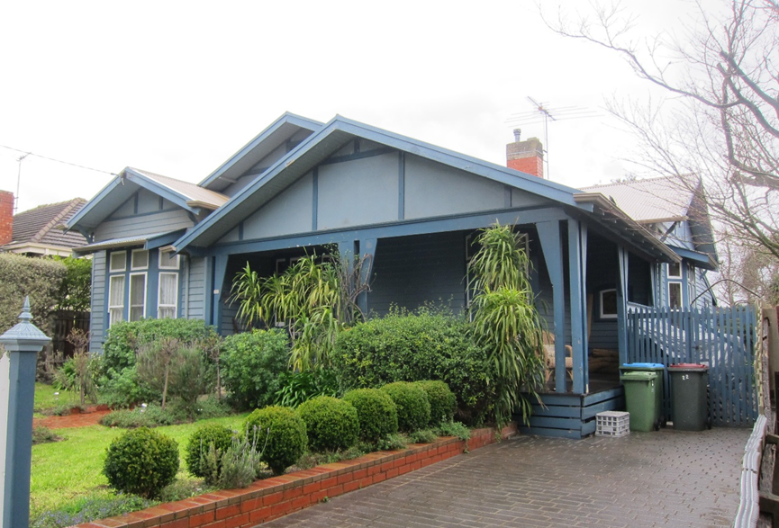

What is significant?
22 James Street, Ringwood, built in 1924-26, is significant.

How is it significant?
22 James Street, Ringwood is of local architectural and aesthetic significance to the City of Maroondah.

Why is it significant?
22 James Street, Ringwood integrates a number of characteristics associated with both the Federation era ‘Queen Anne’ style and the Californian Bungalow style of the interwar period. The overall form of the house resembles the asymmetrical and complex form typical of the style of the ‘Queen Anne’ style. It features a projecting wings at the front and the side, and a return verandah with a boxed bay window across the corner. By contrast, the low-slung roof and wide front gable are more closely associated with the Californian Bungalow style. (Criterion D)

Detailing associated with the ‘Queen Anne’ style includes boxed bay windows to the projecting bays and across the verandah corner, with narrow double hung windows with highlight windows above; a small arched window at the end of the verandah; half timbering to the gable ends (thought typically the gables would be deeper); and a three panel, leadlight entry door with leadlight to the side lights. Detailing associated with the Californian Bungalow style includes timber detailing to the front verandah including paired solid timber posts and elongated timber blade brackets; a timber gable ventilator to the upper gabled end; and a simple brick chimney with rendered top. (Criterion D and E)

The house retains a high level of integrity.

Primary source

Jubilee Park Heritage and Neighbourhood Character Study, Context. Final Report February 2018

Planning Control Recommendations

Recommendations for the Schedule to the Heritage Overlay (Clause 43.01) in the Maroondah Planning Scheme:

External Paint Colours  Is a permit required to paint an already painted surface? | No
Internal Alteration Controls  Is a permit required for internal alterations? | No
Tree Controls  Is a permit required to remove a tree? | No
Victorian Heritage Register  Is the place included on the Victorian Heritage Register? | No
Incorporated Plan  Does an Incorporated Plan apply to the site? | No
Outbuildings and fences exemptions  Are there outbuildings and fences which are not exempt from notice and review? | No
Prohibited uses may be permitted  Can a permit be granted to use the place for a use which would otherwise be prohibited? | No
Aboriginal Heritage Place  Is the place an Aboriginal heritage place which is subject to the requirements of the Aboriginal Heritage Act 2006? | No

This document is an incorporated document in the Maroondah Planning Scheme pursuant to section 6(2)(j) of the Planning and Environment Act 1987

