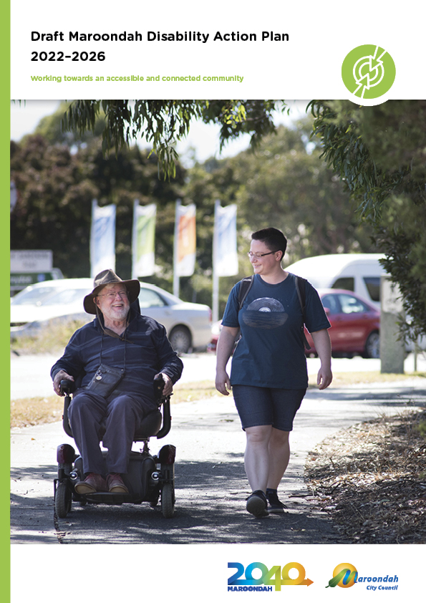
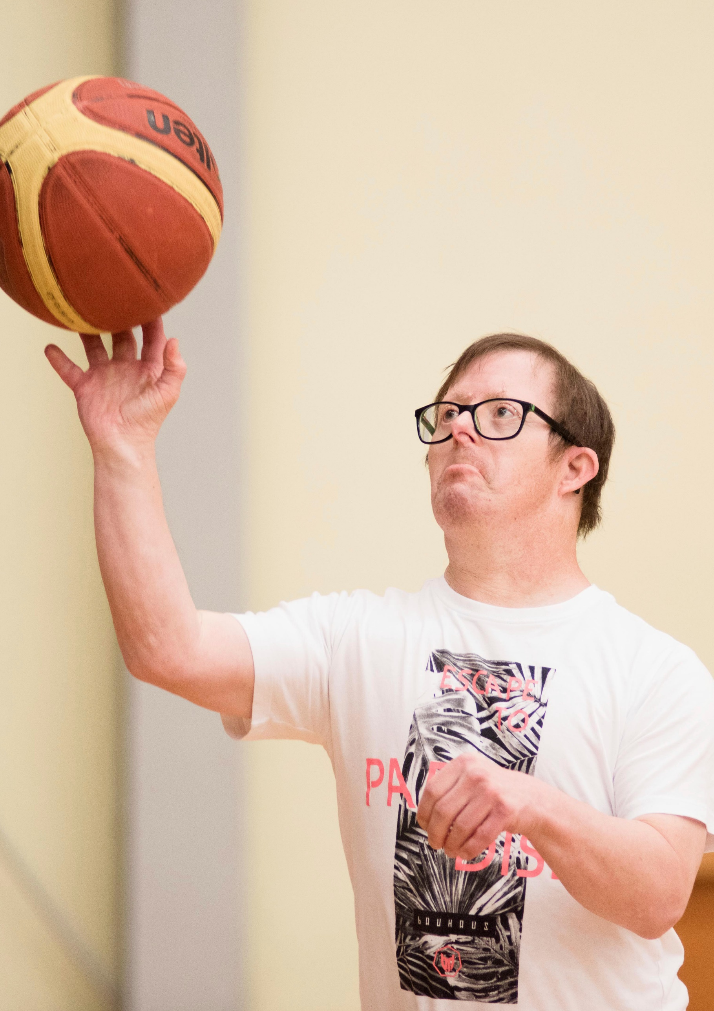

Contents
A message from our Councillors 4
Introduction 5
Relationship to the Council’s Integrated Planning Framework 5
Defining disability 7
The Victorian Disability Action Plan 8
Highlights from the Disability Policy and Action Plan 2019-2021 8
What does the evidence say? 10
What the community told us 12
Our strategic response 13
Our vision for disability access and inclusion 13
Key principles 13
Our key focus areas 14
Outcome area 1 - Social and Economic Inclusion 15
Vision statement 15
Case Study 15
Key Directions and Priority Actions 2022-2026 16
Outcome area 2 - Services and Information 17
Vision statement 17
Case Study 17
Key Directions and Priority Actions 2022-2026 18
Outcome area 3 - Design, Infrastructure and Transport 19
Vision statement 19
Case Study 19
Key Directions and Priority Actions 2022-2026 20
Outcome area 4 - Advocacy and Leadership 21
Vision statement 21
Case study 21
Key Directions and Priority Actions 2022-2026 22
Tracking our progress 23

A message from our Councillors

Council is pleased to present the Maroondah Disability Action Plan 2022-2026.
This Disability Action Plan describes how Council, together with our partners, will continue to work towards reducing barriers faced by people with disabilities in Maroondah and create opportunities for people with disabilities to participate equally in community life.
The plan outlines our vision for disability and inclusion for Maroondah, with equitable opportunities for people of all abilities, their families and their carers to actively and fully participate.
Through the plan’s key directions and priority actions, Council aims to achieve meaningful progress towards providing inclusive and accessible services, infrastructure, facilities and amenities for people with a disability and those that care for them.
Maroondah City Council has a proud history of being an innovative leader in the disability sector. Examples include the Pathways for Carers program, which supports carers’ wellbeing, and the Changing Places campaign which provides best practice accessible toilets. In the past two years the State Government has continued to fund further expansion across Victoria.
More recently Maroondah was instrumental in setting up a consortium to develop Porn is Not the Norm, a first of its kind project which was awarded $900,000 over three years from the Westpac Foundation. Maroondah City Council also employs a worker to support our Maroondah community to understand and navigate the National Disability Insurance Scheme system. This role is unique in Victorian local governments and is highly valued by our community.
Council acknowledges the valuable contribution of the Maroondah Disability Advisory Committee (MDAC) in the development of this Disability Action Plan 2022-2026. The MDAC comprises people with a disability, carers, and service providers.
We commend the Maroondah Disability Action Plan as we continue to work towards a more inclusive community.

Introduction

Disability Action Plans are required, under section 38 of the Victorian Disability Act 2006, to be developed for the purpose of:

- Reducing barriers for persons with disabilities accessing information, goods, services and facilities;
- Reducing barriers to persons with disabilities obtaining or maintaining employment;
- Promoting inclusion and participation in the community; and
- Achieving tangible changes in attitudes and practices that discriminate against
persons with disabilities.

This Act reinforces that people with disabilities have equal rights as members of the community to participate in decision making, access information and receive support.
This Maroondah Disability Action Plan 2022-2026 outlines Council’s commitment and strategic direction in supporting a more accessible and socially inclusive community. It continues work from the Disability Policy and Action Plan 2019-2021 which has guided Council’s work to address the needs of people with disabilities, their carers and families in Maroondah.

The Plan was developed through the examination of local data, consideration of government legislation and consultation with our local community. This process has resulted in the identification of key strategies for people with disabilities and their carers, along with priority actions which Council has committed to implement over the 2022-2026 term of the Plan.

The actions contained within the Disability Action Plan 2022-2026 are captured under four key directions:

- Social and Economic Inclusion
- Services and Information
- Design, Infrastructure and Transport
- Advocacy and Leadership

In accordance with requirements of the Victorian Disability Act 2006, Council is required to report annually in its Annual Report on the progress of the Plan. Annual implementation reporting enables Council to monitor and refine its approach while responding to changes in its environment and adjusting its processes and partnerships to meet those goals.

Relationship to the Council’s Integrated Planning Framework
The Maroondah Disability Action Plan 2022-2026 is a key document within Council’s broader Integrated Planning Framework.

Maroondah 2040: Our future together outlines the community’s vision for Maroondah looking ahead to the year 2040 and beyond. The Maroondah Disability Action Plan is designed to work towards the outcomes of a safe, healthy and active community; an accessible and connected community; and an inclusive and diverse community.

The Maroondah Liveability Wellbeing and Resilience Strategy 2021-2031 adopted in October 2021 is Council’s key social environment strategic plan that describes how Council and partners will work towards achieving enhanced community wellbeing, liveability and resilience over the next 10 years.

The Strategy outlines a vision for the future social environment of the municipality supporting the desired outcomes and key directions within Maroondah 2040 - Our future together. Through this Strategy and supporting action plans, Council and its partners will work towards a common agenda that is evidence informed and community driven.
To articulate the specific actions of Council in working towards the key directions in this Strategy, a number of integrated action plans will be developed/reviewed and implemented. These associated action plans will highlight the short-medium priorities of Council in working towards the Strategy and be reviewed regularly
during the lifespan of the Strategy to ensure they are responsive to community needs.

The Maroondah Liveability Wellbeing and Resilience Strategy 2021-2031 highlights a range of priority areas of focus and key directions for the whole of the community including promoting support, access and inclusion for people with disabilities.

The Maroondah Disability Action Plan will support implementation of the Maroondah Liveability Wellbeing and Resilience Strategy 2021-2031 through actions focused addressing the needs of people with disabilities, their carers and families in Maroondah during the 2022-2026 period.

Governance oversight of the Plan’s implementation will be provided by the Maroondah Disability Advisory Committee and the Maroondah Access, Inclusion and Equity Advisory Committee.

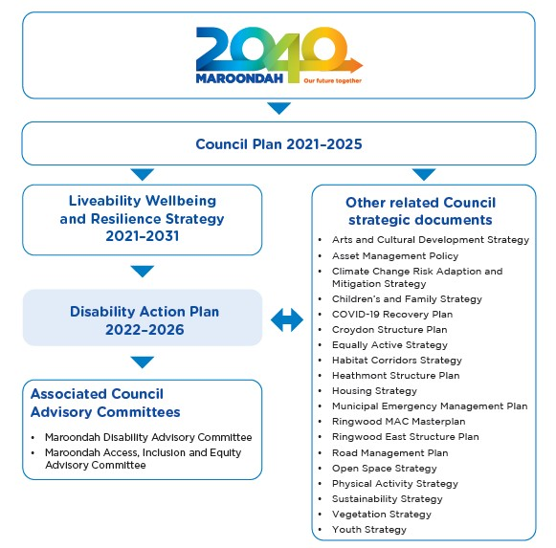
Figure 1: Maroondah’s Integrated Planning Framework

Defining disability
Throughout this Action Plan, reference to disability includes physical, cognitive, psycho-social, sensory, and/or forms of neurodiversity. Council recognises that disability may be episodic or consistent, acquired or congenital, single or plural, and may be invisible.

A full definition of disability can be found in section 4 of the Disability Discrimination Act 1992 which describes disability as “an umbrella term, covering impairments, activity limitations and participation restrictions”.

The United Nations Convention on Rights of Persons with Disabilities (UN Convention) recognises disability as: “an evolving concept and that disability results from the interaction between persons with impairments and attitudinal and environmental barriers that hinder their full and effective participation in society on an equal basis as others. People with disabilities include those who have long term physical, mental, intellectual or sensory impairments” (UN Convention).

The Australian Local Government Association (ALGA) states that it is important in the current Australian context that Council’s should strive to include, involve and accommodate people within all aspects of community life by considering disability on a broad scale.

Types of disability described in the Disability Discrimination Act 1992 (DDA)

Disability can result from an accident, illness or congenital or generic disorder. There are many disability types, including:
- Physical
- Intellectual
- Psychiatric
- Neurological
- Sensory
- Learning
- Physical Disfigurement
- Disease causing organisms.

The DDA defines “disability” in relation to a person as:
- Total or partial loss of the person’s bodily or mental functions; or
- Total or partial loss of a part of the body; or
- The presence in the body of organisms causing disease or illness; or
- The presence in the body of organisms capable of causing disease or illness; or
- The malfunction, malformation or disfigurement of a part of the person’s body; or
- A disorder or malfunction that results in the person learning differently from a person without the disorder or malfunction; or
- A disorder, illness or disease that affects a person’s thought processes, perception of reality, emotions or judgment or that results in disturbed behaviour; and includes a disability that:
- Presently exists; or
- Previously existed but no longer exists; or
- May exist in the future (including because of a genetic predisposition to that disability); or
- Is imputed to a person

To avoid doubt, a disability that is otherwise covered by this definition includes behaviour that is a symptom or manifestation of the disability.

With an ageing population in Maroondah, a key issue in planning for inclusion of all within our community is acknowledging that many will be living with disabilities and/or providing care for a person with disabilities at some point in their lives.

The Victorian Disability Action Plan
Inclusive Victoria: State Disability Plan 2022–2026 is Victoria's fourth state disability plan. The Plan sets out actions that will help the Victorian Government meet its obligations under the United Nations Convention on the Rights of Persons with Disabilities. The plan describes how the Victorian Government will recognise and address forms of structural discrimination people with disability face and build accessibility into everything that government does. The Plan contains six systemic reforms and 22 priority areas, grouped under four pillars: Inclusive Communities, Health, Housing and Wellbeing, Fairness and Safety and Opportunity and Pride.
As part of this new Plan, Victorians with a disability will be consulted on creating a new Disability Inclusion Act and on establishing an Australian-first Commissioner for Disability Inclusion.

Highlights from the Disability Policy and Action Plan 2019-2021
Through implementation of actions in the 2019-2021 Plan, Council has delivered a range of outcomes:
- Council’s NDIS (National Disability Insurance Scheme) Coordinator worked closely with the local community groups and residents to provide support and assistance with NDIS by ensuring community members have the resources and information they need to make informed decisions about their NDIS plans and the implementation of these plans;
- Improving disability facilities and access points in public places. This includes Springfield, Jubilee, Dorset and Proclamation multi-purpose pavilions which will all feature female friendly accessible changerooms. The McAlpin Reserve Play-space renewal project has been designed with accessibility features including an accessible carousel and accessible jumper (trampoline);
- Council’s submission to the Royal Commission into Mental Health Services in Victoria was acknowledged and the Maroondah Positive Education Network was noted as a recommendation for government explore expanding the project to other areas;
- The Porn is not the Norm project, received $900,000 over a three-year period through Westpac’s 2020 Impact Grant, Safer Children, Safer Communities program. Council’s role has evolved to providing support and advice through the project steering group.
- Providing Mental Health First Aid training for the community;
- Facilitating workshops and activities to support the development of people with disabilities and their carers at multiple levels; and
- Council’s online channels are Web Content Accessibility Guide (WCAG) 2.0AA compliant. All new software and applications are assessed for WCAG 2.0AA accessibility in the information technology business case template.

Some key program highlights from the 2019-2021 period include:

Pathways for Carers

This program was designed to combat issues of mental and physical health for carers. The program invites carers of people with disabilities or mental illness to be part of a walk along the Mullum Mullum Creek trail where they can socialise, connect, learn about support services and share their experiences with like-minded carers.

The positive response to the Pathways for Carers program resulted in a number of neighbouring Councils initiating walks within their municipality including Boroondara, Knox/Monash and Manningham. In September 2018, the Pathways for Carers program was awarded the 2018 LGPro Age and Disability Services Award for an outstanding program/project.
State Government funding was announced in 2020 for the expansion of Pathways for Carers. Programs are now offered in both metropolitan and regional Victorian municipalities.

Changing Places campaign

Changing Places was introduced to Australia in 2012 with the establishment of a consortium led by Maroondah City Council. The project was inspired by the desire to achieve best practice in the area of accessible toilets. In 2015, Maroondah City Council was honoured with the converted 2015 National Award for Excellence in Local Government for their rigorous advocacy for Changing Places facilities.

Originating in the UK in 2005, Changing Places facilities address the needs of people with severe and profound physical disability and their carers that mainstream accessible toilets do not provide. Changing Places facilities are designed with toilet facilities, extra physical space, wheelchair accessibility, a tracking hoist system to lift individuals out of chairs and onto toilets, a height adjustable adult sized changing bench assisting carers to change their loved ones and all provided in a clean and safe environment.

Changing Places facilities provide the basic hygiene needs, inclusion, dignity and comfort for users. Without Changing Places toilets, people with physical disabilities and their carers and families may have to be changed whilst lying on the floor of a public toilet, or avoid public spaces and mainstream services completely, resulting in social isolation.

In August 2021, the Victoria Government expanded funding for an additional 18 Changing Places facilities across Victoria. There are currently 191 Changing Places facilities across Australia and the National Construction Code requires Changing Places to be included in certain classes of public buildings.
Several Changing Places accessible toilets can be found in Maroondah at: Aquanation, Eastland, Realm, Ringwood Lake Park, Croydon Town Square and Maroondah Nets. In future years, Council is also looking for opportunities to establish Changing Places in other locations across the municipality.

What does the evidence say?

Council has undertaken a review of relevant data and research literature to assist in the development of priority actions for the Disability Action Plan 2022-2026. This has been supplemented by background research for the Maroondah Liveability Wellbeing and Resilience Strategy 2021-2031.

A key source of information is the Australian Bureau of Statistics (ABS) Census of Population and Housing, where people can indicate that they require assistance with one or more daily core activities including body movement, communication and/or self-care.

Disability trends

At the time of the 2016 Census of Population and Housing, the City of Maroondah had a total of 5,482 (5.0% of total population) residents living with a profound or severe disability, who require assistance with daily activities. Ringwood, Ringwood East, and Warranwood are identified as having the highest percentage of people living with disabilities.

In Maroondah, 47.6% of the population over 85 are identified as in need of assistance with daily activities or living with disabilities. There are more females living with a profound or severe disability in Maroondah than there are males.

Maroondah has almost double the number of people providing unpaid care as they have people in need of assistance. An unpaid carer is defined as a person who provides care or help to a person with a profound or severe disability, or problem long term illness or old age without receiving payment.

For people who live with a profound or severe disability, education and employment can be difficult to access. The percentage of population in need of assistance who are unemployed and looking for work is greater in Maroondah than both the Eastern Metropolitan Region (EMR) and Greater Melbourne.

Women with disabilities experience the same kinds of violence experienced by other women but also disability-based violence and is often specific to the nature of their disability.
Examples include:
- Denial of mobility and communication devices
- Withholding of food, water or medication
- Threats of institutionalisation
- Rough handling by care workers

Future projections
Over the coming decades, Maroondah’s population demographics are expected to change significantly. Population forecasts enable us to estimate future aged care, disability and support service needs for Maroondah by identifying what services will be required and in what quantity. Projections indicate that demand for Council services and assistance will increase over the coming years as dementia, an ageing population and disability are all forecast to increase considerably.

Between 2016-2031, the population of Maroondah residents living with disabilities is expected to increase by 35%. The largest increases are expected in the 70 years and over age range.

Challenges
The National Disability Insurance Scheme (NDIS) is the largest, most complex major national social reform in Australian since the introduction of Medicare. The NDIS provides support for people who are impacted or unable to take part in everyday activities due to a permanent or significant disability. Since its introduction in November 2017, Council has played a key role in supporting local residents to have the knowledge they require to understand how the NDIS relates to them, or to the person that they care for.

Key Statistics

- The City of Maroondah, according to 2016 Census, has a total of 5,482 (5.0% of total population) people living with a profound or severe disability, who require assistance with any or more daily activities.
- Ringwood (6.1%), Bayswater North Community Renewal Area (6.1%) and Ringwood East (5.9%), are identified as having the highest percentage of people living with disabilities identified as ‘in need of assistance’.
- In contrast, Kilsyth South is identified as having the lowest percentage with only 2.8% of the population identified as requiring assistance with daily activities due to disability.
- Whilst Croydon has the highest number of people living with disabilities (1,497) who need assistance, Croydon’s population percentage of people who need assistance due to disability is at 5.5% which is lower than that of Ringwood and Ringwood East.
- The 2016 Personal Safety Survey (PSS) which is led by the Australian Bureau of Statistics (ABS) found women and girls with disabilities are more likely than women and girls without disabilities to experience violence throughout their lives.
- Based on 2018 Survey of Disability, Ageing and Carers, it has been estimated that in 2018, 14.2% of total population in Maroondah (16,516 people) are living with disability; 13.8% of total male population and 14.5% of total female population.
- Between 2016 and 2031, the population of Maroondah living with disabilities is expected to increase by almost 2,000, with an overall percentage increase of 35%, to 7,560 people. The greatest increase is expected, in both number and proportion, in people aged 70 years and over.
- It is forecast 6,150 people will be living with dementia in with Maroondah in 2050, which is an increase, between the years of 2016 and 2050, of 4,160 persons living with dementia.
- The Victorian Government’s population projections indicate that by 2031,19.4% of Maroondah’s population will be aged 65+ years.
These projections suggest that as dementia, an ageing population, and disability are all forecast to increase, the demand for disability services and assistance will also increase over the coming years.

What the community told us

In developing the Disability Action Plan 2022-2026, Council undertook direct engagement with community members and stakeholders to identify the challenges faced by people with disabilities in Maroondah.

Consultation and engagement for the Disability Action Plan 2022-2026 took place during the COVID-19 pandemic and as such was adapted to ensure COVID-19 safe practices.

The Maroondah Disability Advisory Committee (MDAC) is an advisory committee consisting of people with a disability, carers, service providers and Councillors. The Committee was consulted during the development of the Action Plan at key stages. They also provided advice on how Council should consult for the development of the Plan.

The Maroondah Access Inclusion and Equity Advisory Committee is a Council advisory committee consisting of service providers, community representatives and Councillors. The Committee has also provided input on issues relevant for consideration for the Disability Action Plan.

Interviews were conducted with additional key stakeholders with disability expertise.

Council had undertaken surveys for the development of the Maroondah Liveability Wellbeing and Resilience Strategy 2021-2031 and for planning Council’s response to the COVID-19 pandemic in 2020. The results of both surveys were analysed to determine feedback relevant for the Disability Action Plan.

Key issues and opportunities

There were a number of common themes that emerged from the range of engagement activities undertaken. Some of the key themes included:
- Enabling access to employment opportunities
- Access to local infrastructure including safe footpaths and public transport
- Inclusive participation opportunities
- Provision of information
- Promotion of positive stories relating to people with a disability

Our strategic response

Our vision for disability access and inclusion

This Disability Action Plan identifies priorities that respond to the outcomes and key directions with the Maroondah Liveability Wellbeing and Resilience Strategy 2021-2031, ultimately working towards the community vision for Maroondah outlined in Maroondah 2040: Our future together.

The aim of the Maroondah Disability Policy Action Plan is to reduce key issues faced by people with disabilities in Maroondah, and to create opportunities for people with disabilities to participate equally in the life of the community.

Our vision for disability inclusion and access in Maroondah is:

Maroondah will be an inclusive and accessible community that provides an equitable opportunities for people of all abilities, their families and their carers to actively and fully participate.

Key principles

There are five principles that underpin the Disability Action Plan:
- autonomy
- opportunity
- human rights
- diversity
- accountability.

These principles are informed by the Inclusive Victoria: State Disability Plan 2022–2026. All of these principles are considered to be of equal importance and mirror those included in the previous Disability Policy and Action Plan 2019-2021. As foundational considerations, these principles will continue to underpin all of Council’s policy directions and activities in working towards our vision for disability access and inclusion within this Action Plan.

Our key focus areas

In working towards this vision, Council will continue to prioritise four key focus areas that each incorporate a number of key policy directions and priority actions over the next three years. They have been informed by the background research, community feedback and advice from both the Maroondah Disability Advisory Committee and Maroondah Access, Inclusion and Equity Advisory Committee.

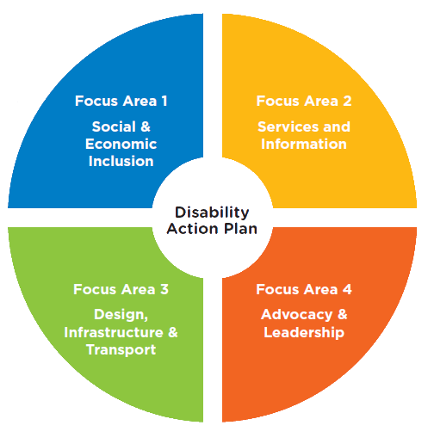.

Outcome area 1 - Social and Economic Inclusion

Vision statement

People with disabilities will have improved access to employment, education and volunteer opportunities along with greater opportunities to participate in leisure, recreation, arts and cultural activities.

Case Study

Art and culture at Maroondah City Council

The Arts and Culture team at Maroondah City Council regularly works on a range of projects that involve people with a disability. Maroondah’s Arts and Cultural Grants are available to fund projects that create opportunities for people with disabilities to engage in arts and performance practice. Artists can also apply to present exhibitions at Maroondah Federation Estate Gallery, and Wyreena Community Arts Centre runs disability arts programs. Both Maroondah Federation Estate Gallery and ArtSpace at Realm regularly present inclusive projects that involve arts groups and artists with a disability. For example:

Islands by Playable Streets was an interactive experience with light, sound and collective musical play in ArtSpace at Realm. The project featured a sound installation designed to be triggered by feet or wheelchairs. Leading inclusive dance and theatre company Weave Movement Theatre created an extraordinary performance in the Islands installation.

Threads by Nadrasca and Studio 4 was a collaborative exhibition in Maroondah Federation Estate Gallery celebrating the work of our local artists with a disability. This collaborative show provided an insight into each artist’s distinctive practice, whilst revealing their shared interests in the Maroondah community.

Baring your soul was an exhibition at Maroondah Federation Estate Gallery by Gifford Arts, an inclusive arts program that welcomes participation from a diverse gathering of artists from all ages and walks of life, including those with and without disabilities.
Maroondah City Council is committed to working with and celebrating the work of inclusive arts groups and artists living with a disability.

Key Directions and Priority Actions 2022-2026

Key Directions | Priority Actions | Lead Service Area | Timeframe
1.1 Reduce barriers to people with a disability accessing goods, services and facilities | 1.1.1 Research and develop a new access and inclusion report within Leisure's new Customer Relationship Management (CRM) system that will inform planning and priority setting. | Leisure | 2022-2024
 | 1.1.2 Work in partnership to facilitate volunteerism and create and promote meaningful and accessible volunteers opportunities, including supporting services provided by Eastern Volunteers. | Community Services | 2022-2023
 | 1.1.3 Provide support to local groups and agencies through the Community Grants program to progress programs empowering groups and individuals with disabilities to participate in community life. | Integrated Planning | 2022-2026
1.2 Provide and support leisure and community services that are engaging for people of all abilities and ages | 1.2.1 Partner with community agencies to host a local community event focused on families and children with disabilities and their access and participation in local programs across leisure and community services. | Leisure;  Community Services | 2022-2024
 | 1.2.2 Explore funding opportunities to provide support for vulnerable people to access leisure facilities. | Leisure | 2022-2023
1.3 Ensure arts and cultural activities in Maroondah are inclusive and accessible | 1.3.1 Explore opportunities to provide one Auslan interpreted performance in the annual Karralyka program and gather feedback to evaluate the impact it creates for the deaf community. | Leisure | 2022-2024
 | 1.3.2 Explore opportunities to celebrate International Day of People with Disability. | Integrated Planning | 2022-2024
1.4 Facilitate education and employment opportunities and reduce barriers for people with disabilities | 1.4.1 Research disability resources and toolkits for business and promote online and during BizHub week. | Business & Activity Centre Development | 2022-2024
 | 1.4.2 Develop knowledge and skills and undertake service area specific disability awareness training where identified. | Workplace, People and Culture | 2024-2026
 | 1.4.3 Explore opportunities to partner with education providers and employers to enable access to sustainable and accessible employment roles. | Lead - Workplace People and Culture  Support - All service areas | 2022-2024
 | 1.4.4 Encourage local businesses to consider volunteer positions/work placement for people with disabilities to create a learning employment pathway. | Business and Activity Centre Development | 2022-2023
 | 1.4.5 Investigate the establishment of a disability work experience/employment pilot program with council departments for people with disabilities. | Integrated Planning | 2022-2026

Outcome area 2 - Services and Information

Vision statement

Services and sharing of information will be easily available for people with disabilities to help increase access to health, social and support resources.

Case Study
Making Sense of the NDIS

The National Disability Insurance Scheme (NDIS) provides support to people who are under 65 years of age (under 50 years of age if the person is of Aboriginal or Torres Strait Islander identity) and have a permanent and significant disability, to live an ordinary life.

The NDIS system provides valuable and much needed support to our community, but at times the technical language and complex criteria can be difficult to understand, or terms can mean different things to different people. Sometimes this can result in people missing out on help they need and are eligible for.

When the Commonwealth government funded NDIS rolled out across Maroondah in late 2017, Council recognised that there was a continuing need to support to our community to help understand the NDIS system.

Maroondah’s NDIS Coordinator provides individualised and general support to anyone who lives, plays or works in Maroondah, as well as to professionals who provide NDIS support or referrals for our Maroondah community members.

Information and support provided to individuals and families includes:
- to understand NDIS technical questions, terms and jargon
- to understand the application process, such as how to answer NDIS application questions in NDIS terms, to give a clearer and more accurate picture of what support is needed
- with advocacy
- by attending preplanning and review meetings - the NDIS Coordinator has attended around 700 planning meetings over the last five years.
The provided service is individualised, as intended by the National Disability Insurance Agency (NDIA) principles, ensuring each person’s story is heard and supported.

Maroondah’s NDIS Coordinator also provides information to groups and providers on understanding the NDIS. Presentations to groups have included to: family groups, carer groups, General Practitioners, Primary Health Networks, Social Workers, hospitals, mental health groups, groups for young children, older persons groups and Indigenous groups.

Council is proud to support our Maroondah community to understand and navigate the NDIS system and is the only known Council in Victoria to provide dedicated NDIS client support to community members.

Client feedback

“During these occasions of incredibly stressful dealings with the NDIS, Kim’s assistance has helped to ease a very heavy weight from our shoulders.”

“We are new to the world of NDIS and whist I image we have a very long way to go, I don’t feel we could even have got to the point we are at now without Kim’s amazing support.”

Key Directions and Priority Actions 2022-2026

Key Directions | Priority Actions | Lead Service Area | Timeframe
2.1 Continue to develop inclusive communication methods in providing customer service to the community | 2.1.1 Investigate the potential for Council customer service centres to become accredited with The Communication Access Network, enabling placement of the communication access symbol at facilities. | Communications & Citizen Experience | 2022-2024
2.2 Support people with disabilities to navigate and connect to relevant support systems. | 2.2.1 Endeavour for all online and print material developed by Council to be in an accessible format for people of all abilities. | Communications & Citizen Experience | 2022-2026
 | 2.2.2 Disseminate information and update Councils website with information and resources that support people with a disability. | Integrated Planning | 2022-2024
 | 2.2.3 Support Maroondah residents to understand and navigate the NDIS through Council’s dedicated NDIS Coordinator. | Community Services | 2022-2023
 | 2.2.4 Update social statistics and insights to include the latest census data and disability data sources. | Integrated Planning | 2022-2023
 | 2.2.5 Explore opportunities to collect gender, disability, carer and age disaggregated data where-ever possible to better inform Council planning of programs and services. | Integrated Planning | 2022-2026

Outcome area 3 - Design, Infrastructure and Transport

Vision statement

A range of enhanced accessible facilities and environment will help to ensure that all people with disabilities can fully participate in community life.

Case Study

Disability Discrimination Act (DDA) program - improving pedestrian access and safety for people with a disability

Under the Council Plan 2021-2025, Council strives to strengthen the accessibility of our built environment and ensure that capital works are informed by accessibility for all ages, abilities and backgrounds.

Each year, Council dedicates budget to improve accessibility in our local area that are specifically to improve accessibility. The projects may be part of a larger redevelopment, or are smaller projects responding to accessibility issues identified and requested by our community members.

In 2021/22, Council is delivering nine projects worth nearly $260,000 to help traffic and pedestrian related infrastructure across Maroondah become compliant with the Disability Discrimination Act (DDA).

Council’s 2021/22 DDA Program Projects include:
- construction of $130,000 of tactile ground surface indicators and kerb ramp upgrades and realignments to improve accessibility in the Croydon Activity Centre.
- design projects (DDA compliant car spaces at Murray Place, Ringwood Major Activity Centre, and a path connection at Waterloo Street to Heathmont Reserve, Heathmont and Victoria Street, Ringwood)
- constructing a missing footpath link (Sunset Drive, Kilsyth South)
- installation of bollards in laneways to improve pedestrian road safety (Burwood Avenue Ringwood and Laurence Grove, Ringwood East)
- installation of street lighting to allow users to see hazards or obstructions on footpaths at night (various locations throughout Maroondah)
- installation of tactile ground surface indicators to improve road safety and accessibility at intersections (at Karingal Street/Exeter Road, and Exeter Road/Nangathan Way, Croydon North)
The program to improve accessibility and DDA compliance is ongoing and users with accessibility needs are encouraged to contact Council about specific accessibility issues they experience in Maroondah.

Key Directions and Priority Actions 2022-2026

Key Directions | Priority Actions | Lead Service Area | Timeframe
3.1 Ensure inclusive design of all major projects in Maroondah | 3.1.1 Continue to incorporate universal design principles into infrastructure planning, upgrades and maintenance to promote mobility and accessibility. | Assets | 2022-2026
3.2 Implement Council's ongoing capital works program to improve accessibility of Council's infrastructure in response to community needs | 3.2.1 Undertake disability access assessments for Council infrastructure and provide advice where required to address infrastructure accessibility and safety issues. | Engineering and Building Services | 2022-2026
3.3 Support environments that are accessible for people with disabilities | 3.3.1 Develop Maroondah Play Plan taking account of all cohorts including people with disabilities. | Assets | 2022-2023
 | 3.3.2 Continue to provide information to the community regarding accessibility requirements for buildings under the building code. | Engineering and Building Services | 2022-2026
 | 3.3.3 Continue to implement the footpath construction program  in-line with Council’s Principal Pedestrian Network, to ensure footpaths are accessible and connected across the municipality. | Engineering and Building Services | 2022-2026
 | 3.3.4 Consider the Disability Standards 2010 and Maroondah's Planning Scheme in Council's planning and development processes. | Statutory Planning | 2022-2026
 | 3.3.5 Develop a Maroondah Public Toilet Plan. | Assets | 2022-2023
 | 3.3.6 Work in partnership to undertake the staged redevelopment of the Croydon Community Wellbeing Precinct to deliver new community hubs that meet the needs of all ages, abilities and backgrounds. | Assets | 2022-2023

Outcome area 4 - Advocacy and Leadership

Vision statement
Council advocacy and leadership will result in increased community recognition of the value of people with a disability whilst broadening commitments from all levels of government and private enterprise to facilitate accessibility and inclusion for all members of the community.

Case study

Porn is not the norm (PINN)

Porn is not the norm is a ‘first of its kind’ project that supports young people with Autism and their parents, carers, teachers, workers and communities to:
- safely navigate the prevalence and influence of online pornography
- critique pornography
- understand and aspire to respectful relationships and sexuality.
The three-year project, now in its second year, includes: advocacy, workshops and training, a media strategy for creating engagement and public discourse, and the development of education resources (including a website and video resources).

PINN was initiated by Maroondah City Council and Maree Crabbe (from It’s Time We Talked) after identifying an unmet need in the community. The project is run by Interchange Outer East (IOE) and was developed by a consortium of partners including: IOE, Maroondah City Council, It’s Time We Talked (Maree Crabbe), Dr Wenn Lawson, Barwon Adolescent Taskforce (BATForce), South Eastern Centre Against Sexual Assault and Family Violence (SECASA) and Kids First Australia. Most of the consortium are actively involved on the PINN Executive Group or the Consortium Reference Group.

An Autism Community Advisory Group ensures the voices and expertise of young people with autism, and others from the autism community, informs and guides the project.

While the project began in Maroondah, other communities now also benefit from PINN. PINN was awarded $300,000 per year over three years as part of the Westpac Foundation’s 2020 Impact Grants Program allowing the project to have a wider reach.

PINN participant feedback:

“[the workshop] Gave me the confidence to open discussion about porn with my… son.”

“Hearing about the themes in mainstream pornography was chilling and a reminder to include a discussion of this with all the young people I see - in a manner that encourages thought.”

Key Directions and Priority Actions 2022-2026

Key Direction | Priority Action | Lead Service Area | Timeframe
4.1 Advocate for people with disabilities, their families and carers | 4.1.1 Work in partnership to support and promote a range of awareness events that reflect the intersectional needs, diversity and priorities of our community, involving input from people with lived experiences, allies and local champions. | Integrated Planning | 2022-2024
 | 4.1.2 Work in partnership to deliver 'Porn is not the Norm' project that supports young people with autism, their families, carers and professionals to understand the intersection between pornography and autism. | Integrated Planning | 2022-2023
 | 4.1.3 Facilitate the Maroondah Disability Advisory Committee to communicate information and undertake consultation. | Integrated Planning | 2022-2026
 | 4.1.4 Promote the Disability Advisory Committee to all areas across Council to encourage consultation and information sharing on projects, services, policies and plans. | Integrated Planning
 | 4.1.5 Facilitate the Maroondah Access Inclusion and Equity Advisory Committee to provide advice and input to Council on a range of issues and projects. | Integrated Planning | 2022-2026
 | 4.1.6 Work in partnership to develop initiatives that improve community inclusion and participation for people with a disability and their carers to help address social isolation. | Integrated Planning | 2022-2024
 | 4.1.7 Work with Eastern Transport Coalition to advocate to State Government on the future direction of public transport to ensure services are accessible to people with disabilities. | Integrated Planning | 2022-2024
 | 4.1.8 Continue to advocate for a Carers Victoria hub in Maroondah. | Integrated Planning | 2022-2024
4.2 Advocate and promote an increase in affordable housing in Maroondah | 4.2.1 Support the delivery of housing market innovations such as Greening the Greyfields initiative. | Integrated Planning | 2022-2024
 | 4.2.2 Explore advocacy actions regarding affordable and suitable housing for people with a disability through regional advocacy groups. | Integrated Planning | 2022-2026
4.3 Promote a positive awareness of people with disabilities in our community | 4.3.1 Facilitate the promotion of accessibility features of Council's new developments, open spaces, sporting and leisure facilities, main events and major projects. | Communications & Citizen Experience | 2022-2026
 | 4.3.2 Use positive images and stories of people with disabilities to demonstrate the valuable contribution they make in the community. | Communications & Citizen Experience | 2022-2026
 | 4.3.3 Ensure people with disabilities are considered when developing community engagement plans for strategic policies, capital works, service delivery and advocacy activities. | Lead - Communications & Citizen Experience  Support -All service areas | 2022-2026

Tracking our progress

Council will monitor the implementation of the Maroondah Disability Action Plan 2022-2026 and report on progress through Council’s Annual Report as required by the Victorian Disability Amendment Act 2012. The Plan will also be evaluated in relation to outcomes and impacts on the lives of people with disability on an ongoing basis.

The Maroondah Disability Advisory Committee will also provide strategic advice and input on the implementation and evaluation of the Plan.

A full review of the Action Plan will be completed in 2025/26.

