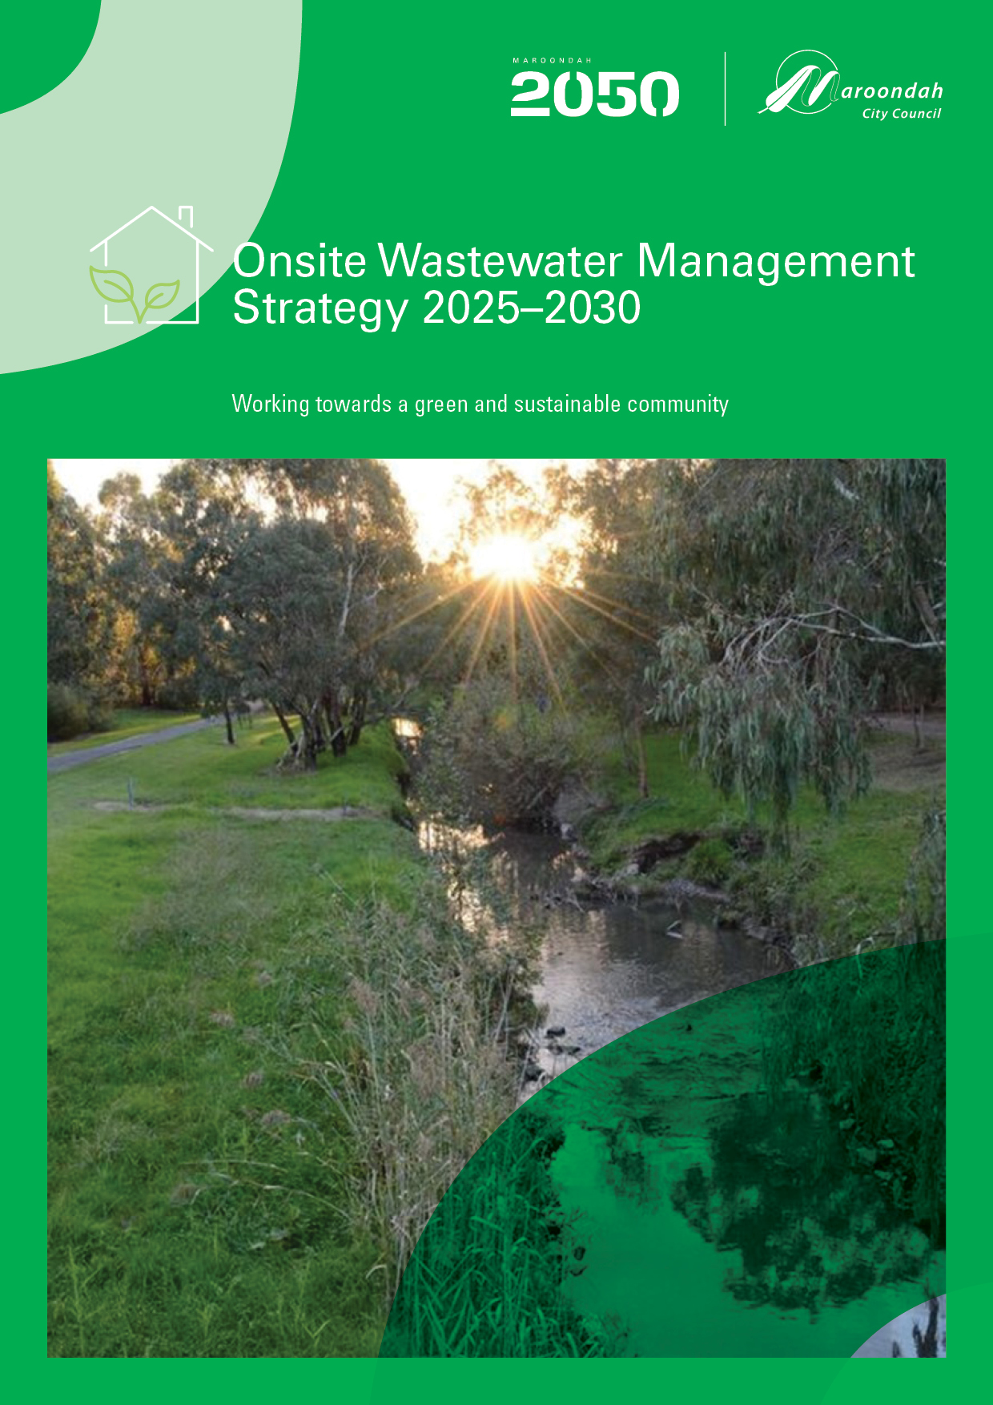
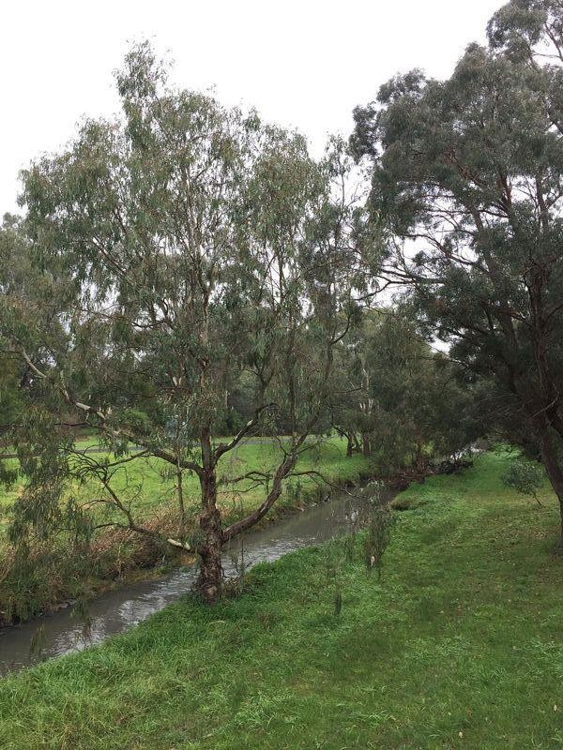

Contents
Contents 3
Purpose of the Strategy 4
Background 5
Legislative Context 5
Roles and Responsibilities 6
Our journey so far 8
Maroondah in Context 10
Strategic context 11
Maroondah 2050 11
Maroondah’s Domestic Wastewater Management Profile 12
Education and Compliance program 15
Identifying Risks Associated with Domestic Wastewater for Maroondah 18
Assessing the Risks 20
Approach to Compliance 25
Our strategic response - the way forward 26
Our vision 26
Future outcomes 26
Outcome 1 - Healthy Environments 27
Outcome 2 - Collaborative Cultures 27
Outcome 3 - Information Management 28
Action Plan 29
References 34
Glossary 35

Purpose of the Strategy

The Onsite Wastewater Management Strategy (the Strategy) is Maroondah City Council’s strategic plan to enhance the management of onsite wastewater management systems by not only improving the current situation but by ensuring processes are improved to guarantee environmentally sustainable and best practice decisions are made in the future.

This Strategy identifies and assess the risks and ensures the necessary actions to ensure that existing onsite wastewater management systems (OWMS) and any new installations or alterations are installed, maintained, and monitored, as to protect the health of the community and the surrounding physical environment.

This Strategy has the following purposes:

- To protect public health and the physical environment from the impacts of domestic wastewater.
- Identify the risks to human health and the environment from unsewered allotments.
- Assess the risks to human health and the environment from existing and future onsite wastewater management systems, including the management of existing systems discharging beyond the boundaries of the allotment or those OWMS that may have the risks of impacting on groundwater or surface water.
- To identify onsite wastewater management system priorities and develop short and long term strategies with timelines for the implementation of these priorities.
- To provide a mechanism for coordinated onsite wastewater management system planning, community education and compliance monitoring by Council and other stakeholders including the local water corporation.
- To promote environmental sustainability by reducing the impacts of onsite wastewater management systems on the local receiving environments.

Background

The Domestic Wastewater Management Strategy (DWMS) was developed in 2017 and highlighted a number of key issues relating to domestic wastewater management at Maroondah. These included:

- Inconsistencies in relation to domestic wastewater data;
- A need to ensure ongoing strategic alliances with the Yarra Valley Water and ensuring the DWMS aligns with future sewerage servicing strategies developed by the water authority;
- Decisions concerning domestic wastewater management at Maroondah were not supported by an over-arching wastewater operational management strategy or decision making framework;
- The need for regional land capability mapping system to assist in the decision making process
regarding individual septic tank installations;
- The number of failing wastewater systems in operation within the municipality was unknown;
- The need for internal referral processes for developments within unsewered areas within the municipality;
- The need to develop a wastewater community education program to assist in improving the community’s knowledge of the risks associated with the poor maintenance of wastewater systems;
- The need for a greywater reuse policy and an associated community education program to ensure greywater is managed appropriately; and
- The legislative framework in Victoria was complex and outdated.

To address these issues, an action plan and the DWMS 2017-2021 was developed to provide a framework for the management of domestic wastewater in Maroondah.

The DWMS underwent an administrative review in 2021, aligning it with the Environment Protection Act 2017, Environment Protection Regulations 2021 and Environment Protection (Transitional) Regulations 2021.

A summary of achievements from this strategy is outlined in Our Journey so far.

Legislative Context
There are several key pieces of legislation, policies and guidelines that assist Council and other stakeholders to aim for best practice management of domestic wastewater. These include:

  - Environment Protection Act 2017 (EP Act)
  - Environment Protection Regulations 2021
  - Environment Protection Transitional Regulations 2021
  - Public Health and Wellbeing Act 2008 (PHWB Act)
  - Local Government Act 2020
  - Planning and Environment Act 1987
  - Water Act 1989
  - Victorian Government Gazette - EPA Obligations of Managers of Land and Infrastructure (Urban Stormwater Management and On-site wastewater management - May 2024
- Regulating on-site wastewater management systems: local government toolkit (EPA publication #1974)

- EPA Guideline for onsite wastewater management (for councils, water corporations and installers)
- EPA Guideline for onsite wastewater effluent dispersal and recycling systems
- Requirements for owners and occupiers with on-site wastewater (for community)
- Victorian Guideline for irrigation with recycled water (EPA publication 168) (for irrigation designers and operators)
- Victorian Land Capability Assessment Framework (MAV)
- AS/NZS 1546.1: 2008, On-site domestic wastewater treatment units, Part 1: Septic tanks
- AS/NZS 1546.2: 2008, On-site domestic wastewater treatment units, Part 2: Waterless composting toilets
- AS 1546.3:2017, On-site domestic wastewater treatment units, Part 3: Secondary treatment systems
- AS 1546.4:2016 On-site domestic wastewater treatment units, Part 4: Domestic greywater treatment systems

Roles and Responsibilities

Environment Protection Authority
The Environment Protection Act 2017 and the Environment Protection Regulations 2021 are the primary legislation that regulates and controls domestic wastewater management. The Environment Protection Authority (EPA) has the overall responsibility for legislation, policy and standards for wastewater management systems. All domestic onsite wastewater management systems need to be issued with a Certificate of Conformance by an accredited conformity assessment body under an Australian Standard, before they are permitted to be installed in Victoria.

The EPA is responsible for any wastewater treatment system that discharges capacities of 5,000 litres or more of wastewater daily. Generally, these are commercial and industrial applications.
Domestic wastewater management in Victoria is one of the environmental health responsibilities delegated to local government. Council acts as the permitting authority, approves the installation of wastewater systems and regulates appropriate maintenance and use of the systems.

Local Government

Under the Environment Protection Act 2017 and Environmental Protection Regulations 2021, local government is the primary agency responsible for the management of domestic wastewater, including systems that have a capacity to treat less than 5,000 litres. Under this Act, a property owner cannot construct, alter or install a wastewater system without a permit from Council.

Councils use permits to regulate the installation and alteration of wastewater systems within their municipal boundaries under the Environment Protection Act 2017. Councils are also responsible for identifying failing wastewater systems that are causing environmental, public health and amenity risks and ensuring owners and operators of onsite wastewater management systems are meeting their obligations under the Regulations and the Act.

Obligations of Managers of Land or Infrastructure (OMLI)
In May 2024, the Victorian Government approved the OMLI (Urban stormwater management and Onsite wastewater management). This Order is made under section 156 of the Environment Protection Act 2017 and requires Local Government to develop an onsite wastewater management plan.

The OMLI also sets out the requirements for Council to implement and review an Onsite Wastewater Management Plan (this document) for their municipality.

Owners and Operators of OWMS

The cornerstone of the Environment Protection Act includes a General Environmental Duty which states that: A person who is engaged in an activity that may give rise to risk of harm to human health or the environment from pollution or waste must minimise those risks, so far as reasonably practicable.

Under delegation from the Environment Protection Authority, Council can now consider management of onsite wastewater management systems that give rise to risk of harm to human health or the environment.

The Regulations also place obligations on owners and operators of onsite wastewater management systems to ensure they are:

    - Maintaining the system in good working order
    - Ensuring those operating the system have the information they need to maintain and operate it effectively and;
    - Responding to any failures

Council has a duty to exercise its enforcement powers where it knows there is a breach of legislation and there is the likelihood of impact to public health and the environment.

Yarra Valley Water

Yarra Valley Water (YVW) provides reticulated sewerage services to properties located within Maroondah.

A limited number of properties can be connected to piped sewerage each year. Based on information about the environmental and public health risks posed by poorly performing OWMS, the Onsite Wastewater Management Plan developed by Local Government and in consultation with the EPA, Melbourne Water, Councils and the State government, Yarra Valley Water submit a 5 yearly plan to the Essential Services Commission (ESC) and to Council outlining the preferred method and plan for sewerage management.

YVW have set a Community Sewerage Program (CSP) and Community Sewerage Areas (CSAs) which aim to provide sewerage to identified areas in all municipalities within their catchment. Within their current plan reprioritised between 2021 - 2024, YVW have properties within Maroondah to be connected to sewer between 2033 to 2042, with 11 properties allocated for connection in 2025 as part of the Park Orchards CSP.

Properties in Maroondah currently included in the Yarra Valley Water Community Sewerage Program can be obtained by contacting Yarra Valley Water https://www.yvw.com.au/contact-us or via their website: https://www.yvw.com.au/faults-works/community-sewerage-program/connect-sewer.

Our journey so far

Council is working to reduce the risks associated with domestic wastewater management.

Some of the actions Council is undertaking are outlined below:

- Information through Council’s communication outlets including website and social media has been provided to the community. This includes information on the correct use and maintenance of their OWMS.

- Information on Maroondah’s website is updated to include Environment Protection legislative framework and providing information to operators and owners of OWMSs about their legislative responsibilities and is also intended to increase the community’s understanding of the importance of managing wastewater systems appropriately.

- The OWMS education and compliance program was initiated in 2023 reaching 67% of properties to assess the current condition of their OWMS and to provide education, including a written report and education material to owner/operators on their legal obligations under the Environment Protection legislative framework. It also included information on how to effectively use and maintain their OWMS. Corrective actions have been required for 23% of property owners.

- New owners of OWMS, when purchasing unsewered dwellings is Maroondah, are provided with information about their OWMS and their legislative obligations and they are offered an onsite OWMS education visit.

- All Certificates for Use of an OWMS issued when an OWMS is installed and approved for use, contain information on effective use and maintenance of an OWMS and owner and operator legal obligations under the Environment Protection Act 2017 and Environment Protection Regulations 2021.

- Council is encouraging OWMS owners to connect to sewer when it becomes available.

Council is monitoring and responding to aerated wastewater treatment system maintenance reports provided to Council by wastewater servicing agents to ensure defects are repaired.

Council works with Yarra Valley Water (YVW) on the Community Sewerage program to advocate for sewer infrastructure to unsewered properties within Maroondah into the future. YVW has released its reprioritised Community sewerage program (CSP), indicating additional properties in Maroondah that will have access to sewer between 2033 - 2042.

- Council undertook work on the Community Sewerage Program reprioritisation in 2021 and supported YVW to plan the piped sewerage infrastructure, based on risk, across pockets of Maroondah.

- A dedicated OWMS portfolio is established and is seen as a key priority area in Community Health.

- Council officers have participated in stakeholder discussions to inform the Environment Protection legislative framework pertaining to the management of onsite wastewater management systems. Council’s Community Health team continue meet regularly with the EPA around OWMS matters.

Our journey so far continued...

- Relationships between Community Health, Planning and Building have been strengthened, including automated referral systems and regular team information sessions to ensure all new developments, subdivisions and alterations to existing properties that are serviced by an OWMS, are managed appropriately.

Council maintains an information management system ensuring all information relating to OWMS is stored appropriately and current owners are linked.

Procedures are prepared to underpin consistency and legal requirements in processes that relate to OWMS and the legislative framework. This includes procedures for the assessment of new or altering OWMS applications, OWMS education, monitoring and compliance procedures, sewered properties and decommissioning processes.

Information on sewered properties and sewerage infrastructure from Yarra Valley Water is being updated on an annual basis and integrated into Council’s geographical information system (GIS).

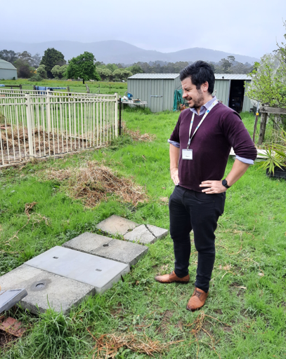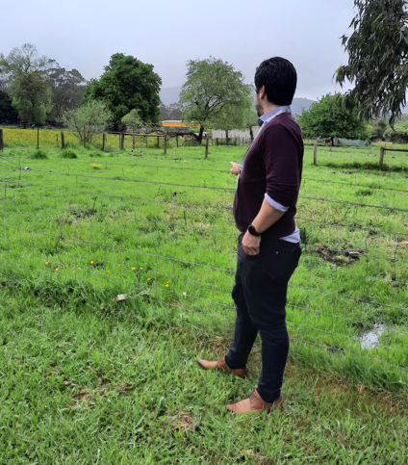

Images: Environmental Health Officer undertaking OWMS education visit and observations of a poorly functioning OWMS.

Maroondah in Context
The City of Maroondah is located within the eastern suburbs of Melbourne and covers an area of approximately 61.4 square kilometres. The area is a substantially developed peri-urban residential municipality, with an estimated population of 119,354residents and 44,167 households with an average of 2.53 people per household.
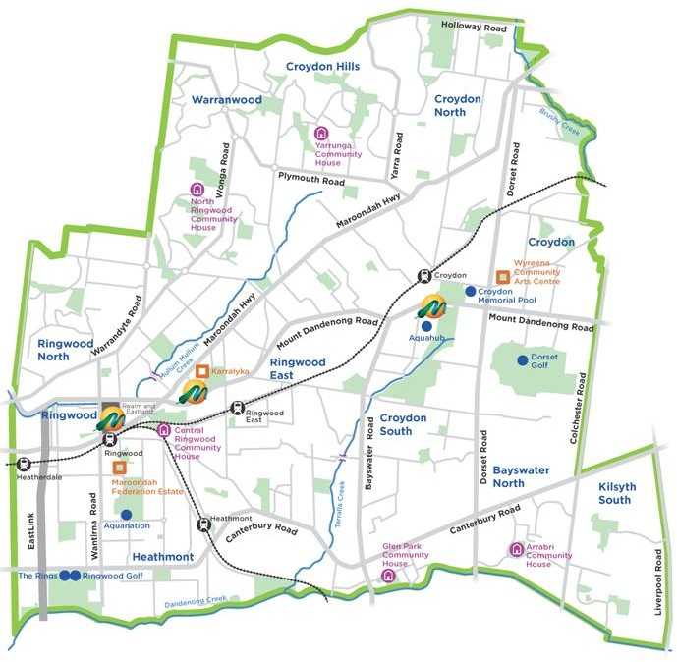
Map of Maroondah

Maroondah is well known for its leafy streets, broad areas of open space, bushland reserves, parks and playgrounds. Sustainable transport links include on-road cycling paths and shared path links to the Mullum Mullum Creek Trail, the EastLink Trail, Tarralla Creek Trail and the Dandenong Creek Trail.

Maroondah’s natural environment is highly valued and our green character is treasured by locals. There is a strong desire for our green open spaces and bushland reserves to be enhanced and protected.

Mullum Mullum Creek and Dandenong Creek are the major waterways in the Maroondah area, with established recreational routes that are well utilised. The waterways within Maroondah also drain to two of Melbourne Water’s main catchments - Dandenong Creek and Yarra River which are enjoyed by a broader community and therefore need to be carefully managed.

Strategic context

Maroondah 2050

Council uses an Integrated Planning and Reporting Framework to strategically connect the long-term aspirations, priorities and needs of the Maroondah community to the long, medium, and short-term strategies, plans, policies and resources of Council.

The Framework ensures alignment between Council’s planning, service delivery and performance monitoring and reporting activities.

The Framework also enables our organisation, our community and our partners to adapt and prioritise initiatives, activities and actions to respond to community needs as well as legislative changes as they emerge and change over time.

The Onsite Wastewater Management Strategy is one of a broad range of strategies, policies and plans - both legislated and Council initiated - that have a significant influence on Council planning and service delivery and contribute to working towards the Maroondah 2050: Our future together Community Vision.

Integrated Planning and Reporting Framework

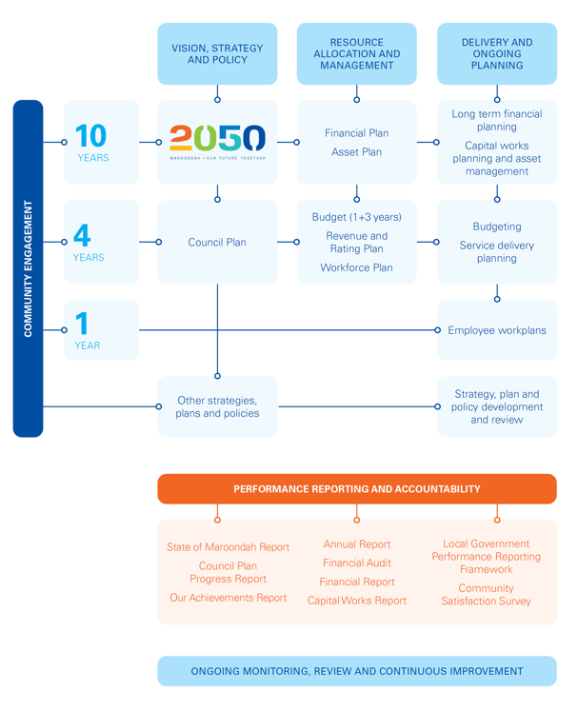

Community Vision

The Community Vision is developed in partnership with the Maroondah community and describes long-term aspirations for the future of Maroondah.

The Maroondah 2050: Our future together Community Vision provides a ‘roadmap’ for the community, Council, organisations and businesses, as well as other levels of government, to partner to create a future that enhances Maroondah as a great place to live, work, play and visit.

The Maroondah 2050 Community Vision describes our community’s aspirations for the future of Maroondah looking ahead to the year 2050. It is a vision that is unique to Maroondah. It speaks to the way our community wants to feel - safe and included, how they want the municipality to be - vibrant and green, and what they want to strive for - a prosperous and sustainable future for all.

The Maroondah 2050: Our future together Community Vison identifies five future outcome areas which establish the broad community aspirations and priorities for Council and the community to work together. The Onsite Wastewater Management Strategy is working towards four of these outcome areas.

A healthy, inclusive and connected community
Everyone in Maroondah feels valued, welcome and respected, and has opportunities to thrive regardless of their background, identity or circumstances. Community members experiencing vulnerability, marginalisation or disadvantage have access to the support they need. Opportunities for social connection, and to enhance health and wellbeing, are encouraged.

A safe and liveable community
Everyone in Maroondah feels physically and emotionally safe. Local neighbourhoods and activity centres are easy to move around. There are the housing options, amenities and services people need to live, work, learn and play locally. The unique attributes of Maroondah, and our local history and heritage, are valued and promoted.

A green and sustainable community
Maroondah’s green, leafy natural environment and landscape continues to be preserved and enhanced, with biodiversity and habitat corridors progressively restored and maintained. Our community is supported to make sustainable choices and is actively working to reduce emissions and waste, as well as adapt to climate change.

A well governed and empowered community
Council continues to be a transparent, accountable, and future-focused leader that collaborates locally and regionally and actively champions local needs. Everyone in Maroondah is informed about matters that affect them and are provided with opportunities to meaningfully engage regarding Council decision making.

Domestic Wastewater Management Profile

There are 136 known properties operating onsite wastewater management systems within the municipality. There are nine properties that operate two OWM systems. An overview of the pocket areas of wastewater systems in Maroondah can be seen in the figure below.
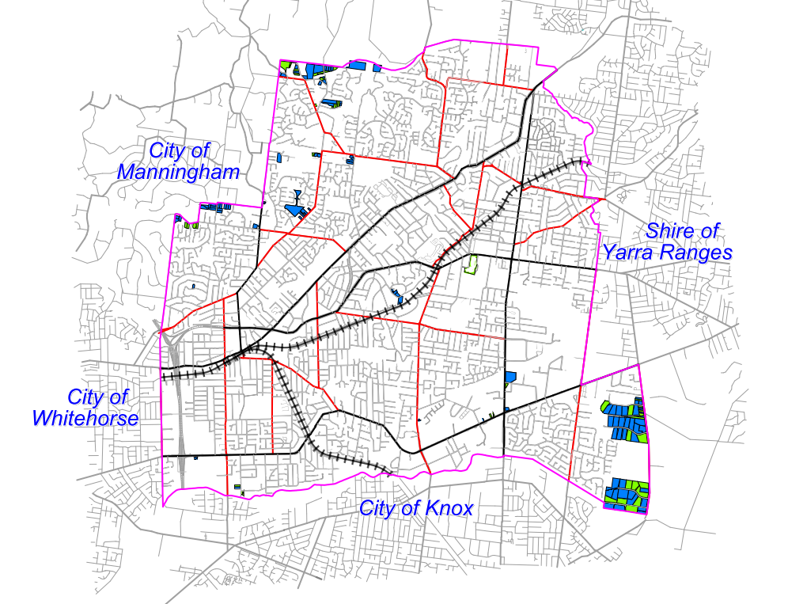
Figure 1: Overview of wastewater systems located throughout Maroondah

Aerated Wastewater treatment system
Primary treatment system

The following table provides a breakdown of the number of properties with wastewater systems for each suburb in Maroondah and the number of properties discharging to storm water. It also provides an indication of the known number properties connected to sewer.

Suburb | OWMS in use (9 properties have 2 systems operating) | Discharging to stormwater | Connected to sewer in last 9 years
Bayswater North | 8 | 2 | 0
Croydon | 6 | 0 | 0
Croydon Hills | 1 | 0 | 0
Heathmont | 5 | 1 | 1
Kilsyth South | 63 | 4 | 0
Park Orchards | 4 | 2 | 1
Ringwood | 3 | 0 | 1
Ringwood North | 22 | 5 | 12
Warranwood | 33 | 4 | 1
Total | 145 | 18 | 16
Table 1: Number of wastewater systems per suburb in Maroondah

These systems include septic tanks, aerated wastewater treatment systems (AWTS), sand filters, greywater treatment systems and worm farms disposing to underground trenches, subsurface irrigation and discharging to stormwater (Figure 2). Council has no records for some properties. This may be due to installation occurring prior to Council’s record keeping or due to amalgamations. There is no sewer currently available for these properties.

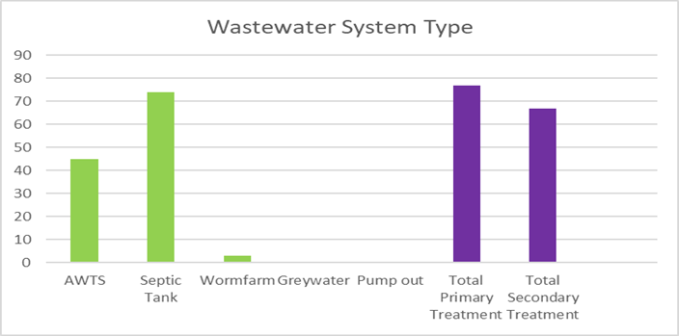

Figure 2: Wastewater system types servicing properties within Maroondah

Figure 3 shows the percentage of properties discharging wastewater to the stormwater system. These properties were granted consent to carry out this activity under their Permit issued by Council at the time. This method of disposing wastewater is no longer permitted in Victoria.

The General Environmental Duty (GED) now makes it possible for Council to require a property owner to upgrade their OWMS to retain wastewater onsite or to connect to sewer where this is available. Council will consider the use of this legislation on a case-by-case basis, in accordance with the Organisational Compliance Policy principles, where the current OWMS system discharging wastewater offsite is found to be defective or is not being maintained.

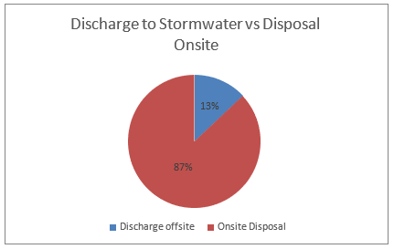

Figure 3: Percentage of properties permitted to discharge wastewater offsite to stormwater.

A number of properties in Maroondah are currently included in the Yarra Valley Water Community Sewerage Program. This information can be obtained by contacting Yarra Valley Water https://www.yvw.com.au/contact-us or via their website: https://www.yvw.com.au/faults-works/community-sewerage-program/connect-sewer.

Education and compliance program

During 2023, Council Environmental Health Officers contacted all owners of OWMS to offer a free onsite education visit to provide information on:
- The type of onsite wastewater management system operating on the property;
- How the system should be effectively used;
- How to maintain the system and;
- What their new obligations were as owners or occupiers operating an OWMS under the Environment Protection Act 2017 and Regulations 2021.

Officers also assessed the current operation of the OWMS and made an overall assessment of the risk the system poses to health and the environment as a result of:
- How effectively it was operating;
- How well it was being maintained;
- Whether wastewater was contained onsite or discharged offsite and;
- The knowledge the operators/owners had about their system and how to use and effectively maintain the system.

The overall risk rating was determined by the following:
Overall OWMS Risk Rating
High (Critical) | - The operator has limited knowledge on how to use the system properly and/or  - There is a physical issue noticeable. E.g., Broken parts and or odour and or wet soggy ground and/or  - The system is not being maintained at all and effluent is being discharged offsite or running outside the property boundaries.
Medium (Major) | - The system is discharging effluent offsite, but it is being maintained well and no odour detected or discoloured water offsite.  AND  - The occupiers are aware of how to use the system properly.  - There is no physical issue noticeable, no broken parts, no odour or wet, soggy ground but some of the maintenance is overdue or never undertaken.  AND  - The operator is aware of how to use the system properly.
Low (Minor or satisfactory) | - System appears to be operating well.  - System is being maintained as required.  - Operator is aware of how to use the system properly.  - Effluent is discharged onsite.

Of 136 properties:
- 97 education visits were conducted and;
- 39 declined or could not be contacted.

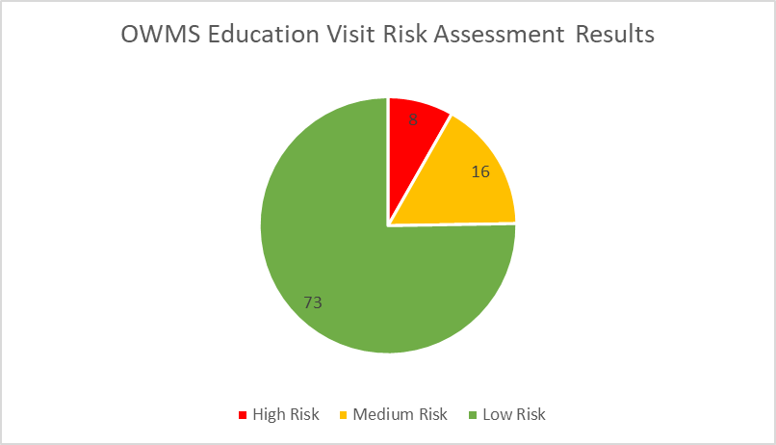
Figure 4: The overall risk rating for the 97 OWMS assessed.

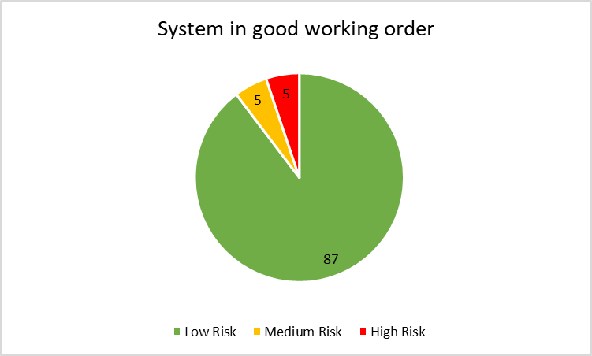
Figure 5: Environmental Health Officer assessment of OWMS functioning.

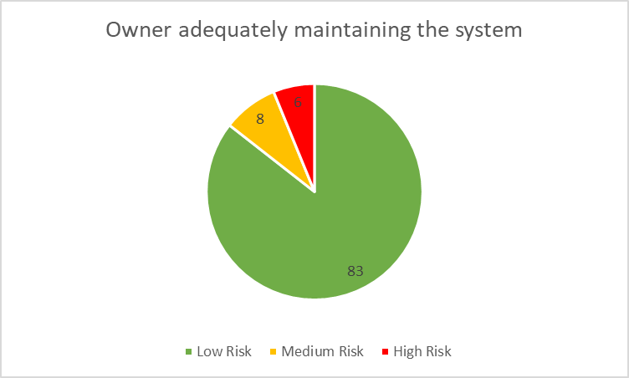
Figure 6: Indication of how well the owner is maintaining the OWMS

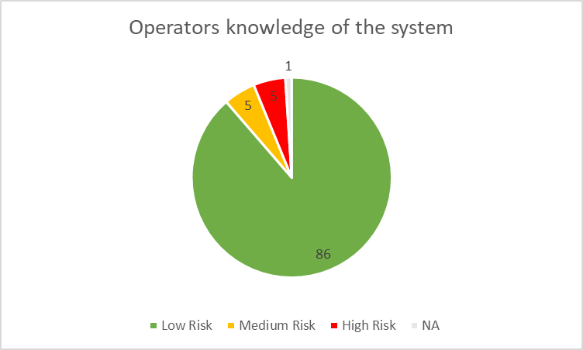
Figure 7: Indication of the Operator’s knowledge of the system

Outcome Education and Compliance program

The OWMS education visit indicated that 75% of OWMS were assessed overall as low risk. 7% were assessed as critical with corrective action required immediately and 16% were assessed as moderate risk with some corrective action required.

The majority of OWMS were operating effectively, well maintained and the operators understood how to use them effectively.

Identifying risks associated with domestic wastewater
From the 1950s, wastewater systems were used and continue to be used extensively throughout Victoria in areas not serviced by reticulated sewerage. Wastewater systems are an acceptable solution to treat domestic wastewater provided the wastewater is contained and disposed of effectively onsite.

In the past, wastewater systems were a key contributor to the increasing pollution of Melbourne’s rivers and creeks that threatened the health of Port Phillip Bay. Wastewater from onsite wastewater management systems, seeps into stormwater drains, waterways and groundwater, whilst also polluting soils and increasing the risks to public health, environmental health and creating detrimental effects to the local amenity.

Maroondah City Council has a responsibility in ensuring the risks associated with domestic wastewater are appropriately managed. From the workings undertaken as part of the domestic wastewater management project and recent education/compliance visits, the risks identified for Maroondah include:

Public Health Risks
Domestic wastewater poses a potential public health risk such as:
- Human diseases such as gastroenteritis, caused from contaminated water bodies; and
- Increased capacity of mosquito breeding as a result of pooling, stagnant wastewater resulting in a vector of disease.

Environmental Health Risks
Domestic wastewater poses a potential risk to the natural environment:
- Contamination of groundwater by nitrates and faecal pathogens;
- Seepage can raise the groundwater table causing salinity;
- Domestic wastewater discharge into water catchments stimulates algal growth and land degradation;
- Domestic wastewater carries suspended solids, ammonia and organic matter, which can affect fish, aquatic plants and micro-organisms; and
- Domestic wastewater can be carried into other water bodies and cause further pollution.

Legal Risks
Under the Environment Protection Act 2017 and the Environment Protection Regulations 2021, local government is the primary agency responsible for the management of onsite wastewater management systems. In addition to the approval of the installation of wastewater systems within the municipality, Maroondah City Council is also responsible for identifying failing wastewater systems that are causing environmental, public health and amenity risks.

The 2006 Auditor General’s report Protecting Our Environment and Community from Failing Septic Tanks, found that most local governments have not allocated adequate resources to effectively carry out their legislative responsibilities for domestic wastewater management.

Council is bound to implement the Environment Protection legislation and ensure owners and occupiers of onsite wastewater management systems are meeting their responsibilities to maintain the system in good working order, ensuring those operating the system have the information they need and respond appropriately to any failures.

Economic and Amenity Risks
The impacts of failing wastewater systems and the associated risks to public health and the health of our natural environment are easy to obtain in comparison to the long term effects on the local economy and local amenity. Domestic wastewater can affect the local economy and amenity of Maroondah in the following ways:

  - Poor septic tank management decreases land amenity and economic value;
  - Contaminated water bodies can negatively impact on aquaculture and agriculture using recreational water bodies;
  - Possibility of increased maintenance to stormwater drains which receive wastewater due to poor system maintenance.

Assessing the Risks

Risk is assessed with an understanding of the likelihood of the event occurring versus the consequences of that event occurring, relative to the scenario.

In the context of domestic wastewater, likelihood and consequences are defined in Table 2 & 3.

Likelihood Rating Table
1 | Rare | Not likely to occur. Less than 25% chance of occurring.
2 | Unlikely | Could occur at sometime within the next 5 years. 25% chance of occurring.
3 | Possible | May occur at some time in the next 3 years. 25-40% of occurring.
4 | Likely | Will probably occur at sometime within the next 2 years. 40-70% chance of occurring.
5 | Almost certain | Will probably occur at sometime within the next 1 year. Greater than 70% chance of occurring.

Table 2 - Likelihood Rating Table

Consequence Rating Table

 |  | Public Health | Environmental Health | Legal | Economic and Amenity
1 | Insignificant | No illness. Some minor exposure. | Minimal land/water contamination. | Meeting legal obligations. | No impact to land amenity and economic value.
2 | Minor | No illness, but there is exposure to untreated wastewater contamination | Minor wastewater contamination of land on primary private property. | Council has failed to meet a minor part of their obligations under EP Act and/or PHWB Act. | Minor impact to land amenity and economic value.
3 | Moderate | Less than 2 people unwell with exposure to wastewater contamination | Minor wastewater contamination of land and/or waterways on secondary private properties. | Council has failed to meet its obligations to ensure compliance with EP Act and or PHWB Act and is subject to investigation or litigation. | Impact to amenity and or water ways moderately reducing their usability and economic value.  Stormwater maintenance is moderately impacted.
4 | Major | 2 - 5 people unwell with exposure to wastewater contamination. | Large wastewater contamination of land and/or waterways extending to secondary properties and or waterways | Council has major failings in meeting its obligations under EP Act and/or PHWB Act and is subject to prosecution and/or litigation. | Major impact to amenity and or water ways reducing their usability and economic value.  Major impact to stormwater maintenance.
5 | Extreme | Significant number of people unwell with exposure to wastewater contamination.  Single or multiple deaths with exposure to wastewater contamination. | Extensive untreated wastewater contamination of waterways, ground water and land on public and/or private properties. | Council has significant failings in meeting its obligations under the EP Act and/or PHWB as is subject to significant prosecution/fines and or serious litigation including class actions. | Significant impact to amenity and or water ways significantly reducing their usability and economic value. Stormwater system maintenance is significantly impacted.

Table 3 Consequence Rating Table

Table 4 provides the risk matrix that establishes the overall risk rating, based on the outcome of the likelihood and consequences assessed for the current situation.

Risk Matrix
Likelihood | Consequence
Likelihood | Insignificant | Minor | Moderate | Major | Extreme
Almost certain | Moderate | Significant | Significant | High | High
Likely | Moderate | Moderate | Significant | Significant | High
Possible | Low | Moderate | Significant | Significant | Significant
Unlikely | Low | Moderate | Moderate | Moderate | Significant
Rare | Low | Low | Low | Moderate | Moderate

Table 4: Likelihood and consequence risk matrix

Table 5 outlines how Council has assessed the current risk level associated with Domestic Wastewater in Maroondah.

Domestic Wastewater Risk Assessment

Risk | Risk Description | Untreated Risk | Current condition and actions achieved | Residual Risk Rating | Desired Risk Rating
PH-01  Public Health | Impact to the health of the public from poorly functioning or defective OWMS | Significant  Likely  Major | Partially effective  - 145 operating OWMS in Maroondah  - 87% contain wastewater onsite and only 13% discharge wastewater offsite.  - Education visits conducted to 67% of OWMS operators in 2023. 75% assessed as low risk.  - Permits issued for new/altering OWMS, must be contained onsite.  - Work progressing with YVW to provide further access to sewerage infrastructure.  - Responsibilities of OWMS operators communicated broadly, including new owners.  - Environment Protection regulatory framework provides powers to Council to address poor performing systems, require records and in some cases require connection to sewer. | Moderate  Likely  Minor | Low
EH-02  Environmental Health | Impact to the health of the environment from poorly functioning or defective OWMS | Significant  Likely  Major | Partially effective  - 145 operating OWMS in Maroondah  - 87% contain wastewater onsite and only 13% discharge wastewater offsite.  - High cost of connection to sewer  - Work progressing with YVW to provide further access to sewerage infrastructure.  - Education visits conducted to 67% of OWMS operators in 2023. 75% assessed as low risk.  - Permits issued for new/altering OWMS, must be contained onsite.  - Responsibilities of OWMS operators communicated broadly including new owners.  - Environment Protection regulatory framework provides powers to Council to address poor performing systems, require records and in some case require connection to sewer. | Significant  Likely  Moderate | Moderate

Risk | Risk Description | Untreated Risk | Current condition and actions achieved | Residual Risk Rating | Desired Risk Rating
LEG-03  Legal | Legal implications for Council from the negative impacts on community health and environmental health from unmanaged OWMS | Significant  Possible  Major | Effective  - Onsite Wastewater Management Strategy with operational action plan.  - Environment Protection legislative framework imbedded in procedures for new/alteration permits, education/compliance visits, complaint response.  - Compliance tools available to use in accordance with Maroondah Compliance Policy.  - Environmental Health Officer training in Land Capability Assessments and OWMS operation and installation.  - Proactive education visits being undertaken ongoing with OWMS operators. | Moderate  Unlikely  Moderate | Low
ECON-04  Economic and Amenity | Economic impact to Council from the negative effects on the amenity from unmanaged OWMS | Significant  Possible Moderate | Partially Effective  - 145 operating OWMS in Maroondah  - 87% contain wastewater onsite and only 13% discharge wastewater offsite  - High cost of connection to sewer  - Work progressing with YVW to provide further access to sewerage infrastructure.  - Education visits conducted to 67% of OWMS operators in 2023.  - Permits issued for new/altering OWMS, must be contained onsite  - Responsibilities of OWMS operators communicated broadly  - Environment Protection regulatory framework provides powers to Council to address poor performing systems, require records and in some case require connection to sewer. | Moderate  Likely  Minor | Low

Table 5: Assessment of risks associated with Domestic Wastewater in Maroondah

Approach to Compliance

Council’s approach to compliance primarily starts with the provision of education and increasing the state of knowledge around OWMS. Owners and operators of OWMS, are provided with information on how to manage their OWMS effectively and meet their legislative obligations.

Council works closely with OWMS installation services and plumbers to ensure appropriate permits are obtained, EPA guidelines and permit conditions are met.

Through the OWMS education and compliance program, Council will monitor compliance and assist owners to ensure their OWMS is used and maintained effectively.

Council may use a range of legislative tools within the Environment Protection Act, the Environment Protection Regulations and Public Health and Wellbeing Act 2008, where deemed appropriate to address risks and encourage compliance.

In some cases, where an existing OWMS is discharging offsite and is found to be defective or not maintained, it may be appropriate for Council to use its compliance tools to require the system to be connected to sewer (if available and reasonably practicable) or upgraded to maintain the wastewater onsite.

Council will manage compliance in line with the following principles.ch.

Figure 8: Maroondah Organisational Compliance Policy principles

Our strategic response: the way forward
The Onsite Wastewater Management Strategy forms part of Council’s response to delivering on Maroondah 2050: Our future together Community Vision. It will be implemented with an integrated whole-of-Council approach to promoting environmental best practice in domestic wastewater management.

Our vision
The vision of this Onsite Wastewater Management Strategy is to:

“Protect public health, the natural environment and the amenity of the municipality by promoting environmental best practice in the management of domestic wastewater”

Future outcomes
To achieve this vision, we will work towards three key outcomes in order to promote environmental best practice in the management of domestic wastewater. The key outcome areas are:
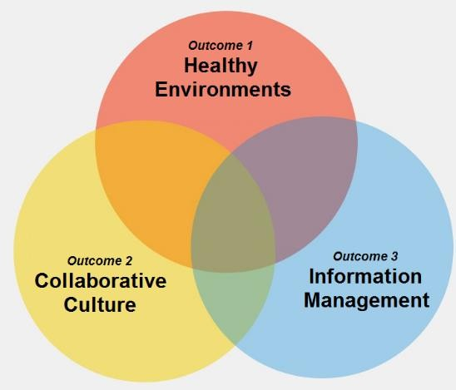

The Strategy outlines actions to be undertaken to work toward three outcome areas which support the overall vision for domestic wastewater management in Maroondah. Additional actions and projects that support this vision and adapt to the changing needs of the Maroondah community may be identified and resourced over the period of the Strategy.

Key Direction indicators have been identified to monitor progress. Over time, these measures will be used to identify how successful Council and its partners have been in working towards the outcomes and key directions outlined in this Strategy. These indicators are not intended to form a definitive list, rather they will be helpful in revealing progress over time.

Outcome 1 - Healthy Environments
Appropriate and effective wastewater management aids in protecting public health and the environment. Domestic wastewater poses a potential public health and environmental risk.

Key Directions

1.1 Work in partnership to reduce wastewater pollution and encourage healthy waterways
Prior to 1997, wastewater systems in Victoria were permitted to discharge to stormwater. There are now legislative mechanisms that enable Council to enforce property owners to ensure wastewater does not enter the stormwater system from these previously approved systems. For water quality to improve, the quantity of wastewater permitted to discharge into stormwater systems must be reduced. Preventing and minimising failing systems is also required to protect our waterways.

1.2 Proactively educate and build community awareness of environmental health issues
Education and awareness is an important mechanism to support homeowners and occupiers to maintain their systems appropriately.
Monitoring of unsewered properties in accordance with relevant legislation and current standards is required by Council Environmental Health Officers.

1.3 Build engaged and responsible communities in the effective maintenance of wastewater systems
Ensuring owners are aware of their responsibilities in maintaining their wastewater system and how this can be achieved is a key strategy in minimising health risks and possible financial implications of poorly functioning systems. There are numerous educational publications and materials available to use.

Outcome 2 - Collaborative Cultures
Encourage community participation and partnerships with key stakeholders for greater involvement in wastewater issues.

Key Directions

2.1 Work in partnership to ensure integrated planning for sewerage connection services
Yarra Valley Water’s Community Sewerage Program aims to eliminate environmental, public health and amenity risks caused by failing wastewater systems. It is critically important that both YVW and Maroondah City Council continue to work together to ensure that this Strategy and future sewerage servicing strategies are aligned. This will provide sewerage connection in areas of environmental or public health concern.

2.2 Facilitate a collaborative approach to the management of domestic wastewater
The successful management of domestic wastewater is not the responsibility of one agency. An integrated approach to approving new developments, managing complex issues relating to wastewater complaints is integral.

2.3 Advocate for the consistent application of the new legislation across Local Governments and to ensure it meets future wastewater management requirements.
The Environment Protection Act 1970 has undergone substantial amendments to form the Environment Protection Act 2017, the Environment Protection Regulations 2021 and the Onsite Wastewater Management Toolkit guidance for Local Government, in consultation with relevant stakeholders including Council, to provide an effective legislation and guidance to assist with the installation, alteration and maintenance of all onsite wastewater management systems. Council will continue to work with the EPA and Yarra Valley Water to ensure the legislation remains relevant and is applied consistently across Local Government.

Outcome 3 - Information Management
By having complete and accurate information Council is better able to plan for sewer and sustainable development.

Key Directions

3.1 Ensure the accuracy of information relating to wastewater systems in Maroondah
Without complete and accurate information about wastewater systems, it is not possible to fully understand the magnitude of environmental, public health and amenity risks or the likely emerging risks. A sustainable strategy to treat the risks and the likely cost of doing so would also not be possible.

3.2 Apply a continuous improvement approach to domestic wastewater management
Clear and precise policies and procedures for the management of onsite wastewater management systems is important to assist in consistent and transparent decision making to support the Environmental Health Officers in undertaking their statutory responsibilities under the Environment Protection Act 2017 and Environment Protection Regulations 2021.

Action plan

Council has outlined actions that aim to reduce the identified risks associated with onsite domestic wastewater.

Outcome 1 - Healthy Environments

Key Directions | Actions 2025-2030 | Timeframe | Key Direction Indicators | Risk reduced
1.1  1.2  1.3 | Develop a communication strategy to ensure key wastewater messages below are provided through website, social media channels and are received by the community on an ongoing basis. Key messages include:  - correct use of OWMS  - importance of OWMS maintenance  - management of OWMS during emergencies such as power outage and floods  - importance of managing wastewater systems appropriately  - sustainable re-use of greywater  - benefits of connecting to sewer when it becomes available. | 30 June 2026 and ongoing | OWMS communication strategy is developed and implemented.  Increased number of owners and operators with good knowledge on the effective use and maintenance of their OWMS.  Reduced number of incidents/complaints or treatment plant servicing reports of poorly functioning OWMS. | EH-01  PH-02  ECON-04
1.1  1.2  1.3 | Communicate with owners of OWMS that discharge effluent offsite and have access to sewer to connect, about the benefits of connecting to sewer.  When an OWMS discharging offsite becomes unsustainable or defective, require connection to sewer when it is available and reasonably practicable to do so. | Ongoing | Communication material encouraging connection to available sewer is distributed to OWMS owners.  Increased number of unsewered properties connect to sewer.  Reduced number of properties discharging domestic wastewater offsite. | EH-01  PH-02  LEG-03  ECON-04

Key Directions | Actions 2025-2030 | Timeframe | Key Direction Indicators | Risk reduced
1.1  1.2  1.3 | Undertake OWMS education/compliance program visits, educating OWMS operators and owners and monitoring system effectiveness and maintenance.  Follow up poor performing systems in line with the current legislative framework. | 30 June 2026 and ongoing | 100% education/compliance program visits have been undertaken.  Owner and operator knowledge on the effective use and maintenance of their OWMS is improved.  Reduced number of incidents/complaints or treatment plant servicing reports of poorly functioning OWMS. | EH-01  PH-02  LEG-03  ECON-04
1.1  1.2 | Implement a 5 yearly reminder system to OWMS owners about OWMS pump out requirement.  Follow up owners of OWMS that have not pumped out the system in line with the current legislative framework. | 30 June 2026 and ongoing | Reduced number of incidents/complaints or treatment plant servicing reports of poorly functioning OWMS.  5 yearly reminder system for OWMS pump out is implemented. | EH-01  PH-02  LEG-03  ECON-04
1.1  1.2 | Review of all aerated wastewater treatment system maintenance reports provided to Council by wastewater servicing agents.  Follow up owners of OWMS that are required to undertake work to repair the aerated treatment plant system in line with the current legislative framework. | Ongoing | Reduced number of incidents/complaints or treatment plant servicing reports of poorly functioning OWMS.  Aerated treatment plant systems service reports are received and are follow up by EHO as required. | EH-01  PH-02  LEG-03  ECON-04

Outcome 2 - Collaborative Cultures

Key Directions | Actions 2025-2030 | Timeframe | Key Direction Indicators | Risk reduced
2.1 | Work with Yarra Valley Water and advocate for all high-risk properties (E.g. commercial, offsite discharge, close to waterways etc) serviced by an OWMS to be included in the Community Sewerage Program.  Meet with Yarra Valley Water at least once per year to discuss promoting connection to sewer and provide information on properties of higher risk requiring sewer access. | Ongoing | More unsewered properties are included in the Yarra Valley Water Community Sewerage Program.  Meeting with Yarra Valley Water and Maroondah undertaken annually to discuss sewer prioritisation. | EH-01  PH-02  ECON-04
2.2  2.3 | Build partnerships with other Councils and peak associations including Environmental Health Professionals Australia to advocate to the State Government to accelerate the community sewerage program. | Ongoing | More unsewered properties are included in the Yarra Valley Water Community Sewerage Program. | EH-01  PH-02  ECON-04
2.1  2.2 | Investigate funding opportunities for programs to improve domestic wastewater management (including where possible ways for community to be supported to upgrade their OWMS or connect to sewer). | 30 June 2027 | Funding is sourced for new programs to improve the management of domestic wastewater. | EH-01  PH-02  ECON-04

Key Directions | Actions 2025-2030 | Timeframe | Key Direction Indicators | Risk reduced
2.2 | Provide technical expertise and strengthen the relationship between Community Health, Planning and Building to ensure all new developments and alterations to existing properties that are serviced by an OWMS, are managed appropriately.  Meet with Planning and Building on an annual basis to discuss management of OWMS and ensure this is addressed in the application process for modifications to properties that require a permit. | Ongoing | All new or altering OWMS are installed in accordance with EPA requirements and guidelines and wastewater is maintained onsite.  All permits to approve multi-dwellings or apartment complexes have access to sewer.  Permits for subdivisions in unsewered areas require access to sewer if available or must ensure all OWMS are installed in accordance with EPA requirements and guidelines and wastewater is maintained onsite. | EH-01  PH-02  LEG-03  ECON-04
2.2 | Provide website information and one on one guidance to plumbers, installers, servicing agents and consultants to outline Council expectations, including the requirement to maintain domestic wastewater onsite and to improve standards in the industry. | Ongoing | All new or altering OWMS are installed in accordance with EPA requirements and guidelines and wastewater is maintained onsite. | EH-01  PH-02  LEG-03

Outcome 3 - Information Management

Key Directions | Actions 2025-2030 | Timeframe | Key Direction Indicators | Risk reduced
3.1 | Maintain the information management system to ensure all information relating to a wastewater system is stored appropriately and remains current. | Ongoing | Effective information maintenance is supporting the management of OWMS and OWMS programs run in Maroondah.  Database information on OWMS licences is current. | EH-01  PH-02  LEG-03
3.1 | Ensure property information from YVW is updated on an annual basis and integrated into Council’s GIS system. | 30 June 2026 & ongoing annually | Effective information maintenance is supporting the management of OWMS and OWMS programs run in Maroondah.  Access to accurate information on YVW sewerage infrastructure is available to Council teams. | LEG-03
3.2 | Undertake regular training for Environmental Health Officers (EHO) to ensure skills and knowledge in OWMS and application assessment is kept current and can be applied practically. | 30 June 2026 & ongoing annually | All new or altering OWMS are installed in accordance with EPA requirements and guidelines and wastewater is maintained onsite.  EHO skills and knowledge in OWMS is current and has been applied correctly. | LEG-03
3.2 | Review Council’s Onsite Wastewater Management Strategy action plan every two years and update as necessary. | 30 June 2026 & ongoing annually | The action plan is current, activities are completed on time and regular reporting is undertaken. | LEG-03

References
Victorian Auditor General, 2006, Protecting our environment and community from failing septic tanks, Victoria
VAGO, 2018, Managing the Environmental Impacts of Domestic Wastewater
Environment Protection Act 2017.
Environment Protection Regulations 2021

Environment Protection Authority, 2024, Obligations of managers of land or infrastructure (Urban Stormwater Management and On-site Wastewater Management) Order made under section 156 of the Environment Protection Act 2017

Environment Protection Authority, 2024, Regulating on-site wastewater management systems: local government toolkit (EPA publication 1974)

Environment Protection Authority, 2024, Guideline for onsite wastewater management (for councils, water corporations and installers)

Environment Protection Authority, 2024, Guideline for onsite wastewater effluent dispersal and recycling systems (for councils, water corporations and installers)

Environment Protection Authority, 2024, Requirements for owners and occupiers with on-site wastewater (for community)
Environment Protection Authority, 2024, Victorian Guideline for irrigation with recycled water (EPA publication 168) (for irrigation designers and operators)

Maroondah City Council, Water Sensitive City Strategy.
Maroondah City Council, , Maroondah 2040 – Our Future Together
Yarra Valley Water, 2025, Yarra Valley Water 2030 Strategy.

Glossary

Aerated Wastewater Treatment Systems Aerated wastewater treatment systems treat all household wastewater and have several treatment compartments. They comprise of a septic tank, aeration chamber, settling chamber and chlorination tank. They are a secondary treatment system.

Blackwater Wastewater from toilets containing faeces and urine.

Community Sewerage Program Water Authorities develop sewerage services strategies and every 5 years, review the prioritisation of properties and areas and develop servicing strategies for upcoming areas.

Domestic Wastewater Wastewater arising from a domestic dwelling. Domestic wastewater can comprise of blackwater or greywater (from bathrooms, laundry and kitchen) or a combination of both.

Disposal Area An area of land specifically designated for the disposal of wastewater.

Effluent Wastewater discharging from a wastewater management system.

Environmental Health Officer An individual who has the qualifications and/or experience necessary to be appointed as an Environmental Health Officer (EHO) and be authorised to undertake responsibilities of relevant Acts such as the Environment Protection Act 2017 and Environmental Health Regulations 2021.

Environment Protection Authority The Victorian Environment Protection Authority administers the Environment Protection Act 2017 and Environment Protection Regulation 2021 and is responsible for producing guidance for onsite wastewater management, including the Code of Practice and other documents, and issuing Certificates of Conformity for particular onsite wastewater treatment systems.

Greywater Domestic wastewater from sources other than the toilet, urinal or bidet (showers, baths, hand basins, laundry, dishwashers and kitchen sinks). Greywater may still contain pathogens, nutrients and potentially harmful chemicals. Also known as sullage.

Onsite Wastewater Management Strategy A planning and management document to minimise the impact of domestic wastewater on public health and the local environment using a risk management approach.

Onsite Wastewater Management System or Wastewater Management System A system for the bacterial, biological, chemical or physical treatment of sewage includes all tanks, beds, sewers, drains, pipes, fittings, appliances and land used in connection with the system.
An on-site wastewater treatment plant with a design or actual flow rate of sewage not exceeding 5000 litres on any day and includes all beds, sewers, drains, pipes, fittings, appliances and land used in connection with the treatment plant. Include septic tanks, aerated wastewater treatment systems, composting toilets, sand filters, reed beds and wetlands that treat wastewater produced by households or businesses generating up to 5000 litres of wastewater per day.

Primary Property Property where the OWMS is located.

Secondary Property Property or properties adjacent to the primary property.

Sand Filter A secondary treatment method.

Septic Tank A conventional septic tank that temporarily holds wastewater. The septic tank provides primary treatment of wastewater.
Sewage Any waste containing human excreta or domestic wastewater (Environment Protection Act 2017).
Sewer Pipe used to transfer sewage from one location to another.

Sewerage The infrastructure used to carry, treat and dispose of sewage.
Subsurface Irrigation The disposal of wastewater through a series of pressure-compensating pipes and emitters at a depth of 100 mm to 150 mm below ground surface level.
Trenches A disposal area which uses the principle of absorption where wastewater is distributed via underground trenches.
Wastewater is defined, within the Environment Protection Regulations 2021, as ‘waste principally consisting of water and includes sewage or other human-derived wastewater’. This means any wastewater from the toilet, bathroom, kitchen or laundry of any premises.

Waterway River, creek, stream, watercourses, natural channel in which water regularly flows, lake, lagoon, swamp, marsh or dam.

Yarra Valley Water Local Water Authority

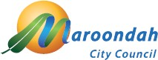

To contact Council telephone 1300 88 22 33 visit our website at: www.maroondah.vic.gov.au or call in to one of our service centres:

Realm
Maroondah Highway Ringwood

Croydon
Civic Square
Croydon

Translating and Interpreter Service 13 14 50

National Relay Service (NRS) 13 36 77

 | www.facebook.com/MaroondahCityCouncil
 | @CityofMaroondah
 | www.youtube.com/CityofMaroondah

maroondah@maroondah.vic.gov.au www.maroondah.vic.gov.au

This is consistent with the findings of the Victorian Auditor General (2006) report.

