

Draft Community Local Law
Community Consultation Report

May 2023

Contents
1. Background 3
2. Community consultation 4
2.1 Communication channels 4
2.2 Consultation tools 4
3. Community feedback 5
3.1 Online submissions - Your Say Maroondah 5
3.2 Formal Submissions 6
3.3 Online Survey 6
3.4 Email submissions 6
4. Summary of responses 7
5. Conclusion 9
6. Next Steps 9

Background

In mid-2022, the community provided feedback on what matters in regard to safety and local amenity, and how important it is for Council to monitor those activities. This feedback has helped us review Council's Local Law No 11 and to prepare the (renamed) Draft Community Local Law 2023.

Significant community consultation and engagement occurred in April to June 2022. More information on this process is available in the Consultation Report - General Local Law Review - July 2022.

This report includes:
- community feedback as to what community safety and amenity issues were important to the Maroondah community
- internal discussions as to how the proposed Local Law could meaningfully address municipal changes, regulatory concerns and emerging issues
- input from several local and partner agencies including Victoria Police and Council’s Liveability Safety and Amenity Advisory Committee.

Using this information, the local law review and drafting process was undertaken in line with the Local Government Act 2020, and the Guidelines for Local Laws - Manual and Resource Book, published by the Victorian Government.

Community consultation

Communication channels
Council sought community feedback on the Draft Community Local Law 2023 during April and May 2023.
A range of communications channels were used to promote the consultation opportunities.
Communications Channel | Reach Statistics
Your Say Maroondah online engagement portal | Emailed to 906 subscribers of Maroondah Your Say updates on 13 April 2023.
Maroondah eNews | Friday 21 April  - Sent to 11,689 recipients  - Clicks on link to Your Say project page: 22 clicks.  Friday 5 May  - Sent to 11,688 recipients  - Clicks on link to YourSay project page: 29 clicks
Social Media organic posts & paid ads | Organic Facebook posts: 17 April, 27 April, 3 May and 8 May2023  Total reach: 3,374  Click on links to Your Say project page: 42  Organic Instagram posts: 17 April, 27 April, 3 May and 8 May2023  Total reach: 1,309  Social media ads: ran from 27 April to 10 May 2023  Total reach: 6,998  Clicks on link to YourSay project page: 348
In person | The project lead attended the Liveability Safety and Amenity Advisory Committee on 29 March 2023, to discuss the community feedback report, and the consultation process. Email links to the YourSay page were distributed.

Consultation tools

Consultation tools | Description | Outcomes
Online | Your Say Maroondah | 756 total visits to project page.

Community feedback

Online submissions - Your Say Maroondah

A total of 756 people visited the consultation page on the Your Say Maroondah engagement website between 10 April and 16 May 2023. The below image is a summary of visitors to the page during the four-week period.
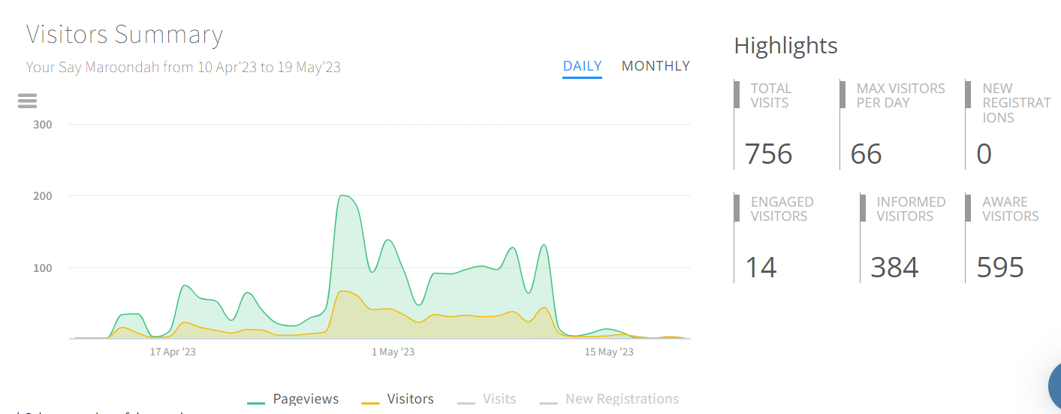

The main spike in activity around 27 April period on the graph corresponds with the social media ads starting. The spike in activity around 21 April corresponds with the Maroondah eNews on 21 April and social media post on 17 April.

The above summary figures are based on the three types of activity with the project on the Your Say Maroondah engagement website:
- Aware: Participants that have viewed the project page and are aware that the project exists. This is the result of your promotional activities.
- Informed: Participants that have viewed various elements within the project page and are well informed about a subject and take time to think before participating.
- Engaged: And, finally, participants who provide feedback and contributions to a consultation.

There were 448 downloads of the documents available on the YourSay page, including:
- 180 downloads of the ‘summary of proposed changes to the Draft Maroondah Community Local Law’
- 103 downloads of the ‘Draft Maroondah Community Local Law 2023’
- 84 downloads of the ‘Consultation report - General Local Law Review July 2022’

Visitors to the project page on the Your Say Maroondah engagement website were asked a few questions around about the Draft Community Local Law 2023. A summary is provided below.

Formal Submissions
There were two formal submissions provided through the YourSay page.

Online Survey
There were 12 surveys completed online through YourSay page.

Email submissions
There were 5 submissions via email directly to Local Laws.

Summary of responses
The following table shows the general themes raised in the submissions and responses. Some respondents raised more than one theme - so the number of responses column does not equal the total number of feedback responses received.
Theme | Comments | No of responses | Action/change Required
Use of inclusive language | Comprehensive, readable and easy to understand | 1
 | Emphasis on tidy and peaceful environment, for humans and animals | 1
Nuisance noise from animal housing | Should be included | 1 | Section 6.2 and Section 6.6 address nuisance caused by animals. There is definition of nuisance is also included in the local law.
Filming | Most responses highlighted clarification on who was impacted i.e. personal filming on your mobile phone vs commercial film productions etc. As it would be bureaucratic to ban or require permits on all filming. | 7 | Definition of filming has been reviewed and changed to be clearer.  Guidelines already available for filming in Maroondah on Council’s website.  Guidelines have clear direction on situations when a permit is and isn’t required. The focus is on high impact filming that disrupts public space, and use of council land, reserves, roads, parking etc.
Graffiti | Support | 1
Drinking and smoking in public places | Not supported | 2 | Commentary regarding not being allowed to have a picnic or beer in the park - however this is still permitted in circumstances where the behaviour is not causing a nuisance.
Noise | Support - but noise is increasing from over development | 3 | Further communication and education campaigns with developers can be prepared by Council to address the impact of noise on neighbours.
Condition of buildings/land | Penalties too harsh for low socio-economic population that cannot maintain their homes. | 1 | Council has guidelines in place for working with residents in these situations. The focus of this clause is generally on vacant buildings and land. Without the passive surveillance of owners living in the dwelling, properties are not maintained and have increased risk of trespassing and squatters.
 | Condition of Buildings should not be assessed on visual amenity alone, as that is subjective to people’s tastes. | 1 | Detriment to the general amenity of the area is not determined on a design or uniqueness of a building, it is used in addition to the other conditions that define unsightly.
 | Should be extended to nature strips as well | 2 | There are guidelines on Council’s website on naturestrip planting and maintaining the nature strip area.
Vehicles and machinery on land | Not supportive | 1 | No action required. There have been recorded significant impacts to neighbours and residents where this has occurred.
Hard waste and illegal dumping | Supportive | 1 | Council resources include a Litter and Illegal Dumping Prevention Officer to address these issues.
Street parties | Not supportive - shouldn’t need a permit for all street parties | 1 | This requirement hasn’t altered from the current Local Law and is important to ensure safety when required.
Camping on land/public land | Homelessness - how will this law be applied when homelessness and rough sleepers are increasing | 2 | This clause has been revised from the previous local law to actually reduce the burden. Council has a partnership approach with other agencies to provide support and not a punitive approach to rough sleepers on Council land.
Animals at large | Maybe duplication with the Livestock Act 1994 | 1 | Reviewed and no change required.

Conclusion
While feedback from this phase of community consultation generally indicates support from the community for the changes to the Local Law to be adopted, it also highlights the need to look for more opportunities for educational material on certain aspects of the Local Law, both on Council’s website and through review and development of relevant guidelines. Education is a key component of Council’s approach in implementing the Local Law. The administration and enforcement sections of the proposed Local Law also addresses these concerns.

Next Steps
As required under section 74 of the Local Government Act - before a Council makes a local law, a Council must obtain a certificate from a qualified person stating that the person is of the opinion that the proposed local law is consistent with the local law requirements. A qualified person means a person who is an Australian lawyer who has been admitted to the legal profession for at least 5 years.
The feedback regarding a change to wording for some clauses in the Draft Community Local Law will be provided as part of the legislative review. Any changes will be highlighted in the report to Council.

