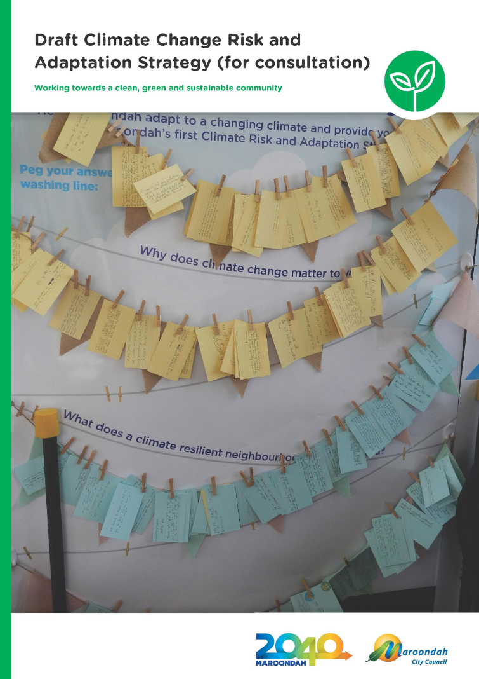

Contents

Contents 2
Introduction 3
Section 1 – Background 4
Section 2 – What the Evidence Revealed 10
Section 3 – What we did and what you told us 21
Section 4 – A Strategy for the Future 22
A vision for a more climate adapted Maroondah 22
Strategic framework 22
Outcome Area 1 – People 23
Our achievements so far 23
What we will do 23
Outcome description 23
What the evidence tells us 23
What the community told us 24
Focus Areas 24
Key Directions 24
Outcome Area 2 – Places 25
Our achievements so far 25
What we will do 25
Outcome description 25
What the evidence tells us 25
What the community has told us 26
Focus Areas 26
Key Directions 27
Outcome Area 3 – Embed Adaptation 29
Our achievements so far 29
What we will do 29
Outcome description 29
What the evidence tells us 29
What the community has told us 29
Focus Areas 30
Key Directions 30
Section 5 – Tracking Progress 31
Section 6 – References 32
Section 7 – Glossary 34
Appendix A – Victorian Government’s Climate Change Adaptation Plan 2017-2020 - Roles and Responsibilities 36
Appendix B – City of Maroondah Targets included in the Port Phillip and Westernport Regional Catchment Strategy 37

Introduction

This Climate Change Risk and Adaptation Strategy outlines how Council and partners will work towards a more climate adapted Maroondah. Building on work already undertaken by Council it draws on a solid evidence base heavily informed by stakeholder engagement and the latest climate science including projections from the Bureau of Meteorology and the national science body, CSIRO, as well as vulnerability information to inform climate change adaptation planning.

The Strategy has at its heart an ethos that the best and most cost-effective approach for climate change adaptation is embedding relevant actions into Council’s existing service delivery. It includes key directions that will help Council to manage identified risks and provide co-benefits.

The Strategy has four overarching objectives:

- Plan for and manage the risks of climate change, in particular, drainage and extreme weather events
- Seek opportunities for partnerships and collaboration with stakeholders and the community that support climate change adaptation
- Use the natural environment to build our adaptive capacity – while a risk itself, the natural environment can also be used to help in climate change management
- Encourage future proofing design – foster places capable of adapting to change and responding to current and future risks.

The Strategy also identifies 42 climate change risks to Council. It includes 25 key directions to assist Council to move towards achieving a climate adapted Maroondah. The preparation of a detailed Action Plan will complement these.

Acknowledgements
The invaluable contributions of the following are acknowledged in the preparation of this Strategy:

- Maroondah councillors and staff, the Strategic Asset Management Working Group, the Risk Management Advisory Group
- The Maroondah Environment Advisory Committee comprising the following members:
  - Cr Marijke Graham
  - Cr Paul Macdonald
  - Cr Samantha Marks
  - Moya Brown
  - Ellen Mitchell
  - Dr Graeme Lorimer
  - Patricia Donati
  - Ken Whitney
  - Fiona Ede
  - Liz Sanzaro
  - Pam Yarra
- Maroondah residents and community groups including:
  - First Friends of Dandenong Creek
  - Transition Towns Maroondah
  - Heathmont Bushcare
- The Eastern Alliance for Greenhouse Action
- The Western Alliance for Greenhouse Action
- The Department of Health and Human Services (Community Sector Climate Resilience Program)
- Resilient Melbourne (Resilient Melbourne Program)
- The Port Phillip and Westernport Catchment Management Authority.

Section 1 – Background

Council has been pursuing responses to climate change for many years and has made significant progress in avoiding and reducing greenhouse gas emissions (i.e. climate change mitigation) through implementation of its Carbon Neutral Strategy & Action Plan adopted by Council in 2015.

However, no matter how quickly we reduce emissions, some changes to our climate are already ‘locked in’.

Climate change adaptation means changing the way we behave and doing things more appropriate for the future climate. Adapting and building resilience to climate change and the overall health and wellbeing of the community are important issues for local government. Council’s operations, assets and service delivery provided to the community is vulnerable to a range of climate hazards such as heatwaves and flooding.

Definition of Adaptation
Adaptation is action taken to prepare for actual or expected changes in the climate, in order to minimise harm, act on opportunities or cope with the consequences.

Climate Change Act 2017

Definition of Resilience
100 Resilient Cities – Pioneered by the Rockefeller Foundation (100RC) defines urban resilience as the capacity of individuals, institutions, businesses and systems within a city to adapt, survive and thrive no matter what kind of chronic stresses and acute shocks they experience.

(City of Melbourne, 2016)
www.melbourne.vic.gov.au/SiteCollectionDocuments/resilient-melbourne-strategy.pdf

The following provides further Maroondah context about why managing climate change is important:
- Impact of the January 2009 heatwave and Black Saturday Bushfires in Melbourne’s East demonstrated the risks that can arise from multiple climatic stressors occurring at once.
- Intense major storm events occurred in 2010, 2011 and 2016, which caused localised flooding.
- Due to the 10-year Millennium Drought through to 2010, Council substantially reduced its use of irrigation for gardens and open spaces notwithstanding the provision of water to sporting grounds is important to keep soils moist and to prevent injuries.
- Maroondah is expected to grow from an estimated residential population of 114,979 in 2016 to 133,526 by 2036.
- The area is a substantially developed peri-urban residential municipality, where future population growth will be mainly stimulated by housing consolidation and medium density development. This growth needs to be responsive to the challenges of climate change.
- Growth in culturally and linguistically diverse (CALD) communities such as the Burmese community.

An effective response to managing the risk of climate change requires climate change mitigation and climate change adaptation. Council is strongly committed to both. This Strategy has a focus on climate change adaptation.

A partnership approach is key as adaptation is a shared responsibility. Local government together with other areas of government, business, community organisations and individuals are actively addressing the impacts of climate change on our municipality.

This Strategy lays out a plan of action for the next four years enabling Council to prepare for the long-term risks of climate change. It will guide Council’s efforts to integrate climate change risk management and adaptation.

Strategy Development
Development of this Strategy was a collaborative effort between Council and the community. Council received strong input from the Maroondah Environment Advisory Committee which was established in 2014 to advise Council on environmental and sustainability issues. It comprises councillors and community representatives with environmental expertise.

Input was also obtained from the Eastern Alliance for Greenhouse Action (EAGA) of which Council is a member. EAGA is a formal collaboration of eight Councils in Melbourne’s east, working together on regional programs that reduce greenhouse gas emissions and facilitate regional adaptation. Part of EAGA’s charter is to assist Council’s to work together to facilitate regional mitigation and adaptation.

In particular, in 2014 staff from a range of Council service areas participated in workshops for the Climate Change Adaptation Roadmap for Melbourne’s East: A guide for decision makers in the EAGA Councils. This Guide was informed by a regional climate risk assessment, and identified priority actions to address the impacts on climate change on Council operations, assets and service delivery responsibilities as outlined in the Roadmap. Priority regional actions were identified with member councils subsequently undertaking actions in their own municipalities. This Strategy has subsequently been prepared in accordance with the Roadmap.

Image 1: Council employees at an EAGA Climate Change Roadshow in August 2014

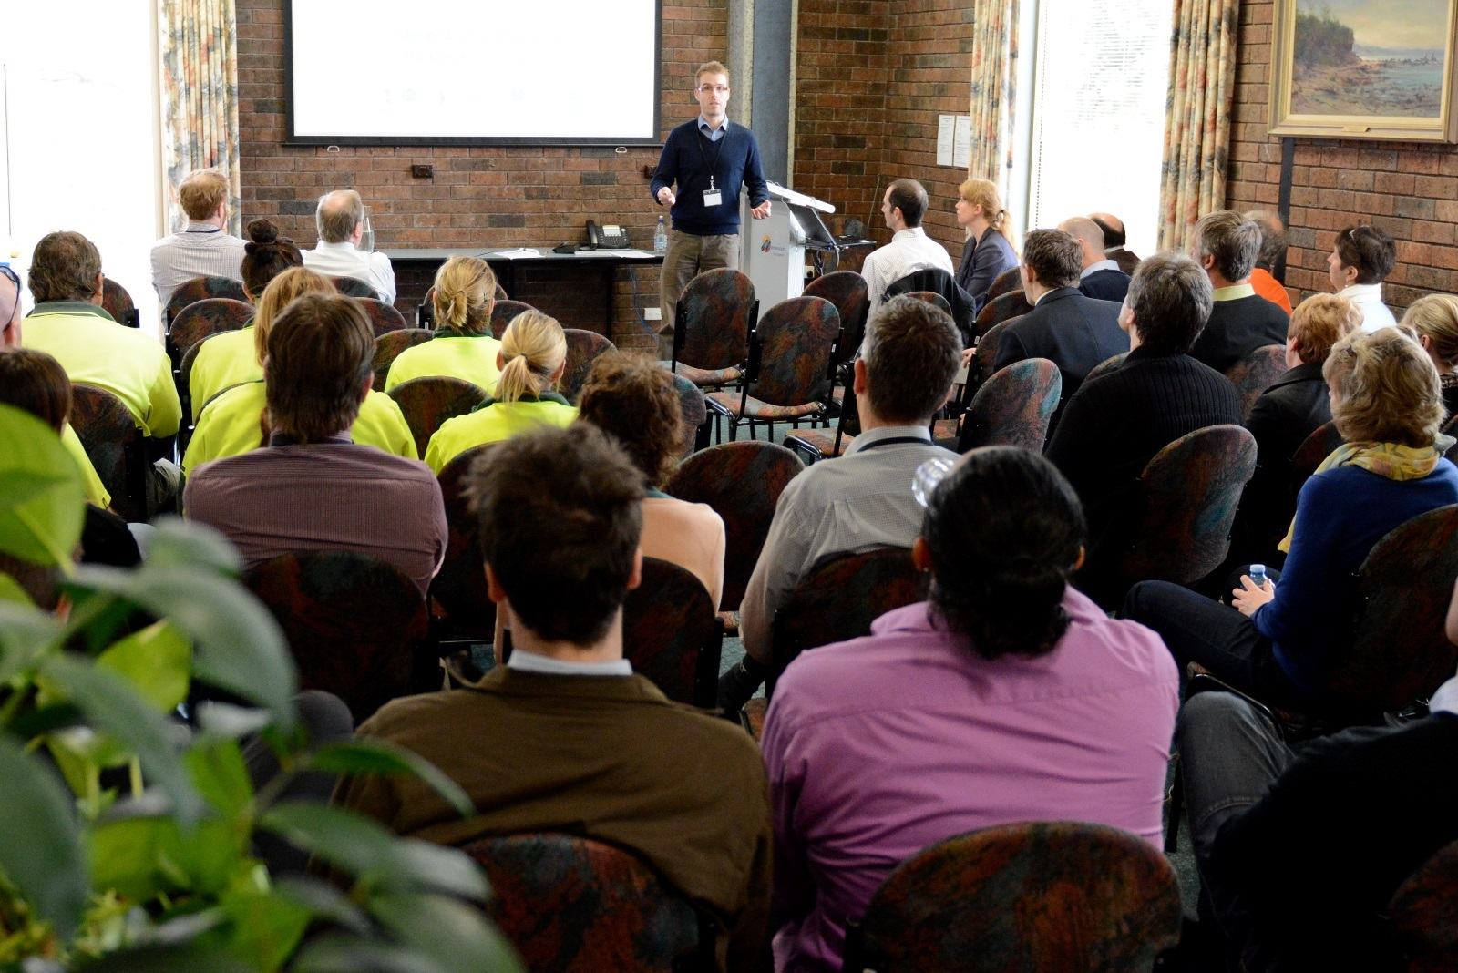

Eastern Alliance for Greenhouse Action Roadmap - Key Points
The EAGA Roadmap revealed that there are many good reasons for councils to incorporate adaptation into their decision-making. These include:
- Rising insurance premiums and liability issues
- Financial sustainability; small investments today will avoid larger costs in the future
- Strong community expectations that local government is preparing for climate change
- The multiple benefits of adaptation responses such as improved health and wellbeing, lower energy bills and lower maintenance costs
- Existing climate impacts are already more frequent and intense than previous decades.

In addition, a “Climate Futures” report was commissioned for the EAGA in 2013 and was undertaken by the CSIRO. It projected that the “most likely climate future” for eastern Melbourne includes increasingly drier and hotter climatic conditions with increasing intensity of rainfall events likely in summer and autumn seasons. As the intensity, severity and duration of extreme weather events increases, enhancing the resilience of operations, assets and service delivery will become more important.

Department of Health and Human Services and Resilient Melbourne Support
In 2016 and 2017, Council participated in the Community Sector Climate Resilience Program run by the Department of Health and Human Services (DHHS). The Program provided facilitated resilience planning assistance to DHHS funded organisations delivering community services, of which local government is one. The Program aims to build resilience to natural disasters and climate change in community service organisations. This included a resilience self-assessment and consulting support which provided an opportunity to come together to reflect, learn from each other and strengthen resilience and social learning networks.

Other opportunities Council participated in included the Resilient Melbourne Program. Resilient Melbourne marks an important point in Melbourne’s development. It prepared Melbourne’s first resilience strategy, a starting point that brings together individuals and organisations critical to the resilience of Melbourne and its diverse communities. The Program is helping cities around the world become more resilient to physical, social and economic shocks and stresses – of which climate change is one. Maroondah is an active participant in the Program.

Policy Context

While Council has taken the lead in preparing this Strategy, it has been developed with reference to Victorian and Australian Government policy, the latest available climate science and community values. A summary of key federal, state and local government polices is found below.

Australian Government

The Australian Government’s National Climate Resilience and Adaptation Strategy sets out how Australia is managing climate risks. It identifies principles to guide adaptation practice and resilience building, and sets a vision for future adaptation practice.

Victorian Government

Victoria’s Climate Change Adaptation Plan 2017-2020 provides a blueprint for action to help Victoria meet the challenges and act on the opportunities of climate change.

The Climate Change Act 2017 is a key statute to manage climate change risks and maximise opportunities that arise from decisive action. The Act identifies councils as one of the decision-makers that must consider the impacts of climate change, specifically during the preparation of a Municipal Health and Wellbeing Plan (MHWP) (in Maroondah this is known as the Maroondah Community Wellbeing Plan).
The Victorian Government’s climate change adaptation plan builds a detailed understanding of Victoria’s exposure to climate change risks and impacts. It seeks to catalyse partnerships for integrated and effective responses to climate change and tackle immediate priorities to reduce climate change risks. In it the Victorian Government commits to commissioning and sharing up-to-date climate change data to ensure the Government and the community can understand and manage the risks and impacts of climate change. The Plan identifies roles and responsibilities for managing the impacts and risks of climate change. A detailed breakdown is included in Appendix A.
The Melbourne Metropolitan Planning Strategy (Plan Melbourne 2017-2050) identifies that the Melbourne of 2050 needs to have become a low-carbon city designed to cope with the effects of climate change. In particular, Direction 6.2, Reduce the Likelihood and Consequences of Natural Hazard Events and Adapt to Climate Change; specifically states the Strategy runs parallel with actions developed as part of Victoria’s Climate Change Adaptation Plan 2017-2020 and builds on the work of local government and emergency management agencies to build safer and more resilient communities. It includes:

- Policy 6.2.1, Mitigate exposure to natural hazards and adapt to the impacts of climate change.
- Policy 6.2.2, Require climate change risks to be considered in infrastructure planning.

Local Government

In Victoria the Local Government Act 1989 requires councils to act in the long-term interest of its local community. This includes addressing the viability and sustainability of key economic, social and environmental issues.

Maroondah City Council

The Maroondah 2040 Community Vision: Our Future Together sets out a vision for a clean, green and sustainable community. Of particular relevance is Key Direction 4.12, Mitigate and Adapt to the Effects and Impacts of Climate Change.

The table below highlights the links between Maroondah 2040 and this Strategy.

Table 1 – Links with Maroondah 2040

2040 Outcome Area | Climate Change Risk and Adaptation Strategy Strategic Outcomes | Climate Change Risk and Adaptation Strategy Focus Areas
A clean, green and sustainable community | People: Maroondah's people are climate resilient, with vulnerable groups prioritised | Focus Area 1: Reduce vulnerability of people at risk in Maroondah
An attractive, thriving and well built community | Places: Maroondah's places (built environment, biodiversity and waterways) are climate resilient, improving our health and wellbeing | Focus Area 2: Reduce vulnerability of the places at risk in Maroondah
A well governed and empowered community | Embed Adaptation: Community and staff capacity is increased through improved awareness, education and encouragement in climate change adaptation | Focus Area 3: Embed Council’s commitment to climate change adaptation

As per the image below, this Climate Change Risk and Adaptation Strategy is a risk management response document. Climate change risks affect every aspect of Council’s assets, operations and service delivery as climate change is not just an environmental issue.

Image 2: Links to other strategies
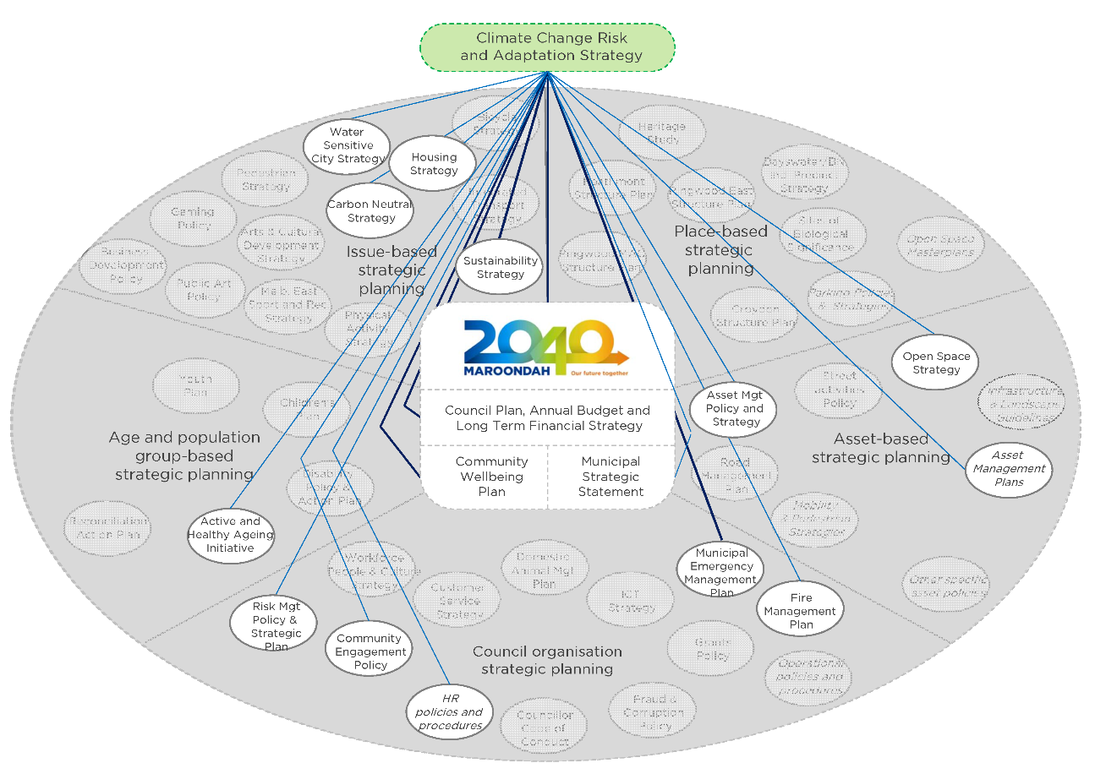

Section 2 – What the Evidence Revealed

There is increasing scientific evidence suggesting that climate change is well underway. According to the latest climate science, Council needs to plan for and adapt to some level of climate change.

Climate change projections and climate impacts referenced in this Strategy have been generated from:

- The national science body, CSIRO and the Bureau of Meteorology – Climate Change in Australia, www.climatechangeinaustralia.gov.au
- Australian Government – Climate Ready Natural Resource Management Planning in Victoria, www.nrmclimate.vic.gov.au
- CSIRO – Climate Futures for Eastern Melbourne report, https://eaga.com.au/wp-content/uploads/App-2b-CSIRO-Climate-Futures_Bushland_EAGA-May-2013.pdf

The Intergovernmental Panel on Climate Change (IPCC) is the leading international body for the assessment of climate change. The Fifth IPCC Assessment Report concluded that it is extremely likely that human influence has been the dominant cause of the observed warming since the mid-20th century. Continued net emissions of greenhouse gases will cause further warming and changes in all components of the climate system.

The climate projections for Australia, produced by the CSIRO together with the Bureau of Meteorology, are provided in the State of the Climate 2016 report. With the future climate for Australia characterised by decreases in winter and spring rainfall for southern continental Australia, with an increase in droughts.

In Victoria, there is a need to prepare for a range of futures resulting from climate change (Image 3).

Image 3: Future Climate for Victoria
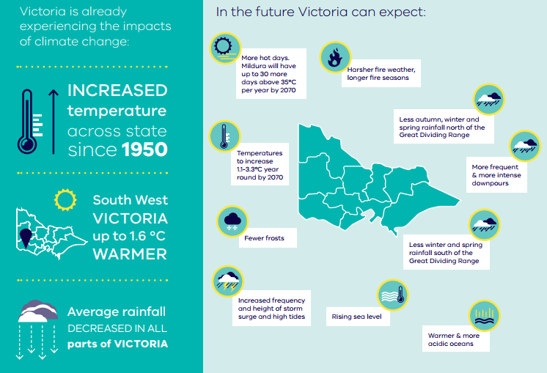
Source: www.climatechange.vic.gov.au
Climate change is predicted to change the regional climate for eastern Melbourne as follows.

Temperature
- Average temperatures will increase in all seasons, most significantly in summer and least in winter.
- The frequency of hot days will increase.
- The frequency of warm nights will increase in all seasons, but most in summer.

Precipitation
- With higher emissions into the future there are likely to be decreases in average rainfall in all seasons.
- The majority of the models project greatest percentage decreases in average rainfall to occur in spring.
- There will be increases in evaporation across all seasons with most models indicating the largest increases will be in winter.
- Projected decreased rainfall and increased evapotranspiration is likely to lead to decreased average streamflow.
- The frequency of dry days will increase.

Relative humidity
- By 2030 a decrease in annual average relative humidity of around 0.8% (+0.2 to -1.8%) is likely.
- By 2050 decreases in annual average relative humidity of around 0.5% (0.2 to 1.0%) and around 2.7% (-2.0 to -3.6%) are likely under low and high emissions scenarios respectively.

Fire Weather
- The frequency of weather conditions conducive to high forest fire risk will increase.
- The fire season will start earlier and end later in the year.

Extreme Wind Speeds
- The majority of models indicate extreme wind-speeds could decrease in spring, summer and autumn and increase in winter.

Solar Radiation
- By 2030 an increase in annual average solar radiation of around 0.8% (0.1 to 1.6%) is likely.
- By 2050 increases in annual average solar radiation of around 0.9% (-0.1 to 1.9%) and around 2.7% (0.6 to 4.8%) are likely under low and high emissions scenarios respectively.

Source: http://eaga.com.au/wp-content/uploads/App-2b-CSIRO-Climate-Futures_Bushland_EAGA-May-2013.pdf

As a result this Strategy has a focus on preparing Council’s operations, assets and service delivery for the anticipated impacts and effects of extreme weather events – considered in the context of climate change and climate projections.

Heat, Heatwaves and the Urban Heat Island Effect – Monash University Research

During summer Australian cities experience an exacerbated urban heat island effect. This involves the additional heating of the air over a metropolitan area as the result of the replacement of natural, vegetated surfaces with asphalt, concrete and rooftops.

Monash University researchers have found a clear association between suburbs with extreme heat vulnerability and the number of hospital emergency visits or ambulance call outs on extremely hot days. Parts of Maroondah are in the list of Melbourne suburbs most at risk due to a combination of extreme heat and social vulnerability, as can be seen in Image 4. Risk factors in the study included lack of tree cover, housing types and age as well as the health and socio-economic status of the population.

Image 4: Mapping heat vulnerability

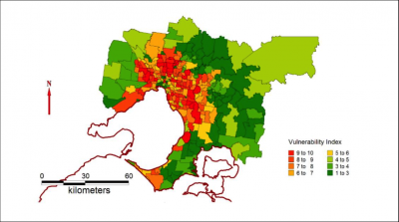
Source: www.mappingvulnerabilityindex.com/home/melbournevi

This gives us an important indication of how vulnerable certain parts of our municipality are to heatwave and urban heat island impacts. It may identify areas that are a priority for interventions such as tree plantings, shadings and targeted communications and programs.

The Economic and Health Impacts of Heatwaves
The Climate Council’s report 2015, The Silent Killer: Climate Change and the Health Impacts of Extreme Heat found that heatwaves have been shown to dramatically affect patient pressure on health services. During the heatwave in southeast Australia in January/February 2009, emergency call-outs increased 46 per cent; cases involving heat-related illness increased 34-fold; and cardiac arrests almost tripled in Victoria. In total, 374 excess deaths were recorded, a 62 per cent increase on the previous year. www.climatecouncil.org.au/silentkillerreport

Identification of Climate Change Risks

Council carried out a risk assessment in partnership with the EAGA to determine how climate change projections would impact on Council’s operations, assets and service delivery. This was done through EAGA facilitated workshops with EAGA member councils. Whilst the risk assessment had a regional focus, it was also developed to be used as a working guide for Councils to embed climate change through their risk registers.

For the purposes of this Strategy and to help concentrate efforts for finding solutions, a total of 42 significant risks relating to climate change where identified across Council.

EAGA found that in the coming decades, Melbourne’s east can expect increasingly hotter and drier conditions with impacts under the following four categories:

- Heat (increased frequency, duration and severity of heatwaves)
- Drought (decreased average rainfall and more severe, prolonged drought conditions)
- Flood and Storm (less regular but more intense rainfall and storm events)
- Bushfire (significant increase in bushfire danger days).

Some risks ranged across all categories.

A breakdown of the Maroondah climate change risk profile according to climate hazards is found in Image 5 and Table 2 with the number of risks set out below:

- Heat (12)
- Drought (9)
- Flood and Storm (6)
- Bushfire (4)
- All (11).

Image 5: Maroondah climate change risk profile according to climate hazards

Table 2: Detailed breakdown of climate hazards

Topic | Issue | Climate change scenario used in the risk workshops | Existing actions to reduce risk
Heat | Increased frequency, duration and severity of heatwaves | - Number of hot days increase  - Frequency of warm nights will increase | - With a changing climate and growing population, Council has a Heatwave Plan in place to reduce the impacts of heatwaves.
Drought | Decreased average rainfall and more severe, prolonged drought conditions | - Decrease in average rainfall  - Increase in severity and duration of droughts | - The Maroondah Water Sensitive City Strategy includes a target to reduce Council’s potable water use.  - Management and actions plans to cover a range of environment impact areas including actions plans for bushland reserves.
Flood and Storm | Less regular but more intense rainfall and storm events | - More extreme rainfall events  - Change in flood patterns | - With a changing climate and growing population, we have the Flood and Storm Plan in place to reduce the impacts of floods.  - Council is reducing flood risk by improving drainage systems, and upgrading stormwater infrastructure.
Bushfire | Significant increase in bushfire danger days | - Fire season to start earlier and end later  - Extreme fire days increase by 12-38% by 2020 and 20-135% by 2050. | - Together the Victorian Government, Country Fire Authority and Council have reviewed and updated bushfire hazard mapping.

Themes

The risk assessment identified that the hotter drier conditions combined with an increase in the frequency and severity and extent of extreme weather events is likely to multiply existing risks faced by councils.

In reviewing the risks, the following themes were identified (Table 3). The risks relate to drainage and flooding, financial impacts, asset damage, health and wellbeing, open space, biodiversity, water security, service demand, service disruption and insurance. The themes provide another way to consider or communicate the Council’s risk profile.

Table 3: Council climate change risk themes

Theme Summary | Theme Description
Drainage and Flooding | Key risk areas for Council around stormwater runoff and flooding, including rainfall and flooding cause infrastructure damage and pollution.
Financial Impacts | Financial impacts, including increasing maintenance and operating costs and reduce asset lifespans.
Asset Damage | Current building design standards are not adequate for projected climate conditions, including for assets that provide the most critical services to the community.
Health and Wellbeing | Direct and indirect health impacts to the Council’s staff and community. Direct health impacts occur at the same time and place as a weather event – for example, floods may cause injury, and heatwaves can cause physiological effects. Indirect health impacts caused by climate change can be triggered by weather events but occur later in time or farther removed in distance – for example, flooding may cause respiratory illness due to increased exposure to air pollutants from moulds, and an indirect health impact of drought may be increased anxiety and depression in communities where incomes and social networks are affected.
Open Space | Increasing heat exposure poses risks to people using Council sport facilities and active outdoor spaces such as hardening of sportsgrounds.
Biodiversity | Increasing temperatures lead to loss of biodiversity and increased environmental management costs. Conditions favour increased spread of weeds.
Water Security | Reduced water availability leads to greater demand for and costs of irrigation.
Service Demand | Increased demand on Council services.
Service Disruption | Council service delivery may be interrupted by heat, flood and storm or fire, including power and communication outages.
Insurance | Rising insurance premiums and liability issues for local government.

Impacts and effects

A range of Council service areas have responsibility for a range of climate change risks across the organisation (Table 4).

Table 4: Legend for responsible area of Council as included in the risk references

Code | Responsible Area of Council
CE | Communications and Engagement
CS | Corporate Services
OAL | Operations, Assets and Leisure
DA | Development and Amenity
SC | Strategy and Community

Table 5 below presents the 42 risks. Some risks have broader impacts and require a coordinated response with others.

Table 5: Climate change risks to Council
Risk reference (and climate hazard) | Risk name | Risk description | Responsible area of Council
SC1 (Heat) | Mortality risk to vulnerable populations | Risk of mortality to vulnerable members of community during heatwaves. | Strategy and Community
SC2 (Heat) | Increased demand on council support services | Increasing number of heatwaves impacts on community leading to greater council demand on support services. | Strategy and Community
SC3 (Heat) | Reduced council services put vulnerable at risk | Reduced council services during heatwave events pose health risks to vulnerable members of community. | Strategy and Community
CS1 (Flood and Storm) | Increased injuries to staff | Increased physical injuries to community and council staff from extreme weather events. | Corporate Services
OAL1 (Heat) | Demand on pools pose safety risk | Heatwaves place greater demand on council swimming pools posing risks to staff and public safety. | Operations, Assets and Leisure
CE1 and DA4 (All) | Inadequate communication | Lack of adequate communication to community during extreme weather events. | Communications and Engagement, Development and Amenity
DA5 (Flood and Storm) | Increase in water borne diseases | Potential increase in water borne viruses from pollution due to flooding | Development and Amenity
DA6 (Drought) | Dust storms leading to public health issues | Increase in dust storms leading to public health issues. | Development and Amenity
DA7 (Heat) | Hot days reduce mental wellbeing | Increasing temperatures and hot days reduce mental wellbeing in community. | Development and Amenity
OAL2 (Bushfire) | Bushfire leading to property damage | Increased bushfire danger leads to more losses or damage to council buildings. | Operations, Assets and Leisure
OAL3 (All) | Climate increases cost of maintaining infrastructure | More extreme climate conditions and weather events damage Council and community infrastructure increasing maintenance and operating costs and reduce asset lifespans and degradation. | Operations, Assets and Leisure
OAL4 (Flood and Storm) | Rainfall and flooding cause infrastructure damage and pollution | Severe rainfall events overwhelm existing drains and retarding basins causing overflow events, localised flooding, damage to infrastructure and environmental contamination. | Operations, Assets and Leisure
OAL5 (Heat) | Higher maintenance costs on transport infrastructure | Damage to transport infrastructure during heatwaves leading to higher maintenance and replacement costs and mobility issues. | Operations, Assets and Leisure
SC8 (Heat) | Increased energy demand from cooling | Increasing temperatures leads to increased energy demand from cooling leading to higher financial costs and greenhouse gas emissions. | Strategy and Community
OAL6 (Drought) | Damage to underground infrastructure | Reduced soil moisture levels lead to increase soil movement damaging underground infrastructure such as drains and building foundations. | Operations, Assets and Leisure
OAL7 (Flood and Storm) | Increased rainfall damages infrastructure | Damage to road and drain infrastructure burst water supply pipes and collapse of drains due to increased intensity of rainfall events. | Operations, Assets and Leisure
SC9 (Drought) | Reduced water leading to economic impacts | Reduced water availability leads to increased water and fresh food costs leading to broad economic impacts on community. | Strategy and Community
SC10 (Heat) | High energy costs lead to economic slowdown | Higher energy costs lead to reduced disposable income leading to regional economic slowdown. | Strategy and Community
SC11 (Drought) | Community concerns about water supply | Inadequate alternative water supply for community and community concerns over reuse and storage. | Strategy and Community
OAL8 (Drought) | Less flushing of roads and waterways | Lack of cleaning, flushing effect of waterways and roads due to reduced rainfall. | Operations, Assets and Leisure
DA12 (All) | Building design standards inadequate | Current building design standards not adequate for projected climate conditions. | Development and Amenity
OAL9 (Drought) | Increased cost of irrigation | Reduced water availability leads to greater demand for and costs of irrigation. | Operations, Assets and Leisure
OAL10 (Heat) | Pest visitation range changes | Temperature increases leading to changes in pest visitation ranges. | Operations, Assets and Leisure
OAL11 (Flood and Storm) | Increased weed spread | Increased weed spread from flooding events lead to increased costs of weed management and revegetation. | Operations, Assets and Leisure
OAL12 (Drought) | Hardening of sportsgrounds | Drier and hotter conditions lead to increased hardening of sports grounds leads to higher rate of injuries and rate of claims. | Operations, Assets and Leisure
OAL13 (Heat) | Loss of biodiversity due to heat | Hotter and drier conditions lead to loss of biodiversity reducing amenity and environmental values. | Operations, Assets and Leisure
OAL14 (Bushfire) | Extreme bushfires lead to biodiversity loss and require increased management | More extreme bushfires lead to loss of biodiversity and long term recovery impacts requiring more management interventions. | Operations, Assets and Leisure
OAL15 (Flood and Storm) | More damaged and fallen trees | Increased extreme weather events leads to more damaged and fallen trees posing risk to safety, loss of services and increased maintenance costs. | Operations, Assets and Leisure
OAL16 (Heat) | Increased environmental management costs | Increasing temperatures lead to loss of biodiversity and increased environmental management costs. | Operations, Assets and Leisure
OAL17 (Drought) | Higher tree mortality and reduced biodiversity | Reduced water availability leads to higher tree mortality and reduction in biodiversity leading to tree failure and less green areas. | Operations, Assets and Leisure
OAL18 (Drought) | Conditions favour spread of weeds | Weeds favoured due to drier and hotter conditions increasing competition against native species. | Operations, Assets and Leisure
SC13 (Bushfire) | Bushfire leading to increase in chemical contamination | Increased risk of chemical contamination and loss of industrial assets in Bayswater North precinct due to increased bushfires. | Strategy and Community
OAL19 (Bushfire) | Greater fire risk management around reserves | Higher fire risk requires greater management of interface between council reserves and private land | Operations, Assets and Leisure
DA14 (All) | Inadequate resources | Council emergency and recovery facilities unable to cope with increased frequency and severity of extreme weather events. | Development and Amenity
CE2 and CS2 (Heat) | Reduction in council service | Power and communication outages during heatwaves leads to loss of council service and ability to respond to extreme events. | Communications and Engagement, Corporate Services
CS3 (All) | Emergency response disrupts business continuity | More bushfire danger days lead to more council staff working on emergency response disrupting business continuity. | Corporate Services
CS4 (All) | Changing weather increase property insurance | Increased rate of claims from damage to property and people from extreme storm events and bushfires. | Corporate Services
CS5 (All) | Service delivery failure in extreme weather | Council unable to meet increased demand on council services during extreme weather events. | Corporate Services
CS6 (All) | Increased climate events reduce council service delivery | Increased resources required to manage and mitigate increasing frequency of climate events reduce other areas of council service delivery. | Corporate Services
CS7 (All) | Less staff can attend work due to transport disruption | Transport disruptions during extreme weather events lead to reduced staff able to attend work. | Corporate Services
CS8 (All) | Insurance premium increase | More extreme weather events reduce public safety and lead to increased rate of claims. | Corporate Services
OAL20 (All) | Extreme weather events require increased costs from recovery | Increased cost of cleanup and recovery from increased frequency and severity of extreme weather events | Operations, Assets and Leisure

How Council will Manage Identified Risks

The effects and impacts of these climate hazards demonstrates the need for policy and decision-making that demonstrates leadership and coordinated effort across Council operations, assets and service delivery.

Early planning for climate change will help reduce impacts. Council supports a proactive approach to managing the risks associated with climate change.

According to policy makers, strategies and actions can be pursued to move towards climate-resilient pathways for sustainable development, while at the same time helping to improve livelihoods, social and economic wellbeing, and responsible environmental management (IPCC 2014). Increased capacity, voice, and influence of low-income groups and vulnerable communities and their partnerships with local governments also benefit adaptation. Decisions range from simple to complex, and some will need to be made sooner than others. The pathways approach to climate change adaptation is the accepted best practice.

Key Functions of Council in Adapting to Climate Change

These include the following:

- Ensuring assets (starting with buildings) can withstand extreme events and climate change
- Identifying how climate change will impact street trees, bushland and urban biodiversity (see Bushland and Urban Biodiversity in a Changing Climate Research project)
- Building community and staff understanding of climate change risks and partnerships internally and externally for risk reduction
- Advocate for the community where Council does not control the outcomes.

Council will foster a process of ongoing organisational learning from experience, adjustment, and transformation.

An intentional focus of this Strategy is on the achievement of co-benefits. For example, investment in greening cities and recycling water could help to address overheating and flood mitigation, whilst also creating new cycle routes and high quality amenity space.

Bushland and Urban Biodiversity in a Changing Climate Research project

A changing climate will impact biodiversity. Along with those impacts, councils will face increased challenges in managing bushland and biodiversity assets. The recommended approaches to come out of the Bushland and Urban Biodiversity in a Changing Climate Research project as developed by the EAGA include:
- Consider the potential implications of climate change in all Council operations and actions
- Use adaptive management to maintain options and flexibility for long-term resilience
- Improve inter-agency and regional coordination
- Increase landscape connectivity, both within and across adjoining municipalities
- Reduce other compounding threats to biodiversity, i.e. weeds and feral animals, habitat fragmentation and pollution
- Create and support programs to communicate knowledge about climate change to policy-makers and the public
- Manage urban bushland by maintaining natural disturbance dynamics e.g. in planning fuel reduction. http://eaga.com.au/wp-content/uploads/Final-Report-May-2013.pdf

Section 3 – What we did and what you told us

Significant community engagement was undertaken in the preparation of this Strategy. This was done through a range of methods including:

- A discussion paper (Maroondah City Council 2016) which drew together a range of research and data on climate change adaptation in Maroondah.
- An online survey.
- Council’s Café Consult marquee at the 2016 Maroondah Festival. Council received 138 written responses to questions posed. Participants provided a total of 378 “hot-dot” (multi-vote counts) against actions people have taken to make their home more comfortable and adaptable to climate change, with the results available at Image 6.
- Meetings with key stakeholders including various greenhouse alliances.
- Website, social media, local newspaper advertisement and display at service centres.

Image 6: Actions residents are already taking on climate change

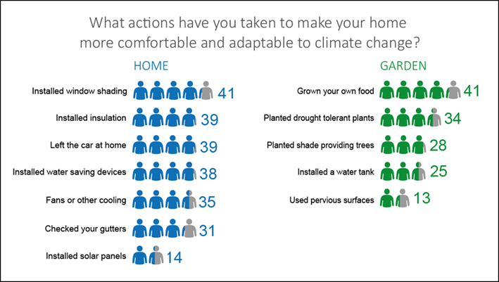

Respondents identified that climate change is an important issue and that Council’s discussion paper was on the right track. They want Council to ‘lead by example’ and ‘work together’ with others and share lessons as they too look to adapt to the challenges of a changing climate.

The two most popular reasons why climate change mattered to the community were:
- Natural environment – for example, impacts on plants and animals; changes to ecosystems; and the impact climate change has on the Earth.
- Health – for example lifestyle impacts and quality of life; human survival; and intergenerational equity considerations (fairness of justice between generations).

To respond to the challenge of climate change, community views suggested a climate resilient neighbourhood within Maroondah should:
- Upscale stormwater reuse
- Be energy efficient
- Adopt integrated transport, and
- Foster urban greening.

Maroondah residents are also taking action on climate change: “I am always mindful of helping the environment so I’ve changed some things at home to play my part. I’ve got water-saving shower heads and solar panels for electricity. I also try to walk as often as possible rather than taking the car. I also have ceiling fans and insulation”.

The views of the community were documented in the Community Engagement Report (Maroondah City Council 2017).

Section 4 – A Strategy for the Future

A vision for a more climate adapted Maroondah

Climate change adaptation will be used to strengthen our ability to be healthy, safe, happy, and vibrant in a changing climate.

Strategic framework

This Vision will be achieved by addressing climate change adaptation through three Strategic Outcomes outlined in the Strategy. The Key Directions for each Strategic Outcome describe how Council will specifically respond.

These Strategic Outcomes recognise the interplay between the built, natural and social environments and seek to ensure climate change risks are managed in a planned and considered way.

Outcome Area 1 – People

Our achievements so far

- Council launched the Solar Savers program in 2017 to support local pensioners to install solar with no upfront costs.
- Council was an initiating project partner of the ‘Let’s Get Ready’ project in 2016, to engage youth in preparedness education, including climate change impacts. The project is educating youth in the preparation for, response to and recovery from disasters.
- 2014 Fire Awareness Awards – Multicultural Award – Winner. Eastern Metro Burmese Communities Fire Engagement Project – Parks Victoria, Manningham Council, Maroondah City Council, the former Department of Environment and Primary Industries, Migrant Information Centre – Eastern Melbourne, Metropolitan Fire Brigade, Country Fire Authority, Victoria Police and Eastern Metro Burmese community.

What we will do

Outcome description

Maroondah’s people are climate resilient, with vulnerable groups prioritised – both community and Council’s staff.

Objectives:
- Decrease the urban heat island effect
- Provide nominated Emergency Relief Centres (ERC) to the community
- Work with other agencies to support vulnerable members of the community in adapting to climate change
- Educate and support the community and staff in adapting to climate change.

What the evidence tells us

Community Health and Wellbeing

Vulnerable people in the community are at greater risk of sickness, death and significant financial and social impacts from climate change, including heat, heatwaves and the urban heat island effect. This includes those who already receive community care, the sick and disabled, indigenous, low income, socially isolated, the elderly and very young and CALD communities. Those with poor quality housing also face increased vulnerability to heatwave. Reduced Council services during heatwave events pose health risks to vulnerable members of the community.

Increasing temperatures lead to increased energy demands from cooling (e.g. air conditioning units) resulting in higher financial costs and greenhouse gas emissions.

Staff Health and Wellbeing

Council employees may be directly exposed to the impacts of climate change, which can affect their health and safety and reduce the productivity of the organisation. Outdoor employees are at particular risk from heat stroke and increased physical injuries from more hot days and extreme weather events. This can lead to a greater Council demand on support services.

What the community told us

- “Effects my work with the sick and elderly. Heat affects them”.
- A climate resilient neighbourhood looks like “Neighbours looking out for each other”.

Focus Areas

Focus Area 1: Reduce vulnerability of the people at risk in Maroondah.

2040 Outcome Area: A clean, green and sustainable community. Key directions from Maroondah 2040: Our Future Together:
- Mitigate and adapt to the effects and impacts of climate change
- Work in partnership to reduce greenhouse gas emissions and support the community in adapting to a post peak oil environment
- Be responsive and adaptive to new environmental opportunities and threats as they occur, building resilience and capacity within the community.

Key Directions

- Manage community safety and emergency risk through an evidence based approach in consideration of Council’s Municipal Emergency Management Plan and sub-plans.
- Help pensioners to save on power bills and afford to use cooling units in their homes, through extending the Solar Savers program.
- Participate in multi-agency events and exercises to support communities and organisations to better connect and make safer and more informed decisions.
- Work with local partners such as the Municipal Emergency Management Planning Committee and the EAGA, to raise awareness of local climate change impacts and how to address them, for residents in the Maroondah area.
- Strengthen Council’s planning and protocols for events (e.g. leisure activities) and human resources.

Image 7: ‘Let’s Get Ready’ project

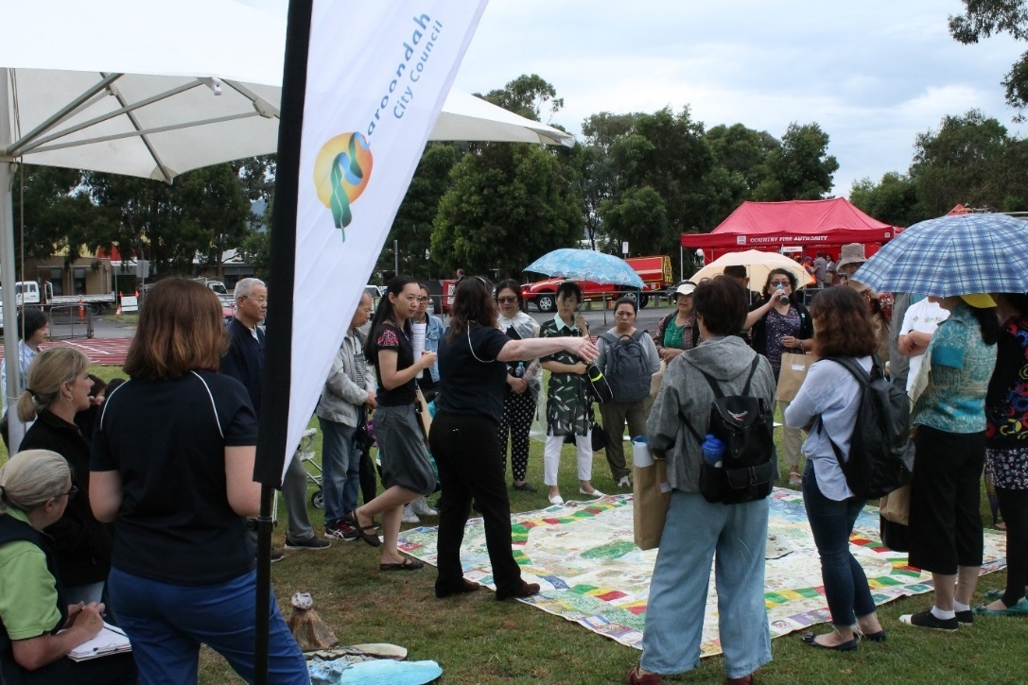
Picture: Disaster education session at Croydon Town Park provided participants an opportunity to learn how to prepare and be ready for emergency events whilst becoming ‘Resilience Ambassadors’ in the community

Outcome Area 2 – Places

Our achievements so far

- As part of the EAGA municipalities, in June 2016 Council received the United Nations Association of Australia (UNAA) World Environment Day Local Government Award for the Biodiversity Monitoring in Melbourne's East project.
- Council has initiated a collaboration with an academic institution to determine the role of multiple stressors on Eucalypt dieback in Maroondah.
- Council has pursued flood mitigation in priority areas and has implemented stormwater management guidelines for developers.

What we will do

Outcome description

Maroondah’s places, including the built environment, its biodiversity and waterways, are climate resilient, improving our health and wellbeing.

Objectives:
- Account for Melbourne’s east experiencing more frequent and prolonged extreme heatwave, drought, bushfires and more intense rainfall events
- Pursue flood risk adaptation responses across the water cycle
- Increase the integrity and connectivity of native vegetation across the landscape (e.g. biolinks)
- Work with all levels of government, other assets managers, stakeholders and the community to cool and green Maroondah (e.g. provide shade, reduce heat islands, connect vegetation communities)
- Use climate sensitive materials and urban elements, including in protecting our local parks and sports fields in a hotter climate.

What the evidence tells us

Assets and infrastructure

More extreme climate conditions and weather events can damage Council and community infrastructure increasing maintenance and operating costs and reducing asset lifespans. Heavy rainfall and flooding often cause significant infrastructure damage and pollution.

Current building design standards are not adequate for projected climate conditions. Decisions about new buildings and renewals should incorporate building vulnerability assessments that consider the risk to assets from climate change. This includes adapting existing assets, particularly those that provide the most critical services to the community.

Natural environment

Extreme weather patterns have impacted on bushland areas with vegetation and plant species declining and extended fire seasons have also been experienced. Increased extreme weather events leads to more damaged and fallen trees posing risk to safety, loss of services and increased maintenance costs. There is also a need for greater fire risk management around reserves.

Climate change challenges assumptions that natural resource management might be able to preserve present or restore past conditions. Increasing temperatures lead to loss of biodiversity and increased environmental management costs. Conditions favour increased spread of weeds.
An Australian Government funded study of 1.5 million trees in 29 council areas across Australia including Maroondah found that higher temperatures and urban heat means new tree species may be introduced, existing trees must be given special care and some trees may disappear in certain locations.

Some 19 per cent of trees were at high risk under business-as-usual in the City of Maroondah. They included Eucalyptus cephalocarpa, Eucalyptus radiate, Eucalyptus goniocalyx, Eucalyptus obliqua, Eucalyptus ovata, Eucalyptus scoparia, Betula pendula, Prunus × blireiana, Eucalyptus globoidea, Eucalyptus macrorhyncha, Pinus radiate.

Clean Air and Urban Landscapes Hub (2017) depicts risk to individual trees within Maroondah’s street tree population colour coded for temperature risk under current climate conditions, an emissions limited climate scenario and a business as usual scenario. The report notes there are several ways to adapt to increasing temperatures such as by providing irrigation or improved pest and disease management, careful site selection for vulnerable species, improved tree maintenance and by selecting trees that are better adapted to future climates.

Sports and Recreation
Council faces challenges from the impacts of drought on the maintenance of local parks, sports and recreational facilities. Increasing heat exposure poses risks to people using Council sport facilities and public open space (e.g. heat stroke, injuries associated with the hardening of sportsgrounds). In addition, reduced water availability leads to greater demands for irrigation and associated financial costs to Council.

Urban development
Key risk areas for Council relating to stormwater runoff and flooding include damage to and loss of land and assets. Impacts are likely to be short term and episodic. There is also an increased risk of bushfire under climate change. Heatwaves are increasing in frequency and intensity, putting people’s lives at risk. This is especially serious in urban areas, when the urban heat island effect increases temperatures even further. Poor quality housing can expose residents to extreme heat. Residents of settlements where public transport is harder to access can also face compounding stresses including a lack of access to services and rising fuel costs.

What the community has told us

- A climate resilient neighbourhood looks like “Having proper shaded playgrounds for our children to play in especially during warm summer days”.
- “…concentrate on things that make lives better and more comfortable – storm water, growing own food, planting greenery, developing solar and wind power, improving infrastructure, reward people for their improvements”.

Focus Areas

Focus Area 2: Reduce vulnerability of the places at risk in Maroondah.

2040 Outcome Area: An attractive, thriving and well built community. Key directions from Maroondah 2040: Our Future Together:
- Ensure the management of infrastructure and prioritisation of capital works considers demographic change, the impacts of climate change, and accessibility for all ages and abilities.
- Coordinate and advocate for the increased utilisation, longevity and availability of fit for purpose public, private and not for profit buildings and spaces that can act as key places for neighbourhood connection.

Key Directions

- Use the natural environment to build adaptive capacity by incorporating green infrastructure involving an integrated approach to land use that maximises economic, social and environmental benefits. Examples include; wetlands, rain gardens, tree pits and green facades.
- Work with stakeholders including the Australian Government, Victorian Government, Melbourne Water, Yarra Valley Water, Port Phillip and Westernport Catchment Management Authority, Parks Victoria and local community groups to improve waterways, enhance local flora and fauna and connect communities.
- Strengthen regional collaboration with other asset managers (e.g. water and transport authorities) and take a leadership role in the Port Phillip and Westernport Regional Catchment Strategy by meeting targets for the native vegetation Council owns and manages (refer Appendix B).
- Pursue resilience from droughts and waterway flooding impacts by addressing water quality and improving the flood mitigation and permeability of urban areas. Adopt Integrated Water Management (IWM) and water sensitive urban design practices in buildings, open space water bodies and street design.
- Together with Melbourne Water pursue the Tarralla Creek Connects project – a place-based renewal of the Croydon Parklands and Dorset Recreation Reserve along Tarralla Creek in Croydon. Anticipated benefits include: a renewed Croydon wetland, an attractive stormwater harvesting facility for irrigating sportsgrounds and re-naturalising of sections of the Tarralla Creek.
- Progress distributed water sources and enhanced water corridors, particularly in low SEIFA Index of Disadvantage areas following concept planning and detailed design.
- Support work with partners to address fire and flood prone areas including community education initiatives.
- Work with regional partners to accommodate changes in storm and rainfall patterns, for better water security and to ensure resilient and connected landscapes in consideration of Council’s Water Sensitive City Strategy and Council’s Open Space Strategy.
- Support sustainable design to encourage new buildings and renewals to integrate building vulnerability assessment.
- Support the planning of buildings for improved building performance in extreme weather and incorporate thermal comfort, drainage, and water storage considerations into building designs.
- Manage the urban heat island effect through material selection, energy efficient design and landscaping.
- Design and plan for increased tree and vegetation coverage, ensure the municipality’s weed management activities support thriving ecosystems, seek opportunities to enhance monitoring of climate impacts on biodiversity, and build community understanding.
- Provide leadership to facilitate improved water, soils and vegetation through community-based planning and capacity building to engage and inspire local participation of landscape-based solutions.
- Where appropriate, work with stakeholders for planned burning programs in the region.

Image 8: Green Infrastructure Case Study

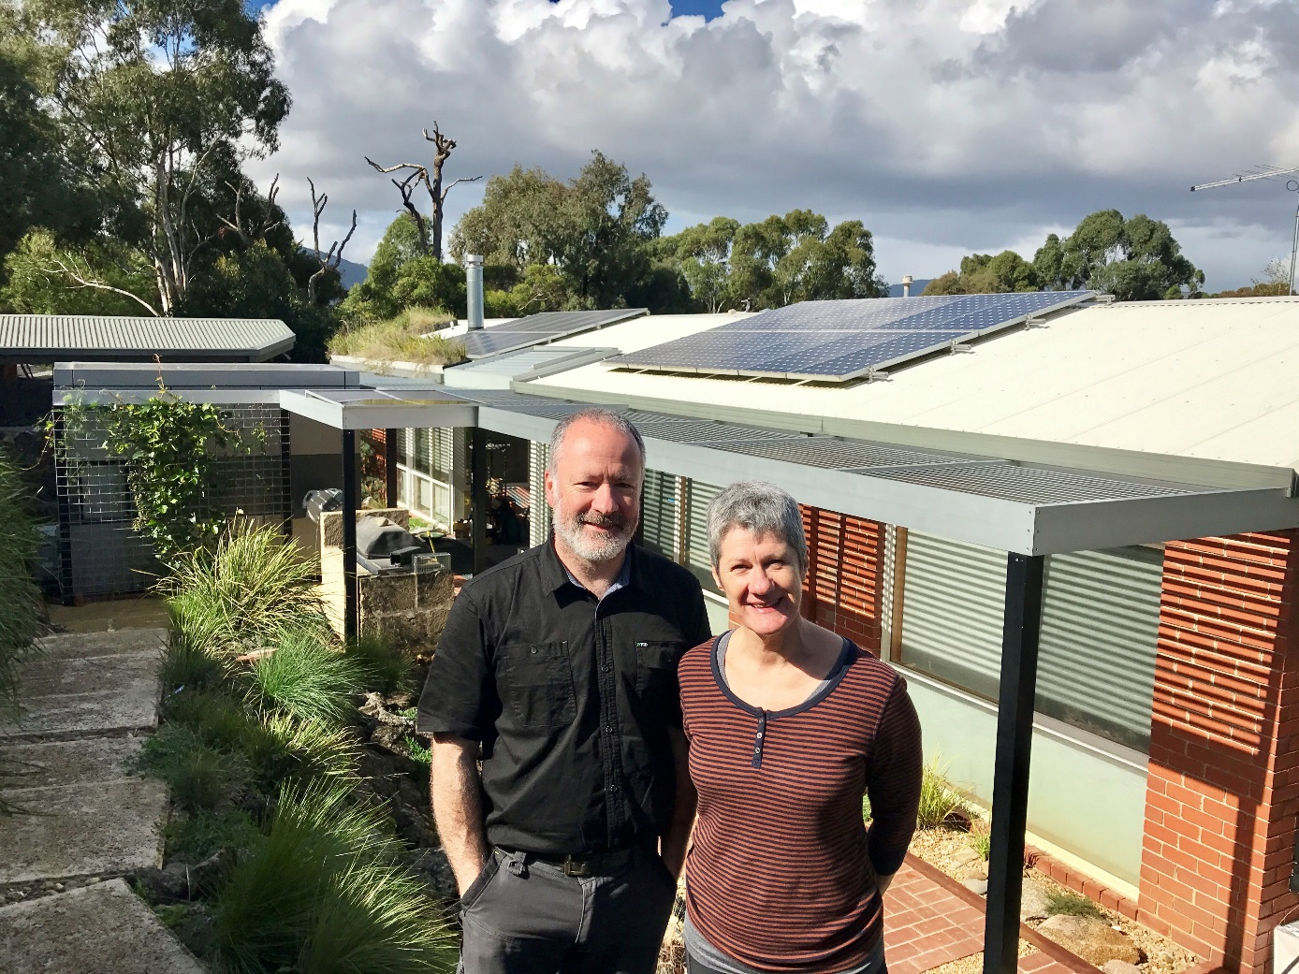
Picture: The owners of this property in Croydon South have embraced green-infrastructure features (eg green roofs, walls and facades) as part of their residential development

Outcome Area 3 – Embed Adaptation

Our achievements so far

- Council supported the mid-2016 local government workshops on the development of Victoria’s Climate Change Adaptation Plan 2017-2020 and participated in Victorian Government sessions to co-design a community of practice for adaptation in local government (from 2017).
- Council was an observer for the ‘How well are we adapting?’ project developed by and for the Western Alliance for Greenhouse Action councils. The project established a web-based climate change adaptation monitoring, evaluation and reporting tool for councils in Melbourne’s western region to assist with building resilience and preparedness. This encouraged organisational learning. It can be viewed at: http://adapt.waga.com.au/
- Council has undertaken a “service criticality” review, identifying which buildings provide the most critical services to the community to help prioritise improvements needed and related business cases.

What we will do

Outcome description

Community and staff capacity is increased through improved awareness, education and support for climate change adaptation practices.

Objectives:
- Pursue relevant Maroondah 2040: Our Future Together community aspirations
- Pursue relevant organisational learning opportunities
- Collaborate internally and externally (e.g. share ideas and opportunities, act as a catalyst for climate change planning, management and adaptation)
- Ensure climate change risks relevant to Council are managed in an integrated way
- Integrate resilience criteria into relevant Council service delivery and decision making
- Monitor and review the performance of Council in improving adaptive capacity
- Seek funding to advance the climate change adaptation agenda across Council, Maroondah and Melbourne’s east with the assistance of EAGA.

What the evidence tells us

Council operations

Council service delivery is subject to interruptions from storm, heat, flood and fire events resulting in significant operational challenges. Power and communication outages during heatwaves can lead to a loss of Council services. Transport disruptions to both public and private transport during extreme weather events lead to reductions in employees able to attend work. Business continuity and risk management are also impacted by extreme weather events. Examples include rising insurance policy costs. Council assets are experiencing increased maintenance costs and are subject to more frequent failures. More extreme weather events typically reduce public safety, lead to increased insurance claims and increased recovery costs.

What the community has told us

- “It is important to do ‘green’ as you save money as well as the area”.
- “Planning for climate change at the individual, community, school level can make a difference”.

Focus Areas

Focus Area 3: Embed Council’s commitment to climate change adaptation.

2040 Outcome Area: A well governed and empowered community. Key directions from Maroondah 2040: Our Future Together:
- Ensure responsible and sustainable management of Maroondah’s resources, assets, infrastructure and natural environment
- Foster a culture of innovation, cooperation, commitment, communication and continuous improvement that positions Maroondah City Council as a leader in local government
- Create opportunities for shared decision making through active community involvement
- Work in partnership to deliver services that recognise and are responsive to the interests and needs of the community.

Key Directions

- Strengthen work at scale – support the Resilient Melbourne Program and the State-Local Partnership Agreement (2017) for climate change (i.e. Resilient Melbourne Strategy, Victoria’s Climate Change Adaptation Plan 2017-2020 respectively).
- Identify climate change adaptation opportunities in Council’s Asset Management Strategy and Capital Works Implementation and Management Strategy.
- Operationalise climate change risks and promote a ‘risk aware’ culture at Council in consideration of Council’s Strategic Risk Management Plan.
- Develop and implement the Risk and Resilience Plan and Framework including business continuity management systems and testing in consideration of Council’s Strategic Risk Management Plan.
- Ensure Council’s risk profile is properly reflected in the insurance program to help mitigate financial risk.
- Help staff track climate change impacts on Council’s assets, operations and services and evaluate responses over the long term.
- Support climate change advocacy by EAGA and other greenhouse alliances for effective policy action on climate change at the Victorian and Australian Government level.

Section 5 – Tracking Progress

This Strategy has been prepared to help ensure that climate change risks are managed in a planned and considered way. As this is Council’s first adaptation strategy much of its focus is on incorporating climate change risks into existing activities to ensure an integrated approach. For example:

- Recognition of climate change as a strategic risk is driving more proactive adaptation planning across Council.
- Linking with emergency management planning will ensure Council is well placed to recognise and manage emerging risks.

The Strategy will be reviewed every two years to track implementation progress, evaluation, continuous improvement and when further review is required. Particular reference will be given to linkages associated with a future review of Council’s Carbon Neutral Strategy.

For Strategy delivery, a cross directorate team will be established to monitor progress supported by the Finance and Governance teams (e.g. financial and risk management advice), and the Integrated Planning Department utilising the best available climate science and vulnerability information.

Evaluation will be undertaken through the development and review of a detailed Action Plan. This Plan will be reviewed annually to track progress on actions, with the results reported back to Council.

The Maroondah Environment Advisory Committee will be engaged regularly to assist with tracking Council’s progress on the Strategy and Action Plan.

Section 6 – References

Australian Government (2015) National Climate Resilience and Adaptation Strategy, last accessed 31 January 2018 www.environment.gov.au/climate-change/adaptation/strategy

Australian Government – Climate Ready Natural Resource Management Planning in Victoria portal, last accessed 31 January 2018 at www.nrmclimate.vic.gov.au

Bureau of Meteorology (BOM), last accessed 31 January 2018 www.bom.gov.au/
City of Melbourne (2016) Resilient Melbourne Strategy, last accessed 31 January 2018 www.melbourne.vic.gov.au/SiteCollectionDocuments/resilient-melbourne-strategy.pdf

Clean Air and Urban Landscapes Hub (2017) Risks to Australia’s Urban Forest from Climate Change and Urban Heat, last accessed 31 January 2018
www.nespurban.edu.au/publications-resources/research-reports/CAULRR07_RisksAustralianUrbanForest_Oct2017.pdf

Climate Council’s report 2015, The Silent Killer: Climate Change and the Health Impacts of Extreme Heat, last accessed 31 January 2018 www.climatecouncil.org.au/silentkillerreport

Commonwealth of Australia (2016) State of the Climate 2016, last accessed 31 January 2018
www.bom.gov.au/state-of-the-climate/State-of-the-Climate-2016.pdf

CSIRO (2013) Climate Futures for Eastern Melbourne: Data prepared for the Eastern Alliance for Greenhouse Action, last accessed 31 January 2018 https://eaga.com.au/wp-content/uploads/App-2b-CSIRO-Climate-Futures_Bushland_EAGA-May-2013.pdf

CSIRO/BOM – Climate Change in Australia website, last accessed 31 January 2018 at www.climatechangeinaustralia.gov.au

Eastern Alliance for Greenhouse Action (2013) Bushland and Urban Biodiversity Management in a Changing Climate, last accessed 31 January 2018 http://eaga.com.au/wp-content/uploads/App-2a-Climate-Change-Projections_Bushland_EAGA-May-2013.pdf

Eastern Alliance for Greenhouse Action (2014) Climate Change Adaptation Roadmap for Melbourne’s East: A guide for decisions makers in the EAGA Councils, last accessed 31 January 2018 https://eaga.com.au/wp-content/uploads/FINAL-ROADMAP-web1.pdf

Eastern Alliance for Greenhouse Action (2014b) Adapting to Climate Change in Melbourne’s East: A Regional Risk Assessment for Member councils of the Eastern Alliance for Greenhouse Action, last accessed 31 January 2018 https://eaga.com.au/wp-content/uploads/EAGAClimateRiskAssessment.pdf

Intergovernmental Panel on Climate Change (2014) Summary for policymakers. In: Climate Change 2014: Impacts, Adaptation, and Vulnerability. Part A: Global and Sectoral Aspects. Contribution of Working Group II to the Fifth Assessment Report of the Intergovernmental Panel on Climate Change [Field, C.B., V.R. Barros, D.J. Dokken, K.J. Mach, M.D. Mastrandrea, T.E. Bilir, M. Chatterjee, K.L. Ebi, Y.O. Estrada, R.C. Genova, B. Girma, E.S. Kissel, A.N. Levy, S. MacCracken, P.R. Mastrandrea, and L.L.White (eds.)]. Cambridge University Press, Cambridge, United Kingdom and New York, NY, USA, pp. 1-32. Last accessed 31 January 2018 www.ipcc.ch/pdf/assessment-report/ar5/wg2/ar5_wgII_spm_en.pdf

Maroondah City Council (2017) Community Engagement Report
Maroondah City Council (2016) Climate Risk and Adaptation Strategy Discussion Paper
Maroondah City Council (2015) Carbon Neutral Strategy & Action Plan 2014/15-2020/21

Maroondah City Council (2014) Maroondah 2040 Community Vision

Victorian Government (2017) Victoria’s Climate Change Adaptation Plan 2017-2020, last accessed 31 January 2018 www.parliament.vic.gov.au/file_uploads/Climate_Change_Adaptation_Plan_080217_B0zm1V3s.pdf

Victorian Government (2017b) Plan Melbourne 2017-2050, last accessed 31 January 2018 www.planmelbourne.vic.gov.au/__data/assets/pdf_file/0007/377206/Plan_Melbourne_2017-2050_Strategy_.pdf

Legislation

Local Government Act 1989

Climate Change Act 2017

Section 7 – Glossary

Adaptation is defined by the Victorian Government as changes in natural or human systems to prepare for actual or expected changes in the climate in order to minimise harm, act on opportunities or cope with the consequences.

Adaptive capacity is defined by the Victorian Government as the capability of a system, sector or social group to adjust to climate change, to minimise harm, to act on opportunities, or to cope with the consequences.

Business Continuity Management Plan (BCMP) is a collection of policies, procedure, protocols and information that has been developed, compiled and maintained in readiness for a business disruption.

Culturally and linguistically diverse (CALD) is a contemporary descriptor for ethnic communities. CALD people are generally defined as those people born overseas, in countries other than those classified by the Australian Bureau of Statistics (ABS) as “main English speaking countries”.

Climate change is defined by the Victorian Government as changes in the state of the climate, including an increase in extreme weather events, long-term changes in weather patterns and sea level rise, attributed directly or indirectly to human activity.

Climate change mitigation involves actions that avoid or reduce the production of greenhouse gas emissions, such as via renewable energy, energy efficiency and behaviour change.

Climate hazards are potentially damaging events.

Eastern Alliance for Greenhouse Action (EAGA) is a formal collaboration of eight councils in Maroondah’s east, working together on regional programs that reduce greenhouse gas emissions and facilitate regional adaptation.

Eastern Metro Councils Emergency Management Partnership (EMCEMP) primarily focuses on the provision of staff from eastern metropolitan councils to set up and assist in the operation of ERCs.

Emergency Relief Centre (ERC) is a building or place established to provide (temporary) support and essential needs to persons affected by or involved in the management of an emergency.

Green infrastructure is the term we use to describe the network of green space and/or blue space (in the case of water) in our municipality and multiple benefits associated with the principles relevant to establishing green infrastructure (e.g. connectivity, multi-functionality). Examples of green infrastructure in Maroondah include; wetlands, rain gardens, tree pits and green facades.

Integrated Water Management (IWM) is a collaborative approach to planning that brings together all elements of the water cycle including sewage management, water supply, stormwater management and water treatment, considering environmental, economic and social benefits.

Maroondah Environmental Advisory Committee is established to inform and advise Council on environmental and sustainability issues and Council’s role in improving the environment in Maroondah.

Municipal Emergency Management Plan sub-plans refers to various sub plans which have been prepared to detail specific emergency arrangements. The sub plans are hazard based and have been developed based on the risk to the community. Sub plans include: Municipal Fire Management Plan; Business Continuity Management Plan; Heatwave Plan; Influenza Pandemic Plan; Flood and Storm Plan; Emergency Relief Centre Sub Plan (Eastern Region and Surrounds); Emergency Relief Centre Facility Plans; and Municipal Emergency Management Team Roles & Responsibilities Guide.

Municipal Emergency Management Planning Committee and its sub-committees, promote and support appropriate prevention and awareness programs.

Port Phillip and Westernport Catchment Management Authority (PPWCMA) provides leadership to a range of stakeholder groups and works to deliver integrated catchment management and sustainability of the region’s catchment assets by coordination and partnerships amongst theme groups. CMAs have undertaken regional climate change adaptation planning across Victoria.

Preparedness refers to measures to ensure that, should an emergency occur, communities, resources and services are capable of coping with the effects.

Resilient Melbourne Program, part of Resilient Melbourne, this program is helping cities around the world become more resilient to physical, social, and economic shocks and stresses.

Socio-Economic Indexes for Areas (SEIFA), is a number, or series of four (4) numbers, which describe the relative level of socio-economic advantage or disadvantage in an area. Advantage is defined in terms of “access to material and social resources and ability to participate in society.”

Stakeholder is any person, institution, organisation, agency, department, authority, club, association or the like which has any interest in, or association with an area. This does not only mean a financial interest. It includes the public.

Transformation in adaptation refers to changes that help us adapt to climate change beyond what can be achieved by small or incremental changes to a business-as-usual approach.

Urban heat island effect is the additional heating of the air over a metropolitan area as the result of the replacement of natural, vegetated surfaces with asphalt, concrete and rooftops.

Urban resilience is defined by 100 Resilient Cities – Pioneered by the Rockefeller Foundation (100RC) as the capacity of individuals, institutions, businesses and systems within a city to adapt, survive and thrive no matter what kind of chronic stresses and acute shocks they experience.

Water security is about diversifying and making better use of alternative sources to potable water such as rainwater, stormwater, recycled wastewater and other sources and not relying solely on a single source.

Water Sensitive Urban Design (WSUD) is a broad term for achieving water efficiency, stormwater treatment to improve water quality, and the capture and reuse of alternative water sources such as rainwater, stormwater and wastewater.

Vulnerability to climate change is defined by the Victorian Government as the degree to which a system, sector or social group is susceptible to the adverse effects of climate change; vulnerability depends on the nature of the climate changes to which the system is exposed, its sensitivity to those changes and its adaptive capacity.

Appendix A – Victorian Government’s Climate Change Adaptation Plan 2017-2020 - Roles and Responsibilities

Local Governments | Provide leadership and good governance, represent the needs and values of local communities, and foster community cohesion:  - Manage climate change risks to council community services and assets, with support from the Victorian Government.  - Identify the needs and priorities of the municipality, and communicate these to Victorian Government where needed.  - Develop and deliver locally-appropriate adaptation responses.  - Build the resilience of local assets and services.  - Plan for emergency management at the municipal level, provide relief and recovery services, and support emergency response operations.  - Help the Victorian Government understand localised impacts and responses.  - Work with the community to help people understand and get involved in climate change adaptation.  - Help connect the Victorian Government with the community.
Communities and Individuals | Understand and actively manage their own risks:  - Plan and act responsibly to reduce the exposure of their own person, families, private property and livelihoods to risks caused by climate change impacts.  - Develop innovative local responses to climate change risks.  - Explain to government and decision-makers what the community needs and values.  - Support and encourage adaptation efforts on the ground.
Businesses and Industries | Understand and proactively manage their own risks, including those in supply chains:  - Identify opportunities created by the need to adapt.  - Drive innovation and changes in products, services and markets to create more sustainable practices.  - Influence customers, suppliers and investment decisions.

Appendix B – City of Maroondah Targets included in the Port Phillip and Westernport Regional Catchment Strategy

- No net loss of the area and quality of existing native vegetation on 171 hectares of land managed by the City of Maroondah to 2040.
- Improved native vegetation quality on an additional 6.7 hectares of land managed by the City of Maroondah by 2025 and a further 13.1 hectares by 2040.
- No net loss in Council’s 2016 stock of 64,200 street trees to 2040.
- No net loss of the 650 hectares of open space owned by Council to 2040.

The Regional Catchment Strategy prepared by the Port Phillip and Westernport Catchment Management Authority helps to coordinate work around its shared vision and targets. It can be viewed at: www.ppwrcs.vic.gov.au


To contact Council telephone 1300 88 22 33
visit our website at: www.maroondah.vic.gov.au
or call in to one of our service centres:

City Offices Service Centre
Braeside Avenue
Ringwood

Realm Service Centre
Maroondah Highway
Ringwood

Croydon Service Centre
Civic Square
Croydon

Translating and Interpreter Service
13 14 50

National Relay Service (NRS)
13 36 77

www.facebook.com/MaroondahCityCouncil
@CityofMaroondah
www.youtube.com/CityofMaroondah

maroondah@maroondah.vic.gov.au
www.maroondah.vic.gov.au

