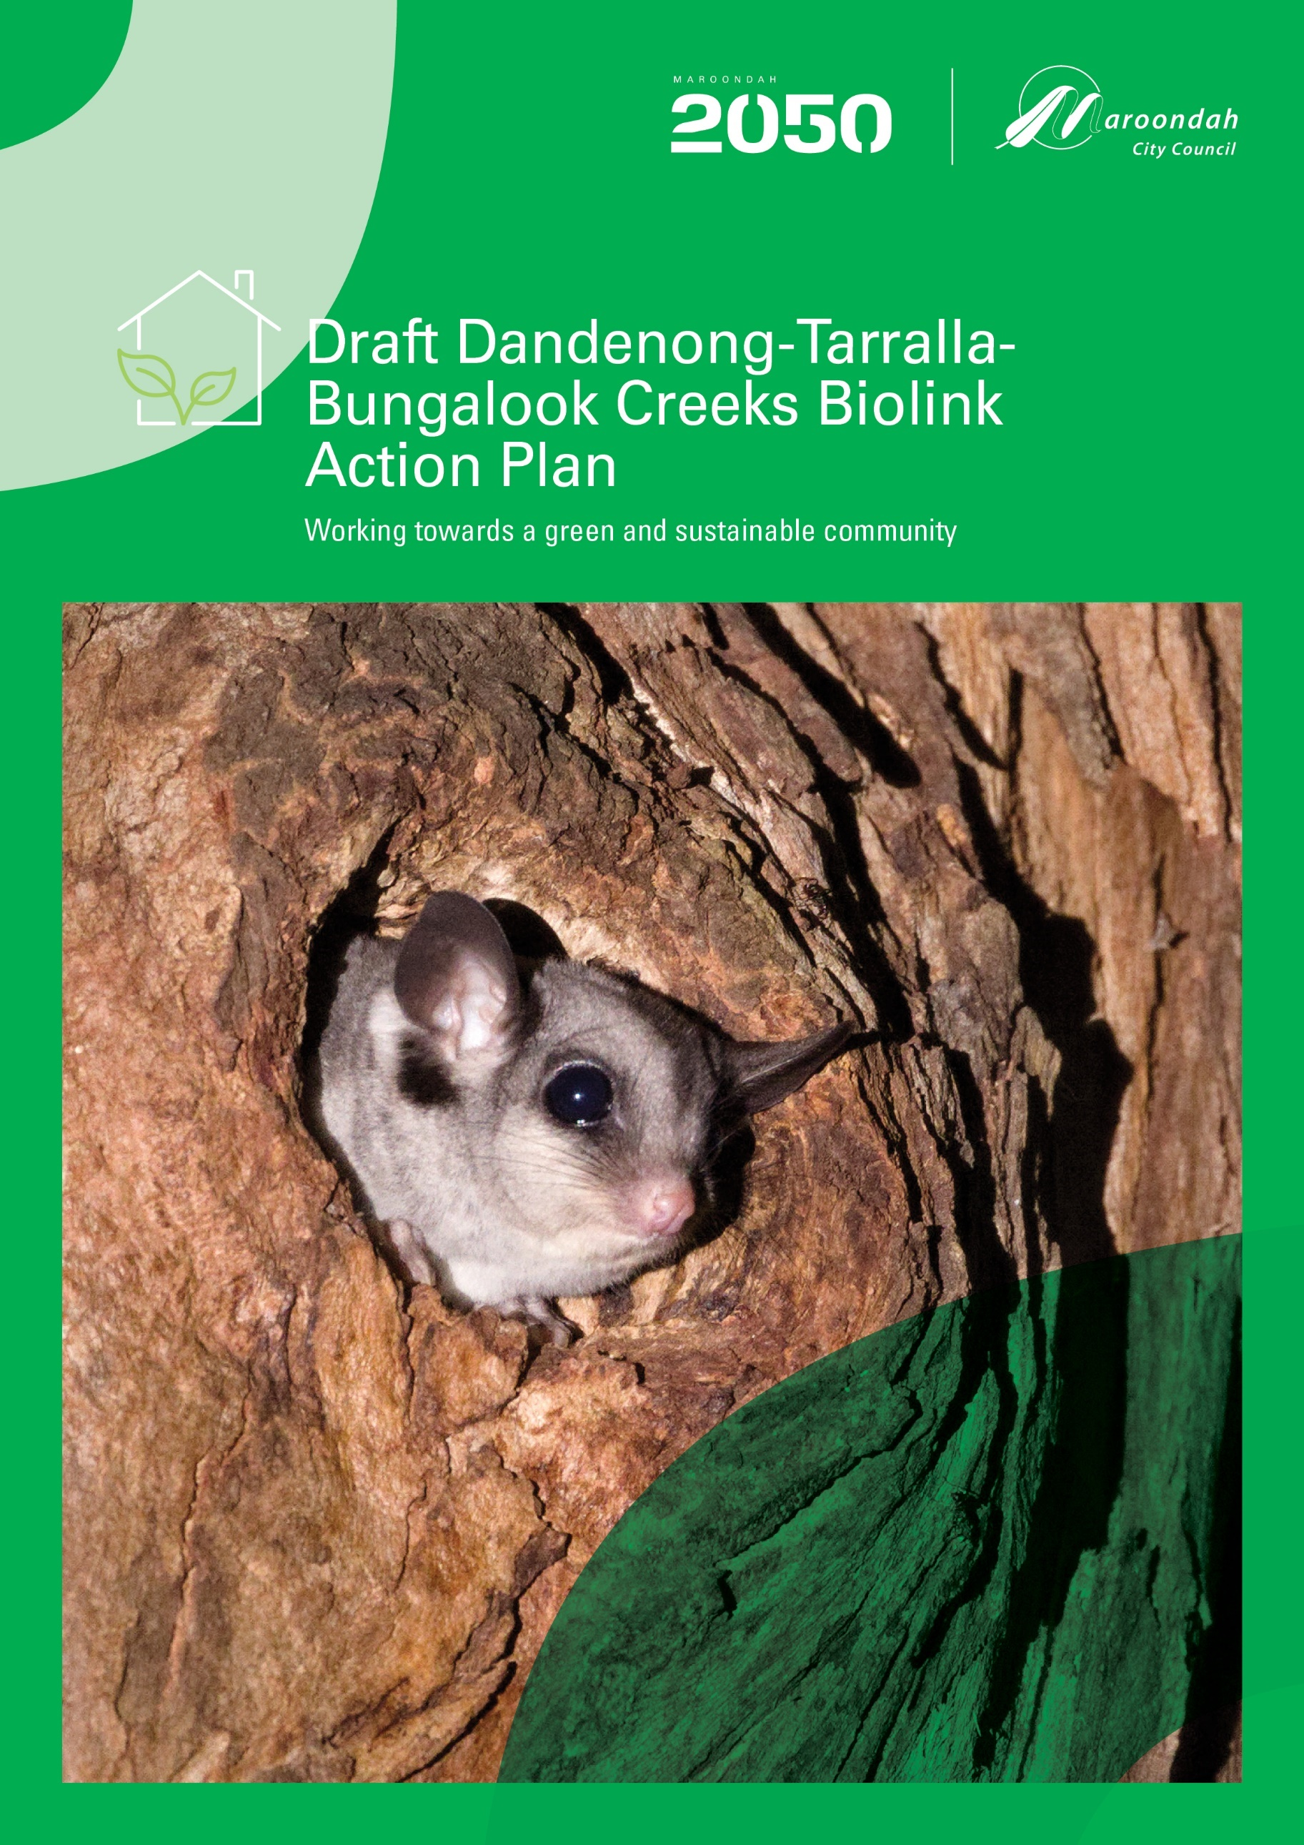
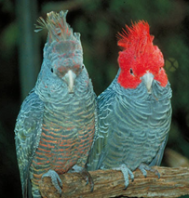
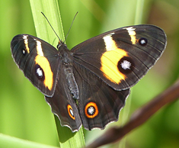
Yarra Valley Grammar bushland
Peter Vergers Reserve
Contents
About this plan 3
What has led us to this point? 4
The Dandenong-Tarralla-Bungalook Creeks Biolink 6
Landscape context 8
Vision 11
Proposed actions 12
Proposed actions – to meet the needs of the focal species 13
1. Blue-banded Bee (Amegilla spp) 14
2. Common Galaxias (Galaxias maculatus) 16
3. Glossy Grass Skink (Pseudemoia rawlinsoni) 20
4. Krefft’s (Sugar) Glider (Petaurus notatus) 22
5. Mistletoebird (Dicaeum hirundinaceum) 25
6. Spotted Marsh Frog (Limnodynastes tasmaniensis) 27
7. Superb Fairy-wren (Malurus cyaneus) 29
Proposed actions – to support the biolink 31
Proposed actions – to sustain the biolink 33
Proposed actions – to connect the community to the biolink 38
Appendix 1 - Key stakeholder group 40
Appendix 2 - Engagement species 41
Appendix 3 - Full list of actions 42

The Dandenong-Tarralla-Bungalook Creeks Biolink forms part of the Traditional Country of the Wurundjeri Woi-wurrung people of the Kulin Nation. We acknowledge and respect their ongoing connection to and culture of caring for Country. We pay our respect to Elders past, present and emerging, and seek to honour their custodianship of its land, water, plants, and animals in establishment of the Dandenong-Tarralla-Bungalook Creeks Biolink.

About this plan

This plan presents a range of actions that have been identified as being needed for building and sustaining the Dandenong-Tarralla-Bungalook Creeks Biolink as a functioning wildlife corridor. As yet, these actions have not been budgeted for, nor formally incorporated into service delivery (or equivalent) planning.

Collectively these actions are designed to progress us towards a shared vision for the biolink and have been identified by a key stakeholder group comprising a mix of representatives from external organisations and teams within Maroondah Council (refer Appendix 1 for the full list of stakeholder organisations).

The purpose of this draft plan is to share and test support for the identified actions with organisations and individuals across the wider Maroondah community. To optimise the likelihood of successfully creating the Dandenong-Tarralla-Bungalook Creeks Biolink, we are seeking to understand the level of community support for creating the biolink overall, the identified actions, and also suggestions that can help us to locate, refine, improve and firm up the actions to be included in the final action plan.

The final action plan will then be used to drive implementation of actions and advocating for further external support and investment.

The actions identified are expected to be implemented over many years by many organisations with a focus on the actions identified as the highest priority. It is proposed that a coordination group be formed to monitor progress and effectiveness, oversee implementation, continually review and reassess actions to confirm the highest priorities and assign lead roles for advocacy, pursuit of external funding, internal budgeting and implementation.

A full list of the proposed actions is also provided in table form in Appendix 3.

What has led us to this point?
Maroondah 2050 - Our future together

Developed with our community, partners and service providers, and endorsed by Council in May 2025, “Maroondah 2050: Our future together” provides a roadmap for our community, Council and other levels of government to partner together and create a future that enhances Maroondah as a great place to live, work, play and visit. “Maroondah 2050: Our future together” states the following:
Outcome: A green and sustainable community
Key focus: Protecting, restoring and enhancing biodiversity, biolinks and habitat corridors

Council Plan 2025-2029


The Council Plan 2025-2029 was adopted by Council in June 2025. The Council Plan is our medium-term strategic document that focuses the work of Council to ensure that what we are doing today contributes to realising the Maroondah 2050 Community Vision. This Council Plan is the first plan created under our new Maroondah 2050 Community Vision. Each year Council undertakes a revision of the four-year Council Plan to ensure that it continues to be aligned with Maroondah 2050 - Our future together and is responsive to emerging community needs and aspirations. The Council Plan 2025-2029 includes the following:
Outcome: A green and sustainable community

Priority Action (for years 2025/26, 2026/27, 2027/28, 2028/29 onwards): Develop and implement a series of Biolink Action Plans that implement the Maroondah Habitat Connectivity Study.

Biodiversity in Maroondah - Volumes 1 & 2 2020
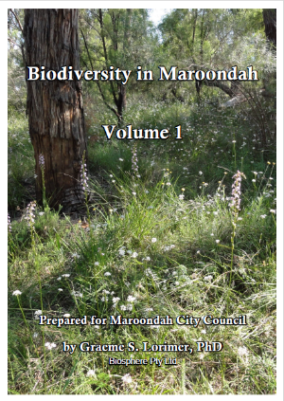
The consultancy Biosphere Pty Ltd was engaged in 2018 to provide a contemporary assessment of Maroondah’s biodiversity with a focus on indigenous species, communities, and habitats. The resulting report, Biodiversity in Maroondah Volumes 1 & 2 2020, is a key component of the municipal-wide vegetation review arising from the Maroondah Housing Strategy 2016. This study also provides an updated assessment of sites of biological significance originally identified in the 1997 report Sites of Biological Significance in Maroondah. The two-volume report has informed the development of both the Maroondah Vegetation Strategy 2020 - 2030 and the Maroondah Habitat Connectivity Plan 2021.

Maroondah Vegetation Strategy 2020 - 2030
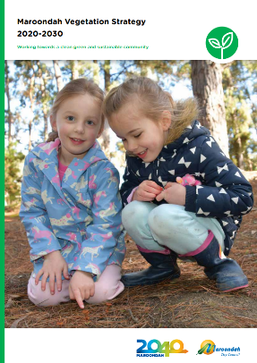
Developed with community input firstly through an Issues and Options Paper, then a draft strategy, the Maroondah Vegetation Strategy 2020 - 2030 was adopted by Council in March 2020. The strategy states the following:
Outcome 2: More nature throughout Maroondah
Priority Action 2.3(b): Review the 2005 Habitat Corridor Strategy to confirm priority linkage routes and align with this strategy’s focus on habitat for a suite of ‘focal’ species

Maroondah Habitat Connectivity Plan 2021
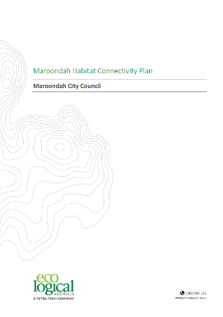
The consultancy Eco Logical Australia was engaged in June 2020 to utilise the spatial modelling decision framework General Approach to Planning Connectivity from Local to Regional Scales (GAP-CloSR) to identify the pathways through the Maroondah landscape that offered the best potential for improving habitat connectivity. Guided by an advisory group of internal and external people with relevant knowledge and expertise, the resulting Maroondah Habitat Connectivity Plan 2021 identified a number of priority locations that together formed a number of biolinks or wildlife movement corridor pathways.
In order to depict these biolinks on a map, a 50-metre buffer was drawn around each priority location with eight biolinks identified and named.

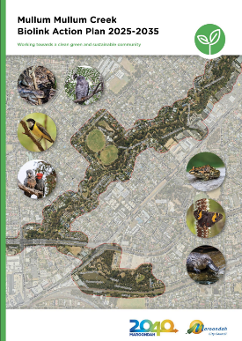
Mullum Mullum Creek Biolink Action Plan 2025-2035
The Mullum Mullum Creek Biolink Action Plan 2025-2035 was adopted by Council in December 2024. The Mullum Mullum Creek Biolink was the first of the eight identified biolinks across Maroondah to undergo the next level of more detailed action planning. The planning process was a highly collaborative one, involving a wide range of key stakeholders from the start, and has provided the action planning process template for the Dandenong-Tarralla-Bungalook Creeks Biolink.

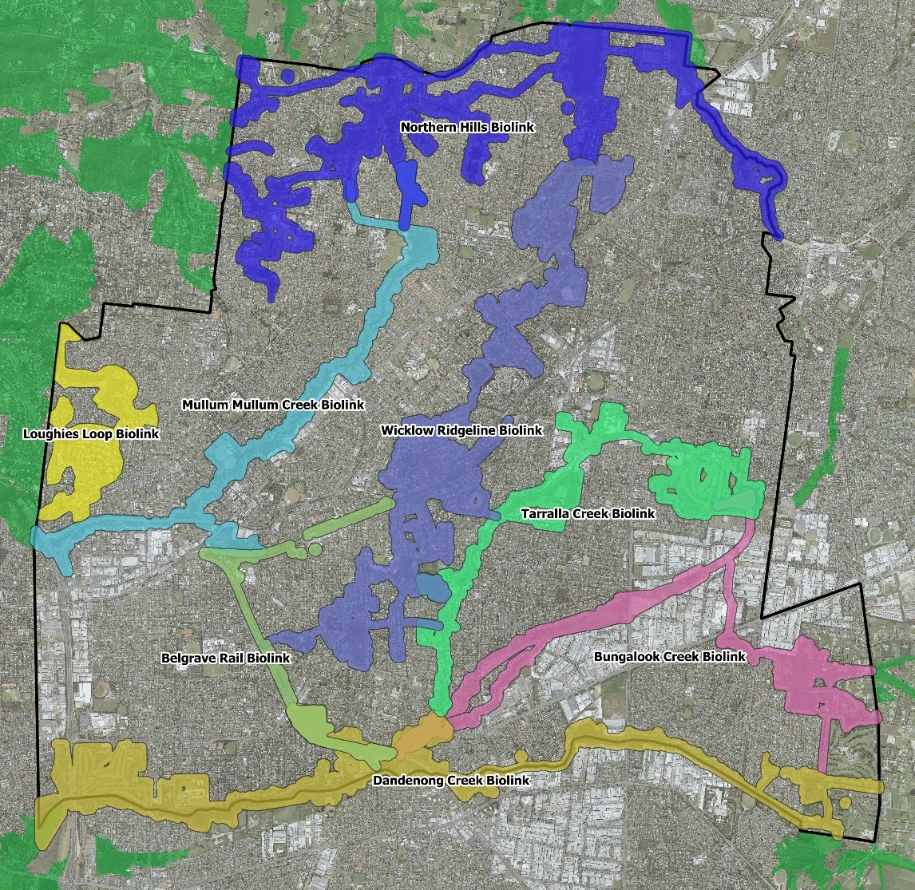
The Dandenong-Tarralla-Bungalook Creeks Biolink
Biolinks are the routes that represent the best opportunities for improving habitat connectivity to facilitate wildlife movement through a landscape.

The Dandenong-Tarralla-Bungalook Creeks Biolink is a combination of three of eight biolinks in Maroondah that have been identified through a process of spatial modelling (for more detail on the modelling process view the consultancy report here).
These eight biolinks are considered the best opportunities to enable more nature to disperse throughout Maroondah.

These biolinks are identified ‘pathways of least resistance’ through the landscape that will each require a diversity of on-ground actions to become functioning wildlife movement corridors. Once created, each biolink is expected to enable a wide range of fauna to move more easily along and into adjacent areas, so that we have more nature throughout Maroondah, and more people in Maroondah able to connect with nature as part of their daily lives.

Action planning for the Dandenong-Tarralla-Bungalook Creeks Biolink follows the same process used to develop the Mullum Mullum Creek Biolink Action Plan 2025-2035, adopted by Council in December 2024.

This document presents the actions needed to establish the Dandenong-Tarralla-Bungalook Creeks Biolink that have been identified to date.

At this stage in the planning, these actions are to be considered opportunities to be further assessed, refined and finalised, that collectively if implemented are expected to create a functioning habitat corridor following the Dandenong, Tarralla and Bungalook Creeks through Maroondah. Your feedback and comments are part of that assessment and refinement process.
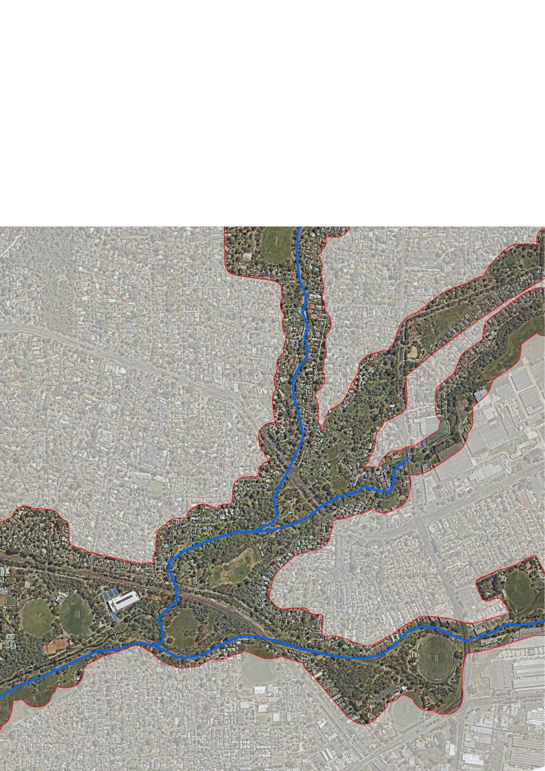

Landscape context

Within Maroondah, the Dandenong, Tarralla and Bungalook Creeks flow through the traditional lands of the Wurundjeri-Woi Wurrung people.

The origins of the creek names are thought to come from:
- the Aboriginal word Tanjenong, meaning ‘high mountain’ for the Dandenong Creek
- a Woi-wurrung word ‘Bungalook’ meaning ‘stringybark’, for Bungalook Creek, and
- an Indigenous word ‘tantala’ meaning ‘to walk fast’ for Tarralla Creek (although it is noted that the original reference may have been misquoted).
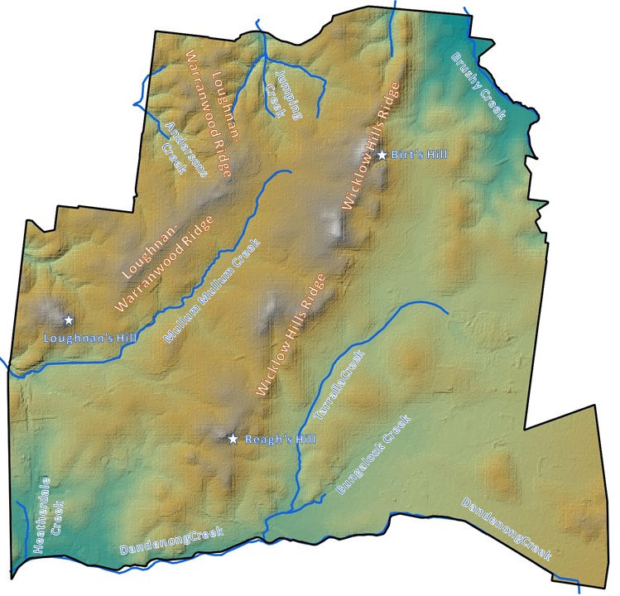

The Dandenong Creek flows around 53 kilometres in total, rising as a series of springs in the Dandenong Ranges near Olinda, flowing along the southern boundary of Maroondah (where it forms the municipal boundary with Knox City Council), and then into the once extensive Carrum Carrum Swamp (now the Edithvale-Seaford Wetlands) that drained into Port Phillip Bay via Mordialloc Creek and Kananook Creek.

Approximately 9.6 kilometres of the Dandenong Creek forms the southern boundary of Maroondah, however this stretch no longer follows a natural course having been largely straightened. For about 1.6 kilometres from the Liverpool Road Retarding Basin in Boronia (Knox) to about 100 metres upstream of the Laura Court Reserve in Bayswater North, the Dandenong Creek takes the form of a straight, steep-sided earthen channel that supports a range of indigenous and introduced plant species of stream banks and wetlands over an underground pipe. From there to approximately 300 metres upstream from the Belgrave Railway Line, the Dandenong Creek flows entirely underground as a low-flow pipe beneath a grassed swale. For around 800 metres downstream of the railway line, the creek has been ‘daylighted’ through a renaturalisation project completed in 2018, then continues as a waterway in a semi-natural form for the remainder of its journey through Maroondah.

Tarralla Creek and Bungalook Creek are both tributaries of the Dandenong Creek.

Tarralla Creek flows around 6.4 kilometres through Maroondah and the form it takes varies along the way. Tarralla Creek first appears near Colchester Road in Kilsyth where it takes the form of a low-flow pipe beneath a grassed swale before flowing into a large storage dam within the Dorset Golf Course. From here it is again piped for a short section before briefly surfacing as a semi-natural waterway for about 250 metres along the boundary of the golf course. From there it is again piped underground beneath the sporting grounds in Dorset Recreation Reserve that act as a retarding basin during high flow events. Tarralla Creek continues as an underground pipe beneath a grassed swale under Dorset Road past the Croydon campus of Swinburne University of Technology to Norton Road. Once past Norton Road, Tarralla Creek emerges as a major constructed wetland completed in 2022 and stretching 500 metres to Vinter Avenue. From there it again heads underground as a pipe beneath a narrow grassy swale to Eastfield Road, where it becomes an open concrete channel for 300 metres behind the Eastfield Shopping Centre, Croydon South to as far as Bayswater Road. From Bayswater Road it continues underground again as a low-flow pipe beneath a grassed swale all the way until it joins Bungalook Creek in Heathmont.

Bungalook Creek rises near Montrose and enters Maroondah in Kilsyth South. Its flow is interrupted firstly by the Colchester Road Retarding Basin and then the Canterbury Road Retarding Basin before being piped beneath industrial land in Bayswater North. It then changes at the Healesville Freeway Reservation near Dorset Road to being piped below a grassed swale. It follows the edge of this road reserve until it resurfaces just past Bayfield Road. Bungalook Creek retains its semi-natural form for the rest of its path to the confluence with Dandenong Creek near H.E. Parker Reserve in Heathmont. The section of Bungalook Creek within Maroondah is approximately 6.3 kilometres in length.

Smaller tributaries of the Dandenong Creek that are also included in the biolink are the Little Bungalook Creek in Kilsyth South and Heatherdale Creek in Vermont. Of note is the fact that in ancient times, near New Street, Ringwood, the Maroondah section of the Mullum Mullum Creek once turned and flowed south of Maroondah Highway down the now dry bed of the upper Heatherdale Creek into the Dandenong Creek and Port Philip Bay. A natural "river capture" (a geomorphological phenomenon caused in this case by headwater erosion of the lower Mullum Mullum Creek) has now taken the waters of the Maroondah section of the Mullum Mullum Creek and diverted them through a narrow gap in the hills to become a tributary of the Yarra River.

The Dandenong-Tarralla-Bungalook Creeks Biolink applies to Maroondah only, with its boundary extending 50 metres either side of the priority locations for this biolink identified in the Maroondah Habitat Connectivity Plan 2021 and covers a total area of approximately 208 hectares.

As such, the Dandenong-Tarralla-Bungalook Creeks Biolink is not limited to the public creek corridors and extends into neighbouring residential, commercial and industrial areas, as well as neighbouring Knox City Council. An estimated 200 parcels of public land (excluding roads) fall wholly or partially within the biolink and cover an estimated 405 hectares. Conversely, an estimated 2024 parcels of private land fall wholly or partially within biolink and cover an estimated 498 hectares.

Pre-settlement vegetation

The Victorian Government have established a state-wide classification scheme for different vegetation types in Victoria called ‘Ecological Vegetation Classes’, or EVCs, based on factors such as climate, soil, topography and vegetation strata. The distribution of EVCs presumed to have been present prior to European settlement have been modelled and provide a guide for efforts to restore or recreate natural habitats.

The four main EVCs within the Dandenong-Tarralla-Bungalook Creeks Biolink are:

- Riparian Forest - the dominant eucalypt species typically being Manna Gum (Eucalyptus viminalis subspecies viminalis)
- Swampy Riparian Complex and Swampy Riparian Woodland - the dominant eucalypt species typically being Swamp Gum (Eucalyptus ovata)
- Swampy Woodland - the dominant eucalypt species typically being Swamp Gum (Eucalyptus ovata) often with Swamp Paperbark (Melaleuca ericifolia)
- Valley Heathy Forest - no single dominant eucalypt species with Silver-leafed Stringybark (Eucalyptus cephalocarpa), Bundy (Eucalyptus goniocalyx), Messmate Stringybark (Eucalyptus obliqua), Red Stringybark (Eucalyptus macrorhyncha) and/or Narrow-leaved Peppermint (Eucalyptus radiata) usually present

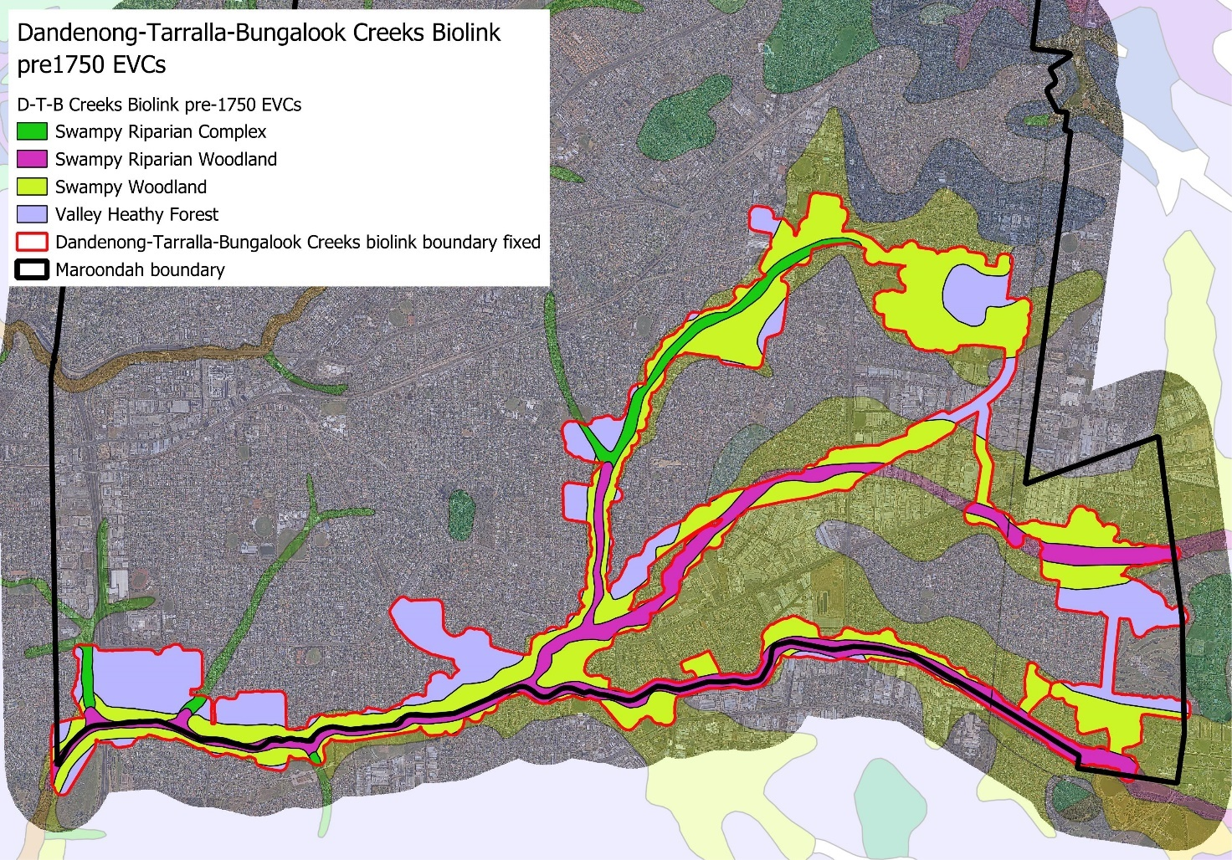
Modelled distribution of pre-European Ecological Vegetation Classes

Vision and proposed actions

A diverse group of key internal and external stakeholders were brought together early in the planning process to guide and oversee the development of the action plan (see Appendix 1 for the list of stakeholders involved)
To date these stakeholders have:
- Discussed and agreed on a shared vision for the biolink
- Discussed and agreed on seven focal species and their habitat needs
- Agreed on the broad actions needed to meet these habitat needs
- Shared what actions they can take relatively easily, and what else they could do if obstacles were removed
- Discussed and agreed on the suite of proposed actions presented in this document

The vision and proposed actions are presented in this draft plan for comment and refinement.

Vision
The Dandenong-Tarralla-Bungalook Creeks biolink immerses you in nature, bringing Wurundjeri culture to the forefront.
Cherished by all, it is cooperatively protected and cared for by community, government and business.

Proposed actions

The proposed actions are described under four headings:
- proposed actions to meet the needs of the seven focal species
- proposed actions to support the biolink
- proposed actions to sustain the biolink
- proposed actions to connect the community to the biolink.

In more detail, the proposed actions described in the following pages focus on:
- habitat creation and improvement (eg availability of food resources, shelter, breeding, dispersal opportunities) and threat reduction (eg from predation, competition, toxins, pollution, extreme flows). These actions are expected to serve the needs of a wide range of plant and animal species and not just the seven focal species (pages 14 - 29)
- supporting the functioning of the biolink (pages 30 - 31)
- monitoring, managing and maintaining the biolink, through monitoring of effectiveness and ongoing maintenance of the existing and created habitats to maintain good condition, and keeping threats at bay (pages 32 - 34)
- connecting people to the biolink through awareness, learning, and contributing (pages 35 - 36)

Proposed actions to meet the needs of the focal species

The stakeholder group selected a small number of different species to provide a focus for provision of habitat and other requirements. Discussions were focused on selecting a suite of focal species whose collective requirements would also serve the needs of a much wider range of species likely to occur in, or potentially be attracted to, Maroondah.

These focal species were selected from a larger suite of ‘engagement species’ (see Appendix 2) previously identified by a working group involved with the spatial modelling project that determined the best routes for improving habitat connectivity.

The seven focal species selected are:

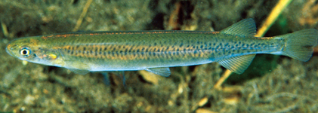
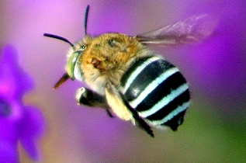
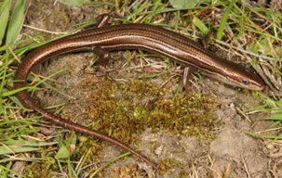

Common Galaxias
Glossy Grass Skink
Blue-banded Bee

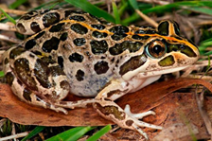
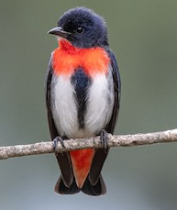
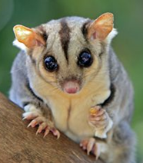
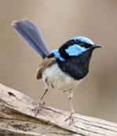

Superb Fairy-wren
Mistletoebird
Spotted
Marsh Frog
Krefft’s (Sugar) Glider

For each of the seven focal species the habitat requirements are described, the potential actions needed to meet these requirements are listed, other species likely to be served by these actions are listed, and suitable habitat is illustrated.

1. Blue-banded Bee (Amegilla spp)
Requirements
There are at least two different species of Blue-banded Bees recorded in Maroondah, and there would be many more native bee species as well.

Blue-banded Bees inhabit urban areas, woodlands, forests, and heath areas with mid- and ground-storeys that feature a range of flowering species.

Blue-banded Bees feed on nectar from a wide range of flowers, both native and introduced, particularly those which are buzz-pollinated such as flax-lilies (Dianella spp), guinea flowers (Hibbertia spp), Bulbine Lily (Bulbine bulbosa) and Kangaroo Apples (Solanum spp), with an apparent preference for blue flowers. They typically forage within 300-400 metres of their nest.

Blue-banded bees are typically solitary, each female building one or more nests in which to rear her offspring without the aid of ‘workers’. She builds these burrows in soft sandstone or clay soils, exposed riverbanks, and even the mortar in old buildings, but will also use existing hollows such as borer holes in dead wood, and man-made cavities such as nail and bolt holes, pipes and cut bamboo.
Cells at the end of the tunnel contain an egg with a pollen/nectar mixture for the emerging larva. Baby bees take about seven weeks to hatch and those that do not hatch due to approaching winter, overwinter in their cells, emerging as adults in the following spring, typically seen visiting flowers from about October through to April.
Male Blue-banded Bees roost together in small groups at night, out in the open, hanging onto twigs or stems with their mandibles. After warming up in the morning they go on their daily routine of foraging and finding a female to mate.
Blue-banded Bees would be natural prey for many animals, including birds and frogs, and are also subject to parasitisation from native cuckoo-bees. The indiscriminate use of insecticides is likely to be a threat, as is the loss or degradation of understorey habitats that support preferred flowering species. A shortage of suitable sites for building nesting burrows may also be a threat.
In many parts of the biolink, indigenous understorey is absent, replaced by mown grass, and where it is present the quality and species diversity is variable.

What actions are needed
Habitat creation and improvement
1.1 Throughout the biolink, protect and improve the condition of existing remnant understorey vegetation.
1.2 Create new habitat areas that aim to replicate vegetation associated with the relevant EVC for each location and where appropriate aim to incorporate under- and midstorey blue-flowering, buzz-pollinated, and tubular-flowered indigenous species (eg Arthopodium, Dianella, Tetratheca, Thysanotus, Solanum, Goodenia, Hibbertia, Pimelea and Correa)
1.3 Retain, or where appropriate, create areas of soft sandstone or clay soils and exposed riverbanks, especially those that occur near (ie within 300-400m) indigenous understorey vegetation
1.4 In suitable locations sheltered from wind and rain, install clusters of artificial nesting blocks made from soft clay (or even fine tennis court loam), each with a couple of 15-20 cm deep blind starter holes about 8-10mm in diameter. Ideally place the blocks to receive the morning sun and if necessary, protect from rain with some form of overhead cover or roof. The addition of a few long trailing stems such as grass flower spikes may encourage the male bees to roost close by.
1.5 The installation of ‘bee hotels’ constructed from pieces of hardwood with numerous blind holes ranging from 2mm to 10mm in diameter drilled to between 10cm and 15cm deep, and/or clusters of hollow stems or tubes (such as bamboo, reeds, dead flower or vegetable stems, or even cardboard tubes) will serve a wider range of native bees
Threat reduction
1.6 Encourage residents within the biolink to avoid or minimise the use of insecticides in their garden by using less-toxic alternatives (eg oil, chilli and garlic-based products) and planting species that are known to attract beneficial insects that can help control pest insects.

Other species likely to be served by these actions
These actions are also likely to serve a wide range other species including:
- Other native bees such as resin, leaf-cutter and reed bees
- Small reptiles such as Pale-flecked Garden Sunskink, Delicate Skink, Weasel Skink and Eastern Bluetongue Lizard
- A wide range of invertebrates such as ants, worms, beetles, moths, butterflies, and spiders that in turn provide food for insectivorous species including microbats and many local birds such as thornbills and Superb Fairy-wren
- Seed-eating bush birds such as Red-browed Finch and Common Bronzewing
- Indigenous understorey plant species through establishment of new populations and improved opportunities for cross-pollination and seed dispersal

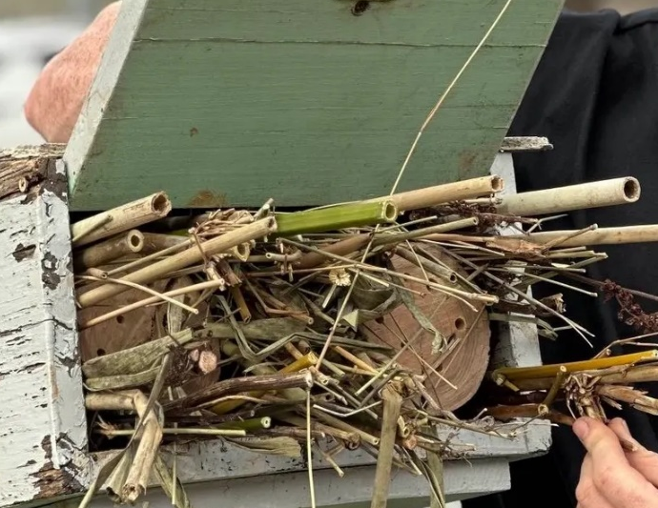
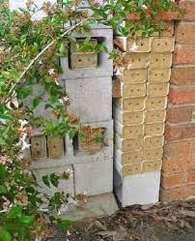
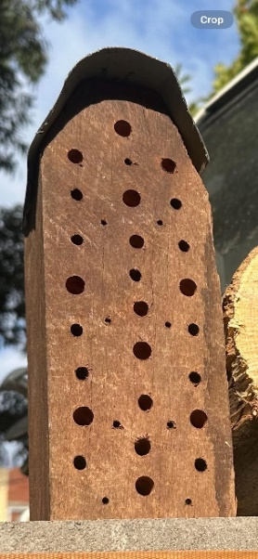
Suitable habitat
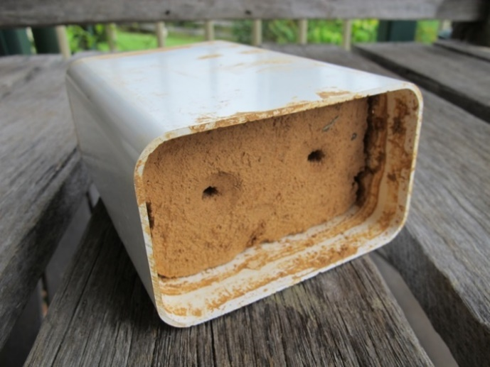

Artificial nesting blocks for native bees: - top left - clay block; middle top and top right - drilled hardwood blocks; bottom left - variety of hollow stems

2. Common Galaxias (Galaxias maculatus)
Requirements
Adult Common Galaxias are most likely to occur in still or slow-moving water in the more natural stretches of the creeks in the biolink and can tolerate a wide range of natural conditions.

They are commonly found in small schools or shoals in slow-moving water but can be more solitary in swifter flowing streams, however, cannot easily climb past instream weirs or waterfalls.
Common Galaxias are carnivorous, eating a wide variety of insects, crustaceans, and molluscs taken from the surface, mid water or the bottom, and take shelter in and around instream woody debris and waterside aquatic vegetation.

Typically a migratory species, their larval stage is marine, spawning mainly in autumn during spring tides in the tidally influenced reaches of rivers, streams and in Port Phillip Bay, although spawning in winter and spring has also occurred. Eggs are laid en-masse on riparian vegetation in the creek estuaries just above the saline ‘wedge’ and need to spend some time out of the water to develop. Spring tides stimulate the eggs to hatch and sweep the larvae out to sea. They spend the first six months or so of their life in the coastal marine environment, where they develop into adults, before migrating back to streams to spend most of their adult life in suitable freshwater habitat. However, when migration to the sea is prevented, such as by natural barriers or human-made structures, Common Galaxias have been known to exist and breed as landlocked populations.

Water pollution, in particular industrial pollution, is a significant threat to water quality and the range of aquatic plants and animals that use the creeks for habitat.

There are three Emergency Relief Structures associated with the Ringwood South Branch Sewer that under high load and/or high rainfall events discharge into the creeks within the biolink - one on Tarralla Creek, and two on Dandenong Creek. These structures are designed to prevent wastewater backing up into private properties, however under extreme conditions can direct sewage into the creeks.

The catchment of the Dandenong, Tarralla and Bungalook Creeks in Maroondah is highly urbanised with a range of industrial activities in the Bayswater Business Precinct occupying a large proportion of the catchment. The high levels of impervious surfaces (roofs, driveways, roads, etc.) in the catchment that drain rainfall directly into the creek via stormwater pipes mean periods of high rainfall result in large volumes of water flowing at speed into and along the creek, causing erosion and destabilising creek banks.

Stormwater runoff can also carry with it sediment, litter, and pollutants that degrade water quality in the creek and can impact on Common Galaxias and other aquatic species, including their food sources.
Roads and roofs in the urbanised catchment are a source of diffuse pollution in the form of litter, grease, oils and metals, while the concentration of industrial businesses in the Bayswater Business Precinct is a known source of point source pollutants, including petroleum, hydrocarbons, solvents, detergents, pesticides and metals. These can enter the creek as a result of direct runoff into stormwater drains, poor onsite practices, accidental spills, leaching from contaminated land, illegal dumping, illegal sewerage connections, cross connections and failing infrastructure. The Croydon Activity Centre with its concentration of retail, commercial and entertainment businesses, and the associated carparking, is also likely to be a significant source of litter.

Within the biolink near Heatherdale Creek, Eastlink maintain treatment wetlands designed to treat stormwater runoff from the freeway before it enters the creek.

The physical form of the creeks in places (ie underground pipe, concrete channel) prevent the establishment of instream vegetation needed to provide refuge from predators and support aquatic invertebrates, and along with any other instream barriers (eg culverts, weirs, etc.) are likely to restrict the ability of the Common Galaxias to move up and down stream.

Introduced fish species are presumed to have a variety of impacts on Common Galaxias within Maroondah including competition (eg mosquitofish), predation (eg mosquitofish, trout, redfin) and habitat degradation (eg carp).

Riparian vegetation along the three creeks is patchy and, in many places, absent, with large areas of mown grass that don’t provide any leaf and branch drop into the water, nor shade over the water. The quality of much of the existing riparian vegetation has been degraded to various degrees due primarily to environmental weed species altering the vegetation structure and/or out-competing and reducing the diversity of middle and ground storey species.

What actions are needed
Creek navigability
2.1 Assess the feasibility for Common Galaxias (and other native fish species) to access the full length of the three creeks to identify any obstacles and barriers to movement up and down the creek and recommend solutions.
2.2 Where identified as feasible, remove/replace/modify culverts and other identified instream barriers (eg weirs) and/or install fishways so they are readily traversable by the range of native fish species expected to realistically occur in these creeks.
Habitat creation and improvement
2.3 Identify and pursue opportunities to extend the daylighting of piped sections of Dandenong and Tarralla Creeks, specifically:
- Dandenong Creek downstream of Liverpool Road Retarding basin to just past Bayswater Road
- Tarralla Creek (next stages of Re-imagining Tarralla Creek project):
    - Upstream of Norton Road into Dorset Recreation Reserve
    - Downstream of Vinter Avenue/Taylors Road to Eastfield Road
    - Downstream of Bayswater Road to the confluence with Bungalook Creek.
2.4 Investigate options for ‘naturalising’ the section of Tarralla Creek that is an open concrete channel (Eastfield Road to Bayswater Road) to offer more instream and riparian habitat elements, and pursue options deemed feasible.
2.5 For the semi-natural sections of the three creeks, undertake a technical investigation to identify viable locations where:
- there is potential to widen and/or deepen the creek channel
- there is potential to add rock weirs to create a series of pools and riffles without negative implications for flows and flood management
- instream habitat is poor, and habitat elements (stony substrates, aquatic vegetation, large woody debris) could be added
- the addition of creek-side riparian vegetation is needed
2.6 Where feasible, widen and/or deepen the creek channel to create slower moving creek sections
2.7 Where feasible, install numerous rock “weirs” to create a series of pools and riffles along the entire length of the creek.
2.8 Where practical and feasible, add instream aquatic vegetation, and potentially cobbled or gravel substrate, to sections of the creek where it is noticeably absent
2.9 In suitable locations close to the creeks, retain, restore or create and connect areas of riparian vegetation with diverse and relatively dense shrub and understorey layers that aim to replicate forest vegetation associated with the EVCs #18 Riparian Forest, #83 Swampy Riparian Woodland, or #937 Swampy Woodland
Threat reduction
2.10 Manage habitat-altering environmental weed species to restore riparian habitat quality.
2.11 Build an understanding of pollution sources through monitoring, research, and pollution sourcing activities to enable targeted action and evaluation of effectives of pollution reduction interventions
2.12 Facilitate the easy, prompt and accurate reporting by community (and others) of observed pollution incidents (eg signage with location details and how to report)
2.13 Deliver a range of inspection, engagement, education and compliance actions for industry and communities associated with the Bayswater Business Precinct to identify and agree on waste management improvement priorities to reduce identified pollution sources
2.14 Assess feasibility of an inline treatment facility along Dandenong Creek to treat base flow and first flush during a stormwater event to reduce concentrations of zinc, lead, copper, silver and insoluble pesticides arising from the Bayswater Business Precinct.
2.15 Pursue options in the catchment to:
- reduce the extent of impervious surfaces
- capture and reuse stormwater (rainwater tanks, stormwater harvesting)
- slow stormwater flows (rain gardens, retarding basins, water sensitive urban design)
- trap sediments and remove pollutants (wetlands that improve water quality and provide wetland habitat)
2.16 Ensure the location, maintenance responsibilities and minimum maintenance requirements of all known stormwater treatment wetlands, litter traps and gross pollutant traps are known and understood, and are managed and maintained to best practice standards
2.17 Research and trial options for managing the impacts of introduced fish species

Other species likely to be served by these actions
These actions are also likely to serve other species including:
- Aquatic/semi-aquatic vertebrates such as Rakali, Flathead Gudgeon, Ornate Galaxias, Climbing Galaxias, Southern Shortfin Eel, Eastern Long-necked Turtle and potentially Platypus
- Many aquatic-breeding invertebrates such as yabbies, dragonflies, water beetles, worms and true bugs that in turn provide food for other species including waterbirds.
- Plant species associated with the EVCs #18 Riparian Forest, #83 Swampy Riparian Woodland and #937 Swampy Woodland, as well as aquatic species, through establishment of new populations and improved opportunities for cross-pollination and seed dispersal

Suitable habitat
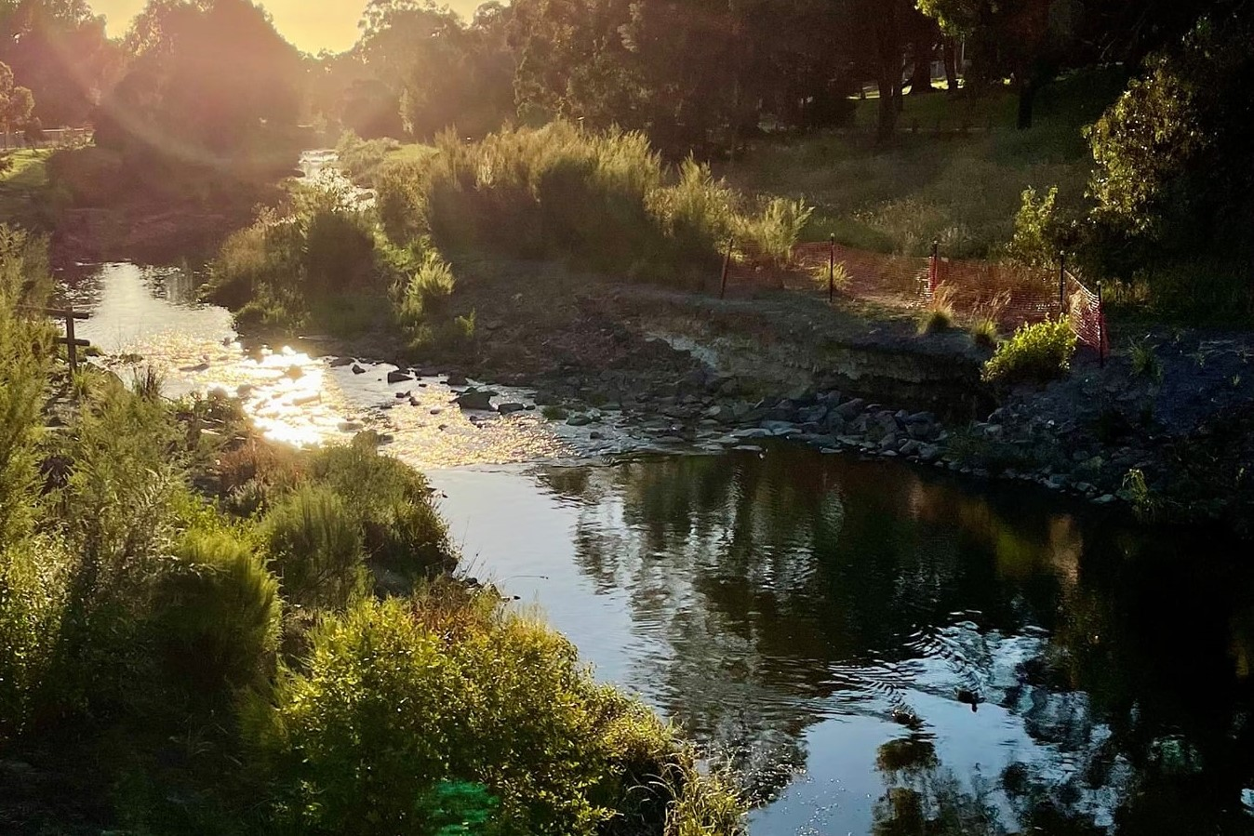
Dandenong Creek, Heathmont - credit Will Harper

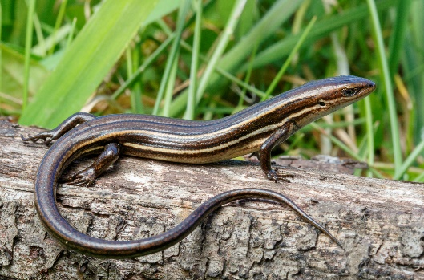
3. Glossy Grass Skink (Pseudemoia rawlinsoni)
Requirements
The Glossy Grass Skink is a ground-dwelling habitat specialist that occurs in densely vegetated and moist microhabitats, typically those found at the margins of creeks, swamps, lakes or otherwise boggy areas.

They favour low, dense vegetation comprised of indigenous rushes, sedges and grasses in moist situations where they forage for small invertebrates but will also use areas of long and dense introduced grasses (eg kikuyu) in swampy areas.

They shelter in the low dense vegetation and under rotting logs, and will bask on grass and rush stems, or logs and rocks. Mating occurs in late summer or autumn, ovulation and fertilisation in spring, with 1-9 live young produced in mid to late summer.

The Glossy Grass Skink has been recorded within the biolink, however suitable habitat is limited and largely occurs as isolated patches. The clearing, draining, drying, slashing or spraying of suitable vegetation in boggy areas reduces the availability of suitable habitats. Aside from predation by natural predators such as kookaburras, Glossy Grass Skinks are also likely to be taken by foxes, cats and introduced rats.
The Glossy Grass Skink is listed as Endangered under the Victorian Flora and Fauna Guarantee Act and is currently being considered for inclusion on Environment Protection and Biodiversity Conservation Act 1999 (EPBC Act) list of threatened species.

What actions are needed
Habitat creation and improvement
3.1 In low-lying parts of the biolink near creeks and swampy areas where there is limited overshadowing from trees and large bushes, retain, restore or create areas of long, dense understorey vegetation ideally comprised of indigenous rushes, sedges and grasses, supplemented with scattered logs and rocks.
3.2 Where possible create habitat that extends and connects known areas of suitable habitat
Threat reduction
3.3 Where areas of dense weedy grasses occur in moist areas close to known or suitable habitat, if possible, avoid spraying and slashing too short (ie no shorter than 10cm)
3.4 Promote the dusk till dawn cat curfew, including options available to residents if they encounter stray and nuisance cats.
3.5 Invite community input into future reviews of the Domestic Animal Management Plan including the cat curfew.
3.6 Target fox control efforts around high-quality habitat patches.

Other species likely to be served by these actions
These actions are also likely to serve other species including:
- Swamp Skink (Lissolepis coventryi), another locally occurring skink that uses similar habitat and is listed as Endangered under the EPBC Act
- Frog species such as Southern Banjo Frog and Verreaux's Tree Frog
- Wetland birds such as White-faced Heron, Buff-banded Rail, Eastern Great Egret and Nankeen Night-Heron
- A range of invertebrates such as ants, worms, beetles, moths, butterflies, and spiders that in turn provide food for insectivorous species including microbats and many local birds
- Semi-aquatic wetland plant species through establishment of new populations and improved opportunities for cross-pollination and seed dispersal

Suitable habitat
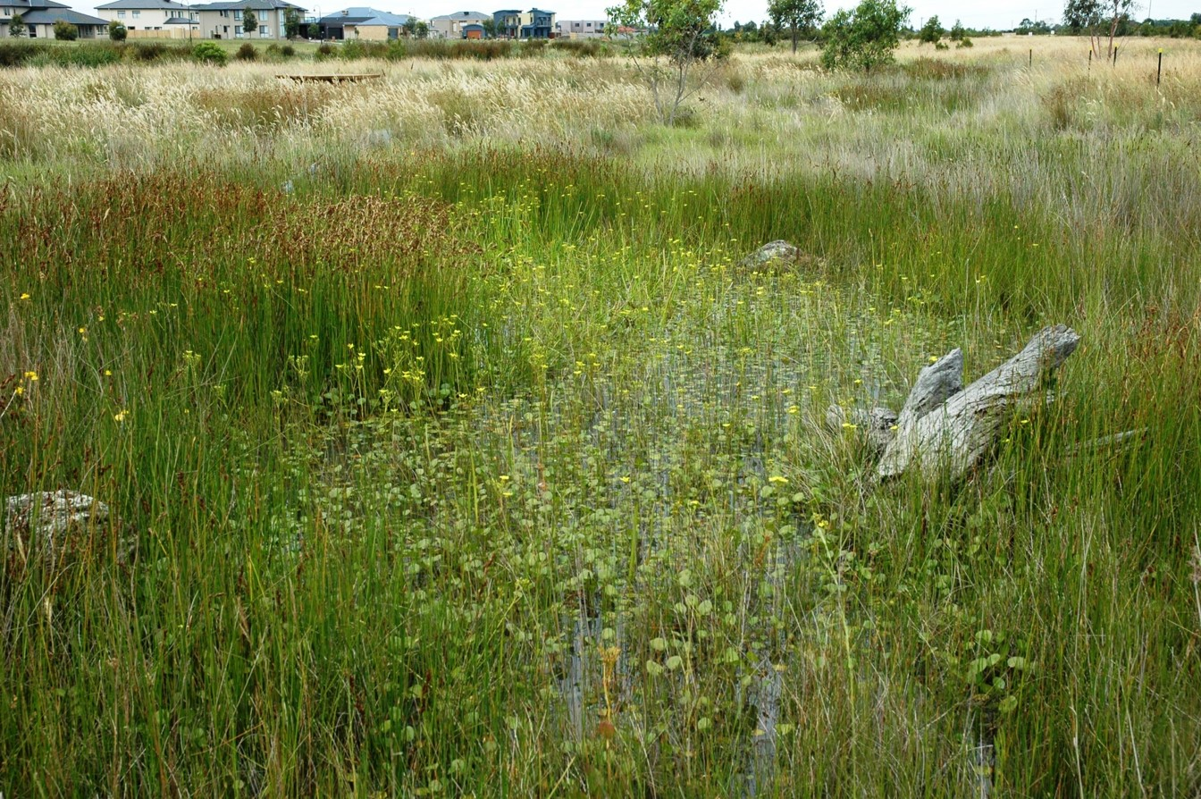
Seasonal rain-filled wetland at The Waterways (for illustrative purposes only) - credit Damien Cook

4. Krefft’s (Sugar) Glider (Petaurus notatus)
Requirements
Following a 2020 taxonomic study the Sugar Glider (Petaurus breviceps) was separated into three new species, including the locally occurring Krefft’s Glider (Petaurus notatus).

Krefft’s Glider is an arboreal nocturnal gliding possum, preferring forests and woodlands with a large number of stems within the canopy, and a dense mid- and overstorey, that facilitate movement through the canopy as well as providing food resources. They can glide over distances up to 50 metres.

They are omnivorous, foraging mainly in the lower layers of the forest canopy, and adapting seasonally to the availability of different food sources. In summer they are primarily insectivorous, whereas in winter when insects are scarce, they feed more on exudates (acacia gum, eucalyptus sap, manna, honeydew or lerp). They can be carnivorous, preying on lizards and small birds, and also will eat many other foods when available, such as nectar, acacia seeds, bird eggs, pollen, fungi and native fruits.
During the day, they shelter in tree hollows lined with fresh leaves. Their young are born in winter and spring (June to November), carried in the pouch for the first two months, then cared for in the tree hollow nests.
Krefft’s Gliders are vulnerable to predation from cats and foxes, especially if they need to come to ground to cross cleared land when moving between patches of forest.

What actions are needed
Habitat creation and improvement
4.1 In areas within the biolink where there are long distances of cleared areas between stands of indigenous trees and large shrubs, particularly along riparian sections, plant indigenous species to create ‘stepping stone’ patches of forest vegetation. Aim to replicate forest vegetation associated with the relevant EVC for each location
4.2 Where the biolink intersects with major transport corridors (eg Eastlink Freeway, Belgrave Railway Line) and conventional vegetation-based connectivity cannot be established, consider alternative ecological connectivity measures (such as glider poles or rope bridges), that are supported by ecological assessment and are feasible in terms of safety, design and maintenance requirements.
4.3 Install suitably sized artificial hollows (eg nest boxes, chainsaw hollows, salvaged tree sections with hollows) with internal dimensions of 30-50cm deep, 20-25cm wide, and an entrance hole 30-40mm wide, ideally with an internal baffle (the entrance hole can be on the front, side or even the rear of the box). Timber nest boxes should be made from rough-sawn timber at least 25mm thick and be mounted 3-5 metres above the ground in large, healthy living trees with good canopy foliage, located within existing stands of established large trees. Consideration should be given to enabling the safe monitoring of nest box use and occupation from the ground (eg tree-mounted camera or within reach of pole-mounted inspection camera)

Threat reduction
4.4 Target fox control efforts around areas of high-quality habitat patches
4.5 Promote the dusk till dawn cat curfew, including options available to residents if they encounter stray and nuisance cats.
4.6 Invite community input into future reviews of the Domestic Animal Management Plan including the cat curfew.
Other species likely to be served by these actions
These actions are also likely to serve other species including:
- Canopy-feeding birds such as thornbills, parrots, honeyeaters, fantails and pardalotes, as well as Golden Whistler, Grey Shrikethrush and Grey Butcherbird.
- A wide range of invertebrates such as ants, worms, beetles, moths, butterflies, and spiders that in turn provide food for insectivorous species including microbats and many local birds.
- Plant species associated with the EVCs #18 Riparian Forest, #83 Swampy Riparian Woodland, and #127 Valley Heathy Forest through establishment of new populations and improved opportunities for cross-pollination and seed dispersal.

Suitable habitat
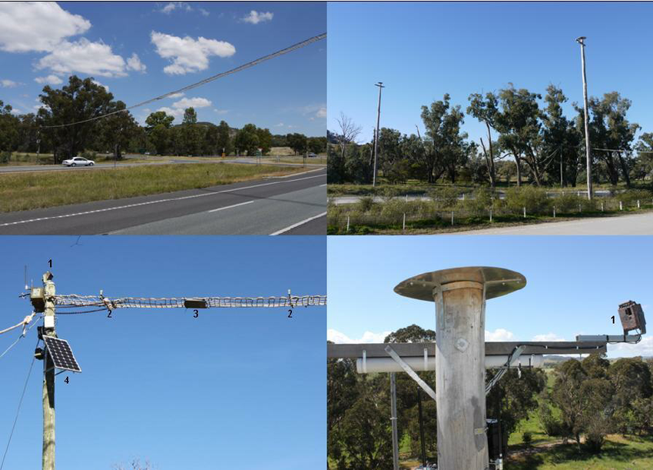
Rope bridges (left) and glider poles (right) - Hume Freeway (for illustrative purposes only)
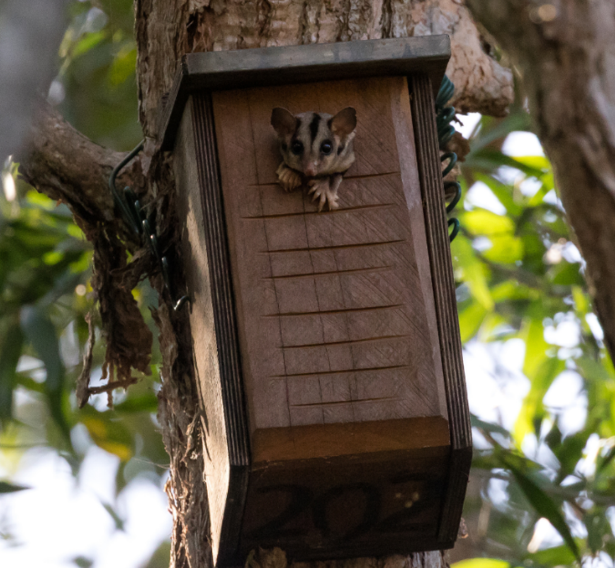
Glider using nest box (for illustrative purposes only)

5. Mistletoebird (Dicaeum hirundinaceum)
Requirements
The Mistletoebird is mostly found in forests and woodlands dominated by any species of Eucalyptus from the dry interior to coastal rainforests, and more likely to occur in mature stands where trees are larger and more likely to have become infested with mistletoe.

It is a specialist frugivore that primarily eats the berries of mistletoes, but will occasionally eat arthropods, nectar, and other berries. The Mistletoebird plays a key role in the dispersal of mistletoe seed and is highly adapted to its diet of mistletoe berries.

It has a simplified digestive system through which the berries pass quickly. It only takes between four and 25 minutes for the mistletoe seed to pass through the Mistletoebird, digesting the fleshy outer parts before depositing the sticky seeds in a string along the branches they perch on.
Mistletoebird pairs nest solitarily and raise up to 3 broods per season. The breeding season is from August to April depending where in Australia, but usually coincides with the fruiting of mistletoe. A pear-shaped nest with a slit side entrance is typically made of plant down, wool, spider webs and spider egg sacs, and suspended from an outer twig or thin horizontal branch especially in eucalyptus, mistletoe, and acacia trees where it is concealed among the foliage. The outside of the nest is coated with dry plant material like leaves, bark and lichen.
Mistletoe numbers in Maroondah and elsewhere are in decline, most likely due to drought and a drying climate, but possibly also negative perceptions of mistletoe leading to their removal. Predation from cats and possibly foxes is also likely to be a threat to the Mistletoebird.

Note: Mistletoes have been recognised as keystone resources within ecosystems. They provide structural (shelter and nesting) and nutritional (food in the form of berries and foliage) resources within canopies (especially during droughts), and nutrient enrichment via litter-fall (a fertiliser effect) in the understorey below leading to increased richness in invertebrates and those that feed on them. There is evidence to suggest that in a natural ecosystem the loss of mistletoes could lead to a 20-30% loss in bird diversity. Most mistletoe species rely on animals for both pollination and fruit dispersal, and the Mistletoebird is considered the most effective disperser of mistletoe seed. The most common species of mistletoe in Maroondah are Drooping Mistletoe (Amyema pendula) that grows predominantly on Eucalyptus spp. and Grey Mistletoe (Amyema quandang) that grows predominantly on Acacia spp.
The Common Brushtail Possum (Trichosurus vulpecula) has been shown to impact on the recruitment of mistletoes.

What actions are needed
Habitat creation and improvement
5.1 Throughout the biolink, retain large mature (and maturing) Eucalyptus and Acacia trees and shrubs
5.2 Trial the reintroduction of mistletoe species by collecting mistletoe seed and applying to branches of indigenous Eucalyptus and Acacia tree species in locations where an indigenous understorey is present underneath, and possum bands can be installed on the host trees.
5.3 Once a mistletoe reintroduction method has been reliably established, incorporate the option of introducing mistletoe into suitable street trees within the biolink, and/or private properties with native gardens through Council’s Nature Havens Program.

Threat reduction
5.4 Where appropriate, protect existing mistletoe plants from possum grazing by installing possum bands on the host trees.
5.5 Target fox control efforts around key areas supporting mistletoe
5.6 Promote the dusk till dawn cat curfew, including options available to residents if they encounter stray and nuisance cats.
5.7 Invite community input into future reviews of the Domestic Animal Management Plan including the cat curfew.

Other species likely to be served by these actions
These actions are also likely to serve other species including:
- A range of birds such as honeyeaters, thornbills, parrots, fantails and pardalotes that feed on nectar and berries, and/or shelter or nest in canopy foliage, as well as ground-feeding insect-eating species such as Scarlet Robin, Superb Fairy-wren and Grey Shrikethrush.
- A wide range of invertebrates such as ants, worms, beetles, moths, butterflies, and spiders that in turn provide food for insectivorous species including microbats and many local birds.
- Plant species associated with the EVCs #18 Riparian Forest, #83 Swampy Riparian Woodland, and #127 Valley Heathy Forest through establishment of new populations and improved opportunities for cross-pollination and seed dispersal.

Suitable habitat
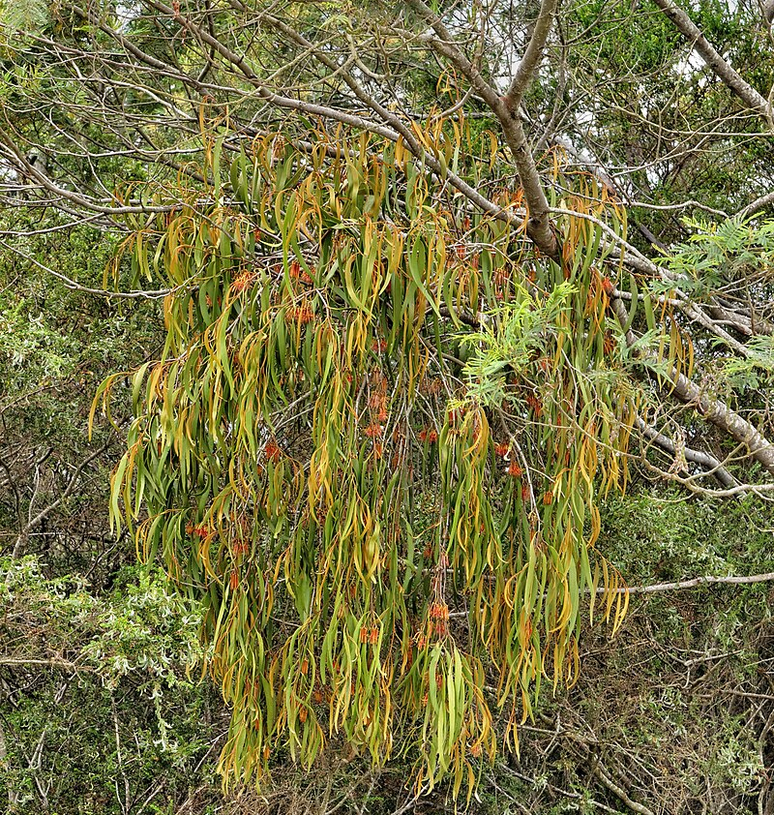
Drooping Mistletoe on Acacia host

6. Spotted Marsh Frog (Limnodynastes tasmaniensis)
Requirements
Spotted Marsh Frogs inhabit dams, roadside ditches, marshy areas, flooded grasslands, streams and ponds with grassy areas, sheltering in cracks in the ground, burrows made by other small animals, beneath logs or rocks, or in dense ground vegetation, near the edge of temporary or permanent water.

Adult frogs are ground dwelling hunters, and mostly active during the night, hunting insects, spiders and other invertebrates. Tadpoles feed in the water, mainly on algae and other plant life, and occasionally (typically dead) invertebrates.
They breed mainly during spring and autumn, but also in winter or summer after heavy rains. Eggs are laid as a foamy mass on the surface of a small temporary or permanent water body, and as the tadpoles take around three and a half months to develop into frogs, the water bodies they float their eggs on need to retain water for at least that long.
A shortage of small and/or ephemeral wetlands suitable for habitat and breeding is likely to be a limiting factor for their distribution across Maroondah. Predation on eggs and tadpoles from the introduced Eastern Mosquitofish (Gambusia holbrooki) is likely to be a significant threat. Predation on adults by kookaburras and larger waterbirds is expected and natural, however adults are also likely to be taken by foxes, cats and dogs.
Surfactants used in herbicide products to improve the herbicide effectiveness are known to be toxic to the tadpoles.

What actions are needed
Habitat creation and improvement
6.1 In locations within the biolink where there are lower-lying or poorly drained, open and sunny areas with minimal overhead tree canopy, create small and medium sized permanent and semi-permanent habitat wetlands, ideally spaced within 500m (and no more than 1000m) of each other. Aim to have 50-100cm depth at deepest point with over 50% submerged and 20-40% floating/emergent, indigenous aquatic vegetation cover, and gently sloping edges and terracing providing a variety of water depths to support a diversity of emergent and semi-aquatic fringing wetland vegetation. Within the surrounding 10 metres, ensure overshadowing canopy and shrubby vegetation is kept to a minimum, and provide 10-20% cover of logs and rocks.
6.2 If a wetland is also expected to provide a sediment trapping function design them to enable desilting (and draining to control Mosquitofish), with minimal disturbance to its ongoing habitat function.
6.3 Encourage the creation of frog bogs/small habitat wetlands or ponds in private residential gardens within the biolink.

Threat reduction
6.4 Ensure dogs using off-lead areas close to the biolink such as Dorset Recreation Reserve, Eastfield Park and Town Park (Croydon), Gracedale Park (Ringwood East), HE Parker Reserve (Heathmont), Glen Park and Laura Court Reserve (Bayswater North), and Appletree Hill Reserve (Kilsyth South) are not allowed to stray into adjacent bushland and creek areas
6.5 Require dogs to be kept on leads in all other locations within the biolink (except for the fenced areas at Bungalook Conservation Reserve and Appletree Hill Reserve which are designated ‘No dog/cat Areas’), and reinforce with proactive patrols by animal management officers
6.6 Promote the dusk till dawn cat curfew, including options available to residents if they encounter stray and nuisance cats.
6.7 Invite community input into future reviews of the Domestic Animal Management Plan including the cat curfew.
6.8 Fence off selected habitat wetland areas to exclude dogs.
6.9 Target fox control efforts around selected wetland habitat areas.
6.10 If herbicide use is necessary, use products that do not include surfactants in the mixture.

Other species likely to be served by these actions
These actions are also likely to serve other species including:
- Other frog species such as Southern Banjo Frog and Verreaux's Tree Frog
- Wetland birds such as White-faced Heron, Buff-banded Rail, Eastern Great Egret and Nankeen Night-Heron
- Many aquatic invertebrates such as dragonflies, water beetles, worms and true bugs that in turn provide food for other species including waterbirds
- Aquatic and semi-aquatic wetland plant species through establishment of new populations and improved opportunities for cross-pollination and seed dispersal

Suitable habitat
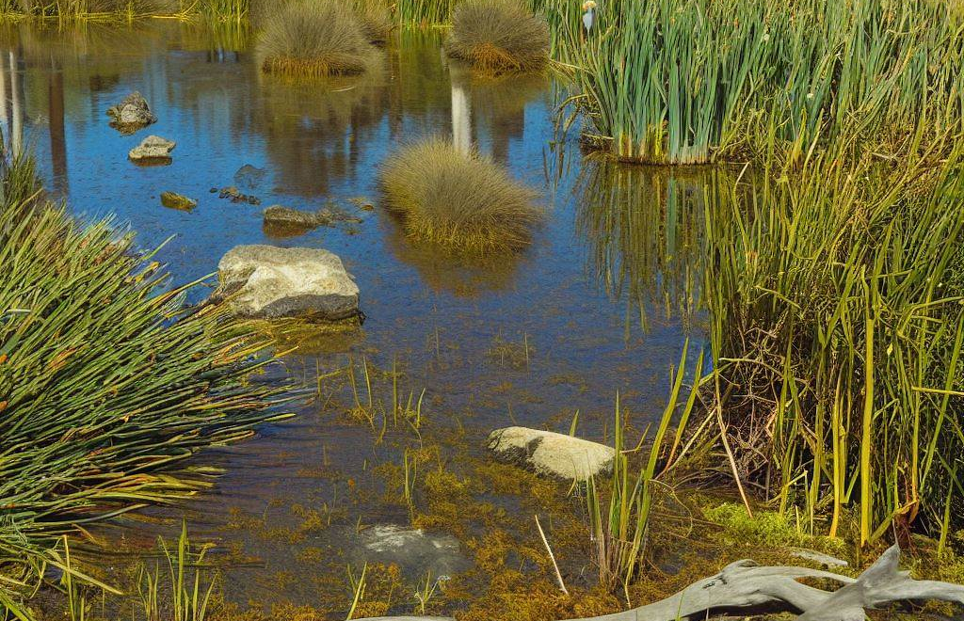
AI-generated image - for illustrative purposes only

7. Superb Fairy-wren (Malurus cyaneus)
Requirements
The Superb Fairy-wren is an insectivore that can be found in many habitat types where suitable dense and low shrubby thickets of vegetation occur including grasslands with scattered shrubs, moderately thick forest, woodland, heaths, domestic gardens, and urban parks and gardens.

It feeds predominantly on a wide range of small creatures (mostly insects and other small arthropods) that are typically caught on open ground near shelter but may also be taken from low bushes, as well as small quantities of seeds, flowers, and fruit.

Superb Fairy-wren populations rely on patches of suitable habitat that are at least 2 hectares in area as core habitat, and the ability to move between these patches by using ‘stepping stones’ of dense shrubby vegetation that are within an estimated 60 metres of each other. As such, much of Maroondah’s urbanised landscape means dispersal opportunities for this species are currently limited.

Dense low and shrubby vegetation is not only important for providing shelter from potential predators, but also for breeding as they construct their dome-shaped nests from grasses and other fine material, usually in thick vegetation close to the ground (<1 metre).

The Superb Fairy-wren is socially monogamous and sexually promiscuous, meaning that although pairs will bond for life, both males and females will regularly mate with other individuals and even assist in raising the young from such pairings.

Breeding season commences in late winter/ early spring when the males adopt their iridescent blue breeding plumage, and carries through to late summer, with pairs or groups of 3–5 birds maintaining and defending small territories year-round.

Females, immatures, and non-breeding males are a plain fawn colour with a lighter underbelly, although the males can be distinguished by their dull greyish-blue tail.

Within Maroondah, predation from cats and foxes is likely to be a major threat, and introduced rats are also known to raid the nests. The Noisy Miner is also considered a key threat. It is a native honeyeater that forms colonies and aggressively defends its territory from predators and intruders (including other bird species such as the Superb Fairy-wren), with a preference for treed habitats with open or no understorey vegetation (eg mown grass).

The Superb Fairy-wren features in a Wurundjeri legend as told to Alfred William Howitt by Wurundjeri Elder, Barak - “Nari- barm-gorŭk is a bird like a small morepork (Australian Owlet-nightjar) that lives in holes in trees. It was once a woman and went up to the sky – the stars which white people call the 5 Virgins (Virgo constellation). Wourn-gūrk = (the Blue wren) is the women's sister. They will not let anyone hurt it. If anyone did so the women would grumble and hit him”

What actions are needed
Habitat creation and improvement
7.1 Retain, restore and create patches of dense indigenous shrubby understorey to expand habitat patches and provide habitat ‘stepping stones’ (ideally within 50 metres of each other) throughout and adjacent to the biolink including private gardens. Target areas where the EVCs #18 Riparian Forest and #127 Valley Heathy Forest once occurred and aim to replicate their associated vegetation.
Threat reduction
7.2 Promote the dusk till dawn cat curfew, including options available to residents if they encounter stray and nuisance cats.
7.3 Invite community input into future reviews of the Domestic Animal Management Plan including the cat curfew.
7.4 Target fox control efforts around high-quality habitat patches.

Other species likely to be served by these actions
These actions are also likely to serve other species including:
- Small and medium bush birds such as thornbills, robins, honeyeaters, fantails and pardalotes, as well as White-browed Scrubwren, Grey Shrikethrush and Grey Butcherbird.
- A wide range of invertebrates such as ants, worms, beetles, moths, butterflies, and spiders that in turn provide food for insectivorous species including microbats and many local birds.
- Plant species associated with the EVCs #18 Riparian Forest and #127 Valley Heathy Forest through establishment of new populations and improved opportunities for cross-pollination and seed dispersal.

Suitable habitat
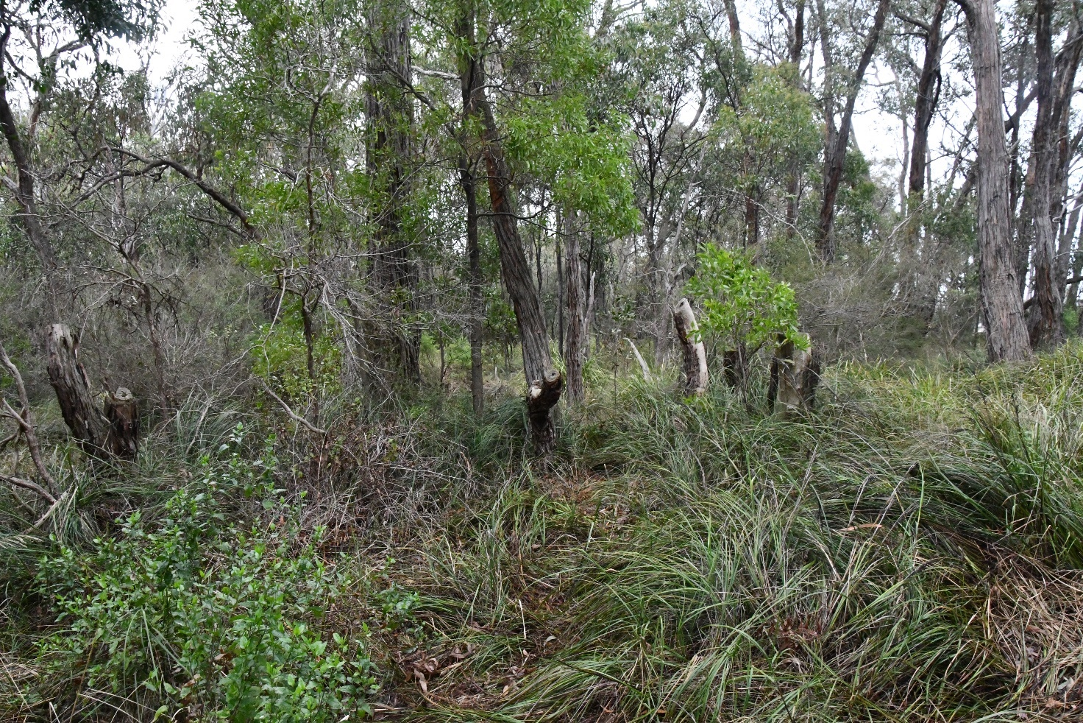
Valley Heathy Forest - Bedford Park, Ringwood - for illustrative purposes

Proposed actions to support the biolink

8. General actions to support the biolink

There are several other proposed actions that aim to support the function of the biolink in general including:
8.1 Incorporate the use of suitable indigenous species into street tree replacement planting along street sections that fall within the biolink. Aim to use large, long-lived species whose canopies can touch both across and along the street
8.2 Incorporate water sensitive urban design features into street renewal projects that fall within the biolink
8.3 On residential properties within the biolink, encourage residents to create habitat in their gardens with information, advice and support provided through participation in Council’s Nature Havens* program
8.4. Encourage residents within the biolink, particularly participants in Council’ Nature Havens* program, to create and maintain understorey habitat on their adjacent stretch of nature strip. A suitable planting plan and permit from Council are required, ideally using a Council-provided template that will facilitate the permit process
8.5 With agreed ongoing maintenance support from adjoining residents, establish a demonstration of understorey habitat creation on nature strips along the length of a street. The planting plan could be used to create a template for other residents to utilise when seeking a permit from Council
8.6 Design public lighting, especially lighting of shared trails, to be wildlife-friendly by minimising light spill and potential impacts on nearby habitats
8.7 Through pre-application meetings and internal referrals to Environmental Planning, encourage elements of new developments to contribute to the functioning of the biolink (eg indigenous landscaping)
8.8 Introduce planning and development controls (eg an Environmental Significance Overlay over the entire biolink) that:
- encourages new developments adjacent to the public creek reserves (and other public land that forms the spine of the biolink) to face the creek/biolink rather than turn their back on it
- requires large setbacks from the biolink spine and landscaping with indigenous plant species that mimic the relevant EVCs
- encourages building and landscaping designs that contribute to the biolink function (eg biodiverse green roofs, indigenous landscaping design templates and species lists, incorporation of artificial hollows)
- protects the biolink from future development and construction that would impact on its future function
- collects development contributions to support larger scale stormwater treatments

*Nature Havens is a Council program that supports Maroondah residents to make their gardens more wildlife friendly by creating habitat ‘stepping stones’ for native animals such as birds, insects, lizards and small mammals. Garden visits are offered to residents as part of the program, where staff from Council’s Bushland Management team will discuss ways they can provide more food, shelter and water for wildlife, and which indigenous flora species are most suitable to their garden.

Creating habitat on nature strips
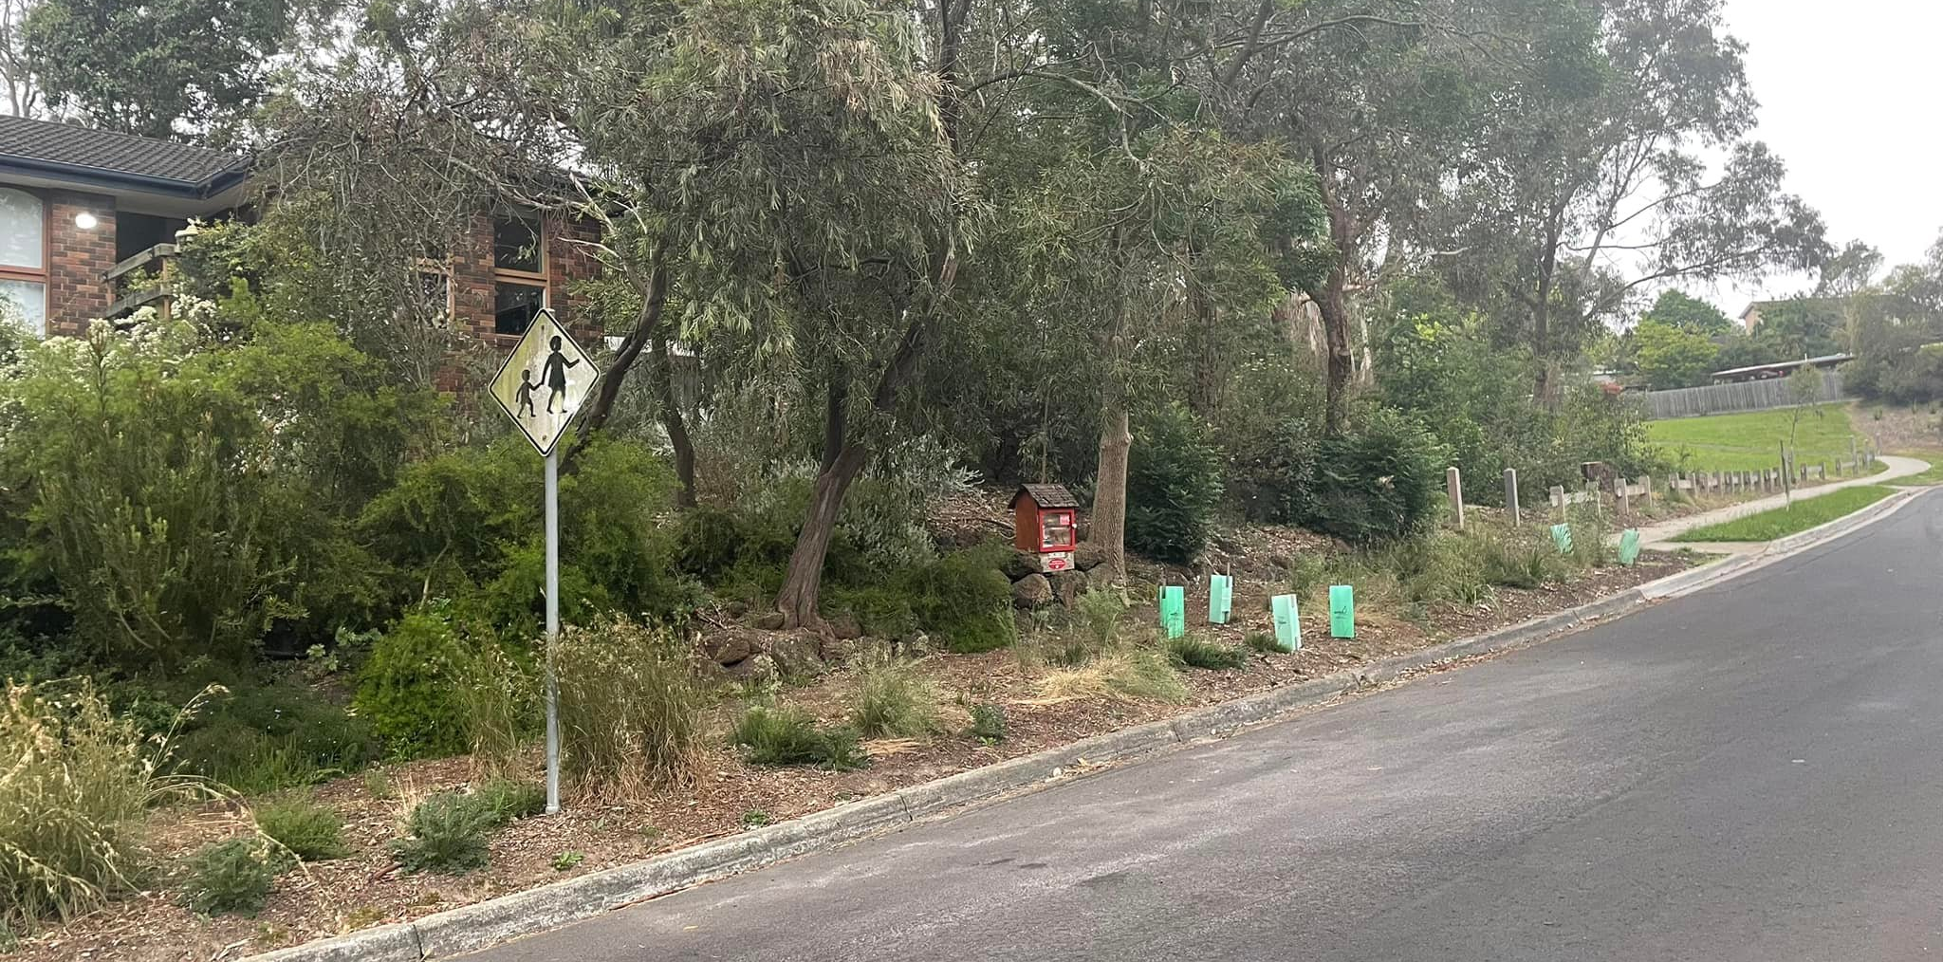

Indigenous understorey habitat on nature strip in Ringwood North
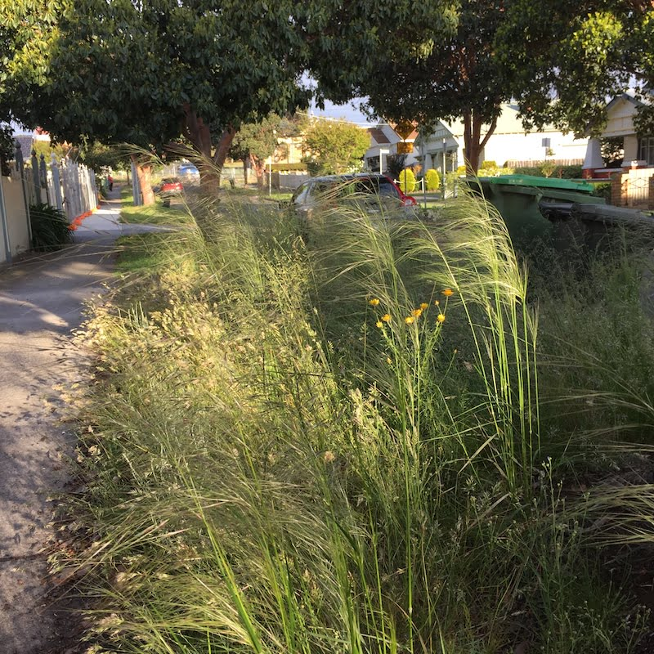
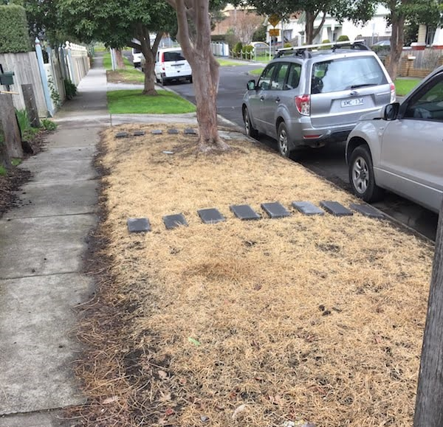
Before and after - creating grassy understorey on a nature strip - for illustrative purposes only

Proposed actions to sustain the biolink

9. Monitoring, management and maintenance actions to sustain the biolink

Monitoring of progress with collective implementation of the actions in this plan, as well as their ultimate effectiveness in ensuring the biolink successfully functions as a wildlife corridor, will be important for building momentum, demonstrating progress and effectiveness, and adapting strategies and actions as needed.
The existing and newly created habitats, and efforts to reduce threats, described in the preceding sections will require ongoing management and maintenance actions in order to keep habitats in good condition such that they sustain the biolink as a functioning habitat corridor for the long term.

Coordinating, monitoring and driving action
9.1 Establish a Dandenong-Tarralla-Bungalook Creeks Biolink Action Plan oversight group to:
- Share and monitor progress with implementing actions
- Help resolve issues with action delivery
- Regularly review and reassess priorities
- Identify and agree on potential new actions (consistent with achieving the vision)
- Identify and track agreed measures of success
- Identify opportunities to promote progress and successes
- Oversee a review of the action plan after 5 years

9.2 Design a practical and cost-effective program of monitoring that community can get involved in that can provide evidence of success (or otherwise) of the biolink functioning as a wildlife corridor (eg changes in use by and distribution of key fauna species such as the focal species)

Managing and maintaining public land
Public land comprises much of the core parts of the Dandenong-Tarralla-Bungalook Creeks Biolink, of which:
- Maroondah City Council owns and manages 58 land parcels covering 220.8 hectares that fall all or partly within the biolink, including both of its public golf courses
- The Department of Transport own and manage 93 land parcels covering 84.4 hectares that together form what is known as the Healesville Freeway Reserve (originally set aside in 1969 to link the Burwood-Box Hill region to Coldstream, parts of it have since been turned over to parkland or sold)
- Melbourne Water own and manage 30 land parcels covering 55.4 hectares, and also have management responsibilities for the ‘bed and banks’ of the three creeks
- Between them, the Department of Education, The Department of Energy, Environment and Climate Action (DEECA, formerly Department of Environment Land Water and Planning) VicTrack, the Department of Families, Fairness & Housing, and Ausnet own and manage another 18 land parcels covering 44.1 hectares

Responsibilities for maintaining Council-owned land are spread across several Council teams:
- The Bushland Management Team manages and maintains indigenous vegetation, trees and habitat creation and management, WSUD stormwater treatment measures, targeted fox control measures, community engagement and environmental volunteer support (including the Nature Havens program)
- The Maroondah Golf Courses and Sportsfields Team manages the Ringwood Golf Course and the Dorset Golf Course
- The Parks Maintenance Team manages and maintains areas of mown grass and nature strips (including the permit process for planting on nature strips)
- The Tree Maintenance Team manages and maintains street and park trees
- The Engineering Team manages and maintains renewal and maintenance of roads and drainage infrastructure
- The Projects and Asset Management Team manages and maintains community facilities (buildings), trails, playgrounds, furniture, signs and other built assets, and also has responsibilities for capital works planning and delivery of built assets
- The Open Space Planning Team has responsibilities for strategic open space planning
- The Local Laws Team have responsibility for enforcing the Maroondah City Council Community Local Law 2023 that includes regulations for the management of cats and dogs and oversee the review and updating of the Domestic Animal Management Plan on a four-year cycle.

Works and activities on public land to sustain the biolink need to be undertaken with relevant authorisation and in accordance with relevant legislation such as the Flora and Fauna Guarantee Act 1988, the Planning and Environment Act 1987, Wildlife Act 1975, Environment Effects Act 1978, Road Management Act 2004, Transport Integration Act 2010 and relevant Crown Land statutes.

The Wurundjeri Woi-wurrung Cultural Heritage Aboriginal Corporation have an established Natural Resource Management team, referred to as the Narrap Team, to support their aspiration of working on Country.

9.3 Manage existing planted and remnant indigenous vegetation patches to optimise their habitat value, primarily through managing environmental weed species to improve vegetation structure, species diversity and habitat quality

9.4 With the creation of substantial new areas of indigenous vegetation and habitat identified through this plan, and the unique and complex nature of managing waterways and wetlands, one or more specialised waterway biolink positions be added to Council’s Bushland Management Team specifically to maintain riparian and semi-aquatic vegetation and habitats on public land within the Dandenong-Tarralla-Bungalook Creeks Biolink and along other waterways within Council’s responsibility.

9.5 Facilitate discussions with Wurundjeri to explore potential for the Narrap Team to undertake Natural Resource Management works within the biolink (and wider Maroondah), to develop skills and capacity in Natural Resource Management (eg Indigenous traineeship with the Maroondah Bushland Management Team), and align desired practices and outcomes for vegetation management

9.6 Explore the potential for applying Trust for Nature covenants on core habitats on both public and private land important to the function of the biolink as a wildlife movement corridor to protect them in perpetuity

9.7 Explore opportunities to resource the coordination of actions associated with creek-based biolinks and liaise with relevant external agencies

9.8 Embed biolinks into strategic planning for open space in Maroondah

9.9 Where feasible, salvage large logs and branches from legally felled trees for use as structural habitat elements in existing and newly created habitats within the biolink

Healesville Freeway Reserve
9.10 Where practicable, ensure planning and design for road infrastructure within the freeway reserve considers the location and biological values of sites of biological significance, to optimise environmental outcomes and contribute to the broader function of biolinks without compromising transport safety, efficiency, or project feasibility
9.11 Subject to safety, operational, legal and access constraints support opportunities for access to sites of environmental significance within the freeway reserve for land management activities such as seed collection, weed control and maintenance in coordination with the relevant transport authority

Swinburne University Croydon Campus
9.12 Explore options for creating habitat and incorporating WSUD features on Swinburne University land to slow and improve the quality of stormwater flowing from their land

Belgrave Rail line
9.13 Provide protective measures for remnant and planted vegetation along the railway reserve

Managing and maintaining private land
Private residential land
9.14 Residents with, or wishing to create habitat in their gardens to be provided with information, advice and support through Council’s Nature Havens program

Bayswater Business Precinct
The Bayswater Business Precinct Transformation Strategy (2021) was prepared for the Department of Jobs, Precincts and Regions and Regional Development Australia - Melbourne, and has been formally adopted by Maroondah, Knox and Yarra Ranges Councils. This strategy identifies several actions that support establishment of the Dandenong-Tarralla-Bungalook Creeks Biolink:
- Action 6. Prepare an urban greening strategy to support climate adaptation and mitigate the impact of urban heat
- Action 8. Develop a water sensitive precinct strategy to enhance climate resilience and improve environmental outcomes across the precinct
- Action 15. Plan for corridors and spaces which contribute to greening, improve access and contribute to health and wellbeing
- Action 19. Link green corridors with urban cooling and greening, delivering improved landscape and greening outcomes across the precinct
9.15 Ensure future development of the precinct incorporates measures to:
- protect existing habitat within the precinct (BBPTS actions 6,15)
- incorporate Water Sensitive Urban Design (WSUD) features that enable stormwater flows (from the precinct, as well as the wider catchment) to be slowed, pollutants removed, and soil infiltration increased before it reaches the creek, including re-direction to swampy areas needing increased soil moisture (BBPTS action 8)
- contribute to the biolink by creating habitat patches that build on, extend, and/or help connect adjacent or nearby habitat patches - eg landscaping that provides habitat values (terrestrial and wetland), incorporate biodiverse green (and blue) roofs into design of new buildings (BBPTS actions 6,8,15,19)

Eastlink (ConnectEast)
9.16 Explore options for renewing landscaping on land managed by ConnectEast (along Eastlink) within the biolink as a key area for providing more habitat opportunities (without increasing the risk of exposing flora and fauna to threats posed by proximity to vehicular traffic)

Managing and maintaining threat prevention measures:
Private residential land
9.17 Council’s Bushland Team, Local Laws and Communications and Engagement Teams to design and deliver community education programs around the use of snail and rat baits, herbicides and the need to keep cats confined to premises during the cat curfew period

Bayswater Business Precinct
9.18 Individual businesses to apply best practice management of their sites and waste management systems and processes to minimise the risk of pollutants entering the creeks (BBPTS action 8)
9.19 Individual businesses to manage employee and contractor understanding and behaviours to prevent pollutants being added to stormwater drains (BBPTS action 8)
9.20 EPA to provide information and education services on environmental duty of care and follow up compliance inspections and reporting of businesses within the precinct (BBPTS action 8)
9.21 Community groups to pre-prepare potential habitat creation projects in readiness for any future requests from EPA for projects as part of their ‘Restorative Project Orders’ (where fines from EPA offences can be directed to community projects)

Eastlink (ConnectEast)
9.22 Ensure regular inspection, maintenance and reporting of their stormwater runoff treatment wetlands so they remain functionally effective

Proposed actions to connect the community to the biolink

10. Promotional, learning and engagement actions to connect people to the biolink

Critical to sustaining the biolink as a functioning habitat corridor for the long term are the connections people make with the biolink and the breadth of support from the community. The biolink will need to be understood, valued and actively cared for by many sectors of the community requiring actions that build community awareness and understanding of its purpose and values, engage people in experiencing it, and provide opportunities to actively contribute to and care for it.

10.1 Create learning opportunities for students of Heathmont College, Marlborough Primary School and Tinternvale Primary School.
Design environmental studies programs and activities with a focus on habitats on or near each school, potentially incorporating:
- Revegetation to create habitat
- Collecting data on the flora and fauna
- Monitoring of nest box use

10.2 Create opportunities for tertiary students (eg Conservation and Ecosystem Management and Conservation and Land Management courses) to have practical involvement in the creation, establishment and care of habitats within the biolink

10.3 Create learning opportunities for people accessing the biolink (eg via trails, parks, golf courses, etc.):
- Involve the Wurundjeri in identifying and designing opportunities for embedding Wurundjeri perspectives into the Dandenong-Tarralla-Bungalook Creeks Biolink. Seek to incorporate Wurundjeri art, language, stories and other cultural elements into interpretive signage, public art installations, wayfinding signage, etc.
- Design and install interpretive signage and/or audio guides that provide information on habitats, flora and fauna (including the focal species), and ecology of the biolink
- Create nature viewing areas (eg bird hides, viewing platforms)
- Incorporate public art installations that feature elements of the biolink

10.4 Create learning opportunities for people living within the biolink
- Prepare and distribute promotional material about the benefits of creating habitat in gardens, and the offer of information, advice and support from Council’s Nature Havens program
- Deliver community education programs around the use of snail and rat baits, herbicides and the importance of keeping dogs on leads in on-leash areas and cats indoors during the cat curfew period

10.5 Create learning opportunities for people visiting the biolink
- Design and deliver community events and activities in the biolink that showcase, celebrate and help people learn about the creek, the biolink and its biodiversity
- Design and deliver community events and activities in the biolink that showcase, celebrate and demonstrate Indigenous/Wurundjeri culture, language, stories, people and practices - involve Wurundjeri in designing works, activities and events that utilise locations in the biolink (eg establishment of a yarning circle/women’s place, construction of a traditional stone eel trap within Tarralla Creek, etc.)
- Investigate the potential for establishing a community environmental education facility for public and school education uses.

10.6 Create opportunities for people from across Maroondah and beyond to contribute to sustaining the biolink
- Provide opportunities and support to volunteers wishing to help build and maintain the biolink (eg joining a community group, corporate planting days, large planting events, etc.)
- Connect the variety of community groups working within the biolink to each other to facilitate inspiration and knowledge sharing
- Provide and support citizen science opportunities for data collection and monitoring of different aspects of the biolink - for example observations of flora and fauna using the biolink (eg the focal species, regular bird surveys at key locations), water quality monitoring (eg Waterwatch), water sampling for eDNA testing, etc.
- Organise photography and/or art competitions or similar that bring attention to, highlight and help promote elements of the biolink and the importance of sustaining the biolink

10.7 Promote the biolink to raise awareness, and build community support and involvement
- Use stakeholder networks and communication channels to promote the biolink and its aims
- Produce tailored educational/informational resources that can be disseminated into the community
- Establish a Council webpage dedicated to the Dandenong-Tarralla-Bungalook Creeks biolink, including information on:
  - this action plan, its vision and the stakeholders who developed it
  - updates on the progress of actions in the plan
  - observations of flora and fauna - especially focal species
  - community activities and events focused on the biolink
  - volunteering opportunities, including Nature Havens program
  - volunteer groups actively involved in maintaining the biolink

Appendix 1 - key stakeholder group

A key stakeholder group was formed to guide action planning for the Dandenong-Tarralla-Bungalook Creeks Biolink.

Group members agreed to take a collaborative approach and contribute their knowledge, skills, influence, and other resources to:
- establish an agreed, shared vision for the Dandenong-Tarralla-Bungalook Creeks Biolink
- identify and agree on, a suite of documented actions that will enable the biolink to function effectively as a habitat corridor, as well as provide other secondary benefits to the Maroondah community
- promote and encourage wide and active support for the agreed vision and action plan through Group member networks and communication channels

Key stakeholder group organisations
- Bayswater Business Precinct
- ConnectEast (Eastlink)
- Department of Transport
- Environmental Protection Authority Victoria
- Knox City Council
- Melbourne Water
- Metro Trains Melbourne
- Paccar Australia Pty Ltd (Kenworth Trucks)
- Swinburne University of Technology - Croydon
- VicTrack

Traditional Owners
- Wurundjeri Woi Wurrung Cultural Heritage Aboriginal Corporation

Community organisations
- Croydon Conservation Society
- David De Angelis (ecologist)
- First Friends of Dandenong Creek
- Friends of Bungalook Conservation Reserves
- Friends of Tarralla Creek
- Heatherdale Creek Parklands Advisory Committee
- Heathmont Bushcare
- Living Links
- Trust for Nature

Maroondah City Council
- City Growth and Precincts
- Strategic Planning and Sustainability
- Maroondah Golf Courses and Sportsfields
- Bushland Management
- Bushland Revegetation and Community
- Environmental Planning
- Integrated Water Engineer
- Open Space Planning
- Parks and Open Space
- Tree Maintenance

Appendix 2 - engagement species
An advisory group of internal and external people with relevant local knowledge and expertise that was formed to guide the habitat connectivity modelling work leading to identification of the biolink routes in the Maroondah Habitat Connectivity Plan 2021 also agreed on a suite of “Engagement species”. The purpose of the ‘Engagement species’ is to use them as a focus for community engagement and support for actions to create biolinks across Maroondah.

The advisory group agreed on a suite of 23 fauna species as a mix of species that:
- come from different faunal groups (i.e. birds, reptiles, frogs, mammals, fish, insects, etc.)
- are associated with different habitats found in Maroondah (ie forests/woodlands, riparian, wetlands, creeks etc).
- have a high likelihood of being increasingly observed in more parts of Maroondah following connectivity improvement
- represent a range of ‘commonness’ and/or conservation significance
- could be potential indicators of ecosystem health and function, and/or connectivity improvement success
- have a high likelihood of being present within or adjacent to the City of Maroondah
- are species that people would take delight in encountering, be relatively easily observed, and that people won’t see as ‘problematic’
- six flora species were also added to complete the list

The “Engagement species” are:

Common name | Scientific name | Common name | Scientific name
Blotched Bluetongue Lizard | Tiliqua nigrolutea | Platypus | Ornithorhynchus anatinus
Buff-banded Rail | Gallirallus philippensis | Powerful Owl | Ninox strenua
Bulbine Lily | Bulbine bulbosa | Prickly Moses | Acacia verticillata
Blue-banded Bee | Amegilla spp | Rakali | Hydromys chrysogaster
Common Galaxias | Galaxias maculatus | Red-browed Finch | Neochmia temporalis
Eastern Spinebill | Acanthorhynchus tenuirostris | Short-beaked Echidna | Tachyglossus aculeatus
Eastern Yellow Robin | Eopsaltria australis | Southern Short-fin Eel | Anguilla australis
Gang Gang Cockatoo | Callocephalon fimbriatum | Spotted Marsh Frog | Limnodynastes tasmaniensis
Glossy Grass Skink | Pseudemoia rawlinsoni | Superb Fairy-wren | Malurus cyaneus
Golden Whistler | Pachycephala pectoralis | Sword-grass Brown | Tisiphone abeona
Grey Parrot Pea | Dillwynia cinerascens | Tawny Frogmouth | Podargus strigoides
Kangaroo Grass | Themeda triandra | Victorian Smooth Froglet | Geocrinia victoriana
Kidney Weed | Dichondra repens | White Stringybark | Eucalyptus globoidea
Krefft's Glider | Petaurus notatus | White-striped Mastiff Bat | Austronomus australis
Laughing Kookaburra | Dacelo novaeguineae

Appendix 3 - full list of actions
The full complement of actions articulated in this draft action plan are listed here in a table.

Proposed actions for creating the Dandenong-Tarralla-Bungalook Creeks Biolink

1. Actions to meet the needs of the Blue-banded Bee
1.1 | Throughout the biolink, protect and improve the condition of existing remnant understorey vegetation
1.2 | Create new habitat areas that aim to replicate vegetation associated with the relevant EVC for each location and where appropriate aim to incorporate under- and midstorey blue-flowering, buzz-pollinated, and tubular-flowered indigenous species (eg Arthopodium, Dianella, Tetratheca, Thysanotus, Solanum, Goodenia, Hibbertia, Pimelea and Correa).
1.3 | Retain, or where appropriate, create areas of soft sandstone or clay soils and exposed riverbanks, especially those that occur near (ie within 300-400m) indigenous understorey vegetation.
1.4 | In suitable locations sheltered from wind and rain, install clusters of artificial nesting blocks made from soft clay (or even fine tennis court loam), each with a couple of 15-20 cm deep blind starter holes about 8-10mm in diameter. Ideally place the blocks to receive the morning sun and if necessary, protect from rain with some form of overhead cover or roof. The addition of a few long trailing stems such as grass flower spikes may encourage the male bees to roost close by.
1.5 | The installation of ‘bee hotels’ constructed from pieces of hardwood with numerous blind holes ranging from 2mm to 10mm in diameter drilled to between 10cm and 15cm deep, and/or clusters of hollow stems or tubes (such as bamboo, reeds, dead flower or vegetable stems, or even cardboard tubes) will serve a wider range of native bees.
1.6 | Encourage residents within the biolink to avoid or minimise the use of insecticides in their garden by using less-toxic alternatives (eg oil, chilli and garlic-based products) and planting species that are known to attract beneficial insects that can help control pest insects.
2. Actions to meet the needs of the Common Galaxias
2.1 | Assess the feasibility for Common Galaxias (and other native fish species) to access the full length of the three creeks to identify any obstacles and barriers to movement up and down the creek and recommend solutions
2.2 | Where identified as feasible, remove/replace/modify culverts and other identified instream barriers (eg weirs) and/or install fishways so they are readily traversable by the range of native fish species expected to realistically occur in these creeks.
2.3 | Identify and pursue opportunities to extend the daylighting of piped sections of Dandenong and Tarralla Creeks, specifically:  - Dandenong Creek downstream of Liverpool Road Retarding basin to just past Bayswater Road  - Tarralla Creek (next stages of Re-imagining Tarralla Creek project):  - Upstream of Norton Road into Dorset Recreation Reserve  - Downstream of Vinter Avenue/Taylors Road to Eastfield Road  - Downstream of Bayswater Road to the confluence with Bungalook Creek.
2.4 | Investigate options for ‘naturalising’ the section of Tarralla Creek that is an open concrete channel (Eastfield Road to Bayswater Road) to offer more instream and riparian habitat elements, and pursue options deemed feasible
2.5 | For the semi-natural sections of the three creeks, undertake a technical investigation to identify viable locations where:  - there is potential to widen and/or deepen the creek channel  - there is potential to add rock weirs to create a series of pools and riffles without negative implications for flows and flood management  - instream habitat is poor, and habitat elements (stony substrates, aquatic vegetation, large woody debris) could be added  - the addition of creek-side riparian vegetation is needed
2.6 | Where feasible, widen and/or deepen the creek channel to create slower moving creek sections
2.7 | Where feasible, install numerous rock “weirs” to create a series of pools and riffles along the entire length of the creek.
2.8 | Where practical and feasible, add instream aquatic vegetation, and potentially cobbled or gravel substrate, to sections of the creek where it is noticeably absent
2.9 | In suitable locations close to the creeks, retain, restore or create and connect areas of riparian vegetation with diverse and relatively dense shrub and understorey layers that aim to replicate forest vegetation associated with the EVCs #18 Riparian Forest, #83 Swampy Riparian Woodland, or #937 Swampy Woodland
2.10 | Manage habitat-altering environmental weed species to restore riparian habitat quality
2.11 | Build an understanding of pollution sources through monitoring, research, and pollution sourcing activities to enable targeted action and evaluation of effectives of pollution reduction interventions
2.12 | Facilitate the easy, prompt and accurate reporting by community (and others) of observed pollution incidents (eg signage with location details and how to report)
2.13 | Deliver a range of inspection, engagement, education and compliance actions for industry and communities associated with the Bayswater Business Precinct to identify and agree on waste management improvement priorities to reduce identified pollution sources
2.14 | Assess feasibility of an inline treatment facility along Dandenong Creek to treat base flow and first flush during a stormwater event to reduce concentrations of zinc, lead, copper, silver and insoluble pesticides arising from the Bayswater Business Precinct.
2.15 | Pursue options in the catchment to:  - reduce the extent of impervious surfaces  - capture and reuse stormwater (rainwater tanks, stormwater harvesting)  - slow stormwater flows (rain gardens, retarding basins, water sensitive urban design)  - trap sediments and remove pollutants (wetlands that improve water quality and provide wetland habitat)
2.16 | Ensure the location, maintenance responsibilities and minimum maintenance requirements of all known stormwater treatment wetlands, litter traps and gross pollutant traps are known and understood, and are managed and maintained to best practice standards
2.17 | Research and trial options for managing the impacts of introduced fish species
3. Actions to meet the needs of the Glossy Grass Skink
3.1 | In low-lying parts of the biolink near creeks and swampy areas where there is limited overshadowing from trees and large bushes, retain, restore or create areas of long, dense understorey vegetation ideally comprised of indigenous rushes, sedges and grasses, supplemented with scattered logs and rocks
3.2 | Where possible create habitat that extends and connects known areas of suitable habitat
3.3 | Where areas of dense weedy grasses occur in moist areas close to known or suitable habitat, if possible, avoid spraying and slashing too short (ie no shorter than 10cm)
3.4 | Promote the dusk till dawn cat curfew, including options available to residents if they encounter stray and nuisance cats.
3.5 | Invite community input into future reviews of the Domestic Animal Management Plan including the cat curfew.
3.6 | Target fox control efforts around high-quality habitat patches
4. Actions to meet the needs of the Krefft’s (Sugar) Glider
4.1 | In areas within the biolink where there are long distances of cleared areas between stands of indigenous trees and large shrubs, particularly along riparian sections, plant indigenous species to create ‘stepping stone’ patches of forest vegetation. Aim to replicate forest vegetation associated with the relevant EVC for each location
4.2 | Where the biolink intersects with major transport corridors (eg Eastlink Freeway, Belgrave Railway Line) and conventional vegetation-based connectivity cannot be established, consider alternative ecological connectivity measures (such as glider poles or rope bridges), that are supported by ecological assessment and are feasible in terms of safety, design and maintenance requirements.
4.3 | Install suitably sized artificial hollows (eg nest boxes, chainsaw hollows, salvaged tree sections with hollows) with internal dimensions of 30-50cm deep, 20-25cm wide, and an entrance hole 30-40mm wide, ideally with an internal baffle (the entrance hole can be on the front, side or even the rear of the box). Timber nest boxes should be made from rough-sawn timber at least 25mm thick and be mounted 3-5 metres above the ground in large, healthy living trees with good canopy foliage, located within existing stands of established large trees. Consideration should be given to enabling the safe monitoring of nest box use and occupation from the ground (eg tree-mounted camera or within reach of pole-mounted inspection camera)
4.4 | Target fox control efforts around areas of high-quality habitat patches
4.5 | Promote the dusk till dawn cat curfew, including options available to residents if they encounter stray and nuisance cats
4.6 | Invite community input into future reviews of the Domestic Animal Management Plan including the cat curfew
5. Actions to meet the needs of the Mistletoebird
5.1 | Throughout the biolink, retain large mature (and maturing) Eucalyptus and Acacia trees and shrubs
5.2 | Trial the reintroduction of mistletoe species by collecting mistletoe seed and applying to branches of indigenous Eucalyptus and Acacia tree species in locations where an indigenous understorey is present underneath, and possum bands can be installed on the host trees
5.3 | Once a mistletoe reintroduction method has been reliably established, incorporate the option of introducing mistletoe into suitable street trees within the biolink, and/or private properties with native gardens through Council’s Nature Havens Program
5.4 | Where appropriate, protect existing mistletoe plants from possum grazing by installing possum bands on the host trees.
5.5 | Target fox control efforts around key areas supporting mistletoe
5.6 | Promote the dusk till dawn cat curfew, including options available to residents if they encounter stray and nuisance cats
5.7 | Invite community input into future reviews of the Domestic Animal Management Plan including the cat curfew
6. Actions to meet the needs of the Spotted Marsh Frog
6.1 | In locations within the biolink where there are lower-lying or poorly drained, open and sunny areas with minimal overhead tree canopy, create small and medium sized permanent and semi-permanent habitat wetlands, ideally spaced within 500m (and no more than 1000m) of each other. Aim to have 50-100cm depth at deepest point with over 50% submerged and 20-40% floating/emergent, indigenous aquatic vegetation cover, and gently sloping edges and terracing providing a variety of water depths to support a diversity of emergent and semi-aquatic fringing wetland vegetation. Within the surrounding 10 metres, ensure overshadowing canopy and shrubby vegetation is kept to a minimum, and provide 10-20% cover of logs and rocks
6.2 | If a wetland is also expected to provide a sediment trapping function design them to enable desilting (and draining to control Mosquitofish), with minimal disturbance to its ongoing habitat function.
6.3 | Encourage the creation of frog bogs/small habitat wetlands or ponds in private residential gardens within the biolink.
6.4 | Ensure dogs using off-lead areas close to the biolink such Dorset Recreation Reserve, Eastfield Park and Town Park (Croydon), Gracedale Park (Ringwood East), HE Parker Reserve (Heathmont), Glen Park and Laura Court Reserve (Bayswater North), and Appletree Hill Reserve (Kilsyth South) are not allowed to stray into adjacent bushland and creek areas
6.5 | Require dogs to be kept on leads in all other locations within the biolink (except for the fenced areas at Bungalook Conservation Reserve and Appletree Hill Reserve which are designated ‘No dog/cat Areas’), and reinforce with proactive patrols by animal management officers
6.6 | Promote the dusk till dawn cat curfew, including options available to residents if they encounter stray and nuisance cats
6.7 | Invite community input into future reviews of the Domestic Animal Management Plan including the cat curfew
6.8 | Fence off selected habitat wetland areas to exclude dogs.
6.9 | Target fox control efforts around selected wetland habitat areas
6.10 | If herbicide use is necessary, use products that do not include surfactants in the mixture
7. Actions to meet the needs of the Superb Fairy-wren
7.1 | Retain, restore and create patches of dense indigenous shrubby understorey to expand habitat patches and provide habitat ‘stepping stones’ (ideally within 50 metres of each other) throughout and adjacent to the biolink including private gardens. Target areas where the EVCs #18 Riparian Forest and #127 Valley Heathy Forest once occurred and aim to replicate their associated vegetation.
7.2 | Promote the dusk till dawn cat curfew, including options available to residents if they encounter stray and nuisance cats.
7.3 | Invite community input into future reviews of the Domestic Animal Management Plan including the cat curfew.
7.4 | Target fox control efforts around high-quality habitat patches.
8. General actions to support the biolink
8.1 | Incorporate the use of suitable indigenous species into street tree replacement planting along street sections that fall within the biolink. Aim to use large, long-lived species whose canopies can touch both across and along the street
8.2 | Incorporate water sensitive urban design features into street renewal projects that fall within the biolink
8.3 | On residential properties within the biolink, encourage residents to create habitat in their gardens with information, advice and support provided through participation in Council’s Nature Havens* program
8.4 | Encourage residents within the biolink, particularly participants in Council’ Nature Havens* program, to create and maintain understorey habitat on their adjacent stretch of nature strip. A suitable planting plan and permit from Council are required, ideally using a Council-provided template that will facilitate the permit process
8.5 | With agreed ongoing maintenance support from adjoining residents, establish a demonstration of understorey habitat creation on nature strips along the length of a street. The planting plan could be used to create a template for other residents to utilise when seeking a permit from Council
8.6 | Design public lighting, especially lighting of shared trails, to be wildlife-friendly by minimising light spill and potential impacts on nearby habitats
8.7 | Through pre-application meetings and internal referrals to Environmental Planning, encourage elements of new developments to contribute to the functioning of the biolink (eg indigenous landscaping)
8.8 | Introduce planning and development controls (eg an Environmental Significance Overlay over the entire biolink) that:  - encourages new developments adjacent to the public creek reserves (and other public land that forms the spine of the biolink) to face the creek/biolink rather than turn their back on it  - requires large setbacks from the biolink spine and landscaping with indigenous plant species that mimic the relevant EVCs  - encourages building and landscaping designs that contribute to the biolink function (eg biodiverse green roofs, indigenous landscaping design templates and species lists, incorporation of artificial hollows)  - protects the biolink from future development and construction that would impact on its future function  - collects development contributions to support larger scale stormwater treatments
9. Monitoring, management and maintenance actions to sustain the biolink
9.1 | Establish a Dandenong-Tarralla-Bungalook Creeks Biolink Action Plan oversight group to:  - Share and monitor progress with implementing actions  - Help resolve issues with action delivery  - Regularly review and reassess priorities  - Identify and agree on potential new actions (consistent with achieving the vision)  - Identify and track agreed measures of success  - Identify opportunities to promote progress and successes  - Oversee a review of the action plan after 5 years
9.2 | Design a practical and cost-effective program of monitoring that community can get involved in that can provide evidence of success (or otherwise) of the biolink functioning as a wildlife corridor (eg changes in use by and distribution of key fauna species such as the focal species)
9.3 | Manage existing planted and remnant indigenous vegetation patches to optimise their habitat value, primarily through managing environmental weed species to improve vegetation structure, species diversity and habitat quality
9.4 | With the creation of substantial new areas of indigenous vegetation and habitat identified through this plan, and the unique and complex nature of managing waterways and wetlands, one or more specialised waterway biolink positions be added to Council’s Bushland Management Team specifically to maintain riparian and semi-aquatic vegetation and habitats on public land within the Dandenong-Tarralla-Bungalook Creeks Biolink and along other waterways within Council’s responsibility.
9.5 | Facilitate discussions with Wurundjeri to explore potential for the Narrap Team to undertake Natural Resource Management works within the biolink (and wider Maroondah), to develop skills and capacity in Natural Resource Management (eg Indigenous traineeship with the Maroondah Bushland Management Team), and align desired practices and outcomes for vegetation management
9.6 | Explore the potential for applying Trust for Nature covenants on core habitats on both public and private land important to the function of the biolink as a wildlife movement corridor to protect them in perpetuity
9.7 | Create a role within Council to coordinate all actions associated with creek-based biolinks and liaise with relevant external agencies
9.8 | Embed biolinks into strategic planning for open space in Maroondah
9.9 | Where feasible, salvage large logs and branches from legally felled trees for use as structural habitat elements in existing and newly created habitats within the biolink
9.10 | Healesville Freeway Reserve  Where practicable, ensure planning and design for road infrastructure within the freeway reserve considers the location and biological values of sites of biological significance, to optimise environmental outcomes and contribute to the broader function of biolinks without compromising transport safety, efficiency, or project feasibility
9.11 | Healesville Freeway Reserve  Subject to safety, operational, legal and access constraints support opportunities for access to sites of environmental significance within the freeway reserve for land management activities such as seed collection, weed control and maintenance in coordination with the relevant transport authority
9.12 | Swinburne University Croydon Campus  Explore options for creating habitat and incorporating WSUD features on Swinburne University land to slow and improve the quality of stormwater flowing from their land
9.13 | Belgrave Rail line  Provide protective measures for remnant and planted vegetation along the railway reserve
9.14 | Private residential land  Residents with, or wishing to create habitat in their gardens to be provided with information, advice and support through Council’s Nature Havens program
9.15 | Bayswater Business Precinct  Ensure future development of the precinct incorporates measures to:  - protect existing habitat within the precinct (BBPTS actions 6,15)  - incorporate Water Sensitive Urban Design (WSUD) features that enable stormwater flows (from the precinct, as well as the wider catchment) to be slowed, pollutants removed, and soil infiltration increased before it reaches the creek, including re-direction to swampy areas needing increased soil moisture (BBPTS action 8)  - contribute to the biolink by creating habitat patches that build on, extend, and/or help connect adjacent or nearby habitat patches - eg landscaping that provides habitat values (terrestrial and wetland), incorporate biodiverse green (and blue) roofs into design of new buildings (BBPTS actions 6,8,15,19)
9.16 | Eastlink (ConnectEast)  Explore options for renewing landscaping on land managed by ConnectEast (along Eastlink) within the biolink as a key area for providing more habitat opportunities (without increasing the risk of exposing flora and fauna to threats posed by proximity to vehicular traffic)
9.17 | Private residential land  Council’s Bushland Team, Local Laws and Communications and Engagement Teams to design and deliver community education programs around the use of snail and rat baits, herbicides and the need to keep cats confined to premises during the cat curfew period
9.18 | Bayswater Business Precinct  Individual businesses to apply best practice management of their sites and waste management systems and processes to minimise the risk of pollutants entering the creeks (BBPTS action 8)
9.19 | Bayswater Business Precinct  Individual businesses to manage employee and contractor understanding and behaviours to prevent pollutants being added to stormwater drains (BBPTS action 8)
9.20 | Bayswater Business Precinct  EPA to provide information and education services on environmental duty of care and follow up compliance inspections and reporting of businesses within the precinct (BBPTS action 8)
9.21 | Bayswater Business Precinct  Community groups to pre-prepare potential habitat creation projects in readiness for any future requests from EPA for projects as part of their ‘Restorative Project Orders’ (where fines from EPA offences can be directed to community projects)
9.22 | Eastlink (ConnectEast)  Ensure regular inspection, maintenance and reporting of their stormwater runoff treatment wetlands so they remain functionally effective
10. Promotional, learning and engagement actions to connect people to the biolink
10.1 | Create learning opportunities for students of Heathmont College, Marlborough Primary School and Tinternvale Primary School.  Design environmental studies programs and activities with a focus on habitats on or near each school, potentially incorporating:  - Revegetation to create habitat  - Collecting data on the flora and fauna  - Monitoring of nest box use
10.2 | Create opportunities for tertiary students (eg Conservation and Ecosystem Management and Conservation and Land Management courses) to have practical involvement in the creation, establishment and care of habitats within the biolink
10.3 | Create learning opportunities for people accessing the biolink (eg via trails, parks, golf courses, etc.):  - Involve the Wurundjeri in identifying and designing opportunities for embedding Wurundjeri perspectives into the Dandenong-Tarralla-Bungalook Creeks Biolink. Seek to incorporate Wurundjeri art, language, stories and other cultural elements into interpretive signage, public art installations, wayfinding signage, etc.  - Design and install interpretive signage and/or audio guides that provide information on habitats, flora and fauna (including the focal species), and ecology of the biolink  - Create nature viewing areas (eg bird hides, viewing platforms)  - Incorporate public art installations that feature elements of the biolink
10.4 | Create learning opportunities for people living within the biolink  - Prepare and distribute promotional material about the benefits of creating habitat in gardens, and the offer of information, advice and support from Council’s Nature Havens program  - Deliver community education programs around the use of snail and rat baits, herbicides and the importance of keeping dogs on leads in on-leash areas and cats indoors during the cat curfew period
10.5 | Create learning opportunities for people visiting the biolink  - Design and deliver community events and activities in the biolink that showcase, celebrate and help people learn about the creek, the biolink and its biodiversity  - Design and deliver community events and activities in the biolink that showcase, celebrate and demonstrate Indigenous/Wurundjeri culture, language, stories, people and practices - involve Wurundjeri in designing works, activities and events that utilise locations in the biolink (eg establishment of a yarning circle/women’s place, construction of a traditional stone eel trap within Tarralla Creek, etc.)  - Investigate the potential for establishing a community environmental education facility for public and school education uses.
10.6 | Create opportunities for people from across Maroondah and beyond to contribute to sustaining the biolink  - Provide opportunities and support to volunteers wishing to help build and maintain the biolink (eg joining a community group, corporate planting days, large planting events, etc.)  - Connect the variety of community groups working within the biolink to each other to facilitate inspiration and knowledge sharing  - Provide and support citizen science opportunities for data collection and monitoring of different aspects of the biolink - for example observations of flora and fauna using the biolink (eg the focal species, regular bird surveys at key locations), water quality monitoring (eg Waterwatch), water sampling for eDNA testing, etc.  - Organise photography and/or art competitions or similar that bring attention to, highlight and help promote elements of the biolink and the importance of sustaining the biolink
10.7 | Promote the biolink to raise awareness, and build community support and involvement  - Use stakeholder networks and communication channels to promote the biolink and its aims  - Produce tailored educational/informational resources that can be disseminated into the community  - Establish a Council webpage dedicated to the Dandenong-Tarralla-Bungalook Creeks biolink, including information on:  - this action plan, its vision and the stakeholders who developed it  - updates on the progress of actions in the plan  - observations of flora and fauna - especially focal species  - community activities and events focused on the biolink  - volunteering opportunities, including Nature Havens program  - volunteer groups actively involved in maintaining the biolink


