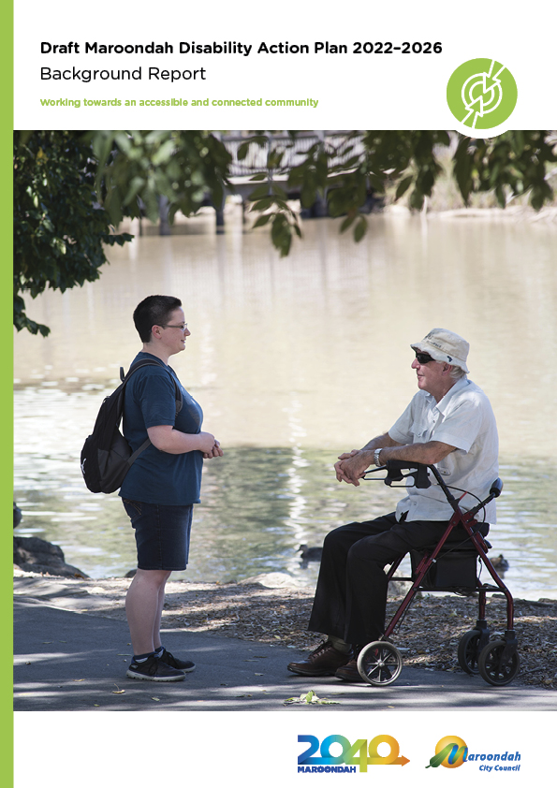
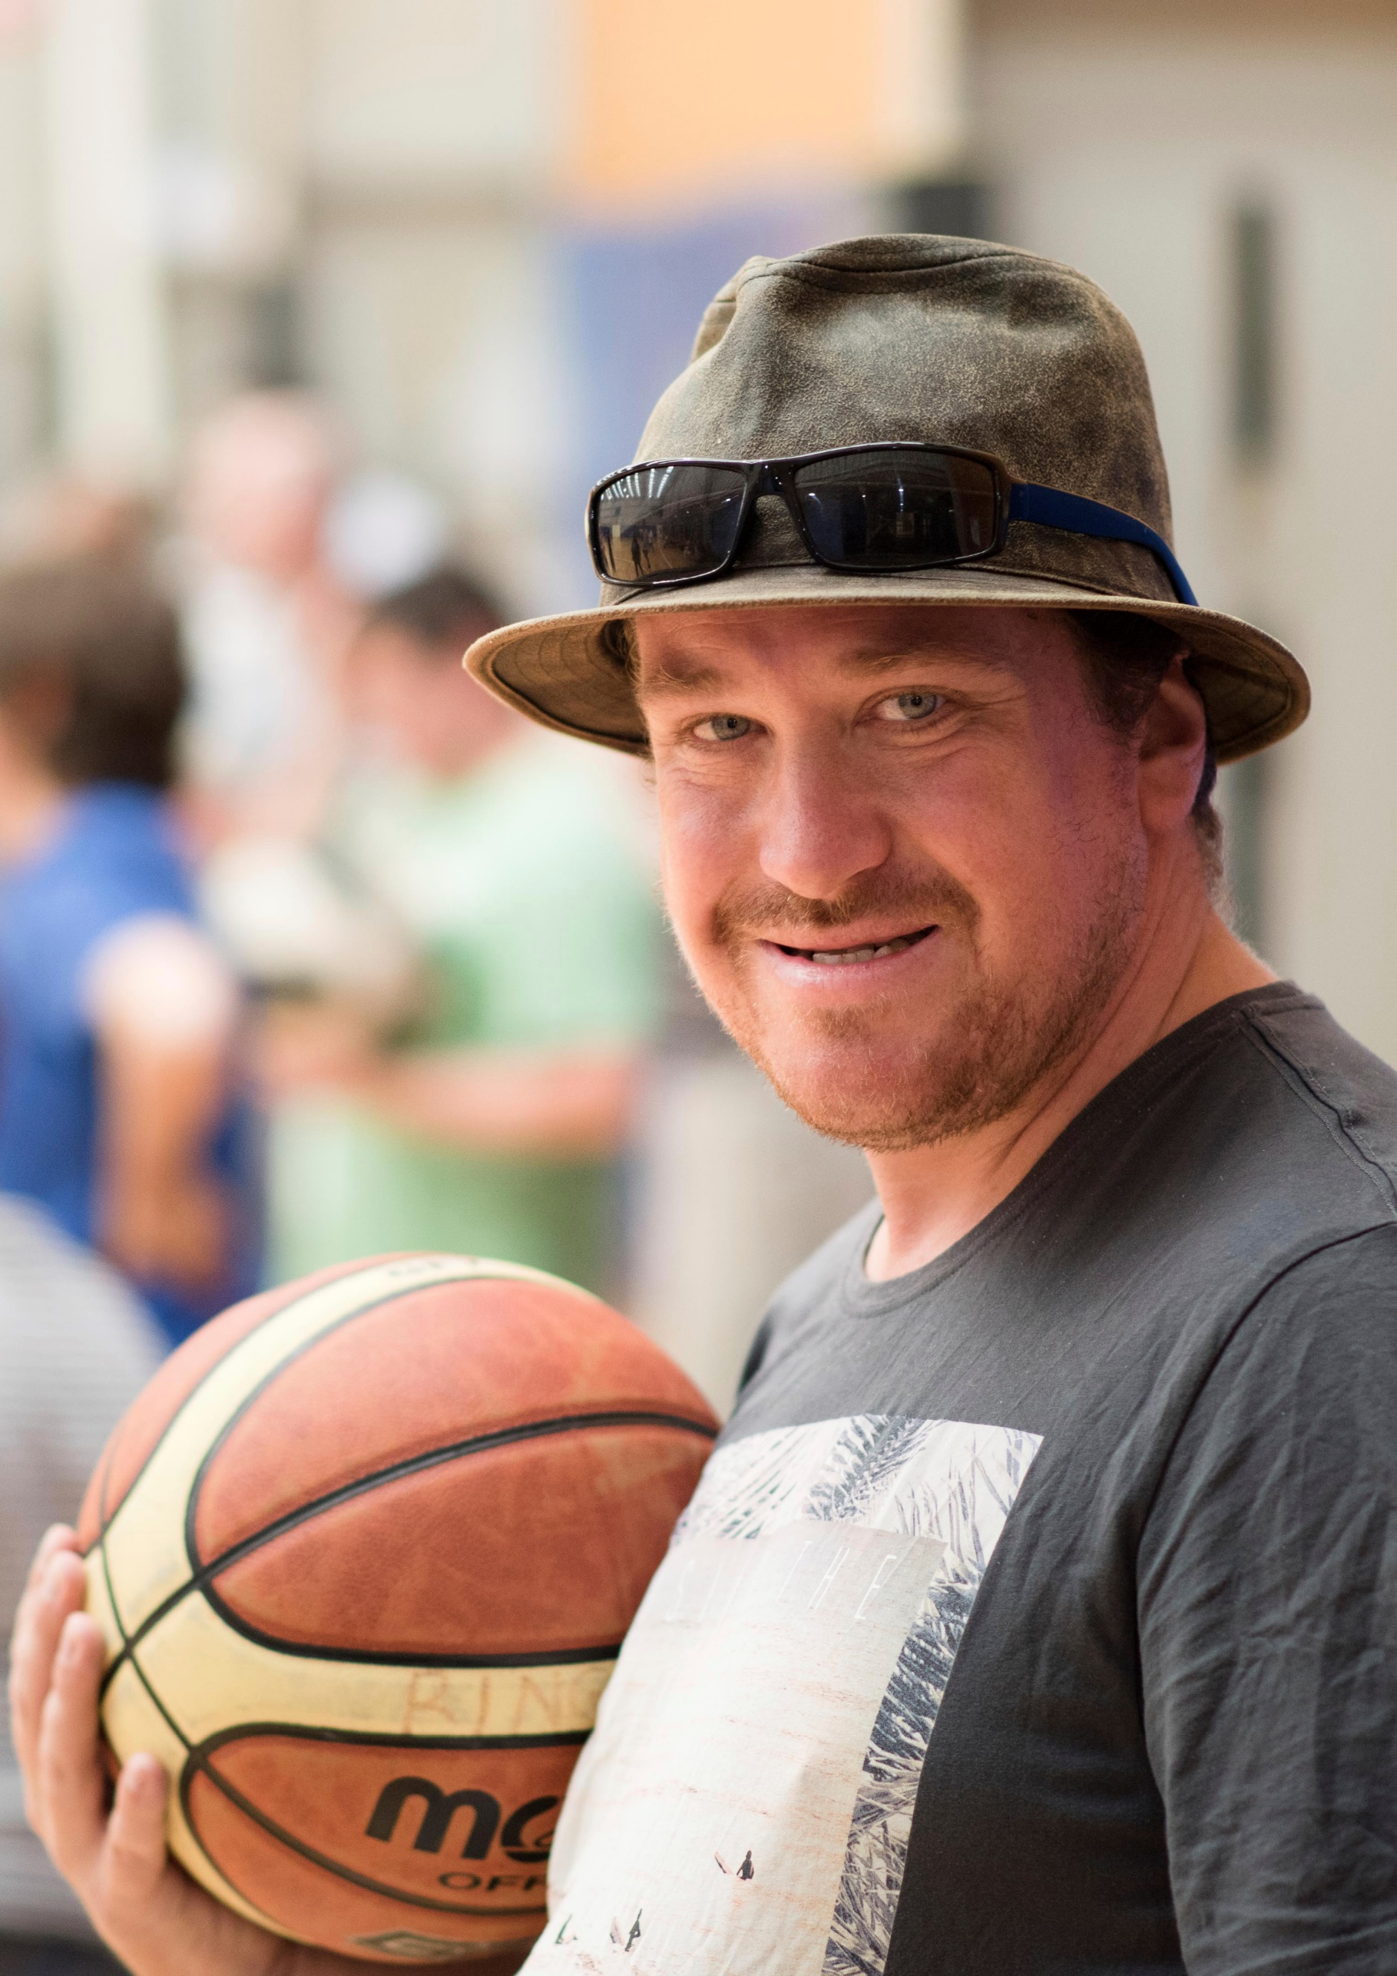
Contents
Introduction 4
Definition 4
Framework/legislation 4
International Policy Context 4
National Policy Context 5
Disability Discrimination Act 1992 (DDA) 5
Disability (Access to Premises – Building) Standards 2010 (Premises Standards) 5
Disability Standards for Accessible Public Transport 2002 (Transport Standards) 6
Disability Standards for Education 2005 (Education Standards) 6
Australia’s Disability Strategy 2021-2031 (the Strategy) 6
National Standards for Disability Services 7
Fair Work Act 2009 7
Federal Policy Context implications 7
State Policy Context 7
Disability Act 2006 (Vic) and Disability Regulation 2007 7
Equal Opportunity Act 2010 (Vic) and Charter of Human Rights and Responsibilities Act 2006 (Vic) 8
The Victorian Disability Action Plan 8
State Policy Context Implications 8
Maroondah Policy Context 9
Data and Statistics 9
Overall Disability Rates 10
Disability Trends 13
Carer Statistics 13
Disability Employment 14
Need for Assistance 14
Future Projections 15
What are the Challenges? 16
Challenges Identified by Council 16
Conclusion 16
Recommendations 16
Appendix 1 18
Appendix 2 28
Challenges faced by other councils 28
References 29

Introduction
Council is pleased to present the Disability Action Plan 2022-2026 Background Report. The Background Report will be used by Council to support development of the Disability Action Plan 2022-2026 and identifies:
- the legislative context along with the current state of disability in Maroondah, relevant international, national, state and local policies and legislation
- a snapshot of Maroondah’s current disability data and statistics, with an insight into the future estimates of disability for the municipality
- the key challenges faced by people experiencing a disability in Maroondah, with comparisons to other municipalities
- recent projects and initiatives in Maroondah to provide support and services to those living with disabilities and their carers.

Definition
‘People with disability’ is defined by the National Disability Strategy (NDS) as ‘people with all kinds of impairments from birth or acquired through illness, accident or the ageing process. It includes cognitive impairment as well as physical, sensory and psycho-social disability’.
The Disability Discrimination Act 1992 defines ‘disability’ in relation to a person as:
- Total or partial loss of the person’s bodily or mental functions; or
- Total or partial loss of a part of the body; or
- The presence in the body of organisms causing disease or illness; or
- The malfunction, malformation or disfigurement of a part of the person’s body; or
- A disorder or malfunction that results in the person learning differently from a person without the disorder or malfunction; or
- A disorder, illness or disease that affects a person’s thought processes, perception of reality, emotions or judgement or that results in disturbed behaviour.
While the above ‘legal definition’ provides a formal description of disability, the Australian Local Government Association (ALGA) states that it is important that in the current Australian context, councils should not limit themselves to these definitions. Alternatively, councils should strive to include, involve and accommodate people within all aspects of community life, by considering disability inclusion on a broader scale (ALGA 2016).

Framework/legislation

International Policy Context
The United Nations ‘Convention on the Rights of Persons with Disabilities’ (CRPD) was adopted by the UN in 2004, stating that ‘all people with disabilities must enjoy equal rights and fundamental freedoms’ (United Nations in ALGA 2016:p11). Under the convention, governments are guided to improve disability inclusion by adhering to eight general principles:
- Respect for inherent dignity, individual autonomy including the freedom to make one’s own choices, and independence of persons
- Non-discrimination
- Full and effective participation and inclusion in society
- Respect for difference and acceptance of persons with disabilities as part of human diversity and humanity
- Equality of opportunity
- Accessibility
- Equality between men and women
- Respect for the evolving capacities of children with disabilities and respect for the right of children with disabilities to preserve their identity.
The CRPD creates obligations for countries to ensure that measures are taken to ensure the eight general principles are upheld. In 2008, the Australian Government approved the CRPD, setting new direction for inclusion policy.

National Policy Context
The Australian Federal Government has multiple legislations and standards set in place to uphold the equal rights and freedom of people with disabilities and implement the standards of the United Nations CRPD.

Disability Discrimination Act 1992 (DDA)
The DDA protects individuals from unfair treatment by making direct and indirect disability discrimination by any person or organisation unlawful and promoting equal rights, opportunity, and access for all people.
The aim of the DDA is to:
- Eliminate discrimination against people with disabilities;
- Ensure the legal equality of people with disabilities; and
- Promote the recognition and acceptance within the community that people with disabilities have the same rights as the rest of the community.

Disability (Access to Premises – Building) Standards 2010 (Premises Standards)
The Premises Standards were developed under the direction of the DDA, to provide access to buildings and premises for all people. Under the legislation, any new premises or upgrade to existing premises must abide by the Premises Standards to ensure disability access is available. The standard is considered to be a minimum requirement by the Australian Human Rights Commission (AHRC), who encourage the use of design beyond the minimum standard.
The Disability (Access to Premises – Building) Standards 2010 (Premises Standards) applies to:
- a boarding house, guest house or hostel that has a floor area less than 300 m2 (Class 1b building).
- A building containing two or more sole-occupancy units each being a separate dwelling that has accommodation for short turn rent (Class 2 building).
- A residential building, (other than a Class 1 or 2 building), which is a common place of long term or transient living for a number of unrelated persons (Class 3 building).
- An office building used for professional or commercial purposes (Class 5 building).
- A shop or other building used for retail or services purposes direct to the public (Class 6 building).
- A building used for storage or the sale of goods for wholesale, or a car park (Class 7a, b building.
- A building used as a laboratory, or for the purpose of handicraft, or process for the production, assembling, altering, repairing, packing, finishing, or cleaning of goods or produce is carried on for trade, sale or gain (Class 8 Building).
- A building of a public nature e.g. Health care or aged building, primary or secondary school (Class 9 building).
- A non-habitable building or structure e.g. a private carpark or shed, a structure being a fence or swimming pool, or a private bushfire shelter (Class 10 building).

Disability Standards for Accessible Public Transport 2002 (Transport Standards)
Similar to the Premises Standards, the Transport Standards sets out framework for public transport providers and operators to provide disability access as part public transport services in compliance with the DDA. The Transport Standards follow a set of guidelines to deliver mandatory public transport performance outcomes, to be met by new and upgrading conveyances, premises and infrastructure to increase disability access to facilities and services.

The Disability Standards for Accessible Public Transport 2002 applies for all land, air, water conveying infrastructure available to members of the public. Some of these services include trains, trams, buses, airlines or vessels that carry passengers and offer services to the public, and charity/public money funded transportation.

Disability Standards for Education 2005 (Education Standards)
The Education Standards created an obligation for education and training providers to ensure that all students with disabilities have the same ability to participate in education as other students. The Education Standards applies to both education providers and Councils that provide preschool and/or kindergarten services. Councils obligation under the standard is to:
- Consult with a student with disabilities (or their family) to understand the impact of their disability and to determine any adjustments or changes that need to be made to assist them.
- Make reasonable adjustments to assist the student with disabilities to participate on the same basis as other students.
- Eliminate harassment and victimisation of students with disabilities.
A review of the Disability Standards for Education 2005 was undertaken in 2020. Although recommendations have been made by the Federal Government, no updates to the 2005 standards have been made.

Australia’s Disability Strategy 2021-2031 (the Strategy)
The Strategy outlines aspirations within the ideals of respect, inclusivity and equality. All levels of government have a responsibility to build a society in which people with disability can participate as equal members with equal opportunities to fulfil their potential. The Strategy builds on the work and achievements of the National Disability Strategy 2010-2020.
The Strategy has seven outcome areas which all have relevance to local government:
Employment and Financial Security
Outcome: People with disability have economic security, enabling them to plan for the future and exercise choice and control over their lives.
Inclusive Homes and Community
Outcome: People with disability live in inclusive, accessible and well-designed homes and communities.
Safety, Rights and Justice
Outcome: The rights of people with disability are promoted, upheld and protected, and people with disability feel safe and enjoy equality before the law.
Personal and community support
Outcome: People with disability have access to a range of supports to assist them to live independently and engage in their communities.
Education and Learning
Outcome: People with disability achieve their full potential through education and learning.
Health and Wellbeing
Outcome: People with disability attain the highest possible health and wellbeing outcomes throughout their lives.
Community Attitudes
Outcomes: Community attitudes support equality, inclusion and participation in society for people with disability.

National Standards for Disability Services
The Standards for Disability Services promotes the implementation of a nationally consistent approach to quality disability services. While these standards apply to all organisations offering services to people with disabilities, they are not related to the DDA and are not legally binding. All organisations must meet a set of six standards if they desire to become NDIS provider. The six National Standards are:
- Rights
- Participation and inclusion
- Individual outcomes
- Feedback and complaints
- Service access
- Service management

Fair Work Act 2009
The Fair Work act provides guidance to reduce discrimination in the work-place. This includes protecting people with disabilities from discrimination by prohibiting adverse actions because of their disability.

Federal Policy Context implications
The above acts, standards and strategies outline the federal governments requirements, framework, and legislations to assist Councils development of the Disability Action Plan 2022-2026. As part of the new Plan, Council will need to ensure that the Plan meets the necessary requirements of the national policy context. Council’s new Plan will ensure legal equity, eliminate discrimination, and promote the acceptance of people with disabilities as per the Disability Discrimination Act 1992. Strategies developed by Council relating to education, employment, services, public transport and building access will be required to follow the legislation and framework of the Disability Standards 2010, Disability Standards for Accessibility Public Transport 2002, Disability Standards for Education 2005, National Standards for Disability Services, and Fair Work Act 2009. The Plan will follow Australia’s Disability Strategy’s 2021-2031 strategic framework for inclusive policy and service provision.

State Policy Context

Disability Act 2006 (Vic) and Disability Regulation 2007
The purpose of the Act is to provide “a stronger whole-of-government, whole-of-community response to the rights and needs of people with a disability, and a framework for the provision of high quality services and supports for people with a disability”. The Act identified that this cannot be achieved without the involvement of all areas of government and the community.
The Act reinforces that people with disabilities have equal rights as members of the community to participate in decision making and have access to information, communication and support. Under the Act, public sector organisations including councils are required to:
- reduce the barriers to goods, services and facilities for people with disabilities
- reduce the barriers for people with disabilities to find employment
- promote inclusion and participation of people with disabilities
- change attitudes and reduce discrimination against people with disabilities.
Using these requirements and the Municipal Association of Victoria’s (MAV) framework for ‘creating a more inclusive community for people with disability’, Councils are required to prepare their own Disability Action Plan. Council’s Disability Action Plan 2022-2026 will respond to these requirements.

Equal Opportunity Act 2010 (Vic) and Charter of Human Rights and Responsibilities Act 2006 (Vic)
These two Acts aim to eliminate discrimination towards people with disabilities by:
- prohibiting discrimination based on several attributes including disability, and
- reinforcing that all people within society are born free and equal in dignity and rights.
The Equal Opportunity Act 2010 applies to all services provided by Council along with community access and use of public spaces. The Charter of Human Rights and Responsibilities Act 2006 applies to all aspects of Council including Councillors, staff, and the organisation.
The Victorian Disability Action Plan
Inclusive Victoria: State Disability Plan 2022–2026 is Victoria's fourth state disability plan. The Plan sets out actions that will help the Victorian Government meet its obligations under the United Nations Convention on the Rights of Persons with Disabilities. The plan describes how the Victorian Government will recognise and address forms of structural discrimination that people with disabilities face and build accessibility into everything that government does. The Plan contains six systemic reforms and 22 priority areas, grouped under four pillars: Inclusive communities, Health, housing and wellbeing, Fairness and safety and Opportunity and pride.
As part of this new Plan, Victorians with a disability will be consulted on creating a new Disability Inclusion Act and on establishing an Australian-first Commissioner for Disability Inclusion.

State Policy Context Implications
The State Policy context provides requirements, framework, and legislation designed by the Victorian government for the development of Disability Policies and Actions Plans at a local government level. For the development of the Disability Action Plan 2022-2026, Council will follow Inclusive Victoria: State Disability Plan 2022–2026’s strategic framework for inclusive communities, health, housing and wellbeing, fairness and safety, and contributing lives. Under the Disability Act 2006 and the Disability Regulation 2007, Council is required to reinforce the equal rights of people with disabilities by reducing the barriers that affect the accessibility and opportunities of people with disabilities from participating in community life, promote inclusion of people with disabilities, and reduce discrimination against people with disabilities.
Under the Equal Opportunity Act 2010 and the Charter of Human Rights and Responsibilities Act 2006, Council will ensure that the Disability Policy and Action Plan 2022-2026 does not discriminate in any aspect including disability. Council is required to prepare the Disability Policy and Action Plan 2022-2026 in accordance with the strategic framework set out by the MAV. The Strategic Framework is designed to assist Council to meet legal obligations to eliminate discrimination against people with disabilities.

Maroondah Policy Context
Council will use the above international, federal, and state Acts, regulations, and frameworks to develop the Maroondah Disability Action Plan 2022-2026. Council also draws on several of its own legislative plans and strategies to support and provide strategic framework for the development of a disability action plan.
Maroondah 2040: Our future together and the Council Plan 2021-2025 are the two key documents that provide the framework for the development of strategic documents such as a disability action plan. Other key legislative plans and strategies include:
- Maroondah COVID-19 Recovery Plan
- Maroondah Liveability, Wellbeing and Resilience Strategy 2021-2031
- Open Space Strategy 2016
- Physical Activity Strategy
- Equally Active Strategy
- Youth Strategy
- Positive Ageing Framework and Action Plan
- Children and Families Strategy
Disability is a key focus for Council across service delivery, advocacy, partnerships, facilitation, and development. Disability is taken into consideration across all major projects and aspects of Council. In preparation of the Disability Action Plan 2022-2026, Council engaged with internal stakeholders across the organisation to ensure that the new plan promotes equality and equal rights of all members of the community.

Data and Statistics
This section of the report will focus on and discuss the existing data and statistics that frame the challenges of disability in Maroondah. The following discussion is based on Tables 1 to 20 in Appendix 1 of this report. Using these statistics, we are able to identify trends that exist in the data to determine the need for disability support and infrastructure across the municipality. ‘Disability’ or ‘need for assistance’, refers to data collected in the ABS Census of Population and Housing 2016 where a member of the population indicated that they require assistance with one or more daily core activities including body movement, communication, and/or self-care.

The discussion takes a closer look at the trends of disability throughout Maroondah, with key comparisons focusing on other trends in the Eastern Melbourne Region (EMR), as well as Greater Melbourne and Victoria. The following discussion points are drawn from Tables 1, 2 and 3 of the Appendix.
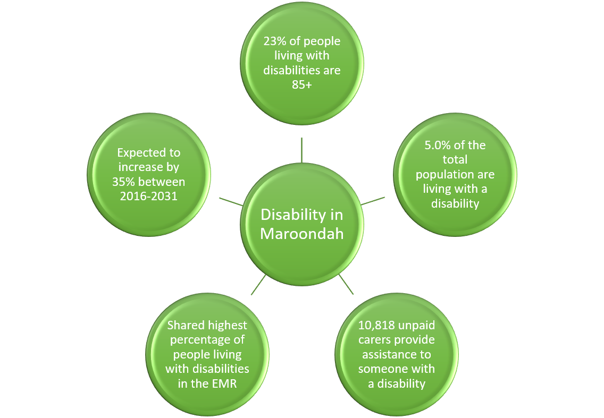

Figure one: Disability in Maroondah

Overall Disability Rates
- The City of Maroondah, according to 2016 Census, has a total of 5,482 (5.0% of total population) people living with a profound or severe disability, who require assistance with any daily activities.
- Ringwood (6.1%), Bayswater North Community Renewal Area (6.1%) and Ringwood East (5.9%), are identified as having the highest percentage of people living with disabilities who self-identified as having a ‘need for assistance’.
- In contrast, Kilsyth South has the lowest percentage population identifying as requiring assistance with daily activities due to disability (2.8%).
- Croydon has the highest number of people living with disabilities (1,497) who need assistance, although the percentage of people who need assistance due to disability living in Croydon, 5.5%, is lower than that of Ringwood and Ringwood East
- The 2016 Personal Safety Survey (PSS) which is led by the Australian Bureau of Statistics (ABS) found women and girls living with disabilities are more likely than women and girls without disabilities to experience violence throughout their lives.
- Based on 2018 Survey of Disability, Ageing and Carers, it has been estimated that in 2018, 14.2% of total population in Maroondah (16,516 people) live with disability: 13.8% of total male population and 14.5% of total female population in Maroondah.
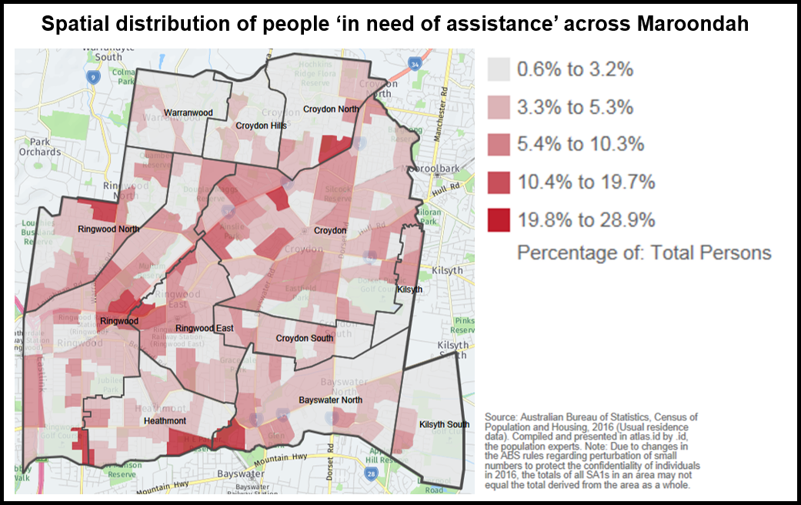
Figure 2: Spatial distribution of people with a need for assistance across Maroondah
- The percentage of persons with a profound or severe disability significantly increases beyond the age of 65 years.
- Maroondah’s population aged 65+ years have the highest percentage of people living with a profound of severe disability in Eastern Metropolitan Region, ranges from 10.9% of people living in Croydon Hills - Warranwood, to 14.9% of people living in Ringwood.
- In Maroondah, 1,260 out of a total of 2,647 population over the age of 85 years (or 47.6%) are identified as having a need for assistance or living with disabilities. Maroondah’s population aged 85+ living with disabilities contribute to approximately 23% of the total population who are living with a disability in Maroondah.
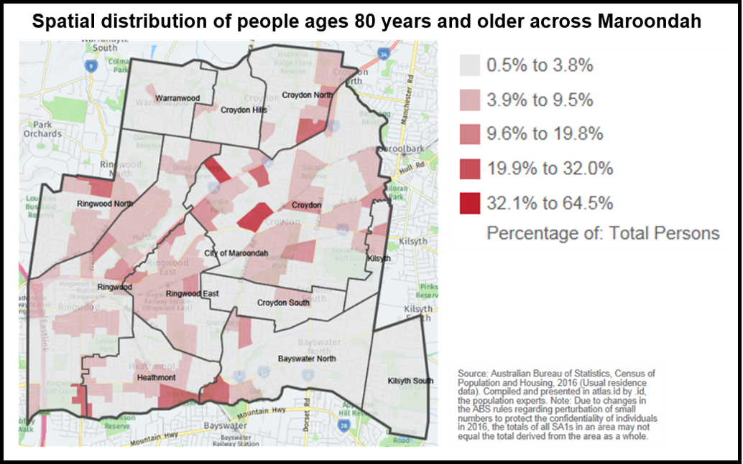
Figure 3: Spatial distribution of people aged 80 years and older across Maroondah
- According to the Maroondah Statistical Profile, Maroondah and Monash had the equal highest percentage (4.6%) of people living with a profound or severe disability in the Eastern Metropolitan Region in 2011. However, in data from the 2016 Census, Maroondah and Manningham now having equal highest percentage of people living with profound or severe disability at 5.0% of the total population.
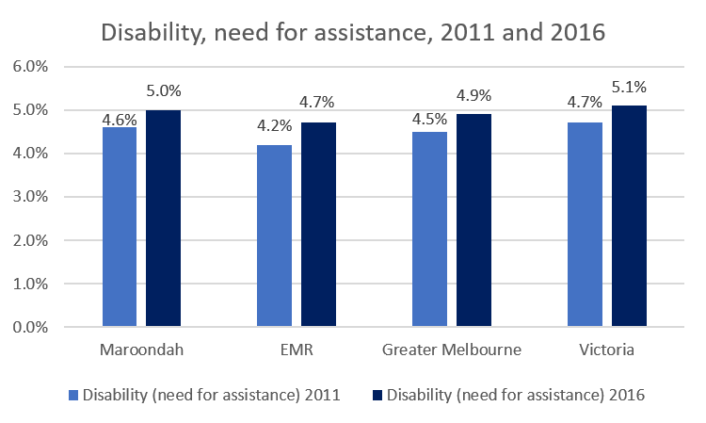
Figure 4: Disability, need for assistance, 2011 and 2016

- Maroondah’s percentage of population living with a profound or severe disability is reported to be slightly higher than that of Greater Melbourne (4.9%), yet slightly lower than that of Victoria.

Disability Trends
Using the data collected from reports of Disability Survey 2018, we are able to identify and discuss trends of disability in Maroondah based on age and gender. The following discussion points are drawn from Tables 4 and 5 of Appendix 1.
- According to the data, over 42.82% of Maroondah’s population over the age of 65 are identified as having a disability.
- The percentage of people living with disabilities increases slowly between the age groups 15-24 and ages above 35, with a sharp increase in percentage from the 45-54 demographic and above.
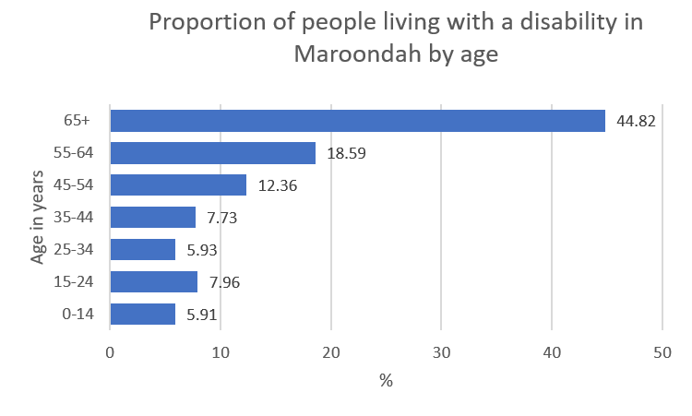
Figure 5: People living with a disability in Maroondah by age
- Both the number and percentage of population living with a profound or severe disability increase significantly among people aged 65 years and over.
- The data identifies that there are more females living with a profound or severe disability in Maroondah than males.
- There is a greater number of males living with disabilities in the age groups of 0-14 years to 25-34 years compared with females.
- There are more females than males living with disabilities in all age groups above 35 years.
- In the 0-14 year old age group, both the number and percentage of females living with disabilities is almost half that of males.

Carer Statistics
An unpaid carer is a person who provides care, help or assistance to a person because of a disability, a long term illness or problems related to old age, without receiving payment. An unpaid carer may not necessarily be a family member to the person they are providing assistance to, and may help with duties including driving, bathing, toileting, feeding, medicating, mobility etc. The following discussion points are drawn from Tables 6, 7 and 8 of Appendix 1.
- According the 2016 census, a total of 10,818 unpaid carers provided assistance to someone with a disability, long term illness or old age in Maroondah.
- The suburbs with the highest number of unpaid carers were Croydon (2,576) and Ringwood (1,704).
- Compared to the Eastern Metropolitan Region (EMR), Maroondah has the third highest in percentage of unpaid after Yarra Ranges and Manningham.
- Of people in need of assistance in Maroondah, 9.1% are identified as providing unpaid care for a child.
- Maroondah has a higher rate of people in need of assistance who provide unpaid care for a child than that of the EMR or Greater Melbourne.
- This level of people in need of assistance who provided unpaid care for a child/children identifies the need for greater and improved in-home assistance services and school services.

Disability Employment
For people who live with a profound or severe disability, education and employment can be hard to access. Employment availability and education attendance datasets can be key indicators of the need for assistance in the school systems and social support services. The following discussion points are drawn from Tables 9, 10 and 11 of Appendix 1.
- Maroondah’s percentage of population who have a need for assistance with daily activities and who are also unemployed and looking for work, is greater than both the EMR and Greater Melbourne.
- People who identify as in need of assistance also are less likely to be employment compared with the overall total population in Maroondah, as well as having a much higher proportion of people looking for either part-time or full-time work.
- The proportion of Maroondah’s population who have a need for assistance and are attending TAFE and University, is similar to that of both the EMR and Greater Melbourne, and slightly lower than the proportion of all Maroondah residents attending University or TAFE.
- Maroondah’s population living with severe or profound disability have a significantly lower percentage of individuals with a bachelor’s degree or higher (15.5% difference), with 20.7% more people reportedly having no qualifications.
- Maroondah has a higher percentage of people living with disabilities who have a vocational qualification, than both the EMR and Greater Melbourne.
- Both the EMR and Greater Melbourne have a higher percentage of people in need for assistance who also have with no educational qualifications than Maroondah.

Need for Assistance
By looking at household factors including income, type and tenure, we can identify how people with disabilities in Maroondah live. This discussion helps to identify how many people living with severe or profound disability in Maroondah are living alone, with their families or other support, their housing types and their available resources. The following discussion points are drawn from Tables 12, 13 and 14 of Appendix 1.
- In Maroondah, 32.9% of the population identified as in need of assistance were also in the lowest income earning group, while a further 29.3% were in the medium-lowest income group.
- These household income figures are identified to be similar to that of both the EMR and Greater Melbourne.
- The percentage of households belonging to the lowest income group out of the total population of Maroondah stands at 13.8%, which is significantly lower than those living with disabilities.
- In Maroondah, 57.7% of people in need of assistance were in households of couples with one or more children.
- Of Maroondah’s population of people living with disabilities, 19.2% are identified as living in lone person households, compared to the 9.6% of people living in lone person households of the total population.
- There is a higher percentage of people with disabilities living in fully owned dwellings (42.4%) than there are across the total population of Maroondah (26.0%). However, Maroondah has a lower percentage of people with disabilities living in fully owned dwellings than that of the Eastern Metropolitan Region (EMR) or Greater Melbourne.
- 8.7% of people living with disabilities are identified as living in social housing, which is a greater percentage than that of the total population of Maroondah (1.9%), the EMR (5.6%), and Greater Melbourne (7.6%).
Access to a motor vehicle or the internet is an indicator of a person’s capabilities to participate in general life activities. Many factors may influence a person with disabilities access to a motor vehicle, such as their ability to drive and old age. Access to vehicles may be particularly important in some areas, depending on the accessibility of public transport. Not having access to the internet or a private motor vehicle can lead to difficulties accessing education, employment, information, communication, and social connection. The following discussion points are drawn from Tables 15 and 16 of the Appendix.
- Overall, 35.3% of people reporting a need for assistance were in households that owned one car, 32.3% owned two cars and 15.5% owned three cars or more.
- Maroondah and the EMR have similar percentages of vehicle ownership for one car, two car, and three or more car households.
- In Maroondah, 19.6% of the population living with disabilities reported not having internet connection at home.
- Whilst this percentage is significantly higher than that of the rest of Maroondah, it is lower than that of both the EMR (22.2%) and Greater Melbourne (24.1%).

Future Projections
Over the coming decades, Maroondah’s population demographic is expected to change significantly. Forecasts have estimated that Maroondah will experience an increase in several cohorts including: the population aged 65+, residents living with dementia, and people with disabilities. These forecasts allow us to estimate the future aged care, disability, and support service needs of Maroondah, by identifying what services will be required and in what quantity. The following discussion points are drawn from Tables 17, 18, 19 and 20 of Appendix 1.
- Between 2016 and 2031, the population of Maroondah living with disabilities is expected to increase by almost 2,000, with an overall percentage increase of 35%, to 7,560 people.
- The greatest increase is expected, in both number and proportion, in people aged 70 years and over.
- It is forecast 6,150 people will be living with dementia in with Maroondah in 2050, which is an increase, between the years of 2016 and 2050, of 4,160 persons living with dementia.
- The Department of Health and Human Services (DHHS) estimated that the average life years of an Australian male born in 2012 is 62.4 years without disability, and a further 17.5 years with some form of disability.
- The average life years of an Australian female born in 2012 is 64.5 years without disability, and a further 19.8 years with some form of disability.
- When comparing the 2001 census data to the 2016 census data, Maroondah’s total percentage of population aged 65 years + has increased by a total of 3.7%.
- According to the Victorian Government’s population and household projections for 2056, the total number of Victoria’s population aged 75+ years will triple between 2016 and 2051 due to increasing life expectancies. The proportion of total population who are aged 75 years and over will increase from 6.7% of the population in 2016, to 11.3% in 2056.
- The Victorian Government’s population projections indicate that by 2031, 19.4% of Maroondah’s population will be aged 65+ years.
These projections suggest that the demand for disability services and assistance will increase over the coming years, as dementia, an ageing population, and disability are all forecast to increase.

What are the Challenges?

Challenges Identified by Council
Throughout the lifespan of the Disability Policy and Action Plan 2019-2021, Council has identified several major challenges of meeting the needs of people with disabilities that will need to be addressed as part of the next Disability Action Plan. These challenges consist of issues that have been acknowledged by Council, as well as ideas and issues raised by members of the public during community consultation. The key themes of these challenges are based around accessibility, infrastructure, communication, social inclusion/connection, education, employment, housing, and governance.
- Many shops and cafes in Maroondah require improvements to be accessible and equipped with entry’s and facilities to accommodate the needs of people with disabilities.
- Improve communication skills/options (i.e. Auslan) at major Maroondah events.
- Job opportunities need to increase so that more people with disabilities can have equal opportunities, to find employment and participate in daily activities within the community.
- Greater assistance and service is needed to provide greater opportunity for people with disabilities and their carers to access support and social groups to reduce the risk of social isolation.
- Providing services to carers and families of people with disabilities.
- Negative stigma and community attitude towards disability, prevents individuals from feeling equal and contributing to community life.

Conclusion
People living with disabilities are faced with daily challenges that prevent them from participating in the daily civic life of a community. The purpose of the Disability Action Plan 2022-2026 will be to set a framework in place that aims to improve the opportunities and inclusion of people living with disabilities and their carers, by providing support and services that improve accessibility and contribution capabilities for everyone in the community. In this report, it has been identified that Council’s Disability Action Plan will need to take into consideration and abide by a variety of Acts, standards, strategies, and policies on all government levels. The new action plan will respond to the needs of Maroondah’s current and future population living with disabilities, and their carers.

Recommendations
This report has identified, that there is a need for Council to continue to advocate and work towards creating equal opportunity and inclusion of people with disabilities in the community. It has also been identified that the Disability Action Plan 2022-2026 will need to focus on reducing the challenges that prevent people with disabilities from participating in the daily life of the community. Council should consider the following recommendations in preparation of the Disability Action Plan 2022-2026.
- Council should continue to facilitate and advocate for equal opportunity for people with disabilities, their families and their carers to actively and fully participate in the community.
- Council should continue to promote and create opportunities for equity across people of all abilities.
- Council should provide good leadership to promote the value of people with disabilities within the community, to educate and change negative stigma and attitudes towards disability within the community.
- Council should continue to play a key role in advocating for greater disability access and facilities in all buildings and places, beyond the minimum design requirements of the Disability (Access to Premises - Buildings) standards 2010.
- Council should continue to provide support services and advocacy for people with disabilities and their carers.
- Council should work in partnership to create opportunities for people with disabilities, their families and carers for community participation and social connection.
- Council should work in partnership with local businesses and social services to increase employment opportunities for people with disabilities.

Appendix 1
Table 1: People in need of assistance across Maroondah, 2016
Age group | Maroondah  (number – %) | Bayswater North  (number – %) | Croydon  (number – %) | Croydon Hills  (number – %) | Croydon North  (number – %)
0-4 years | 97 – 1.3% | 4 – 0.6% | 22 – 1.2% | 3 – 1.2% | 6 – 1.2%
5-9 years | 281 – 4.1% | 24 – 4.6% | 34 – 2.2% | 15 – 4.4% | 11 – 2.2%
10-19 years | 453 – 3.5% | 33 – 3.7% | 62 – 2.3% | 9 – 1.1% | 18 – 1.8%
20-59 years | 1,441 – 2.4% | 89 – 1.8% | 265 – 1.9% | 15 – 0.5% | 28 – 0.7%
60-64 years | 309 – 5.1% | 17 – 3.7% | 60 – 4.3% | 4 – 1.3% | 11 – 2.3%
65-69 years | 303 – 5.7% | 24 – 5.7% | 64 – 4.5% | 0 – | 10 – 2.8%
70-74 years | 325 – 7.6% | 15 – 5.3% | 69 – 6.4% | 4 – 2.4% | 20 – 8.1%
75-79 years | 421 – 13.9% | 34 – 30.4% | 88 – 9.8% | 0 – | 14 – 7.0%
80-84 years | 583 – 24.4% | 33 – 23.6% | 141 – 20.3% | 0 – | 32 – 20.6%
85 years + | 1,260 – 47.9% | 102 – 44.3% | 292 – 42.1% | 10 – 34.5 | 71 – 55.0%
Total | 5,482 – 5.0% | 484 – 5.5% | 1,497 – 5.5% | 137 – 2.6% | 316 – 4.0%
Age group | Croydon South  (number – %) | Heathmont  (number – %) | Kilsyth  (number – %) | Kilsyth South  (number – %) | Ringwood  (number – %)
0-4 years | 0 – 0% | 0 – 0% | 0 – 0% | 0 – 0% | 6 – 0.5%
5-9 years | 15 – 5.3% | 17 – 2.9% | 9 – 8.2% | 6 – 3.2% | 37 – 3.5%
10-19 years | 9 – 1.8% | 29 – 2.4% | 6 – 3.5% | 9 – 1.7% | 45 – 2.5%
20-59 years | 24 – 1.0% | 47 – 1.0% | 14 – 1.7% | 12 – 0.7% | 163 – 1.7%
60-64 years | 13 – 5.3% | 19 – 3.8% | 0 – 0% | 3 – 2.0% | 38 – 4.3%
65-69 years | 8 – 3.3% | 20 – 4.4% | 7 – 9.5% | 6 – 6.5% | 33 – 4.5%
70-74 years | 4 – 2.1% | 13 – 3.2% | 3 – 5.2% | 0 – 0% | 64 – 9.9%
75-79 years | 5 – 5.1% | 34 – 13.0% | 3 – 1.7% | 7 – 30.4% | 77 – 16.7%
80-84 years | 11 – 13.9% | 39 – 19.5% | 10 – 28.0% | 3 – 11.1% | 115 – 25.9%
85 years + | 12 – 29.8% | 69 – 45.1% | 14 – 34.0% | 0 – 0% | 293 – 58.7%
Total | 178 – 3.8% | 397 – 4.0% | 88 – 5.2% | 82 – 2.8% | 1,103 – 5.9%
Age group | Ringwood East  (number – %) | Ringwood North  (number – %) | Warranwood  (number – %) | Ringwood Major Activity Centre  (number – %) | Croydon Activity Centre  (number – %)
0-4 years | 3 – 0.4% | 0 – 0% | 0 – 0% | 0 - 0% | 0 – 0%
5-9 years | 16 – 2.7% | 19 – 3.0% | 0 – 0% | 6 – 9.0% | 4 – 3.4%
10-19 years | 21 – 2.0% | 35 – 2.0% | 21 – 2.6% | 3 – 2.4% | 0 – 0%
20-59 years | 112 – 2.1% | 73 – 1.5% | 26 – 1.0% | 39 – 3.4% | 26 – 2.0%
60-64 years | 16 – 3.3% | 14 – 2.3% | 6 – 2.3% | 9 – 10.1% | 11 – 13.4%
65-69 years | 23 – 5.0% | 27 – 5.4% | 4 – 2.2% | 0 – 0% | 3 – 4.0%
70-74 years | 38 – 10.4% | 22 – 5.0% | 8 – 6.2% | 4 – 8.6% | 0 – 0.8%
75-79 years | 28 – 9.9% | 37 – 12.3% | 3 – 5.8% | 0 – 0% | 5 – 7.3%
80-84 years | 54 – 21.2% | 44 – 27.8% | 7 – 22.6% | 6 – 19.4% | 4 – 11.1%
85 years + | 130 – 56.9% | 85 – 61.6% | 293 – 58.7% | 1 – 21.4% | 16 – 33.2%
Total | 597 – 5.9% | 459 – 4.8% | 1,103 – 6.1% | 96 – 5.5% | 120 – 5.3%
Source: Australian Bureau of Statistics, Census of Population and Housing 2016. Compiled and presented in atlas.id, by .id (informed decisions) the population experts.

Table 2: People in need of assistance across the Eastern Metropolitan Region, 2016
Age  (Years) | Maroondah  (number-%) | Boroondara  (number-%) | Knox  (number-%) | Manningham  (number-%) | Monash  (number-%) | Whitehorse  (number-%) | Yarra Ranges  (number-%)
0-4 | 97 -1.3% | 63 - 0.8% | 144 - 1.6% | 62 - 1.1% | 76 - 0.8% | 90 - 1.0% | 121 - 1.3%
5-9 | 281 - 4.1% | 199 - 2.0% | 331 - 3.7% | 152 - 2.3% | 210 - 2.1% | 255 - 2.7% | 357 - 3.7%
10-19 | 453 - 3.5% | 340 - 1.5% | 580 - 3.1% | 284 - 2.0% | 401 - 1.8% | 421 - 2.2% | 723 - 3.7%
20-59 | 1,441 - 2.4% | 1,109 - 1.2% | 1,868 - 2.2% | 947 - 1.6% | 1,656 - 1.6% | 1,638 - 1.9% | 2,026 - 2.6%
60-64 | 309 - 5.1% | 243 - 2.8% | 427 - 4.5% | 239 - 3.6% | 414 - 4.8% | 378 - 4.7% | 434 - 4.7%
65-69 | 303 - 5.7% | 297 - 3.8% | 549 - 6.8% | 322 - 4.9% | 563 - 6.9% | 443 - 6.0% | 458 - 5.4%
70-74 | 325 - 7.6% | 398 - 6.6% | 534 - 9.5% | 437 - 7.6% | 733 - 10.4% | 537 - 8.6% | 516 - 8.6%
75-79 | 421 - 13.9% | 589 - 13.1% | 692 - 16.4% | 688 - 13.5% | 1,007 - 16.0% | 766 - 14.1% | 497 - 12.8%
80-84 | 583 - 24.4% | 837 - 23.8% | 76 - 26.9% | 969 - 26.7% | 1,329 - 27.5% | 1,014 - 23.5% | 597 - 24.3%
85+ | 1,260 - 47.9% | 2,331 - 48.3% | 1,522 - 49.1% | 1,745 - 47.8% | 2,439 - 47.8% | 2,081 - 41.9% | 1,163 - 45.7%
Total | 5,482 - 5.0% | 6,406 - 3.8% | 7,419 - 4.8% | 5,844 - 5.0% | 8,836 - 4.8% | 7,628 - 4.7% | 6,897 - 4.6%
Source: Australian Bureau of Statistics, Census of Population and Housing 2016. Compiled and presented in atlas.id, by .id (informed decisions) the population experts.

Table 3: Percentage of people living with a profound or severe disability (ALL ages) across the Eastern Metropolitan Region, Greater Melbourne and Victoria, 2016
Area | %
Maroondah | 4.4
Boroondara | 3.7
Knox | 5.0
Manningham | 5.0
Monash | 4.4
Whitehorse | 4.4
Yarra Ranges | 5.0
Greater Melbourne | 5.1
Victoria | 5.6
Maroondah | 4.4
Source: ABS (2020), LGA Modelled Estimates, Disability Ageing and Carers Australia: Summary of Findings 2018 Survey, compiled by Maroondah City Council

Table 4: Percentage of people living with a profound or severe disability by age and sex, 2018
Age  (years) | Females Number | Females % | Males Number | Males  % | All Persons Number | All Persons %
0-14 | 306 | 2.8 | 663 | 5.7 | 960 | 4.3
15-24 | 190 | 2.8 | 251 | 3.5 | 441 | 3.2
25-34 | 132 | 1.5 | 153 | 1.8 | 288 | 1.7
35-44 | 148 | 1.7 | 138 | 1.7 | 281 | 1.7
45-54 | 261 | 3.2 | 169 | 2.3 | 442 | 2.8
55-64 | 339 | 4.9 | 237 | 3.7 | 589 | 4.4
65+ | 1,318 | 13.7 | 822 | 10.6 | 2,149 | 12.4
Source: ABS (2020), LGA Modelled Estimates, Disability Ageing and Carers Australia: Summary of Findings 2018 Survey, compiled by Maroondah City Council

Table 5: Number and percentage of people living with a disability and non-disability comparison by age, Maroondah, 2018
Age (years) | Number of people living with a disability | Number of people not living with a disability | Total | % of people living with a disability
0-14 | 1,327 | 21,136 | 22,463 | 5.91
15-24 | 1,114 | 12,886 | 14,000 | 7.96
25-34 | 1,009 | 16,004 | 17,013 | 5.93
35-44 | 1,293 | 15,436 | 16,729 | 7.73
45-54 | 1,921 | 13,615 | 15,536 | 12.36
55-64 | 2,463 | 10,783 | 13,246 | 18.59
65+ | 7,402 | 9,114 | 17,352 | 44.82
Total | 16,516 | 99,823 | 116,339 | 14.20
Source: ABS (2020), LGA Modelled Estimates, Disability Ageing and Carers Australia: Summary of Findings 2018 Survey, compiled by Maroondah City Council

Table 6: Male and female living with a disability comparison across Maroondah by age, 2018
Age group (years) | % of females with a disability | % of males with a disability | No. of females with a disability | No. of males with a disability
0-14 | 4.4 | 7.4 | 473 | 860
15-24 | 8.0 | 7.8 | 538 | 566
25-34 | 6.0 | 5.9 | 516 | 491
35-44 | 8.8 | 6.6 | 751 | 544
45-54 | 12.7 | 11.9 | 1,027 | 886
55-64 | 18.2 | 19.0 | 1,255 | 1,206
65+ | 42.4 | 42.8 | 4,069 | 3,323
Total | 14.5 | 13.8 | 8,630 | 7,881
Source: ABS (2020), LGA Modelled Estimates, Disability Ageing and Carers Australia: Summary of Findings 2018 Survey, compiled by Maroondah City Council

Table 7: Unpaid carers / assistance given to a person with a disability, long term illness or old age across Maroondah, 2016
Area | Provided unpaid assistance
Bayswater North | 787
Croydon | 2,576
Croydon Hills | 547
Croydon Major Activity Centre | 179
Croydon South | 463
Heathmont | 980
Kilsyth | 158
Kilsyth South | 303
Ringwood | 1,704
Ringwood Metropolitan Activity Centre | 146
Ringwood East | 985
Ringwood North | 1,034
Warranwood | 492
Maroondah | 10,818
Source: Australian Bureau of Statistics, Census of Population and Housing 2016. Compiled and presented in atlas.id, by .id (informed decisions) the population experts.

Table 8: Unpaid carers / assistance given to a person with a disability, long term illness or old age, EMR comparison, 2016
Provided unpaid  assistance | Maroondah | Boroondara | Knox | Manningham | Monash | Whitehorse | Yarra Ranges
Number | 10,818 | 16,806 | 15,000 | 12,091 | 16,993 | 15,784 | 15,155
% | 12.0 | 12.1 | 11.8 | 12.4 | 11.1 | 11.7 | 12.5
Source: Social Health Atlases of Australia: Local Government Areas, 2021, compiled by Maroondah City Council

Table 9: Comparison of Maroondah’s population who has a need for assistance, Maroondah’s total population, unpaid child carers, the Eastern Metropolitan Region and Greater Melbourne who provide unpaid child care assistance, 2016
 | Maroondah  - Need for assistance  Number | Maroondah  - Need for assistance  % | Maroondah - Total Population % | Eastern Metropolitan Region -need for assistance % | Greater Melbourne -Need for assistance  %
Provided unpaid child care | 482 | 9.9 | 30.8 | 9.4 | 10.7
Own children | 228 | 4.7 | 21.8 | 3.9 | 4.9
Others children | 247 | 5.1 | 8.1 | 5.4 | 5.5
Own and others | 6 | 0.1 | 0.9 | 0.2 | 0.3
No unpaid care provided | 4,133 | 85.1 | 63.5 | 86.3 | 85.3
Not stated | 241 | 5.0 | 5.7 | 4.3 | 4.0
Total person aged 15+ | 4,855 | 100.0 | 100.0 | 100.0 | 100.0
Source: Australian Bureau of Statistics, Census of Population and Housing 2016. Compiled and presented by .id (informed decisions) the population experts

Table 10: A regional comparison of people identified as having a ‘need for assistance’ who have some sort of employment across Maroondah, the EMR, and Greater Melbourne, as well as the total population of Maroondah, 2016
 | Maroondah - Need for assistance Number | Maroondah - Need for assistance % | Maroondah -Total Population % | Eastern Metropolitan Region - Need for assistance % | Greater Melbourne - Need for assistance %
Employed | 470 | 83.9 | 94.8 | 86.1 | 84.3
Full time | 144 | 25.7 | 58.1 | 28.8 | 28.4
Part time | 314 | 56.1 | 35.2 | 54.9 | 53.0
Hours not stated | 12 | 2.1 | 1.5 | 2.4 | 2.9
Unemployed | 90 | 16.1 | 5.2 | 13.9 | 15.7
Looking for full time | 30 | 5.4 | 2.7 | 5.0 | 6.2
Looking for part time | 60 | 10.7 | 2.5 | 8.9 | 9.5
Total | 560 | 100.0% | 100.0% | 100.0% | 100.0%
Source: Australian Bureau of Statistics, Census of Population and Housing 2016. Compiled and presented by .id (informed decisions) the population experts.

Table 11: A regional comparison of people identified as having a ‘need for assistance’ attending educational institution across Maroondah, the EMR, and Greater Melbourne, as well as the total population of Maroondah, 2016
 | Maroondah -  Need for assistance Number | Maroondah -  Need for assistance % | Maroondah - Total Population % | Eastern Metropolitan Region - Need for assistance % | Greater Melbourne- Need for assistance %
Not attending | 4,441 | 80.9 | 71.6 | 84.7 | 84.8
Attending | 865 | 15.8 | 23.6 | 12.7 | 12.5
Primary School | 371 | 6.8 | 8.1 | 5.1 | 5.2
High School | 224 | 4.1 | 6.5 | 3.5 | 3.2
University | 58 | 1.1 | 4.3 | 1.2 | 0.9
TAFE | 63 | 1.1 | 1.9 | 1.0 | 0.9
Pre-school | 58 | 1.1 | 1.8 | 0.8 | 0.8
Other | 91 | 1.7 | 1.0 | 0.6 | 1.6
Not Stated | 182 | 3.3 | 4.8 | 3.0 | 2.7
Total | 5,488 | 100.0% | 100.0% | 100.0% | 100.0%
Source: Australian Bureau of Statistics, Census of Population and Housing 2016. Compiled and presented by .id (informed decisions) the population experts

Table 12: A regional comparison of people identified as having a ‘need for assistance’ with a qualification across Maroondah, the EMR, and Greater Melbourne, as well as the total population of Maroondah, 2016
 | Maroondah -  Need for assistance Number | Maroondah -  Need for assistance % | Maroondah - Total Population % | Eastern Metropolitan Region - Need for assistance % | Greater Melbourne - Need for assistance %
Bachelor or Higher degree of | 421 | 8.7 | 24.2 | 10.8 | 8.1
Advanced Diploma or Diploma | 319 | 6.6 | 10.8 | 6.4 | 5.4
Vocational | 705 | 14.5 | 19.1 | 12.4 | 12.0
No Qualification | 858 | 58.9 | 38.2 | 59.1 | 65.1
Not stated | 546 | 11.3 | 7.7 | 11.4 | 9.3
Total people aged 15+ in private dwellings | 4,849 | 100.0 | 100.0 | 100.0 | 100.0
Source: Australian Bureau of Statistics, Census of Population and Housing 2016. Compiled and presented by .id (informed decisions) the population experts

Table 13: A regional comparison of people identified as having a ‘need for assistance’ and household income across Maroondah, the EMR, and Greater Melbourne, as well as the total population of Maroondah, 2016
 | Maroondah -  Need for assistance Number | Maroondah -  Need for assistance % | Maroondah - Total Population % | Eastern Metropolitan Region - Need for assistance % | Greater Melbourne - Need for assistance %
Lowest Group | 1,244 | 32.9 | 13.8 | 32.8 | 35.0
Medium Lowest | 1,109 | 29.3 | 21.0 | 28.5 | 29.8
Medium Highest | 825 | 21.8 | 29.1 | 20.0 | 20.1
Highest Group | 606 | 16.0 | 36.1 | 18.7 | 15.1
Total | 3,784 | 100.0 | 100.0 | 100.0 | 100.0
Source: Australian Bureau of Statistics, Census of Population and Housing 2016. Compiled and presented by .id (informed decisions) the population experts

Table 14: A regional comparison of the household types of people identified with a ‘need for assistance’ across Maroondah, the EMR, and Greater Melbourne, as well as the total population of Maroondah, 2016
 | Maroondah -  Need for assistance Number | Maroondah -  Need for assistance % | Maroondah - Total Population % | Eastern Metropolitan Region - Need for assistance % | Greater Melbourne - Need for assistance %
Couples with children | 1,401 | 33.8 | 53.2 | 33.5 | 34.4
Couples w/o children | 992 | 23.9 | 19.3 | 27.4 | 25.4
One parent families | 752 | 18.1 | 11.6 | 16.6 | 18.2
Other families | 58 | 1.4 | 1.0 | 1.1 | 1.3
Group households | 138 | 3.3 | 2.3 | 3.0 | 3.1
Lone persons | 796 | 19.2 | 9.6 | 18.0 | 17.2
Other not classifiable | 11 | 0.3 | 3.0 | 0.4 | 0.4
Total in private dwellings | 4,148 | 100.0 | 100.0 | 100.0 | 100.0
Source: Australian Bureau of Statistics, Census of Population and Housing 2016. Compiled and presented by .id (informed decisions) the population experts

Table 15: A regional comparison of the household tenures of people identified as having a ‘need for assistance’ across Maroondah, the EMR, and Greater Melbourne, as well as the total population of Maroondah, 2016
 | Maroondah - Need for assistance Number | Greater Melbourne - Need for assistance % | Maroondah - Total Population % | Eastern Metropolitan Region - Need for assistance % | Greater Melbourne- Need for assistance %
Fully owned | 1,758 | 42.4 | 26.0 | 51.6 | 46.3
Mortgage | 1,113 | 26.8 | 46.8 | 24.2 | 25.1
Renting - Total | 1,105 | 26.6 | 22.3 | 19.6 | 24.5
Social housing | 362 | 8.7 | 1.9 | 5.6 | 7.6
Private | 727 | 17.5 | 20.2 | 13.6 | 16.5
Not stated | 17 | 0.4 | 0.2 | 0.4 | 0.5
Other tenure type | 63 | 1.5 | 0.5 | 1.9 | 1.4
Not stated | 108 | 2.6 | 50.4 | 2.6 | 2.7
Total | 4,148 | 100.0 | 100.0 | 100.0 | 100.0
Source: Australian Bureau of Statistics, Census of Population and Housing 2016. Compiled and presented by .id (informed decisions) the population experts

Table 16: A regional comparison of people identified as having a ‘need for assistance’ and access to internet across Maroondah, the EMR, and Greater Melbourne, as well as the total population of Maroondah, 2016
 | Maroondah  - Need for assistance Number | Maroondah  - Need for assistance % | Maroondah - Total Population % | Eastern Metropolitan Region - Need for assistance % | Greater Melbourne - Need for assistance %
Internet connection | 3,266 | 77.7 | 89.8 | 75.4 | 73.3
No internet | 816 | 19.6 | 5.9 | 22.2 | 24.1
Not stated | 112 | 2.7 | 4.3 | 2.4 | 2.6
Total | 4,154 | 100.0 | 100.0 | 100.0 | 100.0
Source: Australian Bureau of Statistics, Census of Population and Housing 2016. Compiled and presented by .id (informed decisions) the population experts

Table 17: A regional comparison of household motor vehicles for people identified as having a ‘need for assistance’ across Maroondah, the EMR, and Greater Melbourne, as well as the total population of Maroondah, 2016
 | Maroondah - Need for assistance Number | Maroondah - Need for assistance % | Maroondah - Total Population % | Eastern Metropolitan Region - Need for assistance % | Greater Melbourne - Need for assistance %
No car | 562 | 13.5 | 2.6 | 13.1 | 14.6
One motor vehicle | 1,465 | 35.3 | 22.8 | 35.0 | 34.9
Two motor vehicle | 1,342 | 32.3 | 44.9 | 31.7 | 30.1
3+ motor vehicle | 646 | 15.5 | 24.9 | 16.9 | 16.8
Not stated | 141 | 3.4 | 4.7 | 3.3 | 3.6
Total in private dwellings | 4,156 | 100.0 | 100.0 | 100.0 | 100.0
Source: Australian Bureau of Statistics, Census of Population and Housing 2016. Compiled and presented by .id (informed decisions) the population experts

Table 18: Maroondah’s disability forecast 2016-2031 - Expected change in disability between 2016 and 2031 in Maroondah
Age | People with a disability 2016 | People with a disability 2031 | Numerical change | % change
0- 4 | 79 | 89 | 9 | 12
5- 9 | 195 | 217 | 22 | 11
10-14 | 204 | 233 | 29 | 14
15-19 | 149 | 163 | 13 | 9
20-24 | 115 | 121 | 6 | 6
25-29 | 142 | 143 | 1 | 1
30-34 | 131 | 136 | 5 | 4
35-39 | 136 | 163 | 27 | 20
40-44 | 184 | 222 | 38 | 21
45-49 | 198 | 232 | 34 | 17
50-54 | 246 | 265 | 19 | 8
55-59 | 252 | 279 | 26 | 10
60-64 | 277 | 333 | 56 | 20
65-69 | 291 | 340 | 49 | 17
70-74 | 353 | 453 | 100 | 28
75-79 | 442 | 694 | 252 | 57
80-84 | 627 | 1,094 | 467 | 74
85+ | 1,574 | 2,385 | 812 | 52
Total | 5,594 | 7,560 | 1,966 | 35
Source: Brown, H, socialstats.com.au

Table 19: Change in the total number of population of people aged 65 years + in Maroondah, 2001 to 2016
Suburbs | Aged 65 years and over Number: 2016 | Aged 65 years and over %: 2016 | Aged 65 years and over Number: 2001 | Aged 65 years and over %: 2001
Bayswater North | 1,220 | 14% | 620 | 7.8
Croydon | 5,050 | 18.6 | 3,464 | 16.5
Croydon Hills | 586 | 11.2 | 292 | 5.2
Croydon North | 1,189 | 15.2 | 631 | 8.7
Croydon South | 734 | 15.9 | 384 | 9.0
Heathmont | 1,584 | 16.6 | 1,218 | 14.1
Kilsyth | 301 | 17.8 | 157 | 12.4
Kilsyth South | 241 | 8.1 | 63 | 2.1
Ringwood | 2,958 | 16.6 | 2,535 | 16.1
Ringwood East | 1,661 | 16.4 | 1,635 | 17.7
Ringwood North | 1,605 | 16.9 | 896 | 9.7
Warranwood | 466 | 9.8 | 186 | 4.2
Maroondah Total | 17,702 | 16.1 | 12,129 | 12.4
Source: Australian Bureau of Statistics, Census of Population and Housing 2016. Compiled and presented by .id (informed decisions) the population experts

Table 20: Percentage of people 65+ with severe and profound disability living in the community
Area | People 65+ with severe and profound disability living in the community % | Rank against all LGAs
Inner East | 12.10% | 12
Boroondara | 10.90% | 59
Manningham | 12.10% | 39
Monash | 13.20% | 25
Whitehorse | 12.00% | 40
Outer East | 11.30% | 15
Knox | 12.60% | 32
Maroondah | 10.50% | 68
Yarra Ranges | 10.60% | 65
EMR | 11.80% | n/a
Victoria | 13.70% | n/a
Source: Inner East Primary Care Partnership, Health and Wellbeing Needs of Older People Living in the Eastern Region of Melbourne, 2017

Table 21: Estimate number of people living in the EMR with dementia in 2016 and 2050.
LGA | Estimate number of people living in the EMR with dementia  2016 | Estimate number of people living in the EMR with dementia  2050
Maroondah | 1,997 | 6,157
Boroondara | 3,334 | 8,817
Knox | 2,491 | 12,711
Manningham | 2,713 | 8,044
Monash | 3,782 | 7,690
Whitehorse | 3,528 | 6,905
Yarra Ranges | 2,118 | 15,656
Source: Inner East Primary Care Partnership, Health and Wellbeing Needs of Older People Living in the Eastern Region of Melbourne, 2017

Appendix 2

Challenges faced by other councils
Maroondah is committed to implementing ‘best practice’ framework as part of the new Disability Action Plan. To achieve this, it is important for Council to acknowledge and identify the challenges faced by other councils as part of their own unique disability plans.
For this report, the disability policies of Glen Eira City Council and Yarra Ranges Council are used as points of reference, to identify the challenges of different councils and how they relate to the challenges of Maroondah. By identifying the key challenges of other municipalities, Council can relate similar issues and identify other issues and learn from the responses to these challenges.
Both Glen Eira and Yarra Ranges challenges can similarly be related to that of Maroondah. Some of the key themes identified by the two councils include accessibility, infrastructure, social inclusion, negative attitudes and stigma, education and employment, and information sharing. The key challenges of disability identified by the two municipalities include:
Glen Eira
- The need for strong council leadership to promote the value of, and change the negative stigma and attitudes towards, people with disabilities.
- The need to improve accessibility (including accessible parking) to all buildings, shops, parks, facilities, amenities, and transport.
- The need for greater opportunities for people with disabilities to access education, employment, and volunteering.
- The need to improve the communication and accessibility of information via a range of formats, regarding services, events and activities.
Yarra Ranges
- A lack of accessible infrastructure, attitudes towards disability, and an absence of planning for inclusiveness, are known barriers that prevent inclusion for people with a disability.
- The need to provide accessible information and communication to everyone in the community.
- The need for equitable opportunities for everyone to be able to participate and be included in community and civic life.
It is evident that the challenges of disability are wide spread and not necessarily unique to one municipality. The key themes of accessibility, infrastructure, negative stigma, information and communication, and inclusiveness were identified as major challenges across all three municipalities. By identifying the similar challenges of other municipalities, council can learn from the framework and strategies others are using to combat the key issues.

References

Australian Bureau of Statistics 2019, Disability, Ageing and Carers, Australia: Summary of Findings, Reference Period 2018, cat no. 4430.0
Australian Bureau of Statistics, Census of Population and Housing 2016. Compiled and presented by .id (informed decisions) the population experts, https://profile.id.com.au/maroondah/
Australian Bureau of Statistics, Personal Safety Survey 2018, https://www.abs.gov.au/statistics/people/crime-and-justice/personal-safety-australia/latest-release
Australian Local Government Association, 2016, Disability Inclusion Planning - A Guide for Local Government, ALGA, https://alga.com.au/disability-inclusion-planning-guide-for-local-government/

Brown, H 2017, Disability Forecasts in Social Stats, http://www.socialstats.com.au/

Borland, C and Wan, E 2016, Access Focus Group: Information Kit on Eastland Shopping Centre Redevelopment, Maroondah City Council, Monash University

Burridge, F 2018, Making a world of difference for carers: The Pathways for carers project, Maroondah City Council, International Journal of care and caring, Vol.2, Issue. 2, p.285-290

Department of Families, Fairness and Housing, 2022, Inclusive Victoria: State Disability Plan 2022-2026, State Government of Victoria, https://www.vic.gov.au/state-disability-plan

Department of Health and Human Services, 2015, Health and wellbeing status of Victoria - Victorian public health and wellbeing plan 2015-2019 companion document, DHHS,
Department of Environment, Land, Water and Planning (DELWP) 2019, Victoria in Future 2016
Population Projections 2016 to 2051, DELWP, https://apo.org.au/node/65560
https://www.google.com.au/url?sa=t&rct=j&q=&esrc=s&source=web&cd=2&ved=2ahUKEwig-eXN_NfdAhVXF4gKHTAfA8UQFjABegQIBhAE&url=https%3A%2F%2Fwww2.health.vic.gov.au%2FApi%2Fdownloadmedia%2F%257B7EFA8FC1-FA31-45B1-9A2B-47F3D96FDC1E%257D&usg=AOvVaw1xnfCYsLnPzzgoBCRkgtvP

Department of Environment, Land, Water and Planning (DELWP) 2019, Victoria in Future 2019
Population Projections 2016 to 2056, p.10, DELWP, https://www.invest.vic.gov.au/resources/statistics/victoria-in-future-population-and-households-projections-to-2051
Glen Eira City Council 2017, Glen Eira City Council Disability Action Plan 2017-2021, Glen Eira,, https://www.gleneira.vic.gov.au/services/disability-and-accessibility/disability-action-plan#:~:text=Our%20Disability%20Action%20Plan%20is,priorities%20for%202017%20to%202021

Inner East Primary Care Partnership, Health and Wellbeing Needs of Older People Living in the Eastern Region of Melbourne, 2017

Maroondah City Council, 2017, Maroondah City Council Health and wellbeing Statistical Profile, Maroondah, http://www.maroondah.vic.gov.au/files/assets/public/documents/strategies/maroondah-city-council-health-and-wellbeing-statistical-profile.pdf

Mulholland, J 2018, Pathways for carers program: VicHealth award nomination - Executive summary, Maroondah City Council, unpublished.

Profile.id, 2017, City of Maroondah - Community Profile, .id Consulting, available online https://profile.id.com.au/maroondah

Population Health Information Development Group (AIHW), Social Health Atlases of Australia: Local Government Areas, 2021, Torrens University, http://phidu.torrens.edu.au/social-health-atlases/data#social-health-atlases-of-australia-local-government-areas
Yarra Ranges Council 2013, Equity, Access and Inclusion Strategy: Yarra Ranges Council 2013-2023, Yarra Ranges, https://www.yarraranges.vic.gov.au/Council/Policies-strategies/Equity-access-inclusion-strategy

