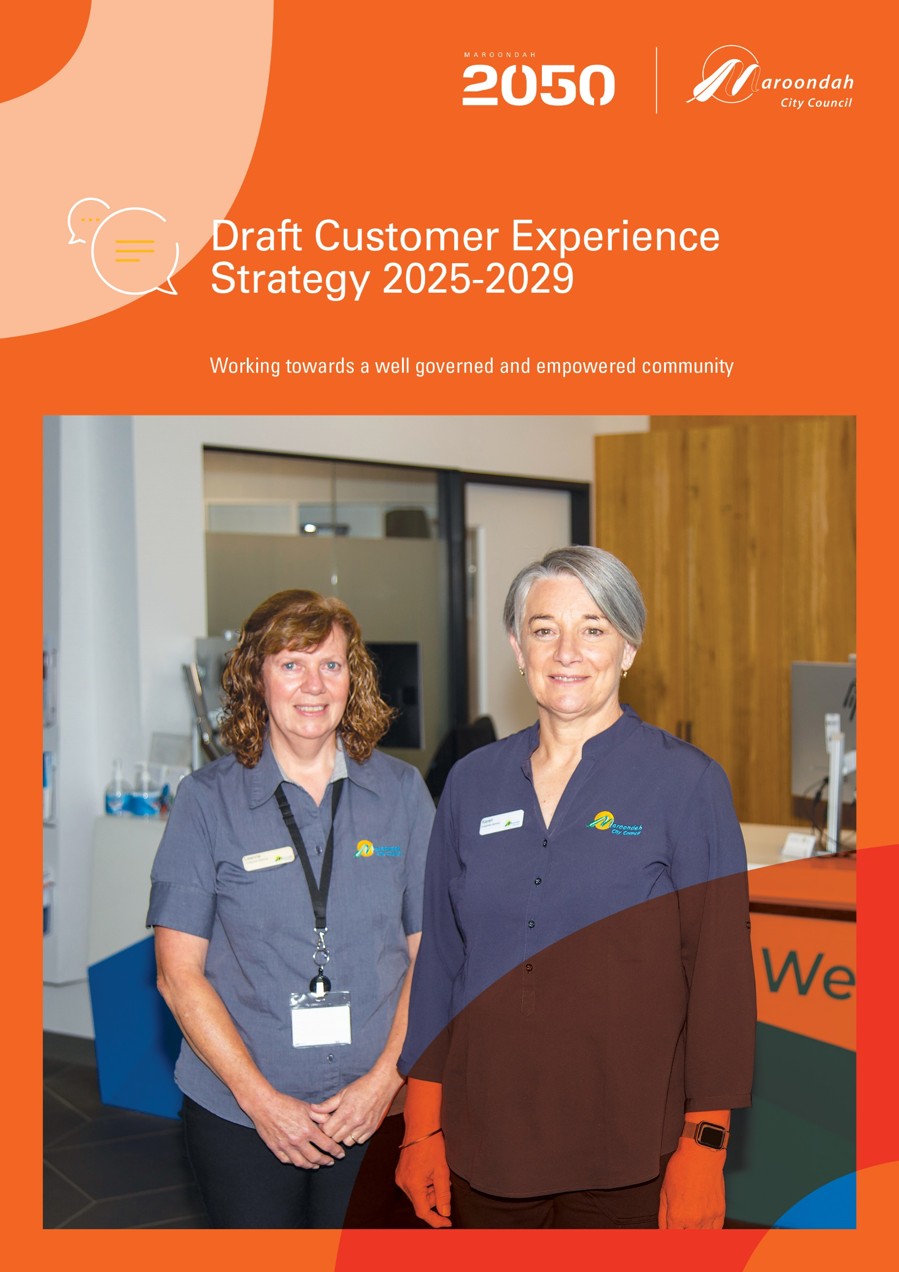
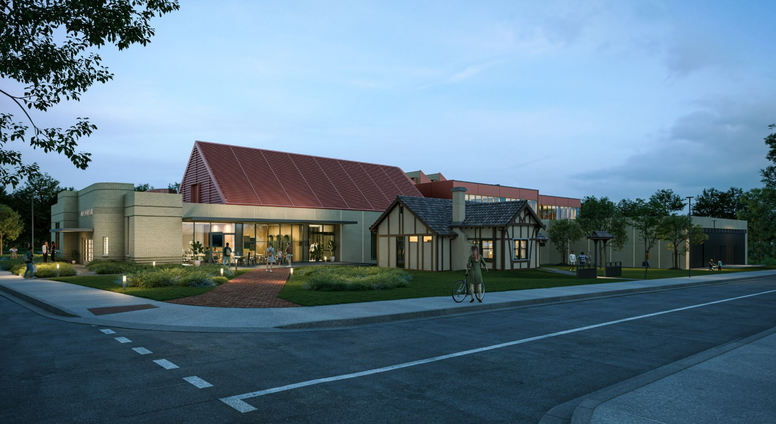
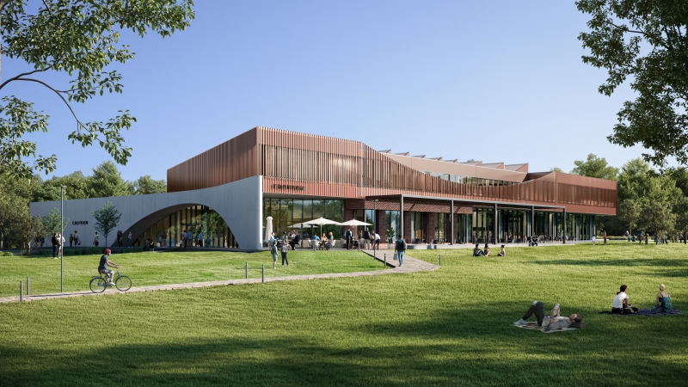
​​​
Contents
Creating a positive experience 5
What does the evidence say? 7
What we did and what you told us 9
A plan for the future 11
Our strategic principles and aspirations 11
A vision for customer experience in Maroondah 11
Strategic principles 11
Guiding principles 12
Outcome area 1 – Community focused customer service 13
Vision statement / Outcome description 13
What the evidence tells us and what the community told us 13
Key directions 13
Priority actions 13
Indicators of progress 14
Outcome area 2 - People and partnerships 15
Vision statement / Outcome description 15
What the evidence tells us and what the community told us 15
Key directions 15
Priority actions 15
Indicators of progress 16
Outcome area 3 - Service innovation 17
Vision statement / Outcome description 17
What the evidence tells us and what the community told us 17
Key directions 17
Priority actions 17
Indicators of progress 17
Outcome area 4 - Technology & processes 19
Vision statement / Outcome description 19
What the evidence tells us and what the community told us 19
Key directions 19
Priority actions 19
Indicators of progress 19
Monitoring our progress and reporting 20
Section 5 – References and Glossary 21
References 21
Glossary 22

​

Executive Summary

Maroondah City Council’s Customer Experience Strategy 2025 - 2029 aims to provide strategic guidance and direction for customer service delivery, ensuring that all community members can contact and engage with Council on channels and in ways that are accessible, easy to use and engaging.

It outlines our approach to providing high level customer service that continues to adapt to changing community expectations and methods of engagement. We will do this by providing services through digital, in-person, and partnership channels, with a focus on accessibility and inclusivity.

The Strategy aligns with the Maroondah 2050 Community Vision and focuses on four key outcome areas:

- Community focused customer service
- People and partnerships
- Service innovation
- Technology and processes

We are committed to maintaining our high customer service satisfaction by allocating resources to people, technology, and collaborative efforts, aiming to address resident needs across multiple platforms and methods.

All Council teams and employees are responsible for upholding customer service standards and delivering consistent customer experiences. This Strategy involves collaboration with employees, stakeholders, and the community to work towards its objectives.
The Strategy outlines priority actions and projects to be incorporated into Service Delivery Plans, with annual reviews and reporting on progress. A full renewal of the Strategy will be undertaken in 2029/2030 to ensure it continues to meet the evolving needs of the Maroondah community.
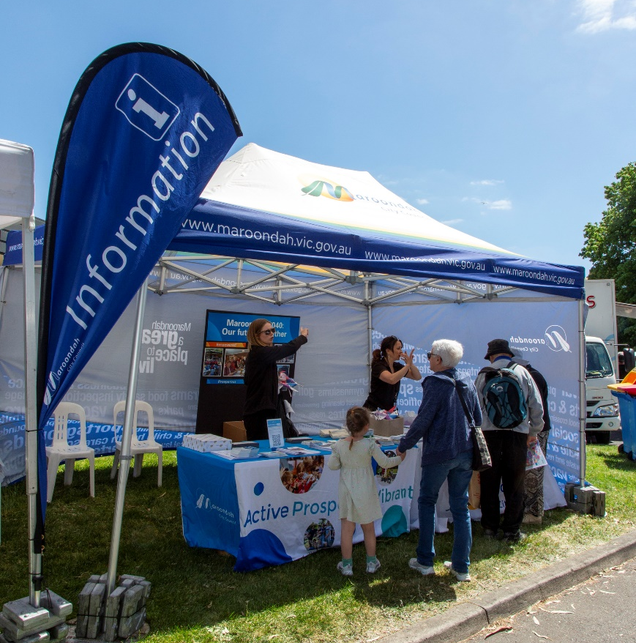

Creating a positive experience

In a local government context, customer service describes how Council employees interact with residents, businesses, groups, and visitors when these individuals seek access to or provide feedback in relation to Council services, programs, or information.

At Maroondah, customer service is built into each employee’s role, as it covers multiple connections, channels and experiences.

Council is continually reviewing and adjusting our approach to ensure we address the changing needs and expectations of customers and visitors. Each interaction, on every channel and location receives equal consideration, and personalised service to ensure their needs are met within current service standards.

Customer Service at Maroondah City Council

Council provides accessible and inclusive customer experiences. Council has had three previous Strategies which has helped deliver some of the highest Customer Satisfaction Scores across the sector over the past 10 years. Council’s previous Customer Service Strategy 2021-2025 and objectives facilitated the renewal of clear service standards, enhancement of customer processes, and adoption of modern digital contact technologies. Many previous completed actions and projects have successfully elevated council customer service above industry standards

Through these advancements, access has expanded beyond traditional in-person services to include more digital channels, offering customers 24/7 utilisation of Council services for information, service requests and payments. Over the past four years, significant progress has been made to develop new customer programs, partnerships, and overall service delivery—benefiting both Council and the wider Maroondah community.

Currently, two customer service counters are strategically positioned across Maroondah at Realm in Ringwood Town Square and Croydon Library in Croydon. These centres offer accessible face-to-face customer locations, as well as enabling innovative partnerships with community groups and organisations, including Your Library Limited. Complementing these face-to-face interactions at Realm is a nine-seat call centre that handles approximately 12,000 calls each month. The live-chat function on Council’s website has seen increased engagement, now exceeding 1,500 interactions monthly, alongside growing SMS and social media messaging channels.

Recent trends show a shift from traditional face-to-face service towards delivering more connected, personalised online experiences, extending service centre operating hours, and fostering new partnerships with local service providers. Insights gained from Realm as well as community feedback continually inform the evolution of future connectivity and wellbeing models.

By integrating advanced technology and adopting contemporary engagement practices, Council strives to streamline service access while strengthening relationships with residents, businesses, and visitors.

Council's new four-year strategy places a strong emphasis on innovation, collaboration, and customer experience focus. Key priorities include upgrading systems, empowering employees, and building effective partnerships to deliver improved outcomes and continues Maroondah’s best in class sector status.

Council remains committed to providing accessible, high-value services that enhance the quality of life for all residents and recognises customer experience as fundamental to each of its 120 Council services.

Why is a Customer Experience Strategy needed?
Our Customer Experience Strategy 2025-2029 assesses the effectiveness and accessibility of Council's contact channels, ensuring that future services meet customer expectations. It will guide best practice to customer service at Council over the next four years. Research indicates that delivering local government services requires an active and integrated approach to maintain standards and reinforce community value.

Council is committed to providing all services with professionalism and consistency, fostering public trust. It strives to continue to deliver customer-focused, high-quality service across all channels -in-person, online, and telephone interactions.

Through clear communication, streamlined processes, and a commitment to a customer-first philosophy, each interaction reflects a high standard and consistent service style. This coordinated approach to customer experience strengthens community relationships and enhances Maroondah’s reputation as a leader within local government.

What does the Strategy include?

This Strategy is designed to promote consistent service standards at Council by providing training, guidance and support for employees to prioritise customer experience across all teams.

The Customer Experience Strategy 2025-2029 outlines four (4) main outcomes identified through broad customer and stakeholder engagement undertaken in 2024. Training will be offered throughout Council, focusing on equipping service teams to respond to various situations. This method is intended to assist all service areas to maintain consistent service levels in different contexts.

Outcome areas | Focus
Community-focused customer service | Consistent, reliable, person-centered, and high-quality experiences across all touchpoints
People and partnerships | Culture driven, capable teams, collaborative partnerships
Service innovation | Integration and improvement for our customers and community
Technology and processes | Smart systems, inclusive access

What does the evidence say?

Council serves over 117,000 residents, 9000 businesses, and thousands of visitors every year, treating each as a valued customer. Maroondah has become a regional centre within Metropolitan Melbourne - with Major Neighbourhood Activity Centres, progressive education providers, dynamic libraries, arts and cultural facilities, and community hubs - offering essential services and opportunities for engagement and connection.

We gathered community and employee feedback and performance data, with the results showing strong progress, but also identifying areas for further improvement.

The 2025 Local Government Community Satisfaction Survey results show that Council is rated at seventy-four (74 - mean index [MI]), which is higher than the state-wide average of sixty-six (66 MI) and the metro Melbourne average of seventy-one (71 MI). This is a consistent result for Maroondah, which shows that our current service delivery is effective and meeting the needs of our community. We seek to remain best practice, and this Strategy will assist this vision.
Who are our customers

Maroondah has 117,484 residents across twelve (12) suburbs, with the largest age group being 35 to 54 years old (.id community, 2024). The community includes 734 First Nations people and around 22,700 non-English speakers. Mandarin, Cantonese, Hakha Chin, Burmese, and Zomi are the top languages spoken by those with limited English proficiency (ABS, 2021). The Burmese community makes up nearly 10% of Maroondah’s population, speaking several distinct dialects including Hakha Chin, Burmese, and Zomi (.id community, 2024).

Across Australia, about 1 in 6 people (18%) have a physical, mental, or behavioural disability (Australian Institute of Health and Welfare, 2024). Individuals with disabilities or who are neurodivergent may need different communication methods.

Maroondah is home to over 600 community groups, such as sporting clubs, scout groups, volunteer organisations, faith communities, employment and disability agencies, community houses, and arts groups.

Over 20,200 people are over the age of 65 years old in Maroondah (.id community, 2024). It is important to ensure that their needs are addressed and considered when it comes to their customer experiences with Council.

Maroondah customers who encounter difficulties with the English language, comprehension, or digital skills continue to require dedicated support. By defining specific objectives and allocating appropriate resources, customised processes can continue to be developed to significantly improve overall experiences including digital translations.

Adapting to evolving expectations
Our commitment is to meet the community where they are both in place and in mindset, ensuring that every experience with Council is clear, helpful, and meaningful. By setting ambitious goals and investing in the right resources, we can better serve all people in Maroondah and continue to deliver customer experiences that respond to changing needs and expectations.

As our digital landscape continues to evolve, providing seamless, responsive, and accurate communication across a variety of platforms remains central to enhancing the customer experience for all members of our community as well as face to face.

The significant increase in online self-service options reflects our ongoing commitment to digital-first engagement. Recent surveys indicate that 75% of residents are seeking stronger connections with Council through improved online services and more efficient payment systems, underscoring the need for continued innovation and accessibility in public service delivery.

Throughout our "Your Say" community engagement initiatives we have seen strong participation, offering valuable feedback that helps guide our objectives and goals. Customers have expressed appreciation for interactive forums, reporting feeling more empowered to share their views on local projects.

These findings show increasing demand for ongoing dialogue in Maroondah.
Maroondah's population spans all age groups, with a notable rise in residents aged 65 and over which means we will continue to develop and deliver bespoke service and experience.

Maroondah City Council's Customer Experience Strategy identifies key trends shaping customer expectations from community feedback:

Trend/Need | Description
Digital engagement | Growing demand for online services and digital communication across council offerings.
Personalised services | Customers want services tailored to their needs.
Inclusive access | Services must be accessible to all, including people with disabilities and non-English speakers.
Proactive communication | Residents seek timely, transparent updates on Council decisions and services.

What we did and what you told us
Overview
Community consultation was conducted from 6 May to 11 June 2024 to inform the development of this Strategy. The process included:

- In-person sessions with interactive activities at Council’s Ringwood and Croydon customer service centres.
- Online and paper surveys, with translated materials available.
- Meetings with key stakeholder groups in Maroondah, such as the Maroondah Disability Advisory Committee, CALD Leaders Network, Wurundjeri Elders, and Maroondah Youth Wellbeing Advocates.
The consultation was publicised through Council’s print and digital channels, including newsletters, social media ads, direct emails, postcards, and posters.

Survey
Respondents were asked a series of questions about their customer interactions with Council, including the service channels they used most, the topics they contact Council about, their accessibility requirements, and their expectations for positive customer experiences.

The following summary outlines the findings:
- 159 survey responses were received from various Maroondah suburbs.
- Over 70% of respondents identified as female.
- The 35-to-44-year age group accounted for more than 27% of responses.
- Council’s website is the primary source respondents use to access Council information.
- Respondents contact Council the most via phone, email, or in-person at a service centre, followed by live-chat and SMS.
- The main reasons for contacting Council included waste management, animals, planning issues, and other topics such as trees, community events, parking, maintenance, safety, and facilities.
- 90% of respondents preferred to use self-service options (e.g. making payments or registering pets).
- When contacting Council, most respondents preferred to speak with a Customer Service Officer, even if this involved waiting on hold for up to five minutes. The next most preferred option was leaving contact details to request a callback. Accessing AI-generated information immediately was the least preferred option.
Response | Percentage of respondents
Issue or request was addressed | 74%
Could not assist immediately but provided timely follow-up | 4.5%
Could not resolve query but referred to someone who could assist | 4.5%
Unable to assist | 8%
Other (no reply received or unhelpful response) | 9%

These findings show a rising preference for digital solutions that enhance accessibility and efficiency. Respondents emphasised the need for user-friendly online platforms and prompt responses in their interactions with council services.

Moving forward, integrating digital channels with traditional service methods will ensure all community members, including those with varying abilities and backgrounds benefit from improved accessibility and support.

Meetings with key stakeholders

Consultation was undertaken with key stakeholders who provided detailed feedback based on specific needs of their group. These stakeholders were:
- Maroondah Youth Wellbeing Advocates
- Maroondah Disability Advisory Committee
- CALD Leaders Network
- First Nations Wurundjeri Elders

This consultation confirmed that community hubs play a vital role in connecting residents to essential resources, providing welcoming spaces that foster engagement, accessibility, and inclusion. Stakeholders called for more accessible, responsive, and inclusive services, emphasising real-time assistance, empathy, and care. This feedback will assist improve Council services for Maroondah’s diverse community.

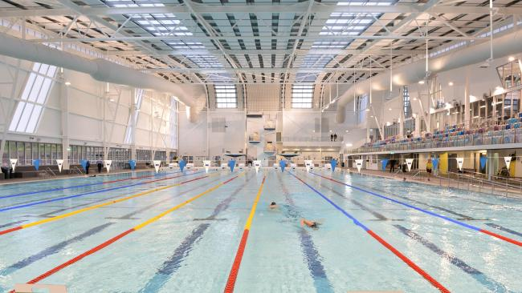

A plan for the future

Our strategic principles and aspirations

A vision for customer experience in Maroondah

In Maroondah, we aim to provide accessible, respectful customer service experiences for our community across all channels. Great customer service starts with listening, trust, and delivering on community priorities. As expectations change, we are dedicated to being responsive, inclusive, and empathetic—ensuring services meet real needs promptly. We work with our community and partners to make sure every voice counts and every interaction matters.

Strategic principles

The Customer Experience Strategy 2025-2029 supports Maroondah 2050’s vision of a well-governed and empowered community.
Council remains committed to accountability, collaboration, and representing local needs. Every resident deserves a seamless experience when engaging with Council, whether it’s online, over the phone, or in person. We aim to remove any barriers and ensure that services, information, and support are provided with clarity, timeliness, and care.
As we work toward delivering the Maroondah 2050 Community Vision, our focus will remain on improving how customers connect with Council, enhancing service channels, inclusive processes, and meaningful feedback opportunities to better understand and remain current with changing local needs.
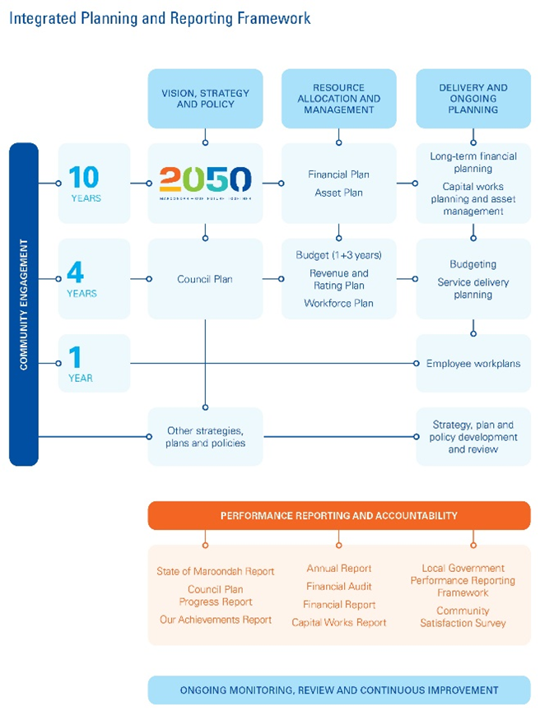
This strategy aligns with Council’s Integrated Planning Framework to ensure customer service meets community expectations. As shown in the diagram to the right, the Strategy supports and aligns with both the 2050 Community Vision and the Council Plan.

Following the development of the Customer Experience Strategy 2025-2029, updates will also be made to internal working documents which set out clear customer service standards and guidance and a complaint’s handling process.

Guiding principles

The key guiding principles throughout the Strategy include.

- People-centred
- Accessible
- Connected
- Future ready
- Sustainable
- Transparent
- Inclusive
- Innovative
- Community-driven
- Responsive
These principles underpin the outcome areas and their key directions and priority actions within this Strategy.

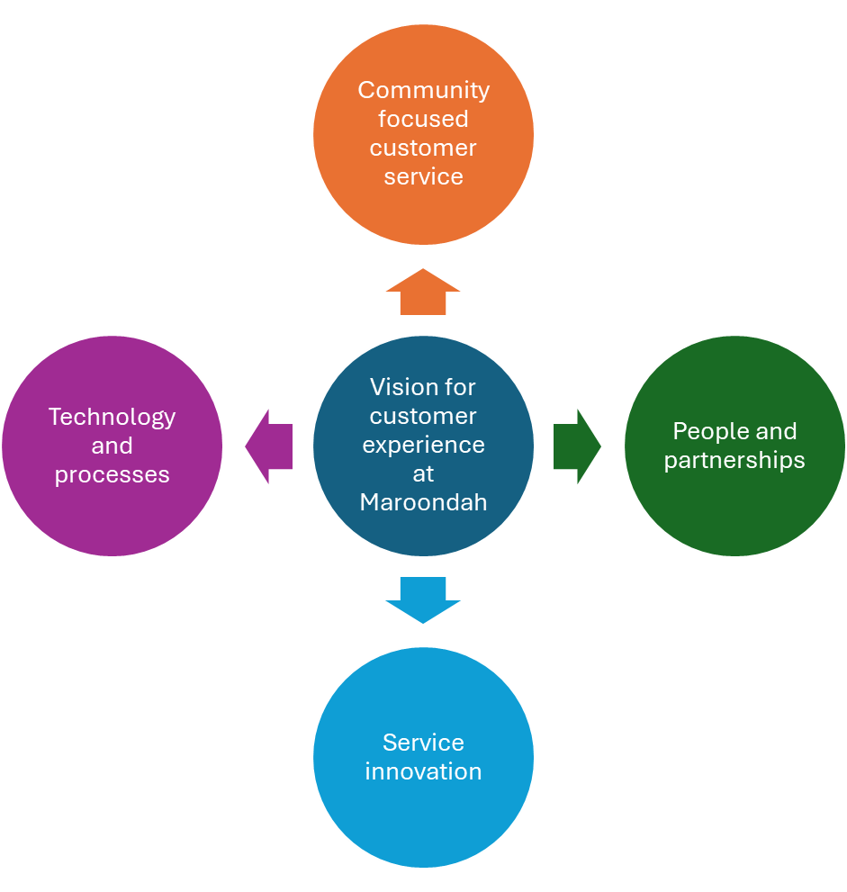

Outcome area 1 – Community-focused customer service

Vision statement / Outcome description

Customers have a consistent experience when interacting with Council. Our people-centred services are delivered in an inclusive and timely manner, aiming to address community needs and expectations. Interactions between Council employees and customers are positive and respectful. Council service centres are a safe environment for all visitors.

What the evidence tells us and what the community told us

Maroondah is a diverse community. In 2024, Mandarin, Cantonese, Hakha Chin, Burmese and Zomi were the top five languages spoken in Maroondah by those with low or no English-speaking proficiency. Other languages spoken in Maroondah include Persian, Vietnamese, Korean, Karen and Khmer (ABS, 2021).

Community Satisfaction Survey results (led by the Victorian Government) in relation to ‘customer service’ are consistently higher than the Melbourne metropolitan and Victorian Council’s average.

Feedback from community consultation told us that while there is an increased use of online services and a desire for self-service options, there are also great community expectations for timely and consistent face-to-face interactions. When asked how Council can better support their customer service needs, respondents identified they want:

- Clear communication and simple customer platforms and processes.
- Employees who are helpful, respectful and knowledgeable.
- Consistent experiences across all channels and service areas.
This provides Council with a deeper understanding of any customer experience gaps that people in the community may be experiencing and provides key insights to focus on this space.

Key directions

1.0. Continue to maintain consistent service delivery across all channels (phone, in person, online).
1.1 Apply service and process design principles that are people centred.
1.2 Utilise customer feedback for ongoing service improvement.
1.3 Continue to enhance internal training and career development.
1.4 Continue to provide safe environments for both customers and Council employees, with respectful and safe customer service interactions that align with Council’s Service Standards.
1.5 Encourage positive and welcoming ‘customer to customer’ and ‘customer to employee’ interactions when community members and visitors visit Council’s service centres. Ensure every interaction ends in a positive and productive way, with respect given from both customers and Council employees.

Priority actions

- Undertake ongoing reviews of customer service standards and benchmarks.
- Deliver customer service training and onboarding for all new employees and regular refreshers for all team members in customer-facing roles.
- Review Customer Relationship Management (CRM) systems.
- Review Council’s Service Standards and Complaints Handling Policy and guidelines.
- Work in partnership with service areas to support proactive interactions with Council.
- Establish an organisational-wide post-service feedback process.
- Enhance customer experiences by identifying and leveraging new platforms and technologies.
- Maintain a knowledge management system to inform and communicate with team members to ensure accurate and timing customer service.
- Conduct a comprehensive review of Council’s Customer Service Standards to ensure that all customer interactions are conducted in a positive manner.

Indicators of progress

- Continued improvement in the annual Community Satisfaction Survey* Customer Satisfaction results, scoring above the Melbourne metropolitan and Victorian Statewide average.
- Growth in positive feedback and customer testimonials, through generative AI feedback and Realm Customer Service Survey activity.
- Implementation of consistent customer experience standards integrated across all service areas.
- Achieve 100% of attendance and participation in customer service training for employees.
- Continuation of strong internal service partnerships and collaboration.
- Implementation of updated Customer Service Standards and Complaints Handling Policy and guidelines.
*Annually undertaken by the Victorian State Government.

Outcome area 2 - People and partnerships

Vision statement / Outcome description

We value empathy, capability, and collaboration in our workplace. We empower all Council teams to deliver high customer service standards by leveraging and building on strong partnerships with internal teams and community organisations.

What the evidence tells us and what the community told us

Council serves over 117,000 residents, 9000 businesses, and thousands of visitors every year, treating each as a valued customer. Maroondah has become a regional centre with Metropolitan, Major and neighbourhood Activity Centres, progressive education providers, dynamic libraries, arts and cultural facilities, and community hubs - offering essential services and opportunities for engagement and connection.

Community and stakeholder consultation told us that our current partnerships with both internal and external groups extend Council’s ability to provide reach and connection to the community, with more community organisations wanting to partner with Council. Those who use our service centres and facilities expect a customer experience that is seamless and integrated. What we are currently doing well includes:
- Our established standards promote responsiveness and collaboration, ensuring consistent customer service across council teams
- Knowledgeable, approachable employees across all areas of Council.
- Customers have the option to speak with a team member for personalised service, which may involve waiting longer on hold or arranging a call back.
- Integrated services with Your Library Limited and other community-based partners/service providers.
Internal consultation with various Council service areas found:
- Employees value delivering a high-quality customer experience and would like to expand on ways to enhance their practice.
- Ongoing professional development and training boosts service confidence and delivery.

This feedback supports Council’s continued approach to focussing on ensuring high quality training and empowering employees to connect with the community. It also highlights the need to continue to build partnerships with key stakeholders and community groups within Maroondah.

Key directions

  - Improve service area knowledge and learnings across Council.
  - Create an organisational-wide Customer Experience Communities of Practice.
  - Expand collaborations with Your Library Limited and community-based partners/service providers.
  - Support the organisation to improve digital accessibility and implement more self-service options for customers.
  - Tailor our service to reflect diverse community needs, including language, culture, and ability.

Priority actions

  - Launch and facilitate a Customer Experience Community of Practice for service teams.
  - Strengthen partnerships with Your Library Limited at Realm and Croydon.
  - Develop a new service delivery model, in partnership with Your Library Limited, for the cultural hub in Croydon Community Wellbeing Precinct.
  - Explore and form new and emerging community partnerships.
  - Standardise customer service practices and digital self-serve options.
  - Create real-time reports and dashboards to track performance and customer experience.
  - Distribute monthly data reports to all service areas for service review and compliance.

Indicators of progress

- Continued improvement in the Community Satisfaction Survey* Customer Satisfaction results, scoring above the Melbourne metropolitan and Victorian statewide average.
- Decrease in customer complaints by a minimum of 10%.
- Provide comprehensive customer service training to enhance participation across all service areas, including quarterly Mad Bad Sad program sessions.
- The Customer Experience Community of Practice holds regular meetings with consistent participation.
- New partnerships established with community-based organisations.
- Positive feedback received from existing partnership organisations and service providers.
* per previous

Outcome area 3 - Service innovation

Vision statement / Outcome description

We deliver a consistent and contemporary customer experience, guided by innovation and future-thinking strategies and processes to support the evolving needs of our community.

What the evidence tells us and what the community told us

Maroondah’s population is consistently growing, with a forecast of growth by nearly 20,000 by the year 2046 (.id community). Ringwood is a designated Metropolitan Activity Centre by the Victorian Government, identified as a key location for employment, residential development and transportation links. Croydon is also a key activity centre, with multiple large developments planned over the next five years in the area.

This growth requires Council to ensure that our services meet the needs of our ever-growing community. Feedback received during consultation found that:
- Libraries are essential for community connection and access.
- Innovation boosts efficiency and positive outcomes for individuals.
- There is a need for access to more translated material across customer service channels.
- A focus on inclusion of people with diverse capabilities in mainstream settings is needed.
- Co-located, integrated services provide easier access for residents.
- Digital options are preferred for efficiency, but face-to-face support remains a priority.
- Services must be inclusive, welcoming, and responsive to individual needs.
This feedback assists us to detail what we are doing well, and what gaps there are currently in our service provision. It provides important direction to what key projects should be undertaken over the next four years to meet the growing demand and growing community.

Key directions

  - Enhance innovation and collaborative design approaches.
  - Position libraries as central locations for community and Council service integration.
  - Increase community outreach efforts and improve digital service accessibility.

Priority actions

- Enhance service delivery model and partnership with Your Library Limited and other community partners at both Realm and the Cultural Hub at Croydon Community Wellbeing Precinct.
- Determine what pilots and partnerships that champion accessibility, equity, and diverse abilities can be launched that are appropriate and innovative.
- Undertake research into local service innovations through inclusive external partnerships, particularly as part of the Croydon Community Wellbeing Precinct.
- Improve digital literacy programs to enhance community engagement.
- Work with community partners to expand employment opportunities or work experience for people of all-abilities.
- Expand Council’s communication access cards and signage to support people with all abilities attending our facilities.

Indicators of progress

- New co-delivered programs were piloted and expanded.
- Implementation of Realm Communication Access Board in partnership with Access Ability Australia.
- Community access to Council information through Your library Limited collaboration, through increased awareness and accessibility across Council and Your Library Limited digital and print channels.
- Increase customer service first contact resolution rates to 70%.

Outcome area 4 - Technology & processes

Vision statement / Outcome description

We invest in accessible and inclusive technology to enhance community and employee engagement.

What the evidence tells us and what the community told us

On average, an adult’s attention span is eight seconds (Kirk, 2019). This means that information must capture a person’s attention immediately or there is a risk of losing their attention and information will not be retained. The average Australia spends 10 hours and 19 minutes a day on electronic media (Mccrindle, 2024).

Community consultation feedback told us that the use of Council’s digital channels (eg. Website and live chat) are increasing, with people seeking more opportunities for self-service (for example, will register their pet online instead of calling or visiting a customer service centre). Simple, mobile-friendly platforms make an experience much easier, along with:
- Simple digital payment options.
- Transparent and timely service updates.
- Sustainable and environmentally-friendly initiatives.
- A personalised experience with friendly communication.

Internal consultation feedback told us that some of Council’s internal systems can be complex and hard to navigate, which can impact the resident’s experience and the timeliness of service.

This information gives Council important feedback to understand what technology is currently providing positive user experiences for both the community and employees and provides important insight into what projects and processes should be focused on in the next four years.

Key directions

4.1 Prioritise user-centric system design and collaboration.
4.2 Streamline procedures and implement automation when suitable.
4.3 Provide technology that is both accessible and inclusive for all users.

Priority actions

- Evaluate and optimise service processes to more effectively meet the needs of our community.
- Implement AI-enabled solutions to provide accurate, prompt and efficient responses to enquiries.
- Inclusion of a digital ethics and privacy statement to align any future Generative AI solutions with community trust expectations, to ensure fairness, accuracy and human oversight.
- Improve accessibility across all digital platforms, ensuring information is readily available.
- Expand opportunities for knowledge sharing through enhancements to Council’s internal customer service toolkit.
- Strengthen contact centre support by upgrading resources and technology, including live chat, online and phone systems.

Indicators of progress

- Faster service processing through increased first contact resolution of at least 70%.
- Increased customer satisfaction with digital tools with increased positive post service feedback.
- Improved user experience with reduced feedback on navigation issues and delays.
- Greater use and positive feedback across communication and Toolkit platforms allowing for increased first contact resolution and lower referrals or delays in responses.
- Improved contact centre grade of service ensuring 80% of all calls are answered in 30 seconds.

Monitoring our progress and reporting

Our comprehensive monitoring and reporting framework encompasses the entire organisation, incorporating:

- Annual strategic reviews aligned with Council Plan reporting and budgeting cycles.
- Ongoing engagement with both the community and employees through surveys, forums, and structured feedback mechanisms (such as website feedback forms).
- Systematic tracking of key performance indicators—including customer satisfaction, response and resolution times, inclusivity, and service accessibility—across all operational areas.
- Organisation-wide visibility of progress, facilitated by internal dashboards, the Toolkit, and other digital reporting solutions.
Through this coordinated and transparent approach, we promote a culture of shared accountability for delivering high-quality, inclusive customer experiences throughout all areas of Council, cementing our ongoing leadership in local government service experience excellence.

By standardising our customer service frameworks, systems, and procedures, we foster a cohesive and agile organisation, capable of efficiently and effectively meeting the diverse needs of residents.

This Strategy outlines the principal initiatives and actions designed to enhance resident engagement with Council services. These enhancements are intended to support exemplary service delivery, ensure positive customer experiences, and strengthen our connections within the community.

Priority actions will be implemented through service plans from 2025 to 2029 and monitored annually via Council’s established reporting processes. As our community continues to grow and change, additional initiatives will be identified and appropriately resourced to maintain services that are relevant, inclusive, and impactful.

A comprehensive review of the Customer Experience Strategy 2025-2029 is scheduled for 2029/2030 to ensure ongoing alignment with the evolving needs and expectations of our community.

Section 5 – References and Glossary

References

Victorian Ombudsman – Councils and Complaints: A Good Practice Guide (2nd Edition)
- Offers clear principles, templates, and a self-assessment tool for Councils.
- Aligns with the Local Government Act 2020 (Vic) and the Charter of Human Rights and Responsibilities Act 2006.
- Encourages a positive culture around complaints and promotes transparency and fairness.
- Available via the Victorian Ombudsman’s official guide.

Australian Standard AS 10002:2022 / ISO 10002:2018
- Internationally recognised framework for complaint management in organisations.
- Supports consistent, fair, and responsive complaint-handling systems.
- Useful for aligning council practices with broader public sector standards.

Victorian Ombudsman – Good Practice Guide: Complaint Handling for Public Sector Organisations
(2025 Edition)
- Updated to reflect the revised Australian Standard.
- Includes practical advice on:
  - Making complaint systems accessible and safe
  - Managing complex complainant behaviour
  - Learning from complaints to improve services
- Find it in the Ombudsman’s practice guide collection.

Local Government Act 2020 (Vic)
- Mandates that Councils must have a complaints policy and process.
- Emphasises accountability, community engagement, and service responsiveness.

Glossary

AI (Artificial Intelligence): The field of computer science that focuses on creating systems capable of performing tasks that typically require human intelligence, such as visual perception, speech recognition, decision-making, and language translation.

CALD (culturally and linguistically diverse): Refers to individuals or communities with varied cultural backgrounds and languages other than the dominant one in a particular country or region. This term highlights the multicultural and multilingual nature of societies and the need for inclusive policies and practices to support diverse populations.

Community of Practice: Refers to a group of individuals united by a shared concern, set of challenges, or passion for a specific topic, who enhance their collective expertise through regular interaction.

Complaint Handling: a process followed by Council

Customer Experience: Defined as the aggregate of all interactions between a customer and an organization, along with the customer's overall perception resulting from those interactions.

Customer Service Toolkit: Describes a suite of resources, templates, and guidelines designed to facilitate the consistent delivery of customer service.

Your Library: Your Library is also the Council partner responsible for providing local library services in Maroondah.

Internal Dashboards: Digital platforms that present real-time data and insights pertaining to organizational performance.

Service Accessibility: Denotes the extent to which services are easily available to all community members, including individuals with disabilities or language differences.

Inclusion: Involves practices that ensure every individual feels welcomed, respected, supported, and valued within the organization and its services.

Key Performance Indicators (KPIs): Quantifiable measures used to assess how effectively objectives are being met.

Toolkit: When referenced independently, provide a concise definition.

People-First: An approach or philosophy that prioritises the needs, perspectives, and well-being of individuals—whether customers, staff, or members of the community in all organisational decisions, policies, and services. This concept ensures people are at the centre of planning and delivery, fostering respect, empathy, and inclusion.

