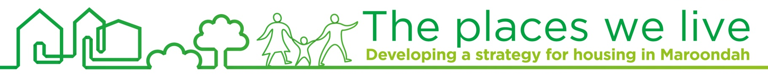
Factsheet #8
November 2015

Community views on housing issues
and how to address them

Find out more
Further details are available on the project website via:
www.maroondah.vic.gov.au
The Maroondah community has identified that balancing development and the natural environment, managing population growth, and the lack of affordable and social housing are priority housing issues for Council to consider looking ahead.
Protecting and enhancing our vegetation, ridgelines and landscapes was identified as the highest community priority in addressing these issues. This was followed by encouraging high quality and innovative development, and advocacy for more affordable and social housing

Get in touch
1300 88 22 33
housing@maroondah.vic.gov.au
The landscape of Maroondah and the challenges we face today have changed dramatically since 1997. Over the next 25 years, population growth and shifting demographic patterns in Maroondah are projected to require an additional 15,000 dwellings by the year 2040.
To inform development of a new housing strategy that considers these challenges, Council has sought to understand community perspectives on priority housing issues facing Maroondah over the next 10-20 years and some ways that these issues might be addressed.
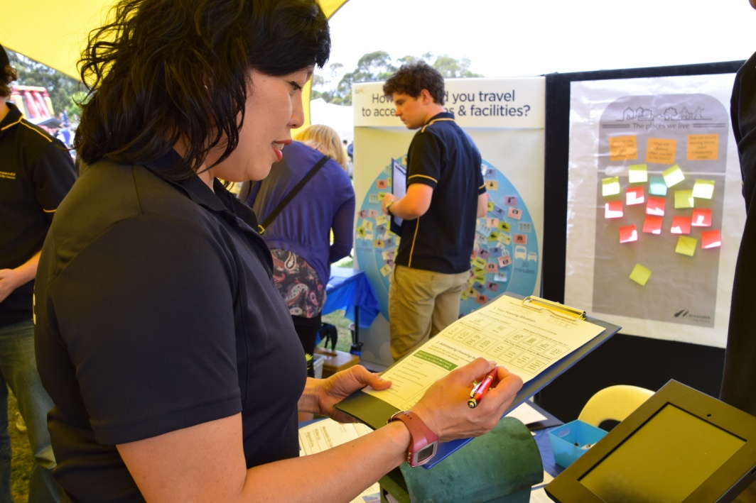

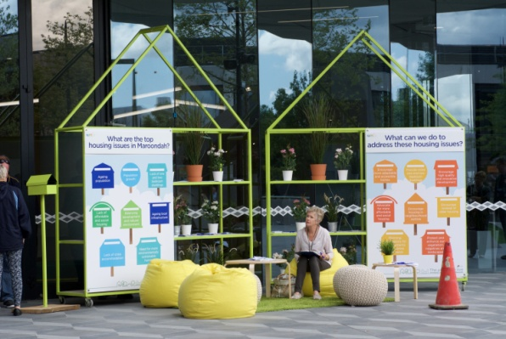
Open house engagement events were run in Croydon at the Maroondah Festival in early November 2015 and in the Ringwood Town Square over a weekend in mid November 2015. Participants were presented with a survey in the form of a letter in which they had the opportunity to prioritize their top three housing issues facing the City of Maroondah and their top three ways to address these issues. A pre-defined list was provided to participants for both issues and some possible ways to address these housing issues. Once completed, participants were asked to post their survey response via a letterbox. Comments from participants that were not specifically related to those predefined responses were captured on a 'fridge' noticeboard.
A total of 402 community members participated in this activity. 80% of participants identified as owner occupiers, 39% were couples with children and more than 42% have lived in the municipality for more than five years.

To contact Council
phone 1300 88 22 33 or (03) 9298 4598
visit: www.maroondah.vic.gov.au
email: maroondah@maroondah.vic.gov.au
Translating & Interpreter Service: 13 14 50
National Relay Service (NRS): 13 36 77
 MaroondahCityCouncil
@CityofMaroondah
 CityofMaroondah
 Maroondah City Council

PRIORITY HOUSING ISSUES IN MAROONDAH


*Note percentage is the number of respondents who identified that the issue was one of the top three in Maroondah

Whilst the issue of balancing development and the natural environment was the highest priority issue overall, this issue was most important to participants aged 50-84 and those who have lived in Maroondah for at least 5 years. The issue of population growth was most important for participants aged between 18-49 and those over the age of 70. It was seen as much less important by those who had only recently moved into Maroondah. The lack of affordable and social housing was particularly seen as an issue for participants aged 12 to 24, those who were renting and those who identified as single.

#1 - Balancing development and the natural environment (53%)

#2 - Population growth
(53%)

#3 - Lack of affordable and social housing (44%)

#4 - Need for more sustainable homes
(41%)

#5 - Ageing population
(33%)

#6 - Ageing local infrastructure (28%)

#7 - Lack of crisis accommodation (18%)

#8 - Lack of one and two bedroom dwellings (15%)

PRIORITY RESPONSES TO ADDRESS HOUSING ISSUES


*Note percentage is the number of respondents who identified a response as one of the top three ways to address housing issues in Maroondah

Protecting and enhancing our vegetation, ridgelines and landscapes was seen as a particularly important response for participants aged over 60 years, those who have lived in Maroondah for a long time and those living in either Ringwood East or Heathmont. Advocating for more affordable and social housing was considered very important for participants aged 12 to 34, those who are single and those who are renting. The concept of encourage high quality and innovative development was of strongly supported by participants aged 25 to 49, those identifying as couples with children and those who have lived in Maroondah between 1-5 years.

#1 - Protect and enhance our vegetation, ridgelines and landscapes (56%)
)

#2 - Advocate for more affordable & social housing
(44%)

#3 – Encourage
high quality and innovative development (43%)

#4 - Encourage renewal of older housing (40%)

#5 - Encourage more adaptable and accessible homes (38%)

#6 - Planning concessions for developments that address local needs (32%)

#7 - Provide more one and two bedroom dwellings (20%)

#8 - Encourage housing in neighbourhood centres (12%)

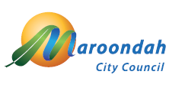
zzz
vhvjvj

