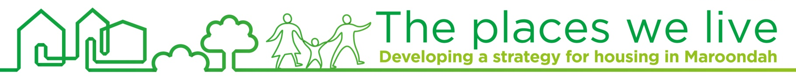
Factsheet #7
November 2015

Stakeholder views on housing issues
Council has commenced preparation of a new Housing Strategy for Maroondah. Three focus groups were held during October 2015, with developers, service providers, and environmental/ community groups. Despite having people with different backgrounds and interests, there was a surprising degree of agreement on key issues.  Liveability  It was agreed that the community highly values the liveability and natural attractions of Maroondah, including the tree canopy and ridgelines. If good development principles, design and practice are developed, liveability could be further enhanced.  Population growth  It was acknowledged that population growth will inevitably lead to higher residential densities. Parks, creeks, bushland and the tree canopy in residential areas will become more valued as Maroondah develops and ‘densifies’. Stakeholders emphasised that a successful housing strategy therefore needs to stretch and link into other areas of Council responsibilities and operations.  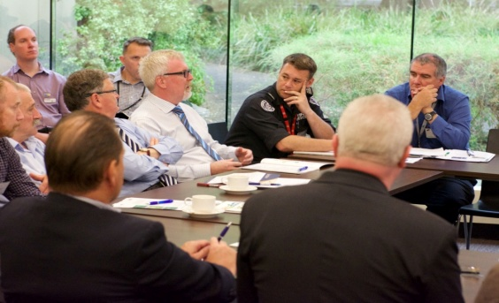  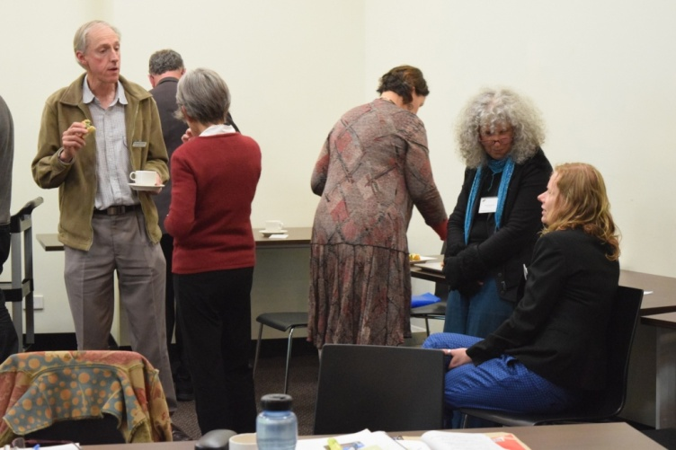  Maroondah needs to be adaptable  While some of the changes that will occur over the next 25 years can be anticipated, many, maybe most, cannot. This includes the future direction of the economy, changes in social values and aspirations, impacts of changing technologies (e.g. the NBN) and the extent and impacts of climate change. Attendees considered that over time, Ringwood may experience the development pressures that Box Hill is now facing and any strategy will need to be flexible and capable of adaption. There will be a new level of housing development, design and planning challenges. Ongoing community consultation and partnerships should be part a central part of managing change.  Development Controls  There was a common concern that development controls can be too restrictive. This can prevent the ability to adapt to change and to find innovative development responses for an increasingly diverse community.  To contact Council  phone 1300 88 22 33 or (03) 9298 4598  visit: www.maroondah.vic.gov.au  email: maroondah@maroondah.vic.gov.au  Translating & Interpreter Service: 13 14 50  National Relay Service (NRS): 13 36 77   MaroondahCityCouncil  @CityofMaroondah   CityofMaroondah   Maroondah City Council  Affordability  Council’s role  Participants acknowledged that Council’s powers and resources are limited and that Council often only plays an advocacy role with state and Commonwealth Governments on specific issues. However, people want to be kept informed and be involved in this process.  Not everyone who live or grew up in Maroondah can afford to stay. People who by circumstance are sometimes forced to move out of Maroondah, are placed in a difficult position by the loss of contact with family, friends and people who provide support. If activated, trusted and empowered, local communities can innovate and find answers to people’s housing needs.  Location of future housing  Views about the location of future housing were mixed. Stakeholders saw the development of Ringwood as an opportunity for a greater range of accessible services and for medium or high density housing. Other centres around railway stations and urban village centres are also seen as better locations for medium density housing, although their environmental sensitivity can be significant.  Working Together  Many participants wanted a combined approach to stakeholder involvement in the housing strategy. Community groups and social organisations wanted more opportunities to work with the development industry to find solutions.  Some argued for new housing to be dispersed across the municipality to any site where development was economically viable. Others thought that a more selective approach, including no go areas, was preferable. The location of new development within Maroondah remains contentious.  Ageing  Population ageing is well known but still has some way to go. Over the next 25 years Maroondah will have many people aged over 70 and 80, who will need alternative housing options.  Design Quality  Design is seen as important. New apartments and unit developments are often perceived to be of poor quality by the community. Dwellings need to be designed with greater energy efficiency. New housing can be perceived as insensitive to local environments.  Capacity Building  A range of ideas to meet the diverse needs of Maroondah’s residents was expressed. Many of these were about the community being empowered and supported to find its own solutions to problems.  Ringwood  The development of the Ringwood Metropolitan Activity Centre is considered a game changer for Maroondah. It will provide a much wider range of services and potentially employment. Given the increasing importance being placed on accessible housing, Ringwood’s attraction will increase.  Physical Environment  Maroondah’s physical environment is highly valued. It is one of the main reasons why people like living here and participants wanted Council to learn from the experiences in other parts of Melbourne.  Infrastructure  Creeks, reserves and parks will become more valuable assets as densities increase. Roads, parking, the drainage system and utilities need to be maintained and improved as the population grows. Improvements need to be managed in an way that is sensitive to the environment.  There was a consensus across all three groups that any new development, resulting from either population growth or the changing housing preferences of Maroondah’s residents, should respect that environment.  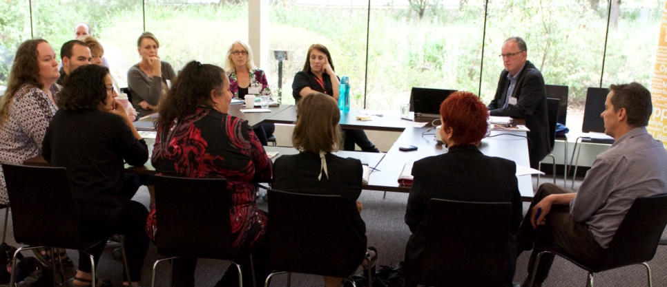 |   Find out more  Further details are available on the project website via:  www.maroondah.vic.gov.au    Get in touch  1300 88 22 33  housing@maroondah.vic.gov.au
 | 