Maroondah City Council
Community Bulletin #5

Affordable and Social Housing Policy

February 2018

Affordable and Social Housing Policy
Since the adoption of the Housing Strategy in June 2016, Maroondah City Council has been working hard to implement the key directions and priority actions identified by the Strategy, to help facilitate growth and liveability within Maroondah.

One of the key issues identified in Strategy, is the need for improved affordable and social housing opportunities in Maroondah. The Strategy found that affordable and accessible housing pressures remain an issue that impacts the community, developers, and service providers

In response, Council has commenced development of a new municipal wide policy to tackle key affordable and social housing issues in Maroondah. As part of this policy, Council will be engaging with key community leaders and service providers to identify the appropriate policy directions to be considered for inclusion in the Policy.

Affordable Housing
Affordability means that housing is
accessible to a wide range of people on
varying incomes. In particular, it is important to ensure that low to moderate income households have options to rent or buy, and that very low income households, have housing security and continue to have realistic housing options within our community.

Affordable housing is accommodation that requires less than 30% of a household’s gross income to be spent on mortgage/rent payments, for households with the lowest 40% of median income.

Affordable housing allows low income households to meet their basic living costs, by reducing the burden of stressful mortgage repayments. Any housing type can be considered affordable, if it fits within this criterion.

Social Housing

Social housing refers to a type of rental housing that is provided and/or managed by the government or a not-for-profit organisation. Social housing is an overarching term that covers public housing, community housing, and crisis accommodation.

Public Housing
A social housing service that is managed by the government, with the purpose of providing homes for very low income earners, victims of family violence, and those who have recently experienced homelessness.
A local snapshot
9.5% of households in Maroondah are thought to be experiencing housing stress, with approximately 3,400 households deemed as low income households.
Maroondah has experienced a rapid decline of affordable new rental dwellings. In 2006, 38% of new dwellings were affordable. By 2008, only 11% of new dwellings were considered to be affordable, dropping to only 4% by 2010.
Only 2.8% of housing stock in Maroondah is used as social housing.
Populations aged between 70-85 are growing at a rate of 2.3% per annum putting stress on the municipalities already lacking supply of affordable age-friendly housing.

Community Housing
Secure and affordable housing for people with a low income or special needs. Community housing is managed by non-for-profit organisations that have been regulated and registered by the state government. Different types of community housing can be provided to facilitate the varying needs of families and individuals.

Crisis Accommodation
Crisis accommodation is organised for individuals and families who are experiencing homelessness. Stay durations in crisis accommodation can vary and support is provided during this time.

Background research
Council has sought assistance from a consultancy to undertake background research and analysis of:
- affordable and social housing issues in Maroondah,
- identification of effective measures that local government can implement, and
- potential policy directions that could be considered for inclusion in the Policy.

Stakeholder engagement
During February and March 2018, Council will seek input from community leaders, service provider organisations and expert advisers in the field to inform future policy directions.

Focus Groups
In February 2018, Council will invite key stakeholders and local organisations who work in affordable and social housing fields, to participate in focus groups. The aim of these focus groups is to learn from the experiences of stakeholders and seek their views on Maroondah’s future needs in relation to affordable and social housing. This information will be used to help inform policy directions and partnership actions to be included in the Policy.

Housing Forum
In March 2018, Council will be host an Affordable and Social Housing Forum at Karralyka in Ringwood. Council has invited more than 80 stakeholders and representatives to attend the event and share their ideas on future policy directions and priority actions for the sector in Maroondah.

Contact Us
If you have any questions regarding the Maroondah Affordable and Social Housing Policy please contact the Council and Community Planning Team on 1300 88 22 33, or email housing@maroondah.vic.gov.au.
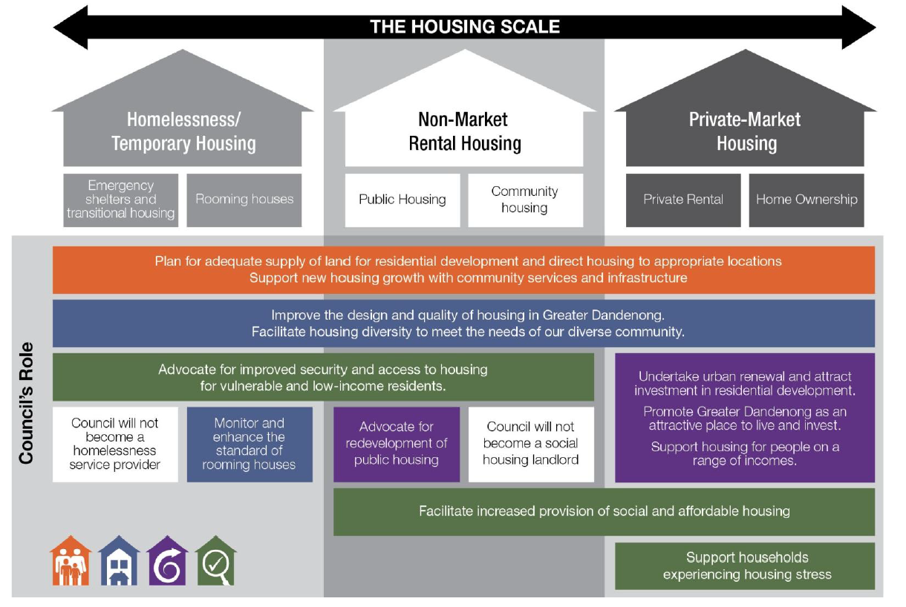
City of Dandenong Housing Strategy 2014-2024



