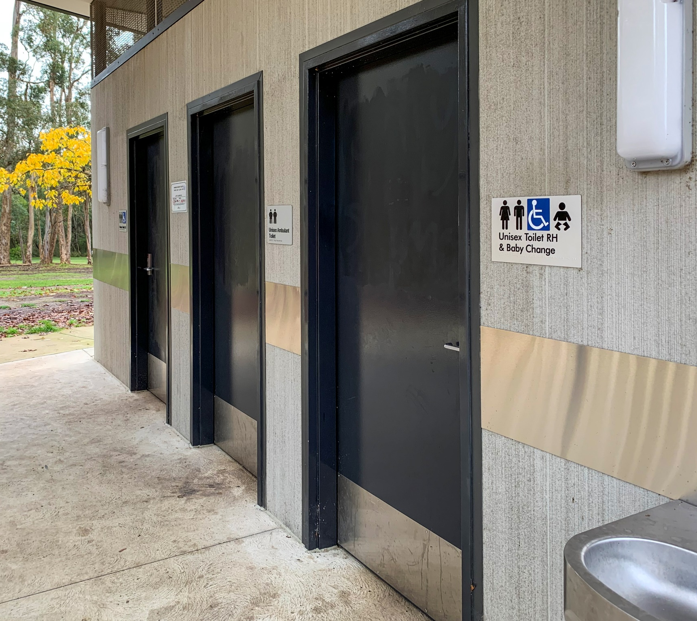

Introduction
Public toilets, sometimes called public amenities, are toilet facilities away from the home that can be accessed by any person.
Public toilet facilities are important community assets. By providing and maintaining public toilets in recreational precincts, some retail centres and civic facilities, Council is supporting participation in a wide range of activities outside of the home that contribute to the overall health and wellbeing of the community.
Through a detailed service assessment, Council identified the need to adopt a consistent and principled approach to decisions about the provision and operation of public toilet facilities.
The Maroondah City Council Public Toilet Policy has been developed in response to this need.
The policy reflects relevant legislation and government policy, Council strategies and plans, as well as community and stakeholder input to establish key priorities for public toilet facilities.
Importantly, the policy establishes guiding principles that will help to ensure Council’s investment in, and management of public toilet facilities, is well aligned to Council’s strategic priorities, responsive to current and future community needs and reflective of best practice approaches.

Strategic Context
Maroondah 2040 – Our future together (Maroondah 2040) is Council’s overarching strategic document.
The Maroondah 2040 Community Vision captures the aspirations, and priorities of the community looking ahead to the year 2040 and beyond.
This long-term vision provides a ‘roadmap’ for the community, Council, and other levels of government to partner together and create a future that enhances Maroondah as a great place to live, work, play and visit.
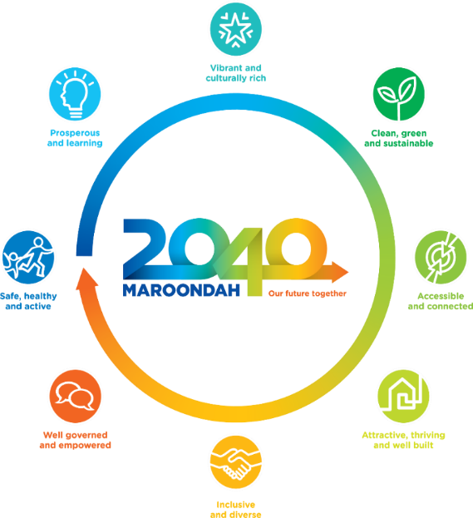
The vision is for “…a vibrant and diverse city with a healthy and active community, living in green leafy neighbourhoods which are connected to thriving and accessible activity centres contributing to a prosperous economy within a safe, inclusive and sustainable environment.”
Figure 1 - Maroondah 2040 – Our future together establishes eight interrelated outcome areas.
The vision encompasses eight (8) future outcome areas shown in Figure 1.
The contribution Maroondah’s public toilet facilities makes to the achievement of these outcomes is summarised in the table in Figure 2.

Maroondah 2040 Supported Outcomes
 | In 2040, Maroondah will be a safe, healthy and active community where all people have the opportunity to experience enhanced levels of social, emotional and physical wellbeing.  Safe and accessible public toilets support participation in active recreation and social activities.
 | In 2040, Maroondah will be a thriving regional centre of economic activity and education, where the sustainable growth of local businesses is supported, and diverse lifelong learning opportunities are accessible for all community members.  The availability of public toilets in retail and business precincts encourages the community to ‘buy goods and services locally’ and supports participation in Maroondah’s vibrant local economy.
 | In 2040, Maroondah will be a vibrant and creative community recognised for celebration of the arts, cultural expression and diverse entertainment options.  The availability of accessible public toilets at festivals and events facilitates participation in arts, cultural and entertainment activities.
 | In 2040, Maroondah will be a resilient community committed to sustainable living, enhancing our natural environment, and providing leadership in responding to climate change.  The provision of modern public toilet facilities contributes to the achievement of waste reduction and sustainability goals.
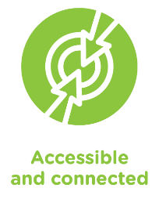 | In 2040, Maroondah will be accessible for all ages and abilities with walkable neighbourhoods, sustainable transport options, and a safe integrated transport network.  The provision of a strategically planned public toilet network is critical to the use of sustainable transport options and a key principle of connected communities.
 | In 2040, Maroondah will be an attractive, sustainable and well-built community with thriving activity centres and a network of neighbourhoods where everyone has the opportunity to live, work and play locally.  The provision of modern, clean and accessible public toilet facilities improves amenity and supports positive experiences of communal spaces.
 | In 2040, Maroondah will be an inclusive and equitable community where all people are valued, supported and socially connected, and diversity is embraced and celebrated.  The provision of public toilet facilities that are safe and inclusive for everyone in the community, fosters participation in all aspects of community life
 | In 2040, Maroondah will be an empowered community actively engaged in local decision making, led by an innovative community inspired Council that collaborates regionally and proactively champions local needs.  Engaging with our community and understanding their needs is essential to the development of an effective public toilet network.
Figure 2 – Public toilet infrastructure supports outcomes established in Maroondah 2040 – Our future together.
The Council Plan 2021-2025 is a medium-term strategic document that sets key directions and priority actions linked to eight (8) broad outcome areas of Maroondah 2040.
A key direction directly relevant to public toilet facilities and the Maroondah Planning Scheme is “to encourage high density development in activity centres with access to high quality facilities, services, and amenities”.
Maroondah residents living in higher density housing areas have more limited access to private open space. As a result, the use of public open spaces and community zones is increasing, creating a greater demand for supporting infrastructure such as public toilet facilities.
The Maroondah Liveability Wellbeing and Resilience Strategy 2021-2031 is Council’s key social environment strategic plan, which outlines how Council and partners will work to enhance community wellbeing, liveability and resilience over the next decade.
This strategy is accompanied by a detailed action plan which outlines the vision for Maroondah’s social environment and supports the key directions and desired outcomes identified in Maroondah 2040.
The provision of a safe, inclusive and accessible public toilet network will support outcomes in key focus areas - healthy lifestyles; liveable neighbourhoods; safe communities; social inclusion; and embracing diversity.
Council has also adopted a range of other strategies and plans that are relevant to the provision of public toilet facilities, often referred to as ‘amenities’.

Public Toilet Framework
The Public Toilet Framework as depicted in Figure 3, is part of a suite of documents that work together to establish Council’s approach to the management of public toilet facilities in Maroondah. The policy is one part of the framework. The other documents within the framework will be subsequently developed in due course.
Figure 3 - Public Toilet Framework

The public toilet policy is a high-level statement of intent that defines Council’s role in the service provision and outlines a set of guiding principles and considerations, which may be used in decision-making to ensure consistency in governance.
The community facilities (public toilet) AMP is intended to be a 10-year outlook encompassing the lifecycle phases of an asset portfolio. The plan outlines the condition and performance and the levels of service for assets to meet existing and future demands, and the consequences of budget scenarios, in particular the scenario that is selected to balance with the long-term financial plan.
The public toilet operational plan is intended to be a document that defines the agreed technical service standards, interventions and performance measures to effectively and efficiently manage and prioritise assets throughout their lifecycle.
The public toilet long-term capital works program will identify, in priority order, the renewal and upgrade works at site specific locations. The program aligns with associated budget allocations in accordance with Council’s long-term financial plan and aims to provide a roadmap as to how the service provision will be delivered through infrastructure.
The public toilet infrastructure guidelines are intended to clearly document and standardise Council requirements for the design and development of municipal infrastructure to ensure consistent and uniform level of asset amenity that meets the agreed level of service.

Policy approach
The policy outlines Council’s role in the provision of public toilet facilities, the broad approach to the delivery of public toilet facilities and key considerations that will inform the planning and delivery of public toilets at specific locations.
The policy will apply to the planning and provision of standalone public toilet facilities and externally accessible toilets that are provided for public use as part of a public building – such as at sports pavilions. The policy will also inform decisions about the management and operation of existing public toilet facilities.
Through the application of the policy, Council aims to support community participation in a wide range of activities outside the home that contribute to health and wellbeing outcomes, local economic activity, access to key services and the achievement of municipal strategic goals.

Council’s Role
While Local Government plays an important role in the delivery of public toilet facilities, Councils are not the sole providers of these.
Many places that are open to the public, such as shopping centres, convenience stores, fast-food outlets, and public transport nodes, provide public toilets for patrons and visitors.
Public toilets are typically viewed as supporting infrastructure that is provided to facilitate participation in activities that occur away from home. Generally, there are three (3) reasons that Council provides public toilet facilities:
- To help facilitate participation in active recreation and community activities;
- To support the local economy; and
- To comply with the requirements of the Maroondah Planning Scheme, the National Construction Code or other regulatory instrument as part of a public building.
Other than for toilets in public buildings, Council has discretion in the provision of public toilet facilities.
The approach taken by Council in relation to the provision of public toilet facilities is based on broader strategic objectives and a commitment to improve health and wellbeing outcomes for the community.

Service challenges
The provision of built infrastructure presents significant challenges for Local Government. Because building and service standards are constantly evolving, it can be difficult to ensure assets, which reflect the standards applied at the time of construction, remain compliant with current standards and fit for purpose. The longer an asset remains in service, the greater these challenges typically become.
Rules relating to environmental sustainability, disability access and all-gender access are examples of service and construction standards that have changed significantly over the past two (2) decades. These changes have a direct bearing on the design and operation of public toilet facilities.
In addition to changes in regulatory standards, Council must strike an appropriate balance between the need to maintain reasonable service standards and the cost to manage and maintain public toilet facilities.
The provision of toilet facilities comes at considerable expense beyond the construction period. Currently in Maroondah, all public toilet facilities are cleaned at least daily; more frequently in key locations and are secured outside opening hours. Repairs due to damage and wear-and-tear are an additional expense.

Contemporary approaches
Many Victorian Councils have adopted public toilet strategies, plans and policies as the requirement to develop Asset Plans under Section 92 of the Local Government Act 2020 brings public toilet facilities into sharper focus.
Some Councils have developed classification systems that link decisions about public toilet provision to park, pavilion, and activity centre hierarchies. While most of these systems rely on location classifications to determine eligibility, facility standards, fit out, consumables and community service expectations, some take a more flexible approach based on site characteristics and individual needs assessments.
Local Government is also working to ensure public toilet facilities are considered as a component of masterplan development. For example, open space master plans, linking the need for toilets to the provision of other infrastructure at the same location, i.e. barbecues, larger playgrounds and picnic shelters – the types of activities expected to facilitate an extended stay at a specific location.
Contemporary approaches tend to reflect a ‘whole of lifecycle’ approach to asset provision, including for public toilets. This approach to facility costings recognises the influence toilet design and location can have on operating expenses, as well as the practical reality that the ongoing cost to operate public toilets quickly eclipses initial construction costs.
While cleaning is a significant expense, it is also one of the most important determinants of community satisfaction with toilet facilities. Prominent wayfinding and informational signage is also important for locating public toilets, letting users know what amenities are available, and overcoming any access issues associated with public toilets that are co-located in other buildings, such as sports pavilions.
There is a clear trend in the industry to move away from the installation of automated toilets. While these facilities may be easier and cheaper to manage, they are disliked by users due to confusion about how they operate, a degree of suspicion about electronic door locks and concerns about time limits.
In line with efforts to encourage participation in active recreation, it has become increasingly common for sports pavilion redevelopments to include externally accessible public toilet facilities. At pavilions and buildings in more isolated locations, however, this may not be appropriate.
Retrofitting or upgrading older public toilets is regarded as problematic due to the difficulties in achieving regulatory compliance, which is typically required when undertaking significant upgrades. Furthermore, older public toilet design and locations are often incompatible with contemporary Crime Prevention Through Environmental Design (CPTED) principles. As a result, it can be more efficient to demolish older public toilet facilities and replace them with fully compliant new facilities, making use of existing services where possible.

Guiding Principles

 | 99%  Cleanliness  very important | Public toilet facilities that are clean and well maintained.
 | 99%  Safety  very important | The safety of public toilet infrastructure, including facility placement, site lines, lighting, vandalism and minimising entrapment areas.
 | 99%  Availability  very important | More public toilets, including in local retail precincts and along bike paths.
 | 93%  Inclusivity & Accessibility  very important | An accessible and inclusive network of public toilets, including the provision of wheeled access and cubicles that can accommodate a parent with young children.
 | 81%  Uniformity  moderately important | Uniform level of amenity across the public toilet network, including baby change tables, lighting, door hooks, shelves and clear signage.
A comprehensive review of feedback previously received through community consultation on various Council policies and strategies, facilitated the identification of five (5) key themes that relate to the provision of public toilet facilities: Cleanliness, safety, availability, inclusivity and accessibility and uniformity. These themes formed the basis of community consultation in 2023 and helped to inform the development of the Maroondah Public Toilet Policy.
Feedback was received from a broad cross-section of the Maroondah community who rated the importance of each theme to the provision and operation of public toilet facilities. Respondents were also asked whether there were other considerations that were more important for public toilet provision by Council.
Respondents confirmed that these key themes continue to be the most important considerations for public toilet provision by Council.
As Figure 4 shows, community feedback emphasised the importance placed on clean and safe public toilets, as well as the need to ensure toilets are available in key locations.
Respondents also identified the need to ensure toilets were adequately stocked with consumables – soap and toilet paper – and reinforced the importance of regular cleaning, safety considerations, adequate opening hours and the provision of additional public toilets in strategic locations, such as at local shopping centres and in busy recreational precincts.
Research suggests that public toilet facilities play an important part in facilitating a wide range of community activities that occur away from home.
To help clarify Council’s role in the provision of public toilet facilities, five (5) principles have been established to guide decision making and shape the approach Council will take to the delivery and management of public toilet facilities in Maroondah.
Figure 4 - Key themes for the provision of public toilet facilities and ratings of importance.

These principles, which are shown in Figure 5 on the following page, reflect the outcomes of a detailed service assessment, community consultation, contemporary approaches to the provision of public toilet facilities and Council’s broader strategic objectives.

Maroondah Public Toilet Facilities Guiding Principles
 | Public toilets are ancillary infrastructure provided to support key services and participation in activities that occur away from home. The provision of public toilet facilities aims to contribute to the achievement of community health and wellbeing outcomes and Council’s strategic objectives.
 | Council will prioritise the provision of public toilet facilities at locations that have the greatest community need, and where the public toilet facilities subsequently provide the greatest community benefits.
 | Consistent with community feedback, the provision and operation of public toilets by Council will prioritise uniformity, safety, cleanliness, inclusion and accessibility.
 | The provision of public toilets at locations primarily for the benefit of a single group may require external funding contributions. Council will take a partnership approach to the delivery of public toilet infrastructure across the municipality.
 | Council may advocate for new or upgraded public toilet facilities in places where it has no direct role in infrastructure provision. Advocacy activities may relate to funding, access to land, provision of space, or the delivery of public toilet facilities by private providers or other tiers of government.

Figure 5 - Guiding principles for the provision of public toilet facilities

Key considerations
Further to the guiding principles, Council has identified key considerations that will inform decisions about the provision of public toilet facilities at specific locations. These are shown in Figure 6, below.
The application of these considerations will assist with prioritising projects that are well aligned to the guiding principles, and which deliver the greatest community benefits.

Maroondah Public Toilet Facilities Key Considerations
Key consideration |  | Application to decision making
 | The activities at the location that the public toilets are intended to support. | 1.1 | Locations where people participate in activities that improve health and wellbeing outcomes or contribute to municipal strategic goals will be prioritised.
 | The level of activity the location is intended to accommodate. | 2.1 | Busier locations that host a wide range of activities will be prioritised over other sites.
 | Other infrastructure provided by Council at the location. | 3.1 | Locations with significant community infrastructure will be prioritised over locations with less infrastructure.
 | The suitability of the site for public toilet facilities. | 4.1 | Examples of site suitability considerations include accessibility, availability of utilities, proximity to key activities and safety.
 | The condition of existing public toilet facilities. | 5.1 | Public toilet facilities in poor condition will be prioritised for maintenance, renewal or replacement over facilities in good condition.
 | The current or expected level of utilisation. | 6.1 | Priority will be given to public toilet facilities that will be well utilised.
 | The availability of other public toilet facilities nearby and how easily these can be accessed. | 7.1 | Priority will be given to the provision of public toilet facilities at locations without existing access to public toilets.
 | The cost to provide and operate public toilet facilities at the location. | 8.1 | Council will prioritise cost-efficient public toilet facilities.
 | Feedback from user groups, residents and businesses at the location. | 9.1 | Council will consider community needs and local feedback when planning public toilet facilities.
 | Any other matters that are relevant to the provision of public toilets at the location. | 10.1 | Council recognises that a wide range of site-specific issues must be considered when providing public toilet facilities.
Figure 6 -Key considerations for the provision of public toilet facilities.

Maroondah City Council, Maroondah 2040 – Our future together, 2014 (revised June 2021).

