

Road Management Plan 2025-29

Community Consultation Report

June 2025

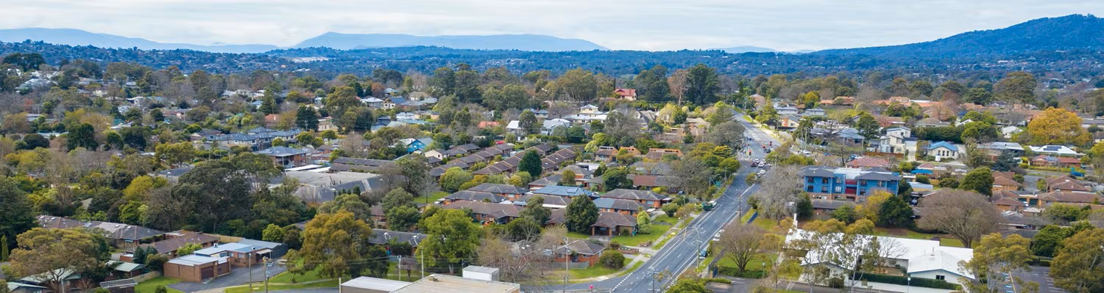

Contents

Road Management Plan 2025-29 1
Community Consultation Report 1
June 2025 1
Contents 2
1. Background 3
The review process: 3
Findings: 3
Proposed changes: 3
2. Community consultation 4
2.1 Communication channels 4
2.2 Consultation tools 6
2.3 Consultation questions 6
3. Community feedback 6
3.1 Online submissions - Your Say Maroondah 7
4. Consultation outcomes 8
5. Conclusion 9
6. Next Steps 9

Background

Council’s Road Management Plan (RMP) outlines Council’s commitment to a safe road and pathway network and details maintenance standards, inspection frequencies and authority/service provider management demarcations.
The Road Management Act 2004 outlines Council’s role and obligation (as a road authority) to inspect, maintain and repair public roads within its jurisdiction.
The Road Management (General) Regulation 2016, requires Council to undertake a review of its RMP following the election of a new Council, or by 30 June.
The review of Council’s RMP has been undertaken in accordance with Road Management (General) Regulations 2016 public notice requirements and Council’s Community Engagement Policy - to ensure that road management responsibilities, maintenance schedules, and safety standards are transparent and aligned with community needs and aspirations.

The review process:

In 2023, the Municipal Association of Victoria (MAV) initiated a process to audit and benchmark Council’s RMP. The aim of the audit was to assess Council’s RMP against peer group standards and demonstrate liability risks that could be mitigated by adjusting Council’s RMP to align with industry sector standards, like the MAV best practice RMP Template.

Following the MAV audit, Council’s key stakeholders met to consider the suitability of the audit recommendations for incorporation into Council’s next RMP iteration (RMP 2025-2029) by 30 June 2025.

Findings:
The audit noted the requirement for Council to have clear standards for roads inspection and maintenance, comparable to other Victorian Councils. The audit found discrepancies between intervention and measurement levels documented in Council's publicly available Road Management Plan and the MAV best practice RMP Template.

Proposed changes:
The audit recommended the following changes to Council’s RMP:
- Align the Plan with new MAV Best Practice Template clarifying relevant stakeholders, updating references, glossary, images, tables and figures.
- Enhance relevant key legislation and key strategic links (Council Vision, Council Plan and Asset Plan).
- Amend level of service for overhanging vegetation in relation to defect definitions, identification, severity and response times to ensure achievable targets, taking account of resource levels (i.e. 3m to 2.5m and 140 days to 56 days).
- Enhance sign defect definition RD13 to improve operational practices and systems.
- Clarify hierarchy, inspection frequencies and categories to ensure achievable targets, taking into account Council resources.

Contact Council to obtain a full list of changes - quote reference number 24/184975.
To learn more visit Council’s Road Management Plan webpage.

Community consultation

Community consultation ran from Thursday 3 April 2025 to Wednesday 30 April 2025.

In line with the requirements of the Act, the goal of community consultation is to ask for submissions from residents relating to the proposed Plan. This process allowed the community to have their say on our local road and pathway network as outlined in the proposed plan.

  - Communication channels
A range of communications channels were used to promote the consultation opportunities.
Communications Channel | Reach Statistics
Your Say Maroondah website | Total page visits: 631  Max visitors per day: 132  New Your Say registrations: 1  Engaged visitors (no. of survey submissions): 8  Informed visitors: 401  Aware visitors: 529  The above summary figures are based on the three types of activity on the Your Say Maroondah website.  Aware: Participants have viewed the project page and are aware that the project exists. This is the result of promotional activities.  Informed: Participants have viewed various elements within the project page and are well informed about a subject and take time to think before participating.  Engaged: Participants have provided feedback and contributions to a consultation.
Social media organic post/s (Facebook and Instagram) | Social media engagement  Good engagement rates are 2% to 5%  Facebook:  - Facebook post engagement (on average): 8.16%.  Instagram:  - Instagram post engagement on average: 0.86%.
TV screens in Council Service Centres | On display for the length of the campaign in both Realm and Croydon Customer Service Centres, available to view on a loop with other unrelated content.  Realm and Croydon Customer Service Centres have 100s of people passing through on a week day and even more on a weekend.
Maroondah eNews | Maroondah eNews had 42 referrals to Your Say Maroondah for the Road Management Plan.  Targeted emails were the main source of traffic to Your Say Maroondah with 165 referrals.
Maroondah News March edition | Distributed to every residential and business address in Maroondah, roughly 50,000 addresses.
Victorian Government Gazette (in line with legislative requirements) | Publicly available via the Victorian Government Gazette website. It is very hard to determine reach for this platform, however it is widely used across government, not-for-profit and private organisations.

In accordance with the Act and regulations, the amended plan was made available to the community from Thursday 3 April 2025 to Tuesday 30 April 2025. As part of the consultation approach, physical paper copies of the amended plan were made available at Council Service Centres throughout the length of the campaign.

Consultation tools

Consultation tools | Description | Outcomes
Your Say website | Online survey | 8 responses of a general nature, primarily focusing on planting more trees and vegetation to support local habitat, plus prioritising new footpath construction projects.  See Your Say webpage reach statistics in table above.  Website traffic sources:  - Total views - 624  - Peak views: Thursday 3 April, 121 views  Top 5 traffic sources:  - Maroondah eNews (165)  - Facebook organic (137)  - Direct (126)  - Your Say subscriber email (64)  - Maroondah eNews (42) - different edition  Learnings:  - Targeted emails were the main source of referrals at 26% of referrals.  - Organic socials also did well with 22% of referrals.  - Maroondah News had 42 referrals.

2.3 Consultation questions

The survey contained the following questions:
Q1 - First name (required, short answer)
Q2 - Email (required, email field)
Q3 - Suburb (required, suburb search field)
Q4 - What do you identify as? (required, choose any one option)
Q5 - Age range (required, choose any one option)
Q6 - Please provide your feedback on the draft Road Management Plan (required, long answer)
Q7 - File upload (option, file upload field)
Q8 - Would you like to subscribe to Maroondah News?

Community feedback

Online submissions - Your Say Maroondah
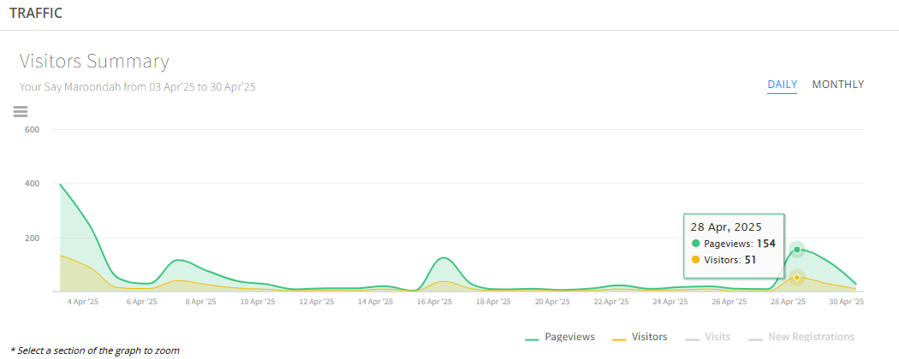
Figure 1 shows activity on the Your Say webpage over the campaign period. Noting there are peaks around 16 April and 28 April which align with eNews and social posts.

Above: Figure 1

As shown below in Figure 2, the amended plan was downloaded 355 times over the campaign period, with only 8 people viewing the outgoing plan.
With only 8 survey submissions, this suggests the vast majority of those who viewed the amended plan were agreeable to the amendments and as such had no further feedback to provide.

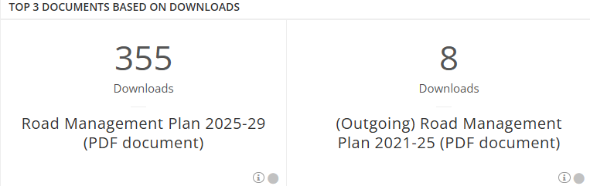
Above: Figure 2
Figure 3 shows the traffic source to the Your Say webpage, noting the highest rate of survey respondents came through social posts and the highest number of page visits came through email (eNews).
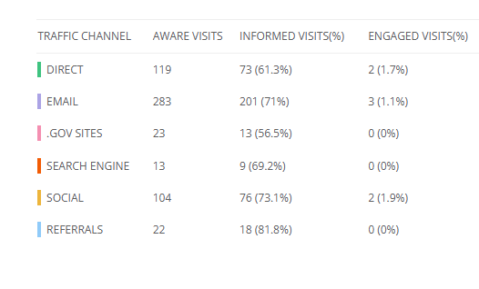

Above: Figure 3

Consultation outcomes

At the conclusion of the engagement period, no formal submissions were received regarding the proposed amendments to plan. There were however eight responses of a general nature, primarily focusing on the below key themes.
Road upgrades and safety concerns
- Concerns regarding traffic and safety issues on Bayswater Road due to increased housing density, with requests for road duplication to enhance traffic and pedestrian safety.
- Calls for road widening and safer pedestrian crossings on Dorset Road to address congestion and safety concerns.
Pedestrian safety and infrastructure needs
- Requests for pedestrian crossings on Dorset Road at Moore Avenue and between Adams Reserve Playground and the childcare centre.
- Appeals for new footpaths on Hillcrest Avenue and other roads to ensure pedestrian safety.
Traffic management strategies
- Suggestions for monitoring traffic congestion and implementing strategies such as traffic light sequence optimisation and speed limit reductions.
- Emphasis on the importance of maintaining roadside verges and median strips for a more visually appealing environment that also helps to reduce line of sight issues.

While these themes fall outside the scope of the plan, the feedback has been provided to Council's Engineering Services Team for consideration and appropriate action, noting that ongoing advocacy and projects in the following areas are underway:
- Bayswater Road upgrade (Council)
- Canterbury Road upgrade (Transport Victoria)
- Lincoln Road footpath works (Council)
- Works nearby Hillcrest Ave (Council)

Conclusion
The Road Management Plan review process has been conducted in compliance with the Act, regulations, and Council's community engagement policy, considering relevance, affordability, and achievability.
The proposed amendments to Council's Road Management Plan 2025-29 aim to enhance the plan clarity and effectiveness, leading to increased road safety for the community.
Following community consultation an update was prepared for Council Management Team and Councillors. Feedback was invited ahead of the Council meeting held on 30 June 2025 in which the proposed document was to be put up for official adoption.

Next Steps
Having followed the prescribed processes in accordance with the Act and Council's community engagement policy, the Road Management Plan 2025-29 went to the Council meeting held on 30 June 2025. The Road Management Plan 2025-29 was formally adopted by Councillors at the Council meeting on 30 June 2025.
The endorsed plan is available to view by visiting Council’s Road Management Plan webpage.

