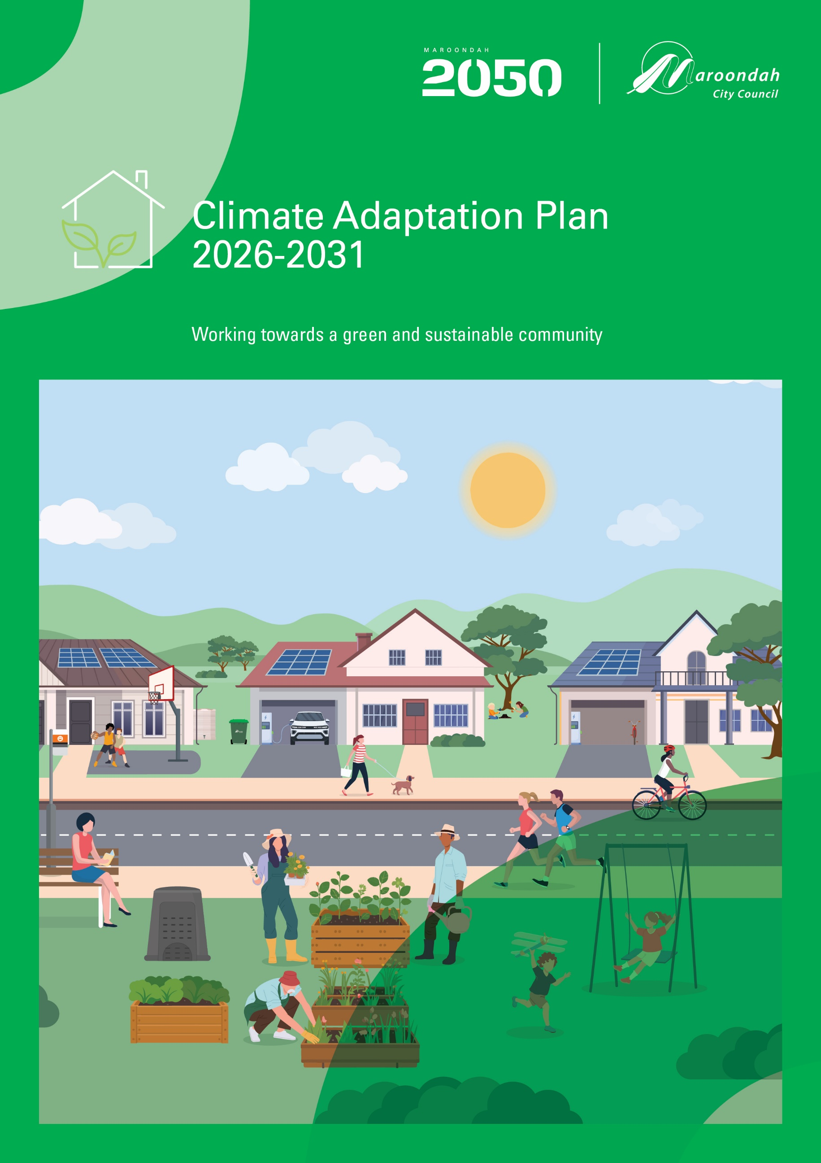

Contents
Acknowledgement of Country 2
Executive Summary 3
1. Climate Change in Maroondah 5
Maroondah context 5
Purpose 5
Climate change and caring for Country 6
2. What does the evidence say? 6
What is climate change? 6
Council’s role in addressing climate change 7
Co-benefits of climate action 8
What has Council done so far to address climate change? 9
Community emissions 11
3. What we did and what you told us? 13
4. A plan for the future 16
A vision for a climate resilient Maroondah 16
Strategic Framework 16
Outcome area 1 - Reducing Council’s Greenhouse Gas Emissions 17
Key directions 19
Outcome area 2 - Building a Resilient Maroondah 20
Key directions 21
Outcome area 3 - A Climate Ready Community 22
Key directions 23
Tracking our progress 23
5. Climate Change Action Plan 24
6. References and Glossary 27
References 27
Glossary 27

Acknowledgement of Country

We, in the spirit of Reconciliation, acknowledge the Wurundjeri People of the Kulin Nation as traditional custodians of the land now known as the City of Maroondah, where Indigenous Australians have performed age-old ceremonies. We acknowledge and respect their unique ability to care for Country and their deep spiritual connection to it. We pay our respects to their Elders, past, present and emerging.

Executive Summary
Climate change is already impacting Maroondah. It poses a significant environmental, social and financial risk to Maroondah City Council and the Maroondah community. It is essential that Council plan and prepare for climate change to ensure the ongoing sustainability of Council operations and services, while also supporting the Maroondah community to do the same.

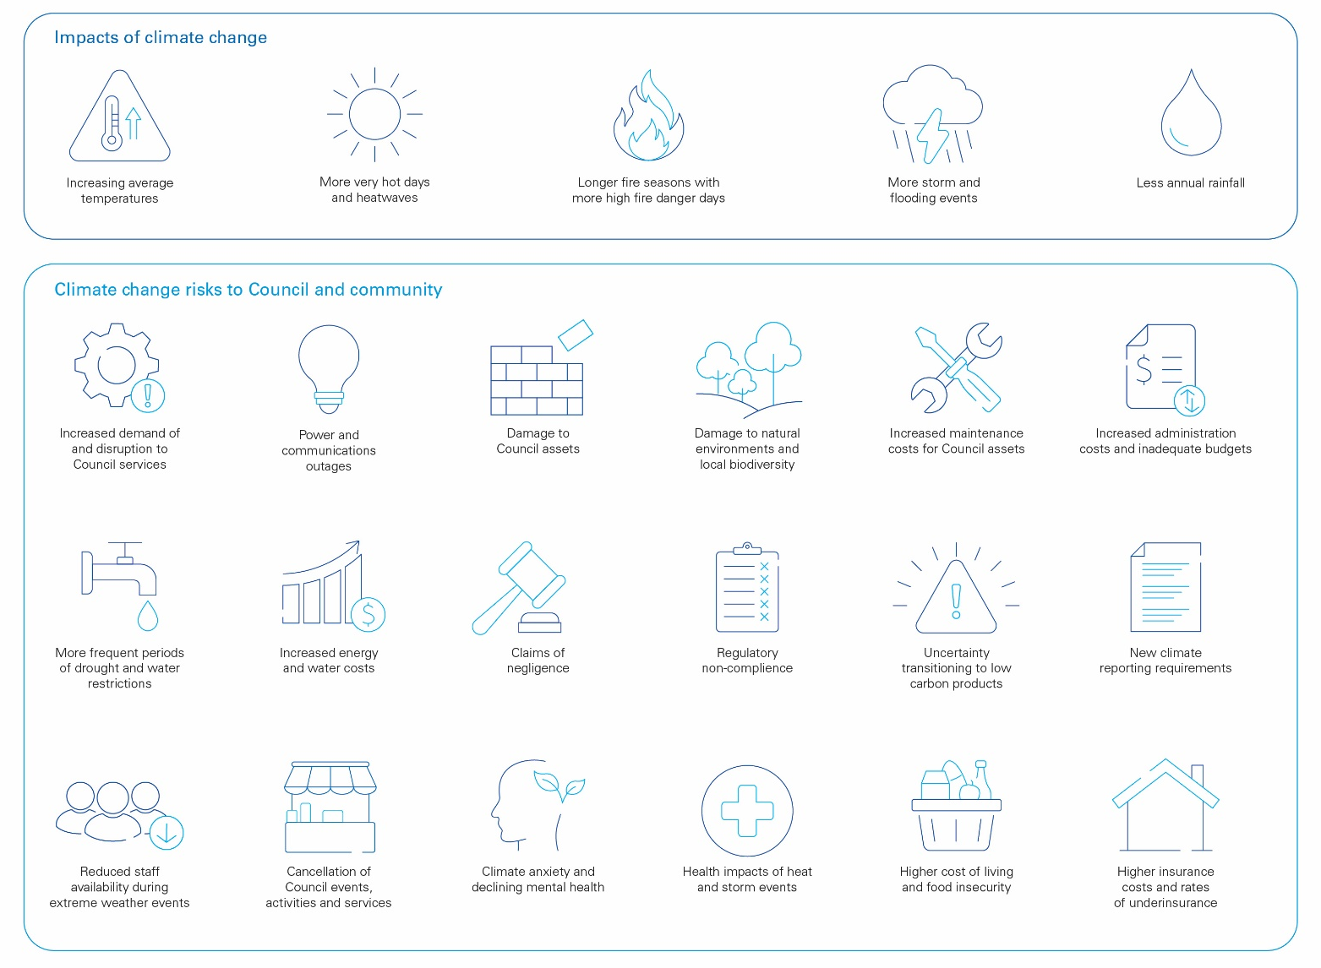

Maroondah City Council has a long history of climate action, first setting an emissions reduction target in 2001 to cut emissions by 20% from 1995 levels by 2010 as part of the ICLEI Cities for Climate Protection Program. Since 2011/12, Council has achieved a more than 65% emissions reduction from Council operations, with the Carbon Neutral Strategy 2014/15-2020/21 and the Climate Change Risk and Adaptation Strategy 2018/19-2021/22 each providing a clear pathway for climate action across Council’s operations.

The Climate Adaptation Plan 2026-2031 combines climate change mitigation and adaptation actions into a single plan and provides the next steps to continue to prepare Council and the community for the impacts of climate change, including:

- Climate change mitigation: reducing Council’s greenhouse gas emissions
- Climate change adaptation: preparing for the impacts of climate change on Council operations and services
- Embedding climate change in Council processes and decision-making
- Meeting Council's legislative obligations (including Local Government Act 2020 and the Climate Action Act 2017) to address climate change
- Supporting the Maroondah community to reduce greenhouse gas emissions and adapt to climate change

This Climate Adaptation Plan 2026-2031 presents the following vision for a climate resilient Maroondah:

Maroondah is a strong and climate resilient community, with declining greenhouse gas emissions for both Council operations and across our community.

The Plan also presents Council’s new emissions reduction target:

Council will reduce operational scope 1 and scope 2 greenhouse gas emissions by 50% of 2021/22 levels by 2035.

Key directions and actions are presented across three outcome areas. Each outcome area supports the Maroondah 2050 community vision as well as outcomes of the Sustainability Strategy 2022-2031.

- Reducing Council’s greenhouse gas emissions
- Building a resilient Maroondah
- Climate ready Maroondah

Climate action also provides a broad range of co-benefits, including improving building design and quality, lowering operating and renewal costs, reducing energy and water waste, supporting safe, vibrant, and accessible parks and outdoor recreation facilities, promoting an active and healthy community, and creating strong and healthy ecosystems. Similarly, actions Council is already taking to deliver community building outcomes can also contribute to a more climate resilient Maroondah.

This Plan recognises that while climate change poses a risk, thoughtful and well-planned action today also presents an opportunity to improve economic outcomes and maintain a safe, healthy and resilient Maroondah for tomorrow.

1. Climate Change in Maroondah

Climate change is a global issue with local impacts. Maroondah is already facing many of the impacts of climate change, such as more frequent extreme heat and storms, damage to local biodiversity, and rising insurance costs.

Climate change poses risks to both Maroondah City Council and the Maroondah Community. This Climate Adaptation Plan supports the community vision outlined in Maroondah 2050 - Our Future Together, working towards a green and sustainable community and a safe and liveable community in Maroondah.

This Plan recognises that while climate change poses a risk, thoughtful and well-planned action today also presents an opportunity to improve economic outcomes and maintain a safe, healthy and resilient Maroondah for tomorrow.

Maroondah context
The City of Maroondah covers an area of 61.4 square kilometres in outer eastern Melbourne, including suburbs of Bayswater North, Croydon, Croydon Hills, Croydon North, Croydon South, Heathmont, Kilsyth South, Ringwood, Ringwood East, Ringwood North and Warranwood. The City also includes small sections of Kilsyth, Park Orchards, Vermont and Wonga Park suburbs.

The traditional owners of the land on which the City of Maroondah now sits are the Wurundjeri People of the Kulin Nation. The Wurundjeri People have lived on this land for tens of thousands of years and have a deep spiritual connection and care for Country.

Maroondah has a population of 119,354 people across 44,167 households. Approximately 25% of the population was born overseas, with the United Kingdom, China, India and Myanmar the most common countries.

The City of Maroondah has 649 hectares of open space, with 578 parks and reserves containing approximately 750,000 trees, including 46 bushland reserves. Council prioritises planting indigenous species across Council reserves to support local biodiversity. The municipality also has good transport connectivity, with 39 kilometres of shared trails, including the Mullum Mullum Creek, Eastlink, Tarralla Creek and Dandenong Creek trails. Additionally, there are two train lines and numerous bus lines operating throughout Maroondah, providing both active and public transport options.

Purpose
The Climate Adaptation Plan has been developed to support a green and sustainable Maroondah and a safe and liveable community today and into the future. This Plan will help to build resilience to climate change in Council’s operations and services, and reduce Council’s operational greenhouse gas emissions. This Plan will also support the Maroondah community to reduce greenhouse gas emissions and improve its ability to be more resilient to the effects of climate change.

What is ‘climate resilience’?
Climate resilience is the ability of a community, ecosystem, or system to prepare for, withstand, and recover quickly from climate-related shocks and stresses, like extreme heat, floods, or droughts, while maintaining essential functions and adapting to future changes.

What is ‘sustainability’?
Sustainability can be defined as “balancing economic, social and environmental factors. It is concerned with how we can manage resources to ensure future generations have the same opportunities that we enjoy today” (City of Melbourne, 2016).

Climate change and caring for Country

A strong, healthy and connected natural environment is central to a strong, healthy and resilient Maroondah and Maroondah community.

The Wurundjeri Woi-Wurung People of the Kulin Nation have cared for this land for tens of thousands of years. Their ongoing connection to the land, water and sky Country, depicted in their principles outlined in the Whole of Country Plan, highlights the importance of caring for Country. Aboriginal Cultural Heritage connects deeply to land, trees, waterways and biodiversity across Maroondah and the broader region.

Climate change poses an inherent risk to Country. Caring for Country is a central principle to address climate change in Maroondah. If we prioritise the health of our natural environment, we are in a strong position to address climate change.

The Climate Adaptation Plan prioritises taking small but meaningful steps to encourage those who live, work, learn and play in Maroondah to act in a way that supports our natural environment. We look to collaborate with Wurundjeri Woi-Wurrung, incorporating their principles as we move forward in the management of climate change.

2. What does the evidence say?

What is climate change?
Climate change is caused by the amplification of the natural greenhouse effect. It is caused by increasing concentrations of greenhouse gases, such as carbon dioxide and methane, in our atmosphere from activities such as burning fossil fuels and deforestation. These greenhouse gases trap more heat in the atmosphere, warming the oceans and supercharging weather systems.

Climate change is causing hotter and drier weather, more intense storms and flooding, and more severe bushfires and periods of drought. The flow on effects will impact more than just our environment. It will disrupt healthcare, food chains and supply systems, make responding to extreme weather and emergencies more difficult, and place pressure on global financial markets.

Addressing climate change requires action across the community and all levels of government, including Maroondah City Council.

Maroondah is already experiencing the effects of climate change, with impacts including:
- Hotter average temperatures and more days of extreme heat
- Lower annual rainfall totals, with more rainfall coming in intense rainfall events leading to localised flooding
- Increased frequency and intensity of storm events, including wind and hail
- Increased length and intensity of bushfire seasons

The impacts of climate change will affect the health and resilience of Maroondah, including:
- Damage to buildings, infrastructure, and a decline in the natural environments and biodiversity from extreme weather and long-term climatic patterns
- Disruption to Council services
- Increased asset and infrastructure construction and management costs
- Power and communications outages
- More frequent periods of drought and water restrictions
- Increased energy, water, and food costs and insecurity
- Higher insurance costs and rates of underinsurance
- Heat related illnesses and exacerbation of existing physical health conditions
- Increased climate anxiety and declining mental health

It is widely accepted that some level of climate change is locked in. However, reducing our reliance on fossil fuels and the associated greenhouse gas emissions still plays an important role in limiting the severity of future climate change.

Council’s role in addressing climate change
Addressing climate change requires collaboration between federal, state and local governments, alongside businesses, organisations and community members. Council has a legislated responsibility to lead and support the Maroondah community to prepare for the impacts of climate change, including under the following Acts:

- Local Government Act 2020 (Vic)
- Climate Action Act 2017 (Vic)
- Planning and Environment Act 1987 (Vic)
- Public Health and Wellbeing Act 2008 (Vic)
- Environment Protection Act 2017 (Vic) - General Environment Duty

Maroondah’s Climate Adaptation Plan has been developed to support existing Victorian and Australian emissions reduction targets, along with climate adaptation plans. The Victorian Government has a legislated state target to be net zero by 2045, with interim state-wide emissions reduction targets based on 2005 emissions levels:

- 28-33% emissions reduction by 2025
- 45-50% emissions reduction by 2030
- 75-80% emissions reduction by 2035

The Australian Government (DCCEEW, 2025) has set the following 2035 Nationally Determined Contribution (NDC) under the Paris Agreement:

Australia’s 2035 target is a 62-70% reduction in net national greenhouse gas emissions below 2005 emissions levels, covering all sectors of the economy and all greenhouse gases.

This will be implemented as an emission budget over 2031–35. This target aligns with Australia’s Net Zero Plan, which charts out Australia’s path to achieving our commitment to reach net zero by 2050.

The Climate Adaptation Plan details Council's actions to strengthen:

- Climate change mitigation: reducing Council’s greenhouse gas emissions
- Climate change adaptation: preparing for the impacts of climate change on Council operations and services
- Embedding climate change in Council processes and decision-making
- Meeting Council's legislative obligations to address climate change
- Supporting the Maroondah community to reduce greenhouse gas emissions and adapt to climate change

What is ‘climate change mitigation'?
Climate change mitigation means “a human intervention to reduce emissions or enhance the sinks of greenhouse gases” (IPCC 2018).

What is ‘climate change adaptation’?
Climate change adaptation means “the process of adjustment to actual or expected climate and its effects” (IPCC 2018). This means taking actions to reduce the negative impacts of climate change and make the most of opportunities that arise. Climate change adaptation isn’t only about preparing for extreme weather. It is also about preparing to transition to more sustainable practices, and new ‘green’ markets and technologies.

What is ‘embedding climate change’?
Climate change will impact all areas of Council and the Maroondah community. It’s important to look for ways to address climate change as a part of Council’s regular operations. This includes in Council decision-making processes, policies, strategies, plans, and budgets. Making climate change action a part of ‘business as usual’ will ensure Council is prepared for the impacts of climate change. It will also ensure there is adequate budgeting for the rising costs of emergency management, asset maintenance, utility costs, and insurance premiums.

Co-benefits of climate action
The actions outlined in the Climate Adaptation Plan will improve Council’s resilience to climate change and support a strong, healthy and vibrant Maroondah. Actions taken to address climate change also have additional benefits to both Council and our community. This includes:

- Supporting safe, vibrant, and accessible parks and outdoor recreation facilities, promoting an active and healthy community
- Creating strong and healthy ecosystems and supporting Maroondah community groups who care for our natural environment
- Enhancing building design to improve user comfort and building quality, lowering operating and renewal costs, and reducing energy and water waste
- Reducing Council’s reliance on, and exposure to price fluctuations in the energy market
- Improving community health outcomes by:
  - Improving air quality
  - Decreasing heat-related illnesses and supporting vulnerable residents through extreme heat
  - Increasing walkability and active transport options around Maroondah
- Identifying opportunities to address the rising cost of living, including:
  - Reducing energy and water costs by improving efficiency and identifying behaviour change opportunities within our community
  - Reducing transport costs by improving low-cost active transport infrastructure
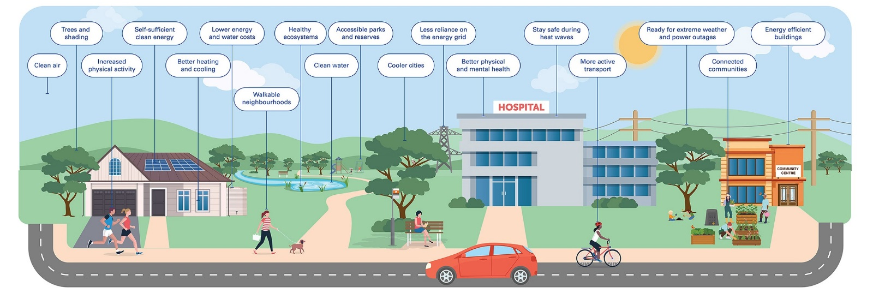

What has Council done so far to address climate change?
Council has recognised the importance of addressing climate change for decades. Key achievements are outlined below:

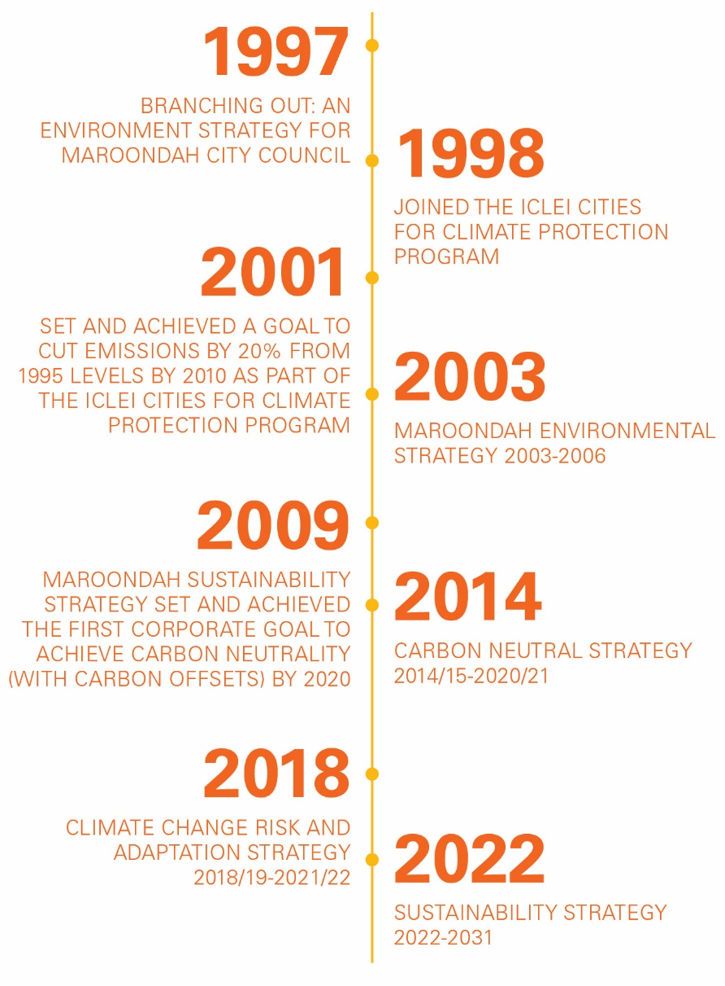
These plans not only demonstrate Council’s long-term commitment to address its legislated obligations but also recognise the success of past plans which have achieved a more than 65% emissions reduction from Council operations since 2011/12.

There are a wide range of completed and ongoing projects arising from these strategies that have contributed to reducing Council’s greenhouse gas emissions, including:

- Victorian Energy Collaboration (VECO) power purchase agreement - purchasing renewable electricity from July 2021, in partnership with councils across Victoria
- EAGA Joint Energy Performance Contract (EPC) to improve energy efficiency at Aquahub, Aquanation, The Rings, Maroondah Federation Estate, and Realm
- Improving energy efficiency of Council buildings using best practice and environmentally sustainable design (ESD)
- Upgrading street lighting to energy efficient LED lights
- Installing solar PV across Council facilities
- Reducing waste to landfill and encourage recycling and composting from Council buildings
- Encouraging energy saving behaviour for Council building users
- Encouraging active and public transport options over personal vehicles
- Capturing and reporting on energy and emissions data

The graph below outlines Council’s greenhouse gas emissions since 2011/12 alongside the major emissions reduction activities.

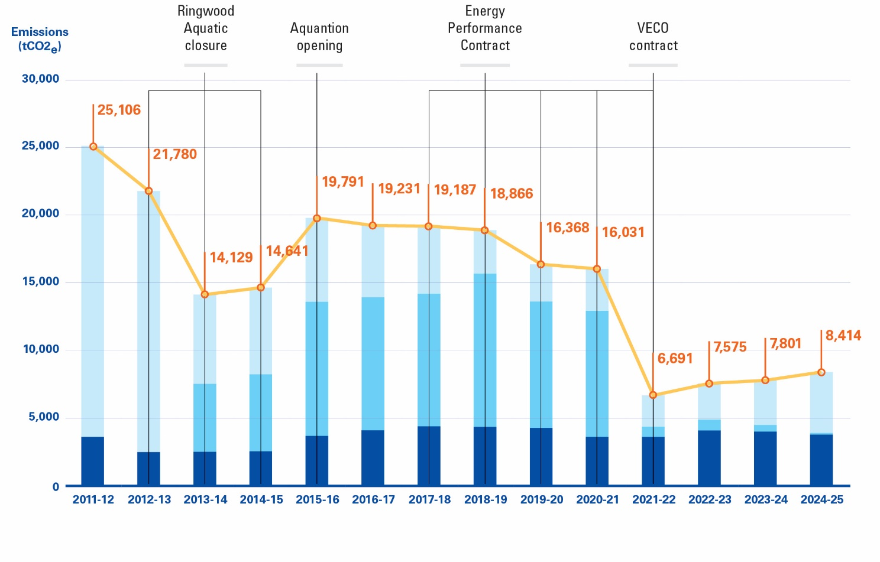
Measuring emissions - What is tCO2e?
Greenhouse gases are measured using tonnes of carbon dioxide equivalent (tCO2e). This is because different greenhouse gases, such as carbon dioxide, methane and nitrous oxide, all have different abilities to trap heat and contribute to climate change. Carbon dioxide is considered the benchmark for measuring greenhouse gas emissions, so emissions from other greenhouse gases are converted into the equivalent tonnes of carbon dioxide by applying their global warming potential (GWP).

Climate change is already recognised as a risk affecting Council operations and services and is embedded in existing strategies and plans across Council. This includes:

- Maroondah 2050 and the Council Plan
- Sustainability Strategy 2022-2031
- Maroondah Liveability, Wellbeing and Resilience Strategy 2021-2031
- Vegetation Strategy 2020-2030
- Municipal Emergency Management Plan 2023-2026
- Waste, Litter and Resource Recovery Strategy 2020-2030
- Asset Management Strategy
- Open Space Strategy 2016
- Water Sensitive City Strategy

The Climate Adaptation Plan supports existing and future Council strategies and plans to further strengthen Council’s climate response.

Community emissions

Our community plays an important role in climate change mitigation. The Maroondah community, including commercial, industrial and residential sources, contribute approximately 99% of Maroondah’s greenhouse gas emissions. This includes emissions from energy consumption (electricity, gas, fuel), transport, waste and industrial processes and product use (IPPU) (industrial processes, refrigerant use).

Since 2018/19, our community has reduced emissions by approximately 12.6% from 1,144,000 tCO2e to 1,000,100 tCO2e (Snapshot, 2025). Businesses and households continue to look for opportunities to reduce energy consumption and greenhouse gas emissions. This can include:

- Installing solar PV and energy efficient products
- Prioritising environmentally sustainable design when constructing or retrofitting buildings
- Choosing more active forms of transport and reducing reliance on private vehicles
- Making changes to common behaviours, such as turning off lights and appliances when not in use
- Sending less waste to landfill, including using programs such as household FOGO bins

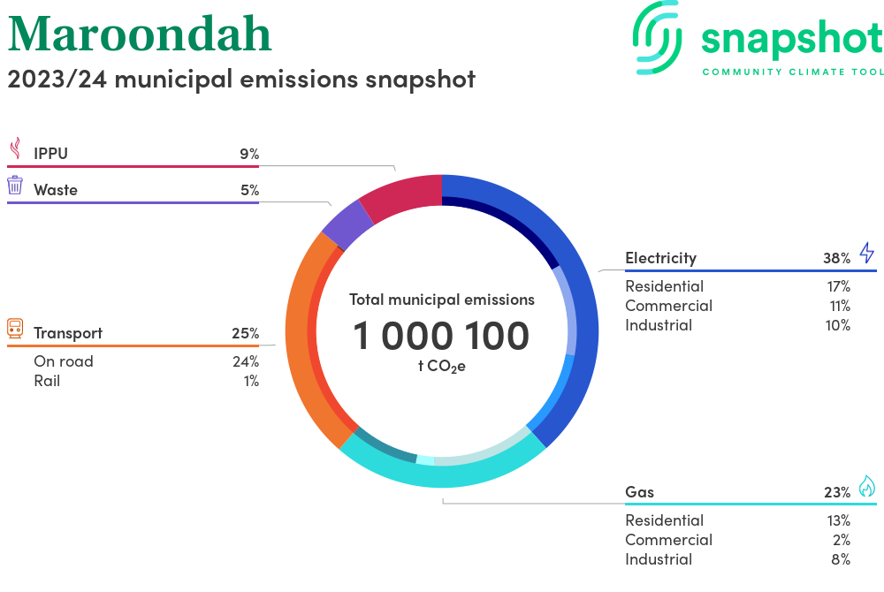

3. What we did and what you told us?

The Draft Climate Adaptation Plan 2026-2031 was released for community consultation between 7 November and 12 December 2025. Consultation included a survey on Council’s Your Say website where participants were asked:

- What is your age group?
- How are you connected to Maroondah?
- Are you providing a response on behalf of a group or organisation?
- How concerned are you about climate change? (Not concerned, slightly concerned, moderately concerned, very concerned, extremely concerned)
- How much support do you have for the proposed three outcomes of the draft Climate Change Plan 2026-2031? (Strongly support, support, neutral, oppose, strongly oppose)
- Please provide any comments about the draft Climate Change Plan 2026-2031
- What would you like more information on? (Transport other than my car, reduce energy bills, navigating worries about climate change, prepare for extreme weather or power outages, advice for solar or energy efficient appliances, gardening and growing food)
- If you would like information on a topic not listed above, please list it here
- How would you like Council to provide information
- Would you like to be kept updated on this project and similar future consultations?

A series of pop ups, including Café Consult at the Maroondah Festival, and storytimes at Realm and Croydon Libraries were held to reach more people. Pop ups provided an opportunity for community members to answer two questions:

- How concerned are you about climate change?
- What would you like more information on? (Select 3 options)

Council officers also met with the Maroondah Youth Wellbeing Advocates and Wurundjeri Woi-Wurung Aunties to discuss key themes and priority areas of the Climate Adaptation Plan.

Across the consultation period, total responses included:

- Your Say page survey: 122 responses
- Café Consult, Maroondah Festival: 532 people
- Maroondah Youth Wellbeing Advocates: 9 people
- Croydon and Realm Library pop ups: 31 people
- In person consultation with Wurundjeri Woi-Wurung Aunties
- Direct written submissions: 1
Climate change was generally considered concerning across the Maroondah community, with 74% of respondents expressed they were either “very” or “extremely concerned” about climate change and only 6% “not concerned” about climate change.
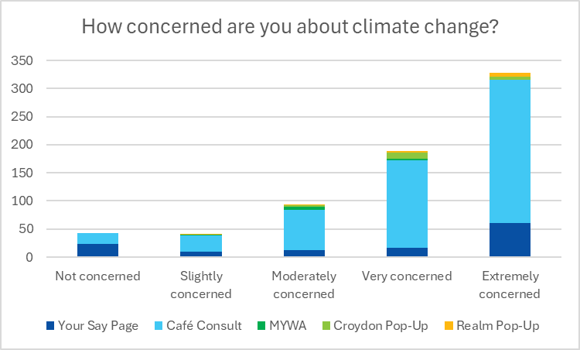

Feedback provided from the Your Say survey found that most survey respondents supported all three outcome areas of the draft Climate Adaptation Plan:

- Outcome Area 1: Reducing Council’s Greenhouse Gas Emissions
  - 66% of respondents supported or strongly supported Outcome Area 1
  - 24% of respondents opposed or strongly opposed Outcome Area 1 (including 1 person who opposed OA1 as it was not ambitious enough)
- Outcome Area 2: Building a Resilient Maroondah
  - 70% of respondents supported or strongly supported Outcome Area 2
  - 23% of respondents opposed or strongly opposed Outcome Area 2
- Outcome Area 3: A Climate Ready Community
  - 68% of respondents supported or strongly supported Outcome Area 3
  - 24% of respondents opposed or strongly opposed Outcome Area 3

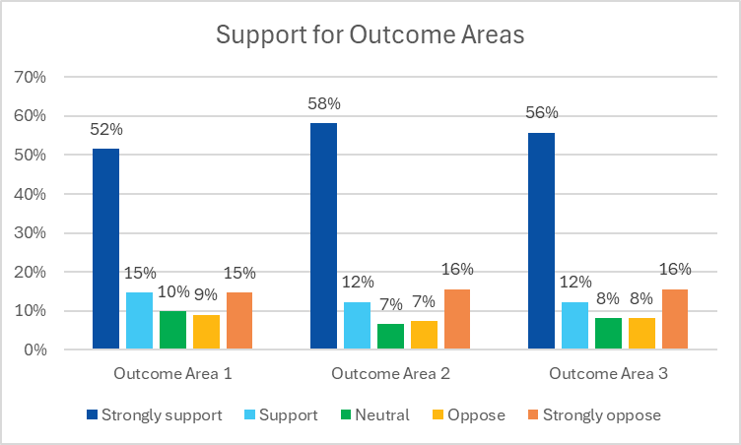

Feedback from the comment box in the Your Say survey fell into three main categories:
- The draft Climate Adaptation Plan is not ambitious enough and/or Council should push for net zero as soon as possible
- The draft Climate Adaptation Plan provides appropriate and ambitious direction for Council to pursue climate action
- Climate change is not an issue and/or there is nothing that Council can or should be doing to address it

Feedback has been incorporated into the Climate Adaptation Plan where possible and appropriate. It is important to recognise that the consultation did not seek feedback on the legitimacy of climate science, nor Council’s responsibility to respond to climate change. Council relies on the local, national and global science community to understand the predicted impacts of climate change on Maroondah. Council’s responsibilities to respond to climate change are also clearly outlined in the Local Government Act 2020 and the Climate Action Act 2017.

Detailed responses to community comments can be found in the Draft Climate Adaptation Plan Engagement Report.

4. A plan for the future

A vision for a climate resilient Maroondah

Maroondah is a strong and climate resilient community, with declining greenhouse gas emissions for both Council operations and across our community.

Strategic Framework

The Climate Adaptation Plan 2026-2031 responds to key directions presented in the Sustainability Strategy 2022-2031. It presents a plan to address climate change mitigation and adaptation within Council operations, as well as supporting a climate ready community, across three outcome areas.

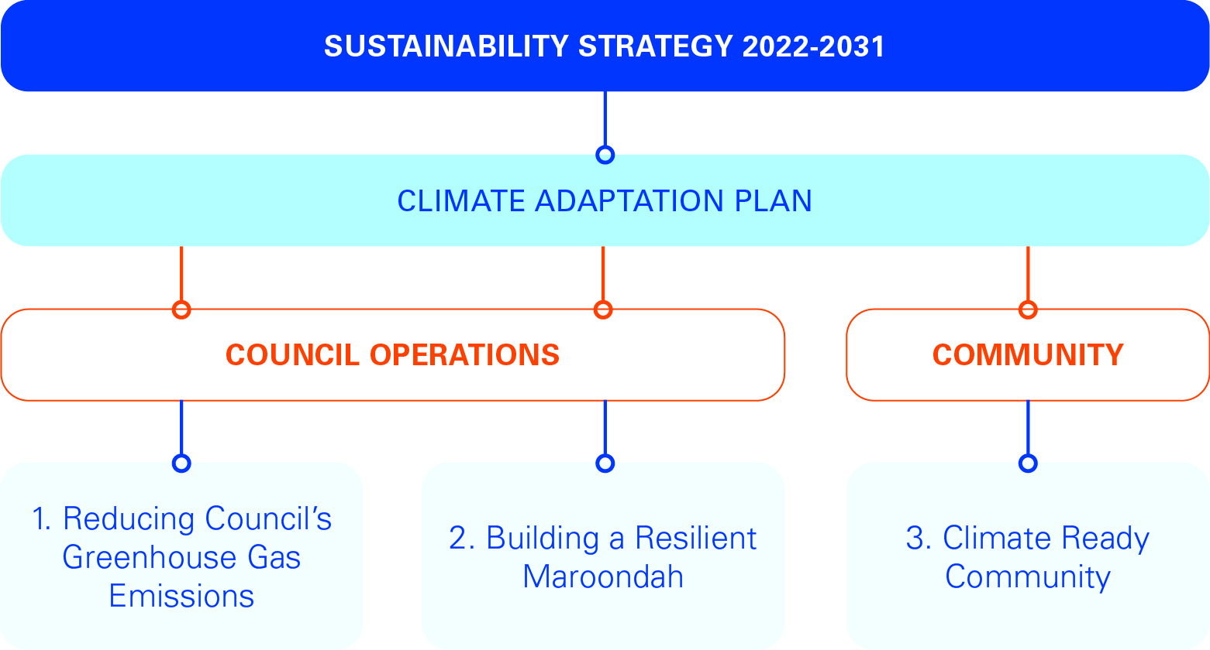

Outcome area 1 - Reducing Council’s Greenhouse Gas Emissions

Council will reduce operational scope 1 and scope 2 greenhouse gas emissions by 50% of 2021/22 levels by 2035.

Council plays an important role in reducing greenhouse gas emissions while leading our community in climate change mitigation actions. Council is prioritising reducing scope 1 and 2 emissions by electrifying assets and moving away from gas where possible, improving energy efficiency, and shifting to renewable energy sources. This follows the increasing availability and feasibility of new technologies, such as electrification of aquatic centres and fleet, over recent years. Forecasted emissions reduction over the next decade are outlined in the graph below.

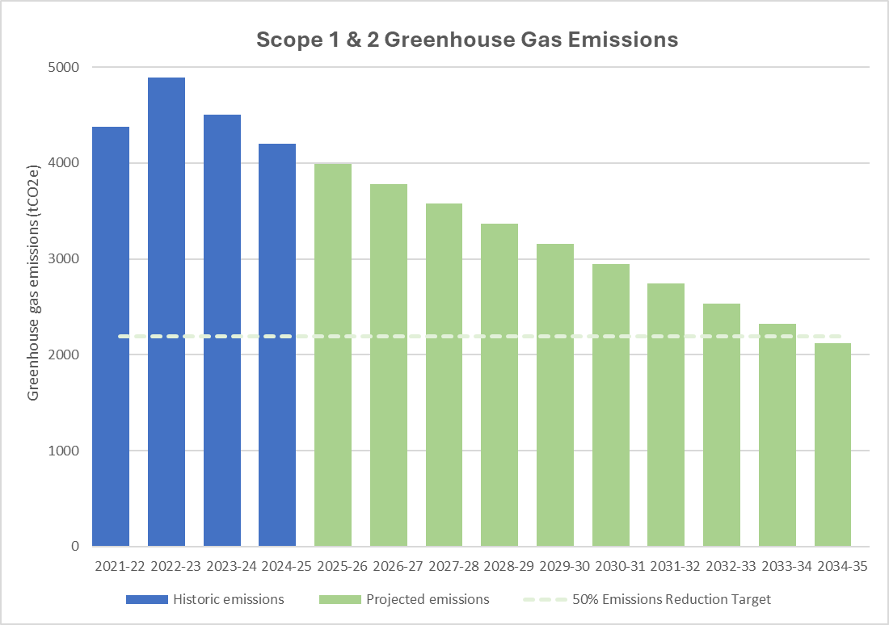

Understanding Greenhouse Gas Emissions
Council’s operational greenhouse gas emissions can be categorised into direct (scope 1) and indirect (scope 2 and 3) emissions, depending on the level of control that Council has over the emissions (Clean Energy Regulator, 2025).

Scope 1: Emissions directly released into the atmosphere from Council’s activities (eg. Burning natural gas for heating, or petrol in vehicles)
Scope 2: Indirect emissions released from the production of electricity (eg. Electricity purchased from the grid)
Scope 3: Indirect emissions released during the production, delivery or disposal of goods and services used by Council (eg. Food and drink, IT services, paper, building materials, etc.).

Council will use the emissions reduction pathway below to prioritise actions that will deliver the greatest drop in operational greenhouse gas emissions. The emissions reduction pathway begins by reducing the overall energy consumption of Council assets and the associated emissions, then steps through five emissions reduction stages. Actions and implementation timeframes are dependent on the development of a business case or feasibility study, including budget availability and indirect benefits (eg. social, process efficiency) where possible.

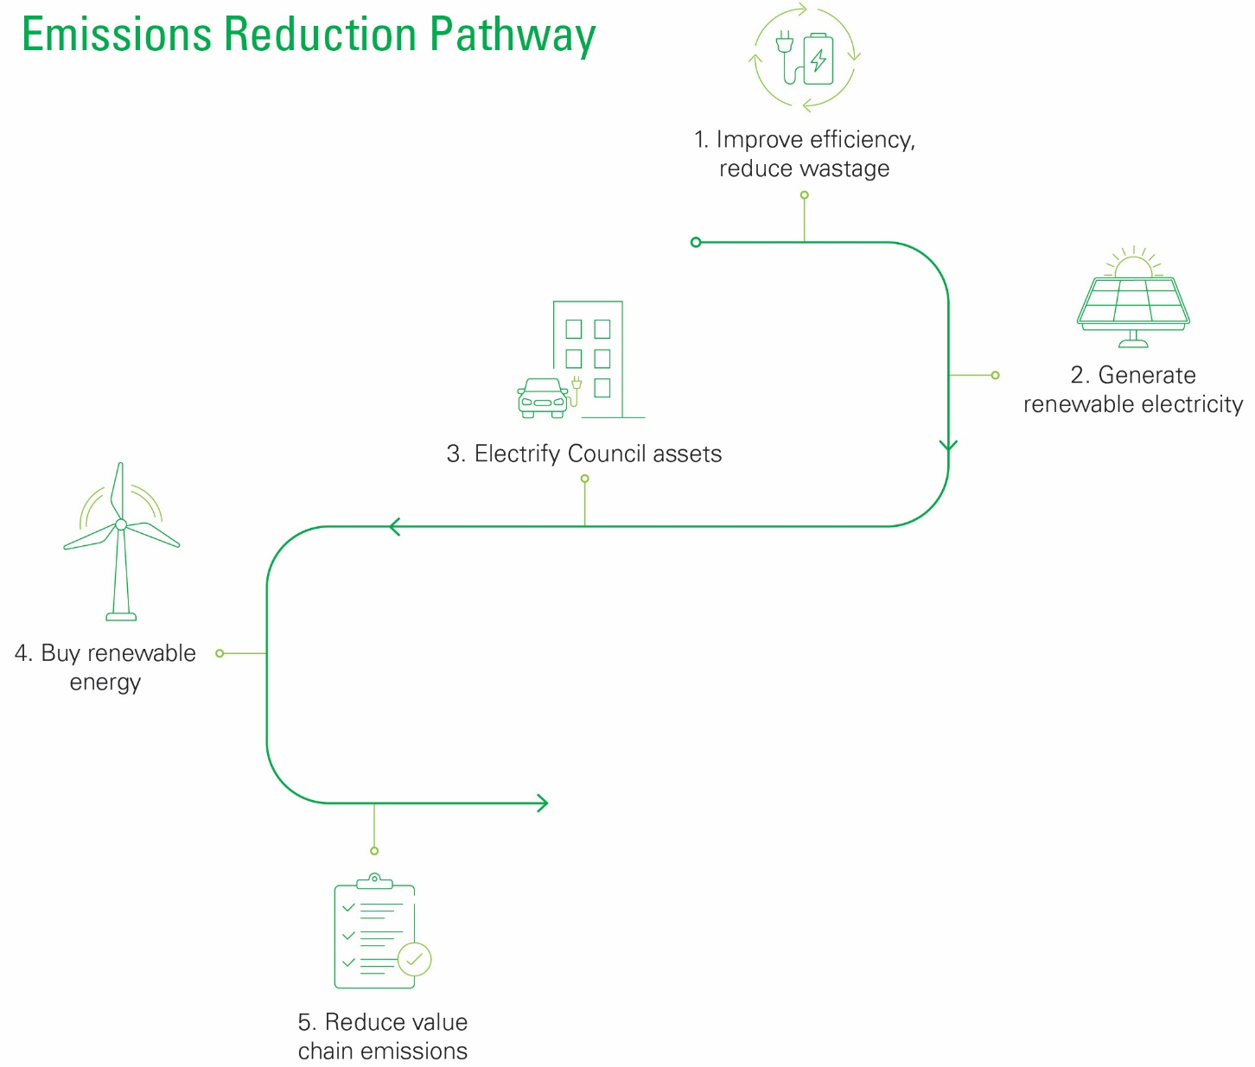

- Improve efficiency, reduce wastage
The first step to reducing our operational emissions is improving energy and water efficiency to reduce the total energy and water consumption of Council assets. This includes:
  - Council buildings
  - Public and street lighting
  - Irrigation at parks, reserves and sporting ovals

By using best-practice techniques and investing in quality buildings and new technologies, we will reduce energy and water wastage and operating costs. This will deliver long term cost and emissions savings, as well as community-centred assets and facilities.

- Generate energy
Council is continuing to invest in solar photovoltaic (PV) systems across Council facilities. Solar PV is an effective way to reduce the reliance on grid-power and reduce electricity costs. Solar PV generates renewable electricity onsite, reducing operating and electricity distribution costs and emissions.

- Electrify
Many Council buildings currently rely on natural gas, including Council’s three aquatic centres, Aquanation, Aquahub, and the Croydon Memorial Pool, as well as sporting pavilions and community facilities. Similarly, Council fleet and plant equipment is primarily petrol and diesel based.

Replacing natural gas and fuel consumption with electric alternatives will enable us to move from non-renewable and emissions intensive energy sources to renewable energy sources. Using onsite generation from solar PV wherever possible also means Council will produce more of the energy we use.

- Buy renewable - the Victorian Energy Collaboration
In 2021, Council joined with other members of Victorian Greenhouse Alliances, including EAGA, to purchase 100% renewable electricity for large Council sites. Since then, Council has expanded this to all Council operated facilities and street lighting. The project is the largest emissions reduction project undertaken by the local government sector in Australia and has resulted in significant emissions and costs savings for Council.

- Reduce scope 3 emissions
Value chain, or scope 3 emissions, include emissions associated with producing, transporting and disposing of products or services used by Council, such as food, paper, construction materials, and equipment. Reducing our scope 3 emissions can be achieved by either using less of a product or service or switching to a lower emission alternative product.
Scope 3 Emissions
In the short term as more data becomes available, Council’s operational scope 3 emissions will appear to rise significantly. This should not be a barrier for improving data collection, but instead an opportunity to build a comprehensive understanding of scope 3 emissions and to set an ambitious scope 3 emissions reduction target in the future.

One of the biggest challenges in reducing scope 3 emissions is in the availability of reliable emissions data. Council has been reporting on some scope 3 emissions data where available, however there is still work to be done. Recent changes to national mandatory sustainability reporting are expected to improve the availability of scope 3 emissions factors and data over coming years, but this will still require improvements to Council’s data collection capabilities.

Key directions

  - Reduce scope 1 emissions by electrification of Council assets and reduce Council's reliance on fossil fuels
  - Reduce scope 2 emissions by investing in renewable energy sources and storage for Council assets
  - Reduce scope 3 (value chain) emissions using sustainable procurement processes and responsible use of resources
  - Improve Council's environmental data quality and reporting capabilities to better facilitate opportunities for emissions reduction

Outcome area 2 - Building a Resilient Maroondah
Climate change is already affecting the health and resilience of our environment and community. It is increasing the frequency of extreme weather and affecting supply chains, increasing the pressure on Council operations and services, households, and local businesses and organisations.

A resilient Maroondah is a climate-ready Maroondah. We will become more prepared for the impacts of climate change by embedding climate change as part of Council’s “business as usual” decision making processes instead of using isolated actions to address climate change. For example, how can Council manage parks and reserves to ensure they are climate resilient and continue to be a valuable community asset with healthy ecosystems that support active lifestyles, mental health, and connection to nature?

- Resilient buildings and infrastructure
Council has buildings, assets, and infrastructure around Maroondah that provide Council services and support the community. Buildings and infrastructure may be vulnerable to both damage from extreme weather, and higher maintenance and replacement costs from long term climate change. It is important that we embed climate change adaptation measures into building and infrastructure planning and design. This will reduce asset vulnerability and ensure Council’s services are adaptable and resilient.

- Resilient environments
Leafy green neighbourhoods and high canopy cover are often highlighted as one of Maroondah’s most loved features by our community. Plants, animals, fungi and microorganisms within Maroondah also form interconnected ecosystems and support local biodiversity. It is important to recognise the unique role of vegetation, biodiversity and green infrastructure in improving the resilience of the Maroondah environment to climate change.
Green infrastructure
Green infrastructure describes the use of vegetation and natural systems to deliver ecosystem services such as clean air, clean water, stormwater management and flood mitigation, and local cooling. Green infrastructure can also be used to achieve environmental, social and economic outcomes, including mental and physical health benefits of getting outside, more liveable neighbourhoods and more resilient local biodiversity. This is often in contrast to traditional “grey” or built infrastructure, such as roads, paths and stormwater drains.

Extreme weather events can cause damage to ecosystems, while long term changes to climatic patterns, such as warmer average temperatures and droughts, can place additional stresses on the environment. This amplifies the pressures of urbanisation on the natural environment, such as the urban heat island effect and damage to local habitats.

Council is already embedding climate change in the management of Council bushland, parks, reserves, golf courses, and tree maintenance, but there is still more work to be done. This includes species selection, weed and pest management, watering regimes and the use of recycled or harvested stormwater. Embedding climate change into the management of Maroondah’s natural environments now will support healthy and resilient environments today and into the future.

- Reliable and responsive Council services
Council provides a broad range of services to the Maroondah community, all of which are vulnerable to the effects of climate change. These include:

- Waste collection
- Road and footpath maintenance
- Maternal and child health services
- Public health and immunisation services
- Meals on Wheels
- Occasional Care
- Youth programs
- Seniors’ programs

Considering the impacts of climate change in planning ensures that Council services are resilient and able to support the Maroondah community. These impacts may include the effects of extreme weather on service delivery, disruptions to supply chains, the rising cost of living and insurance, or a lack of access to cool spaces.

- Preparing for and responding to emergencies
Extreme weather is not new in Maroondah. The area has been exposed to droughts, heatwaves, floods, and storms throughout its history. Maroondah, and the eastern region of Melbourne, have emergency management plans that are enacted in the case of local emergency. The plans include local councils, response and recovery agencies, and relevant local businesses and community representatives.

Climate change supercharges extreme weather events. As a result, they may become more frequent and more severe, affecting emergency management and recovery planning, budgeting and resourcing.

Maintaining Council operations and services before, during and after emergency events will be embedded in business continuity planning across service areas.

- Transition to a low carbon economy
Climate change brings uncertainty and unpredictability. Transition risks are risks associated with the transition to a low carbon economy. This means moving away from fossil fuels and greenhouse gas emitting activities and replacing them with low carbon alternatives, such as wind and solar electricity generation.

Risks associated with this transition may include:

- Energy market uncertainties, including availability and price
- Changes to state and federal climate change policies
- Changes to mandatory climate reporting requirements
- Knowledge gaps in new sustainable products and technologies, and reporting requirements and methodologies
- Policy, legal and reputational risks caused by a failure to address climate change
- Market and financial risks

- Risk, reporting, and compliance

Council has responsibilities under State and Federal legislation to address and embed climate change in Council decision making. We are currently updating our climate change risk assessment and risk register. This will manage the ongoing and evolving risks associated with climate change and further encourage embedding climate action across all Council departments and services.

Key directions

2.1 Use shared resources and technical expertise through the Eastern Alliance for Greenhouse Action (EAGA) to advocate to state and federal governments for support to address climate change mitigation and adaptation, maximising efficiencies of scale
2.2 Use green infrastructure and best-practice management tools to adapt to climate change and support the ongoing health and resilience of existing vegetation and biodiversity across Maroondah
2.3 Identify opportunities to improve the resilience of built assets and infrastructure to climate change
2.4 Embed climate change adaptation and risk management in decision making processes
2.5 Embed climate change risk in emergency management

Outcome area 3 - A Climate Ready Community

Maroondah is a strong and vibrant community, filled with passionate and knowledgeable individuals, groups and organisations who are already implementing climate action. ‘Friends of’ groups, libraries and toy libraries, repair cafes, and food support organisations are just some of the ways our community shares knowledge and resources to build a more climate resilient Maroondah.

Council’s role is to support the Maroondah community, ensuring that we can tackle the challenges posed by climate change together.

- Reducing community emissions
Businesses, organisations, and residents across Maroondah contribute approximately 99% of Maroondah’s greenhouse gas emissions. Actions such as prioritising environmentally sustainable design and improving energy efficiency of appliances, installing solar PV and batteries, and implementing behaviour change, not only helps to reduce community emissions, but also reduces energy and water costs.

Improving building quality through draught proofing, insulating, shading, and following good design principles, such as building orientation, also makes homes healthier and more comfortable during hot and cold weather. Some of these solutions can be implemented at low cost and with minimal effort by both homeowners and tenants.

The availability and accessibility of active and public transport infrastructure, including walking and cycling infrastructure, can also play a role in reducing community emissions while also improving mental and physical health outcomes, and cost of living pressures.

- Managing emergencies, building resilience
Climate change brings an increased risk of extreme weather events, such as extreme heat and heatwaves, storms and heavy rainfall, and bushfires. This can lead to property damage, accessibility issues, and power outages. It can also pose a significant risk to community health and wellbeing.

The most vulnerable members of our community are also often those hardest hit by extreme weather events and rising costs from impacts to supply chains. Connected communities are more resilient to emergencies, sharing information, resources, support and friendship.

- Knowledge building and sharing
Climate change can seem overwhelming, and climate anxiety is increasingly common across the community. Sharing knowledge and information can make challenges seem more manageable and empower individuals to make sustainable choices in their own lives. This may include identifying ways to improve home energy efficiency and using environmentally sustainable design and draught proofing, choosing native vegetation for drought tolerant gardens, or helping to install solar PV or batteries. Every action moves us towards becoming a climate ready community.

There is also an opportunity to embed the Wurundjeri-Woi-wurung principles of caring for Country within knowledge building and sharing across the municipality. This may include:

- Supporting residents to plant indigenous species in their gardens
- Encouraging people of all ages to spend more time in the natural environment.
- Providing support and resources to help our community understand the role of natural systems in our everyday lives, (eg. clean air, clean water, shade and local cooling, biodiversity, etc.) and the benefits of creating a built environment that embraces natural ecosystem services rather than working against them.

Key directions

  - Identify opportunities to encourage a connection to nature and care for Country
  - Identify opportunities to improve the accessibility of active transport options around Maroondah and reduce reliance on vehicles
  - Deliver programs to reduce waste to landfill and encourage the circular economy in Maroondah
  - Provide support and education resources to Maroondah residents and businesses to encourage emissions reduction and facilitate adaptation to climate change
  - Identify opportunities to improve emergency preparedness and community resilience to climate change

Tracking our progress

Climate change reporting is becoming more comprehensive as large corporations in Australia are required to complete mandatory climate reporting under legislation introduced by the Australian Government. This has recently expanded to include climate risk reporting, in addition to emissions reporting. As of 2025, there is no requirement for Council to complete this mandatory reporting, however, Council is working on improving reporting functionality and data collection methodology, in preparation for the likelihood that we will be required to complete this reporting in the future.

Annual greenhouse gas emissions reporting is also essential to evaluating the success of emissions reduction actions. Annual organisational emissions reporting will continue to follow best practice and will be published on Council’s website, with total greenhouse gas emissions to be included in Council’s Annual Report.

The associated Climate Change Action Plan identifies key actions to address climate change mitigation, adaptation, risk management, and opportunities to support our community to manage the impacts of climate change. The evolving nature of climate change means that actions must be dynamic and adaptable based on both operational and community needs. Climate change will also be embedded across Council policies, strategies and plans as they are developed, with new actions developed as required or as legislation changes.

Climate Change Action Plan progress will be reviewed annually. An interim review of the Climate Adaptation Plan will be completed in 2028 and a full review conducted in 2031.

5. Climate Change Action Plan
Key Directions | Actions | Time Frame (years)
Outcome Area 1: Reducing Council’s Greenhouse Gas Emissions |  | 1-2 | 2-4 | 4+
1.1 Reduce scope 1 emissions by electrification of Council assets and reducing Council's reliance on fossil fuels | Transition at least 50% of Council's passenger fleet vehicles from internal combustion engines (ICE) to electric vehicles (EV) by 2030 |  |  | •
 | Electrify at least one of Council’s aquatic centres by 2035 |  |  | •
1.2 Reduce scope 2 emissions by investing in renewable energy sources and storage for Council assets | Investigate further opportunities for onsite energy storage, including battery and thermal energy storage, to maximise benefits of solar PV and reduce export to the grid |  | • | •
1.3 Reduce scope 3 (value chain) emissions using sustainable procurement processes and responsible use of resources | Investigate sustainable procurement principles for purchasing processes to increase the use of low-carbon materials and to reduce waste |  | •
 | Review Council's Environmentally Sustainable Design Policy for Council Buildings and Infrastructure to reflect current best practice and meet evolving assets needs and technologies | •
 | Identify opportunities for additional technical support and resources to improve accessibility and feasibility of new low-carbon materials |  | •
1.4 Improve Council's environmental data quality and reporting capabilities to better facilitate opportunities for emissions reduction | Cease Climate Active certification and prioritise emissions reporting using best practice without the need to purchase carbon offsets | •
 | Conduct annual reporting of Council's operational greenhouse gas emissions in line with best practice, clearly defining emissions scope boundaries based on the availability of data and accurate emissions factors | • | • | •
 | Improve data collection for scope 3 emissions and review Council's emissions boundary annually, based on best practice and available data | • | • | •
 | Monitor and respond to standards used for mandatory reporting and re-evaluate emissions reduction targets based on necessary scope boundaries. Review the need to incorporate scope 3 emissions in Council's emissions reduction target upon introduction of mandatory reporting. | • | • | •
 | Investigate opportunities to streamline and/or automate data capture and reporting through the Council finance system and utilities management platform | •
Outcome Area 2: Building a Resilient Maroondah
2.1 Use shared resources and technical expertise through the Victorian Greenhouse Alliances to advocate to state and federal governments for support to address climate change mitigation and adaptation, maximising efficiencies of scale | Advocate for funding to enhance the climate resilience of Council infrastructure and buildings following disasters | • | • | •
 | Participate in EAGA projects that support ongoing emissions reduction and adaptation outcomes for Council and the community | • | • | •
 | Advocate for the further roll-out of the Snapshot community emissions platform to continue tracking annual community emissions | • | • | •
2.2 Use green infrastructure and best-practice management tools to adapt to climate change and support the ongoing health and resilience of existing vegetation and biodiversity across Maroondah | Review and update the Water Sensitive City Strategy | •
 | Strengthen the protection, health and longevity of vegetation and biodiversity across Maroondah and restore/create new habitat in key locations.  For more detail, please see the Maroondah Vegetation Strategy 2020-2030 | • | • | •
 | Effectively manage blue-green infrastructure to maximise environmental and social benefits |  | •
2.3 Identify opportunities to improve the resilience of built assets and infrastructure to climate change | For more detail, please see the Asset Management Plan | • | • | •
2.4 Embed climate change adaptation and risk management in decision making processes | Embed climate change in relevant Council policies, plans, strategies and reports | • | • | •
 | Embed climate change in position descriptions of all relevant staff members in climate change related roles and responsibilities | •
 | Develop climate change training for Council staff and Councillors | •
 | Review climate change risks within operational risk profiles and business continuity plans | • | • | •
2.5 Embed climate change risk in emergency management | For more detail, see Municipal Emergency Management Plan and Municipal Fire Management Sub Plan 2023-26 | •
Outcome Area 3: A Climate Ready Community
3.1 Identify opportunities to encourage a connection to nature and care for Country | Continue to be a member of the Eastern Alliance for Sustainable Learning to boost education about sustainability, environment and indigenous culture in our schools and foster leadership and citizenship by young people. | • | • | •
 | Encourage children and young people’s passion for environmental protection and sustainability.  For more detail, see Liveability, Wellbeing and Resilience Strategy and associated action plans | • | • | •
3.2 Identify opportunities to improve the accessibility of active transport options around Maroondah and reduce the reliance on vehicles | For more detail, see Maroondah Transport Strategy 2025-2035 | • | • | •
3.3 Deliver programs to reduce waste to landfill and encourage the circular economy in Maroondah | For more detail, see Waste, Litter and Resource Recovery Strategy 2020-2030 | • | • | •
3.4 Provide support and education resources to Maroondah residents and businesses to encourage emissions reduction and facilitate adaptation to climate change | Add a "sustainability" category in the Council community grant program | •
 | Promote programs, such as Solar Savers and My Energy and Water Saver Kits, to support Maroondah residents and businesses to electrify and reduce their energy usage and costs | • | • | •
 | Investigate opportunities to subsidise energy efficiency actions and outcomes for Maroondah residents | •
 | Provide community education for climate change adaptation and mitigation via workshops, webinars or online educational videos and resources | • | • | •
 | Investigate opportunities to work with or promote sustainability or climate action focused community groups to deliver community education workshops or knowledge sharing | •
3.5 Identify opportunities to improve community resilience to climate change and emergency preparedness | Support connections within the Maroondah community to build resilience to climate change and emergency preparedness | • | •
 | Support vulnerable residents to address preparedness for extreme weather and emergency events.  For more detail, see Liveability, Wellbeing and Resilience Strategy and associated Action Plans | •
 | Create a Maroondah Cool Places Map to improve community knowledge of places to visit and ways to stay cool during extreme heat | •

6. References and Glossary

References

Choice 2023, ‘Weathering the Storm: Insurance in a Changing Climate’, <https://www.climatecouncil.org.au/resources/weathering-the-storm-insurance-in-a-changing-climate/>

City of Melbourne 2016, ‘Resilient Melbourne’, viewed 26 November 2021, <https://resilientmelbourne.com.au/wp-content/uploads/2016/05/COM_SERVICE_PROD-9860726-v1-Final_Resilient_Melbourne_strategy_for_web_180516.pdf>

Clean Energy Regulator 2025, ‘Emissions and energy types’, viewed 18 August 2025, <https://cer.gov.au/schemes/national-greenhouse-and-energy-reporting-scheme/about-emissions-and-energy-data/emissions-and-energy-types>

Department of Climate Change, Energy, the Environment and Water (DCCEEW) 2025, ‘Australia’s 2035 Nationally Determined Contribution’, Canberra.

IPCC, 2018: Annex I: Glossary [Matthews, J.B.R. (ed.)]. In: Global Warming of 1.5°C. An IPCC Special Report on the impacts of global warming of 1.5°C above pre-industrial levels and related global greenhouse gas emission pathways, in the context of strengthening the global response to the threat of climate change, sustainable development, and efforts to eradicate poverty [Masson-Delmotte, V., P. Zhai, H.-O. Pörtner, D. Roberts, J. Skea, P.R. Shukla, A. Pirani, W. Moufouma-Okia, C. Péan, R. Pidcock, S. Connors, J.B.R. Matthews, Y. Chen, X. Zhou, M.I. Gomis, E. Lonnoy, T. Maycock, M. Tignor, and T. Waterfield (eds.)]. Cambridge University Press, Cambridge, UK and New York, NY, USA, pp. 541-562, doi:10.1017/9781009157940.008.

Snapshot 2025, ‘Maroondah’, <https://snapshotclimate.com.au/locality/australia/victoria/maroondah/>

Glossary

Adaptation
The process of adjustment to actual or expected climate and its effects.

Best practice
A method or technique that has consistently shown results superior to those achieved with other means, and that is used as a benchmark.

Biodiversity
The term given to the variety of life on Earth. It is the variety within and between all species of plants, animals and micro-organisms and the ecosystems within which they live and interact.

Climate change
Climate change is caused by the amplification of the natural greenhouse effect. It is caused by increasing concentrations of greenhouse gases, such as carbon dioxide and methane, in our atmosphere from activities such as burning fossil fuels. These greenhouse gases trap more heat in the atmosphere, warming the oceans and supercharging weather systems.

Eastern Alliance for Greenhouse Action (EAGA)
The Eastern Alliance for Greenhouse Action is a formal collaboration of eight Councils in Melbourne’s east, working together on regional programs that reduce greenhouse gas emissions and facilitate regional adaptation.

Environmentally Sustainable Design (ESD)
The sustainable design of buildings seeks to provide a framework to include sustainability in the whole of the building process including planning, design, construction, occupancy and decommissioning. The aim is to create comfortable and healthy indoor environments while reducing resource use (including energy and water consumption), waste, and operating costs.

Greenhouse gas emissions
The seven major greenhouse gases emitted from burning fossil fuels such as coal and natural gas are water vapour; carbon dioxide (CO2); methane (CH4); nitrous oxide (N2O); hydro fluorocarbons (HFCs); per fluorocarbons (PFCs); and sulphur hexafluoride (SF6).

Green infrastructure
The use of vegetation and natural systems to deliver ecosystem services such as clean air, clean water, stormwater management and flood mitigation, and local cooling. Green infrastructure can also be used to achieve environmental, social and economic outcomes, including mental and physical health benefits of getting outside, more liveable neighbourhoods and more resilient local biodiversity. This is often in contrast to traditional “grey” or built infrastructure, such as roads, paths and stormwater drains.

Mitigation
A human intervention to reduce emissions or enhance the sinks of greenhouse gases.

Power Purchase Agreement (PPA)
A power purchase agreement or PPA is a direct agreement between an electricity consumer, or group of consumers, and seller. They are increasingly used by organisations as a method of purchasing renewable energy to cover all their electricity consumption without having to install renewable generation, such as solar PV panels, on site. Meanwhile, solar and wind farm developers use PPAs to fund their projects to guarantee an ongoing income stream.

Resilience
Resilience is the capacity of a system to deal with change and continue to develop. Melbourne is made up of hundreds of interdependent systems that support our critical services (e.g. transport, healthcare, energy, local support networks). An interruption to one of these systems can have cascading impacts across Melbourne.

Sustainability
Sustainability encompasses the simple principle of taking from the earth only what it can provide indefinitely, therefore leaving future generations with no less than we have access to ourselves.

Victorian Electricity Collaboration (VECO)
A group power purchase agreement (PPA) including over 60 Victorian councils that has provided Council with renewable electricity from Victorian windfarms since 2021.



