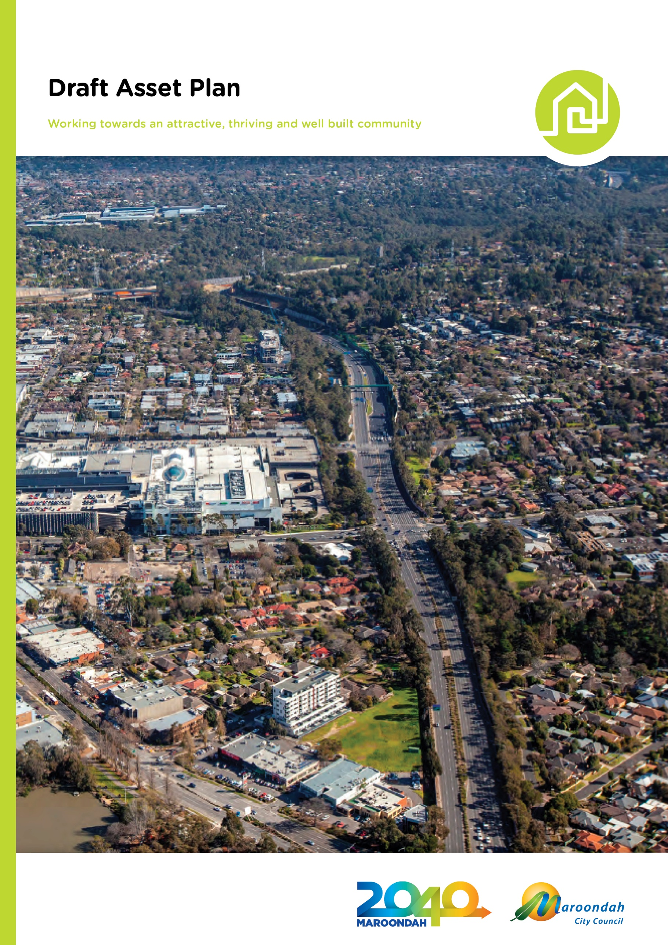

Introduction

Why is asset management important?
Council manages community assets valued at $2.1 billion in accordance with community needs and local, state and national plans, policies, legislation and standards. This represents a significant investment made over many generations, and hence, prudent management of these community assets is a core Council function to ensure long-term sustainability and the continuity of service provision to the community.

The Victorian Government has had an increasing focus on the aspect of local government sustainability, specifically as part of the Local Government Act review. This results in a growing emphasis on service planning, to determine the physical asset needs and support the delivery of a service at a defined level and affordable cost.

Council’s community assets play an integral part in supporting the delivery of a range of services to the community as summarised below:

Community Assets | Services
Roads | Vehicle and pedestrian transportation access into and within the municipality
Carparks | Public parking facilities for residents and visitors
Land (Open Space) and Park Infrastructure | Active and passive open space (i.e. parks and reserves), including all associated park infrastructure (i.e. trails, waterways, playspaces etc.) and natural environment (i.e. bushland, trees etc.)
Buildings (Community Facilities) | Various, and diverse community facilities to support a range of community based activities and services, including but not limited to children’s services, youth and family services, aged care services, disability services, arts and cultural services, sport and recreation services, waste management services, etc.
Stormwater Drainage | Collection and discharge of stormwater via stormwater pits and underground stormwater pipes
Fleet, Plant and Equipment | Support the delivery of the services summarised above

Council is governed by the Local Government Act 2020 in delivering its services to the community and managing the community assets supporting service delivery.

Asset Management Vision and Framework
Council’s Asset Management Policy outlines the following vision for asset management to support the Maroondah 2040 Community vision and outcomes to be achieved.

Council will provide assets that are accessible, safe, sustainable and responsive to the needs of the community and the contemporary environment.

This vision is supported by an asset management framework as shown below:

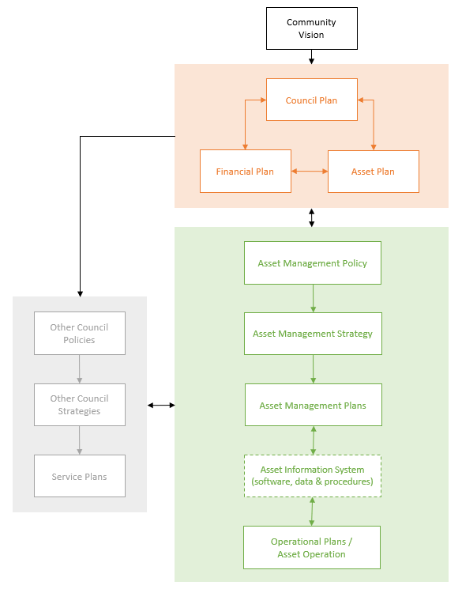

Asset Management Principles
Council is committed to best appropriate lifecycle asset management (acquisition, operation, maintenance, renewal and disposal) and will:

Embed an asset management framework aligned with Council’s vision and objectives, legislative, statutory and best practice requirements

Ensure service delivery needs form the basis of asset management within the context of best value – balancing services, financial, environmental, and social aspects

Direct the preparation of asset management plans informed by community engagement
- Ensure asset management decisions are informed, evidence based and prioritised, focusing on asset renewal, demand management and innovative and better use solutions to limit expansion of the asset base, unless justified
- Promote a culture of accountability and responsibility for asset condition, use and performance with respect to asset management and reporting to the community on outcomes
- Implement asset management systems and processes to facilitate lifecycle asset management enabling data for analysis, scenario planning, visualisation and decision making
- Establish a risk-based asset management approach to achieve a desired balance of cost, risk and performance
- Monitor and manage external forces (Political, Economic, Sociological, Technological, Legal and Environmental) for the sustainable management of assets
- Apply a continuous improvement approach to enhancing Council’s asset management maturity in alignment with International Asset Management Standards and the National Asset Management Assessment Framework (NAMAF).

The purpose of the Asset Plan
The Asset Plan is a legislated document required under section 92 of the Local Government Act 2020. It is intended to be a strategic document that informs the community on how assets are to be managed to achieve the Council Plan objectives and Community Vision statement in a financially sustainable manner.

Scope of the Asset Plan
Council manages an extensive portfolio of community assets, however this Asset Plan will cover assets shown below only.

Strategic Context
Council’s asset management approach is service driven and guided by the Community Vision, Council Plan, Financial Plan and other Council policies, strategies and plans.

The Asset Plan aligns with the Council Plan and Financial Plan to help Council achieve the long-term community vision outlined in Maroondah 2040: Our future together. The Council Plan sets the priority actions, key directions and outcomes to work towards.

Community Engagement
Our community and stakeholders play a vital role in shaping the City of Maroondah. Effective community
engagement enables Council to make well-informed decisions at an operational and strategic level and creates a better level of understanding between Council and our community.

Section 55 (2(g)) of the Local Government Act 2020 specifies that Council’s Community Engagement Policy is required to give effect to deliberative engagement practices capable of being applied to the development of the Community Vision, Council Plan, Financial Plan and Asset Plan.

The Asset Plan has been informed by the outcomes of recent engagements including the broad engagement undertaken in the development and interim review of the Maroondah 2040 Community Vision; the engagement undertaken for the Maroondah COVID-19 Recovery Plan; broad scale engagement for the Maroondah Liveability, Wellbeing and Resilience Strategy; and the deliberative engagement of a 40 member community panel.

The deliberative engagement found that our community values the assets and services provided by Council. Panel members acknowledged the breadth of assets that Council is responsible for providing and maintaining for the Maroondah community.

The Maroondah community understands that Council must make effective asset management decisions. In making future decisions, panel members encouraged Council to consider alignment with the Maroondah 2040 Community Vision; safety; impact on the greatest number of community members; and future cost (if action is not taken now) when making decisions about assets. They also expressed a desire for infrastructure to keep pace with population growth.

The community would like to have an ongoing role in informing asset management decisions for Maroondah into the future.

Future Drivers for Asset Management
The table below summarises the future drivers for asset management that may impact on Council’s ability to deliver on its community vision, outcomes and key directions priority areas:

Driver | Description | Impact to Service / Assets
Economic | - Cost of construction and maintenance of assets increasing at a rate greater than CPI.  - Rate capping impact on Council’s revenue and ability to fund the continued provision of current levels of service  - Ageing assets and increasing financial liability for funding asset renewals to ensure sustainability of service delivery  - Financial impact of COVID-19 and potential changes to future community needs and assets required for service delivery  - Potential reduction in government grants and reliance on alternate income streams for financial sustainability | Council needs to balance the affordable provision of services and assets against the needs of the community, ensuring Council’s financial sustainability is not materially impacted.
Political | - Local Government Act 2020 and increased requirements on developing an asset plan with deliberative community engagement  - Victorian Auditor-General’s Office’s (VAGO) increased scrutiny of asset management planning and practices  - Compliance with other legislative requirements and Australian Accounting Standards relating to asset management  - Improving alignment with best appropriate practice standards outlined in ISO 55001 and the National Asset Management Assessment Framework | Council needs to make considered decisions to manage competing funding demands of services and assets, ensuring Council’s financial sustainability is not materially impacted.
Social | - The population in the municipality in 2020 is estimated to be 121,218 and is forecast to grow by approximately 20% to 145,281 by 2040  - Future population growth will be mainly stimulated by housing consolidation and medium density development which will impact on the planning and upgrade of assets required for service delivery  - Consumer attitudes, preferences, needs and expectations and increased demand for quality, responsive, convenient and accessible services  - Popularity trends also significantly altering services and assets supporting service delivery, particularly in the sport and recreation space  - Communities actively engaged in decision making with respect to asset planning and affordability of levels of service being delivered | Council needs to review its services and assets to cater for the growing community and be responsive to meet changing needs.  Council will need to make investments in assets to ensure they are fit for purpose for the growing and changing needs.  Council will need to optimise the use of Council’s asset portfolio and consider partnerships for service provisions.
Technology | - Emerging technologies, digitalisation, smart cities, artificial intelligence, automation  - Internet of Things (IoT) facilitating real time asset information for capacity, utilisation and asset self-diagnosis  - Flexible working arrangements and real-time access to information in the field  - Reliance on technology to improve productivity and streamline processes  - Advanced analytics to assist with improved decision-making | Council will need to be adaptable to emerging technologies and could make data more accessible to the community.
Environment | - Climate change impact on assets and resilience of assets to extreme weather events, such as bushfires, heatwaves, droughts, flooding and rising sea levels  - Minimising the negative impacts of assets on the climate, natural environment, and human health, and where possible maximising opportunities to deliver the services provided by green infrastructure. | Council will need to continue to consider changing weather events when planning services and assets, ensuring Council’s financial sustainability is not materially impacted.

Funding for Long-Term Sustainability
The Council Plan, Financial Plan and Asset Plan, in conjunction with our asset management principles, highlight the need for Council to responsibly manage services and assets to meet the needs of the Maroondah community.

There are various drivers that influence the delivery of community assets. However, Council’s primary responsibility is to ensure its Maroondah 2040 Community Vision and Asset Management Vison are achieved.

Lifecycle Asset Management Activities
Lifecycle asset management activities allow Council to plan our budgets and track an asset’s services and performance. The lifecycle asset management activities for infrastructure covered in the Asset Plan are as follows:

Asset Management Activities | Description
Operation | Activities associated with utilising an asset to provide a service, such as workforce, energy and materials.
Maintenance | All actions necessary for retaining an asset as near as practicable to its original condition and service potential.
Renewal | Activities on an existing asset or on replacing an existing asset that returns the service capability of the asset to its original capability.
Acquisition | Activities that create a new asset or extend the capacity of an existing asset that provides a service that does not currently exist.

Lifecycle Asset Management Considerations
When prioritising lifecycle asset management activities, we reflect on our asset management principles and take the following considerations into account:

Consideration | Description
Condition | The assessment of the physical state of the asset (i.e. the physical appearance of the asset as a whole).  Council measures condition using a 1-5 grading system.  - Very Good: No signs of deterioration. No intervention required.  - Good: Minor deterioration or defects present. No immediate intervention required, manage with planned maintenance and minor renewal or rehabilitation.  - Fair: Moderate deterioration or defects. Generally able to address through panned maintenance and moderate renewal or rehabilitation.  - Poor: Significant deterioration or defects evident which may limit the assets’ ability to provide services. Significant renewal or rehabilitation required.  - Very Poor: Significant deterioration or defects evident which has a very high likelihood of impacting the assets’ ability to provide services. Significant renewal, rehabilitation or replacement required as soon as possible.
Function | The assessment of an asset’s delivery of service to the organisation and community.  Council will examine the following measures.  - Fit-for-Purpose: Does the asset meet the current service purpose well, and in the future? What constitutes a perfect asset?  - Capacity: What is the maximum level of output of an asset?  - Reliability: Does the asset consistently perform to meet the service need?  - Availability: Can the asset be used or obtained as required to provide the service?  - Best Practice design: Does the asset meet industry and environmental standards for similar services?
Utilisation | The assessment of the practical and effective use of the asset to benefit the community.  Council will examine the following measures.  - User types: Review of demographic data to determine the need for a service?  - Use number: How many users are currently / predicted to use the asset?  - Use diversity: Is the asset used by single or multiple user types?  - Frequency of use: What is the demand for the asset?
Criticality | The assessment of the service or asset risks associated with non-delivery.  Council will examine the following measures.  - Consequences: What is the consequence of the asset failing?  - Reliability: What is the likelihood of the asset developing a fault?  - Detectability: Can a fault or issue be identified prior to failure?
Cost | The assessment of the environmental and total lifecycle cost of the asset including acquisition, operation, maintenance, renewal and disposal expenditures.

State of Maroondah’s Assets
The State of Maroondah’s Assets provides a summary of the current state of Maroondah infrastructure asset groups - buildings, open space, roads and stormwater, by providing:
- Asset quantities;
- Information on how assets support Maroondah 2040;
- Information on the current replacement costs;
- Examples of lifecycle asset management activities;
- An assessment of the condition of the infrastructure assets;
- Information on the financial sustainability of the assets; and
- Identifies future improvement actions.

Buildings Asset Group
Replacement Value - $353,975,000 (at end of 30 June 2021)

Asset Details
Asset Category | Quantity
Amenities (Public Toilets) | 22
Ancillary (Sheds, Shade sails, Shelters, etc.) | 345
Community (Kindergartens, Maternal Child Health Centres, Scout Halls, Community Halls etc.) | 79
Operational (Workshops and Maintenance Offices) | 11
Recreational (Recreation Centres, Sporting Pavilions etc.) | 56
Residential (Public Housing) | 5

Maroondah 2040
The below table outlines the Maroondah 2040 community outcomes and key directions associated with the buildings asset group. These assets support the delivery of the listed key direction services and actions.

Community Outcome |  | Key Direction
Safe, healthy and active | 1.7 | Work in partnership to develop integrated health, leisure and community service hubs that support the needs of community members of all ages, abilities and backgrounds
 | 1.13 | Promote physical activity by supporting education initiatives and providing a diverse range of accessible active and passive open spaces, state of the art sporting precincts and integrated recreation facilities
Clean, green and sustainable | 4.8 | Mitigate and adapt to the risk, effects and impacts of climate change and be responsive and adaptive to new environmental opportunities and threats as they occur
Accessible and connected | 5.2 | Apply universal design principles to create a built environment that strengthens the inclusiveness and accessibility of our local neighbourhoods, activity centres, facilities and services
Attractive, thriving and well built | 6.7 | Coordinate and advocate for the increased utilisation, longevity and availability of fit for purpose community facilities and spaces that meet local needs and act as key places for neighbourhood connection
 | 6.8 | Ensure the management of infrastructure and prioritisation of capital works is informed by demographic change, technological advancement, the impacts of climate change, and accessibility for all ages, abilities and backgrounds
 | 6.9 | Plan for and support a range of multi-use community connection hubs that are inclusive, promote social interaction, encourage lifelong learning, and provide a wide range of services
Inclusive and diverse | 7.1 | Support people of all ages, abilities and backgrounds to be connected, valued and empowered within their local community through accessible and inclusive services, programming and facilities
Well governed and empowered | 8.2 | Ensure responsible and sustainable management of Maroondah’s resources, assets, infrastructure and natural environment
 | 8.7 | Embrace emerging technology, the digital economy and opportunities for innovation in the delivery of services, enhancement of assets, and engagement of the community

Lifecycle Asset Management Activities
Lifecycle Asset Management Activities | Examples of Activity
Acquisition | - Creation of new buildings and the upgrade of some buildings to deliver the vision outlined in the Croydon Community Wellbeing Precinct Masterplan  - Deliver of four (4) new multi-story activity centre car parks which are funded by the Federal Government
Operation | - Ensure electrical equipment in a building is safe  - Keep roof and gutters clean
Maintenance | - Ensure roofs and gutters are operating as intended  - Ensure water and sewer services are operating as intended
Renewal | - Heating and cooling within buildings are efficient and effective  - Building roofs are in a good condition

Asset Condition
Number

Based on modelling, 99% of the asset group fall into the fair to very good categories, with a 1% minority (or six buildings) falling within the poor category. The assets identified as having a poor condition have been scheduled for renewal over the next 5 years, as part of Council’s annual capital works Community Facilities Improvement Program. The services provided from these assets are being managed or monitored to ensure service continuity.

Lifecycle Management

The analysis shows that Council is funding the lifecycle costs of this asset group. This projection will be reviewed as part of Council’s next round of condition assessments.

Council recognises the importance of, and is committed to, the continuous improvement associated with the management of this buildings asset group to facilitate the continued provision of extensive services to the community. As such, improvement actions are identified at the end of this plan.

Open Space Asset Group
Replacement Value - $5,410,000 (at end of 30 June 2021)

Asset Details
Asset Category | Quantity
Playspaces | 158

Maroondah 2040
The below table outlines the Maroondah 2040 community outcomes and key directions associated with the open space asset group. These assets support the delivery of the listed key direction services and actions.

Community Outcome |  | Key Direction
Safe, healthy and active | 1.5 | Promote the health and wellbeing of the community through accessible and affordable initiatives and services that respond to community needs
 | 1.13 | Promote physical activity by supporting education initiatives and providing a diverse range of accessible active and passive open spaces, state of the art sporting precincts and integrated recreation facilities
Clean, green and sustainable | 4.4 | Create and foster a culture within our community that is committed to protecting and enhancing the unique features of Maroondah’s landscape, including our ridgelines, waterways, canopy vegetation, green open space and bushland reserves
 | 4.5 | Enhance Maroondah’s parklands, bushlands, gardens and open spaces
 | 4.8 | Mitigate and adapt to the risk, effects and impacts of climate change and be responsive and adaptive to new environmental opportunities and threats as they occur
Accessible and connected | 5.2 | Apply universal design principles to create a built environment that strengthens the inclusiveness and accessibility of our local neighbourhoods, activity centres, facilities and services
Attractive, thriving and well built | 6.1 | Work in partnership to deliver high quality urban design and architecture that provides for a healthy, sustainable, attractive and desirable built form
 | 6.8 | Ensure the management of infrastructure and prioritisation of capital works is informed by demographic change, technological advancement, the impacts of climate change, and accessibility for all ages, abilities and backgrounds
Inclusive and diverse | 7.1 | Support people of all ages, abilities and backgrounds to be connected, valued and empowered within their local community through accessible and inclusive services, programming and facilities
Well governed and empowered | 8.2 | Ensure responsible and sustainable management of Maroondah’s resources, assets, infrastructure and natural environment
 | 8.7 | Embrace emerging technology, the digital economy and opportunities for innovation in the delivery of services, enhancement of assets, and engagement of the community
Lifecycle Asset Management Activities
Lifecycle Asset Management Activities | Examples of Activity
Acquisition | - Asset donated to Council as part of a development
Operation | - Ensure proactive inspections are completed as per Council’s Open Space Operational Plan
Maintenance | - Ensure defects identified via proactive inspection are responded to as per set standards  - Respond to reactive customer requests
Renewal | - Playspaces are in good condition

Asset Condition
Based on current data, less than 6% of the network (or less than 10 playspaces) is in a poor condition. 94% of the network is in a fair, good or very good condition, with a majorty of this percentage falling into the fair category. The assets identified as having a poor condition are located throughout the municipality and have been scheduled for renewal over the next 5 years, as part of Council’s annual capital works Playspace Improvement Program. These assets are still being managed in the interim, so they can continue to be used by the community.

Lifecycle Management

The analysis shows that Council is funding the lifecycle costs of this asset group. This projection will be reviewed as part of Council’s next round of condition assessments.

Council also recognises the importance of, and is committed to, the continuous improvement associated with the management of this open space asset group to facilitate continued provision of service to the community. As such, improvement actions are identified at the end of this pan.

Roads Asset Group
Replacement Value - $420,597,000 (at end of 30 June 2021)

Asset Details
Asset Category | Quantity
Roads (Sealed) | 478 km total length
Roads (Unsealed) | 8.6 km total length
Carparks (Sealed) | 233,169.41 m² of surface area
Carparks (Unsealed) | 7,928.82 m² of surface area
Pathways | 997,829 m² of surface area

Maroondah 2040
The below table outlines the Maroondah 2040 community outcomes and key directions associated with the roads asset group. These assets support the delivery of the listed key direction services and actions.

Community Outcome |  | Key Direction
Safe, healthy and active | 1.2 | Plan and advocate for the application of community safety principles that facilitate a safe built environment
Clean, green and sustainable | 4.8 | Mitigate and adapt to the risk, effects and impacts of climate change and be responsive and adaptive to new environmental opportunities and threats as they occur
Accessible and connected | 5.7 | Advocate and work in partnership to enhance Maroondah’s road network, including planning for increased automated vehicles and emerging transportation technologies
 | 5.8 | Enhance Maroondah’s walking and cycling shared path network to promote walkability and strengthen connections with the wider metropolitan Melbourne network
Attractive, thriving and well built | 6.8 | Ensure the management of infrastructure and prioritisation of capital works is informed by demographic change, technological advancement, the impacts of climate change, and accessibility for all ages, abilities and backgrounds
Well governed and empowered | 8.2 | Ensure responsible and sustainable management of Maroondah’s resources, assets, infrastructure and natural environment
 | 8.7 | Embrace emerging technology, the digital economy and opportunities for innovation in the delivery of services, enhancement of assets, and engagement of the community

Lifecycle Asset Management Activities
Lifecycle Asset Management Activities | Examples of Activity
Acquisition | - Construction of missing pathway links in accordance with Council’s Principle Pedestrian Network (PPN)
Operation | - Ensure proactive Inspections are completed as per Council’s Road Management Plan  - Street and pathway sweeping
Maintenance | - Ensure defects identified via proactive inspection as responded to as per Council’s RMP  - Respond to reactive customer requests
Renewal | - Resurface roads at the optimal time to maximise the useful life  - Major patching of roads and carparks to be undertaken to protect pavement  - Resurface carparks at the optimal time to maximise the useful life  - Reconstruct failed pathways

Asset Condition

Number of segments

Based on modelling using Council’s pavement management system, approximately 97% of the asset group fall into the fair to very good categories, with a 3% minority falling within the poor category. As assets are proactively monitored and any hazardous defects are actioned in accordance with Council’s Road Management Plan to ensure service continuity. The small percentage of assets identified as having poor condition are all scheduled for renewal over the next 5 years as part of Council’s annual capital works Road Improvement, Carpark Improvement and Pathway Improvement Programs.

Lifecycle Management

The analysis shows that Council is funding the lifecycle costs of this asset group. This projection will be reviewed as part of Council’s next round of condition assessments.

Council also recognises the importance of, and is committed to, the continuous improvement associated with the management of this roads asset group to facilitate the continued provision of service to the community. As such, improvement actions are identified at the end of this plan.

Stormwater Asset Group
Replacement Value - $459,891,000 (at end of 30 June 2021)

Asset Details
Asset Category | Quantity
Stormwater Drainage Pits | 29,179 total number
Stormwater Drainage Pipes | 805 km of total length

Maroondah 2040
The below table outlines the Maroondah 2040 community outcomes and key directions associated with the stormwater asset group. These assets support the delivery of the listed key direction services and actions.

Community Outcome |  | Key Direction
Safe, healthy and active | 1.2 | Plan and advocate for the application of community safety principles that facilitate a safe built environment
Clean, green and sustainable | 4.3 | Work in partnership to ensure the long-term protection and re-naturalisation of Maroondah’s creeks and wetlands to improve water quality; streamflow; habitat connectivity and function; and adjacent surroundings
 | 4.8 | Mitigate and adapt to the risk, effects and impacts of climate change and be responsive and adaptive to new environmental opportunities and threats as they occur
Attractive, thriving and well built | 6.8 | Ensure the management of infrastructure and prioritisation of capital works is informed by demographic change, technological advancement, the impacts of climate change, and accessibility for all ages, abilities and backgrounds
 | 6.11 | Work in partnership with other catchment authorities to ensure effective stormwater management and flood mitigation across Maroondah
Well governed and empowered | 8.2 | Ensure responsible and sustainable management of Maroondah’s resources, assets, infrastructure and natural environment
 | 8.7 | Embrace emerging technology, the digital economy and opportunities for innovation in the delivery of services, enhancement of assets, and engagement of the community

Lifecycle Asset Management Activities
Lifecycle Asset Management Activities | Examples of Activity
Acquisition | - Minimise impacts to private property caused by flooding from Council’s stormwater drainage network  - Service properties not currently serviced by Council stormwater assets
Operation | - Pit cleaning  - Pipe cleaning / root cutting  - CCTV inspection
Maintenance | - Pit / Pipe Civil Repairs  - Pit / Pipe Patching
Renewal | - Replace stormwater drains at the end of their useful life  - Replace stormwater drains at failure

Asset Condition
Based on current data, less than 10% of the network is in a poor condition. 90% of the network is in a fair, good or very good condition, with a majorty of this percentage falling into the fair category. Assets with poor condition are identified reactively and issues with these assets are resolved in a timely manner to ensure service continuity. It should be noted that as these assets are long-life assets (up to 110 years), and vary significantly in terms of their service provisions (from servicing a few properties, through to servicing significant catchment areas), a higher portion of the network is expected to be within the poor category when compared to other asset groups.

In addition, as stormwater assets are buried, have a significant network quantity and may be difficult to access, obtaining current and accurate condition data for the entire network is challenging. Council’s resources for stormwater drainage assets are therefore focused on the renewal and upgrade of high risk assets (based on service provision and the consequences of any failure) to improve flood mitigation based on the extensive and sophisticated municipal wide flood modelling that Council has completed.

Lifecycle Management

The analysis shows that Council is funding the lifecycle costs of this asset group. This projection will be reviewed as part of Council’s next round of condition assessments.

Council also recognises the importance of, and is committed to, the continuous improvement associated with the management of this stormwater asset group to facilitate the continued provision of service to the community. As such, improvement actions are identified below.

Improvement Actions
The following improvement actions have been identified for all asset groups:
- Expand the asset classes included in the open space, roads and stormwater asset groups, to include further detail about the associated sub assets;
- Further improve Council’s understanding of the future service requirements associated with the community assets, and develop performance monitoring measures;
- Undertake asset condition assessments, including a review of useful lives, to facilitate more accurate decision making in relation to asset management; and
- Develop enhanced lifecycle modeling capabilities to ensure accurate projections and subsequent future budgets meet the required expenditure for service provision.

