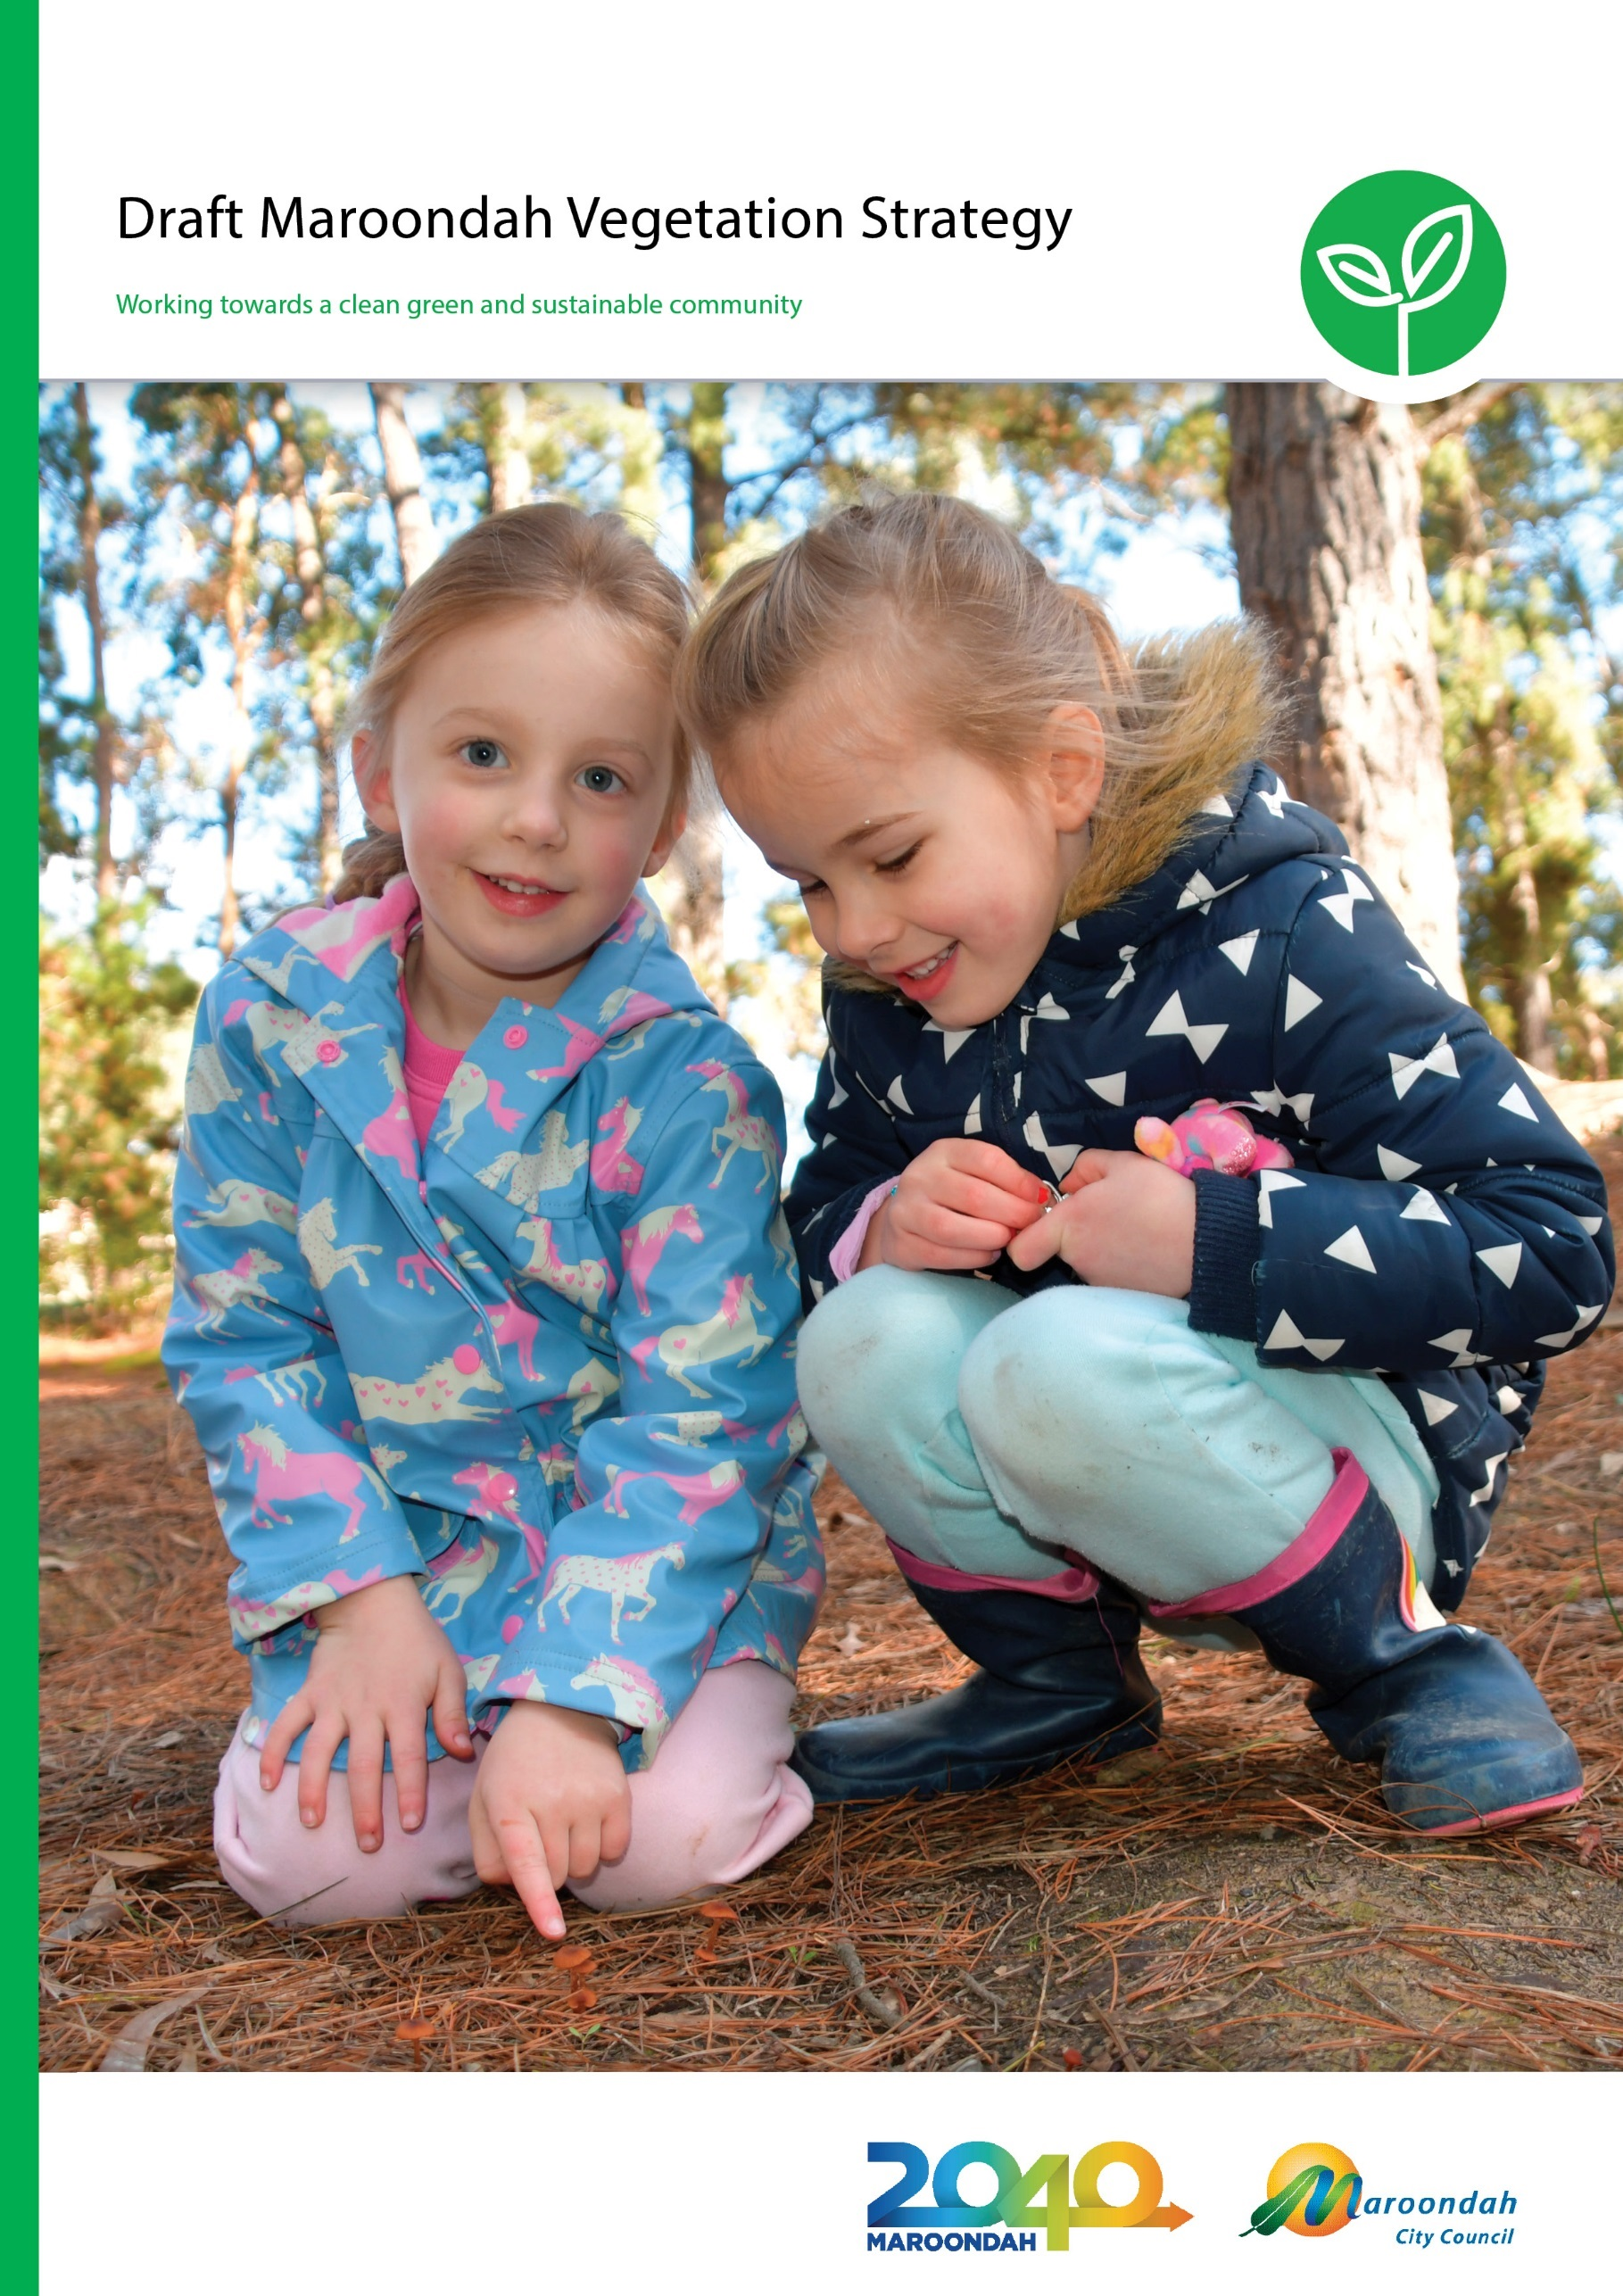

Acknowledgement of Country
Maroondah City Council acknowledges the Wurundjeri people as traditional owners of the land that now forms the municipality of Maroondah, and we pay our respect to elders past, present and emerging. The Wurundjeri people have lived in and taken custodianship of the land, water, plants, and animals of this area for many thousands of years, and maintain cultural connections to this day.

August 2019

Front cover image - Ellie V Pullin Pre-school students, Abigail and Annabelle, discover nature as part of the Bush Kinder program.

Contents
Executive Summary 4
Introduction 6
Background 9
Policy context 9
Maroondah context 13
Community input 21
Strategy Vision, Mission, and Outcomes 22
1. A more liveable Maroondah 22
2. More nature throughout Maroondah 22
3. Council support 23
A focus on fauna 23
Key Directions and Actions 27
Outcome 1: A more liveable Maroondah 27
Key Direction 1.1: Strengthen protection of existing tree canopy cover 27
Key Direction 1.2: Ensure the health and longevity of existing tree canopy cover 33
Key Direction 1.3: Increase tree canopy cover in key locations 38
Outcome 2: More nature throughout Maroondah 46
Key Direction 2.1: Strengthen protection of existing habitat 47
Key Direction 2.2: Ensure the health and longevity of existing habitat 49
Key Direction 2.3: Restore/create new habitat in key locations 55
Outcome 3: Council support 63
References 69
Glossary 70

Executive Summary
The draft Maroondah Vegetation Strategy establishes Council and the community’s vision for protecting, enhancing, restoring, and creating vegetation in Maroondah’s natural and urbanised areas. The Strategy contains actions in areas including: vegetation management and conservation, policy and planning controls, advocacy, education, and support to community.

Vision
“In 2040, more people, plants and animals in Maroondah are reaping the wellbeing and habitat benefits of abundant and diverse vegetation for healthier living and life.”

Council’s Mission
“Through direct action, strategic partnerships, and developing a community culture of custodianship, Council will lead and coordinate collaborative action to protect and extend the foundation of vegetation that supports healthier life for people, plants, and animals in a changing Maroondah.”

Extensive community engagement, detailed research, and a robust evidence base have informed the draft Maroondah Vegetation Strategy. Much of this was summarised in the Maroondah Vegetation Review Issues and Options Paper released for community feedback in February 2019. This paper helped to raise awareness of, and invite discussion across the community, of the value of our vegetation, the many benefits and ‘ecosystem services’ it provides, and the issues facing the area.
Key research undertaken for the draft Strategy was undertaken as follows:
- Biodiversity in Maroondah - Volume 1 (Biosphere P/L), 2019
- Maroondah Canopy and Landscape Analysis 2011 to 2016 (Greenspace Consultant), 2018
- Maroondah City Council: Vegetation Planning Policy Review (Claire Scott Planning), 2018

In addition, a series of fact sheets were produced as per below:
- Fact sheet 1 “What you have told us” (community feedback received via Café Consult in 2017)
- Fact Sheet 2 “Seeing the woods for the trees” (summary of tree canopy cover analysis)
- Fact Sheet 3 “Vegetation, what is it good for?” (summary of the range of benefits provided by vegetation in an urban setting)
- Fact Sheet 4 “Your vegetation and your Council” (summary of relevant policies and legal responsibilities for Council)
- Fact Sheet 5 “Pink-bells and Blue Stars: Maroondah’s Plants” (summary of the importance of Maroondah’s plants)
- Fact Sheet 6 “Sugar Gliders and Golden Whistlers: Maroondah’s Animals” (summary of the importance of Maroondah’s animals)
The Issues and Options Paper, the Fact Sheets, and thee research reports are all available for viewing on the Your Say Maroondah webpage for the Vegetation Review: https://yoursay.maroondah.vic.gov.au/maroondah-vegetation-review

Introduction
Council is committed to stewarding a ‘nature-loving’ Maroondah, an area where vegetation and nature is experienced and appreciated in its many forms by the people who live, work, and play here.
People are innately affiliated with other living things - people are a part of nature and nature is important for people and their wellbeing - and Council seeks to foster a culture of stewardship for nature that will build prosperous, healthy, and sustainable communities.
The prospect of having more native fauna, from Blue-banded Bees to Powerful Owls living in, and moving through, Maroondah is highly valued. We want to make Maroondah more liveable, where people’s health and wellbeing is improved through their connections to the natural environment.
Maroondah’s vegetation is the living greenery that includes trees, shrubs, wetland, and ground layer plants both planted and remnants of pre-settlement vegetation. Maroondah’s vegetation is diverse, as are the places it is found in - bushland reserves, creeks and drainage lines, public parks big and small, nature strips, private and public gardens, even on the roofs and walls of buildings.
All vegetation captures carbon dioxide, water, and the energy from sunlight and converts these into oxygen and stored chemical energy in the form of carbohydrates.
Indigenous vegetation is critical for Maroondah’s indigenous plants and animals, and the ecosystems that these plants and animals form provide ‘services’ that maintain our air and water quality, recycle waste, pollinate our gardens and crops, and many more. Different native animal species are adapted to, and require different habitat conditions for their survival. They need the right food, places to shelter from predators and the weather, and in many cases special places to breed and raise their young. Vegetation is fundamental to providing the habitat needs - the ‘goods and services’ - for our native animals, from food in the form of seeds, fruit, nectar, and foliage, to shelter in the form of tree hollows, dense shrubs, leaf litter, fallen logs, and grass and sedge tussocks. Many insects and other small animals that take food and shelter from these habitats, are in turn food for larger animals. Streams and wetlands are also critical for animals such as fish, amphibians, platypus, water birds, and some insect larvae.
For animals to survive in the long-term, they need enough habitat to support their local populations, and these need to be connected in ways that allow individual animals to move through the landscape so that local populations can interbreed.
Vegetation and nature is also important for human wellbeing. Visual and physical contact with nature helps reduce stress, anxiety, blood pressure and muscle tension, improves self-esteem, encourages positive feelings, and helps us recover from mental illness.
A network of safe and pleasant walking and riding routes that provide access to green spaces in an urban environment also encourages physical activity and the obvious benefits this brings to physical health. Indigenous Australians relied on food, medicine and materials from vegetation and have a deep culture of caring for nature. The practice of ‘forest bathing’ in Japan, doctors providing ‘green space’ prescriptions in the UK, and bush kinders in Victoria, all recognise and reap the health benefits of vegetation.
In an increasingly urbanised setting like Maroondah, vegetation makes the places we live, more liveable. Plants provide pleasure for our senses, not only to look at, but also smell, feel and taste. Trees provides shade and all vegetation improves the air we breathe and cools our urban areas. Natural green spaces encourage social interaction, provide tranquil places for relaxation, calm traffic on streets and improve walkability of neighbourhoods. Exposure to natural environments can also assist mental health and wellbeing. Vegetation and access to nature and green spaces make neighbourhoods more appealing places to live.
Vegetation, in particular the canopy cover of trees, is also a major contributor to the character of neighbourhoods in Maroondah. “The character of Maroondah is intrinsically linked to its natural landscape and vegetation cover These elements are cherished by the local community, provide environmental, aesthetic and health benefits, and unify the otherwise diverse residential neighbourhoods” (Maroondah Neighbourhood Character Study 2019).
Our vegetation can be seen as ‘green infrastructure’ providing a range of benefits and services for our plants, animals, and us. As with other infrastructure, it needs to be:
- Planned for to ensure it takes account of expected growth and other changes into the future
- Designed to ensure it is providing the right services where they are needed most,
- Installed/built to high standards to ensure effectiveness and longevity
- Maintained to ensure it retains a healthy condition and continues to provide the services
- Renewed when it reaches the end of its useful life.

Maroondah City Council is committed to a ‘clean, green and sustainable community’ as set out in Maroondah 2040: Our future together, and our vegetation provides the ‘green’ element.
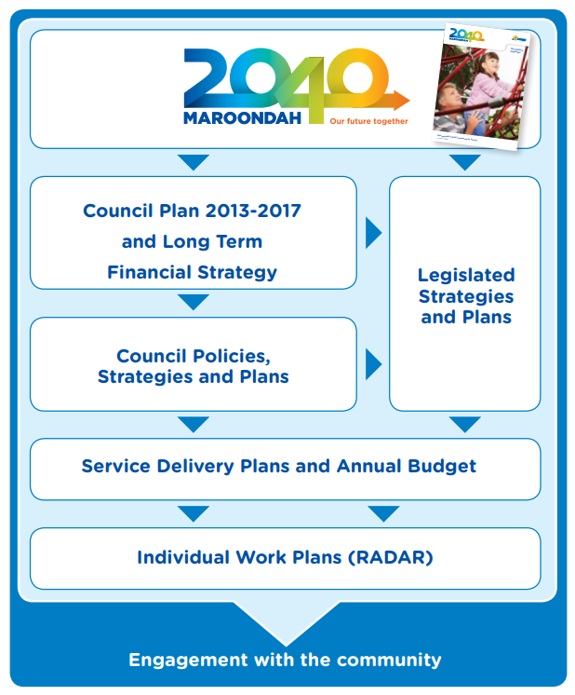In 2040, Maroondah will be a vibrant and diverse city with a healthy and active community, living in green leafy neighbourhoods which are connected to thriving and accessible activity centres contributing to a prosperous economy within a safe, inclusive and sustainable environment.” Community Vision, Maroondah 2040

Background

Policy context
In addition to Council’s existing policies and strategies, Maroondah is also influenced by a range of key Victorian Government policies and plans, and regional strategies it has signed up to. This section identifies where actions in this strategy have clear and specific alignment to the broader policy context.

Plan Melbourne 2017-2050
Plan Melbourne 2017-2050 is the Victorian Government’s metropolitan planning strategy that defines the future shape of the city and state over the next 35 years. Integrating long-term land use, infrastructure and transport planning, Plan Melbourne sets out to support jobs and growth, while building on Melbourne's legacy of distinctiveness, liveability, and sustainability.
Of the seven outcomes articulated in the plan, Outcome 6 ‘Melbourne is a sustainable and resilient city’ is the most relevant to this strategy, which include the directions:
- 6.4 Make Melbourne cooler and greener
- 6.5 Protect and restore natural habitats.
In addition, a separate 5-year Implementation Plan with 112 actions has been developed.
Overseen by the Department of Environment, Land, Water and Planning, the delivery of Plan Melbourne involves many implementing partners, including government departments, agencies and local councils. Metropolitan Partnerships and other groups will support the implementation of many of Plan Melbourne's actions, including the engagement with local communities about their priorities.
Plan Melbourne 2017-2050 is given statutory effect through amendments to the State Planning Policy Framework within the Victoria Planning Provisions.

Protecting Victoria’s Environment – Biodiversity 2037
Protecting Victoria’s Environment – Biodiversity 2037 is Victoria’s plan to stop the decline of our native plants and animals and improve our natural environment so it is healthy, valued, and actively cared for. It makes the case for increased effort and defines a modern approach to managing our biodiversity.

Biodiversity 2037 has set two goals - ‘Victorians value nature’ and ‘Victoria’s natural environment is healthy’, and includes targets of:
- All Victorians connecting with nature
- A net gain of the overall extent and conditions of habitats across terrestrial, waterway and marine environments.
Biodiversity 2037 goes on to identify several priorities, including the following of direct relevance to this strategy:
- Priority 4. Increase opportunities for all Victorians to have daily connections with nature
- Priority 5. Increase opportunities for all Victorians to act to protect biodiversity
- Priority 6. Embed consideration of natural capital into decision making across the whole of government, and support industries to do the same
- Priority 7. Help to create more liveable and climate-adapted communities.
It is supported by the Biodiversity 2037 Implementation Framework February 2018 that identifies the key implementation actions for each of the 20 priorities of Biodiversity 2037.

Victorian Public Health and Wellbeing Plan 2015–2019
The Victorian Public Health and Wellbeing Plan 2015–2019 sets out a long term agenda for improving health and social outcomes in Victoria. One of the three ‘platforms for change’ it identifies is ‘Healthy and sustainable environments’. The plan goes on to state “Healthy environments are critical to the health and wellbeing of the current and future generations. All levels of government, industry and the community across Victoria have a responsibility to support and maintain sustainable, diverse and safe natural and built environments”.
It is supported by the Implementing the Victorian Public Health and Wellbeing Plan 2015–2019: Taking action - the first two years that identifies key implementation actions for each of the Plan’s six priorities and three platforms for change.
It is also supported by the Victorian Public Health and Wellbeing Outcomes Framework that identifies relevant outcomes under Domain 6: ‘Victoria is liveable’:
- Victorians belong to resilient and liveable communities
- Victorians have access to sustainable built and natural environments.

Victoria's Climate Change Adaptation Plan 2017 - 2020
Victoria’s Climate Change Adaptation Plan 2017-2020 lays out a blueprint for action that will help Victoria meet the challenges and act on the opportunities of climate change. It sets out the Victorian Government’s priorities for leading and supporting the community to adapt to climate change, and explains how the Government will support adaptation and coordinate action on different scales (local, regional, and sectoral). It describes several new and ongoing actions under three priority areas for action. Under Priority Action 5.6 ‘Improving the resilience of our built environment’, the Plan states: “A safe and resilient built environment is essential to the wellbeing of a community”.

Water for Victoria: Water Plan
Water for Victoria is a plan for a future with less water as Victoria responds to the impact of climate change and a growing population.
The actions set out in the plan support a healthy environment, a prosperous economy with growing agricultural production, and thriving communities.
Water for Victoria sets out nine objectives, including the directly relevant: ‘Resilient and liveable cities and towns. We will help transform Victorian cities and towns into the most resilient and liveable in the world. We will include all elements of the urban water cycle in the way we plan and manage water so that Victorian communities can continue to thrive in all climates’, for which eight actions have been identified.

Healthy Waterways Strategy 2018-2028
Led by Melbourne Water, the Healthy Waterways Strategy is a shared strategy across Melbourne Water, state and local government, water corporations and the community. The Strategy provides strategic direction towards a regional vision for the health of rivers, estuaries and wetlands in the Port Phillip and Western Port region.
The Healthy Waterways Strategy was collaboratively designed, bringing together professional expertise with the lived experience of landholders, community groups, Traditional Owners, developers, and other stakeholders.
The Healthy Waterways Strategy is supported by five Co-Designed Catchment Programs that provide a flexible framework for managing waterways in each of the five main catchments of the region. Maroondah City Council was a development partner for the Catchment Programs for both the Yarra River and Dandenong Creek catchments.
These Catchment Programs describe performance objectives, key values, waterway, and vegetation conditions for the Mullum Mullum Creek and Dandenong Creek Middle sub-catchments, and Ringwood Lake.

Port Phillip and Western Port Regional Catchment Strategy
Maroondah City Council is one of 38 local governments in the Port Phillip and Western Port region. The Port Phillip and Westernport Catchment Management Authority (PPWCMA) prepares the Port Phillip and Western Port Regional Catchment Strategy (PPW RCS) and coordinates and monitors its implementation.
The region’s environmental assets are however managed by Government organisations, Councils or private landholders. The individual work of these organisations and individuals, and the collaboration between them, are key drivers of the environmental health and resilience in this region.
Local governments are invited to become PPW RCS partners by developing and agreeing on targets for the future condition of the environmental assets in their care, and to take the lead role in the efforts to achieve the targets.
In 2017 Council became a PPWC RCS partner by publicly committing to achievement of measurable targets for its vegetation, street trees and open space.

Living Melbourne: Our Metropolitan Urban Forest Strategy (2019)
The Living Melbourne: Our Metropolitan Urban Forest Strategy was developed by The Nature Conservancy and Resilient Melbourne with input from 32 metropolitan Melbourne councils, state government agencies, non-government, and community organisations. The Strategy describes a shared vision for an urban forest for metropolitan Melbourne – thriving and resilient communities, connected through nature.
Maroondah City Council has been an active contributor to its development, and in May 2019 formally endorsed its support for Living Melbourne’s Vision, Goals, and Actions, recognising that they are well-aligned to, and supportive of, the directions in the draft Maroondah Vegetation Strategy.
Living Melbourne was officially launched on 5 June 2019, with Maroondah City Council one of the 30 local government endorsing partners.
The Strategy lists six high level actions that frame twenty sub-actions. One of these actions is to “Establish and implement urban forest greening targets including, as a minimum, ‘tree canopy’ and ‘tree canopy and shrub’ cover for each region”. Targets are proposed for each of six metropolitan regions, based on a 2015 baseline.
Maroondah is in the ‘Eastern’ region along with Knox, Manningham, Monash, Whitehorse, and Yarra Ranges.

Climate Change Adaptation Roadmap for Melbourne’s East (2015)
The Climate Adaptation Roadmap for Melbourne’s East was prepared by the Eastern Alliance for Greenhouse Action (EAGA) and identifies regional priority actions to address the impacts of climate change on council operations, assets, and service delivery responsibilities. The Roadmap is informed by a regional climate change risk assessment undertaken by EAGA in August 2014.

Maroondah context
Prior to European settlement, the Wurundjeri people lived with, and cared for the land that is now Maroondah, and actively managed the native vegetation that it supported. The use of fire, and the harvesting of plants and animals, were conducted in ways that reflected a deep understanding of ecology and ensured food and other resources were provided sustainably over thousands of years. As it has ever since European settlement, Maroondah continues to change. From its early settlement days as farmland, Maroondah has evolved and is now an urbanised part of a growing metropolitan Melbourne. Evidence of the past remains in the landscape, for example, as remnants of the original vegetation, or historic orchards as relics of a farming past. For residents, their observed changes to Maroondah began when they first arrived, and the longer they have been in Maroondah, the more change they will have observed. What is less apparent to them is that their own arrival contributed to a changing Maroondah that perhaps only those before them may have observed.

Demographics and Housing
Maroondah is home to 117,396 residents made up of diverse cultures occupying 44,227 households, and 9,000 businesses that employ 36,000 people. Maroondah’s population is growing steadily (between 2013 and 2108 the resident population grew by an average of 1,526 people per year) and is expected to continue to grow to 146,335 by 2041. Residential development forecasts predict the number of dwellings in Maroondah will increase by an average of 618 dwellings per annum to 60,161 in 2041 (source: profile.id.com.au accessed 10.5.19). The Maroondah Housing Strategy, adopted by Council in 2016, provides more detail.
Maroondah’s population is also ageing with the average age increasing from 35 in 2001 to 38 in 2016 and estimated to reach 43 in 2041 (Maroondah Housing Strategy). As people age they often become less mobile and more vulnerable to heat stress and other medical conditions. Not only is our population ageing, based on Maroondah’s development history, so are large proportions of our housing stock. The older parts of Maroondah expanded around Ringwood and Croydon from the 1950’s, with the outer areas of Maroondah developed later in the 1970’s and 1980’s onwards. As housing stock passes 50 years of age the likelihood of being redeveloped increases markedly. The Maroondah Active & Healthy Ageing Initiative launched in 2015 details a range of Council initiatives to support an ageing population.

Changing Climate
Climate projections for the eastern region of Melbourne suggest that by 2055 the average annual surface temperature will have increased by between 0.8-1.5⁰C, and the average annual rainfall will have reduced by between 5.1% to 7.5%. In addition, droughts are expected to be more severe and last longer, the number of hot days is expected to increase, and although expected to be fewer in number, rainfall events are expected to be more extreme with more intense floods (Source: CSIRO (2013) Climate Futures for Eastern Melbourne - study for the Eastern Alliance for Greenhouse Action’s Bushland and Urban Biodiversity Management in a Changing Climate project).
More hot days will exacerbate existing health risks, increasing pressure on hospitals and emergency services. The urban heat island will add to heat stress. Vulnerable groups may need assistance to manage extreme heat and flooding. More frequent extreme weather events and impacts on the economy and jobs may affect the community’s mental health.
These changes are expected to amplify the existing threats to flora and fauna, including changes to habitat (such as drying of soils), and changing dynamics of weed and pest animal species.
The Maroondah Climate Change Risk and Adaptation Strategy 2018/19-2021/22 establishes a plan of action enabling Council to prepare for the long-term risks of climate change. It is guiding Council’s efforts to integrate climate change risk management and adaptation.

Challenges to Existing Vegetation
Maroondah’s vegetation competes for space alongside urban development, the associated services infrastructure (eg roads, footpaths, electricity supply, water, and sewer), and community assets for recreation and other purposes.
This is evident in recent analysis of Maroondah’s significant tree canopy cover.
Maroondah boasts one of the highest tree canopy cover levels of all the Melbourne metropolitan municipalities.
The Living Melbourne: Our Metropolitan Urban Forest Strategy (April 2019) estimated the overall tree canopy cover for metropolitan Melbourne at 15.4%, and shrub cover at 15.1% using remote sensing data from 2015. For the Maroondah municipality, the estimates were much higher than average with 29% tree canopy cover, and 18.9% shrub cover.
The Maroondah Canopy and Landscape Analysis 2011 to 2016 supported this finding of high canopy cover by estimating Maroondah’s tree canopy cover in 2011 as 26.2% and in 2016 as 27.1% (using the i-Tree statistical sampling method).
The Maroondah analysis also estimated changes in cover of tree canopy, shrub, grass/bare earth, and hard surfaces between 2011 and 2016, and found that between 2011 and 2016, Maroondah experienced a small (0.8%) increase in overall tree canopy cover. However the dynamic nature of canopy cover was revealed in that gains were made in some locations but losses were identified elsewhere. The analysis suggests that much of the gains are likely to be existing canopy trees growing older and increasing the size of their crowns rather than an increased number of canopy trees in the ground. The canopy cover losses are most likely to be the result of removal of canopy trees rather than reductions in tree crowns, suggesting that Maroondah’s overall total number of trees is likely to be reducing in number.
It also found that the greatest losses occurred in grass/bare earth areas, which were converting mainly to hard surfaces and not to shrub or tree cover.
Although the Maroondah-wide net retention of canopy cover result is good news, these results also suggest that we are drawing down on the stock of next generation canopy trees (assuming some of the ‘shrub’ cover includes young canopy trees).
The increasing cover of hard surfaces equates to a corresponding reduction in area of ‘permeable’ land surface. This is compromising our ability to supply and sustain the next generations of canopy trees and shrubs as the soil and space they need to grow in is being lost, and less of the water needed to sustain them is able to infiltrate into the soil.
Our existing canopy trees will not live forever, and without an adequate tree renewal program to provide replacement canopy cover as existing trees approach the end of their life expectancy, Maroondah’s overall canopy cover will reach a tipping point whereby canopy will begin to decline and could do so quite rapidly.

The primary factors leading to tree canopy losses in Maroondah include:
- Removal of trees to manage risk (real and perceived) and nuisance (eg fire, safety, tree death, building and infrastructure damage)
- Cut and fill of land for developments on slopes resulting in much wider impact than the building footprint
- Removal of trees for new construction
- Drying of naturally wet soils, and lowering of water table, due to changes in drainage and less rain
- Death and decline of stringybark eucalypt species

There is also growing competition for land used as public open space. The City of Maroondah is currently home to 650ha of open space enjoyed by the community in the form of 430 reserves including conservation areas, regional parks, trails, sporting fields, neighbourhood parks and more. Whilst this has grown from 540ha in 2005 there continues to be more residents, workers and visitors needing to use these spaces, and new developments to accommodate residential growth. Open space contributions from these developments need to be strategically targeted to support Council’s open space acquisitions and capital improvements program consistent with its policy.
Maroondah’s Open Space Policy 2016 makes several policy position statements, including:
Open Space Planning will:
- deliver diversity in recreational activities and sporting opportunities through well planned public open spaces which contribute to improved community health, physical activity, and neighbourhood connection.
- establish an integrated network of trails across the municipality that provides connectivity for travel purposes as well as for recreational use.
- identify opportunities for strategic land acquisitions which would improve the accessibility, connectivity, natural environment, and functionality of Maroondah's open spaces.
Open Space Development will:
- seek to preserve and rehabilitate natural bushland environments, wildlife corridors and remnant vegetation to nurture a sustainable environmental system.
Open Space Management will:
- actively protect and nurture the health of natural environments containing significant trees, waterways and native flora, fauna, and habitat.

Biodiversity Decline
Biodiversity is in decline globally and locally.
At the global scale, up to 1 million species of the total number of animal and plant species on Earth, estimated at 8 million, are threatened with extinction, many within decades.
Over 500,000 of the world’s estimated 5.9 million terrestrial species don’t have enough habitat for long term survival without habitat restoration.
Much of this is put down to human actions that have caused habitat loss and deterioration, climate change, and an increase in numbers of invasive alien species (Source: Global assessment report on biodiversity and ecosystem services - Intergovernmental Science-Policy Platform on Biodiversity and Ecosystem Services (May 2019)).
The 2018 Victorian State of the Environment Report tells a similar tale for Victoria: “Victoria’s biodiversity – the number of animal and plant species our environment supports – has seriously decreased over the past two centuries. The loss has come from land clearing, fire, pest plants and animals, land development, river regulation, water pollution, and more recently, reduced resilience under climate change. Many of our native species are now threatened, and native vegetation continues to be lost”.
Declines in biodiversity occur through the disappearance of species, communities, or genetic variants. Loss of species has been happening at varying rates in Maroondah ever since European settlers began clearing the land. It has also been happening on a more localised scale in each of Maroondah’s patches of natural and semi-natural habitat. The comprehensive report “Biodiversity in Maroondah 2019” makes this explicit.
Indigenous Plant Diversity
Of the 563 plant species (including named hybrids and sub species) recorded for Maroondah, 80 species are now presumed to be locally extinct, with another 172 species considered to be critically endangered locally.
Forty species (out of 92) of orchid have been lost, with another 32 species considered critically endangered locally.
Eleven species (out of 45) that are specially adapted to winter-sodden/summer-dry floodplains have also been lost, with the remaining 34 species all considered critically endangered locally.

Indigenous animal diversity
Of the 200 vertebrate animal (mammals, birds, reptiles, amphibians, and fish) species recorded for Maroondah, 33 species are not expected to return in the foreseeable future (in effect, locally extinct), with another 12 species not recorded for at least 20 years.
An additional 13 indigenous bird species have seen a major decline in records since 1997. Conversely seven indigenous bird species have seen a major increase in records since 1997.
Of 22 butterfly species recorded, all but two are in decline.

The primary factors leading to biodiversity losses in Maroondah include:
Loss of habitat
- Removal of habitat (typically native vegetation) for new construction
- Removal of habitat (typically native vegetation) to manage risk (eg fire, safety, building and infrastructure damage).
Isolation of habitat
- Fragmentation of habitat – leading to reduced area, increased isolation
- Specialist species losing critical dependencies – eg pollinators, fungi, hollows
- Decline in habitat condition (less species or structural diversity)
- Drying of naturally wet soils, and lowering of water table, due to changes in drainage and less rain
- Competition and displacement by key non-indigenous species (environmental weeds)
- Offsite impacts of development – runoff, erosion, pollution, domestic pets, increased people traffic impacting on adjacent habitat
- Death and decline of stringybark eucalypt species - leading to spread of introduced species and/or loss of important habitat structural elements.
Natural habitats are the physical, chemical, and biological systems that support our biodiversity. More simply put, habitats are the places where these organisms live.
As a result of changing land uses from farming to residential and commercial development, the original natural habitats that once covered Maroondah, have been reduced to scattered small pockets of remnant vegetation

Victorian Government Land Use Planning Reforms
Several new land use planning reforms have been introduced in recent years by the Victorian Government that have relevance for vegetation.
In December 2017, the Victorian Government introduced Amendment VC138 Native Vegetation Framework to implement changes to Victoria's native vegetation removal regulations.

In July 2018, the Victorian Government introduced Amendment VC148 which represents a significant overhaul of the Victorian Planning Provisions. Designed to modernise and simplify the Victorian Planning System, Amendment VC148:
- Introduces a new Planning Policy Framework (PPF)
- Enables the future introduction of a Municipal Planning Strategy (MPS)
- Simplifies the VPP structure by:
  - restructuring particular provisions
  - integrating VicSmart into applicable zones, overlays, and particular provisions
  - consolidating operational and administrative provisions
- Amends specific zones, overlays and particular provisions to improve their structure and operation, and to support the future translation of Local Planning Policy Frameworks (LPPFs) to the MPS and PPF.
In October 2018, the Victorian Government introduced Amendment VC154 Stormwater Management to implement integrated water management reforms.
In April 2019, the Victorian Government introduced Amendment VC136 Better Apartments Design Standards that implements state-wide planning requirements for apartment developments.
These amendments represent significant changes, and will require Maroondah to update key sections of its planning scheme. The amendments also present key opportunities to refine and improve Maroondah’s planning controls that relate to vegetation. A well-informed community and well-prepared Council staff can support the smooth introduction of significant changes.

Community input
The future provision of a substantial, healthy, and inter-connected ‘green and leafy environment’ for our community is fundamental to maintaining the essential services vegetation can and does provide the Maroondah community.
Through consultation undertaken by Council to date for this strategy people have said that they highly value Maroondah’s vegetation and the services it provides them. The top three responses collected at Café Consult in 2017 for why they value vegetation where “Native plants and animals”, “Clean air“, and “Shade and cooling”.
Council have also heard from the community that it is important for vegetation to be managed to prevent degradation from weeds and pests, to prevent trees dying, to prevent trees causing damage to buildings and paths, to manage safety risks, and to protect waterways.
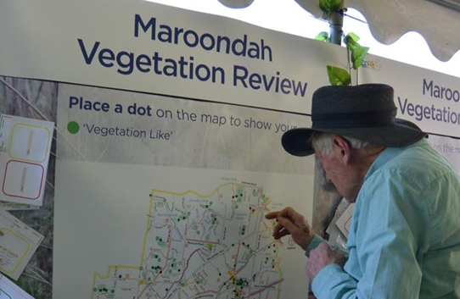
There are numerous opportunities for Maroondah to navigate the coming changes and create the green and leafy future Maroondah we desire. Grasping these opportunities, and creating more, require a partnership approach between Council, businesses, developers, residents, and the wider community - to join forces in elevating the importance of vegetation, establishing a culture of collaboration and custodianship, and together finding new and innovative ways of doing things, facilitated by a willingness to innovate, change, and adapt.

Strategy Vision, Mission, and Outcomes
Based on the wide range of evidence collected, this strategy sets the following vision for vegetation in Maroondah, and Council’s mission for achieving the vision.
Vision
“In 2040, more people, plants and animals in Maroondah are reaping the wellbeing and habitat benefits of abundant and diverse vegetation for healthier living and life.”
Council’s Mission
“Through direct action, strategic partnerships, and developing a community culture of custodianship, Council will lead and coordinate collaborative action to protect and extend the foundation of vegetation that supports healthier life for people, plants, and animals in a changing Maroondah.”

To achieve the vision, and fulfil Council’s mission, three key outcomes are sought to help create a greener and leafier Maroondah for health, wellbeing, and biodiversity, as detailed below:

1. A more liveable Maroondah
More vegetation, especially an extensive and connected canopy of trees providing shade, cooling, pleasant and tranquil green spaces, water absorption, and habitat elements, that supports community health and wellbeing by helping people connect with nature, avoid heat-related illnesses, reduce anxiety and stress, avoid flooding issues, and engage in outdoor physical activity (walking/riding/playing).

2. More nature throughout Maroondah
More vegetation, in the form of a well-connected network of indigenous trees, shrubs and understorey plants providing a wide range of habitat elements such as the food, shelter, and opportunities to move through the landscape that native flora and fauna in Maroondah need to flourish, and simultaneously create more opportunities for people to encounter and connect with nature close to where the live, work and play.

Council’s role in vegetation management
All types of vegetation play a role in achieving these outcomes, and Council has responsibilities that influence vegetation management in four key areas:
- Planning and management of vegetation public assets and open spaces
- Administration of the planning scheme that guides Maroondah’s ongoing growth and development
- Providing information and support to guide community action
- Leadership and influence.
Achievement of the two key outcomes above can be well supported by a Council that has organisational arrangements that provide clarity of purpose, facilitate collaboration, and drive action. As such we also aim to achieve a third, foundational outcome.

3. Council support
Council has clear policy and direction that supports implementation of this Strategy with a focus on the importance of vegetation collaborative action, and measurable targets coupled with monitoring and reporting of progress.

A focus on fauna
Council appreciates the importance of a suite of focal fauna species – recognisable species that can potentially be encountered in Maroondah if their habitat needs are provided, and species that people will want to seek out, connect to, and take delight in discovering.
Although the Maroondah municipality is highly urbanised, it still retains numerous, relatively small patches of remnant vegetation that provide critical habitat for native fauna, and is bounded by larger areas of key habitat supporting even more native fauna in neighbouring municipalities.
This provides the real opportunity to attract and spread more native fauna throughout Maroondah if we can provide the range of habitat elements, and the habitat connectivity, that different fauna species need to survive and disperse.
From Blue-banded Bees and Sugar Gliders, to Powerful Owls and Short-finned Eels, there is value in short-listing potential species with the aim of landing on a suite of species that occur in and around Maroondah, and that we have a realistic chance of attracting into, and spreading through, Maroondah. By selecting a suite of species that together have a diverse range of habitat needs, when we provide their habitat needs, we also provide for many other species. The following two pages present 24 candidate species for our suite of focal species.
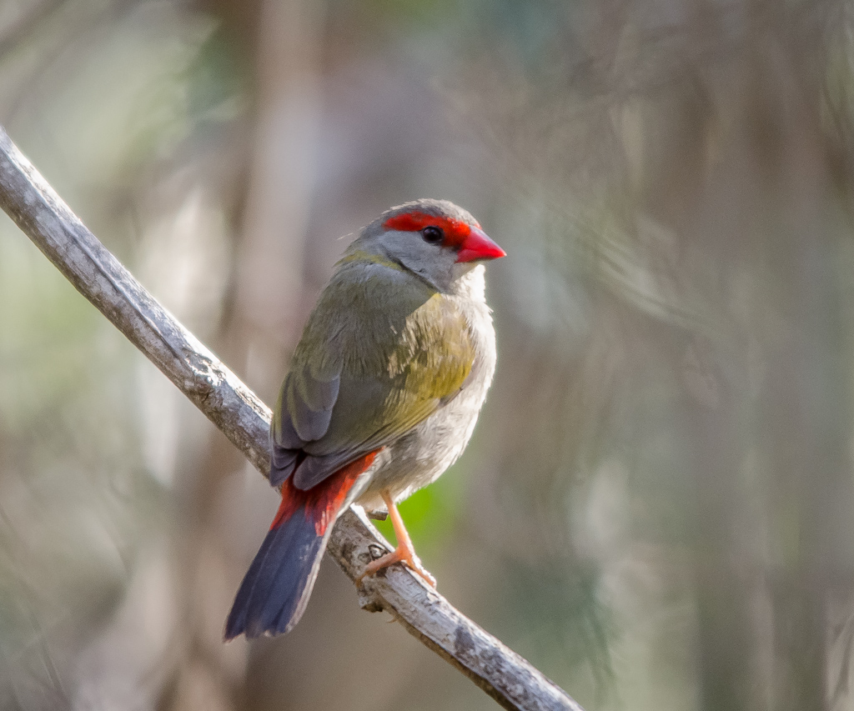
Red-browed Finch
feeds on seeds and insects, and needs shrubs, grasses and leaf litter for feeding, shelter and breeding
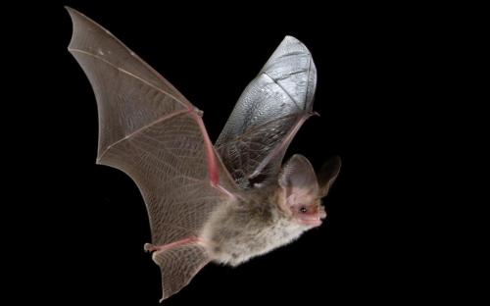
Lesser Long-eared Bat
feeds on flying insects, and needs tree hollows and cracks for shelter and breeding
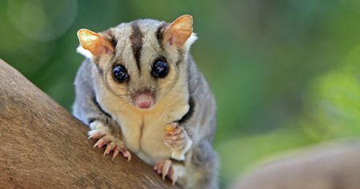
Sugar Glider
feeds on pollen, bark sap, and insects and need tree foliage and hollows for feeding, shelter and breeding
Rakali
feeds on aquatic animals, and needs waterbodies, with dense low surrounding vegetation, and hollow logs and creek banks for feeding, shelter and breeding

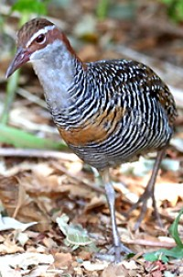
Buff-banded Rail
feeds on frogs and invertebrates, and needs waterbodies, with dense low surrounding vegetation for feeding, shelter and breeding

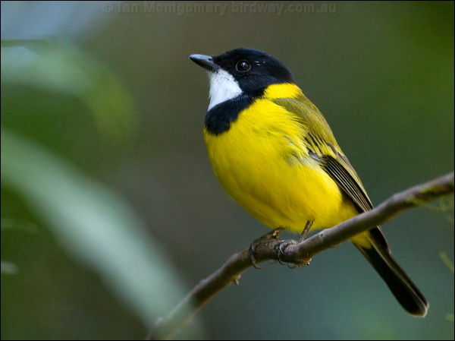
Golden Whistler
feeds on insects on canopy foliage and bark, and needs tree and shrub foliage for feeding, shelter and breeding
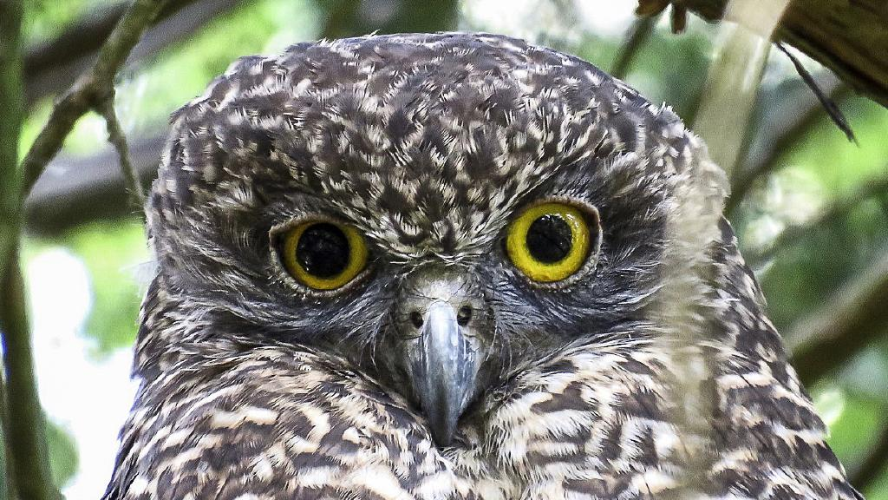
Powerful Owl
feeds on possums and other arboreal mammals, and needs large trees, canopy foliage, and large tree hollows for shelter and breeding
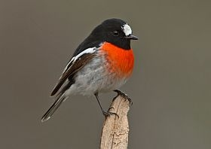
Scarlet Robin
feeds on insects, and needs canopy and shrub foliage and bark, grasses and leaf litter, and tree branch forks, for feeding, shelter and breeding

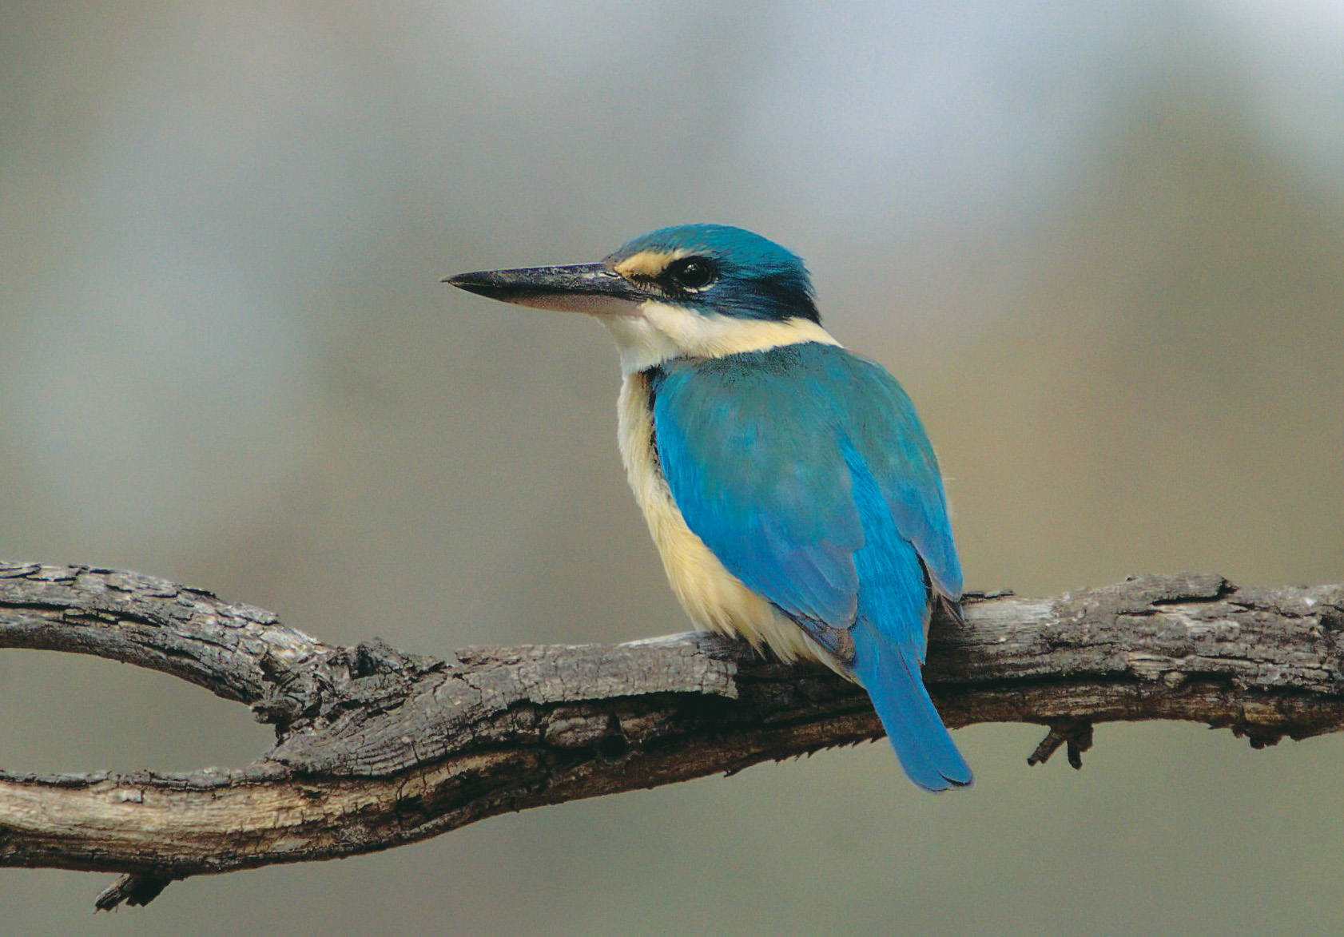
Sacred Kingfisher
feeds on insects, fish, and frogs, and needs waterbodies with surrounding vegetation and creek banks, and tree hollows, for feeding, shelter and breeding

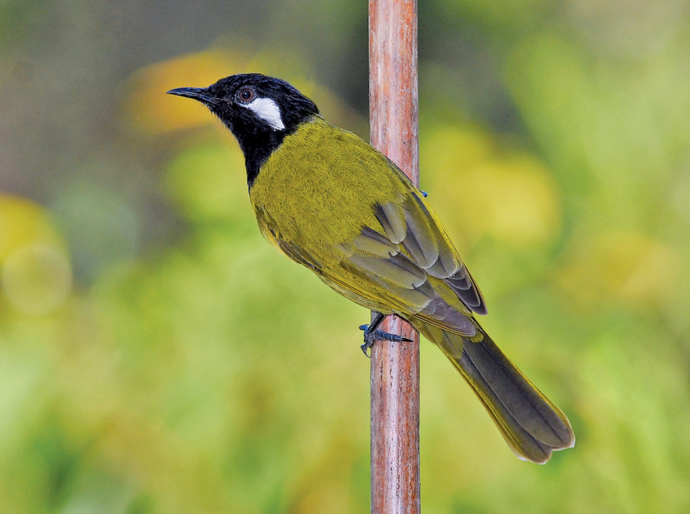
White-eared Honeyeater
feeds on nectar and insects in tree and shrub flowers and foliage, and needs shrub foliage for shelter and breeding
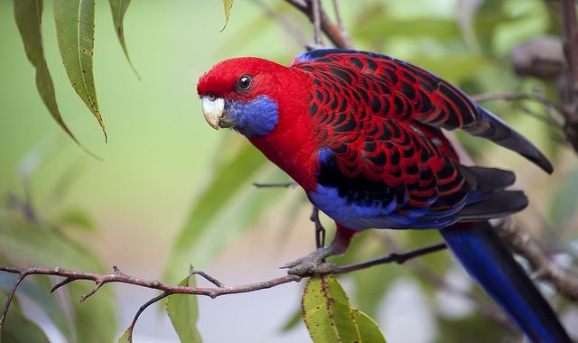
Crimson Rosella
feeds on fruit, seeds and berries, and needs canopy, shrub and grass foliage and flowers, and tree hollows, for feeding, shelter and breeding
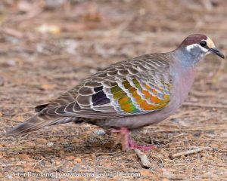
Common Bronzewing
feeds on seeds off the ground, and needs trees, shrubs and leaf litter for feeding, shelter and breeding

Candidate focal fauna species

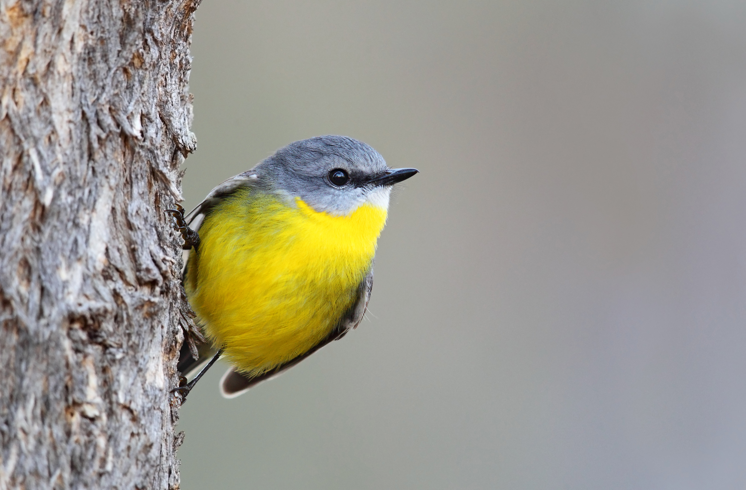
Eastern Yellow Robin
feeds on insects, and needs bark, shrubs, grasses and leaf litter for feeding, shelter and breeding
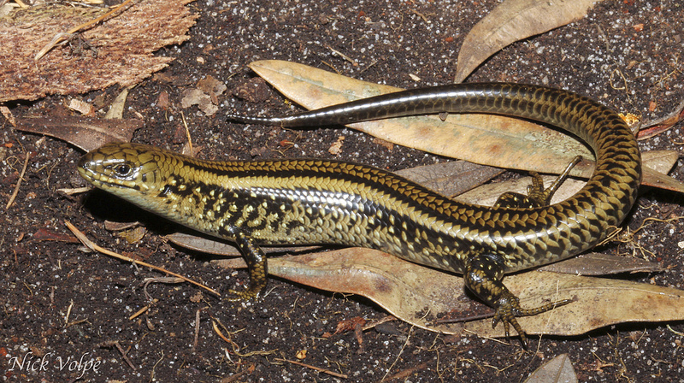
Swamp Skink
feeds on insects, and needs waterbodies with dense surrounding groundlayer vegetation, leaf litter and logs, with sparse canopy for feeding, shelter and breeding
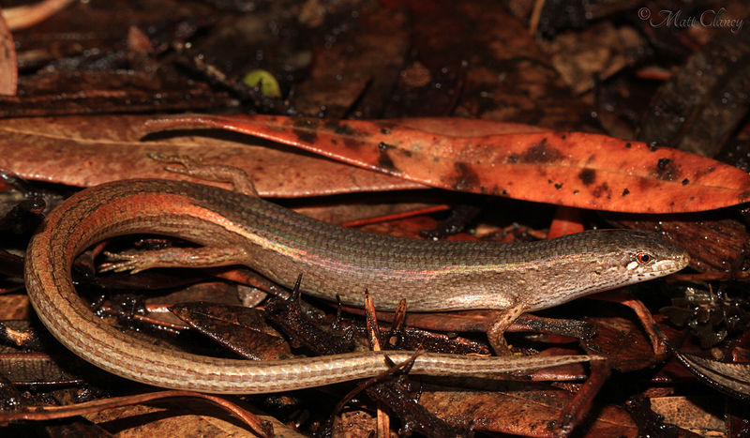
Weasel Skink
feeds on insects, and needs dense groundlayer vegetation, leaf litter and logs for feeding, shelter and breeding
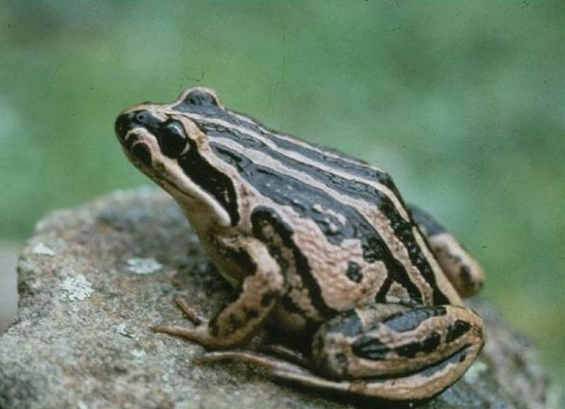
Striped Marsh Frog
feeds on insects as adult, and aquatic vegetation as tadpole, and needs waterbodies with emergent and surrounding vegetation and logs for feeding, shelter and breeding
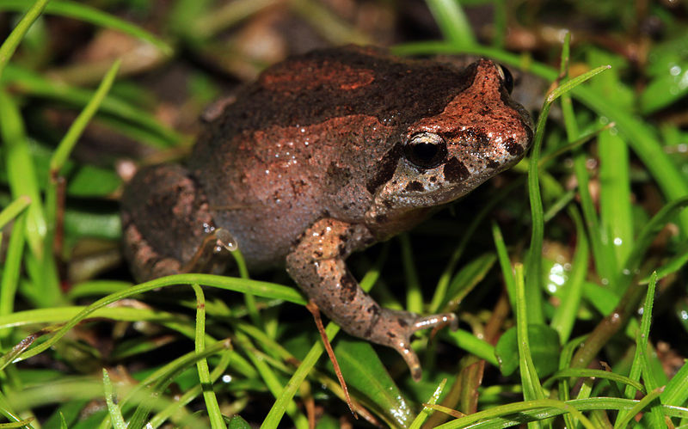
Victorian Smooth Froglet
feeds on insects as adult, and aquatic vegetation as tadpole, and needs ephemeral wetlands with surrounding vegetation and leaf litter for feeding, shelter and breeding

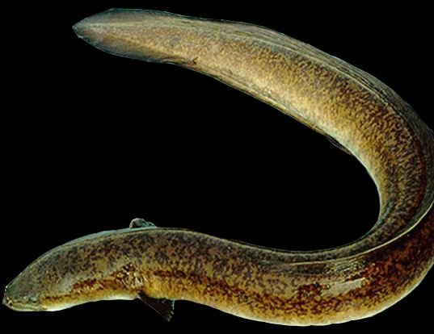
Short-finned Eel
feeds on aquatic animals, and needs waterbodies with connectivity to the sea in spring/summer, and aquatic and shading riparian vegetation for feeding, shelter and breeding
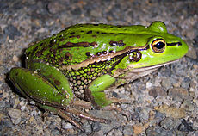
Growling Grass Frog
feeds on insects as adult, and aquatic vegetation as tadpole, and needs waterbodies with emergent and surrounding vegetation and logs for feeding, shelter and breeding
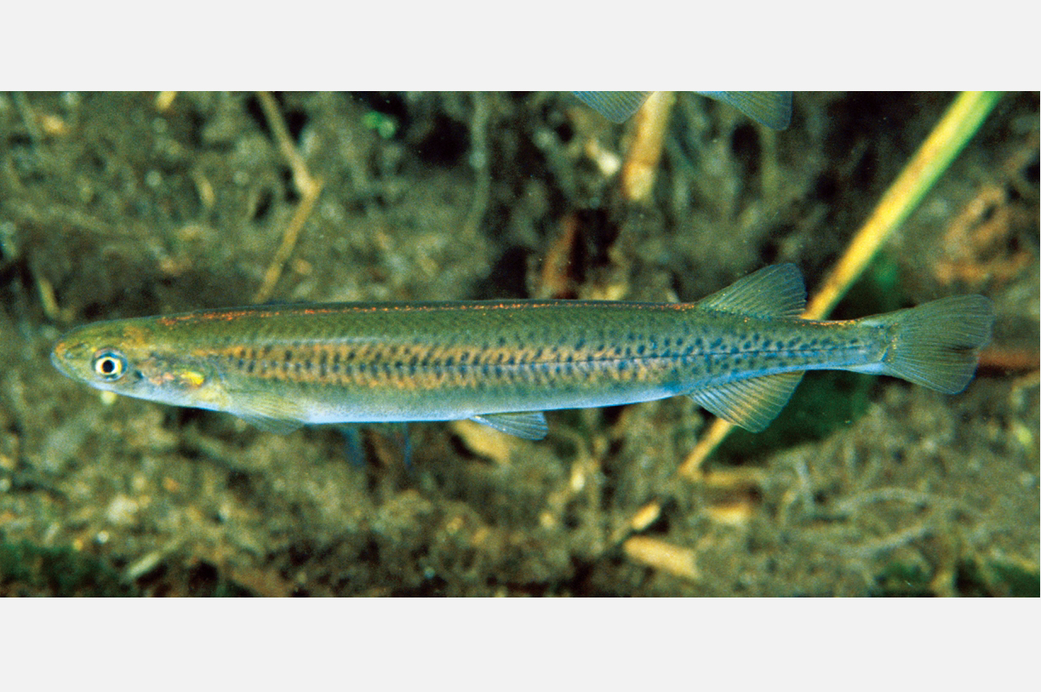
Common Galaxias
feeds on aquatic invertebrates, and needs slow-moving streams with connectivity to the estuaries in autumn, and dense aquatic vegetation and shading riparian vegetation for feeding, shelter and breeding

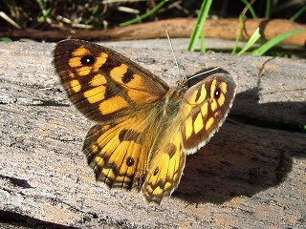
Klugs Xenica (Butterfly)
feeds on nectar as adult and native grass foliage as caterpillar, and needs tree, shrub and groundlayer flowers, and native grasses for feeding and breeding
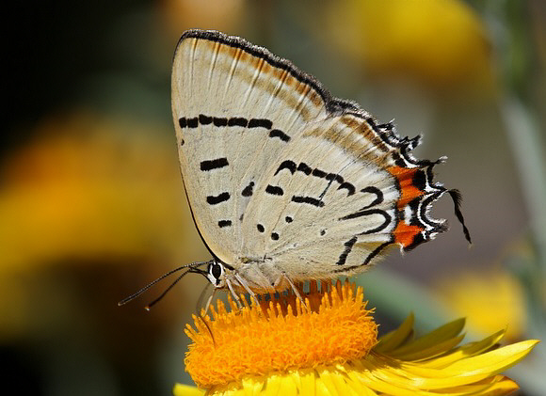
Imperial Hairstreak (Butterfly) (feeds on nectar as adult and wattle foliage as caterpillar, and needs tree and shrub flowers, wattle foliage, and a particular type of ant for feeding and breeding
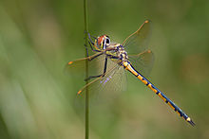
Tau Emerald (Dragonfly)
feeds on flying insects as adult and aquatic invertebrates as larva, and needs permanent and ephemeral wetlands with surrounding vegetation for feeding and breeding

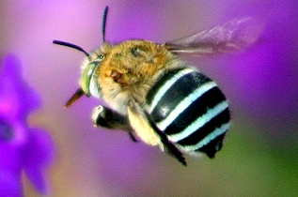
Blue-banded Bee (feeds on nectar, and needs tree, shrub and groundlayer flowers, and soft clay or dirt banks for feeding and breeding

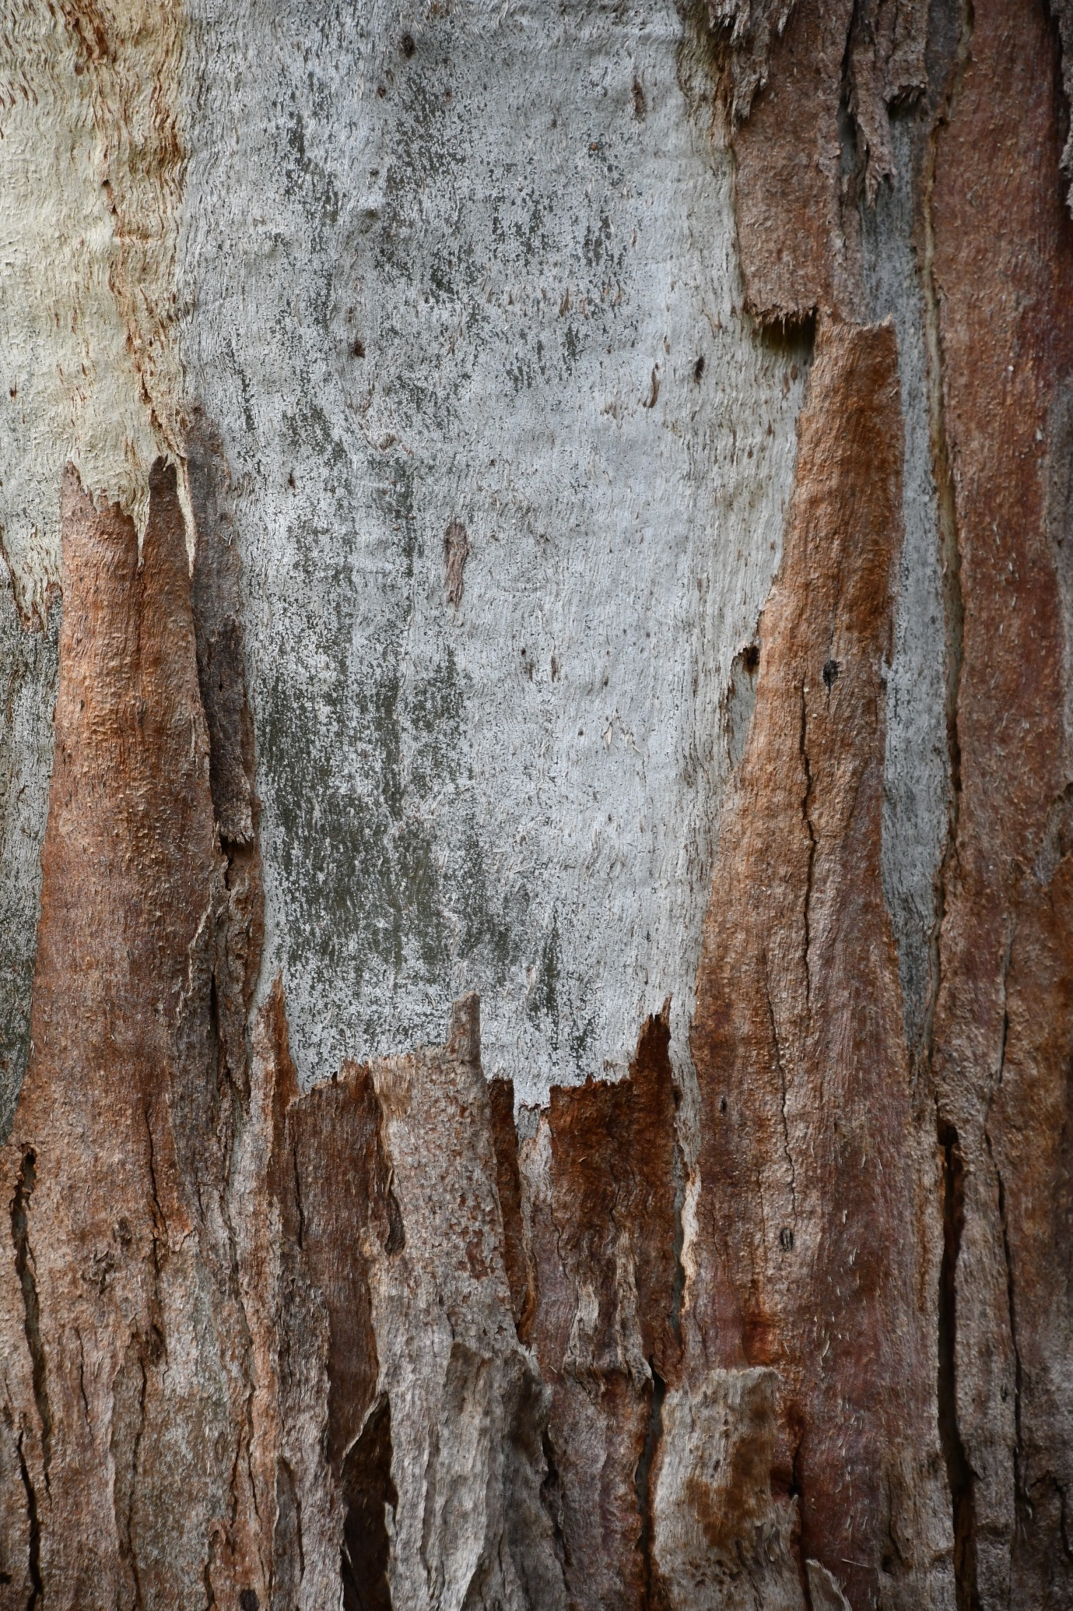

Key Directions and Actions

Outcome 1: A more liveable Maroondah
Vegetation, especially an extensive and connected canopy of trees providing shade, cooling, pleasant and tranquil green spaces, water absorption, and habitat elements, that supports community health and wellbeing by helping people connect with nature, avoid heat-related illnesses, reduce anxiety and stress, avoid flooding issues, and engage in outdoor physical activity (walking/riding/playing)
To achieve this, we aim to provide more tree canopy cover and other vegetation that is healthy, long-lived, and is the right vegetation in the places it is needed most for reducing heat vulnerability, alleviating stress, mitigating flooding, and encouraging outdoor activity.
This requires us to protect the existing tree canopy whilst accommodating residential growth, ensure its health and longevity, and add new trees at a rate greater than foreseeable losses, with a focus on the locations where their community health and wellbeing benefits are most needed.
Key Directions
  - Strengthen protection of existing tree canopy cover
  - Ensure the health and longevity of existing tree canopy cover
  - Increase tree canopy cover in key locations

Key Direction 1.1: Strengthen protection of existing tree canopy cover
Trees on private land provide a large proportion of Maroondah’s highly valued tree canopy cover, but these trees are also the most vulnerable to residential development pressures as Maroondah’s population continues to grow. Accordingly, there is a need to minimise tree losses by strengthening protection of existing tree canopy cover in ways that still allow Maroondah to accommodate increased residential growth.

Land with a focus on commercial or industrial use is more intensively developed and has a lower proportion of tree canopy cover than most other parts of Maroondah, with many of the existing canopy trees often found in carparks. Carparks and the space they occupy are also prime targets for new commercial developments. Commercial areas are places where people congregate, and the protection and provision of tree canopy cover in commercial area carparks present a key opportunity for providing liveability benefits of vegetation to the people they attract.
Outside of the sites of Biological Significance identified in “The Biodiversity of Maroondah, 2019”, much of the existing tree canopy (and other vegetation) on residential land is afforded protection, and the need for a permit to remove, by the Significant Landscape Overlays (SLO’s) Maroondah currently has in place.
Planning scheme protection of canopy trees and other vegetation on residentially zoned land may be best served by retention of the SLOs, but with strengthening of the associated schedules and decision-guidelines. Planning scheme protection of canopy trees and other vegetation in commercial and industrial areas can be served by extending the coverage of Maroondah’s planning provisions into these areas.

Priority Action: 1.1.(a)
Amend the planning scheme to strengthen planning controls that protect canopy trees on private and commercial land.
Living Melbourne: Our metropolitan urban forest:
Scale up greening in the private realm. Action 3.2 Strengthen regulations to protect canopy trees
Plan Melbourne 2017-2050: Action 91
Whole-of-government approach to cooling and greening Melbourne. Create urban forests throughout the metropolitan area by:
- assembling and disseminating spatial data on the green space network, existing tree cover and surfaces. This data will be the baseline for modelling future greening strategies and their impacts on amenity of our urban areas including cooling effects
- working with local government to establish greening targets for each of the metropolitan regions
- liaising with water corporations to identify opportunities for use of alternative water supply ton support greening strategies
- supporting development of municipal urban forest strategies using a coordinated approach with VicRoads, private road operators and other public land owners and managers
- preparing greening strategies for state-owned public land, including schools, parkland, road, rail, and utility corridors, achieving an appropriate balance between asset protection and urban greening
- investigating a targeted grants program to support innovation and actions for greening neighbourhoods
- investigating demonstration projects including green roofs, green walls, and landscapes
- preparing new guidelines and regulations that support greening new subdivisions and developments via landscaping, green walls, green roofs and increase the percentage of permeable site areas in developments
Living Melbourne: Our metropolitan urban forest:
Scale up greening in the private realm. Action 3.1 Strengthen regulations to support greening in new subdivisions and developments – to benefit human health and wellbeing, and increase biodiversity
Living Melbourne: Our metropolitan urban forest:
Collaborate across sectors and regions. Action 4.2 Mobilise broad community support
Living Melbourne: Our metropolitan urban forest:
Collaborate across sectors and regions. Action 4.3 Foster and promote urban forest champions, in both the public and private sectors
Living Melbourne: Our metropolitan urban forest:
Build a toolkit of resources to underpin implementation. Action 5.1 Build the capacity of public and private sector practitioners to protect, enhance and expand the urban forest

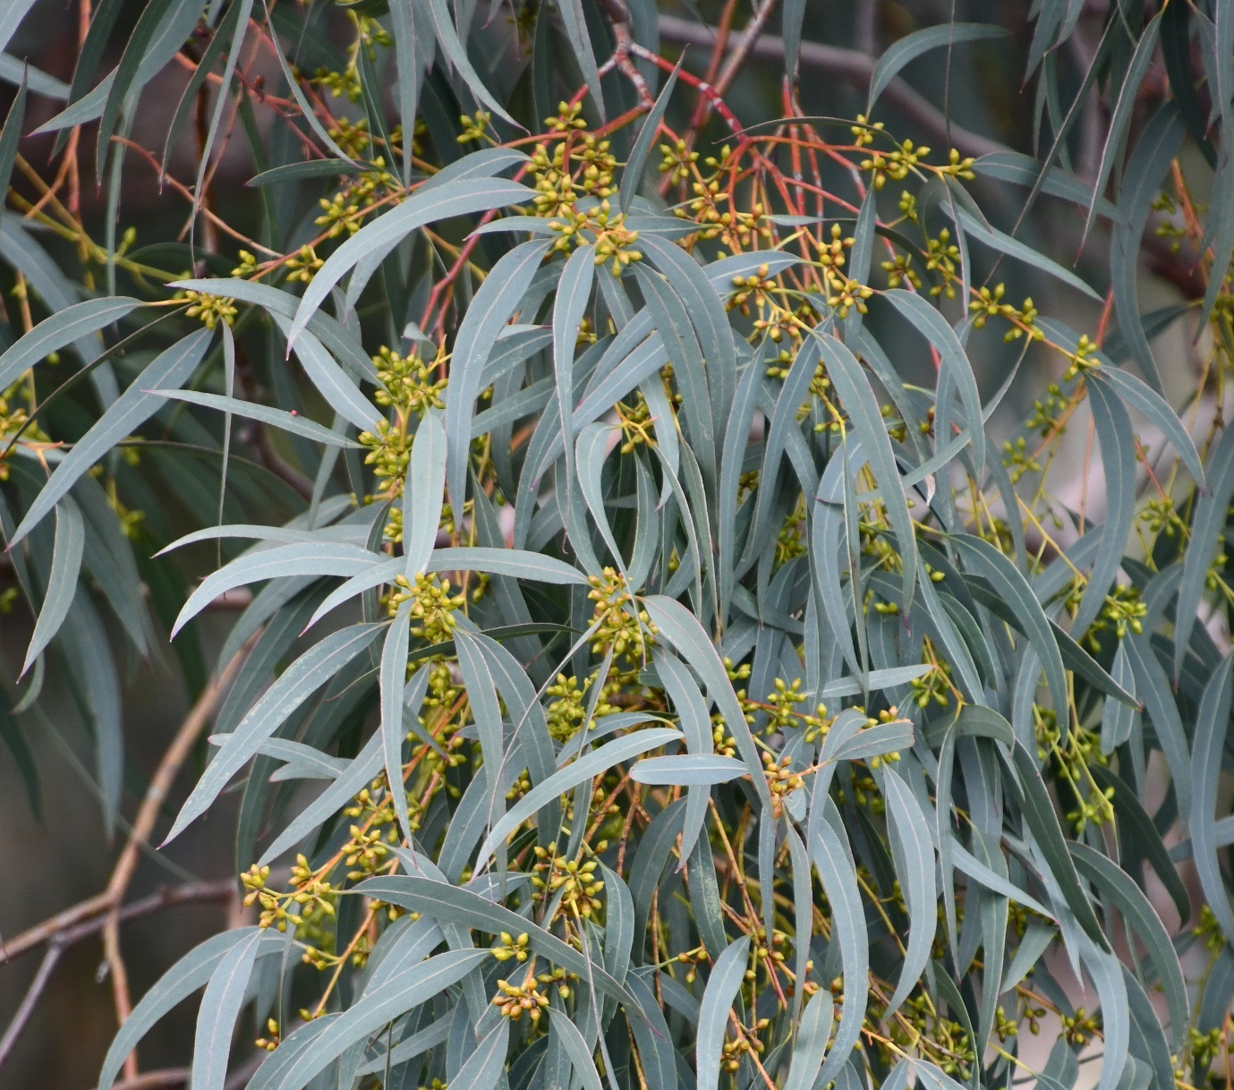
The value of vegetation is not necessarily well understood, and planning provisions and rules around vegetation protection can be a source of frustration for those wishing to develop their land. Alerting prospective applicants early (eg via website notifications, posters) of the importance of retaining trees, and talking through development ideas and objectives with Council planning officers well before advancing their development designs and submitting an application, provides the opportunity to resolve potential issues and find solutions that meet the objectives of both parties. Finding satisfactory solutions through negotiation early in the process can also mean avoiding costly arbitration through the VCAT process. Council is encouraging applicants to incorporate sustainability objectives into their designs through the Sustainable Design Assessment in the Planning Process (SDAPP). Pre-application discussions framed around the Urban Ecology section of the SDAPP, and the online Built Environment Sustainability Scorecard, can help with the design and planning permit process in relation to incorporation of trees, vegetation, and green infrastructure.

Priority Action: 1.1.(b)
Provide early and clear messaging to landowners and developers around the expectation that proposed designs will need to demonstrate that retention of existing trees has been central to all design efforts. Increase promotion of Council’s availability to hold pre-application meetings early in the design process to identify potential issues and facilitate responsive design solutions that retain desirable vegetation, and incorporate other vegetation considerations in the design, as part of the SDAPP process.
Plan Melbourne 2017-2050: Action 91
Whole-of-government approach to cooling and greening Melbourne. Create urban forests throughout the metropolitan area by:
- assembling and disseminating spatial data on the green space network, existing tree cover and surfaces. This data will be the baseline for modelling future greening strategies and their impacts on amenity of our urban areas including cooling effects
- working with local government to establish greening targets for each of the metropolitan regions
- liaising with water corporations to identify opportunities for use of alternative water supply ton support greening strategies
- supporting development of municipal urban forest strategies using a coordinated approach with VicRoads, private road operators and other public land owners and managers
- preparing greening strategies for state-owned public land, including schools, parkland, road, rail, and utility corridors, achieving an appropriate balance between asset protection and urban greening
- investigating a targeted grants program to support innovation and actions for greening neighbourhoods
- investigating demonstration projects including green roofs, green walls, and landscapes
- preparing new guidelines and regulations that support greening new subdivisions and developments via landscaping, green walls, green roofs and increase the percentage of permeable site areas in developments
Living Melbourne: Our metropolitan urban forest:
Scale up greening in the private realm. Action 3.1 Strengthen regulations to support greening in new subdivisions and developments – to benefit human health and wellbeing, and increase biodiversity
Living Melbourne: Our metropolitan urban forest:
Collaborate across sectors and regions. Action 4.2 Mobilise broad community support
Living Melbourne: Our metropolitan urban forest:
Collaborate across sectors and regions. Action 4.3 Foster and promote urban forest champions, in both the public and private sectors
Living Melbourne: Our metropolitan urban forest:
Build a toolkit of resources to underpin implementation. Action 5.1 Build the capacity of public and private sector practitioners to protect, enhance and expand the urban forest

Residential redevelopment largely occurs on a lot-by-lot basis, as and when dwellings become old and outdated, and owners are ready to make a change. Typically, this does not occur in a strategic or organised fashion often leading to adhoc and inefficient use of land, including space available for tree canopy and vegetation.
Significant opportunities for vegetation protection and expansion open up if residential redevelopment can be planned at a precinct scale, and where landowners could work together to get larger scale and more sustainable redevelopment.
The Greening the Greyfields project that Maroondah is piloting in two locations in partnership with the Centre for Urban Transitions at Swinburne University, the CRC for Low Carbon Living, FrontierSI, and the Department of Environment, Land, Water and Planning (DELWP), has developed ‘playbooks’ to help landowners, developers and local governments to do just this. Further information can be viewed at: https://yoursay.maroondah.vic.gov.au/gtg

Priority Action: 1.1.(c)
Identify precincts where redevelopment rates are expected to increase in the near future, and facilitate collaborative precinct planning to protect and increase tree canopy and other desirable vegetation cover, preserve permeability, and improve walk/ride networks, whilst enabling redevelopment and lot consolidation.
Plan Melbourne 2017-2050: Action 23
Redevelopment of greyfield areas. Support Councils to identify greyfield areas suitable for redevelopment for medium-density housing and lot consolidation
Plan Melbourne 2017-2050: Action 91
Whole-of-government approach to cooling and greening Melbourne. Create urban forests throughout the metropolitan area by:
- assembling and disseminating spatial data on the green space network, existing tree cover and surfaces. This data will be the baseline for modelling future greening strategies and their impacts on amenity of our urban areas including cooling effects
- working with local government to establish greening targets for each of the metropolitan regions
- liaising with water corporations to identify opportunities for use of alternative water supply ton support greening strategies
- supporting development of municipal urban forest strategies using a coordinated approach with VicRoads, private road operators and other public land owners and managers
- preparing greening strategies for state-owned public land, including schools, parkland, road, rail, and utility corridors, achieving an appropriate balance between asset protection and urban greening
- investigating a targeted grants program to support innovation and actions for greening neighbourhoods
- investigating demonstration projects including green roofs, green walls, and landscapes
- preparing new guidelines and regulations that support greening new subdivisions and developments via landscaping, green walls, green roofs and increase the percentage of permeable site areas in developments
Biodiversity 2037 Implementation Framework
Help to create more liveable and climate-adapted communities. Action 7.1 Support the establishment of new green infrastructure to maximise the co-benefits to communities and test new approaches for connecting Victorians to nature in an urban context
Victoria's Climate Change Adaptation Plan 2017 - 2020
Improving the resilience of our built environment. Through initiatives such as Plan Melbourne,
the Government will support cooler, greener cities projects (from 2017) to support the uptake of urban greening and integrated water management
Living Melbourne: Our metropolitan urban forest:
Scale up greening in the private realm. Action 3.1 Strengthen regulations to support greening in new subdivisions and developments – to benefit human health and wellbeing, and increase biodiversity

Numerous trees across Maroondah are notable in terms of their historic significance, scientific interest, habitat value, rarity, size, age, or beauty. As such they offer themselves up as distinguished examples that the Maroondah community can be proud of, and that in turn can support efforts to build a community culture that values and cares for trees. Establishing clear categories and contemporary criteria for ‘notability’ and engaging community in the nomination process, coupled with appropriate measures for protection and support for sustaining health of listed trees, can facilitate this. Different planning overlays offer a choice of protective controls that can be tailored to the different values such notable trees may hold, including ecological function, landscape contribution, and heritage significance.

Priority Action: 1.1.(d)
Design a process to engage the community in building a ‘Notable Trees of Maroondah’ inventory, and provide listed trees with appropriate protection from removal, and monitoring and landowner support to sustain tree health.
Living Melbourne: Our metropolitan urban forest:
Scale up greening in the private realm. Action 3.3 Encourage private landholders to protect and enhance the urban forest and expand greening activities by offering incentives for planting, installing and maintaining natural infrastructure
Living Melbourne: Our metropolitan urban forest:
Collaborate across sectors and regions. Action 4.2 Mobilise broad community support
Living Melbourne: Our metropolitan urban forest:
Collaborate across sectors and regions. Action 4.3 Foster and promote urban forest champions, in both the public and private sectors

Key Direction 1.2: Ensure the health and longevity of existing tree canopy cover
For trees to flourish and grow and age, they need air, water, sunlight, space, and good soil to support them. Active monitoring and maintenance can also enhance their health and extend their life expectancy.
Providing for these needs in an urban setting can be challenging as urbanisation brings with it extensive areas of impervious surfaces and stormwater drainage systems that rapidly channel rainwater away, restrict natural water infiltration, and in some locations create flooding issues in high rainfall events. Access to sunlight can also become restricted.
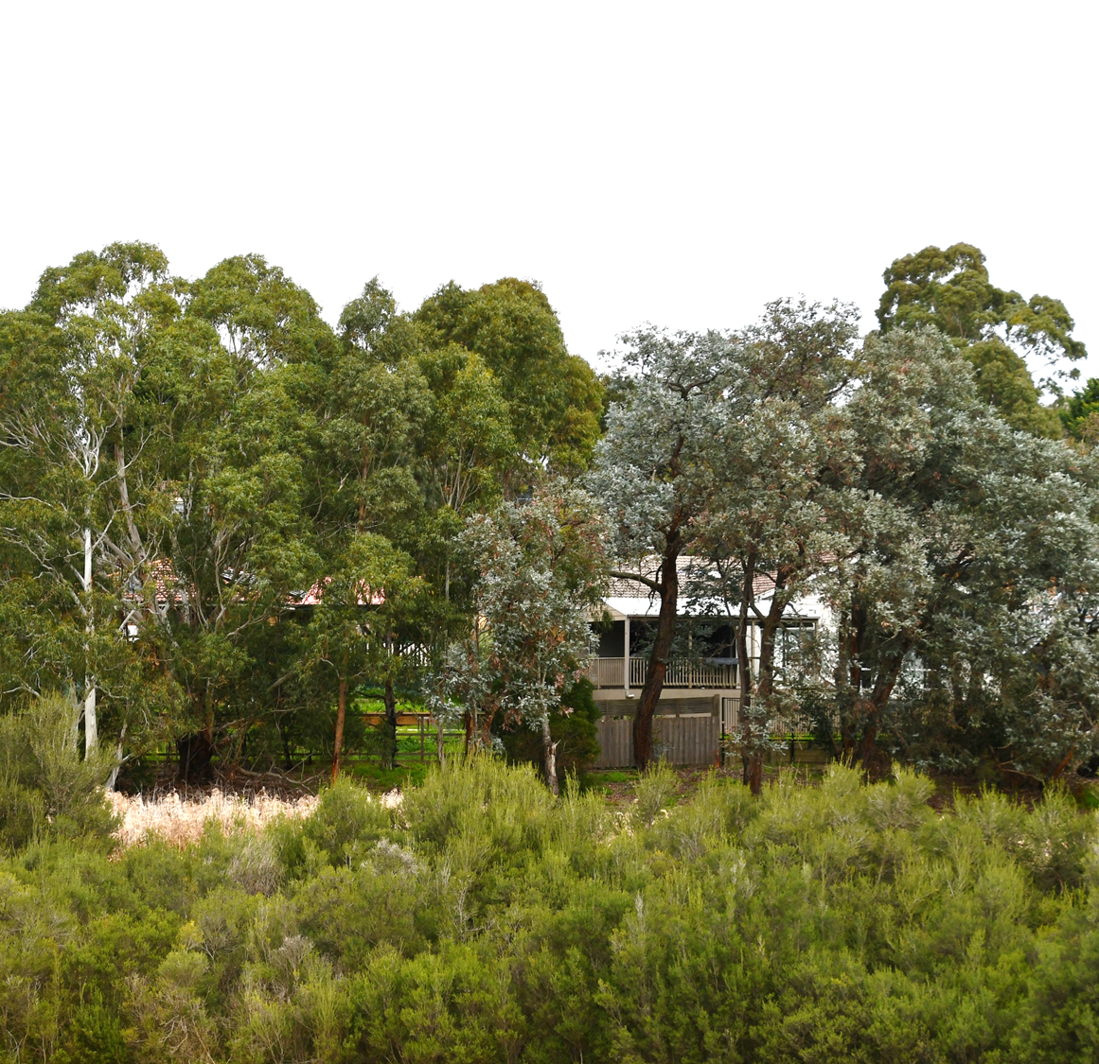

In a drying climate, maintaining high levels of permeability becomes more important for allowing rainfall to be absorbed into the soil, with trees and other vegetation more likely to be able to meet their watering needs from soil moisture rather than from reticulated drinking water supplies.
In a redevelopment situation, the ability to retain and require canopy trees is affected by the space available to plant and sustain them, which in turn is affected by the ratio of permeable land to hard, impervious surfaces. The current Rescode baseline minimum permeability requirement is 20% of a lot, however with recent changes to the Victorian Planning Provisions (Amendment VC148) there are opportunities to prescribe maximum site coverage percentages (area covered by buildings) and minimum permeability percentages (to restrict area of impervious surfaces) in different schedules to residential zones tailored to different situations. DELWP’s Better Apartment Design Guidelines also provides standards for the provision of deep soil to support canopy trees, as well as solar access to communal outdoor open space.

Priority Action: 1.2.(a)
Amend the planning scheme to strengthen planning controls to preserve high levels of permeability on private residential land.
Plan Melbourne 2017-2050: Action 91
Whole-of-government approach to cooling and greening Melbourne. Create urban forests throughout the metropolitan area by:
- assembling and disseminating spatial data on the green space network, existing tree cover and surfaces. This data will be the baseline for modelling future greening strategies and their impacts on amenity of our urban areas including cooling effects
- working with local government to establish greening targets for each of the metropolitan regions
- liaising with water corporations to identify opportunities for use of alternative water supply ton support greening strategies
- supporting development of municipal urban forest strategies using a coordinated approach with VicRoads, private road operators and other public land owners and managers
- preparing greening strategies for state-owned public land, including schools, parkland, road, rail, and utility corridors, achieving an appropriate balance between asset protection and urban greening
- investigating a targeted grants program to support innovation and actions for greening neighbourhoods
- investigating demonstration projects including green roofs, green walls, and landscapes
- preparing new guidelines and regulations that support greening new subdivisions and developments via landscaping, green walls, green roofs and increase the percentage of permeable site areas in developments
Living Melbourne: Our metropolitan urban forest:
Set targets and track progress. Action 2.2 Establish a measure of permeability across the regions, with the aim of implementing a permeability target for public and private land
Living Melbourne: Our metropolitan urban forest:
Scale up greening in the private realm. Action 3.1 Strengthen regulations to support greening in new subdivisions and developments – to benefit human health and wellbeing, and increase biodiversity

Water Sensitive Urban Design (WSUD) is an approach to planning and design of urban areas to make use of stormwater as a resource and reduce the harm it causes to our rivers and creeks. By maximising on-site infiltration where rain falls, before it enters the drainage system, WSUD enables natural filtration of water, potential reduction in flooding, slowing and treatment of stormwater, and mitigation of the impacts of high intensity flows such as erosion. By increasing moisture in soils, it supports the health and longevity of nearby trees and other vegetation. The recent introduction of Amendment VC154 Stormwater Management including the new Clause 53.18 - Stormwater management in urban development supports Council in achieving current best practice performance stormwater management objectives for works on public land (i.e. those covered by Public Use Zone and Public Park and Recreation Zone), as well as non-residential development in residential zones (i.e. Residential Growth Zone, Neighbourhood Residential Zone and General Residential Zone). For Council, major road upgrades present a key opportunity to incorporate WSUD elements such as vegetated swales to increase infiltration of water into soils that support street trees and other vegetation.

Priority Action: 1.2.(b)
Apply WSUD where practicable within public works in locations where benefits such as passive irrigation of street trees or reduction of localised flooding can be achieved.
Victoria's Climate Change Adaptation Plan 2017 - 2020
Improving the resilience of our built environment. Through initiatives such as Plan Melbourne,
the Government will support cooler, greener cities projects (from 2017) to support the uptake of urban greening and integrated water management
Water for Victoria: Water Plan:
Resilient and liveable cities and towns. Action 5.1 Use diverse water sources to protect public spaces Water corporations will work with local government and other public open space managers to identify water sources to maintain community assets, such as sporting facilities, public gardens, and street trees during drought to enhance community health, wellbeing, and liveability.
Water corporations, local government, catchment management authorities and community leaders will work together to enhance public spaces through integrated water management in our existing and new urban environments. This will be achieved by:
- selecting priority parks, gardens, public open spaces and playing fields to look after during drought by 31 March 2017
- seeking opportunities to promote urban cooling
- building a shared understanding of the costs of water restrictions to the community and community expectations about restrictions, and using this to inform water supply and demand management decisions.

Reaping the benefits of green, leafy suburbs also means putting time and effort into planting, watering, pruning, weeding, and cleaning up leaves. It means understanding and sensitively managing some of the risks that trees and other vegetation may present such as falling limbs, fire hazard, and the potential for harbouring snakes and spiders, whilst protecting the vegetated landscape we cherish.
Living, growing plants and trees need to be maintained and managed. Careful pruning and disease management can extend the life of a tree, and help manage unwanted impacts such as lifted footpaths or shading of solar panels. Avoiding actions that may affect the health of a tree, such as root damage, soil compaction, and bark damage are also key factors in allowing a tree to flourish, grow old and large, and contribute to a sustained tree canopy cover for Maroondah.
Cultivating a community that values and cares for trees that contribute to our canopy cover will build community support for canopy protection measures and enable individual landowners to retain and keep healthy trees on their property for the long term.

Priority Action: 1.2.(c)
Provide information and advice to help landowners value and maintain the health of their trees.
Living Melbourne: Our metropolitan urban forest:
Scale up greening in the private realm. Action 3.3 Encourage private landholders to protect and enhance the urban forest and expand greening activities by offering incentives for planting, installing and maintaining natural infrastructure
Living Melbourne: Our metropolitan urban forest:
Collaborate across sectors and regions. Action 4.2 Mobilise broad community support
Living Melbourne: Our metropolitan urban forest:
Collaborate across sectors and regions. Action 4.3 Foster and promote urban forest champions, in both the public and private sectors

Street trees are also a major component of Maroondah’s tree canopy cover. To maximise the benefits each tree provides and to provide the care and maintenance they need to thrive into old age, it is important for Council to regularly inspect the street tree population and remediate any tree health concerns. This ensures proactive management of the street tree population. Council currently undertakes regular checks of the health of street trees, with a cycle that sees each tree inspected every two years.

Priority Action: 1.2.9d)
Monitor street tree health by maintaining current inspection cycle of two years, continue a proactive street tree maintenance program to ensure the health and longevity of the street tree asset, and gradually expand the program to include trees in reserves and public open space areas.
Plan Melbourne 2017-2050: Action 60
Improved streetscapes. Finalise and implement a long-term metropolitan strategy for streetscapes, including boulevards, and encourage local measures to improve streetscapes, accessibility, and local amenity

Over the past few years there has been a noticeable decline in the condition of numerous eucalypt trees in our bushland reserves, in particular indigenous stringybark species such as Red Stringybark, White Stringybark, and Messmate. There is evidence to suggest that this is not limited to Maroondah. Council is currently investigating the cause(s) of the declines in Maroondah with the aim of determining appropriate management responses.

Priority Action: 1.2.e)
Continue to investigate cause(s) of stringybark decline and determine how best to respond (address cause or adapt)

Key Direction 1.3: Increase tree canopy cover in key locations
In addition to protecting the existing tree canopy cover, there is opportunity to extend canopy cover into places where the benefits of canopy cover are most needed in Maroondah. These include areas of high heat vulnerability (to reduce incidence of heat-related illnesses), medical precincts (to help alleviate stress), in and around schools and kindergartens (to encourage outdoor activity and connection to nature), locations where localised flooding occurs (to reduce flooding damage and stress), areas of high pedestrian activity and along walking and bike riding routes (to encourage outdoor physical activity and alternatives to using a car).
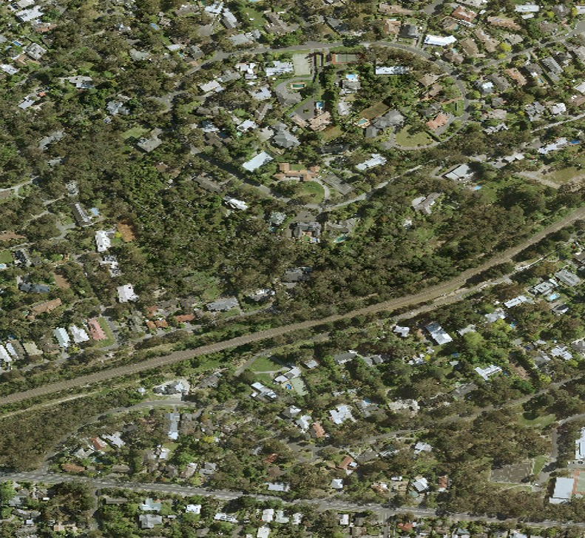

However, it takes many years for a newly planted tree to get big enough to provide canopy cover benefits. Consequently, long-term planning to identify where and when these next generations of canopy trees should be planted is important to mitigate the loss of canopy when older canopy trees reach the end of their life and need to be removed.
In commercial areas where the opportunities for increasing tree canopy cover are limited largely to streetscapes and carparks, innovative approaches such as green roofs and walls provide alternative ways of introducing the liveability benefits of vegetation.
In 2017, Council adopted Environmentally Sustainable Design (ESD) policy and guidelines for Council buildings and has commenced development of an ESD policy for incorporation into the Maroondah Planning scheme. ESD aims to reduce the impact of construction and building use on the natural environment to secure today’s living standards, help future-proof communities against rising energy, water, and waste disposal costs, and reduce the impact of climate change. The ESD policy and the associated planning provisions offer opportunities for requiring more vegetation across all land uses.
Recent changes to the Victorian Planning Provisions (Amendment VC148) provide opportunity to require the provision of canopy trees and other landscaping, and the space and solar access needed for these, in schedules to different residential zones.

Priority Action: 1.3.(a)
Amend the planning scheme to strengthen planning controls to require the provision of canopy trees, and the associated growing conditions they need to flourish and grow old and large (such as sufficient deep soil, canopy growing space, solar access, and passive and active irrigation).
Plan Melbourne 2017-2050: Action 91
Whole-of-government approach to cooling and greening Melbourne. Create urban forests throughout the metropolitan area by:
- assembling and disseminating spatial data on the green space network, existing tree cover and surfaces. This data will be the baseline for modelling future greening strategies and their impacts on amenity of our urban areas including cooling effects
- working with local government to establish greening targets for each of the metropolitan regions
- liaising with water corporations to identify opportunities for use of alternative water supply ton support greening strategies
- supporting development of municipal urban forest strategies using a coordinated approach with VicRoads, private road operators and other public land owners and managers
- preparing greening strategies for state-owned public land, including schools, parkland, road, rail, and utility corridors, achieving an appropriate balance between asset protection and urban greening
- investigating a targeted grants program to support innovation and actions for greening neighbourhoods
- investigating demonstration projects including green roofs, green walls, and landscapes
- preparing new guidelines and regulations that support greening new subdivisions and developments via landscaping, green walls, green roofs and increase the percentage of permeable site areas in developments
Living Melbourne: Our metropolitan urban forest:
Scale up greening in the private realm. Action 3.1 Strengthen regulations to support greening in new subdivisions and developments – to benefit human health and wellbeing, and increase biodiversity
There is a need for Maroondah’s street tree planting program to be well planned for the long term (ie beyond responding to individual requests). With the regular monitoring of the health of Maroondah’s street trees, Council is now able to forecast when street trees are expected to reach the end of their safe useful life, meaning they can schedule new tree plantings to offset the expected losses of trees. It is currently estimated that 25% of Maroondah’s street tree population are likely to reach the end of their useful lives within the next 10-15 years. To compensate for this loss, Council will need to actively plan for both vacant site in-fill planting as well as actively removing trees that are beyond their useful lives and replace with new trees. Establishment of a long-term program of planned street tree removals and replacements will facilitate the required budget forecasting, and for scheduled tree removals streamlining of the permit requirements that Council currently abides by can be achieved.
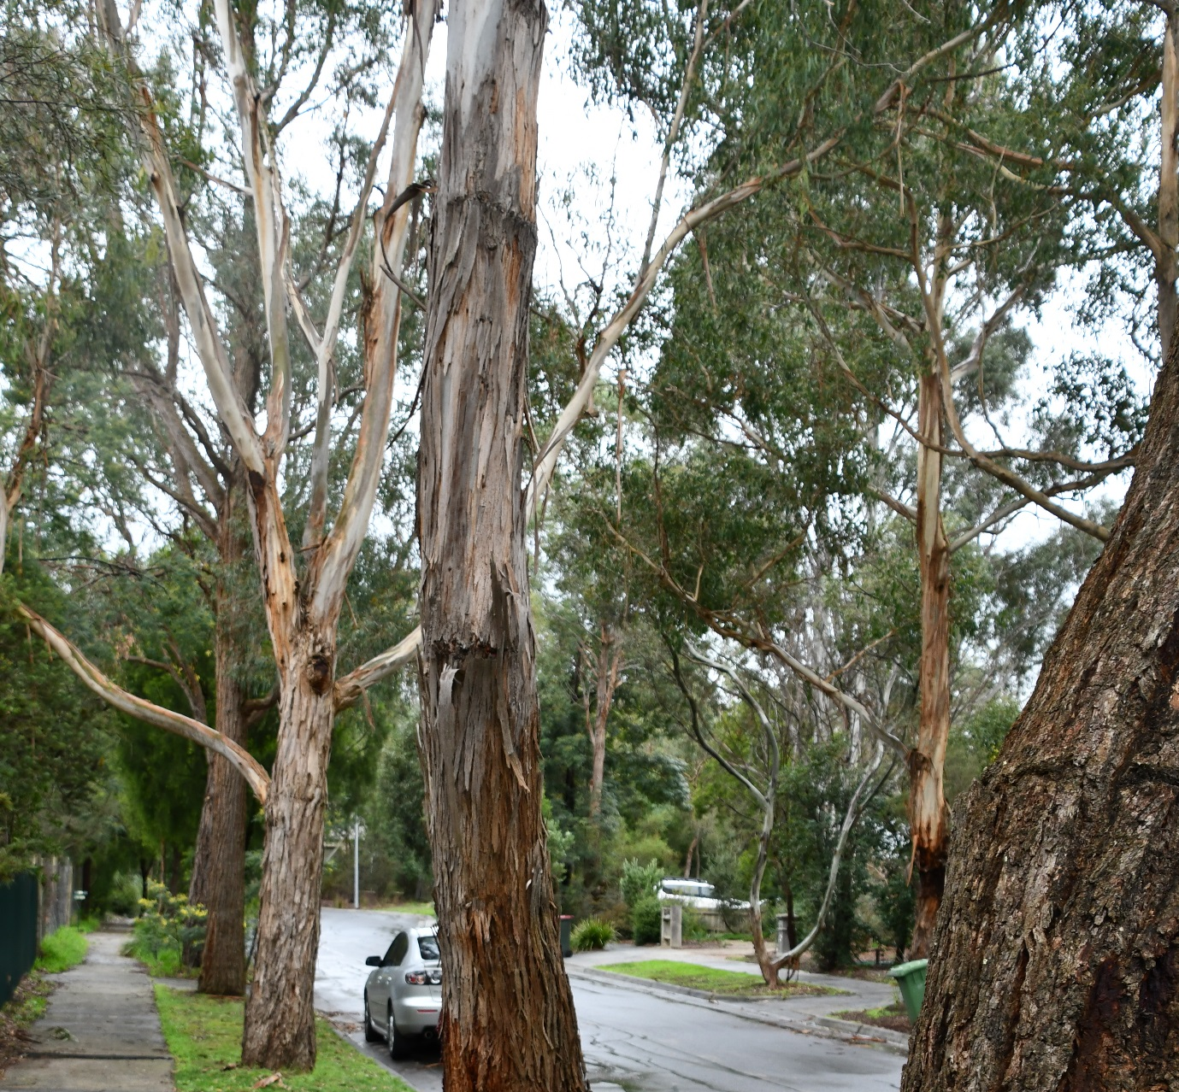

It is noted that as Maroondah’s population continues to grow and urban development is required to accommodate this growth, the contribution of street trees and public open space to our overall tree canopy cover will become increasingly important. Given that this is land that Council can control, increasing the canopy cover contribution on public land will be a key priority for Council.

Priority Action: 1.3.9b)
Identify key locations for providing additional tree canopy cover benefits, especially in areas of heat vulnerability, health precincts, schools, nature play spaces (eg bush kinders), local flooding and key walk/ride routes, and prioritise these locations for new street tree, car park and open space plantings.

Priority Action: 1.3.(c)
Prepare business case to develop and resource a 10-year street and park tree masterplan and renewal program based on tree inspection data that includes:
- priority locations to target for increasing tree canopy cover
- where and when vacant street tree sites can be filled
- where and when renewal of trees nearing the end of their useful life expectancies will be needed
- a two-year establishment program for watering and formative pruning
- long-term budget forecasting for planned removal, renewal, and establishment costs.
Plan Melbourne 2017-2050: Action 60
Improved streetscapes. Finalise and implement a long-term metropolitan strategy for streetscapes, including boulevards, and encourage local measures to improve streetscapes, accessibility, and local amenity
Plan Melbourne 2017-2050: Action 91
Whole-of-government approach to cooling and greening Melbourne. Create urban forests throughout the metropolitan area by:
- assembling and disseminating spatial data on the green space network, existing tree cover and surfaces. This data will be the baseline for modelling future greening strategies and their impacts on amenity of our urban areas including cooling effects
- working with local government to establish greening targets for each of the metropolitan regions
- liaising with water corporations to identify opportunities for use of alternative water supply ton support greening strategies
- supporting development of municipal urban forest strategies using a coordinated approach with VicRoads, private road operators and other public land owners and managers
- preparing greening strategies for state-owned public land, including schools, parkland, road, rail, and utility corridors, achieving an appropriate balance between asset protection and urban greening
- investigating a targeted grants program to support innovation and actions for greening neighbourhoods
- investigating demonstration projects including green roofs, green walls, and landscapes
- preparing new guidelines and regulations that support greening new subdivisions and developments via landscaping, green walls, green roofs and increase the percentage of permeable site areas in developments

Plan Melbourne 2017-2050: Action 93
Metropolitan open space strategy. Prepare a metropolitan open space strategy that enhances recreation, amenity, health and wellbeing, species diversity, sustainable water management and urban cooling across Melbourne. The strategy will include measure to:
- protect and enhance existing open spaces, underpinned by improved and accessible spatial data
- plan for an increase in open space, particularly in areas identified as lacking access to open space, areas undergoing substantial population growth, and areas where the network of green spaces could be expanded or improved
- enhance the role, function, and overall community value of currently underutilised public land assets (eg utility easements, school grounds) in contributing to the open space network
- better coordinate the delivery and management of open space across state and local government, including identifying management objectives for different parts of the network and developing standard agreements to manage land
- provide improved network planning and provision guidance for both state and local government
Biodiversity 2037 Implementation Framework:
Raise the awareness of all Victorians about the importance of the state’s natural environment. Action 3.3 Support the Nature Play, Bush Kinders and Outdoor Learning to enable kids to connect to nature
Biodiversity 2037 Implementation Framework:
Help to create more liveable and climate-adapted communities. Action 7.1 Support the establishment of new green infrastructure to maximise the co-benefits to communities and test new approaches for connecting Victorians to nature in an urban context
Biodiversity 2037 Implementation Framework:
Help to create more liveable and climate-adapted communities. Action 7.6 Prepare a metropolitan open space strategy that enhances recreation, amenity, health and wellbeing, species diversity, sustainable water management and urban cooling across Melbourne.
Victorian public health and wellbeing plan 2015–2019: Action plan update
Healthy and sustainable environments. Installing more shade and trees in community spaces to protect Victorians from harmful UV radiation through the Community Shade Grants Program, and in government schools through the School Shade Grants Program
Victoria's Climate Change Adaptation Plan 2017 - 2020
Improving the resilience of our built environment. Through initiatives such as Plan Melbourne,
the Government will support cooler, greener cities projects (from 2017) to support the uptake of urban greening and integrated water management
Living Melbourne: Our metropolitan urban forest:
Build a toolkit of resources to underpin implementation. Action 5.1 Build the capacity of public and private sector practitioners to protect, enhance and expand the urban forest
Climate Change Adaptation Roadmap for Melbourne’s East (?2015
Adaptation objective: Reduce the heat island effect through the region to mitigate projected temperature increases Action: Develop a Greening for a Cool East Strategy

In general, larger tree species offer greater environmental and wellbeing benefits than an equivalent number of smaller species, but in a suburban garden setting can create issues. Indigenous species offer more biodiversity benefits than native species, which in turn offer more than non-native species. With our changing climate the suitability of different species of tree and other vegetation for climatic conditions of the future will need to be considered. The challenges of maintaining vegetation in a drying climate are evident even today, with the emerging need to sustain street trees through active watering. Given that newly planted trees will be in our landscape for decades, due diligence needs to be given to the selection of species being planted now such that they will survive and flourish into the expected future climate, are still fit for purpose, and optimise the derived benefits.

Priority Action: 1.3.(d)
Research appropriate tree and vegetation species mixes for Maroondah that can provide the desired services tailored to different locations and are suited for the predicted future climate.
Victoria's Climate Change Adaptation Plan 2017 - 2020
Improving the resilience of our built environment. Through initiatives such as Plan Melbourne,
the Government will support cooler, greener cities projects (from 2017) to support the uptake of urban greening and integrated water management

Green roofs and walls have been around in a basic form for a long time, however the modern versions are a relatively new technology and are continuing to evolve. Green roofs are more expensive to install, and require establishment and maintenance. However, they return benefits such as reducing runoff and improving storm water quality, thermal insulation that conserves energy, cooling that mitigates the urban heat island, UV protection that increases longevity of roofing membranes, acoustic insulation that reduces noise, and carbon dioxide absorption that sequesters carbon.
In locations such as commercial areas and activity centres with higher density development where canopy cover is relatively low, and the opportunities to plant additional canopy trees are limited, green roofs and walls provide an alternative means for providing beneficial living vegetation up where the canopy would be.
With private developments, there may be opportunities to ‘incentivise’ the incorporation of green roofs and walls, with negotiated acceptable exceptions to existing requirements.
To stimulate wider adoption of a relatively new technology with upfront costs, it needs high quality local examples that can be used to demonstrate how the installation and maintenance challenges can be addressed, as well as the return benefits and savings.
In 2017 Maroondah adopted its Environmentally Sustainable Design Policy Guidelines for Council Buildings. Under the Urban Ecology section, the policy states the requirement “Identify demonstration sites for green walls, roofs or facades, particularly in areas exposed to high temperatures and where tree canopy is limited”.
Maroondah has established an internal Carbon Neutral Revolving Energy Fund (CNREF) that provides a funding source for projects that reduce energy, fuel use and greenhouse gas emissions, with the aim of reinvesting the resulting financial savings to implement more carbon reduction projects.

Priority Action: 1.3.(e)
Identify opportunities in forthcoming building projects (small or large) to design in demonstration green roofs and/or green walls, ideally in locations where canopy cover is low and opportunity for additional canopy trees is limited (eg commercial areas, new public buildings), and evaluate the potential to use the CNREF (or similar) to help establish green roof/wall demonstration projects.

Priority Action: 1.3.(f)
Evaluate options for incentivising the provision of green roofs and green walls in private developments, in terms of benefits, issues, and acceptable circumstances.
Plan Melbourne 2017-2050: Action 55
Excellence in built environmental design. Promote excellence in how Victoria’s built environment is designed and constructed by:
- embedding design review in the assessment of significant development projects to ensure the highest possible design outcomes are achieved on major public and private sector projects. This will apply to:
  - significant government or funded (including local government) projects
  - projects that impact on places on the Victorian Heritage Register
  - significant private sector projects referred by local government
- strengthening the design understanding and capabilities within all levels of government
Plan Melbourne 2017-2050: Action 91
Whole-of-government approach to cooling and greening Melbourne. Create urban forests throughout the metropolitan area by:
- assembling and disseminating spatial data on the green space network, existing tree cover and surfaces. This data will be the baseline for modelling future greening strategies and their impacts on amenity of our urban areas including cooling effects
- working with local government to establish greening targets for each of the metropolitan regions
- liaising with water corporations to identify opportunities for use of alternative water supply ton support greening strategies
- supporting development of municipal urban forest strategies using a coordinated approach with VicRoads, private road operators and other public land owners and managers
- preparing greening strategies for state-owned public land, including schools, parkland, road, rail, and utility corridors, achieving an appropriate balance between asset protection and urban greening
- investigating a targeted grants program to support innovation and actions for greening neighbourhoods
- investigating demonstration projects including green roofs, green walls, and landscapes
- preparing new guidelines and regulations that support greening new subdivisions and developments via landscaping, green walls, green roofs and increase the percentage of permeable site areas in developments
Victoria's Climate Change Adaptation Plan 2017 - 2020
Improving the resilience of our built environment. The Government will work with the City of
Melbourne to build a large, publicly accessible green roof in Melbourne’s CBD (from 2017). This project will help the community learn about the benefits of green roofs and inspire other projects
Living Melbourne: Our metropolitan urban forest:
Collaborate across sectors and regions. Action 4.3 Foster and promote urban forest champions, in both the public and private sectors

In an urban setting such as Maroondah, street trees compete for space alongside the infrastructure needed for essential utility services such as electricity, telephone, drinking water, storm water and sewer. Road and footpath infrastructure also occupies significant space.
Electricity cables servicing residential areas are typically strung between poles as overhead cables down one side of a street. This severely limits the overhead space available for street trees to grow large and provide good canopy cover, meaning that either no trees are planted down one side of a street, or trees under the cabling are small and/or severely pruned to avoid interference with the cabling. Underground services that run beneath permeable surfaces such as nature strips also restrict opportunities for planting street trees, especially larger species. Renewal of roads and footpaths present opportunities for both innovative re-design, and relocation of services, to provide more space and permeability for providing and sustaining more and larger street trees.

Priority Action: 1.3.(g)
Advocate for service providers and developers to act on opportunities to relocate services such as electricity, phone, water, and sewer to free up tree canopy potential (eg improved water and soil access, and overhead space for large trees) without impacting on existing vegetation. Examples include undergrounding of overhead cables, and relocating underground services from beneath naturestrips to under roads footpaths and driveways.
Plan Melbourne 2017-2050: Action 55
Excellence in built environmental design. Promote excellence in how Victoria’s built environment is designed and constructed by:
- embedding design review in the assessment of significant development projects to ensure the highest possible design outcomes are achieved on major public and private sector projects. This will apply to:
  - significant government or funded (including local government) projects
  - projects that impact on places on the Victorian Heritage Register
  - significant private sector projects referred by local government
- strengthening the design understanding and capabilities within all levels of government

Outcome 2: More nature throughout Maroondah
More vegetation, in the form of a well-connected network of indigenous trees, shrubs and understorey plants providing a wide range of habitat elements such as the food, shelter, and opportunities to move through the landscape that native flora and fauna in Maroondah need to flourish, and simultaneously create more opportunities for people to encounter and connect with nature close to where the live, work and play.
To achieve this, we aim to provide more of the right vegetation that is healthy and in the places where it can optimise habitats for native flora and fauna, and provide new opportunities for people to connect to nature, with a focus on enabling key native animal species to spread through Maroondah. (a range of potential candidate species that currently occur within or near Maroondah, and collectively have habitat needs that would serve a much wider range of species, are outlined on pages 24 and 25).
Natural habitats are the physical, chemical, and biological systems that support our biodiversity. More simply put, habitats are the places where our native plants and animals live. Vegetation can support nature by providing critical elements of natural habitat in the form of the food, shelter and opportunities to move through the landscape that native flora and fauna in Maroondah needs.
As a result of changing land uses from farming to residential and commercial development, the original natural habitats that once covered Maroondah, have been reduced to scattered small pockets of remnant vegetation. This fragmentation of natural habitat increases the degrading pressures on the remaining habitat patches and their increased isolation disconnects populations of plants and animals.
This requires protecting the existing habitat, ensure its health and longevity, and creating new habitat with a focus on the locations where habitat linkages are most viable. To create opportunities for more people to experience and connect to nature as part of their everyday living, there is a need to provide habitat close to where people live, work and play.
Key Directions
2.1 Strengthen protection of existing habitat
2.2 Ensure the health and longevity of existing habitat
2.3 Restore/create new habitat in key locations

Key Direction 2.1: Strengthen protection of existing habitat
The best available natural habitat for native flora and fauna in Maroondah are the remnants of the original vegetation. These cannot be replicated through revegetation, and to even get close is a long-term and costly endeavour. Therefore, protecting the patches that remain is critical to enabling more nature to disperse through Maroondah. Restoration of degraded remnant vegetation patches offers more habitat potential than reconstructed versions.
The patches of existing habitat that remained in Maroondah were first identified as Sites of Biological Significance by Dr Graeme Lorimer in 1997, and were afforded protection through the planning scheme with the application of Vegetation Protection Overlays (VPO) that control the removal of vegetation. Changes in planning law and state government guidelines have meant these protective measures have lost some of their effectiveness and relevance since their introduction. In 2018, Council again engaged Dr Lorimer to provide a contemporary analysis of the sites of biological significance in Maroondah. After the planning controls Council introduced based on the 1997 study, the Victorian Government has also introduced planning controls designed to protect biodiversity more effectively, including the Environmental Significance Overlay (ESO) that can be applied directly to significant sites of biodiversity as well as adjacent areas that act as buffers, to ensure development is compatible with identified environmental values. DELWP’s Planning for Biodiversity: Guidance (December 2017) explains the ESO has broader applicability than the VPO and is the preferred overlay when seeking to achieve biodiversity outcomes.

Priority Action: 2.1.(a)
Amend the planning scheme to strengthen controls that protect existing habitat, including application of ESOs and other planning controls to protect and buffer currently recognised Sites of Biological Significance (Biodiversity in Maroondah 2019) - eg from direct removal, non-conservation land uses, clearing for fire risk, sediment from runoff, hydrological impacts (such as reduction in water infiltration), excessive vehicle and/or pedestrian traffic.
Living Melbourne: Our metropolitan urban forest:
Protect and restore species habitat and improve connectivity. Action 1.2 Assess the values and quality of information, to develop a list of priority areas for immediate protection

The long-term security of existing habitat is generally enhanced when it is in public ownership and managed primarily for conservation purposes. Long term security of habitat on private land can also be achieved when a landholder enters an on-title agreement with Trust for Nature to place a Conservation Covenant over the parts of their property that hold important habitat values. There are still a small number of patches of high value remnant vegetation that occur on private land without that security, and therefore potentially at risk from current and future owner land use aspirations that don’t have habitat protection as the highest priority.

Priority Action: 2.1.(b)
Evaluate options for protecting high value habitat still in private ownership, including Public Acquisition Overlay, Conservation Covenants, etc.
Biodiversity 2037 Implementation Framework:
Maintain and enhance a world-class system of protected areas. Action 18.1 Investigate opportunities to secure more permanently protected areas on private land
Living Melbourne: Our metropolitan urban forest:
Protect and restore species habitat and improve connectivity. Action 1.2 Assess the values and quality of information, to develop a list of priority areas for immediate protection
Living Melbourne: Our metropolitan urban forest:
Protect and restore species habitat and improve connectivity. Action 1.4 Implement priorities for conservation, and secure and build habitat connectivity

Parts of Maroondah are covered by the Bushfire Management Overlay (BMO) that has been applied to land that may be significantly affected by a bushfire based on mapping by the state government. Properties within the BMO are exempted under the 10/50 rule from needing a permit to clear certain vegetation that represents a bushfire hazard.
As Maroondah has continued to urbanise, there are likely to be places where the BMO is no longer applicable and the associated ability to remove vegetation without a permit no longer justifiable.
The BMO mapping is regularly updated by DELWP, and Council has been approached by the Country Fire Authority (CFA) to identify locations in Maroondah where application of the BMO may no longer be justified.

Priority Action: 2.1.(c)
Negotiate with the CFA and DELWP for removal of BMO where it is no longer justifiable.
Living Melbourne: Our metropolitan urban forest:
Protect and restore species habitat and improve connectivity. Action 1.4 Implement priorities for conservation, and secure and build habitat connectivity

Key Direction 2.2: Ensure the health and longevity of existing habitat
Due to its fragmentation, and the effects from surrounding urban land uses, the health and condition of existing patches of remnant vegetation, and their capacity to function as habitat, requires ongoing active management. Competition from environmental weeds is a major and sustained threat. For swampy vegetation, the drying climate and increasing cover of impervious surfaces is reducing the levels of natural infiltration of rainfall into soils, preventing the wetting and drying cycles this type of vegetation needs for survival.

Largely through specialised weed control works, Council has been successful in improving and maintaining the condition of the most important sites of biological significance on Council-owned land that were originally identified in 1997. However due to the significant number of sites, the remaining lower quality sites of biological significance on Council-owned land are treated for weeds on an occasional basis with the use of external specialist contractors. Adding to the challenge, more sites requiring management including community planting sites, are regularly being added to Council’s management responsibilities.

Priority Action: 2.2.(a)
Prepare business case to bring more areas of important native vegetation (eg more Sites of Biological Significance, community plantings, future habitat corridors, acquired public land) under direct Council management for habitat condition improvement.
Living Melbourne: Our metropolitan urban forest:
Protect and restore species habitat and improve connectivity. Action 1.4 Implement priorities for conservation, and secure and build habitat connectivity
Living Melbourne: Our metropolitan urban forest:
Build a toolkit of resources to underpin implementation. Action 5.1 Build the capacity of public and private sector practitioners to protect, enhance and expand the urban forest

Waterways and their adjacent land offer great potential to function as habitat corridors through an urban environment, as well as providing semi-natural recreational spaces that encourage outdoor physical activity and opportunities for people to experience and connect to nature. They are also important cultural places for aboriginal people as they were vital as sources of water, food, and places to live and meet, and consequently can also play an important role in engaging people in and embracing Aboriginal culture.
For example, the Mullum Mullum Creek flows through Maroondah, but for much of its length its condition as natural habitat is poor. To realise its potential as a habitat corridor and popular recreational and cultural space will require significant investment, and collaboration across many organisations over a long period of time. Creating a ‘flagship project’ around the restoration of the Mullum Mullum Creek, or other waterways, is a way of raising its profile and generating interest from investors and collaborators.

Priority Action: 2.2.(b)
Advocate for restoring natural and cultural waterway and riparian condition along waterways such as Mullum Mullum Creek, to improve habitat corridor function, and passive recreational access and use.
Plan Melbourne 2017-2050: Action 63
Waterway corridor masterplans. Prepare waterway corridor masterplans for priority waterways to ensure that Traditional Owner and community values of waterways, such as access, amenity, and connection to nature, are protected and improved
Plan Melbourne 2017-2050: Action 93
Metropolitan open space strategy. Prepare a metropolitan open space strategy that enhances recreation, amenity, health and wellbeing, species diversity, sustainable water management and urban cooling across Melbourne. The strategy will include measure to:
- protect and enhance existing open spaces, underpinned by improved and accessible spatial data
- plan for an increase in open space, particularly in areas identified as lacking access to open space, areas undergoing substantial population growth, and areas where the network of green spaces could be expanded or improved
- enhance the role, function, and overall community value of currently underutilised public land assets (eg utility easements, school grounds) in contributing to the open space network
- better coordinate the delivery and management of open space across state and local government, including identifying management objectives for different parts of the network and developing standard agreements to manage land
- provide improved network planning and provision guidance for both state and local government
Biodiversity 2037 Implementation Framework
Help to create more liveable and climate-adapted communities. Action 7.1 Support the establishment of new green infrastructure to maximise the co-benefits to communities and test new approaches for connecting Victorians to nature in an urban context
Biodiversity 2037 Implementation Framework
Help to create more liveable and climate-adapted communities. Action 7.6 Prepare a metropolitan open space strategy that enhances recreation, amenity, health and wellbeing, species diversity, sustainable water management and urban cooling across Melbourne.
Biodiversity 2037 Implementation Framework
Engage with Traditional Owners to include Aboriginal values and traditional ecological knowledge in biodiversity planning and management. Action 14.3 Through the implementation of Plan Melbourne 2017-2050 prepare waterway corridor master plans for priority waterways to ensure that Traditional Owner and community values of waterways, such as access, amenity, and connection to nature, are protected and improved
Victoria's Climate Change Adaptation Plan 2017 - 2020
Improving the resilience of our built environment. Through initiatives such as Plan Melbourne,
the Government will support cooler, greener cities projects (from 2017) to support the uptake of urban greening and integrated water management
Healthy Waterways Strategy 2018-2028: Co-Designed Catchment Program for the Yarra Catchment
Mullum Mullum Creek Performance Objective 1: Establish a continuous riparian vegetated buffer (2 km, 7 ha) and maintain existing vegetation (12 km, 46 ha) along priority reaches (using EVC benchmarks to at least a level 3 vegetation quality)
Mullum Mullum Creek Performance Objective 5: Increase access to and along waterways (about 1 km of path) by improving connections with existing path network and in conjunction with urban development
Mullum Mullum Creek Performance Objective 6: Increase participation rates from low to high; support community groups and build capacity through citizen science and cultural engagement. Increase participation through support of inter-agency waterway improvement projects
Living Melbourne: Our metropolitan urban forest:
Protect and restore species habitat, and improve connectivity. Action 1.4 Implement priorities for conservation, and secure and build habitat connectivity
Living Melbourne: Our metropolitan urban forest:
Collaborate across sectors and regions. Capitalise on existing collaborations between local and state governments and the private sector

Community volunteers contributing their time towards improving the condition of habitat in Council bushland reserves, creek reserves, road reserves, nature strips and schools is a highly valued extension to the work of Council in managing habitat. Supporting community-led biodiversity initiatives empowers and builds a stewardship culture amongst community. In recognition of this, Council has redirected resources to supporting the growing number of volunteers. The beneficial contributions of volunteers can be increased through recruitment of more volunteers and developing their bushland management knowledge and skills. Regular community events that promote local biodiversity and develop habitat management skills are a proven method for doing this but require ongoing resources to deliver.
Site-specific decisions for management of bushland reserves are best based on, and responding to, changes to biodiversity at the reserve scale. Currently monitoring of biodiversity at the reserve scale is constrained by resourcing levels, and does not occur in a systematic manner.

Priority Action: 2.2.(c)
Prepare business case for sustained provision of support, direction and oversight for volunteers working in bushland reserves, delivery of community events focussed on biodiversity and capacity building, and monitoring of biodiversity change at reserve level to inform management decisions.
Biodiversity 2037 Implementation Framework
Raise the awareness of all Victorians about the importance of the state’s natural environment. Action 3.3 Engage Victorians with key biodiversity objectives and actions, by showcasing Victoria’s rich biodiversity through ongoing public, science and education programs
Biodiversity 2037 Implementation Framework
Increase opportunities for all Victorians to act to protect biodiversity. Action 5.4 Support Victoria’s conservation volunteer groups such as Landcare, Coastcare and Friends Groups to continue building environmental and community resilience
Living Melbourne: Our metropolitan urban forest:
Collaborate across sectors and regions. Action 4.2 Mobilise broad community support
Living Melbourne: Our metropolitan urban forest:
Collaborate across sectors and regions. Action 4.3 Foster and promote urban forest champions, in both the public and private sectors
Living Melbourne: Our metropolitan urban forest:
Build a toolkit of resources to underpin implementation. Action 5.1 Build the capacity of public and private sector practitioners to protect, enhance and expand the urban forest

As a consequence of their fragmentation and isolation, and the surrounding urbanisation, our patches of remnant vegetation are missing many of the ecological processes that contribute to sustaining their condition and diversity. These include the absence of different animals that would have kept foliage growth in check, turned over and aerated the soil, pollinated certain plant species, controlled the numbers of certain animal species, and the absence of different plants that would have provided critical food or shelter requirements for certain animal and plant species. There are also many aboriginal practices now absent, for example traditional cool burning, that would have influenced the condition of habitat.
Finding ways to reintroduce or replicate some of these elements and processes can be important contemporary management methods for improving the health and condition of our remaining habitats.

Priority Action: 2.2.(d)
Continue to investigate and trial innovative and traditional bushland management techniques for increasing biodiversity and habitat condition (eg biomass slashing, traditional burning, enrichment planting).
Living Melbourne: Our metropolitan urban forest:
Build a toolkit of resources to underpin implementation. Action 5.1 Build the capacity of public and private sector practitioners to protect, enhance and expand the urban forest

In Victoria, an offset is generally required when an approval or permit to remove native vegetation is granted. An offset compensates for biodiversity losses arising from native vegetation removal. Offset owners secure and manage offset sites to improve native vegetation condition. All offset sites need to be secured on title under one of the following:
- An agreement with the Secretary to DELWP under section 69 of the Conservation, Forests and Lands Act 1987
- An agreement with a responsible authority (eg local government) under section 173 of the Planning and Environment Act 1987
- An agreement with Trust for Nature to register an offset covenant under the Victorian Conservation Trust Act 1972.
As a result of permitted clearing in Maroondah, 85 offset sites have been established. The significant majority of these are located outside of Maroondah but within the Port Phillip and Western Port region. Although most of these sites fall under the agreement approaches a) and c) above, and would be subject to ongoing management obligations for the purposes of biodiversity preservation, Council does not have a current understanding of their condition, and therefore their contribution as functional habitat. The small number of offset sites that are located on private land within Maroondah are subject to 173 Agreements between the landholder and Council.

Priority Action: 2.2.(e)
Prepare a business case to undertake regular audits of existing offset sites, with an initial focus on S173 vegetation offset sites within Maroondah, to determine extent and condition, any compliance concerns, and provide support for restoring condition where required.
Living Melbourne: Our metropolitan urban forest:
Protect and restore species habitat and improve connectivity. Action 1.4 Implement priorities for conservation, and secure and build habitat connectivity
Living Melbourne: Our metropolitan urban forest:
Scale up greening in the private realm. Action 3.3 Encourage private landholders to protect and enhance the urban forest and expand greening activities by offering incentives for planting, installing and maintaining natural infrastructure

Prior to European settlement, approximately one quarter (25%) of Maroondah’s land area was covered by vegetation associated with streams, wetlands, and swampy floodplains. Many of the streams and wetlands are assumed to have been ephemeral in that they did not have open water all year round, but all of this vegetation would typically be associated with high levels of soil moisture through the winter seasons.
As Maroondah has urbanised, the increasing area of impervious surfaces has resulted in more of the rain that falls being rapidly transported away through stormwater drains and into streams, and less soaking into and hydrating soils. Compounded by drought and climate change reducing the amount of rainfall, this has led to the loss of plant species that are reliant on soils that are typically sodden in winter and dry over summer, and erosion issues in some stream channels.
Water for Victoria sets out the Victorian Government’s commitment to resilient and liveable cities including improving ‘stormwater management for greener environments’ and working ‘across government for healthy and resilient urban landscapes’.
Nature based solutions including Water Sensitive Urban Design (WSUD) treatments such as wetlands, raingardens and pervious landscapes are options available for Council-managed land that would contribute to achieving a green infrastructure network.
Recently adopted Victoria-wide planning provisions requiring best practice stormwater objectives and controls for subdivision, buildings and works, and construction will lead to application of more WSUD measures on private land. This holistic response will enable much greater use of local rainfall to support vegetation whilst reducing flow rates and pollutants damaging our waterways.
Where WSUD works are proposed in lower lying areas of Maroondah that historically supported swampy floodplains and wetlands, such works can add moisture to soils that swampy vegetation needs, and provided drainage and water treatment function and maintenance are not compromised, the use of indigenous swamp and wetland plant species in WSUD treatments can add habitat values to the product.

Priority Action: 2.2.(f)
Apply WSUD and utilise indigenous species where practicable to public works in locations that currently, or once, supported swampy vegetation.
Victoria's Climate Change Adaptation Plan 2017 - 2020
Improving the resilience of our built environment. Through initiatives such as Plan Melbourne,
the Government will support cooler, greener cities projects (from 2017) to support the uptake of urban greening and integrated water management
Water for Victoria: Water Plan:
Resilient and liveable cities and towns. Action 5.1 Use diverse water sources to protect public spaces Water corporations will work with local government and other public open space managers to identify water sources to maintain community assets, such as sporting facilities, public gardens, and street trees during drought to enhance community health, wellbeing, and liveability.
Water corporations, local government, catchment management authorities and community leaders will work together to enhance public spaces through integrated water management in our existing and new urban environments. This will be achieved by:
- selecting priority parks, gardens, public open spaces and playing fields to look after during drought by 31 March 2017
- seeking opportunities to promote urban cooling
- building a shared understanding of the costs of water restrictions to the community and community expectations about restrictions, and using this to inform water supply and demand management decisions.
Living Melbourne: Our metropolitan urban forest:
Protect and restore species habitat and improve connectivity. Action 1.4 Implement priorities for conservation, and secure and build habitat connectivity

Key Direction 2.3: Restore/create new habitat in key locations
The fragmented nature of our remaining patches of remnant vegetation, and the challenges for native animals to move through the less hospitable areas that surround these patches, means movement through the Maroondah landscape is severely limited for many animal species. Creating new habitat based on the habitat needs of a suite of focal fauna species, in locations that improve connectivity along strategic habitat corridor routes, can enable these and other species to more readily move through Maroondah. This in turn increases the opportunities for people to encounter and connect with nature near where they live, work, go to school, or play in Maroondah. Habitat connectivity does not necessarily need to be continuous bands of habitat - patches of habitat that are close enough to each other can act as important habitat ‘stepping stones’ that still allow some fauna movement between them.
The choice of animal species to focus on is ideally based on a mix of species that currently occur within or near Maroondah, that collectively have habitat needs that would serve a much wider range of species, and that we have a realistic chance of attracting further into and around Maroondah (a range of potential candidate species and their key habitat requirements are outlined on pages 24 and 25).
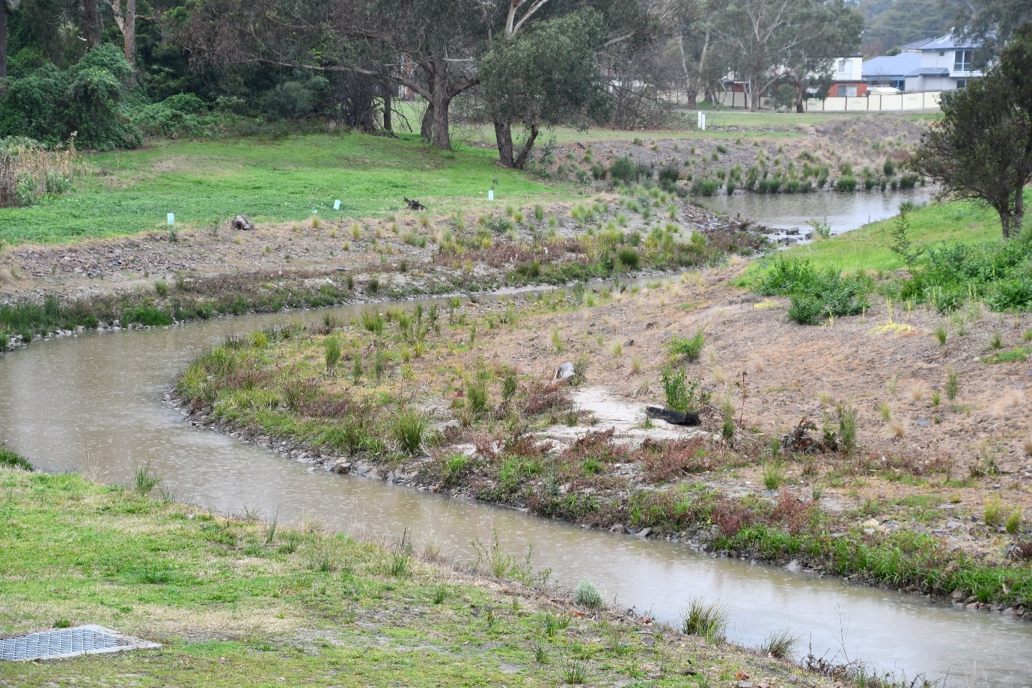
In 2005, Council released the Habitat Corridors Strategy that provided the rationale for a network of habitat links connecting larger areas of remnant vegetation to protect and enhance biodiversity within and beyond the City of Maroondah.
With Council’s intention to focus on a suite of focal fauna species, the habitat requirements of these species will be assessed against the potential corridor routes to ensure important corridor routes are afforded protection, and their capacity to function as habitat corridors is gradually built as opportunities present, to enable these species to further disperse throughout Maroondah.
The analysis of potential corridors and their relative priority would benefit from a contemporary review and confirmation, with translation into a habitat corridor masterplan.

Priority Action: 2.3.9a)
Review the 2005 Habitat Corridor Strategy to confirm priority linkage routes and align with this strategy’s with a focus on habitat for a suite of ‘focal’ species, and accurately depict their spatial extent and arrangement on Council’s GIS system.
Living Melbourne: Our metropolitan urban forest:
Protect and restore species habitat and improve connectivity. Action 1.3 Map existing and new areas for biodiversity connectivity at different scales, and prioritise areas for strengthening connectivity and biolinks, including responses to climate change, within each municipality and across the region

The creation and establishment of a network of functioning corridors will take decades, so once the priority corridor routes are known, protecting their long-term corridor potential against incompatible and irreversible actions is desirable. The Environmental Significance Overlay (ESO) is a planning control that can be used for this purpose and can also be used to gradually build habitat corridor function of priority routes by encouraging actions that add habitat elements such as landscaping with suitable species.

Priority Action: 2.3.(b)
Identify locations where the ESO is a sound and logical tool for ensuring that changes to use or development of priority routes enhance and do not prejudice their current and future capacity to function as habitat corridors.
Living Melbourne: Our metropolitan urban forest:
Protect and restore species habitat and improve connectivity. Action 1.4 Implement priorities for conservation, and secure and build habitat connectivity

Many priority habitat corridor routes are likely to follow creeks and roads and pass through public open spaces and even private land in some locations. Where they run along or across roadsides managed by Maroondah, their ability to function as corridors will be improved through the use of indigenous tree species for street tree planting, and in key locations nature strips present an opportunity for providing important understorey habitat elements such as native grasses and herbs, leaf litter and even logs.

Priority Action: 2.3.(c)
Where practical use indigenous species for street tree plantings and re-create and increase complexity of habitat with indigenous plantings in public spaces, where these coincide with corridor routes.

Priority Action: 2.3.(d)
Evaluate the potential for utilising nature strips in key locations to contribute to habitat corridor function (beyond street trees).
Plan Melbourne 2017-2050: Action 93
Metropolitan open space strategy. Prepare a metropolitan open space strategy that enhances recreation, amenity, health and wellbeing, species diversity, sustainable water management and urban cooling across Melbourne. The strategy will include measure to:
- protect and enhance existing open spaces, underpinned by improved and accessible spatial data
- plan for an increase in open space, particularly in areas identified as lacking access to open space, areas undergoing substantial population growth, and areas where the network of green spaces could be expanded or improved
- enhance the role, function, and overall community value of currently underutilised public land assets (eg utility easements, school grounds) in contributing to the open space network
- better coordinate the delivery and management of open space across state and local government, including identifying management objectives for different parts of the network and developing standard agreements to manage land
- provide improved network planning and provision guidance for both state and local government
Biodiversity 2037 Implementation Framework
Help to create more liveable and climate-adapted communities. Action 7.1 Support the establishment of new green infrastructure to maximise the co-benefits to communities and test new approaches for connecting Victorians to nature in an urban context
Biodiversity 2037 Implementation Framework
Help to create more liveable and climate-adapted communities. Action 7.6 Prepare a metropolitan open space strategy that enhances recreation, amenity, health and wellbeing, species diversity, sustainable water management and urban cooling across Melbourne.
Living Melbourne: Our metropolitan urban forest:
Protect and restore species habitat, and improve connectivity. Action 1.4 Implement priorities for conservation, and secure and build habitat connectivity

Maroondah has a number of waterways that provide relatively continuous linear stretches of open space through the landscape that are well suited for development as habitat corridors, less so where the waterway has been channelled through underground pipes.
In 2018 Melbourne Water completed ‘daylighting’ of 0.8km of the Dandenong Creek along the Maroondah boundary under their ‘Enhancing Our Dandenong Creek’ project, and under their ‘Reimagining Taralla Creek’ project is preparing concept plans to do the same for about 1km of Taralla Creek through Croydon. Such projects are complex and costly and need collaborative support and investment.

Priority Action: 2.3.(e)
Where they are part of important corridor routes, advocate for more daylighting and re-naturalising of creek sections that are currently piped to improve their capacity to function as habitat corridors (eg Tarralla Creek, Dandenong Creek).
Plan Melbourne 2017-2050: Action 63
Waterway corridor masterplans. Prepare waterway corridor masterplans for priority waterways to ensure that Traditional Owner and community values of waterways, such as access, amenity, and connection to nature, are protected and improved
Biodiversity 2037 Implementation Framework
Help to create more liveable and climate-adapted communities. Action 7.1 Support the establishment of new green infrastructure to maximise the co-benefits to communities and test new approaches for connecting Victorians to nature in an urban context
Healthy Waterways Strategy 2018-2028: Co-Designed Catchment Program for the Yarra Catchment
Dandenong Creek Middle Performance Objective 4: stablish a continuous riparian vegetated buffer (12 km, 47 ha) and maintain existing vegetation (29 km, 114 ha) along priority reaches (using EVC benchmarks to at least a level 3 vegetation quality)
Dandenong Creek Middle Performance Objective 7: Increase access to and along waterways from 51% to 58% (about 5 km) by extending and filling gaps in path network and improving crossings of major roads, and along Bungalook Creek and tributaries
Dandenong Creek Middle Performance Objective 8: Increase participation rates from low to high; support community groups and connect with growth area communities. Increase participation in citizen science and capacity building programs as population grows
Living Melbourne: Our metropolitan urban forest:
Collaborate across sectors and regions. Action 4.1 Capitalise on existing collaborations between local and state governments and the private sector

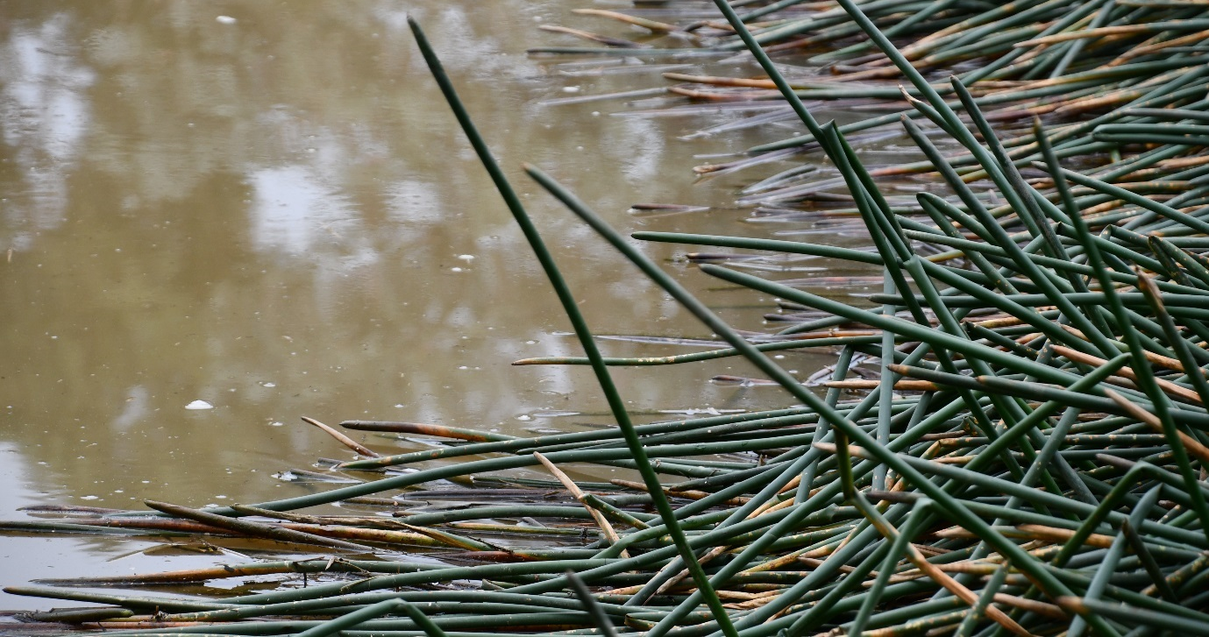
Prior to European settlement much of Maroondah was low-lying and covered by swampy vegetation. A feature of the swampy landscape would have been numerous scattered wetlands, many ephemeral in nature. Wetlands by their nature, provide many important habitat resources, and as such are vital habitat for many different species.
Stage 2 of Melbourne Water’s ‘Enhancing Our Dandenong Creek’ collaborative project is focusing on enhancing Parklands, Floodplains, Billabongs and Wetlands in the middle-Dandenong Creek catchment, which includes around half the area of the municipality of Maroondah.

Priority Action: 2.3.(f)
Identify locations, especially in lower lying areas of public open space (eg Swampy Woodland EVC), where there is potential to create wetlands, especially ephemeral, to act as habitat ‘stepping stones’, and pursue available opportunities as identified.
Biodiversity 2037 Implementation Framework
Help to create more liveable and climate-adapted communities. Action 7.1 Support the establishment of new green infrastructure to maximise the co-benefits to communities and test new approaches for connecting Victorians to nature in an urban context
Living Melbourne: Our metropolitan urban forest:
Protect and restore species habitat, and improve connectivity. Action 1.4 Implement priorities for conservation, and secure and build habitat connectivity

In locations along important habitat corridor routes where development density is relatively high, such as commercial areas and activity centres, green roofs that ideally use indigenous species and replicate understorey habitats can provide habitat ‘stepping stones’ for smaller mobile species that are reliant on understorey (eg insects and small birds). Green roofs and walls provide multiple benefits ranging from biodiversity, stormwater retention and liveability benefits and where indigenous species aren’t suited to the unique growing conditions of green roofs and walls, non-indigenous plant species with similar habitat function can be considered.
If these locations are also where many people congregate (eg activity centres), the opportunities for people to encounter nature increase.

Priority Action: 2.3.(g)
Identify opportunities in future building projects to design in demonstration green roofs (small or large) that feature indigenous plant species and replicate understorey habitat elements, where they occur along strategic habitat corridor routes and activity centres (eg new commercial and/or public buildings).
Plan Melbourne 2017-2050: Action 55
Excellence in built environmental design. Promote excellence in how Victoria’s built environment is designed and constructed by:
- embedding design review in the assessment of significant development projects to ensure the highest possible design outcomes are achieved on major public and private sector projects. This will apply to:
  - significant government or funded (including local government) projects
  - projects that impact on places on the Victorian Heritage Register
  - significant private sector projects referred by local government
- strengthening the design understanding and capabilities within all levels of government
Plan Melbourne 2017-2050: Action 91
Whole-of-government approach to cooling and greening Melbourne. Create urban forests throughout the metropolitan area by:
- assembling and disseminating spatial data on the green space network, existing tree cover and surfaces. This data will be the baseline for modelling future greening strategies and their impacts on amenity of our urban areas including cooling effects
- working with local government to establish greening targets for each of the metropolitan regions
- liaising with water corporations to identify opportunities for use of alternative water supply ton support greening strategies
- supporting development of municipal urban forest strategies using a coordinated approach with VicRoads, private road operators and other public land owners and managers
- preparing greening strategies for state-owned public land, including schools, parkland, road, rail, and utility corridors, achieving an appropriate balance between asset protection and urban greening
- investigating a targeted grants program to support innovation and actions for greening neighbourhoods
- investigating demonstration projects including green roofs, green walls, and landscapes
- preparing new guidelines and regulations that support greening new subdivisions and developments via landscaping, green walls, green roofs and increase the percentage of permeable site areas in developments
Biodiversity 2037 Implementation Framework
Help to create more liveable and climate-adapted communities. Action 7.1 Support the establishment of new green infrastructure to maximise the co-benefits to communities and test new approaches for connecting Victorians to nature in an urban context
Victoria's Climate Change Adaptation Plan 2017 - 2020
Improving the resilience of our built environment. The Government will work with the City of
Melbourne to build a large, publicly accessible green roof in Melbourne’s CBD (from 2017). This project will help the community learn about the benefits of green roofs and inspire other projects

Where strategic habitat corridor routes traverse private residential land the opportunities for incorporating habitat are largely dependent on the willingness and capacity of individual landholders to design in, and use, indigenous plants and other habitat elements into their own gardens. There are several existing programs in Victoria designed to encourage and support this, such as Boroondara’s Backyard Biodiversity program, Knox’s Gardens for Wildlife program (now being adopted by several other councils across metropolitan Melbourne), and biodiversity-focussed grant and rate rebate schemes. Such programs have potential to provide habitat elements in highly urbanised landscapes, as well as help connect people to nature and build a culture of biodiversity custodianship in the community.
Each of these programs require resourcing and time to design, establish and maintain. An understanding of critical components for effectiveness, and their comparative returns in terms of enhanced biodiversity and community custodianship, is needed to inform decisions on how best to increase habitat on private land in Maroondah.

Priority Action: 2.3.(h)
Evaluate the options for engaging and supporting landholders to increase habitat provision on private land along important habitat corridor routes in order to help build a community culture supportive of biodiversity.
Biodiversity 2037 Implementation Framework:
Raise the awareness of all Victorians about the importance of the state’s natural environment. Action 3.3 Engage Victorians with key biodiversity objectives and actions, by showcasing Victoria’s rich biodiversity through ongoing public, science and education programs
Biodiversity 2037 Implementation Framework:
Increase incentives and explore market opportunities for private landholders to conserve biodiversity. Action 11.1 Examine the suite of Victorian private land conservation mechanisms and programs to assess their complementarity and investigate the pathways with the highest potential to increase landholder participation in biodiversity protection
Living Melbourne: Our metropolitan urban forest:
Protect and restore species habitat, and improve connectivity. Action 1.4 Implement priorities for conservation, and secure and build habitat connectivity
Living Melbourne: Our metropolitan urban forest:
Scale up greening in the private realm. Action 3.3 Encourage private landholders to protect and enhance the urban forest and expand greening activities by offering incentives for planting, installing and maintaining natural infrastructure
Living Melbourne: Our metropolitan urban forest:
Collaborate across sectors and regions. Action 4.2 Mobilise broad community support
Living Melbourne: Our metropolitan urban forest:
Collaborate across sectors and regions. Action 4.3 Foster and promote urban forest champions, in both the public and private sectors

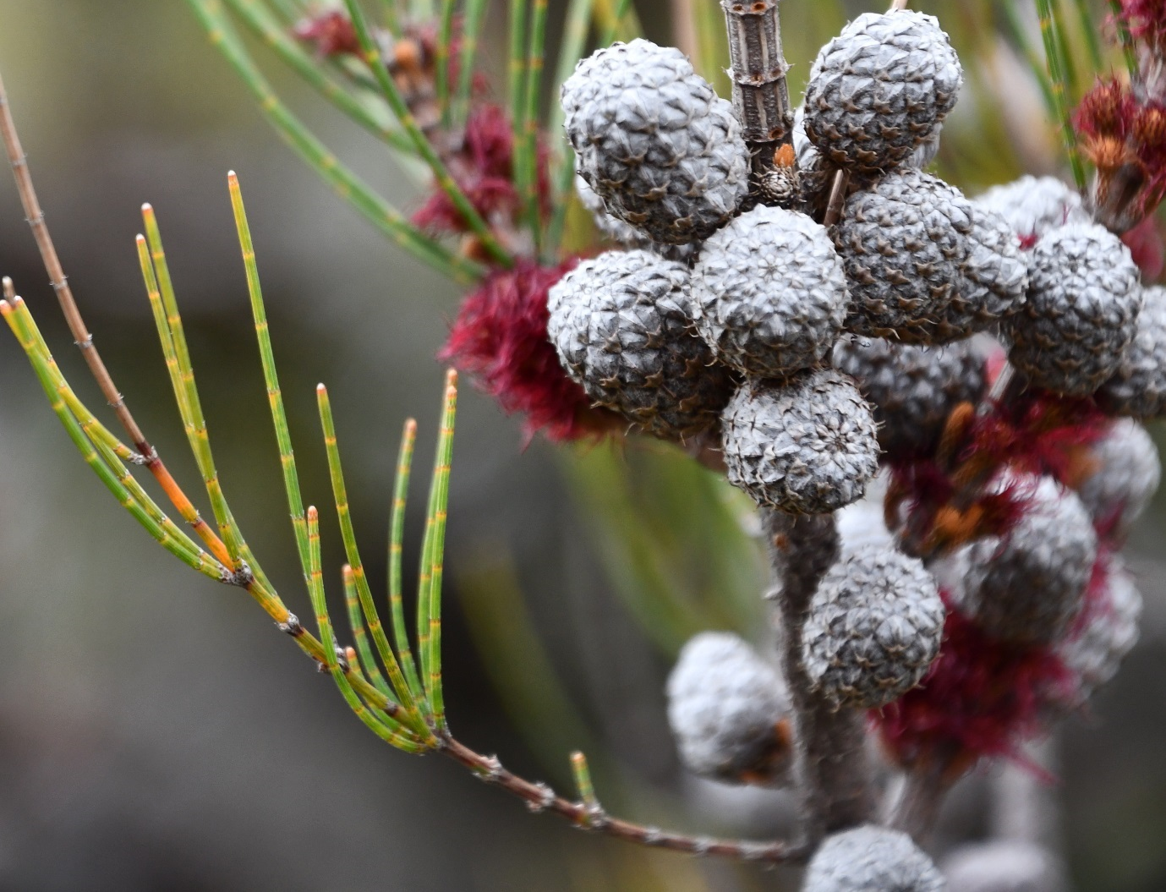
In Victoria, a native vegetation offset is generally required when an approval or permit to remove native vegetation is granted. An offset compensates for biodiversity losses arising from native vegetation removal. First party offsets are on land owned by the holder of the permit to remove vegetation. Third party offsets are on land owned by another party, where permit holders can buy native vegetation credits from other landowners to meet their offset requirements. Offsets cannot be provided on publicly owned land and must be on land in private ownership.
The Department of Environment, Land, Water and Planning has specific requirements around native vegetation offsetting, and provides accreditation for a range of independent offset providers that broker arrangements between a permit holder and a landowner willing to provide the matching offset. The Australian Government’s Department of the Environment and Energy also have an environmental offsets policy under their Environmental Protection and Biodiversity Conservation Act.
Some Victorian councils have secured accreditation as an offset broker to assist permit holders find the offsets they need, and to help find suitable offset sites within their own municipality that enable the offsets to benefit their local environments and biodiversity.

Priority Action: 2.3.(i)
Investigate potential for inhouse vegetation offset brokering program in accordance with Australian and Victorian Offset requirements

Outcome 3: Council support
Council has clear policy and direction that supports implementation of this Strategy with a focus on the importance of vegetation collaborative action, and measurable targets coupled with monitoring and reporting of progress.

The European Union defines Green Infrastructure as a ‘strategically planned network of natural and semi-natural areas with other environmental features designed and managed to deliver a wide range of ‘ecosystem services’. Vegetation provides many ecosystem services that can help deliver on the objectives of many different sectors of Council. By viewing vegetation as a form of essential ‘green infrastructure’, with collective consideration of the services desired from vegetation, the plans and strategic decisions Council makes for vegetation protection and provision, particularly in the public realm, can lead to coordinated and integrated achievement of these objectives.
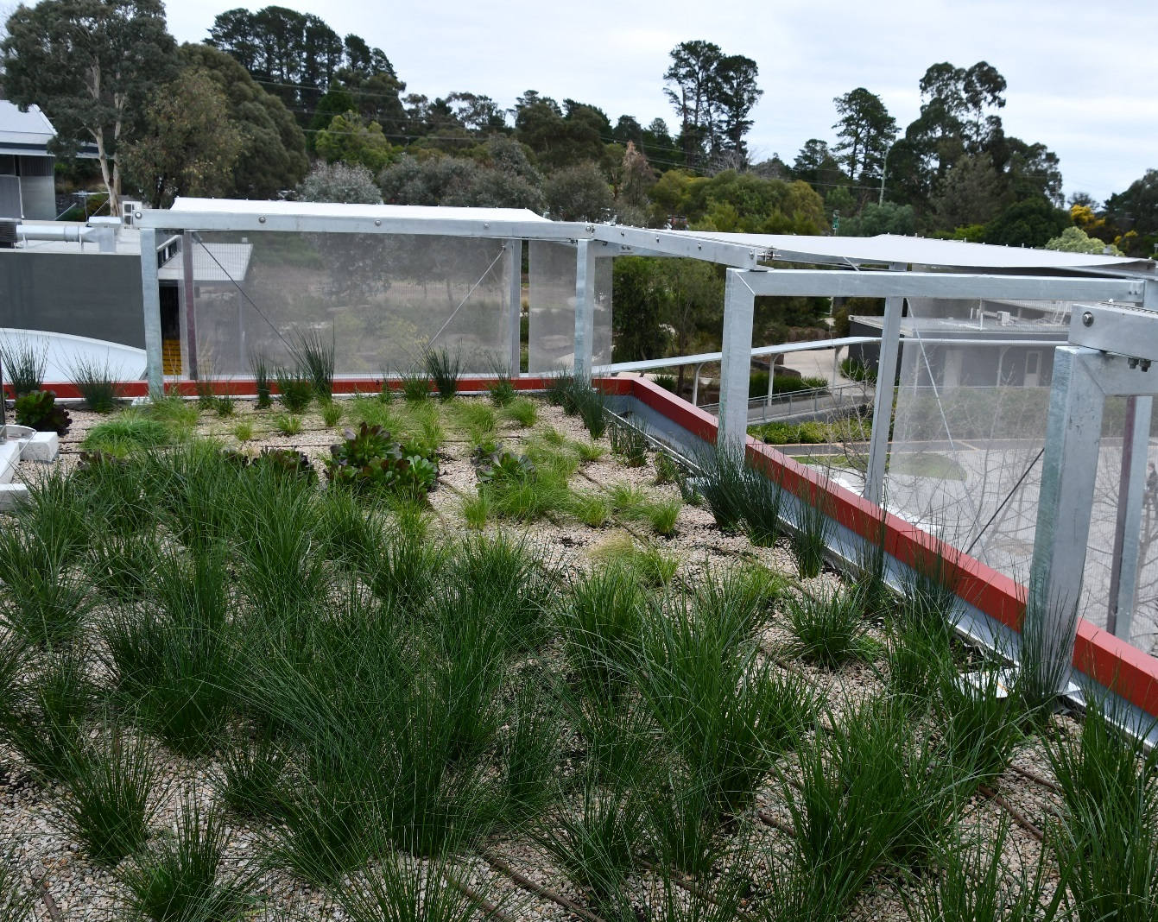

Priority Action: 3.1
Establish internal and external arrangements that offer opportunity for achieving multiple benefits from green infrastructure.
Biodiversity 2037 Implementation Framework
Help to create more liveable and climate-adapted communities. Action 7.1 Support the establishment of new green infrastructure to maximise the co-benefits to communities and test new approaches for connecting Victorians to nature in an urban context

Seizing real opportunities to trial collaborative green infrastructure planning, design and implementation in a practical way can provide staff across Council the experience and learnings that will build their skills and confidence to apply a green infrastructure approach more widely.
In partnership with the community the preparation of structure plans present ideal opportunities for trialling and gaining experience in collaborative green infrastructure planning.

Priority Action: 3.2
Use the preparation of structure plans for activity centres to trial collaborative green infrastructure planning, design, and implementation approaches.
Biodiversity 2037 Implementation Framework
Help to create more liveable and climate-adapted communities. Action 7.1 Support the establishment of new green infrastructure to maximise the co-benefits to communities and test new approaches for connecting Victorians to nature in an urban context
Living Melbourne: Our metropolitan urban forest:
Build a toolkit of resources to underpin implementation. Action 5.1 Build the capacity of public and private sector practitioners to protect, enhance and expand the urban forest

There are several actions in this strategy that involve amendment of the Maroondah Planning Scheme to introduce new planning provisions, and the Victorian Government has also introduced several new planning provisions that are related to vegetation. Strong, clear, integrated, and supportive high level planning policy statements will best serve these new provisions.
In July 2018, the Victorian Government introduced a new Planning Policy Framework (PPF) through Amendment VC148. The new PPF enables the future introduction of a Municipal Planning Strategy that replaces the Municipal Strategic Statement that sits atop each council’s planning scheme, providing the opportunity to incorporate clear policy statements (existing and new) in support of the proposed vegetation planning provisions. With any major changes to the planning scheme arising from this strategy and new policies introduced by the Victorian Government, their smooth introduction will be well served by ensuring the Maroondah community is aware of the changes and their implications.
Priority Action: 3.3
Incorporate into a new Maroondah Municipal Planning Strategy (requirement of VC148) clear supporting policy statements, objectives and strategies around biodiversity and vegetation (including its health, habitat, and neighbourhood character benefits), the importance of streams, wetlands, permeability and WSUD for vegetation, and the importance of connecting people with nature. Ensure integration with the objectives of VC154 Stormwater Management and other recent key amendments.
Priority Action: 3.4
Provide clear and accessible information, and support Council’s statutory planners with training and clear decision guidelines, standard conditions, and peer support arrangements to enable smooth introduction of any new vegetation planning provisions.

Monitoring of the effectiveness and impact of this strategy requires suitable indicators that can be used to establish measurable targets, and cost-effective mechanisms for collecting the data to enable monitoring and reporting of progress over time towards those targets. Finding suitable indicators to determine whether we are achieving the desired outcomes of “A More Liveable Maroondah”, and “More Nature throughout Maroondah” will be a challenge.
In the interim, it is proposed that we aim to establish measurable targets for canopy cover on the assumption that more canopy cover will contribute to increased liveability, and for habitat extent and condition on the assumption that more habitat will contribute to more nature.
The Living Melbourne: our metropolitan urban forest strategy has set targets for different regions of metropolitan Melbourne to increase tree canopy and shrub cover over time. Maroondah falls in the Eastern Region, which also includes the municipalities of Knox, Manningham, Monash, Whitehorse, and Yarra Ranges. Targets are set for each of 2030, 2040 and 2050. These targets provide a sound basis for setting targets for Maroondah to increase our own tree canopy and shrub cover over time, and in turn make a fair and equitable contribution to achieving the Eastern Region targets and wider targets for metropolitan Melbourne.
The baseline and proposed tree canopy and shrub cover targets for the Eastern Region for 2040 are:
- Existing 2015: Total tree canopy cover - 25%; Total tree and shrub cover - 44%
- Target 2040: Total tree canopy cover - 29%; Total tree and shrub cover - 50%
The setting of targets needs to be accompanied by sound and repeatable indicators and methods for monitoring progress towards their achievement. The i-Tree statistical analysis used for the Maroondah Canopy & Landscape Analysis 2011 to 2016 offers one method, but emerging methods such as analysis of LiDAR (Light Detection and Ranging) remote sensing data, the ‘Tree Ledger’ machine learning technology and CSIRO’s Urban Monitor project that can recognise trees from aerial imagery, have the potential to provide more absolute measures of tree numbers and canopy cover.

Priority Action: 3.5
Establish a reliable and cost-effective method for ongoing monitoring of tree and shrub cover, starting with trialling of the suitability of ‘Tree Ledger’, and set Maroondah-wide tree canopy and shrub cover targets that are aligned with the Living Melbourne strategy.
Plan Melbourne 2017-2050: Action 91
Whole-of-government approach to cooling and greening Melbourne. Create urban forests throughout the metropolitan area by:
- assembling and disseminating spatial data on the green space network, existing tree cover and surfaces. This data will be the baseline for modelling future greening strategies and their impacts on amenity of our urban areas including cooling effects
- working with local government to establish greening targets for each of the metropolitan regions
- liaising with water corporations to identify opportunities for use of alternative water supply ton support greening strategies
- supporting development of municipal urban forest strategies using a coordinated approach with VicRoads, private road operators and other public land owners and managers
- preparing greening strategies for state-owned public land, including schools, parkland, road, rail, and utility corridors, achieving an appropriate balance between asset protection and urban greening
- investigating a targeted grants program to support innovation and actions for greening neighbourhoods
- investigating demonstration projects including green roofs, green walls, and landscapes
- preparing new guidelines and regulations that support greening new subdivisions and developments via landscaping, green walls, green roofs and increase the percentage of permeable site areas in developments
Living Melbourne: Our metropolitan urban forest:
Set targets and track progress. Action 2.1 Establish and implement urban forest greening targets including, as a minimum, ‘tree canopy’ and ‘tree canopy and shrub’ cover for each region
Living Melbourne: Our metropolitan urban forest:
Set targets and track progress. Action 2.4 Develop a system for consistently collecting and analysing urban forest data, and coordinate the collection and publication of data in a publicly available, comparable database

In April 2017 Maroondah City Council formalised its status as a ‘Regional Catchment Strategy Partner’ with the Port Phillip and Westernport Catchment Management Authority, by publicly committing to the following vegetation targets:
- No net loss of the area and quality of existing native vegetation on 171 hectares of land managed by the City of Maroondah to 2040.
- Improved native vegetation quality on an additional 6.7 hectares of land managed by the City of Maroondah by 2025 and a further 13.1 hectares by 2040.
- No net loss in Council’s 2016 stock of 64,200 street trees to 2040.
- No net loss of the 650 ha of open space owned by Council to 2040.

Priority Action: 3.6
Establish a reliable and cost-effective method for monitoring habitat extent and condition across Maroondah, and progress towards the Maroondah-wide native vegetation targets that were committed to as part of partnering with the PPWCMA’s Regional Catchment Strategy.
Living Melbourne: Our metropolitan urban forest:
Set targets and track progress. Action 2.3 Establish a method for monitoring, evaluating and reporting on the improvement of the urban forest, including indicators and measures for quality and
extent

This strategy seeks to create a greener and leafier Maroondah by protecting, improving, and extending vegetation throughout Maroondah. In doing so it endeavours to deliver two key outcomes that result from vegetation. In addition to measuring progress towards vegetation targets, it is important to understand whether the desired outcomes are being achieved - that is are we having the impact we set out to achieve?
The two key outcomes are:
Outcome 1. A more liveable Maroondah
More vegetation, especially an extensive and connected canopy of trees providing shade, cooling, pleasant and tranquil green spaces, water absorption, and habitat elements, that supports community health and wellbeing by helping people connect with nature, avoid heat-related illnesses, reduce anxiety and stress, avoid flooding issues, and engage in outdoor physical activity (walking/riding/playing)
‘Liveability’ and ‘community wellbeing’ are influenced by many factors, of which vegetation is only part. The Maroondah Health and Wellbeing Plan 2017 - 2021 identifies numerous indicators and data sources that relate to aspects of health, wellbeing, and liveability, some of which may offer potential for measuring aspects of liveability and/or wellbeing attributable to vegetation.
Outcome 2. More nature throughout Maroondah
More vegetation, in the form of a well-connected network of indigenous trees, shrubs and understorey plants providing a wide range of habitat elements such as the food, shelter, and opportunities to move through the landscape that native flora and fauna in Maroondah need to flourish, and simultaneously create more opportunities for people to encounter and connect with nature close to where the live, work and play.
Biodiversity refers to the variety of all forms of life - species diversity, genetic diversity within species, and diversity of communities formed by species. Inherent in Outcome 2 is the objective of protecting, and reversing the decline of, biodiversity in Maroondah. The Eastern Alliance for Greenhouse Action (EAGA) delivered a project titled “Biodiversity Monitoring in Melbourne’s East (2015)” that pioneered the development and trial of a new framework for monitoring indicators of biodiversity health in the context of a changing climate. Dr Graeme Lorimer in “Biodiversity of Maroondah - Volume 1 (2019)” discusses this and other options for monitoring changes in biodiversity in Maroondah. Citizen science also presents opportunities to involve the community in collecting data that may be useful in monitoring biodiversity changes.

Priority Action: 3.7
Investigate and evaluate potential indicators and monitoring methods for measuring the strategy’s effectiveness in terms of achieving the outcomes of “A More Liveable Maroondah”, and “More Nature throughout Maroondah”.
Climate Change Adaptation Roadmap for Melbourne’s East
Adaptation objective: Improve the management of biodiversity and open space under hotter and drier conditions with more extreme events. Action: Seek further funding for reporting and analysis of data associated with the EAGA Biodiversity Monitoring Framework.

References
- CSIRO (2013) Climate Futures for Eastern Melbourne: Data provided for the Eastern Alliance for Greenhouse Action
- DELWP (2016) Better Apartments Design Standards
- DELWP (2017) Planning for biodiversity: Guidance
- DELWP (2018) Amendment VC154 - Stormwater management. Planning Advisory Note 75
- IPBES (2019) Global assessment report on biodiversity and ecosystem services of the Intergovernmental Science- Policy Platform on Biodiversity and Ecosystem Services (IPBES Secretariat)
- Kaspar, J. (2018) Maroondah Canopy and Landscape Analysis 2011 to 2016 (Greenspace Consultant)
- Lorimer, G. (2018) Biodiversity in Maroondah - Volume 1 (Biosphere P/L)
- Lorimer, G. et al, (1997) Sites of Biological Significance in Maroondah (Biosphere P/L)
- Maroondah City Council (2019) Maroondah Vegetation Review: Issues & Options Paper
- Scott, C. (2019) Maroondah City Council: Vegetation Planning Policy Review Recommendations Report (Claire Scott Planning)
- Scott, C. (2019) Maroondah Neighbourhood Character Study Review: Recommendations Report (Claire Scott Planning)

Glossary
Biodiversity: The diversity of all forms of life, including species, the genetic diversity within each species and the diversity of communities that species form. Biodiversity spans organisms from the smallest virus to the largest trees.
Canopy: The lateral extent of the upper layer of foliage (tree crown) of an individual tree or group of trees.
Canopy cover: The fraction of ground area covered by the vertical projection of tree crown perimeters
Green infrastructure (or blue-green infrastructure): A strategically planned network of natural and semi-natural areas with other environmental features designed and managed to deliver a wide range of ‘ecosystem services’ including stormwater management, climate adaptation, less heat stress, more biodiversity, food production, better air quality, sustainable energy production, clean water and healthy soils, as well as increased quality of life through recreation and providing shade and shelter in and around towns and cities.
Ecosystem: The combination of an interdependent community of living things and the physical features that support it, such as climate, soil, and water.
Ecosystem services: Practical benefits that flora and fauna provide to humans, such as the shade, wind protection and air purification provided by trees or the pollination of garden plants by insects.
Environmentally Sustainable Design (ESD): The philosophy of designing physical objects, the built environment, and services to comply with the principles of ecological sustainability, such that they reduce consumption of non-renewable resources, minimise waste, and create healthy, productive environments.
Habitat: The natural home or environment of an animal, plant, or other organism. It is characterised by both physical and biological features, and is where a species can find the food, shelter, protection, and mates for reproduction it needs.
Heat vulnerability: Specific population and community characteristics that mark vulnerability to heat waves.
Human wellbeing: The human state of being comfortable, healthy, or happy. It is a complex combination of a person's physical, mental, emotional, and social health factors. Wellbeing is strongly linked to happiness and life satisfaction, and could be described as how you feel about yourself and your life.
Indigenous: A species of flora or fauna is ‘indigenous’ to an area if it is presumed to have occurred there prior to European colonisation. A species may be indigenous to one part of Maroondah and not to another.
Invertebrate: An animal without a backbone, e.g. an insect, spider, worm, or mollusc.
Liveability: The sum of the factors that add up to a community’s quality of life; including the built and natural environments; economic prosperity; social stability and equity; educational opportunity; and cultural, entertainment and recreational possibilities.
Nature: Equivalent to the natural world, and refers to living plants and animals, geological processes, weather, physics, such as matter and energy, and other natural elements of the Earth.
Permeability: The property of a soil which permits the passage or seepage of water through its interconnecting voids
Vegetation: An assemblage of plant species and the ground cover they provide. It is a general term, without reference to particular species, life forms, structure, spatial extent, or any other specific botanical or geographic characteristics.
Vertebrate: An animal with a backbone. The vertebrates indigenous to Maroondah include mammals, birds, reptiles, frogs, and fish.
Water Sensitive Urban Design (WSUD): An integrated approach to water management that integrates urban design and planning with social and physical sciences in order to deliver water services and protect aquatic environments in an urban setting. A WSUD approach could include the integration of raingardens and wetlands in an urban area to manage stormwater.

