Draft Maroondah Affordable and Social Housing Policy 2018
Working towards an attractive, thriving and well built community

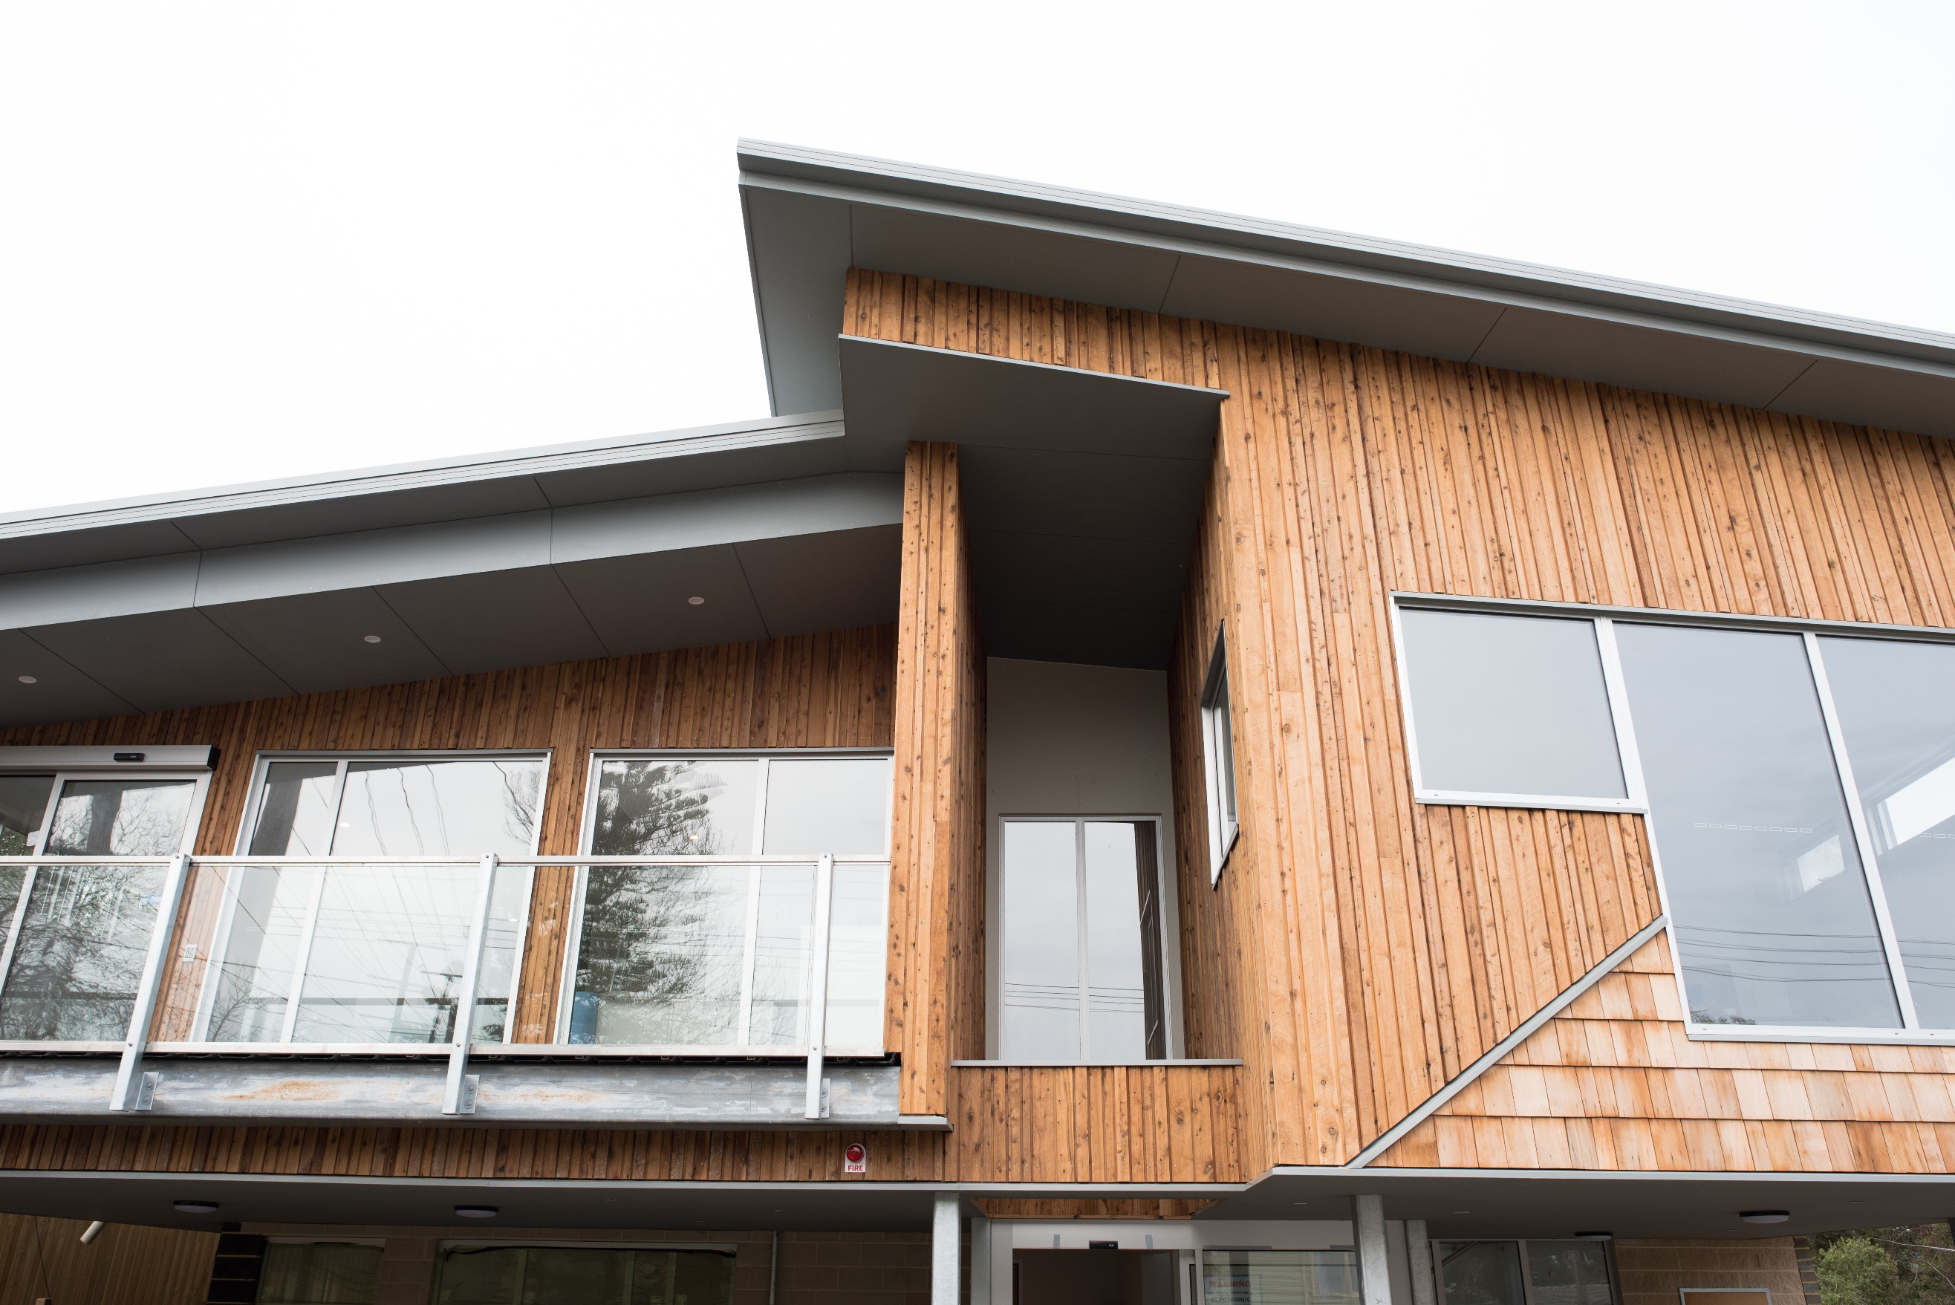
Working towards a safe, healthy and active community

Policy Title  Maroondah Affordable and Social Housing Policy 2018 (draft) |  | Policy No  IP-003 | Policy type  Council Policy
Policy creation date  April 2018 | Current version adopted  N/A | Current version number  01 | Policy review date  June 2026
Parent policy  None | Child policy/policies  None | Policy responsibility  Manager Integrated Planning | eCLIP record number  N/A


Working towards an attractive, thriving and well built community

Contents

Executive Summary | 4
What is the purpose of this Policy? | 5
Why is this issue important? | 6
How was this Policy prepared? | 6
What is the policy context? | 7
What does the evidence tell us? | 12
What were we told by stakeholders? | 22
Our strategic response | 26
Monitoring and review | 27
Glossary | 28
References | 30

Executive Summary

The City of Maroondah has traditionally been a location where people can afford to live, work and retire. This scenario is increasingly under threat with access to affordable and social housing in Maroondah becoming more challenging. In turn this is having a detrimental effect on the livability, affordability and well-being of the municipality. In particular, more than 4,000 households are currently experiencing severe housing stress. Those affected require significant housing assistance to be able to live in Maroondah. The causes are complex and the solutions will require the assistance of many parties.

By way of background, affordable housing is that which doesn’t cost (in rent or mortgage payments) more than 30% of gross income for households in the bottom two quintiles (40%) of the income distribution. ‘Social housing’ represents a subset of affordable housing. It is distinguished by its ownership by the State or State registered not for profit providers, its permanent dedication for affordable rental (as distinct from ownership tenure).

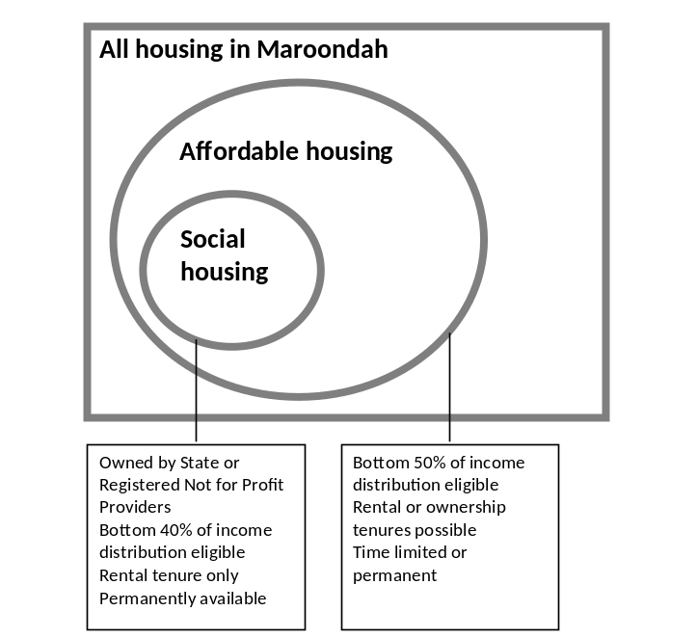

As the population of Maroondah continues to change, Council recognises the need to address the housing issues of current residents, as well as improve the diversity and affordability of housing for future generations. This Policy outlines Council’s position, role, and commitment to delivering sufficient housing infrastructure, allowing residents to invest within Maroondah’s housing market, age in place and have access to secure affordable and social housing.

Council’s Policy for affordable and social housing is heavily informed by the Maroondah 2040 Community Vision for a safe, healthy, attractive, thriving, well-built, inclusive, and diverse community. The following Maroondah 2040 key directions are relevant:

- Advocate and promote the provision of a diversity of affordable housing options to suit a range of lifestyle needs and life-stage requirements;
- Encourage and support the provision of a diverse range of housing across Maroondah, that meets the needs of current and future residents;
- Plan and facilitate the development of a community where everyone can live, work and play locally;
- Facilitate the provision of affordable, accessible, and responsive services, resources and initiatives that support the physical and mental health and wellbeing of the community.
The Maroondah Housing Strategy (2016) identified the need for an affordable and social housing policy, to ensure that Maroondah remains an affordable and liveable location for its residents, with access to services, employment, infrastructure, and a diversity of housing.

It particularly identified the need to:

- Encourage and implement planning concessions that increase community benefits such as affordable or social housing;
- Promote affordable housing, social housing and age-friendly accommodation through regional collaboration, advocacy to higher levels of government and policy development
To deliver the affordable and social housing aspects of this vision, and support the directions outlined in Maroondah 2040: Our future together and the Maroondah Housing Strategy 2016, this Policy outlines four priority areas that will enable Council to play an increased role:

- Facilitate effective planning direction and innovative support
- Play a key facilitation and brokerage role to support the delivery of increased affordable and social housing in Maroondah
- Work in partnership to advocate for increased investment and support for affordable and social housing
- Apply a proactive approach to encouraging greater investment and supply of social and affordable housing through land use planning provisions

A range of specific policy directions are identified under each priority area.

Council looks forward to working in partnership to implement this Policy to improve the supply of social and affordable housing in Maroondah.

What is the Purpose of this Policy?

The Maroondah Housing Strategy (2016) found that affordable and accessible housing remains a key issue for the community, developers and service providers. Changes in the housing market and an increased demand for affordable housing in Maroondah, are two key issues impacting the supply of affordable and social housing. As a result, many households within Maroondah are struggling to meet rent and mortgage repayments and secure accommodation.

Approximately 9.5% of all Maroondah households (a total of 4,000 low income households) are in housing stress, contributing more than 30% of their household income to rent or mortgage repayments (SGS Economics and Planning). For home owners, housing affordability in Maroondah has decreased in recent years as the proportion of household income required to purchase the average house has increased substantially. In 2011, 34% of Maroondah households owned a dwelling outright, 22% were renting, and 44% were repaying mortgages (SGS Economics and Planning). For renters, the proportion of affordable new rental lettings declined dramatically between 2006 and 2010 in the City of Maroondah, from a total of 38% of all new lettings in 2006 to 11% in 2008, and then to 4% in 2010. Since then, the proportion has remained relatively constant (SGS Economics and Planning)

In addition to the private home buyers market, there is a critical need for social and special needs housing across Melbourne. Part of a liveable and accessible Maroondah includes having access to special needs housing and social and affordable housing to support the most vulnerable members of our community. The spatial location of this housing is also important to ensure easy access to public transport, employment and community services.

Affordable and social housing is a growing issue, not just for Maroondah, but across Victoria. Among Australian states and territories, Victoria has the lowest percentage of total housing stock provided as social housing. A 2013 analysis by Swinburne University showed the percentage of social housing in Victoria at 3.4% (Burke, 2013). At the 2011 census, social housing made up a total of 2.8% of the total housing stock in Maroondah (SGS, 2018)

The Maroondah Housing Strategy acknowledged that Council has a role to play in the affordable and social housing space. This Policy clarifies Council’s position, role and function on these issues within its scope of influence.

Why is this Issue Important?

Affordable and accessible housing remains a key issue for the community, developers and service providers. These groups recognise the impacts of rising house prices, the increase in demand for housing, and the falling supply of affordable rentals.

According to the Maroondah Housing Strategy (2016), low income households with children are finding it increasingly difficult to access appropriate and affordable housing often resulting in families breaking down. Similarly young adults are finding it particularly difficult to move out of home and secure affordable housing locally. Affordable private rental accommodation is very constrained and levels of homelessness are rising alarmingly.

The Maroondah population is ageing. The fastest population growth of all age categories is in the 70 to 84-year age group, with an average increase of 2.3% per annum. However, there is a lack of access to affordable age-friendly housing for the ageing population which is becoming an increasing source of housing and general life stress. If suitable accommodation and care isn’t available, relatives often have to cut back on their work commitments to provide assistance.

The establishment of a formal Council policy in this space will enable Council to play an increased role in facilitating affordable housing, social housing and age-friendly accommodation through regional collaboration, advocacy to higher levels of government, and through land use planning policy. It will encourage Council to build on partnerships with local community and service organisations.

How was this Policy Prepared?

The need for this Policy was initially raised in Council’s ‘The places we live: Maroondah Housing Strategy 2016’. In preparation of this Policy, Council reviewed the data in the housing strategy, to identify gaps in knowledge. SGS Economics and Planning (SGS) were subsequently engaged to help address these gaps, and inform policy direction for the affordable and social housing needs of Maroondah. Council worked closely with SGS in the preparation of a discussion paper that identified the municipalities affordable housing challenge, the role of local government in affordable housing and our policy options.

To inform the discussion paper, Council facilitated stakeholder engagement with key organisations actively working in the field locally. One on one interviews were used to build an understanding of the perspectives and experiences of respected stakeholders who have worked directly with people affected by the challenges of affordable and social housing. Focus group sessions were used by SGS to further develop an understanding of the perspectives of stakeholders to share and debate their ideas. Council invited 20 key individuals from leading organisations in the sector including Community Housing Ltd - Eastern Metropolitan, Eastern Domestic Violence Service Inc., the Salvation Army Community Connections, and Wesley Homeless and Support Service, to participate in these focus group sessions.

In March 2018 Council also facilitated an Affordable and Social Housing Forum with key local stakeholders and community leaders, to discuss the changing role of affordable and social housing in Australian policy, and the need for affordable and social housing in Maroondah. The forum was facilitated by Dr Marcus Spiller from SGS, with guest presentations by Suzi Hayes (Eastern Affordable Housing Alliance), Shari McPhail (Community Housing Ltd.), and Judy Sutherland (Department of Health and Human Services). The Forum enabled Council to identify people who are working within the field, local needs and opportunities, as well as investigate potential partnerships to work with in delivering affordable and social housing.

From these inputs, Council has prepared an Affordable and Social Housing Policy which clarifies Council’s policy position, along with Council’s current and future role and function in responding to affordable and social housing issues.

What is the Policy Context?

The City of Maroondah covers a land area of 61.4 square kilometres in Melbourne’s outer east, 22 kilometres from the Melbourne Central Business District. Maroondah has the strategic advantage of being located at the north-eastern junction of the Eastern Freeway – EastLink corridor. There are two train lines and a large number of bus routes linking the City with other regions.

Maroondah is well known for its leafy streets, broad areas of open space, bushland reserves, parks and playgrounds. Sustainable transport links include on-road cycling paths and shared path links to the Mullum Mullum Creek Trail, the EastLink Trail, Taralla Creek Trail and the Dandenong Creek Trail.

The City hosts a regional health precinct including a major public hospital and a large private hospital; educational facilities that cater from early childhood learning to tertiary level; two libraries; arts and cultural centres; an art gallery; and a range of community centres. Maroondah is also home to a range of world class sporting facilities including Aquanation, a regional recreation and leisure facility.

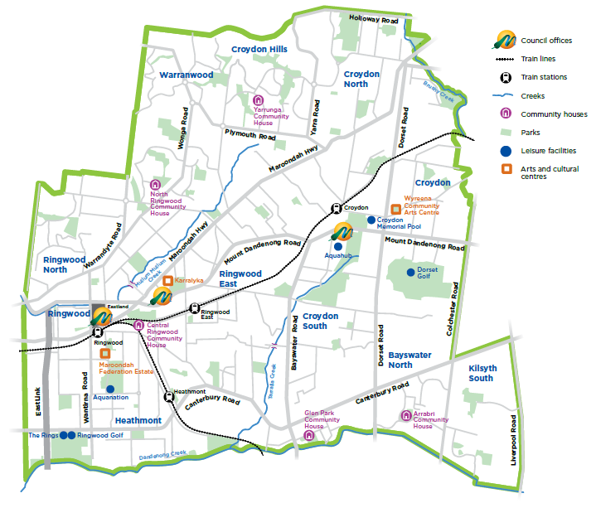

Affordable and social housing is a complex and challenging issue involving initiatives, agreements, policies, and strategies at a national, state, and local level. Each level of government is responsible for the development and implementation of their own strategic approach to affordable and social housing. However, it is not without a collaborative effort between the three tiers of Government that the challenges of social and affordable housing can attempt to be addressed.

Federal Policy Context

The National Housing and Homelessness Agreement, 2009, is one of several policies used by the Commonwealth Government to influence the spatial distribution and profile of housing. The NHHA is the Commonwealth Governments key affordable and social housing agreement, which works in partnership with the state governments to provide policy framework to fund social housing and homelessness services provision. Other policies and programs for affordable and social housing relate to providing infrastructure to support housing development, taxation, social services, immigration, and the financial sector. These initiatives are shown in Table 1 below:

Table 1 Commonwealth Government Initiatives 2017/18 Budget
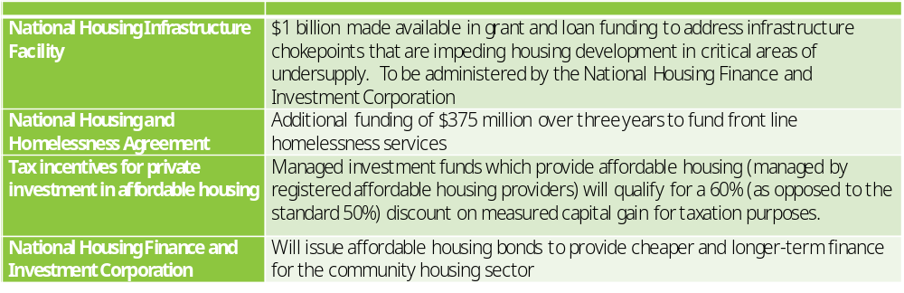
Source: CHFV

State Policy Context

The Victorian Government plays a key role in supporting affordable and social housing and focuses on social housing supply, social housing regulation, homelessness services, planning and development standards, tenancy law, and first home buyer’s assistance.

Plan Melbourne 2017-2050 is the Victorian Government’s long term strategic plan which highlights a number of polices addressing affordable housing in the planning system. Two key policies that are relevant for Maroondah include:

- Policy 2.3.3 – Strengthen the role of planning in facilitating and delivering the supply of social and affordable housing.
- Policy 2.3.4 – Create ways to capture and share value uplift from rezoning.

As part of the Victorian Government’s commitment to Plan Melbourne, legislation was passed in September 2017 that allows affordable housing to be used as a legitimate planning purpose under the Planning and Environment Act 1988. The Planning and Building Legislation Amendment (Housing Affordability and Other Matters) Bill 2017 provides a definition for affordable housing as ‘housing that includes social housing that is appropriate for the housing needs of; very low income households, very low income households, and moderate income households.’

Home’s for Victoria (2017) is the key Victorian Government affordable housing strategy which includes several initiatives and reforms that support the affordable and social housing policies of Plan Melbourne, and attempts to address housing affordability challenges across Victoria. This includes a $1b investment to expand the supply of social housing, through capital acquisition and leveraging, from the ‘Victorian Social Housing Growth Fund’. The Victorian Social Housing Fund is the Victorian Government’s first major contribution to the expansion of social housing since the Global Financial Crisis stimulus package, and is expected to generate $70m of revenue per annum to be deployed as capital acquisition of social housing and or to leverage investment into social housing by private investors.

This $70 million per year investment is estimated to be enough to increase the supply of social housing by 3,500 dwellings over a period of 25 years, but is not expected to be enough to make up the current difference between demand and supply, and effectively keep up with future social housing needs.

Local Policy Context

Council has three key strategic documents that directly inform the need for affordable and social housing within the municipality. Maroondah 2040: Our future together (2014), Council Plan 2017-2021 and the Maroondah Housing Strategy 2016 provide overarching direction on issues of affordable and social housing, and outline priority actions for the improvement of housing affordability and diversity. The development of this Policy is a priority action in both the Council Plan 2017-2021 and the Maroondah Housing Strategy 2016.

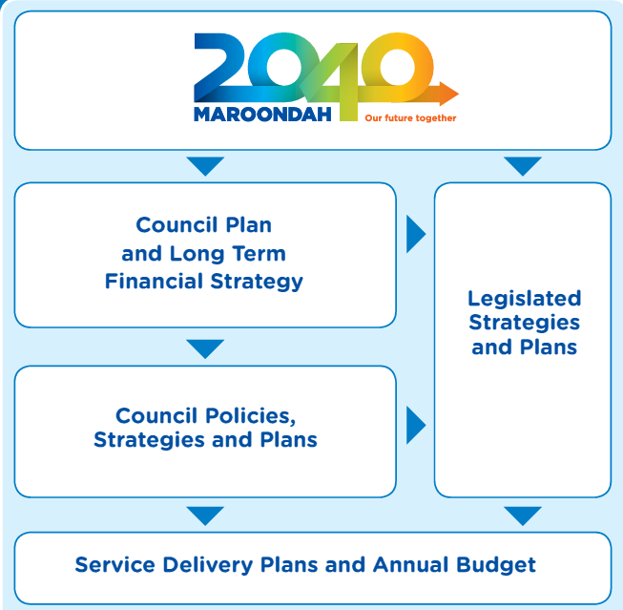

Council Plan 2017-2021

Housing Strategy 2016

Other Legislated Strategies and Plans

Other Council Policies, Strategies and Plans

Maroondah Affordable And Social Housing Policy

Service Delivery Plans and Annual Budget

Maroondah 2040
The Maroondah 2040 Community Vision for a safe, healthy and attractive community, an attractive, thriving and well-built community, and an inclusive and diverse community, are central to the development of this Affordable and Social Housing Policy. The key directions outlined by Maroondah 2040 include:

- 1.15 – To facilitate the provision of affordable, accessible and responsive services, resources and initiatives that support the physical and mental health and wellbeing of the community.
- 6.7 – to Plan and facilitate the development of a community where everyone can live, work and play locally.
- 6.8 – To encourage and support the provision of a diverse range of housing across Maroondah, that meets the needs of current and future residents.
- 7.5 – To advocate and promote the provision of a diversity of affordable housing options to suit a range of lifestyle needs and life-stage requirements.

Many of the key directions of Maroondah 2040 are based on a long-term vision for the municipality, therefore the Council Plan 2017-2021 is used to outline the Councils commitments relevant to a four year timeframe.

Council Plan 2017-2021
The Council Plan 2017-2021 is Maroondah City Council’s medium-term strategic document that sets key directions and priority actions to work towards the long-term community vision outlined in Maroondah 2040: Our future together.

The Council Plan plays a vital role in shaping Maroondah’s future over a four-year period. It identifies both challenges and opportunities for our community at a local and regional level within the context of the community’s long term Maroondah 2040 vision. It also forms the basis for Council to make decisions regarding resources and priorities in response to community needs and aspirations.

The development of this Affordable and Social Housing Policy is identified as a priority action in the Council Plan 2017-2021.

Maroondah Housing Strategy 2016
The Maroondah Housing Strategy 2016 was developed to support the delivery of the Maroondah 2040 community vision. The housing strategy is Maroondah’s long-term strategy to meet the current and future demands for housing diversity and affordable and social housing, whilst maintaining and improving the existing community. The key focus area outlined by the housing strategy relating to affordable and social housing is: Focus Area 4 -Improving affordability, accessibility and social housing opportunities

Strategic policy directions outlined in the Maroondah Housing Strategy 2016

- Key Direction 4.1 - Find ways to encourage and implement planning concessions that increase community benefits such as affordable or social housing, open space, off street parking, sustainability or design excellence
- Key Direction 4.2 - Continue to promote affordable housing, social housing and age-friendly accommodation through regional collaboration, advocacy to higher levels of government and policy development

Priority actions outlined in the Maroondah Housing Strategy 2016:

- 4.2a Develop a Council policy position on affordable and social housing that considers the introduction of additional measures and advocacy activities.
- 4.2b Work with the Eastern Affordable Housing Alliance to identify opportunities to achieve more social, affordable and special needs housing.
- 4.2c Support housing associations seeking to develop social and affordable housing projects.
- 4.2d Develop a land register of all Council, Crown and public land and underutilised/vacant land and identify strategic redevelopment opportunities in accordance with the objectives of this strategy through the application of a Design and Development Overlay for strategic sites.

Other Council Policies, Strategies and Plans
A number of other Council strategic documents also play a role in supporting and influencing this Policy.

These strategic documents include:

- Maroondah Health and Wellbeing Plan 2017-2021
- Active, Healthy and Ageing Initiative
- Disability Policy & Action Plan
- Youth Plan
- Children’s Plan
- Ringwood MAC Structure Plan
- Croydon Structure Plan
- Ringwood East Structure Plan
- Heathmont Structure Plan

Eastern Affordable Housing Alliance

Council also has a major avenue for advocacy through partnership with the Eastern Affordable Housing Alliance (EAHA) which is a collaborative association between six local councils in the Eastern Metropolitan Region (EMR). The EAHA was formed in 2010 in response to the diminishing investment in social housing in the eastern region, from the State and Federal Governments. The aim of the alliance is to ensure access to safe, secure and affordable housing for the EMR’s most disadvantaged people, to provide better health, wellbeing, and a higher quality of life to all.

Together, the Cities of Knox, Manningham, Maroondah, Monash, Whitehorse, and Yarra Range work to create enabling environments for increased investment by government and non-government stakeholders in social and affordable housing for the EMR. The advocacy role played by the EAHA is the first step towards increasing affordability, by developing an understanding for the affordable housing need in the EMR.

What does the Evidence tell us?

Affordable and social housing is a complex issue that challenges communities and policy makers at all levels of government. Insufficient access to affordable and social housing can affect an individual’s mental and physical well-being, reduce their quality of life, and lead to social disconnection and exclusion. The lack of affordable and social housing stock within an area, has a strong influence on the liveability and accessibility of a municipality.

Affordable Housing

Affordability means that housing is accessible to a wide range of people on varying incomes. While some housing will be more or less affordable, there needs to be affordable options for everyone. In particular, it is important to ensure that low to moderate income households have options to rent or buy and that very low income households, often in social housing, have housing security and continue to have realistic housing options within our community. Our definition of affordable housing is "that which does not cost (in rent or mortgage payments) more than 30% of gross household income for households in the bottom two quintiles of area (i.e. Greater Melbourne) median income."

Affordable housing refers to the availability of secure and appropriate housing for those in the lowest 40% (bottom two quintiles) of income earners.

Housing Stress

1 in 10 households in Maroondah are experiencing either serious or severe housing stress, requiring assistance for rent or mortgage repayments. This equates to more than 9.5% or 4,000 households within the Maroondah municipality requiring mortgage or rental assist to pay for accommodation. (SGS Economics and Planning, 2018).

As shown in Figure 1 below, the percentage of households experiencing housing stress is unevenly distributed throughout the municipality, with higher proportions of housing stress coming from the suburbs of Ringwood and Croydon (Spatial Economics, 2015).

Figure 1. Distributions of households experiencing housing stress across Maroondah
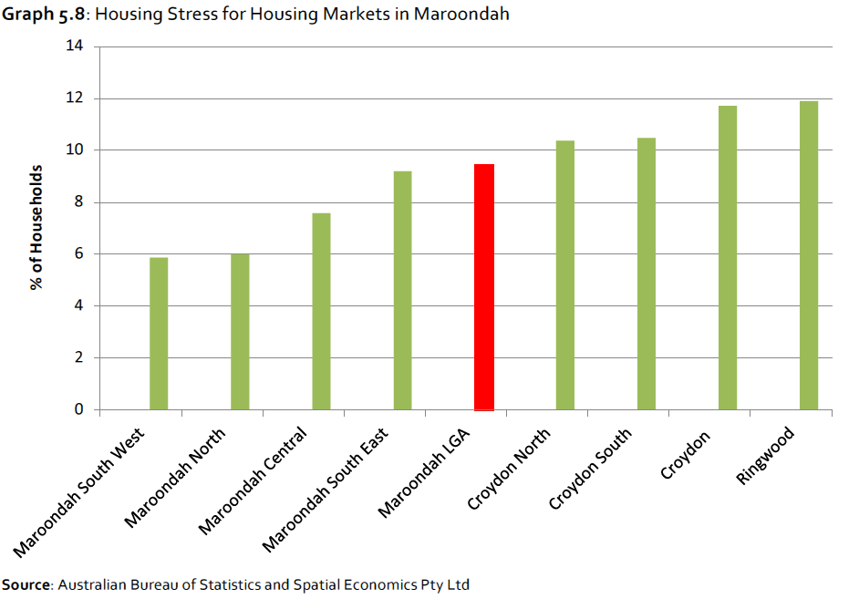
When compared to the other six municipalities within the Eastern Metropolitan Region, Maroondah’s 9.5% housing stress is above the regions average of 9%. As evident in the graph below (Figure 2), the municipalities within the eastern region have only slight variations in housing stress with the expectation of Manningham where the housing stress is a relatively low 7.3%.

Figure 2. Percentage of low income households in housing stress.
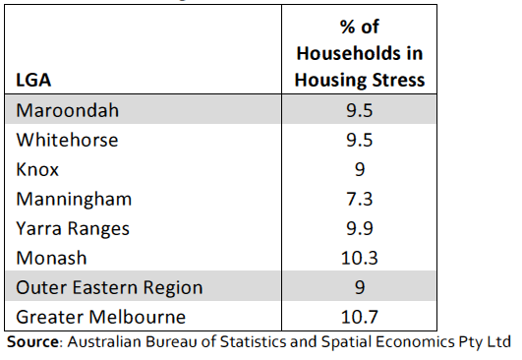

Home ownership

Whilst Maroondah has a ‘healthy’ majority of residents owning their own home (outright or with a mortgage), home ownership in the municipality has only increased by 1.1% per annum over the last 10 years, whilst renters have increased by 2.3% per annum. Home ownership is more prevalent in Ringwood North, Warranwood, and Croydon Hills, whilst the highest proportion of residents renting are found in Ringwood and Croydon which were also identified as having higher percentages of housing stress. Statistics indicate that younger populations are finding it difficult to enter the home ownership market, implying great pressure on the City’s affordable and social housing supply.

Rental Affordability

Of the households renting in Maroondah, 27% (2,313) low income households are considered to be experiencing significant rental stress. When compared to the other six municipalities within the Eastern Metropolitan Region, Maroondah’s 27% rental housing stress is even with the average of the region (figure 3).

Figure 3. Low income Households in Rental Stress by LGA & Region.

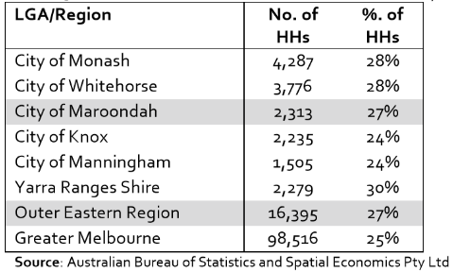

Maroondah has experienced a significant decline of affordable rental housing stock since the early 2000s. In 2006, 38% of new rental lettings were affordable for low income earners. By 2013, the percentage of new rental housing stock affordable for low income earners had rapidly declined to just 4%. This rapid decline in affordable housing has put enormous pressure on low-income households to access affordable housing across the municipality. The affordability of rental housing has continued to decline since 2011, both in affordability and distribution across the municipality.

Figure 4 below shows the affordability of rental housing across the suburbs of Maroondah, for a single working parent household earner $70,000pa. It compares the affordability of rental housing between 2011 and 2016. In 2011, acceptable rental housing opportunities can be found in all suburbs within the municipality. However, by 2016, this distribution of affordable rental housing has become segregated to the regions of Kilsyth and Bayswater North. It is clear that the availability of affordable rental housing not only continues to decline, but is also limiting the location opportunities for demographics such as low income single working parent households.

Figure 4. Rental Affordability Index for a ‘Single Working Parent’ – Maroondah Qtr 1, 2011 versus Qtr 4 2016
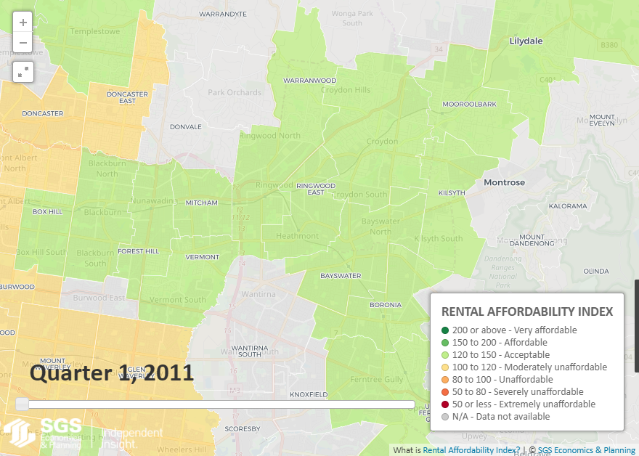
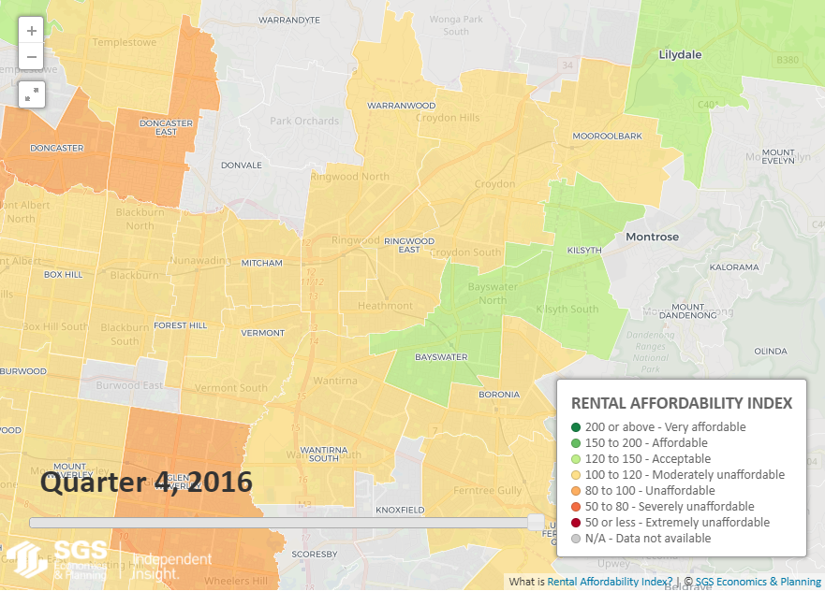
Source: SGS Economics & Planning Pty Ltd

Social Housing

Social housing is a subset of affordable housing, which focus’ on the bottom two quintiles (40%) of income distribution, and refers to a type of rental housing that is provided and/or managed by the State or State registered not-for-profit organisation. Social housing is an overarching term that covers public housing, community housing, and crisis accommodation. Public Housing^{1,2} – is a social housing service that is managed by the State Government, with the purpose of providing homes for very low income earners, victims of family violence, and those who have recently experienced homelessness.
Community Housing^{1,3} – this provides secure and affordable housing for people with low income or special needs. Community housing is managed by non-for-profit organisations that have been regulated and registered by State Government. Different types of community housing can be provided to facilitate the needs of families and individuals with different needs.
Crisis accommodation^{1,4,5} - is housing managed by not-for-profit organisations, for individuals and families who are affected by legal, family, drug, or alcohol issues. Stay durations in crisis accommodation are dependent on the circumstances of the renter, and is used to help struggling members of the community get ‘back on their feet’ (Archibald n/d). Crisis accommodation is generally in the form of self-contained dwellings, with a maximum of 10 inhabitable rooms.

1: Whitehorse Housing Strategy 2014
2: Department of Health Services: Public Housing
3: Department of Health Services: Community Housing
4: Clause 22.22 Crisis Accommodation
5: Ian Archibald: Crisis Help Network

An estimated 10% of Maroondah’s housing stock would need to be allocated for permanent social housing to provide housing for all those in need. Unfortunately, Maroondah’s social housing sector comprises of only 1,084 dwellings or 2.5% of total housing stock resulting in a deficiency of approximately 7.5% of social housing stock. Social housing stock in metropolitan Melbourne, as well as Maroondah, has fallen from 3.2% in the 1991, to only 2.3% in 2016. These statistics alone provide evidence for the growing need for change in both Maroondah and State policy and provision.

On a national scale, Victoria has the lowest percentage of social housing stock out of any state or territory. Victoria has a public housing stock of more than 65,000 state owned and controlled public housing dwellings, with only 877 existing within Maroondah. The remaining 207 social housing dwellings of Maroondah consist of sub-market rental units controlled by a variety of community housing associations.

The accessibility of public housing is a significant issue for Maroondah, due to the uneven distribution of both state owned public housing and community housing across the City. As evident in Figures 5 and 6 below, most the City’s social housing stock is found in Ringwood, Croydon East, and Bayswater North. Areas such as Croydon Hills and Ringwood North have the lowest percentage of social housing stock, reducing the accessibility to residents within those regions.

This uneven distribution makes it difficult for people living in areas including Croydon Hills and Ringwood North to access social housing as a result of low housing stock.

Figure 5: Distribution of Social Housing in Maroondah, 2016

Source: Australian Bureau of Statistics, Census 2016

Figure 6: Percentage of Social Housing across Maroondah, 2016
Suburb | Public Housing | Community Housing
Bayswater North | 15% | 14%
Croydon Hills | 9% | 6%
Ringwood | 21% | 45%
Ringwood East | 13% | 5%
Ringwood North | 1% | 3%
Croydon East | 17% | 14%
Croydon West | 14% | 13%
Croydon South | 10% | 3%

Source: Australian Bureau of Statistics, Census 2016; SGS ECONOMICS AND PLANNING

Homelessness

According to the Australian Bureau of Statistics, community members experiencing homelessness are unevenly distributed throughout Maroondah (Figure 7). The 2016 Census of Population and Housing found that the highest number of homeless persons can be found in the Ringwood (94), Ringwood East (62), Croydon East (58), and Croydon West (49) statistical areas. Lower numbers of homeless persons were recorded in the north and north eastern areas of Ringwood North (4) and Croydon Hills – Warranwood (13).

Figure 7. Homelesses in Maroondah by Statistical Area
Suburb | Numbers | % of population
Bayswater North | 29 | 2.49% (11,650)
Croydon East | 58 | 3.87% (15,006)
Croydon West | 49 | 3.71% (13,217)
Croydon Hills – Warranwood | 13 | 0.74% (17,639)
Croydon South | 21 | 4.5% (4,660)
Ringwood | 94 | 5.47% (17,179)
Ringwood East | 62 | 3.05% (20,340)
Ringwood North | 4 | 0.43% (9,357)
Vermont | 18 | 1.74% (10,370)
Maroondah | 425 | 0.28% (114,979)
Source: Australian Bureau of Statistics, 2016

When comparing these figures to population size, Ringwood (0.43%), Croydon South (4.51%), and Croydon East (3.87%) are considered to be the statistical areas with the highest percentages of homlessness. These three areas recorded a significantly higher percentage of homeless persons than the overall Maroondah average of 0.28%. The areas with the lowest percentage of homeless persons were recorded in the north and north eastern areas of Ringwood North (0.43%) and Croydon Hills – Warranwood (0.74%).

Figure 8. below identifies the distribution of homeless and severely overcrowded persons across Greater Melbourne. The highest proportions of homeless persons, can generally be found in the west, north, south east, and central regions of Melbourne. This also allows for comparison to be made on a regional scale, between Maroondah and the neighbouring municipalities. Figure 8 reveals that the statistical areas of Ringwood and Croydon South have some of the highest propotions of homeless and severly overcrowded persons in the eastern region of Melbourne. In comparison to its surrounding area, Maroondah generally has a higher percentage (2-7%) of homeless or overcrowded persons within statistical areas, than that of the surrounding eastern region.

Figure 8: Number of Homeless Persons per 1,000 population: 2016
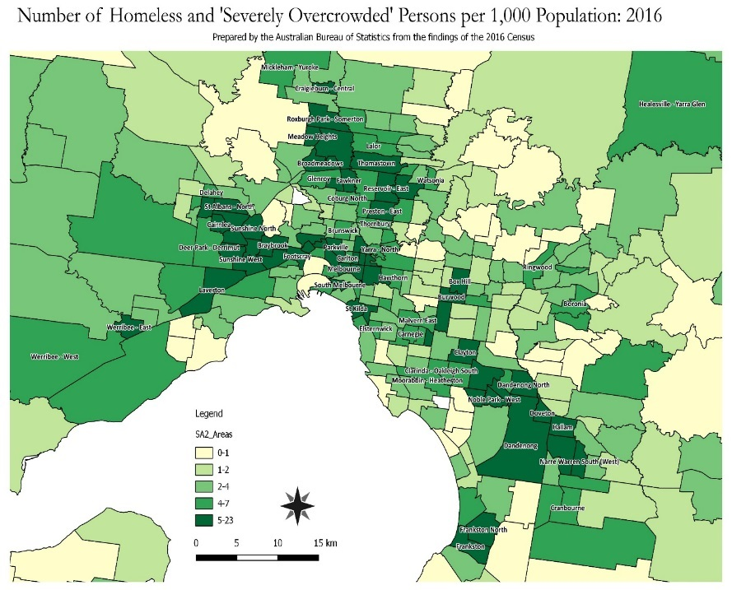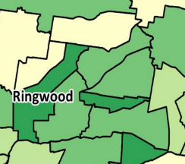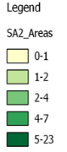

Source: ABS (2016)

The increasing price of private rental is considered a key factor that has led to the increase of homelessness in suburbs such as Ringwood and Croydon. Proportionally, the suburb of Croydon is identified as having the largest proportion of individuals living in social housing, or without a home (figure 9).

Figure 9: Homelessness and Social Housing per 100,000 persons, 2011

Source: ABS Census of Population and Housing: Estimating Homelessness, 2011

Social Factors Influencing Affordable and Social Housing

Affordable and social housing affects various groups and demographics within a community including ageing populations, younger people, victims of family violence and family breakdown, people with disabilities, and those who are homeless.

Low income is one of several underlying factors that drive the need for affordable and social housing. Victims of family violence, homelessness, ageing populations, disability, mental health, and those exiting the justice systems are just some of the target groups that are likely to require the support of affordable and social housing services.

Age
The negative consequences of inaccessible affordable and social housing affect all age groups. Parents struggling to pay rent can often find it difficult to maintain a job and meet the schooling needs of their children, just as seniors who do not have enough superannuation earnings or income often are forced to more to a more affordable and unfamiliar area away from their support networks. As of 2016, there were 2,797 residents over the age of 50 living in private rental accommodation, close to 50% of which living in Ringwood (25%) and Ringwood East (20%). Research has shown that a large percentage of these residents are dependent on income support and spend a large proportion of their age pension to cover rent. Unfortunately, due to the unpredictably of the rental market, private rental residents living off an age pension are amongst those at risk of housing stress and homelessness. Over the next 30 years, Maroondah will be faced with the challenge of meeting the rising demand for affordable housing suitable for older age groups with predictions of demographic change such as people aged over 70 expecting to increase by 65%.

Domestic Violence:
Victims of domestic and family violence comprise a significant proportion of people requesting assistance from homelessness services. Maroondah has a reported family violence rate of more than 800 incidents per 100,000 residents (Figure 10). Whilst this rate is lower than the that of Metropolitan Melbourne and the whole of Victoria, it is still significantly high. Safe and secure affordable and social housing is a necessity for those attempting to escape family violence, as victims often end up returning to their perpetrator due to unsafe and often short stay emergency accommodation.

Figure 10: Family Incident Rate per 100,000 Population, 2016

Source: Crime Statistics Agency, 2017

Socio-Economic Disadvantage
When comparing the municipality to Greater Melbourne, Maroondah is not considered to be relatively disadvantaged. Maroondah does however have three areas that have a higher share of low income households than the average for Greater Melbourne. Figure 11 below shows the share of households in the bottom 20% of national income distribution between Maroondah and Greater Melbourne. Croydon East, Croydon West and Ringwood have a higher share of households in the bottom 20% of national income distribution than Greater Melbourne. Alternatively, there are also areas within Maroondah such as Croydon Hills – Warranwood and Ringwood North, that have a significantly lower share of households in the bottom 20% of national income distribution than Greater Melbourne.

Figure 11: Share of households in the bottom 20% of national income distribution, 2016

Source: Census 2016; SGS ECONOMICS AND PLANNING background report

In terms of general disadvantage, Maroondah can also be assessed using the Index of Relative Socio-economic Disadvantage (IRSD). The IRSD in a socio-economic index that measures both the social and economic conditions of people and households within an area. Areas indicated to have a relatively greater disadvantaged are given a lower number, whilst areas considered to be generally less socio-economic disadvantage are given a higher number. As shown in Figure 12 below, the areas that are considered to have greater disadvantage are Croydon East, Croydon West, Croydon South, and Ringwood. Croydon East, Croydon South and Ringwood are all considered to have a relatively greater disadvantage to that of Greater Melbourne.

Figure 12: SEIFA Index, Index of Relative Socio-economic Disadvantage, 2016
Source: Australian Bureau of Statistics, 2016; SGS Economics and Planning, 2018

What Stakeholders Told Us

Development of this Policy involved direct engagement with many local people and organisations through interviews, focus groups, and an Affordable and Social Housing Forum. This helped Council and participants to learn about the experiences and perspectives of those working within the field, as well as to gain a better understanding of the local issues and opportunities of delivering affordable and social housing in Maroondah.

Stakeholder Interviews and Focus Groups

These engagement activities involved a wide variety of local stakeholders and community leaders which included the Eastern and Affordable Housing Alliance (EAHA), Common Equity Housing, Eastern Domestic Violence Service, the Department of Health and Human Services (DHHS), Salvation Army, Safe Futures Foundations, and Wesley Homeless and Support Service.

During stakeholder interviews and focus group sessions, participants were asked to consider:

- What is causing the affordable housing problem in the City of Maroondah, and what are the associated impacts and costs for various groups?
- What is Council’s role in working towards addressing these problems?

The responses received to these questions varied and are outlined below:

What is causing the Affordable Housing Problem, and what are the Associated Impacts and Costs for Various Groups?
The most commonly mentioned factors included:

1. The lack of Suitable Accommodation for Single Persons.
Victims of domestic violence and single parents suffering severe rental stress, are heavily impacted by the lack of single person accommodation in Maroondah. This lack of availability often results in victims of domestic violence returning to their perpetrators, or moving into rooming homes which are known to be both expensive and unsafe. Parents experiencing severe rental stress often find it difficult to sustain a job and provide adequate education for their children due to rent payment priorities, resulting in increased stress and anxiety.
-More recently, stakeholders have identified an increase of the ‘working poor’ suffering rental stress. The working poor is identified as people who earn enough income to be ineligible of Centrelink benefits, yet spend a large percentage of their income on rent. These groups along with retirees who struggle to cover their core expenses on their savings and superannuation, are in high demand for single room accommodation and are at high risk of homelessness.

2. Negative Public Perceptions of Affordable Housing Services.
Although the community has identified the need Affordable and Social Housing in previous community engagement activities, the public will often respond negatively to local social housing projects due to negative stigma. This negative perception can make it difficult for council and housing providers to facilitate an increase in affordable and social housing supply.

3. The permanent nature of public housing
When compared to other regions, Maroondah is lacking in public housing stock. Due to this lack of stock and the permanent nature of the public housing model, Maroondah has a long waiting lists for long term accommodation meaning people are continuously moving between short term housing.

4. The Unstable Nature of Rental Housing.
Centrelink recipients are either having difficulties finding housing with affordable rent, or are ineligible to rent due to property owners not considering Centrelink as a feasible source of income. It is also common for tenants to enter homelessness services after being evicted from their homes after not being able to afford one month’s rent.

5. High Level Planning and Tax Related Policies
The Commonwealth Governments current tax system is reported to be a key cause in placing pressure on housing tenures and preventing people from entering the housing market, which in term results in increased issues of homelessness in Maroondah.

What is Council’s role in working towards addressing these problems?
When discussing Councils role in address the problem of affordable and social housing, stakeholders suggested a mixed method approach using a range of initiatives from advocating for state and federal government support, to providing council owned land for new housing projects. Stakeholders highlighted that the role of Maroondah City Council should be to:

Address Rooming House Issues
- apply a regulatory role that frequently audits rooming houses and other available services.
- form a clear policy framework statement for the role and appropriate use of rooming housing.
- research new opportunities to expand the diversity and improve rooming housing.
- work with housing providers to improve the safety and quality of rooming housing.

Collaborate with other Councils
- Affordable and social housing should be addressed as a regional issue, involving the collaboration multiple councils with the same definition, goals, and strategies.

Work more closely with State Government
- Council could be more active in the delivery of affordable housing, by acting as an intermediator between State Government and developers for land appropriately located close to public transport and amenities.

Enable Affordable Housing through the Planning System:
- The introduction of inclusionary zoning and negotiated planning agreements to generate affordable housing contributions are the biggest lever that the planning system has and should be used.

Support the Tiny House Movement:
- The Tiny House movement was identified as a way to deliver affordable housing, however stakeholders acknowledged that it may not always be a suitable long-term option.

Affordable and Social Housing Forum

Council organised an Affordable and Social Housing Forum on 19 March 2018 at the Karralyka Centre in Ringwood attended by over 50 stakeholders from the sector. Local stakeholders were invited to further discuss the issues and drivers of affordable and social housing, as well as Council’s role in addressing the problem.

The Forum highlighted the change in Australian policy regarding affordable since the mid-late 19th century, and addressed the reduction of State and Commonwealth government investment since the early decade’s post world war two. The forum was facilitated by Dr Marcus Spiller from SGS, with guest presentations by Suzi Hayes (Eastern Affordable Housing Alliance), Shari McPhail (Community Housing Ltd.), and Judy Sutherland (Department of Health and Human Services).

It was acknowledged by attendees that Council should play a more active role in facilitating affordable and social housing, with an emphasis on the delivery of more housing stock.

Identified issues and suggested responses

The Forum highlighted three key issues and a range of strategic responses in Maroondah.

Issue 1 - Services available for those at risk of homelessness or those who need support are not readily available and/or are not up to date

Suggested responses
- Support services need to be kept up to date on the Council website
- Greater understanding of who is responsible for particular services in Maroondah
- Create a network of service delivery
- Target particular groups at risk
  - Older single persons
  - Youth in and out of home care system
  - Family violence victims
  - Children of family violence
  - Disabled persons, and
  - Indigenous communities.

Issue 2 - Negative perception of social housing in the community prevents affordable housing projects from getting off the ground

Suggested responses
- Raise awareness of the need and reality of social housing
- Highlight stories of benefits of affordable and social housing
- Planning scheme inclusionary zoning strategy – if a requirement for affordable housing was applied across all dwellings, there would be less conflicts from the community because it would be the new ‘normal’.

Issue 3 - Planning System and Policy Related Challenges

Suggested responses
- Inclusionary zoning - provide a firm % requirement on social housing
- Council to ensure real estate agents provide additional support to tenants, eg referral to emergency relief, funding etc. prior to eviction
- Allow for modifications to land / housing – eg tiny house, unit in the backyard
- Investment in the sector from Council by donating land
- Understand the type of need and provide suitable supply
- Reduce red tape for housing associations and support services to access funding
- Aggregate developments to build more units
- Develop upwards where appropriate

Our Strategic Response

The Vision for Housing in Maroondah

In accordance with the Maroondah Housing Strategy 2016, Council’s long term vision for housing in the municipality is:
In 2040, Maroondah will have high quality housing environments in appropriate locations that meet the community’s diverse and changing needs. There will be a wider range of living options and housing will increasingly be revitalised in affordable, sustainable and well-designed ways. Maroondah’s activity centres will be more accessible and provide a broader range of services that meet community needs. In partnership with the community, Council will continue to plan for housing growth strategically backed by a strong evidence base.

To deliver the affordable and social housing aspects of this vision, and support the directions outlined in Maroondah 2040: Our future together and the Maroondah Housing Strategy 2016, there are four priority areas that will enable Council to play an increased role in supporting affordable and social housing in Maroondah. These are:

- Facilitate effective planning direction and innovative support
- Play a key facilitation and brokerage role to support the delivery of increased affordable and social housing in Maroondah
- Work in partnership to advocate for increased investment and support for affordable and social housing
- Apply a proactive approach to encouraging greater investment and supply of social and affordable Housing through use of landuse planning provisions

Under each of these four focus areas, there are a number of policy directions which provide the framework for Council to play a role in supporting affordable and social housing in Maroondah.

Priority Area 1: Facilitate Effective Planning Direction and Innovative Support.

Council will aspire to facilitate efficiency through in the local housing market, through the delivery of best practice strategic and statutory planning controls in the context of the Maroondah Strategic Framework Plan within the Maroondah Planning Scheme.

Council will:
- Ensure the delivery and implementation of well-designed planning controls;
- Apply best practice strategic planning principles in providing for Maroondah’s housing needs, whilst also delivering an adequate supply of land, and development opportunities in strategically placed locations
- Build a positive investment culture in Maroondah through use of Council’s statutory planning frameworks;
- Work with Victorian Government to develop planning mechanisms for the delivery of affordable and social housing.
- Support the delivery of housing market innovations such as Greening the Greyfield initiative and the Tiny Homes movement.

Priority Area 2: Play a key facilitation and brokerage role to support delivery of increased affordable and social housing in Maroondah.

Council will facilitate and broker additional affordable and social housing in Maroondah through development of partnerships and work in collaboration with the sector.

Council will:
- Facilitate strong relationships between private developers and housing associations.
- Provide assistance and guidance for others to deliver affordable and social housing.
- Facilitate partnerships between the Victorian and Commonwealth governments, private organisations, Community land Trusts, philanthropic foundations, ethical investors, charities, and other housing providers.

Priority Area 3: Work in Partnership to Advocate for Increased Investment and Support for Affordable and Social Housing.

Council will act as the key liaison on behalf of the Maroondah community to advocate for greater affordable and social housing supply and support from other levels of government.

Council will:
- Advocate for the increased involvement of State and Commonwealth Government, developers, housing providers, and social services organisations to increase affordable and social housing in Maroondah; and
- Support greater regional collaboration through membership of the Eastern Region Group of Councils and the Eastern Affordable Housing Alliance, as well as Maroondah-specific advocacy groups.
- Support efforts that address homelessness, and associated stigmatisation, and improve pathways out of homelessness.
- Advocate for increased public and community housing stock in the municipality.
- Advocate to the State Government for legislative change to the Victorian Planning Scheme to include requirements for developer contributions to the supply of community and/or public housing (e.g. inclusionary zoning).

Priority Area 4: Apply a Proactive Approach to Encourage Greater Investment and Supply of Social and Affordable Housing.

Council will apply a proactive approach to encourage greater investment and supply of social and affordable housing. In part, this will be realised through development assessment and planning scheme amendment processes undertaken by Council and will be secured through Section 173 agreements, requiring proponents to demonstrate to Council that they have duly transferred housing or equivalent assets to nominated providers.

Council will:
- Establish policy to include incentives for proponents to include community contributions as part of planning applications, through the delivery of social housing.
- Investigate best practice social and affordable housing models and policy to increase the supply.
- Investigate the use of ‘Value Sharing requirements’ as a form of development contribution (Under this principle, access by a proponent to additional development capacity above a nominated threshold is contingent upon the delivery of a public benefit of equivalent value)

continued over page…
- Work towards the application of inclusionary provisions/standards which would require proponents to contribute a designated proportion of affordable and/or social housing dwellings (considered as an environmental attribute), as part of new developments/redevelopments over a certain level and subject to State Government planning provisions
- Investigate the inclusion of local policy directions in the Maroondah Planning Scheme (eg Municipal Strategic Statement) to facilitate diversity/choice of housing sizes and types across the municipality with the aim of facilitating a proportion of well designed and located housing which through market forces will be at the lower end of the price continuum, and thus be more affordable to lower income households.
- Explore opportunities to offer rate reductions to community housing associations who contribute a designated proportion of amount of social housing within their developments.
- If appropriate, Council may consider being involved in site specific development opportunities.

Monitoring and review

The Maroondah Housing Strategy 2016 identified the need for Council to remain abreast of planning and population conditions throughout the lifetime of the strategy. By incorporating a system of monitoring and review, Council is well placed to build in flexibility to adapt to changing conditions. This data review will help to ensure that Council monitors the effectiveness of this Policy and the implementation of its policy directions.

The Maroondah Housing Strategy commits to undertaking two updates to our data every five years, with one following each Census being a major update of all data and minor updates in the intervening two and a half year period. These updates should include updates for Metropolitan, Outer Eastern Regional and Maroondah for the following areas:

- Population change
  - growth rates
  - ageing (Census years only)
  - household composition and formation (Census years only)
- Housing change
  - Numbers of dwelling approvals and completions
  - The composition of the new housing: dwelling types and locations
  - Households and dwellings analysis (Census years only)
  - Migration – where household are coming from and going to (Census years only)
- Housing market data
  - Median house prices (and change) for different dwelling type and by location
  - Median rents (and change) for different dwelling type and by location
  - Affordability calculations
- Economic data
  - Broad economic indicators
  - Local employment and industry data

A full review of this Policy is scheduled by June 2026 to ensure that the Policy reflects current planning and population conditions, along with up-to-date Council policy position statements.

Glossary

Affordable housing:
That which does not cost (in rent or mortgage payments) more than 30% of gross household income for households in the bottom two quintiles of area (i.e. Greater Melbourne) median income.

Age friendly accommodation:
Accommodation that has been designed or retrofitted/ adapted with the needs of aged people in mind.

Ageing in place:
A term used to describe a senior living and remaining in the residence of their choice as they age, while being able to have services (or other support) they might need over time as their needs change, for as long as they are able.

Best practice:
To adopt or develop standards, actions or processes for the provision of goods, services or facilities which are equal to or better than the best available on a state, national or international scale.

Cash acquisitions:
To purchase and assume control over another organisation or corporate bodies assets.

Council:
The collective group of nine Councillors that set the strategic direction for Maroondah City Council, monitor organisational performance, liaise with stakeholders and ensure operational compliance.

Demographic changes:
Changes to population characteristics based on factors such as age, race, sex, economic status, level of education, income level and employment, etc.

Diversity:
Types and cost of housing (houses, town houses, apartments etc.) and the size of the dwellings (studios, one and two bedroom or large family homes with a back-yard).

Greening the Greyfields:
A federally funded project aimed at promoting sustainable housing regeneration in the middle suburbs. Usually concerns sites where residential building stock is failing (physically, technologically and environmentally) and energy, water and communications infrastructure is in need of regeneration.

Homelessness:
A person is considered homeless if their current living arrangement is in a dwelling that is inadequate, has no tenure (or if their initial tenure is short and not extendable) or does not allow them to have control of, and access to space for social relations (based on Australian Bureau of Statistics definition). Includes ‘rooflessness’, also known as ‘primary homelessness’ where a person typically lives on the street.

Housing Stock:
The total number of residential dwellings within a subject/given area.

Housing stress:
Defined when individuals and households who earn less than 80% of the median income pay more than 30% of weekly household income on housing.

Inclusionary Zones:
Relates to the mandatory contribution of development toward social housing needs through planning controls and provisions in the Planning Scheme.

Leveraging:
Borrowing capital for the purpose of an investment, where the profits gain are expected to be greater than the interest repayments.

Low income households:
A household whose equivalised gross income falls in the bottom two-fifths (40%) of the population.

Municipality:
A geographical area that is delineated for the purpose of local government.

Plan Melbourne:
The metropolitan planning strategy prepared by Victorian Government.

Planning and Environment Act 1987:
The legislation that governs land use planning in Victoria.

Planning scheme mechanism:
A planning control that can be used to achieve a given outcome e.g. a schedule to a planning zone or a design and development overlay, etc.

Quintiles of income distribution:
The division of an areas total income earning population into five equally sized segment.

Rooming House:
A form of social housing where one or more rooms are available to rent within a single dwelling, and can be occupied by four or more people.

Social housing:
A type of rental housing that is provided and/or managed by the government or by non-government organisations. Social housing is an overarching term that covers both public housing and community housing.

Socio-economic:
Socio-economic is a measurement that takes into account multiple variables including occupation, education, income, wealth, and place of residency.

Tiny Homes Movement:
A movement that is radically reshaping how households perceive and use residential space. The Tiny Homes is a growing movement of mobile dwellings designed to improve affordability and sustainability.

Value sharing requirement:
A development condition that requires proponents to share part of the uplift in land value brought about by rezoning or granting of additional height or density.

Venture Capital:
Capital investment into a project where the profitable gain is expected to be greater than the original investment.

Working poor:
Individuals or households who earn enough income to be ineligible of Centrelink benefits, yet spend a large percentage of their income on rent.

References

Australian Bureau of Statistics 2018, Census of Population and Housing: Estimating homelessness 2016, ABS

Archibald, I, n/d, About Crisis Accommodation, Crisis Help Network: Melbourne Homeless Services, http://www.melbourne.homeless.org.au/about-crisis-accommodation.html

Burke, T 2017, Community sector offers a solid platform for fair social housing, Swinburne University, online article, accessed online 18th of May http://www.swinburne.edu.au/news/latest-news/2017/07/community-sector-offers-a-solid-platform-for-fair-social-housing.php

City of Port Phillip 2016, In Our Backyard: Growing Affordable Housing in Port Phillip 2015-2025, City of Port Phillip.

City of Whitehorse, 2014, Whitehorse Housing Strategy, City of Whitehorse, accessed online 30th of March http://www.whitehorse.vic.gov.au/IgnitionSuite/uploads/docs/Whitehorse%20Housing%20Strategy%20April%202014%20Intro%20and%20Chapters%201-4[1].pdf

Department of Health and Human Services, 2016, Social Housing: Public Housing, DHHS, http://www.housing.vic.gov.au/public-housing

Department of Health and Human Services, 2017, Social Housing: Community Housing, DHHS, http://www.housing.vic.gov.au/community-housing

Maroondah City Council 2018, Council Plan 2017-2021, Maroondah City Council.

Maroondah City Council 2014, Maroondah 2014 Community Vision: Our Future Together, Maroondah City Council.

Maroondah City Council 2016, The Places We Live: Maroondah Housing Strategy 2016, Maroondah City Council.

Moreland City Council 2014, Affordable Housing Strategy 2014-2018, Moreland City Council.

SGS Economics and Planning 2018, Maroondah Affordable and Social Housing Discussion Paper, SGS Economics and Planning, p.1-35, Melbourne.

Spatial Economics 2015, Housing Demand Study – Maroondah, Spatial Economics, Melbourne.

