Maroondah City Council
DRAFT Council Plan 2017-2021
2018/19 Update
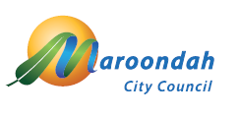
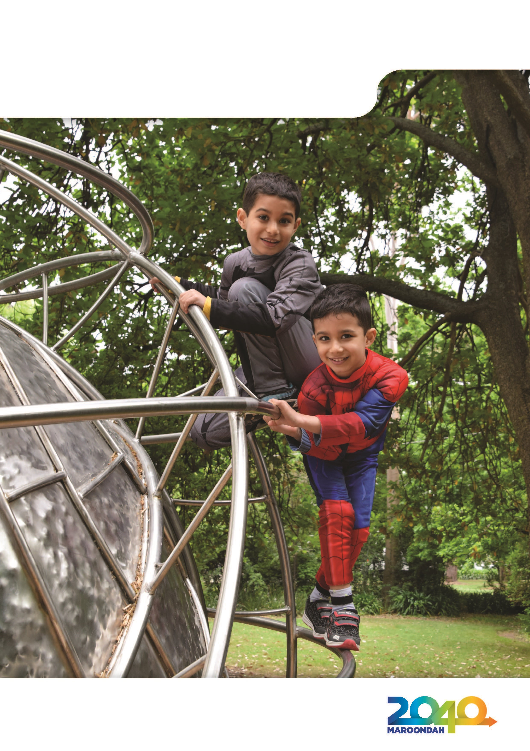

Realm

Public exhibition of draft Council Plan

Please note: The draft Council Plan 2017-2021 has been placed on public exhibition for a four week period between 13 April 2018 to 11 May 2018.

The draft Council Plan is available for download and viewing on Council’s website - www.maroondah.vic.gov.au

Copies are available for inspection during normal opening hours during this period at the City Offices Service Centre in Braeside Avenue, Ringwood, at Civic Square Service Centre, Croydon, and Realm in Ringwood Town Square, Ringwood. Copies are also available for inspection at the Croydon and Realm Libraries during normal opening hours

Any person proposing to make a written submission on a proposal contained in the Council Plan must do so before 5.00pm on Friday 11 May 2018. Where such person wishes to address Council (in person or by a person acting on his or her behalf) regarding their submission, that wish must be indicated in the submission. All submissions will be considered in accordance with Section 223 of the Local Government Act 1989.

Submissions can be:
- Made online by completing a: Public Submission Form available on Council’s website: www.maroondah.vic.gov.au
- Sent by email to: maroondah@maroondah.vic.gov.au
- Posted to:
Chief Executive Officer
Maroondah City Council
PO Box 156
Ringwood 3134

Welcome to the Council Plan 2017-2021

The Council Plan 2017-2021 is Maroondah City Council’s medium-term strategic document that
sets key directions and priority actions to work towards the long-term community vision
outlined in Maroondah 2040: Our future together.

The Council Plan plays a vital role in shaping Maroondah’s future over a four year period. It
identifies both challenges and opportunities for our community at local and regional levels
within the context of Maroondah 2040: Our future together. It also forms the basis for
Council to make decisions regarding resources and priorities in response to community needs
and aspirations.

The Council Plan is implemented through a service delivery planning process, and outcomes
are measured and reported regularly. Achievements are reported back to Council and
the community through the Maroondah City Council Annual Report at the end of each financial year.

Each year, Council undertakes a revision of the four-year Council Plan. This helps to ensure that
the Council Plan continues to be aligned with Maroondah 2040: Our future together, and is
responsive to emerging community needs and aspirations. The annual review also helps to
ensure that all Council service planning, strategies, policies and processes take their lead
from the key directions outlined within the Council Plan.

Table of Contents

Welcome to the Maroondah City Council Plan 2017-2021 3
Message from the Mayor and Chief Executive Officer 5
Our City 6
Our Council 9
Our Vision 15
Our Commitments 20
A safe healthy and active community 21
A prosperous and learning community 24
A vibrant and culturally rich community 27
A clean, green and sustainable community 29
An accessible and connected community 31
An attractive, thriving and well-built community 33
An inclusive and diverse community 35
A well governed and empowered community 37
Integrated service delivery 40
Council Plan Priority Actions 2017/18 to 2020/21 42
Organisational Scorecard 47
Strategic Resource Plan 48
Glossary of terms 62

Front page image:
Wyreena Playspace, Croydon

Message from the Mayor and Chief Executive Officer

On behalf of Maroondah City Council, we are pleased to present the 2018/19 update to the Maroondah City Council Plan 2017-2021.

The community’s vision as outlined in Maroondah 2040: Our Future Together is the foundation from which Council shapes its long term plans for the municipality. Following extensive community and key stakeholder consultation this long term vision for the future of Maroondah was adopted in 2014.

The Council Plan 2017-2021 was developed based on the community directions in Maroondah 2040 and feedback gathered through Council’s ongoing community consultation activities.

The Council Plan plays a vital role in shaping the future for Maroondah over the four year period, and lists the major activities to be undertaken to ensure the work and priorities set by Council align with the community’s vision. It also highlights the key directions which underpin the planning and budget blueprints for the Maroondah community.

The community aspirations and 74 Priority Actions are grouped into eight broad outcome areas providing the structure for the Council Plan. Significant projects identified for delivery across the four years include:
- Undertake operational readiness planning and construct the new HE Parker Multi Sports Complex in Heathmont
- Implement the Croydon Civic Masterplan and commence redevelopment of the precinct
- Create a new Croydon Town Square and advocate for the grade separation of the level crossing at Coolstore Road, Croydon
- Undertake a municipal wide review of Council’s neighbourhood character and heritage controls; and finalise the Maroondah Vegetation Review
- Accelerate Council’s footpath construction program
- Commence $2million improvement works on the site of the former Croydon South Primary School
- Develop and implement a new Disability Policy and Action Plan
- Update Council’s administrative facilities
- Commence the redevelopment of Karralyka

The Council Plan includes a Strategic Resource Plan which notes the linkages between Council’s Strategic objectives and actions and service delivery to the community. The Plan also documents the physical, human, and financial resources required by Council.

The years ahead are full of energy and promise for Council and the community, as we work together to create a City that will be an exciting and sustainable place to live, work and visit.

Cr Nora Lamont
Mayor

Steve Kozlowski
CEO

What we have already achieved

Since the adoption of the Council Plan 2017-2021 in June 2017, Council has been working to implement a broad range of priority actions.

In 2017/18, Council’s achievements included:

- Completing the design works and commencing operational readiness planning for the $16.5m HE Parker Multi Sports Complex
- Commencing undertake works to implement CCTV in Croydon Town Centre, including detailed design and documentation, along with the supply and installation of cameras
- Preparing a new Maroondah Health and Wellbeing Plan 2017-2021
- Commencing development of an Affordable and Social Housing Strategy
- Progressing the amendment of planning controls relating to alcohol density through participation in the South East Melbourne Council’s Alliance (SEMCA) Alcohol Density Project
- Commencing sportsfield reconstruction works at Jubilee Park in Ringwood
- Preparing a Gender Equity Policy
- Undertaking pedestrian, vehicle access and carpark improvement works at Heathmont Shopping Precinct - Canterbury Road, Heathmont
- Progressing an update of the Ringwood Metropolitan Activity Centre Masterplan
- Continuing to develop, promote and expand the BizHub Co-Working Space
- Completing community engagement and detailed design of the new Croydon Town Square
- Implementing a range of innovative and engaging arts events and outcomes in Ringwood Town Square arts precinct
- Developing a Climate Change Risk and Adaptation Strategy
- Commencing a major upgrade of the playground at Ringwood Lake Park
- Commencing the Maroondah Vegetation Review
- Continuing to advocate for grade separation of the Lilydale railway line at Coolstore Road in Croydon
- Accelerating Council’s footpath construction program
- Continuing to advocate to the Commonwealth and Victorian Government for provision of new and upgraded major transportation infrastructure in Maroondah
- Commencing an upgrade of Lincoln Road, east of Dorset Road
- Continuing the upgrade of drainage including flood mitigation works in Acacia Court catchment in Ringwood and the Scenic Avenue catchment in Ringwood East
- Commencing a municipal wide review of Council’s neighbourhood character and heritage controls
- Developing a Female Participation Strategy for physical activity
- Commencing investigation of additional female changing facilities at local sporting venues
- Progressing Council’s innovative digital services transformation
- Continuing to work on Innovation and Customer Service delivery models , including online services and additional payment options for customers

Our City

The City of Maroondah covers a land area of 61.4 square kilometres in Melbourne’s outer east, 22 kilometres from the Central Business District (CBD). The area is a substantially developed
peri-urban residential municipality, with an estimated population of 114,979 residents and
44,304 households with an average of 2.59 people per household.

The City of Maroondah includes the suburbs of Bayswater North, Croydon, Croydon Hills, Croydon North, Croydon South, Heathmont, Kilsyth South, Ringwood, Ringwood East, Ringwood North and Warranwood. The City also includes small sections of Kilsyth, Park Orchards, Vermont and Wonga Park.

With little remaining land available for greenfield residential development, future population growth will be mainly stimulated by housing consolidation and medium density development.

Maroondah has the strategic advantage of being located at the north-eastern junction of the
Eastern Freeway - EastLink corridor. There are two train lines and a large number of bus routes linking the City with other regions. Our sustainable transport links continue to expand, with on-road cycling paths and 35km of shared trails, including the Mullum Mullum Creek Trail, the EastLink Trail, Taralla Creek Trail and the Dandenong Creek Trail.

Our history
The first settlers to the area prior to European colonisation were the Wurundjeri people of the Kulin nation approximately 40,000 years ago. The territory of the Wurundjeri lies within the inner city of Melbourne and extends north to the Great Dividing Ranges, east to Mt Baw Baw, south to Mordialloc Creek and west to Werribee River.
European settlers arrived in the 1830’s and commenced using the land for grazing cattle. The original Ringwood village emerged in the mid to late 19th century, following the initial sale of land and the local proliferation of grazing, fruit growing, antimony mining and brick making activities.
The first constructed road through the area led to Mount Dandenong and was known as Sawmill Road, then Oxford Road, then finally given its current name of Mount Dandenong Road. The area became better known as it was used by bullock teams heading for the gold fields in Woods Point and the Great Dividing Range.
The railway line from Melbourne commenced its eastward development in 1861 extending to Lilydale through Ringwood and Croydon in December 1882. This resulted in a consolidation of township facilities, including the provision of local churches, banks and schools to accommodate a growing population. The line to Ferntree Gully followed soon afterwards.
The proclamation in 1924 of the Borough of Ringwood coincided with the electrification of the railway line, encouraging township development and subdivision. Electric trains were in service between Ringwood and Croydon in 1924 and were extended to Lilydale in 1925.
During its early days, Croydon was part of the Shire of Lillydale’s South-West Riding. Unlike some neighbouring towns, it had not been planned and proclaimed a town by the Department of Crown Lands and Survey, but resulted from the private subdivision of crown land in the Parishes of Warrandyte, Mooroolbark and Ringwood. Severance of Croydon from Lillydale Shire was requested in 1957 since it was the most densely populated part of the Shire. The Shire of Croydon was declared in 1961.
Considerable suburban expansion during the post-war period gave rise to the declaration of the City of Ringwood in 1960 and formal recognition as part of the broader metropolitan region. Eastland was established in 1967 as a major ‘new format’ retail centre. In 1971, the City of Croydon was declared, reflecting increased residential development and population growth in this area.

Maroondah City Council was formed on 15 December 1994 by the amalgamation of the former Cities of Croydon and Ringwood, and parts of the former Shire of Lillydale and the former City of Doncaster and Templestowe. The term ‘Maroondah’ is named after an aboriginal word meaning ’leaf’ which symbolises the green environment of the city.

Our community
Maroondah has an estimated population of 114,979 residents and 44,304 households with a similar age structure to the State’s average.

Compared with metropolitan Melbourne, Maroondah has a slightly higher proportion of residents aged between 45 to 69 years and a lower proportion of residents aged between 20 to 35 years.

Cultural diversity in Maroondah is increasing, with the highest numbers of recent overseas immigrants arriving from Burma, China, Malaysia, India, Thailand and Iran. Maroondah is now home to the largest Burmese community in Melbourne’s eastern region.

There is a strong sense of community participation within Maroondah embodied by a large number of committed volunteers. More than two thirds of parents in Maroondah are actively involved in their local schools and one third of Maroondah’s residents are members of organised community groups.

Our environment
Maroondah has 42 bushland reserves that offer residents and visitors the enjoyment of wildflowers, wildlife, bush walks and wetlands. There are more than 750,000 trees (mostly native species) in parks and reserves providing shade and shelter, helping to control water runoff, evaporation and erosion and providing a home for wildlife. During 2015/16, Council planted over 3,000 additional street trees and over 20,000 trees and plants in parks and reserves in conjunction with Friends Groups.

There are many areas of recreational open space in Maroondah. The City has 450 parks and reserves with 48 sports ovals. Open space areas include two golf courses, 128 public playgrounds, three skate areas, three BMX dirt jump sites and fives outdoor exercise equipment locations.

Maroondah’s residents and businesses are great recyclers: over 24,260 tonnes of recycling and green waste diverted from landfill in 2015/16. Maroondah has one of the highest diversion rates amongst Victoria’s 79 Councils.

Our economy
Almost 9,000 businesses operate within the City with small business comprising over 96 percent of these organisations. The majority of businesses are in the construction, property and business services, finance and insurance, retail trade and manufacturing sectors.

The largest industry employers are the manufacturing, retail trade and health care sectors. In total, businesses in Maroondah provide employment for 35,898 people and the municipality has a gross regional product (GRP) of $5.12 billion.

Maroondah has two major retail centres at Croydon and Ringwood, with Ringwood being one of the largest in Melbourne. In addition, a range of key service and retail precincts are clustered along the Maroondah Highway corridor and 21 neighbourhood shopping centres are spread throughout the municipality.

Maroondah is well positioned to take advantage of Victoria’s future growth. Ringwood is identified as a Metropolitan Activity Centre within Plan Melbourne, the Victorian Government’s metropolitan planning strategy. Croydon is also identified as a key activity centre with concentrated retail opportunities and medium density housing development continuing to strengthen its thriving town centre.

The Bayswater North Employment Precinct is a major industrial and economic hub where many national and international firms have established their headquarters. The area offers diverse and flexible business accommodation with strategic access to EastLink, the Eastern Freeway and other major arterial roads.

Our Council

Our role and function

The Victorian Constitution Act 1975, Section 64A(1) provides for “a system of local government consisting of democratically elected Councils having the function and powers that the Parliament considers necessary to ensure the peace, order and good government of each municipal district.”

The role of a Council is defined in the Local Government Act 1989 which formalises a Council’s legal status, purpose and objectives, delegates Council with specific functions and powers, and imposes Council with various duties.

At Maroondah City Council, our role is to:
- Deliver services that meet the needs and expectations of the Maroondah community.
- Advocate on behalf of community needs to other levels of Government.
- Facilitate the delivery of outcomes by working in partnership with residents, businesses, community organisations and key stakeholders.

Over 120 different services are offered by Council including: aged and disability care, business development, community planning and development, youth services, infrastructure maintenance and renewal, leisure facilities, maternal and child health, parks and reserves, planning and building, and waste and recycling.

Meet your Councillors
The municipality is divided into three wards: Arrabri, Mullum and Wyreena. Each ward is represented by three Councillors.

Councillors are responsible for the stewardship and governance of Council. The nine Councillors are the elected representatives of all residents and ratepayers across the City.

Section 65 of the Local Government Act 1989, defines the role of a Councillor:
- to participate in the decision-making of the Council;
- to represent the local community in that decision-making; and
- to contribute to the strategic direction of the Council through the development and review of key strategic documents of the Council, including the Council Plan.

Arrabri Ward

Cr Tony Dib JP
Mobile: 0438 515 089;
tony.dib@maroondah.vic.gov.au
Sworn in February 2010

Cr Paul Macdonald
Mobile: 0436 001 760;
paul.macdonald@maroondah.vic.gov.au
Elected in October 2016

Cr Kylie Spears
Mobile: 0436 003 660
kylie.spears@maroondah.vic.gov.au
Elected in October 2016

Mullum Ward

Cr Nora Lamont (Mayor)
Mobile: 0428 394 581
nora.lamont@maroondah.vic.gov.au
First elected November 2008

Cr Samantha Marks
Mobile: 0408 145 110
samantha.marks@maroondah.vic.gov.au
First elected November 2012

Cr Mike Symon (Deputy Mayor)
Mobile: 0436 002 080
mike.symon@maroondah.vic.gov.au
Elected October 2016

Wyreena Ward

Cr Marijke Graham
Mobile: 0418 109 015
marijke.graham@maroondah.vic.gov.au
Elected October 2016

Cr Michael Macdonald
Mobile: 0436 001 852
michael.macdonald@maroondah.vic.gov.au
Elected October 2016

Cr Rob Steane
Mobile: 0407 519 986
rob.steane@maroondah.vic.gov.au
First elected November 2008

An open invitation
Council meets on the third Monday of each month and meetings are open to the public. Meeting dates may change if the meeting falls on a public holiday. Council is generally in recess in January.

At the meetings, Councillors are responsible for making decisions about policy and local issues ensuring efficient operation of services within Maroondah.

Councillor representation
There are two types of committees requiring formal Council representation, internal and external.

Internal committees have been initiated by Council. They typically consider in-depth issues that are related to Council policy or activities. Their primary purpose is to advise Council on various issues. An extension of these committees has been the development of internal committees with a large degree of community representation.

External committees are outside the control of Council as they operate under their own charter and determine their own procedures, policies and practices. In these instances, Council involvement is to participate and influence the activities of those external committees where those activities are in Maroondah’s interest.

These committees provide Council with the opportunity to advocate on behalf of the local community on a broad range of issues.

Committee representation is reviewed on an annual basis and coincides with the election of the Mayor. Convention indicates that where the Mayor is a member of an internal committee of Council he or she would automatically act as chairperson, unless he or she relinquishes that role. In accordance with good governance practice, the Mayor may exercise the option to attend any committee in an ex-officio capacity if he or she is not a specific member of a committee.

Council Committees

Council committee  (November 2017 to November 2018) | Council representatives
Arts Advisory Committee | Cr Spears, Cr Graham and Cr Symon
Audit and Risk Advisory Committee | The Mayor of the Day and Cr. Symon
Disability Advisory Committee | Cr Spears and Cr Dib  Substitute representative - Program Manager Community Planning and Development
Maroondah Business Advisory Committee | Cr Spears, Cr Steane and Cr Dib
Maroondah City of Wellbeing Steering Committee | Cr Marks and Cr Graham  Substitute representative - Manager Integrated Planning
Maroondah Community Safety Committee | Cr Lamont, Cr Steane and Cr Paul Macdonald  Substitute representative - Community Safety Officer
Maroondah Partners in Community Wellbeing Committee | Cr Marks and Cr Graham  Substitute representative - Social Planning and Development Officer and Program Manager Community Planning and Development
Maroondah Environment Advisory Committee | Cr Marks, Cr Graham and Cr Paul Macdonald

External Committees
External committee  (November 2017 to November 2018) | Council representatives
Eastern Affordable Housing Alliance | Cr. Paul Macdonald  Substitute representative - Program Manager Community Planning and Development and/or Manager Integrated Planning
Eastern Alliance for Greenhouse Action | Cr. Graham  Substitute representative - Director Planning and Community and/or Manager Integrated Planning
Eastern Regional Group - Mayors and CEO’s | The Mayor of the Day, the Deputy Mayor of the Day and the Chief Executive Officer
Eastern Regional Libraries Corporation | Cr Spears and Cr Graham  Substitute representative - Cr Paul Macdonald and Director Corporate Services (or nominee) and Manager Revenue, Property and Customer Service
Eastern Transport Coalition | Cr Michael Macdonald  Substitute representative - Cr Spears and the Strategic and Transport Planner and/or Team Leader Strategic Planning and Sustainability
Local Government Safe Cities Network | Cr Steane  Substitute representative – Cr Paul Macdonald
Metropolitan Local Governments’ Waste Forum | Cr Symon  Substitute representative - Director Corporate Services, Manager Finance and Governance and Waste Management Coordinator
Municipal Association of Victoria | Cr. Symon  Substitute representative – Cr Spears
Victorian Local Government Women’s Charter | Cr Marks, Cr Graham, Cr Spears and Cr Lamont as Council representatives / Charter champions, along with the Director Corporate Services

The Council Organisation
Maroondah City Council is led by the Chief Executive Officer and four Directors who form the Corporate Management Team (CMT). CMT meets on a weekly basis to oversee and manage the operations of Council, discuss forthcoming Council agendas and discuss strategic and policy issues. Members of CMT attend all Council meetings to provide information and advice enabling the Council to make informed decisions.

CMT is supported by Service Area Managers and employees with specialist skills to develop, implement, manage and deliver the operational, service and administrative activities required to meet the needs and expectations of the community.

The Chief Executive Officer, Directors and Service Area Managers are employed under fixed-term employment contracts and their performance is measured and reviewed annually against key performance indicators.

Corporate Performance and Values
Councillors review the performance of the CEO whilst the CEO reviews the performance of Directors and Service Area Managers. Employee activities are strongly guided by Council’s four values of Cooperation, Commitment, Communication, and Continuous Improvement and Innovation.

These values guide the behaviour of employees and service areas across the organisation, contributing to Council’s ability to meet community needs and expectations.

Your rates and charges at work

The diagram below outlines how Maroondah City Council allocates resources for the provision of a broad range of services to the community. It shows how much is allocated to each area for every $100 that Council spends.

- Leisure and Culture: $24.27
- Environment: $23.97
- Capital Works: $16.74
- Community Support: $15.73
- Transport and Access: $11.29
- City Development: $8.00

Council’s organisational structure
The following organisation chart details the structure of Maroondah City Council as at 30 June 2018.

Chief Executive Officer
The position of Chief Executive Officer (CEO) is established by the Local Government Act 1989 to oversee the day-to-day management of Council operations in accordance with the strategic directions of the Council Plan. Steve Kozlowski is Council’s Chief Executive Officer.

Directors
Reporting to the CEO are four Directors who provide oversight of a Directorate which comprise of a number of service areas. As at 30 June 2018, the four Directors are:
- Marianne Di Giallonardo – Director Corporate Services
- Andrew Fuaux – Acting Director Development and Amenity
- Adam Todorov – Director Operations, Assets and Leisure
- Phil Turner – Director Strategy and Community

Direct reports to the CEO
There is one service area manager who reports directly to the CEO:
- Sherryn Dunshea – Manager Communications and Engagement

Corporate Services Directorate - Service Area Managers
There are four service area managers who report to the Director Corporate Services. As at 30 June 2018: these managers are:
- Tony Rocca – Manager Finance and Governance
- Stephen Bishop – Manager Human Resources
- Les Schneider – Manager Information Technology
- Dale Muir – Manager Revenue, Property and Customer Service

Operations, Assets and Leisure Directorate - Service Area Managers
There are three service area managers who report to the Director Operations, Assets and Leisure. As at 30 June 2018: these managers are:
- Steve McIntosh – Manager Assets
- Tim Cocks – Manager Leisure
- Vincent King – Manager Operations

Strategy and Community Directorate - Service Area Managers
There are three service area managers who report to the Director Strategy and Community. As at 30 June 2018, these managers are:
- Chris Zidak – Manager Business and Development
- Wendy King – Manager Community Services
- Grant Meyer – Manager Integrated Planning

Development and Amenity Directorate - Service Area Managers
There are three service area managers who report to the Acting Director Development and Amenity. As at 30 June 2018, these managers are:
- Andrew Taylor – Manager Engineering and Building Services
- Kirsten Jenkins – Acting Manager Health, Local Laws and Emergency Management
- Angela Kechich – Acting Manager Statutory Planning

Our Vision

Maroondah will be a vibrant and diverse city with a healthy and active community, living in green and leafy neighbourhoods which are connected to thriving and accessible activity centres contributing to a prosperous economy within a safe, inclusive and sustainable environment.

Our Future Outcomes
Over a two year period, Council worked with the community to develop a vision for the future of Maroondah. Maroondah 2040: Our future together identifies a range of preferred outcomes for the community looking ahead to the year 2040. The community’s future vision is for:

A safe, healthy and active community
In 2040, Maroondah is a safe, healthy and active community with local opportunities provided for people of all ages and abilities to have high levels of social, emotional and physical wellbeing.

A prosperous and learning community
In 2040, Maroondah is a thriving centre of economic activity and opportunity within the eastern region where the sustainability and growth of local businesses is supported. All community members, groups, education providers and local businesses have access to a wide range of quality learning resources and facilities.

A vibrant and culturally rich community
In 2040, Maroondah is a creative cosmopolitan community recognised for its celebration and promotion of arts and culture. There are a broad range of engaging entertainment options, diverse cultural activities and the creation and display of contemporary and traditional forms of art.

A clean, green and sustainable community
In 2040, Maroondah is a leafy green community with high levels of waste diversion and sustainable approaches to infrastructure development, urban design and management of natural resources. Our community is resilient and has the knowledge, capacity and resources to make sustainable lifestyle choices

An accessible and connected community
In 2040, Maroondah is an accessible community for all ages and abilities with walkable neighbourhoods, effective on and off-road transport networks, and access to a range of sustainable transport options.

An attractive, thriving and well built community
In 2040, Maroondah is an attractive community with high quality urban form and infrastructure that meets the needs and aspirations of all ages and abilities. A diverse range of housing options are available and thriving activity centres provide a broad range of facilities and services to meet community needs. The character of local neighbourhoods continues to be maintained while also accommodating population growth.

An inclusive and diverse community
In 2040, Maroondah is an inclusive community where social connections are strong across generations and diversity is embraced and celebrated

A well governed and empowered community
In 2040, Maroondah is an effectively empowered community that is actively engaged in Council decision making through processes that ensure their voice is heard and considered. Council provides strong and responsive leadership, ensures transparent processes and works with the community to advocate and champion their needs.

Organisational vision
In working towards achievement of the Maroondah 2040 Community Vision, Maroondah City Council should be an organisation that:
- Applies best practice in all that we do. We should be aware of how other organisations conduct their business and ensure we adopt the most practicable approaches/methods that are possible.
- Is a recognised leader in the local government sector. We should strive to set an example to others in innovation, service delivery, governance, performance and advocacy.
- Easily retains and attracts high quality staff. We should ensure that our reputation and staff practices are second to none.
- Fosters continuous improvement and innovation. We should encourage new ideas and changes to processes that are capable of improving our efficiency and effectiveness in service delivery and outcomes.
- Is transformational. We should acknowledge that by striving to meet the aspirations of Maroondah 2040, our organisation's work will change the look and feel of the Maroondah community.
- Is nimble, flexible and sustainable. We should ensure that we are proactive in identifying and planning for change and implement actions that endure.
- Is outwardly focused. We should focus on community outcomes, working together in partnership with State and Regional bodies, local stakeholders and the Maroondah Community.

Our Mission
Maroondah City Council will be an effective and dynamic leader, working in partnership with the community, business and other spheres of government to foster quality, accessible and sustainable lifestyles for the community.

Our Values
Values are important and enduring beliefs or ideas shared by members of a workplace about what is good or desirable. They exert major influences on the behaviour of an individual and serve as broad base guidelines in all workplace cultures.

Our core values at Maroondah City Council are:

Co-operation
Working together and sharing knowledge to achieve common goals and agreed outcomes.

Commitment
Leading by example to achieve the best result for the organisation and the community

Communication
Sharing information and ideas at all levels, the Council and the community.

Continuous Improvement and Innovation
Consistently finding better ways of delivering service and value

How we plan
Council’s strategic documents are linked to an Integrated Planning Framework. The Framework seeks to ensure Council’s activities and resources are aligned in order to meet the aspirations, needs and expectations of the Maroondah community.

The Maroondah 2040 Community Vision and the Council Plan 2017-2021, along with associated legislation and regulatory requirements provide the direction for Council strategy, policies, plans and service delivery.

These strategic documents in turn guide internal service delivery plans that identify service delivery activities and projects to be undertaken by Council to meet community needs and expectations.

The Framework includes a number of other key planning documents, the Long Term Financial Strategy and Annual Budget, as well as a range of supporting strategies and policies adopted by Council.

All community focused plans, strategies and policies have been formally adopted by Council and can be accessed via Council’s website.

Maroondah 2040
Council’s Integrated Planning Framework is underpinned by the shared long term community vision outlined in Maroondah 2040: Our future together.

The aspirations and priorities for the future have been grouped into eight broad outcomes.
Under each of these outcomes, a range of key directions have been identified that are high level strategies aimed at guiding the activities of Council and the community in working toward the achievement of the vision.

Council Plan
From Maroondah 2040: Our future together evolves a four year Council Plan that establishes Council’s medium-term key directions (strategies) and resourcing to deliver on the outcomes identified within the vision.

The Council Plan outlines the role of Council in delivering on the Maroondah 2040 community vision. It also articulates the mission statement and the core values of Council.

Other major plans
In addition to Maroondah 2040: Our future together and the Council Plan 2017-2021, there are a range of other strategic documents that have a significant influence on Council service delivery and the Maroondah community.

These include:
- The Municipal Strategic Statement provides a clear, concise statement of land use issues and directions, and outlines a vision for the future development of the municipality.
- The Maroondah Health and Wellbeing Plan provides directions and guidelines for working towards the improved health and wellbeing of the Maroondah community.
- The Municipal Emergency Management Plan addresses the prevention of, response to and recovery from emergencies within the municipality of Maroondah.

There are also many other strategies and plans that contribute to the delivery of outcomes and key directions within Maroondah 2040: Our future together and the Council Plan 2017-2021.

Service Delivery Plans
The provision of strategic direction through Maroondah 2040: Our future together, the Council Plan 2017-2021, and the Long Term Financial Strategy sets direction for detailed service delivery plans across each of Council’s service areas. These plans are reviewed annually to meet community needs and expectations.

Long Term Financial Strategy
The Long Term Financial Strategy takes the outcome areas and key directions as specified in the Council Plan 2017-2021 and expresses them in financial terms over a rolling 10 year period.

Annual Budget
The Annual Budget documents the financial and non financial resources required by Council to implement the outcome areas, key directions and priority actions identified in the Council Plan 2017-2021.

Community consultation is conducted on the draft Annual Budget and feedback is considered before Council adopts the final budget.

Key Principles

Best Value
Best Value is a commitment from Maroondah City Council to provide the best value for the resources we use and the best possible service for our community. Maroondah City Council is required by the Local Government Act 1989 to consider Best Value principles when planning, implementing and reviewing services. Maroondah City Council applies these principles to continuously improve its strategic and service planning as well as its service delivery.

Charter of Human Rights
Council recognises and protects the rights, interests and responsibilities of individuals, the community, and public bodies in the City of Maroondah in accordance with the Charter of Human Rights and Responsibilities. Council’s strategies, policies and decision-making procedures are compatible with the Charter of Human Rights. Council aims to ensure that it pursues a human rights approach across all areas of Council activity.

Risk Management
Council continues to build upon its culture of risk management as an integral part of corporate governance and operations, developing strategies and systems to minimise risks. This ensures sustainable delivery of services and amenities enjoyed by ratepayers, residents and visitors. The identification and management of risk will continue to be undertaken in a systematic process, implementing the principles set out in the Australian Standards for risk management AS/NZS ISO 31000:2009. The Maroondah City Council Strategic Risk Management Plan and Policy provide the framework for this to be achieved.

Community Engagement
Council is committed to engaging with its community in a meaningful, accountable, responsive and equitable way. Maroondah’s Community Engagement Policy 2015 is a formal expression of Council’s commitment to engaging the Maroondah community through the use of appropriate, effective and inclusive practices.

The Policy outlines Council’s position, role and commitments to ensure community engagement is integrated into Council activities to support decision making, build relationships and strengthen communities. The Policy also seeks to improve Council’s engagement processes and outcomes through encouraging a consistent approach and continual learning through evaluation, and through expanding the range of engagement methods used.

Community engagement is defined as the range of opportunities for public involvement in Council decision-making, relationship building and community strengthening. Community engagement is achieved when the community is, and feels, part of a process.

Some community engagement processes are undertaken to support decision making, some are about relationship building whilst others are focused on community strengthening (or capacity building). Often engagement processes support two or all three of these objectives.

Council’s Community Engagement Policy is built upon a set of commitments that guide the planning, development, implementation, evaluation and continuous improvement of community engagement processes undertaken by Council. These commitments are based on core values identified by the International Association for Public Participation and will be undertaken in accordance with Council’s Privacy Policy.

The Local Government Act 1989 (the Act) and a range of other legislation set out minimum requirements for some specific consultations. The preparation and adoption processes for both the Council Plan and the Annual Budget are subject to compliance with Section 223 of the Act. In many instances Council will go above and beyond the minimum requirements of the Act to gain a strong understanding of our community’s wants and needs to ensure we are achieving the best possible outcomes for our community.

Our Commitments

How this section works
The Council Plan is divided into eight future outcome areas, each with a set of four-year key directions (strategies), annual priority actions, strategic indicators and supporting strategies and plans. The priority actions identified work towards the achievement of the key directions, and ultimately toward the outcomes and vision outlined in Maroondah 2040: Our future together. A range of Council activities linked to these key directions and Council Plan priority actions are reported in Council’s Annual Report.

For each of the eight Maroondah 2040 outcome areas within the Council Plan 2017-2021, there is:
- The vision - Describes where the community would like the municipality to be by the year 2040 in relation to this future outcome.

- Key Directions - Identifies key Council strategies over the four-year term of the Council Plan that work towards the achievement of preferred future outcomes identified in Maroondah 2040: Our future together

- Priority Actions - Highlights priority activities to be undertaken by Council over the 2017-2021 period that will contribute to the achievement of the preferred outcome outlined in Maroondah 2040: Our future together.

- Council Plan Indicators - List a number of Council driven performance measures that help monitor progress made towards the achievement of Maroondah 2040 preferred outcomes and Council Plan key directions over the 2017-2021 period.

- Supporting policies, strategies and plans - These supporting policies, strategies and plans contribute to the delivery of preferred outcomes outlined within the Maroondah 2040 Community Vision and the Council Plan.

A safe healthy and active community

In the year 2040, Maroondah will be a safe, healthy and active community with local opportunities provided for people of all ages and abilities to have high levels of social, emotional and physical wellbeing.

Key Directions 2017 - 2021

A safe community
1.1 Work in partnership to address community safety issues, with a focus on activity centres, public spaces, roads and public transport
1.2 Plan and advocate for the application of community safety principles that facilitate a safe built environment
1.3 Promote and facilitate safer cultures relating to issues of alcohol, drugs, tobacco, gambling, child abuse and family violence
1.4 Encourage and support the implementation of initiatives and programs aimed at improving the actual and perceived safety of the community

A healthy community
1.5 Facilitate the provision of affordable, accessible and responsive services, resources and initiatives that support the physical and mental health and wellbeing of the community
1.6 Actively promote health and wellbeing principles and initiatives within the community
1.7 Support the establishment of an integrated regional health precinct
1.8 Advocate for the increased provision of affordable primary, allied and specialist treatment services and facilities
1.9 Facilitate development of integrated health and community service hubs within neighbourhood centres in partnership with key service providers
1.10 Embrace a preventative evidence-based approach to addressing issues of chronic and communicable disease, food safety, and public health
1.11 Work in partnership to address and promote awareness of mental health issues within the community
1.12 Apply healthy by design principles in planning for the development and revitalisation of activity centres and public spaces.
1.13 Plan and advocate for the provision of leading edge facilities and services to support the needs of an ageing population
1.14 Ensure that all young people and their families in Maroondah have access to affordable childcare, education, health and leisure services
1.15 Advocate and promote the increased provision of affordable housing options in accessible locations
1.16 Advocate for the development of an equitable and sustainable regionally-sourced healthy food system
1.17 Promote healthy eating and physical activity by supporting education initiatives and providing a diverse range of accessible open spaces, and recreation facilities and services

An active community
1.18 Enhance and maintain an integrated and connected network of passive and active open space to promote community health and wellbeing
1.19 Provide a range of integrated recreation and leisure facilities that meet the needs of all ages and abilities
1.20 Enhance Maroondah’s state of the art sporting precincts to cater for a wide range of recreational pursuits
1.21 Support and empower local community groups, sporting clubs and special interest groups across Maroondah

Council Plan Indicators

- Participation in the Maternal and Child Health service
- Number of visits to aquatic facilities per head of municipal population
- Community satisfaction with recreation facilities
- Customer satisfaction with Children’s Services Programs
- Participant satisfaction with Youth Services Programs
- Percentage of required food safety assessments undertaken

Supporting policies, strategies and plans

- Children’s Plan 2015-2019
- Maroondah Health and Wellbeing Plan 2017-2021 (incl. Municipal Public Health Plan)
- Domestic Animal Management Plan 2017-2021
- Gaming Policy 2007
- Melbourne East Sports and Recreation Strategy 2016
- Open Space Policy 2016
- Open Space Strategy 2016
- Physical Activity Strategy 2015-2019
- Youth Strategy

Priority Actions 2017 – 2021

Council Plan Priority Actions | 17/18 | 18/19 | 19/20 | 20/21
Design and construct the $2.5m Jubilee Sporting Pavilion redevelopment  ** Subject to external funding |  | ● | ●
Design and construct the $3.0m HE Parker Sporting Pavilion redevelopment |  | ●
Develop a Gender Equity Policy/Statement
Finalise a new Gaming Policy and commence preparation of a planning scheme amendment to incorporate the policy into the Maroondah Planning scheme |  | ●
Complete the design works, undertake operational readiness planning and construct the $16.5m HE Parker Multi Sports Complex |  | ● | ●
Undertake works to implement CCTV in Croydon Town Centre, including detailed design and documentation, along with the supply and installation of cameras |  | ●
Prepare and commence implementation of a new Maroondah Health and Wellbeing Plan 2017-2021 |  | ● | ● | ●
Commence sportsfield reconstruction works at Jubilee Park in Ringwood
Commence construction of the $2.7m Silcock Sporting Pavilion redevelopment in Croydon |  | ●
Amend planning controls relating to alcohol density through participation in the South East Melbourn Council’s Alliance (SEMCA) Alcohol Density Project |  | ●
Undertake sportsfield reconstruction works at Quambee Reserve No.1 Oval in Ringwood North |  | ●
Design and construct the Springfield Sporting Pavilion redevelopment |  | ● | ●
Commence construction of the $1m Dorset Sporting Pavilion Redevelopment |  |  | ●
Complete the Proclamation Park Sporting Pavillion redevelopment  ** Subject to external funding |  |  | ● | ●
Undertake a review and develop a Physical Activity Strategy 2020-2024 |  |  | ● | ●
Commence development of an updated Youth Strategy |  |  |  | ●
Undertake an investigation into additional synthetic surfaces for sportsfields in Maroondah |  |  |  | ●

A prosperous and learning community

In the year 2040, Maroondah will be a thriving centre of economic activity and opportunity within the eastern region where the sustainability and growth of local businesses is supported. All community members, groups, education providers and local businesses have access to a wide range of quality learning resources and facilities.

Key Directions 2017 - 2021

A prosperous community
2.1 Advocate, promote and market key business opportunities and the competitive strengths of the municipality
2.2 Promote and leverage the strategic location of Ringwood as the Metropolitan Activity Centre for the outer eastern region
2.3 Promote the diversification and localisation of Maroondah’s economy to stimulate job growth and encourage the community to work and live locally
2.4 Provide support to small and medium enterprises to help them fulfil their potential and be successful
2.5 Establish a business resource hub to empower local business, encourage innovation and support alternative modes of employment
2.6 Work in partnership to promote local employment opportunities for marginalised and disadvantaged population groups
2.7 Embrace a place-based approach to the development and revitalisation of neighbourhood centres that provide opportunities for local business and places for social connection and interaction
2.8 Seek increased investment in targeted industries, including advanced manufacturing and associated supply chains
2.9 Embrace the full potential of a new digital economy and encourage participation and collaboration by residents, businesses, health and community services and education sectors
2.10 Identify and facilitate development of under-utilised key urban renewal sites along transit corridors
2.11 Facilitate, support and encourage initiatives that increase education, training and employment opportunities for children, youth and young adults
2.12 Broker community-government-business partnerships that build social capital, create community connections and foster a culture of corporate social responsibility
2.13 Facilitate business-business partnerships that advance collaboration, peer support, mentoring, training opportunities and knowledge sharing
2.14 Facilitate the enhancement and revitalisation of industrial and commercial precincts that maximise investment, promote diverse job opportunities and provide for value adding industries

A learning community
2.15 Facilitate and encourage the provision of world-class life-long learning opportunities in Maroondah, from early learning through to adult and tertiary levels
2.16 Advocate for and encourage increased access to and participation in tertiary education
2.17 Facilitate and encourage places, spaces and programming that provide for a third place of community connection beyond home and work.
2.18 Advocate for and adopt the rollout of high speed broadband to all neighbourhoods and encourage take-up by businesses, services, education providers and households
2.19 Advocate for and support a coordinated, integrated and evidence based approach to addressing skill shortages for local businesses
2.20 Encourage lifelong learning opportunities that support mature age and retired people to participate in the workforce, learn new skills and build community connections
2.21 Help local businesses to position themselves and embrace the requirements of a low carbon economy
2.22 Work in partnership to encourage and support young people to remain engaged in education and training, and promote links to employment
2.23 Facilitate connections between education providers, businesses and the broader community to support employment pathways, intergenerational connections and knowledge transfer

Council Plan Indicators

- Proportion of active library members in municipality
- Business participation in Bizhub Business Development Program
- Positive improvement in business skills/performance through Bizhub Business Development Program

Supporting policies, strategies and plans

- Bayswater / Bayswater North Industrial Precinct Strategy 2015
- Melbourne East Regional Plan 2020
- Ringwood Metropolitan Activity Centre Masterplan
- Street Activities Policy 2014

Priority Actions 2017 – 2021

Council Plan Priority Actions | 17/18 | 18/19 | 19/20 | 20/21
Undertake pedestrian and vehicle access improvement works at Heathmont Shopping Precinct - Canterbury Road, Heathmont
Commence Regional Service Partnerships at Realm |  | ● | ●
Update the Ringwood Metropolitan Activity Centre Masterplan |  | ●
Work in partnership to implement the Bayswater / Bayswater North Industrial Precinct Strategy to assist local businesses and promote investment attraction |  | ● | ● | ●
Develop, promote and expand the BizHub Co-Working Space |  | ● | ● | ●
Improve carparking in the Heathmont and Ringwood East neighbourhood centres
Commence delivery of the Croydon Library Integrated Customer Service Project |  |  |  | ●
Plan and implement carparking improvements in the Ringwood Metropolitan Activity Centre and the Croydon Activity Centre |  | ● | ● | ●
Work in partnership to facilitate appropriate development within the Ringwood Metropolitan Activity Centre and Croydon Activity Centre |  | ● | ● | ●

A vibrant and culturally rich community

In the year 2040, Maroondah will be a creative cosmopolitan community recognised for its celebration and promotion of arts and culture. There will be a broad range of engaging entertainment options, diverse cultural activities and the creation and display of traditional and contemporary forms of art.

Key Directions 2017 - 2021

A vibrant and culturally rich community
3.1 Facilitate the establishment and consolidation of cosmopolitan food, dining and cultural precincts in key activity centres
3.2 Provide a diverse range of engaging entertainment spaces, events and activities
3.3 Support festivals and events that celebrate local arts, diversity and produce
3.4 Promote innovative, contemporary and socially engaged arts practice
3.5 Support and celebrate the unique cultures of emerging communities in Maroondah
3.6 Promote, celebrate and recognise our indigenous arts and culture
3.7 Encourage artistic expression and community participation in the arts
3.8 Promote opportunities and spaces for artists to create and display their work
3.9 Broker partnerships and relationships to better connect local artists and the broader community
3.10 Encourage a range of temporary and permanent public art that celebrates the unique characteristics of Maroondah including our history, cultural diversity, environment and future aspirations
3.11 Advocate for and value the contribution of the arts in supporting thriving neighbourhoods and vibrant activity centres
3.12 Encourage community-business partnerships that support local artists
3.13 Utilise emerging technologies and online mediums to promote emerging and established artists and arts practice

Council Plan Indicators

- Community satisfaction with arts centres and libraries
- Proportion of households who engaged in one or more arts and cultural activities over the last 12 months
- Number of community members involved in classes at Wyreena Community Arts Centre

Supporting policies, strategies and plans

- Arts and Cultural Development Strategy 2014-2018
- Public Art Policy 2015

Priority Actions 2017 – 2021

Council Plan Priority Actions | 17/18 | 18/19 | 19/20 | 20/21
Create a new Croydon Town Square, including community engagement, completion of detailed design and construction works. |  | ●
Implement innovative and engaging arts events and outcomes in Ringwood Town Square arts precinct |  | ●
Establish a new Arts Advisory Committee and implement new public art across Maroondah in accordance with Council’s Public Art Policy |  | ● | ● | ●
Commence development of an Arts and Cultural Development Strategy 2018-2022 |  | ●
Commence the $10m Karralyka redevelopment  ** Subject to funding |  | ● | ● | ●

A clean, green and sustainable community
Wyreena Community Arts Centre, Croydon

In the year 2040, Maroondah will be a leafy green community with high levels of waste diversion and sustainable approaches to infrastructure development, urban design and management of natural resources. Our community is resilient and has the knowledge, capacity and resources to make sustainable lifestyle choices.

Key Directions 2017 - 2021

A clean community
4.1 Ensure the long-term protection and rehabilitation of the city’s waterways and wetlands to improve water quality and streamflow
4.2 Provide leadership and adopt sustainable innovative approaches to limit consumption, prevent litter, reduce waste to landfill and encourage reuse and recycling of resources
4.3 Build the capacity of households and businesses to behave more sustainably, reduce waste and minimise consumption of natural resources
4.4 Work in partnership to improve air quality by enhancing vegetation and encouraging use of sustainable transport modes

A green community
4.5 Enhance Maroondah’s parklands, bushlands, gardens and open spaces
4.6 Protect and restore biodiversity and native habitat for local plants and animals on public and private land
4.7 Preserve and enhance Maroondah’s canopy vegetation
4.8 Create and foster a culture within our community that is committed to protecting the unique features of Maroondah’s landscape, including our ridgelines, waterways, canopy vegetation, green open space and bushland reserves
4.9 Work in partnership with local communities to encourage thriving community gardens and promote sustainably grown local produce
4.10 Encourage increased green spaces within activity centres that link the built environment to the natural landscape

A sustainable community
4.11 Strive to become a carbon neutral Council by implementing energy efficient initiatives and embracing clean energy solutions
4.12 Mitigate and adapt to the effects and impacts of climate change
4.13 Advocate for increased stormwater harvesting and greywater reuse by households and businesses
4.14 Support, educate and build the capacity of our community to make more environmentally sustainable lifestyle choices
4.15 Work in partnership to reduce greenhouse gas emissions and support the community in adapting to a post peak oil environment
4.16 Be responsive and adaptive to new environmental opportunities and threats as they occur, building resilience and capacity within the community

Council Plan Indicators

- Recycling diversion rate from landfill
- Proportion of streetlights changed over to energy efficient LED
- Kerbside collection bins missed per 10,000 households

Supporting policies, strategies and plans

- Carbon Neutral Strategy 2014/15 - 2020/21
- Climate Change Risk and Adaptation Strategy
- Sites of Biological Significance
- Sustainability Strategy 2016-2020
- Water Sensitive Cities Strategy

Priority Actions 2017 – 2021

Council Plan Priority Actions | 17/18 | 18/19 | 19/20 | 20/21
Commence implementation of the Eastern Organics Contract |  | ●
Develop a Climate Change Risk and Adaptation Strategy
Undertake preliminary works to rehabilitate the waterway and infrastructure at Yanggai Barring in Warranwood
Undertake a major upgrade of the playground at Ringwood Lake Park
Finalise the Maroondah Vegetation Review and prepare planning controls for inclusion in the Maroondah Planning Scheme |  | ● | ●
Commence renewal works on the Mullum Mullum Trail shared path |  |  | ●
Introduce an environmentally sustainable development policy into the Maroondah Planning Scheme |  |  | ● | ●
Undertake a review and update Council's Sustainability Strategy |  |  |  | ●
Undertake a review and update Council's Carbon Neutral Strategy |  |  |  | ●

An accessible and connected community

In the year 2040, Maroondah will be an accessible community for all ages and abilities with walkable neighbourhoods, effective on and off-road transport networks and access to a range of sustainable transport options.

Key Directions 2017 - 2021

An accessible community
5.1 Ensure public buildings are accessible to people of all ages and abilities, and promote high levels of accessibility in commercial premises
5.2 Work in partnership to provide improved accessibility and safety for transport users across all modes
5.3 Ensure events and festivals are accessible for people of all ages and abilities

A connected community
5.4 Work in partnership to provide a safe and efficient integrated transport network that enhances liveability, encourages a shift in travel modes and promotes Maroondah as a 20-minute city
5.5 Improve the efficiency of Maroondah’s road network through effective asset management, maintenance and renewal works
5.6 Advocate for and encourage the use of sustainable transport by enhancing local access to public transport nodes, supporting behaviour change initiatives and enhancing the pedestrian and cycling network, including the provision of on-road bicycle lanes
5.7 Advocate for an integrated public transport network with improved connectivity, capacity and service frequency
5.8 Work in partnership to ensure sustainable transport options and public transport connections are considered in the design of new developments and public spaces
5.9 Promote streetscapes that encourage social interaction, physical activity and connection to the natural environment
5.10 Work in partnership to improve the walkability within and between neighbourhoods and activity centres through effective urban design, open space planning, way-finding signage, improved public lighting and accessible infrastructure
5.11 Enhance and promote Maroondah’s walking and cycling shared path network ensuring connections with the wider Metropolitan Melbourne trail network
5.12 Work in partnership with businesses, schools and community groups to promote informed transport choices

Council Plan Indicators

- Proportion of sealed roads below the set intervention level
- Square metres of sealed local roads reconstructed

Supporting policies, strategies and plans

- Maroondah Principal Pedestrian Network
- Road Management Plan 2017-2021

Priority Actions 2017 – 2021

Council Plan Priority Actions | 17/18 | 18/19 | 19/20 | 20/21
Advocate for grade separation of the Lilydale railway line at Coolstore Road in Croydon
Commence Hughes Park carpark improvement works
Work in partnership to implement intersection improvement works at the corner of Maroondah Highway and Dorset Road in Croydon North |  | ●
Develop a Maroondah Carparking Framework, incorporating a Parking Policy, updates to parking strategies and permit systems |  | ●
Commence road renewal works in Caroline Street, Ringwood |  | ●
Undertake the renewal of New Street in Ringwood, between Maroondah Highway and Sylvia Grove |  |  | ●
Undertake carpark renewal works at Merrindale Shopping Centre in Croydon South |  |  |  | ●
Undertake the renewal of Norton Road in Croydon |  |  |  | ●
Accelerate Council's footpath construction program |  | ● | ● | ●
Advocate to the Commonwealth and Victorian Government for provision of new and upgraded major transportation infrastructure in Maroondah; including freeway connections, upgrade to arterial roads and intersections, and major public transport enhancements |  | ● | ● | ●

An attractive, thriving and well-built community

In the year 2040, Maroondah will be an attractive community with high quality urban form and infrastructure that meets the needs and aspirations of all ages and abilities. A diverse range of housing options are available and thriving activity centres provide a broad range of facilities and services to meet community needs. The character of local neighbourhoods continues to be maintained while also accommodating population growth.

Key Directions 2017 - 2021

An attractive community
6.1 Encourage high quality urban design that provides for a healthy, attractive and desirable built form
6.2 Work in partnership to ensure development considers urban design principles that enhance the connection between the built environment and the natural environment
6.3 Work in partnership to deliver distinctive and high quality architecture through the use of urban design guidelines and principles
6.4 Facilitate, lead and educate the community in the use of environmentally sustainable design across all forms of infrastructure to limit carbon emissions and reduce resource consumption
6.5 Work in partnership to encourage the use of a water sensitive approach in the development and renewal of the built and natural environment
6.6 Facilitate a vibrant day and night-time economy through development of high quality public spaces that incorporate diverse food, entertainment and cultural precincts

A thriving and well built community
6.7 Plan and facilitate the development of a community where everyone can live, work and play locally
6.8 Encourage and support the provision of a diverse range of housing across Maroondah, that meets the needs of current and future residents
6.9 Encourage high density development in activity centres where there is access to high quality facilities, services and amenities
6.10 Develop and implement an urban form that enhances the desirable attributes of Maroondah to protect and value ridgelines, vegetation, neighbourhood character, local history and cultural heritage
6.11 Ensure the management of infrastructure and prioritisation of capital works considers demographic change, the impacts of climate change, and accessibility for all ages and abilities
6.12 Work in partnership to establish and implement regional sustainable funding models for local infrastructure
6.13 Coordinate and advocate for the increased utilisation, longevity and availability of fit-for-purpose public, private and not-for profit buildings and spaces that can act as key places for neighbourhood connection
6.14 Work in partnership with other catchment authorities to ensure effective stormwater management across Maroondah, including the identification and implementation of appropriate strategies that increase the storage, re-use and re-direction of storm water and provide flood mitigation for the community
6.15 Plan for and support a range of multi-use inclusive community connection hubs that promote social interaction, encourage lifelong learning and provide a wide range of services

Council Plan Indicators

- Council’s infrastructure renewal/maintenance ratio
- Percentage of annual Capital Works budget expended
- Proportion of planning applications decided within 60 days
- Proportion of building permit applications issued within 15 days
- Total value of building approvals (residential, commercial and industrial)
- Community satisfaction with general town planning policy
- Community satisfaction with Council’s planning and building permits process
- National Asset Management Assessment Framework Score
- Average duration for assessment of Engineering Development Plans (1st plans)

Supporting policies, strategies and plans

- Croydon Town Centre Structure Plan 2006
- Heathmont Structure Plan 2013
- Housing Strategy 2016
- Maroondah Planning Scheme (incl. Municipal Strategic Statement)
- Ringwood East Structure Plan 2013

Priority Actions 2017 – 2021

Council Plan Priority Actions | 17/18 | 18/19 | 19/20 | 20/21
Continue the upgrade of drainage including flood mitigation works in Acacia Court catchment in Ringwood and the Scenic Avenue catchment in Ringwood East
Upgrade Lincoln Road, east of Dorset Road |  | ●
Develop a Council policy position on affordable and social housing
Undertake a municipal wide review of Council’s neighbourhood character and heritage controls |  | ●
Continue the upgrade of drainage including flood mitigation works in Power Street catchment |  | ●
Develop and commence implementation of priority open space and public realm enhancement plans |  | ● | ●
Work in partnership to implement the Greening the Greyfields Project to facilitate a sustainable approach to urban redevelopment in identified residential precincts  ** Subject to funding |  | ● | ●
Continue the upgrade of drainage including flood mitigation works in the Scenic Avenue catchment in Ringwood East |  |  | ●
Accelerate Council's drainage improvement program |  |  | ● | ●
Commence the $10m Croydon Community Precinct redevelopment  ** Subject to funding |  |  | ● | ●
Commence preparation of a new Croydon Structure Plan |  |  | ● | ●
Commence renewal works on the Dandenong Creek Trail shared path |  |  |  | ●
Continue the upgrade of drainage including flood mitigation works in Kandra Street catchment |  |  |  | ●

An inclusive and diverse community

In the year 2040, Maroondah will be an inclusive community where social connections are strong across generations and diversity is embraced and celebrated

Key Directions 2017 - 2021

An inclusive community
7.1 Ensure accessibility and social inclusion principles are considered in the planning, delivery and evaluation of facilities and services
7.2 Encourage programs and initiatives that raise the awareness of accessibility issues and deliver improved access to facilities and services for all ages and abilities
7.3 Promote a culture of volunteerism across all life-stages that builds an inclusive, supportive and connected community
7.4 Support community members to age in place, live in accessible neighbourhoods and remain socially connected
7.5 Advocate and promote the provision of a diversity of affordable housing options to suit a range of lifestyle needs and life-stage requirements
7.6 Work in partnership to break cycles of poverty and socio-economic disadvantage, particularly within marginalised communities
7.7 Work in partnership to facilitate and promote sustainable social enterprises that create community connections, empower under-represented and marginalised population groups and are positioned for long term success
7.8 Support all ages and population groups to be valued, connected, supported and empowered within their local community through the provision and coordination of accessible services, programming and facilities
7.9 Promote the value, expertise and contribution of mature aged workers and encourage intergenerational mentoring and skills-transfer

A diverse community
7.10 Promote and create opportunities for community connectedness, learning, mentoring and social interactions for people from all life-stages and cultural backgrounds
7.11 Ensure the needs of community members from all ages, backgrounds and lifestyles are considered in planning for local services, programs and infrastructure
7.12 Work in partnership to support culturally and linguistically diverse communities, including refugees and new arrivals in Maroondah
7.13 Encourage and provide community education and awareness on diversity issues
7.14 Establish a built environment that is child, youth and age friendly through strengthening the inclusiveness and accessibility of our local neighbourhoods and activity centres
7.15 Acknowledge, recognise and value our indigenous heritage and communities
7.16 Celebrate and recognise the diversity of our community through a range of festivals, events, programs and cultural activities
7.17 Advocate for and support the needs of people from all sexualities, gender identities and sex identities

Council Plan Indicators

- Number of volunteers engaged within the organisation
- Compliance with Community Care Common Quality Standards for Home and Community Care services
- Average number of days from referral to commencement for Home and Community Care services

Supporting policies, strategies and plans

- Active and Healthy Ageing Initiative 2015-2020
- Disability Policy and Action Plan 2014-2018
- Reconciliation Action Plan 2017

Priority Actions 2017 - 2021

Council Plan Priority Actions | 17/18 | 18/19 | 19/20 | 20/21
Monitor the federal National Disability Insurance Scheme and My Aged Care reform agenda and implement transitional arrangements for relevant areas of Council service delivery |  | ●
Develop a Female Participation Strategy for physical activity
Investigate and implement additional female changing facilities  at local sporting venues |  | ● | ● | ●
Continue implementation of the Corporate Volunteering Program |  | ● | ●
Commence $2m improvement works on the former site of Croydon South Primary School |  |  | ●
Develop and commence implementation of a new Disability Policy and Action Plan |  | ●
Commence development of an Active and Healthy Ageing Strategy 2020-2025 |  |  | ● | ●
Commence construction of the $3m Croydon Family & Children's Centre  ** Subject to external funding |  |  |  | ●

A well governed and empowered community

In the year 2040, Maroondah will be an effectively empowered community that is actively engaged in Council decision making through processes that ensure their voice is heard and considered. Council provides strong and responsive leadership, ensures transparent processes and works with the community to advocate and champion their needs.

Key Directions 2017 - 2021

A well governed community
8.1 Provide enhanced governance that is transparent, accessible, inclusive and accountable
8.2 Ensure responsible and sustainable management of Maroondah’s resources, assets, infrastructure and natural environment
8.3 Provide community inspired leadership in democratic governance
8.4 Foster a Council culture of innovation, cooperation, commitment, communication and continuous improvement that positions Maroondah as a leader in local government
8.5 Work in partnership with key agencies and other levels of government to provide leadership in emergency preparedness, response and recovery processes
8.6 Embrace emerging technology and the digital economy in the delivery of services, enhancement of assets, and engagement of the community

An empowered community
8.7 Ensure that all community members have access to and are informed on matters that affect them, including the provision of tailored information for under-represented and hard-to-reach groups
8.8 Undertake inclusive engagement and consultation using accessible and tailored approaches to consider the needs and aspirations of different age and population groups
8.9 Create opportunities for shared decision making through active community involvement
8.10 Work in partnership to advocate for and champion the needs and aspirations of the community to other levels of government, service providers and the business sector
8.11 Foster a Council culture of collaboration and partnerships with individuals, community groups, businesses, service providers and other levels of government
8.12 Deliver accessible and responsive customer service and contact, including the provision of full customer service in Ringwood and Croydon activity centres
8.13 Encourage individuals, groups and organisations to proactively connect with and contribute to their local community
8.14 Work in partnership to deliver services that recognise and are responsive to the interests and needs of the community

Council Plan Indicators

- Community satisfaction with overall performance of Council
- Community satisfaction with overall direction of Council
- Community satisfaction with decisions made in the interests of the community
- Community satisfaction with customer service provided by Council
- Average liabilities per assessment
- Operating result per assessment
- Average rates and charges per residential assessment
- Community satisfaction with Council’s community consultation and engagement
- Community satisfaction with Council lobbying on behalf of the community
- Level of employee engagement with organisation and job role compared with Australian benchmark
- Proportion of inbound customer calls answered within 30 seconds
- Proportion of medium-to-high level risks reduced to a lower level risk
- Proportion of Council decisions made at meetings closed to the public

Supporting policies, strategies and plans

- Annual Budget (incl. Borrowing Strategy, Fees and Charges Strategy, and Rating Strategy)
- Community Engagement Policy 2015
- Customer Service Strategy 2017-2021
- Councillor Code of Conduct 2017
- Councillor Confidentiality Policy 2017
- Councillor Expenses and Entitlements Policy 2017
- Grants Policy 2009
- Information Communication and Technology Strategy 2017-2020
- Long Term Financial Strategy (part of current Budget)
- Municipal Emergency Management Plan 2017
- Privacy Policy 2014
- Procurement Policy 2016
- Protected Disclosure Guidelines 2013
- Risk Management Strategic Plan 2015-2017
- Risk Management Policy 2016
- Workforce People and Culture Strategy 2016-2020

Priority Actions 2017 - 2021

Council Plan Priority Actions | 17/18 | 18/19 | 19/20 | 20/21
Progress Council’s innovative digital services transformation |  | ● | ● | ●
Continue to work on Innovation and Customer Service delivery models, including online services and additional payment options for customers |  | ● | ● | ●
Update Council’s administrative facilities |  | ● | ●
Participate in an Electoral Representation Review as mandated by State Government |  |  | ●
Develop the Workforce, People and Culture Plan 2021-2025 |  |  | ●
Undertake a review of Council's Community Engagement Policy |  |  | ●
Engage the community in undertaking an interim review of  Maroondah 2040: Our future together |  |  | ●
Advocate for Maroondah to become a "Smart City" |  |  |  | ●
Work in partnership with the Victorian Electoral Commission to coordinate a Council Election for the 2021-2025 period |  |  |  | ●
Prepare a new Council Plan 2021-2025 |  |  |  | ●

Our integrated service delivery

Council delivers a broad range of services that all play a role in delivering on the Maroondah 2040 Community Vision and the associated outcome areas. The table below indicates the range of primary outcome areas for different services delivered by Council.

 | A safe, healthy and active community | A prosperous and learning community | A vibrant and culturally rich community | A clean, green and sustainable community | An accessible and connected community | A attractive, thriving and well built community | An inclusive and diverse community | A well governed and empowered community
Aged and Disability Services | ● |  | ● |  | ● |  | ●
Aquahub | ●
Aquanation | ●
Arts and Cultural Development | ● |  |  |  |  | ● | ●
Asset Management |  |  |  |  | ● | ●
Building Services |  |  |  |  | ● | ●
Bushland and Weed Management |  |  |  | ● |  | ●
Business Support |  | ● |  |  |  | ●
Capital Works | ● | ● |  | ● | ● | ● | ●
Children's Services | ● | ● |  |  | ● |  | ●
Communications and Engagement |  | ● | ● |  | ● |  | ● | ●
Community Health | ● | ● |  | ● |  |  |  | ●
Construction Maintenance |  |  |  |  | ● | ●
Contracts and Purchasing |  |  |  |  |  |  |  | ●
Council and Community Planning | ● |  |  |  | ● |  | ● | ●
Croydon Memorial Pool | ●
Customer Service | ● |  |  |  |  |  | ● | ●
Engineering Services |  |  |  | ● | ● | ●
Facilities |  |  |  | ● | ● | ● |  | ●
Financial Services |  |  |  |  |  |  |  | ●
Governance |  |  |  |  |  |  |  | ●
Human Resources Advisory Services | ● |  |  |  |  |  |  | ●

 | A safe, healthy and active community | A prosperous and learning community | A vibrant and culturally rich community | A clean, green and sustainable community | An accessible and connected community | A attractive, thriving and well built community | An inclusive and diverse community | A well governed and empowered community
IT Applications |  |  |  |  |  |  |  | ●
IT Infrastructure |  |  |  |  |  |  |  | ●
Karralyka |  |  | ●
Learning and Development |  | ● |  |  |  |  | ● | ●
Local Laws |  |  |  |  |  | ● |  | ●
Major Projects |  | ● | ●
Maroondah Federation Estate | ● | ● | ● |  |  |  | ●
Maternal and Child Health Services | ● |  |  |  |  |  | ●
Occupational Health and Safety | ● |  |  |  |  |  |  | ●
Open Space | ● |  |  | ● |  | ●
Property and Valuations |  |  |  |  |  | ● |  | ●
Realm Coordination and Ringwood MAC |  | ● | ● |  |  | ●
Remuneration and Benefits |  |  |  |  |  |  |  | ●
Revenue and Property |  |  |  |  |  |  |  | ●
Ringwood and Dorset Golf | ● |  |  | ●
Risk Management | ● |  |  |  |  |  |  | ●
Sports and Projects | ● |  | ● | ● | ● |  | ● | ●
Statutory Planning | ● |  |  | ● |  | ●
Strategic Planning and Sustainability | ● |  |  | ● | ● | ●
The Rings | ● |  |  |  |  |  | ●
Tree and Park Maintenance |  |  |  | ● |  | ●
Waste Management |  |  |  | ● |  | ●
Workforce Relations and OHS | ● |  |  |  |  |  |  | ●
Wyreena | ● | ● | ● |  |  |  | ●
Youth Services | ● | ● | ● |  |  |  | ● | ●

Our Priority Actions 2017/18 to 2020/21

There are a number of high priority activities that will be undertaken by Council over the 2017-2021 period that will contribute to the achievement of preferred community outcomes outlined in Maroondah 2040: Our future together.

This section provides a summary of these priority actions and the anticipated financial year that they will be undertaken. Council will monitor its progress towards the achievement of Council Plan priority actions on a quarterly basis with annual progress to be reported in Council's Annual Report.

A safe, healthy and active community

Council Plan Priority Actions | 17/18 | 18/19 | 19/20 | 20/21
Design and construct the $2.5m Jubilee Sporting Pavilion redevelopment  ** Subject to external funding |  | ● | ●
Design and construct the $3.0m HE Parker Sporting Pavilion redevelopment |  | ●
Develop a Gender Equity Policy/Statement
Finalise a new Gaming Policy and commence preparation of a planning scheme amendment to incorporate the policy into the Maroondah Planning scheme |  | ●
Complete the design works, undertake operational readiness planning and construct the $16.5m HE Parker Multi Sports Complex |  | ● | ●
Undertake works to implement CCTV in Croydon Town Centre, including detailed design and documentation, along with the supply and installation of cameras |  | ●
Prepare and commence implementation of a new Maroondah Health and Wellbeing Plan 2017-2021 |  | ● | ● | ●
Commence sportsfield reconstruction works at Jubilee Park in Ringwood
Commence construction of the $2.7m Silcock Sporting Pavilion redevelopment in Croydon |  | ●
Amend planning controls relating to alcohol density through participation in the South East Melbourn Council’s Alliance (SEMCA) Alcohol Density Project |  | ●
Undertake sportsfield reconstruction works at Quambee Reserve No.1 Oval in Ringwood North |  | ●
Design and construct the Springfield Sporting Pavilion redevelopment |  | ● | ●
Commence construction of the $1m Dorset Sporting Pavilion Redevelopment |  |  | ●
Complete the Proclamation Park Sporting Pavillion redevelopment  ** Subject to external funding |  |  | ● | ●
Undertake a review and develop a Physical Activity Strategy 2020-2024 |  |  | ● | ●
Commence development of an updated Youth Strategy |  |  |  | ●
Undertake an investigation into additional synthetic surfaces for sportsfields in Maroondah |  |  |  | ●

A prosperous and learning community

Council Plan Priority Actions | 17/18 | 18/19 | 19/20 | 20/21
Undertake pedestrian and vehicle access improvement works at Heathmont Shopping Precinct - Canterbury Road, Heathmont
Commence Regional Service Partnerships at Realm |  | ● | ●
Update the Ringwood Metropolitan Activity Centre Masterplan |  | ●
Work in partnership to implement the Bayswater / Bayswater North Industrial Precinct Strategy to assist local businesses and promote investment attraction |  | ● | ● | ●
Develop, promote and expand the BizHub Co-Working Space |  | ● | ● | ●
Improve carparking in the Heathmont and Ringwood East neighbourhood centres
Commence delivery of the Croydon Library Integrated Customer Service Project |  |  |  | ●
Plan and implement carparking improvements in the Ringwood Metropolitan Activity Centre and the Croydon Activity Centre |  | ● | ● | ●
Work in partnership to facilitate appropriate development within the Ringwood Metropolitan Activity Centre and Croydon Activity Centre |  | ● | ● | ●

A vibrant and culturally rich community

Council Plan Priority Actions | 17/18 | 18/19 | 19/20 | 20/21
Create a new Croydon Town Square, including community engagement, completion of detailed design and construction works. |  | ●
Implement innovative and engaging arts events and outcomes in Ringwood Town Square arts precinct |  | ●
Establish a new Arts Advisory Committee and implement new public art across Maroondah in accordance with Council’s Public Art Policy |  | ● | ● | ●
Commence development of an Arts and Cultural Development Strategy 2018-2022 |  | ●
Commence the $10m Karralyka redevelopment  ** Subject to funding |  | ● | ● | ●

A clean, green and sustainable community

Council Plan Priority Actions | 17/18 | 18/19 | 19/20 | 20/21
Commence implementation of the Eastern Organics Contract |  | ●
Develop a Climate Change Risk and Adaptation Strategy
Undertake preliminary works to rehabilitate the waterway and infrastructure at Yanggai Barring in Warranwood
Undertake a major upgrade of the playground at Ringwood Lake Park
Finalise the Maroondah Vegetation Review and prepare planning controls for inclusion in the Maroondah Planning Scheme |  | ● | ●
Commence renewal works on the Mullum Mullum Trail shared path |  |  | ●
Introduce an environmentally sustainable development policy into the Maroondah Planning Scheme |  |  | ●
Undertake a review and update Council's Sustainability Strategy |  |  |  | ●
Undertake a review and update Council's Carbon Neutral Strategy |  |  |  | ●

An accessible and connected community

Council Plan Priority Actions | 17/18 | 18/19 | 19/20 | 20/21
Advocate for grade separation of the Lilydale railway line at Coolstore Road in Croydon
Commence Hughes Park carpark improvement works
Work in partnership to implement intersection improvement works at the corner of Maroondah Highway and Dorset Road in Croydon North |  | ●
Develop a Maroondah Carparking Framework, incorporating a Parking Policy, updates to parking strategies and permit systems |  | ●
Commence road renewal works in Caroline Street, Ringwood |  | ●
Undertake the renewal of New Street in Ringwood, between Maroondah Highway and Sylvia Grove |  |  | ●
Undertake carpark renewal works at Merrindale Shopping Centre in Croydon South |  |  |  | ●
Undertake the renewal of Norton Road in Croydon |  |  |  | ●
Accelerate Council's footpath construction program |  | ● | ● | ●
Advocate to the Commonwealth and Victorian Government for provision of new and upgraded major transportation infrastructure in Maroondah; including freeway connections, upgrade to arterial roads and intersections, and major public transport enhancements |  | ● | ● | ●

An attractive, thriving and well built community

Council Plan Priority Actions | 17/18 | 18/19 | 19/20 | 20/21
Continue the upgrade of drainage including flood mitigation works in Acacia Court catchment in Ringwood and the Scenic Avenue catchment in Ringwood East
Upgrade Lincoln Road, east of Dorset Road |  | ●
Develop a Council policy position on affordable and social housing
Undertake a municipal wide review of Council’s neighbourhood character and heritage controls |  | ●
Continue the upgrade of drainage including flood mitigation works in Power Street catchment |  | ●
Develop and commence implementation of priority open space and public realm enhancement plans |  | ● | ●
Work in partnership to implement the Greening the Greyfields Project to facilitate a sustainable approach to urban redevelopment in identified residential precincts  ** Subject to funding |  | ● | ●
Continue the upgrade of drainage including flood mitigation works in the Scenic Avenue catchment in Ringwood East |  |  | ●
Accelerate Council's drainage improvement program |  |  | ● | ●
Commence the $10m Croydon Community Precinct redevelopment  ** Subject to funding |  |  | ● | ●
Commence preparation of a new Croydon Structure Plan |  |  | ● | ●
Commence renewal works on the Dandenong Creek Trail shared path |  |  |  | ●
Continue the upgrade of drainage including flood mitigation works in Kandra Street catchment |  |  |  | ●

An inclusive and diverse community

Council Plan Priority Actions | 17/18 | 18/19 | 19/20 | 20/21
Monitor the federal National Disability Insurance Scheme and My Aged Care reform agenda and implement transitional arrangements for relevant areas of Council service delivery |  | ●
Develop a Female Participation Strategy for physical activity
Investigate and implement additional female changing facilities  at local sporting venues |  | ● | ● | ●
Continue implementation of the Corporate Volunteering Program |  | ● | ●
Commence $2m improvement works on the former site of Croydon South Primary School |  |  | ●
Develop and commence implementation of a new Disability Policy and Action Plan |  | ●
Commence development of an Active and Healthy Ageing Strategy 2020-2025 |  |  | ● | ●
Commence development of an updated Children’s Plan 2020-2024 |  |  | ● | ●
Commence construction of the $3m Croydon Family & Children's Centre  ** Subject to external funding |  |  |  | ●

A well governed and empowered community

Council Plan Priority Actions | 17/18 | 18/19 | 19/20 | 20/21
Progress Council’s innovative digital services transformation |  | ● | ● | ●
Continue to work on Innovation and Customer Service delivery models, including online services and additional payment options for customers |  | ● | ● | ●
Update Council’s administrative facilities |  | ● | ●
Participate in an Electoral Representation Review as mandated by State Government |  |  | ●
Develop the Workforce, People and Culture Plan 2021-2025 |  |  | ●
Undertake a review of Council's Community Engagement Policy |  |  | ●
Engage the community in undertaking an interim review of  Maroondah 2040: Our future together |  |  | ●
Advocate for Maroondah to become a "Smart City" |  |  |  | ●
Work in partnership with the Victorian Electoral Commission to coordinate a Council Election for the 2021-2025 period |  |  |  | ●
Prepare a new Council Plan 2021-2025 |  |  |  | ●

Our organisational scorecard

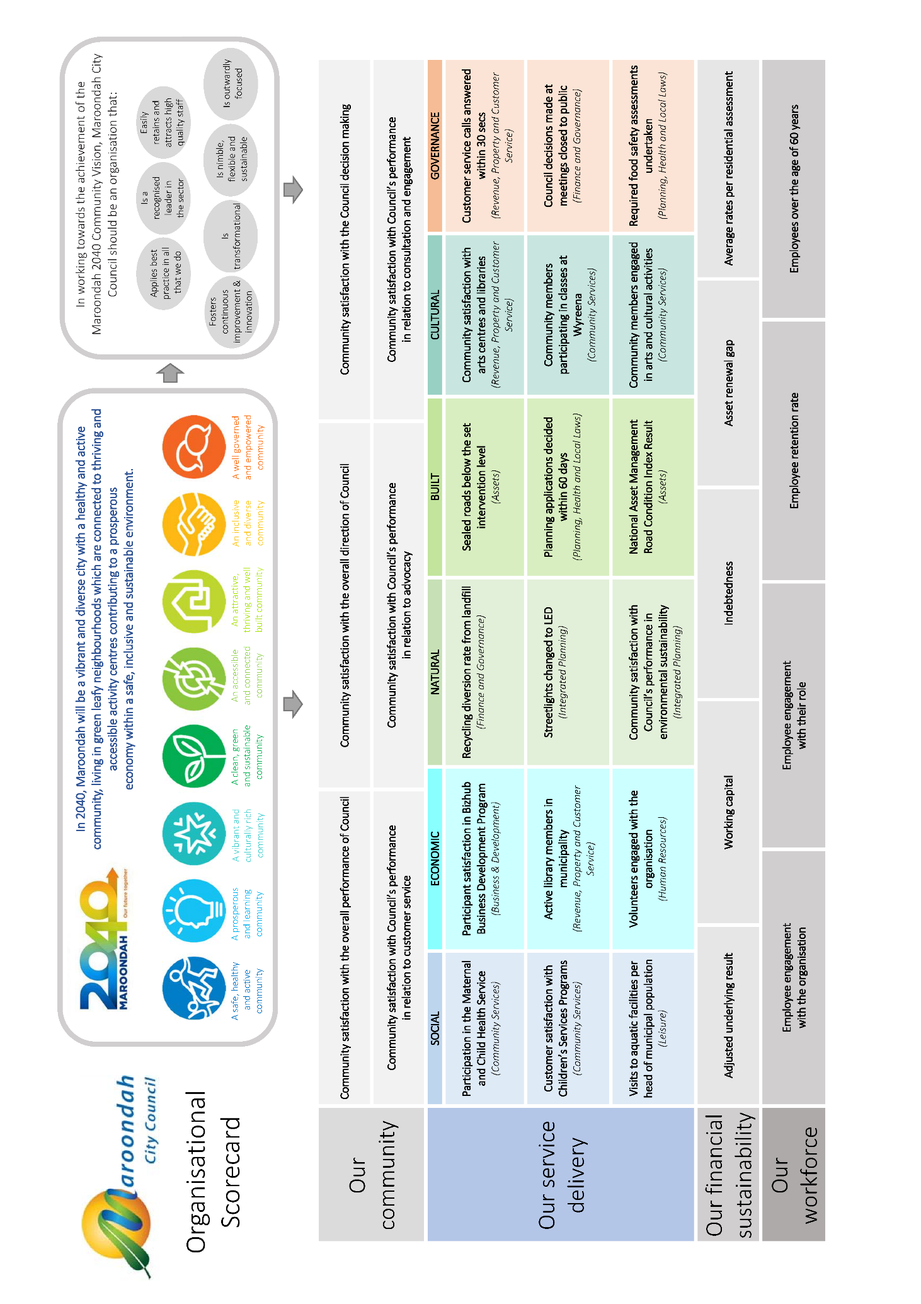

Strategic Resource Plan

The achievement of the Maroondah Council Plan 2017-2021 is dependent on the recognition, promotion and sustainability of physical, human and financial resources. The Plan provides the strategic framework for the provision of these resources ensuring a clear linkage between service delivery and planning and the achievement of the Maroondah 2040 Community Vision.

Physical Resources Plan
Over the past decade Maroondah City Council has continued to evolve its framework for the management of the community’s physical assets. This Framework has evolved due to the vast and diverse range of assets that Council manages, and is focused on facilitating the delivery of a wide range of services to the community.

To place the importance of this framework in a financial context, it is noted that as part of Maroondah’s net assets as at 30 June 2018, physical, service-delivering assets including infrastructure, property, plant, land and equipment totalled $1.9b. Within Maroondah, there are 150 community facilities and a further 370 minor structures which are owned by Council. Council also has management responsibilities for 478km of local roads and 450 sporting and recreational reserves.

Council’s asset management framework is based on a commitment to ensure effective and efficient total life cycle management of the community’s assets. Council believes that such an approach, combined with the principles of long term sustainability, will maximise the long term service delivery potential associated with the community’s assets.

This framework involves the combined application of financial, economic, technical, social and environmental functions, with the objective of providing a required level of service in the most cost effective manner over the lifecycle of each community asset.

Council remains committed to the further development, implementation and improvement of this framework for the management of the community’s physical assets. This is being achieved through the allocation of human and financial resources dedicated to an ongoing program of monitoring, recording and analysing the condition and performance of the community’s physical assets and translating the outcomes to optimised proactive asset management regimes.

Council is continually developing its asset management system solution across the organisation, to facilitate more effective identification/prioritisation, planning, and optimisation of all aspects associated with the management of the community’s physical assets.

Council has a rolling four (4) year Capital Expenditure Program for new, upgrade, and renewal capital expenditure that reflects Council’s strategy to ensure that the community’s existing assets are managed effectively.

The framework is underpinned by Council’s planning and budgeting processes, and has a strong connection with the key directions and priority actions within the Council Plan and Maroondah 2040.

Human Resources Plan
Council’s Workforce People and Culture Strategy 2016-2020 has been developed as part of Council’s strategic planning framework and aims to provide an organisational road map for the development, implementation, review and measurement of Human Resources (HR) services, activities and systems while recognising the economic, social, environmental and political factors that may impact on Council’s operations.

Human Resources aspire to optimise workforce performance through contemporary human resources and organisational development practices and educate the organisation about the importance of mitigating risk, attracting, retaining, valuing and leading of employees for sustainable organisational performance.
Human Resources aims to achieve the following outcomes:
- enable and enhance organisational capability, engagement and alignment through the promotion of a high performance and values based culture
- apply a best practice, quality and innovative approach to people management and planning
- promote a collaborative, respectful and consultative approach to workforce compliance, risk, quality and diversity
- support transformational change for organisational sustainability
- foster positive stakeholder relationships and partnerships to deliver quality organisational outcomes.

Human Resources operate within a dynamic framework where external challenges intersect with Council’s organisational culture. Within this system, effective processes are required to facilitate continual organisational development (maintaining a learning orientated, appropriately structured, high performing and engaged organisation), improving leadership capacity, and encouraging consultation and collaboration with members of the organisation and the broader community.
A holistic approach to personal and professional development is necessary so that Council can create a workplace that positively contributes to ongoing job satisfaction, a high skill base, high levels of customer satisfaction, improved service delivery and, hence, employee engagement.

Council also operates within a complex legal and industrial relations framework with a variety of occupational categories and working conditions. Changes in employment related legislation is directly relevant to the day-to-day human resource management, requiring a continual monitoring and alignment of internal policies and procedures to ensure continued legislative compliance and harmonious employee and industrial relations.
Such processes are central to the achievement of Council’s intended outcomes, continuous improvement (including innovation) to enhance equity and diversity, high morale, commitment, trust and a willingness to embrace change and high productivity.

This is achieved through consultation and communication with employees by:
- providing high quality professional human resource expertise
- being collaborative, consultative and supportive
- fostering and enhancing effective and productive relationships
- modelling inclusive behaviour in all activities at all levels
- aligning HR activities to the organisational core business and culture
- utilising transparent systems and regularly evaluating these to facilitate improvement
- implementing an employee training and development framework
- identifying and embracing new opportunities and challenges, and
- continually striving for excellence in service delivery, continuous improvement and best practice.

Council will proactively apply leading people management principles, plans, policies, frameworks (models), technology and systems in the delivery of value-added workforce services. Council is committed to the provision of quality services and activities to meet the aspirations, needs and expectations of Council and the community.

Financial Resources Plan
Maroondah City Council’s strategic approach to the planning and management of its financial resources is founded on the following principles.

Council will:
- Continue to remain financially viable and sustainable both in the short and long term
- Look to maximise its revenue from all available external sources before calling on the community for funds
- Balance its spending targets against the affordability of municipal rates that it levies on the community
- Apply the principle of inter-generational equity to its capital expenditure and loan funding programs
- Maintain its overall role of stewardship of the community’s assets including financial assets
- Apply best practice in financial monitoring and reporting as well as in high levels of internal controls.

With guidance from these principles, a range of financial policies and strategies have been developed to assist in achieving consistency and balance in Council’s financial planning endeavours. The more significant of the policies relate to rating, fees and charges, borrowing, investments and capital expenditure.

Based on these principles and policies, each year Council prepares a detailed Annual Budget for the year ahead, and updates its Long Term Financial Strategy and Capital Expenditure Program for the next ten years.

The primary objective of our current strategy is to ensure financial sustainability into the long term, whilst still achieving the Maroondah 2040 Community Vision preferred outcomes and key directions as outlined in the Council Plan.

To this end, our aim is to achieve annual surplus operating budget results in order to support Council’s Capital Works Program, maintain cash reserves sufficient to account for ongoing financial commitments and maintain a positive working capital ratio to meet short-term financial obligations.

The outcomes of Council’s financial planning are embodied in the six financial schedules described below demonstrating Council’s ability to resource its proposed activities and manage its financial sustainability over the 2018/19 to 2021/22 period and beyond.
- Comprehensive income statement – summarises the operating (i.e. non-capital) expenditure and all revenue of both cash (e.g. materials) and non-cash (e.g. depreciation) nature and provides an annual net operating result.
- Balance sheet – takes the projected position at the commencement of the financial year and incorporates the annual net operating result.
- Statement of changes in equity - identifies all movements in assets and liabilities to provide the total equity of the Council as reflected in the net assets within the municipality.
- Statement of cash flows – identifies the planned cash inflows and outflows from Council’s operating, capital expenditure and financing activities to provide the net annual movement in cash and investment levels. It also shows the linkage between the annual net operating result as shown in the comprehensive income statement and the net cash movement from operating activities.
- Statement of capital works – provides the broad categorisation of Council’s planned capital expenditure program, the split of that expenditure between renewal, expansion or upgrade of existing assets, and new projects, and details the movement in net levels of physical assets from one year to the next.
- Statement of human resources - shows all council staff expenditure and numbers of full time equivalent council staff.

Financial Statements

Comprehensive Income Statement
For the four years ended 30 June 2022

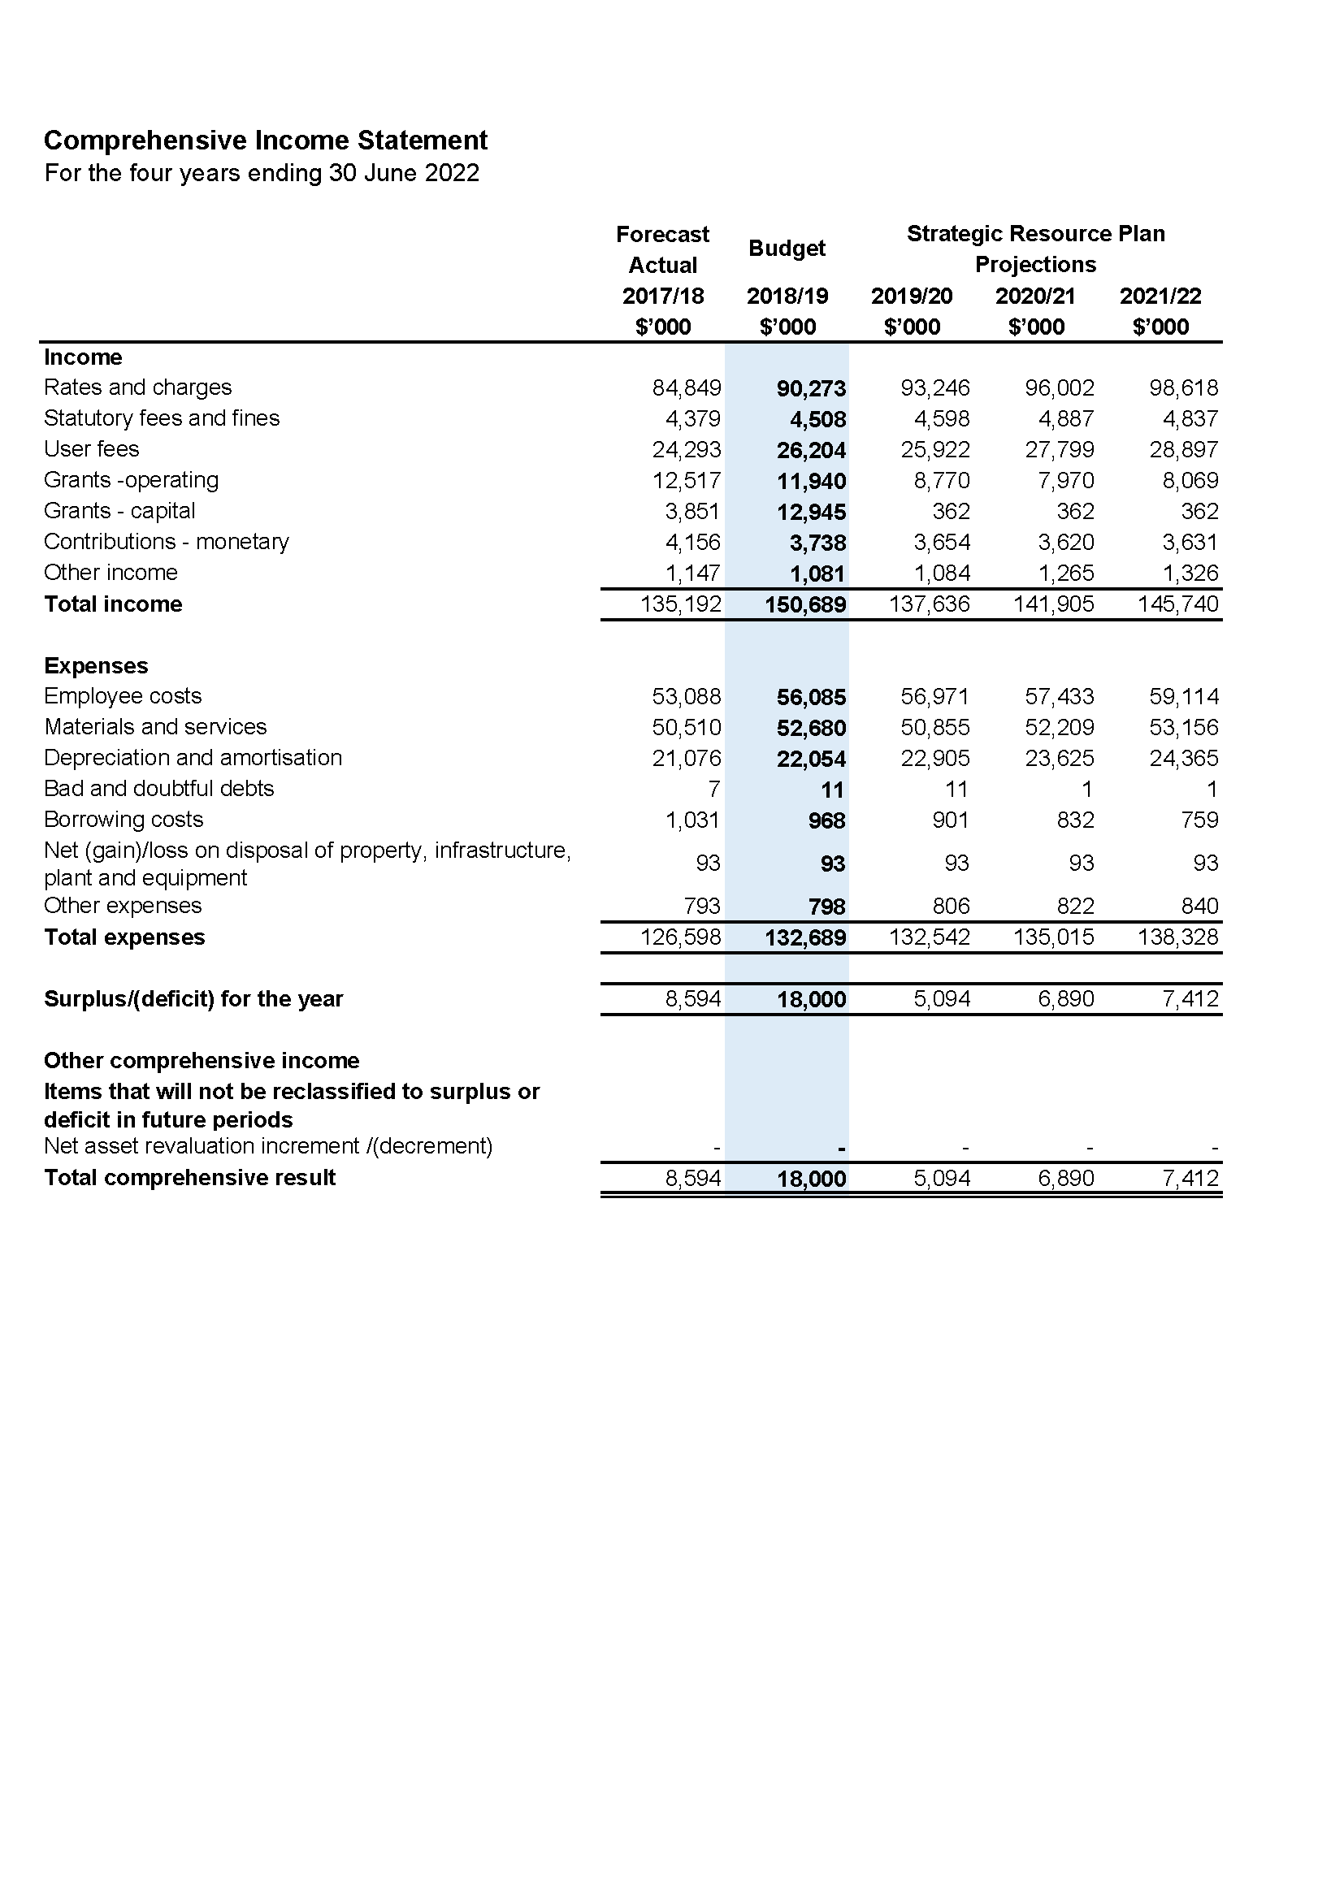

Balance Sheet
For the four years ended 30 June 2022

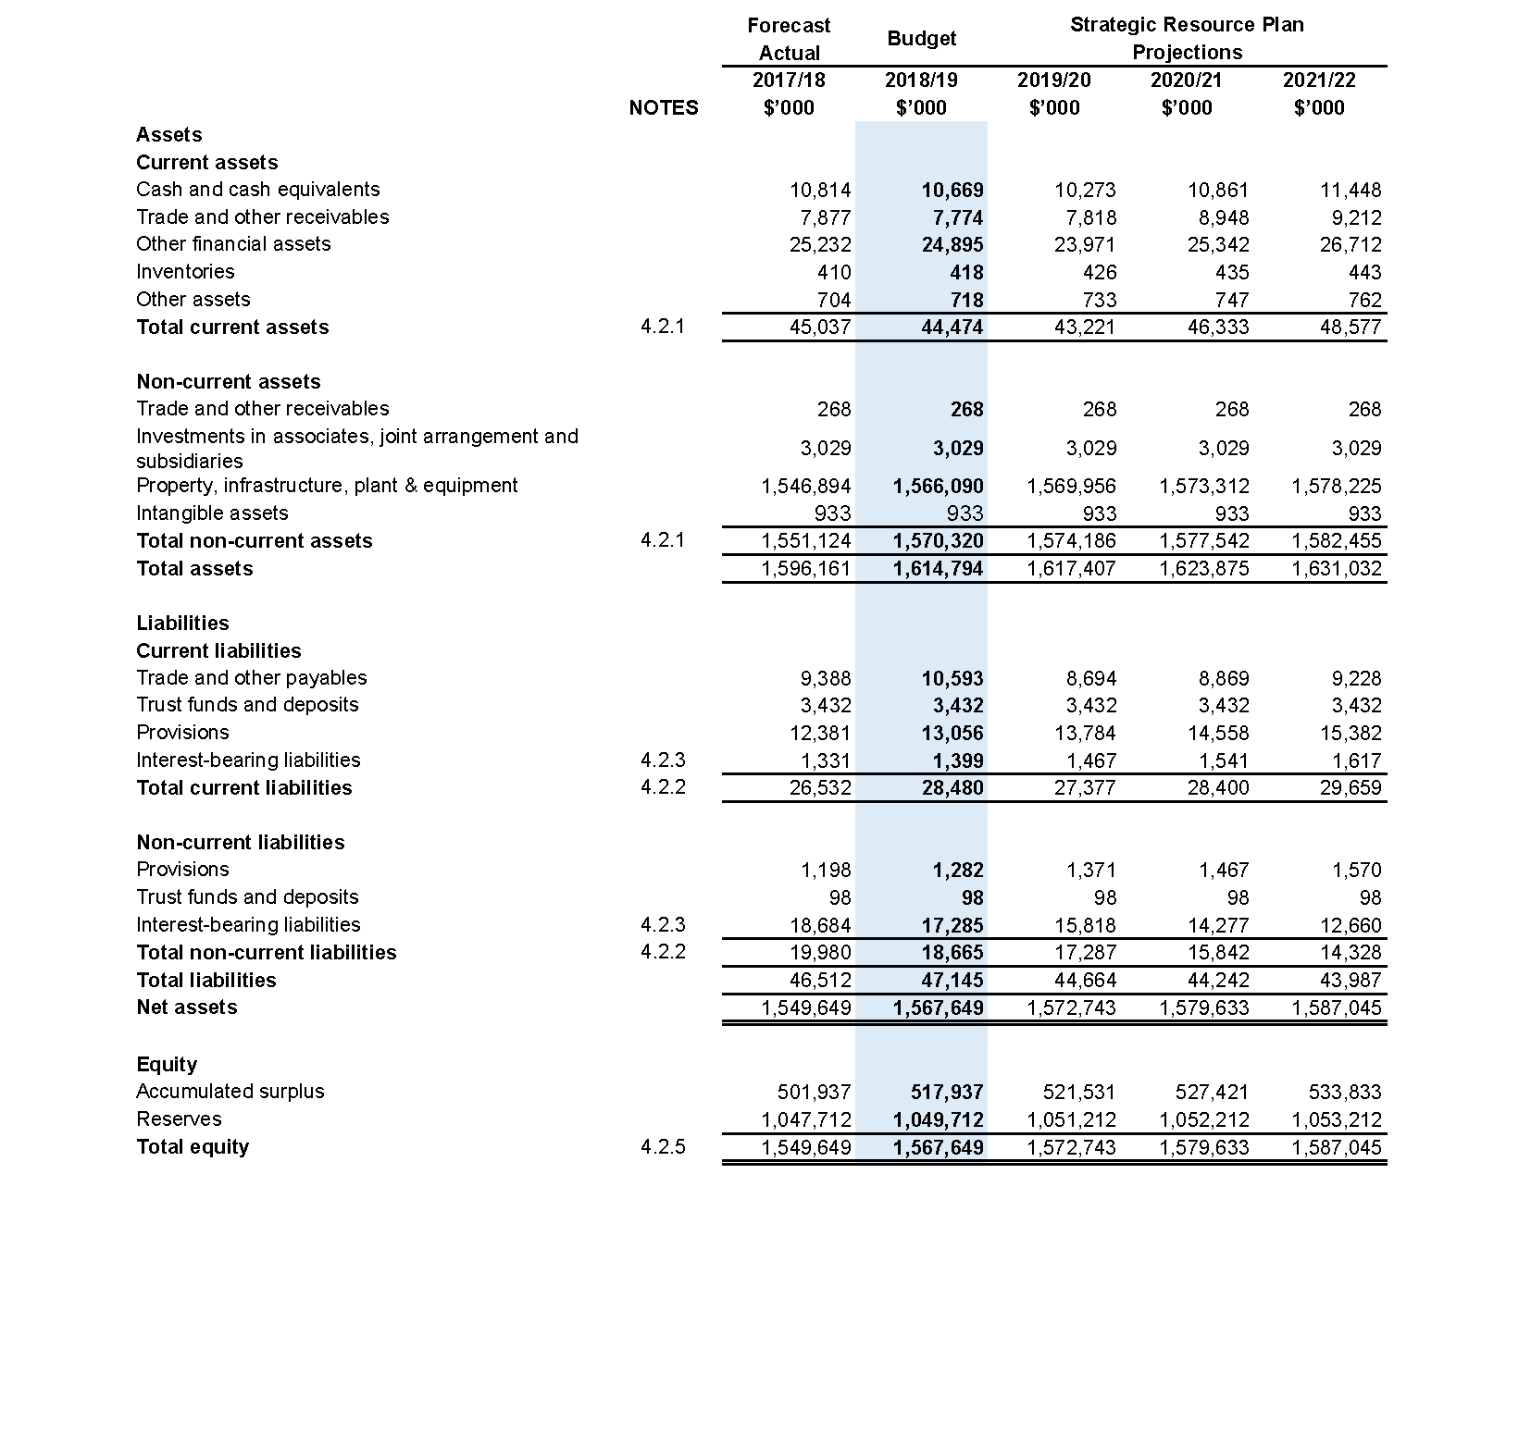

Statement of Changes in Equity
For the four years ended 30 June 2022

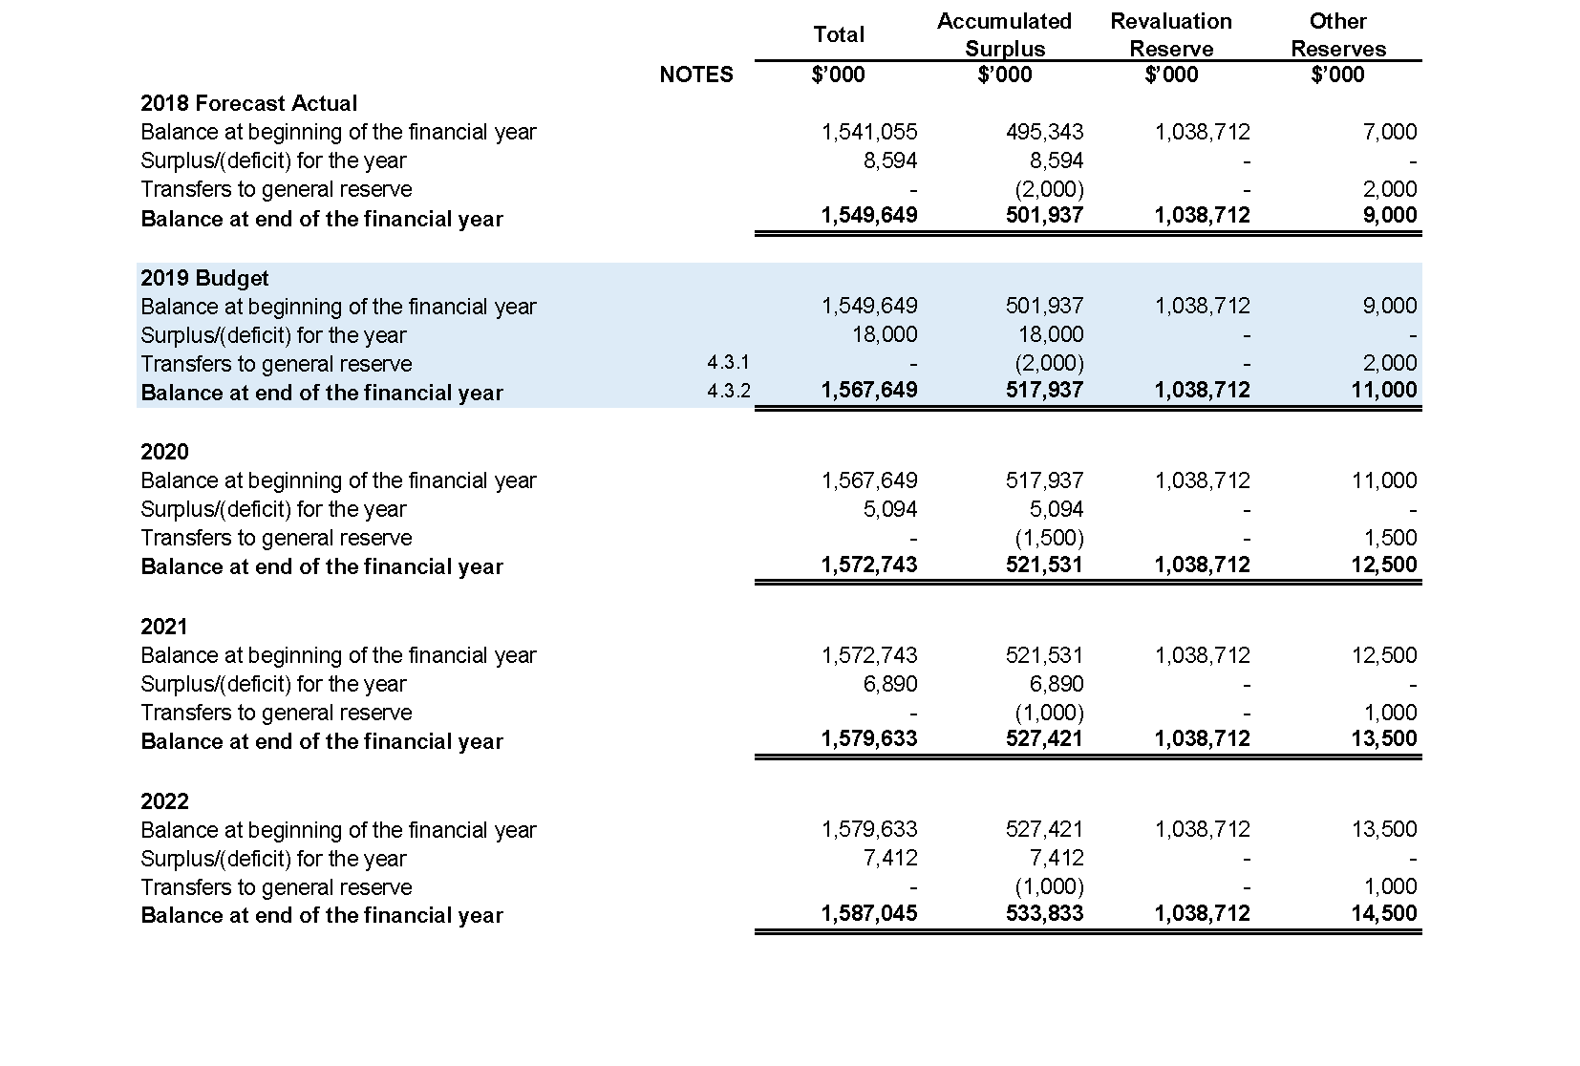

Statement of Cash Flows
For the four years ended 30 June 2022

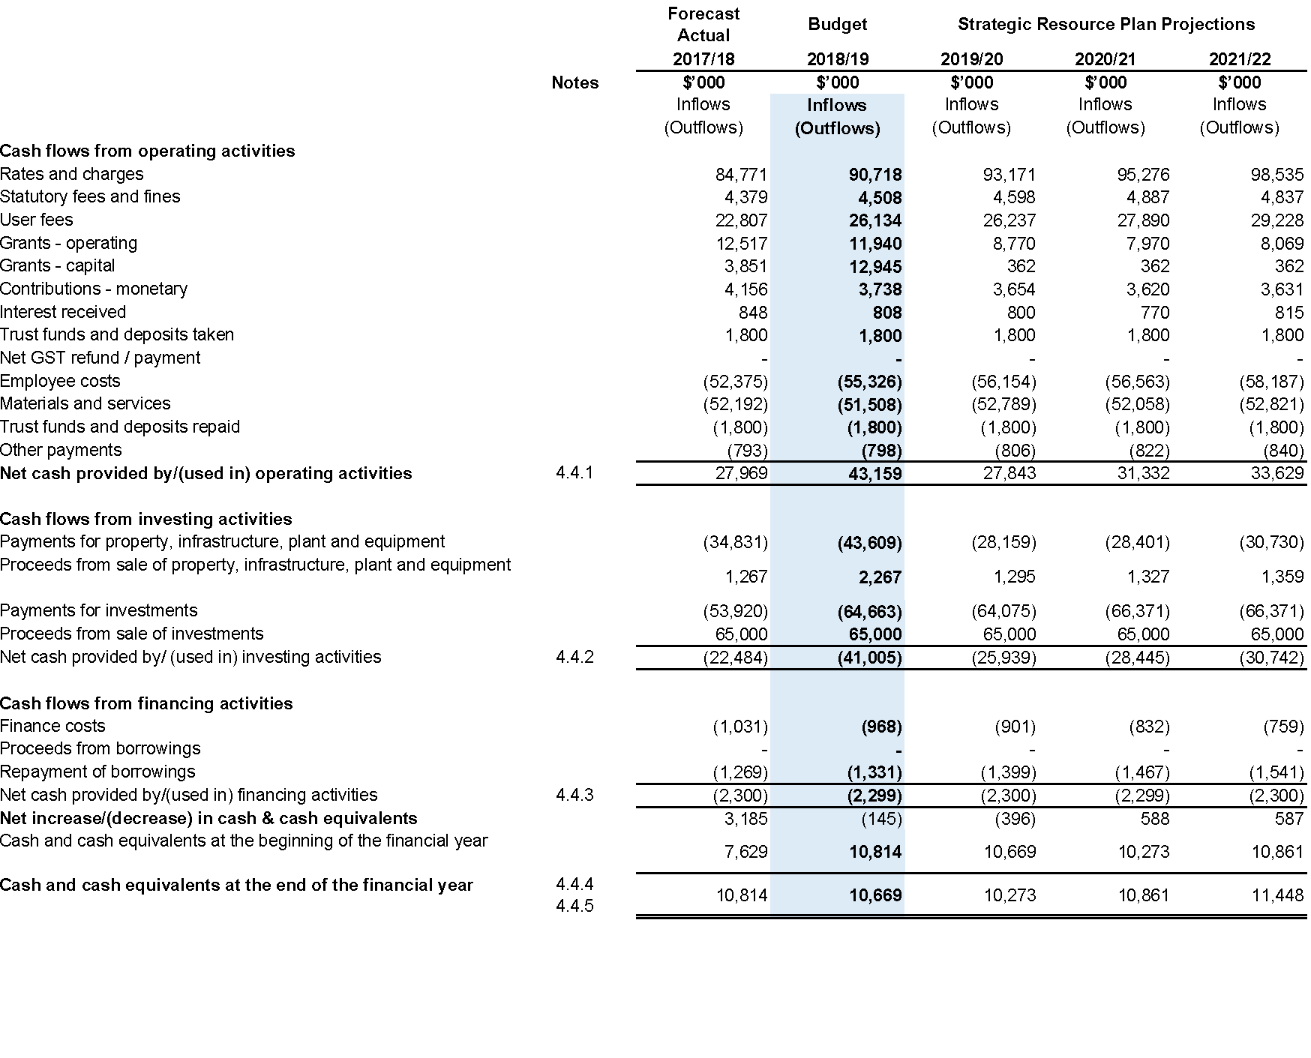

Statement of Capital Works
For the four years ended 30 June 2022

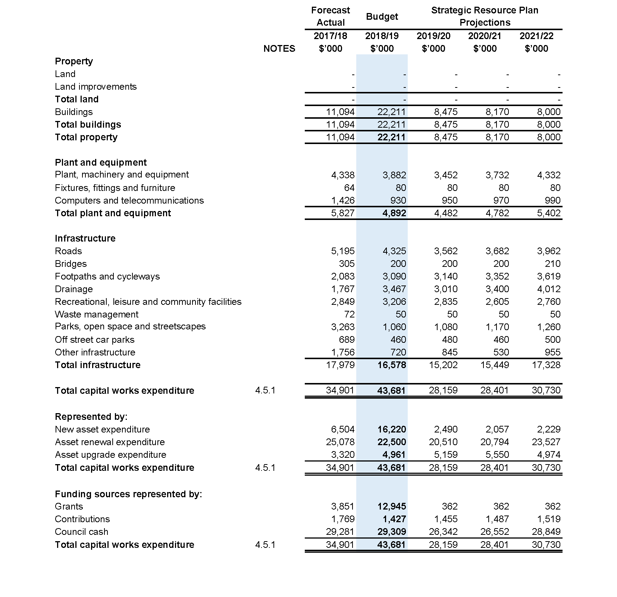

Statement of Human Resources
For the four years ended 30 June 2022

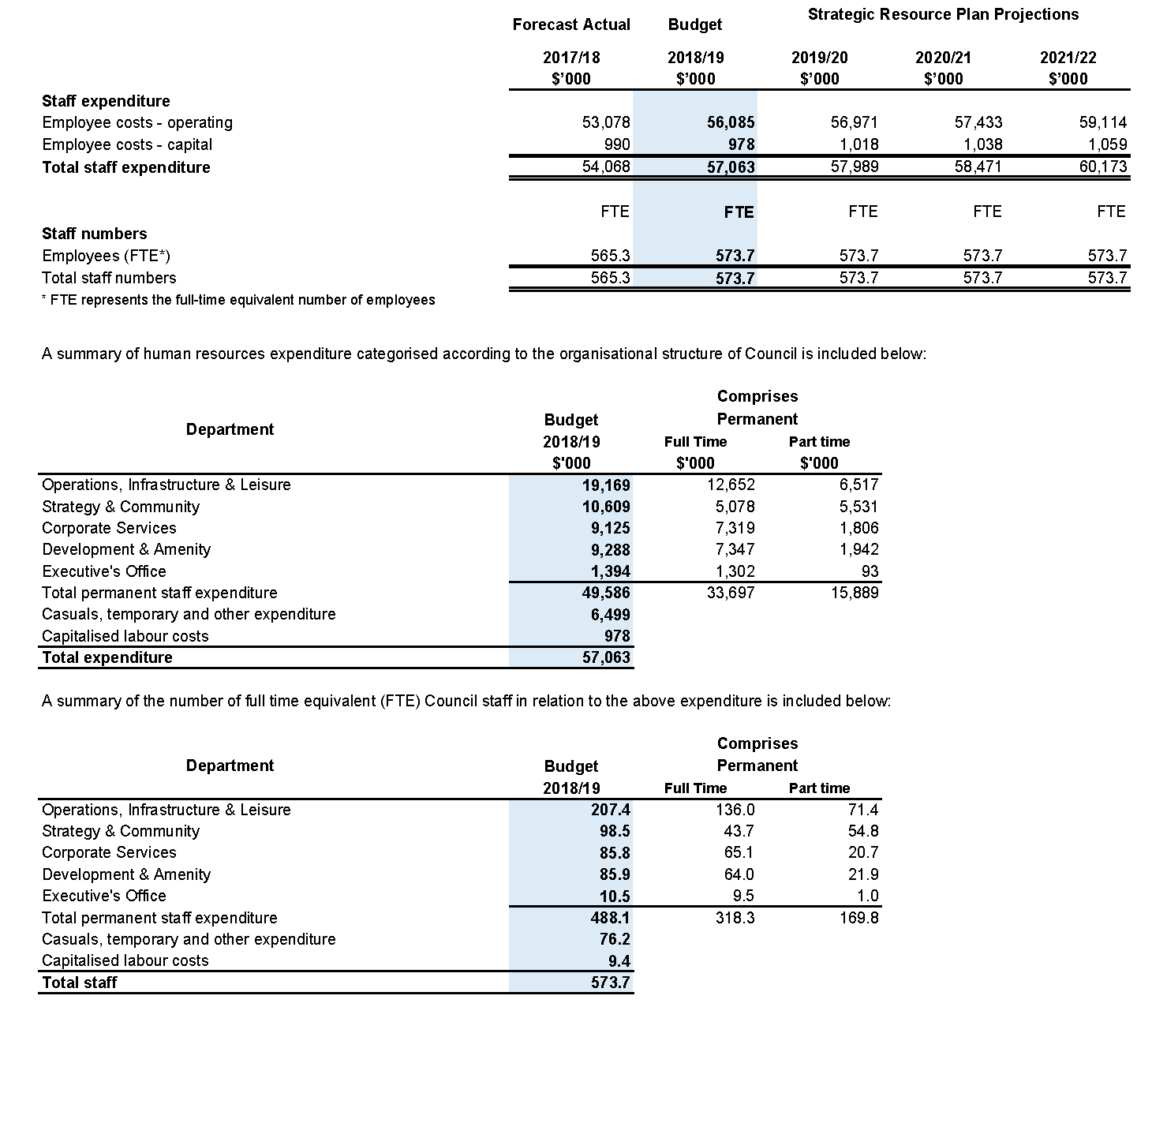

Other information

Summary of planned capital works expenditure
For the four years ended 30 June 2022

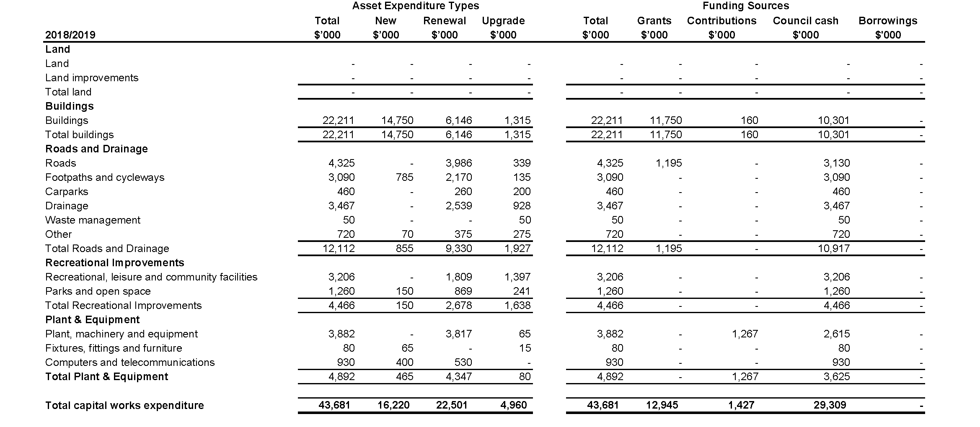

Summary of planned capital works expenditure
For the four years ended 30 June 2022

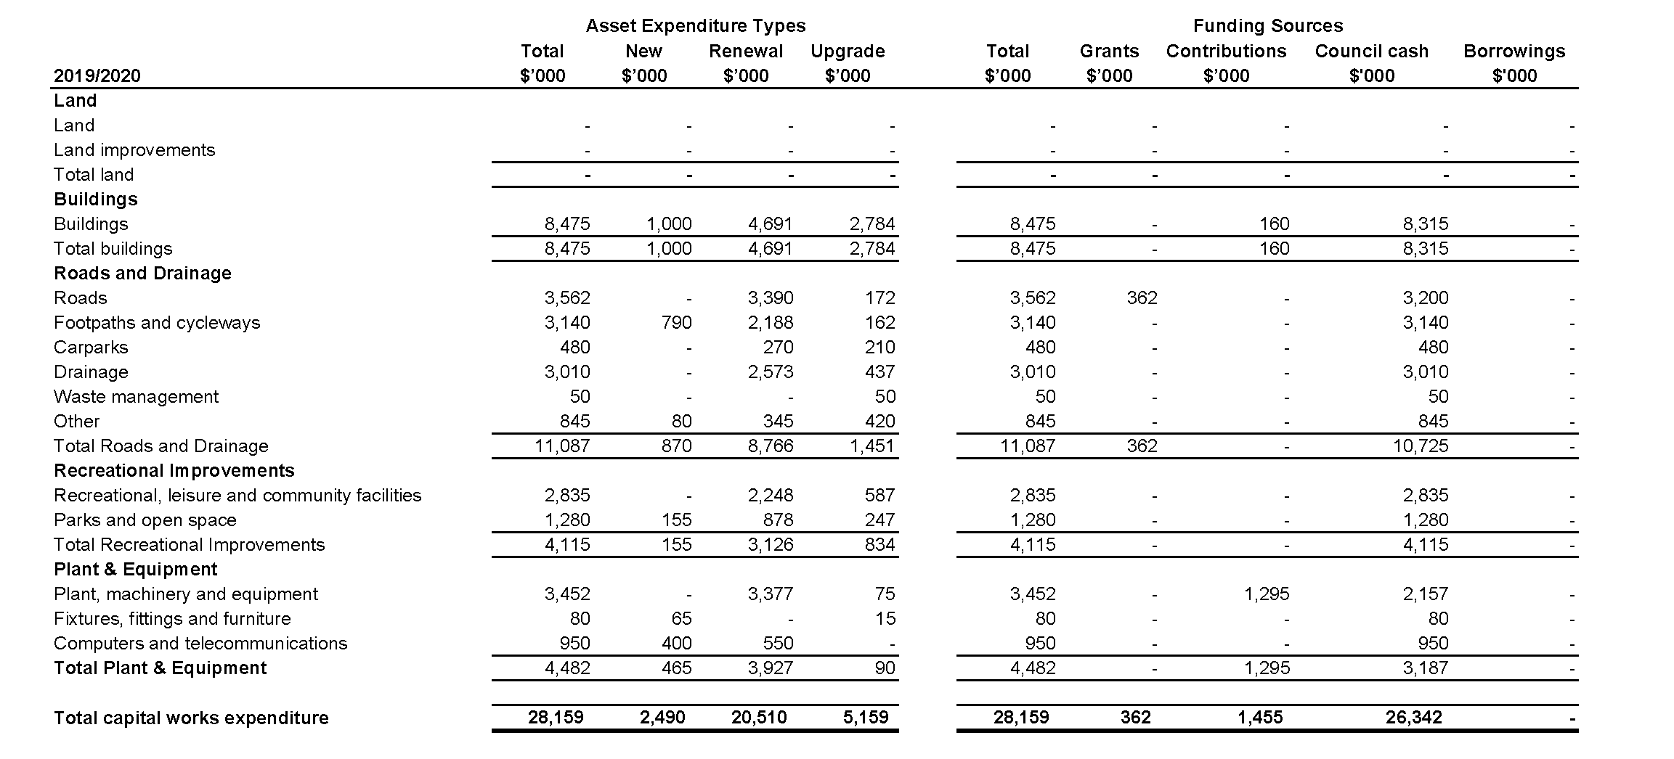

Summary of planned capital works expenditure
For the four years ended 30 June 2022

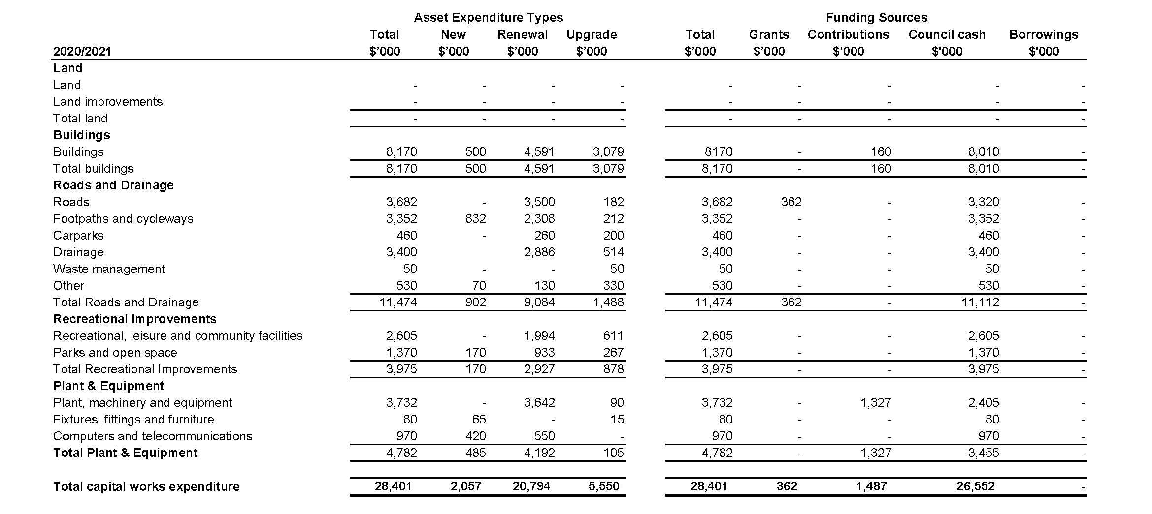

Summary of planned capital works expenditure
For the four years ended 30 June 2022

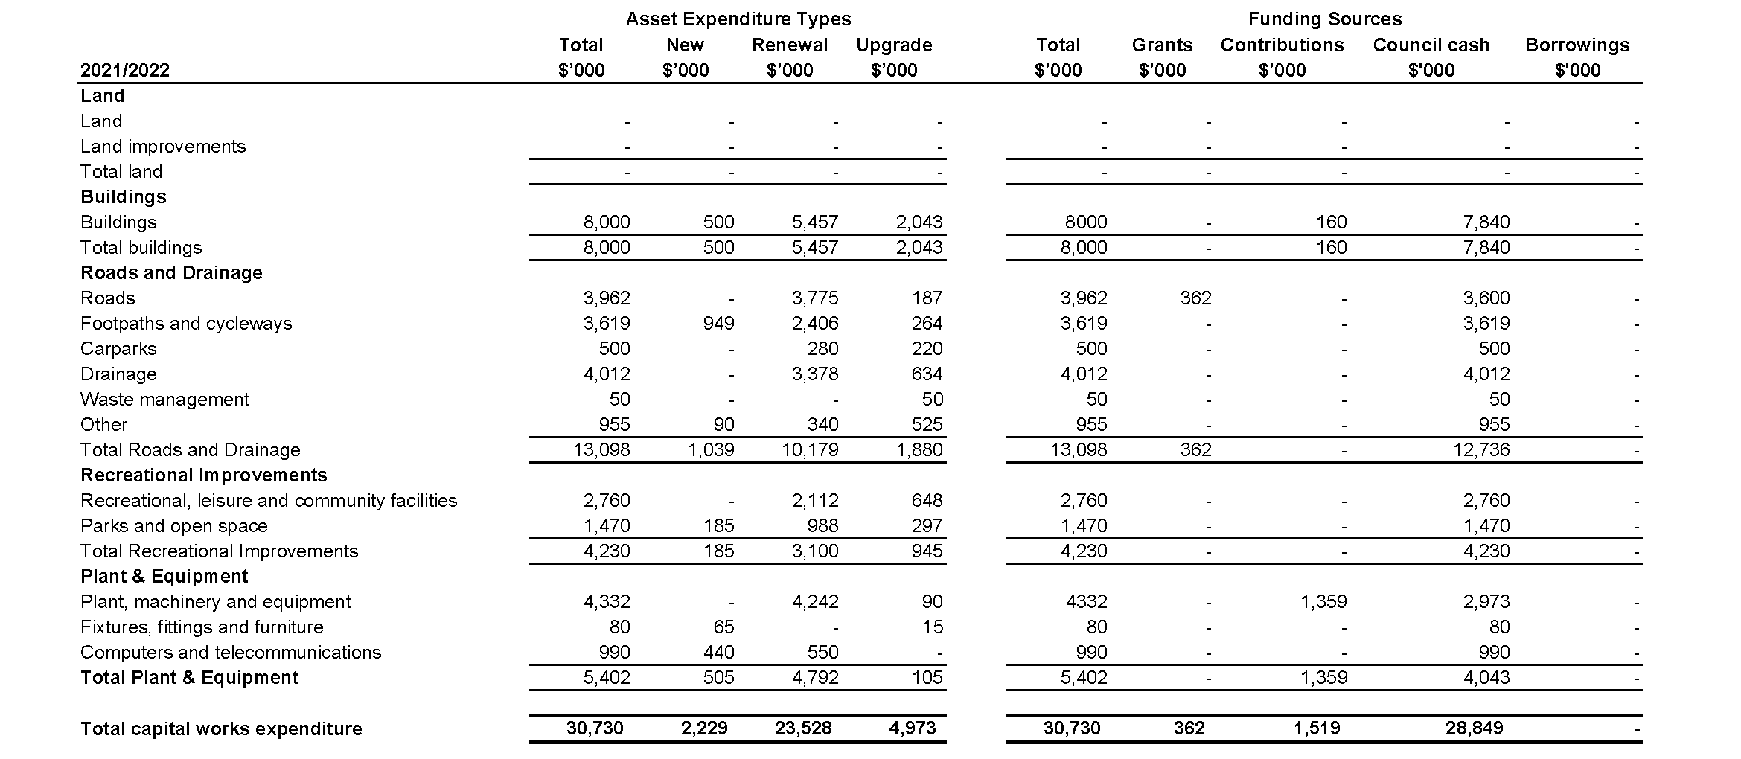

Summary of planned human resources expenditure
For the four years ended 30 June 2022

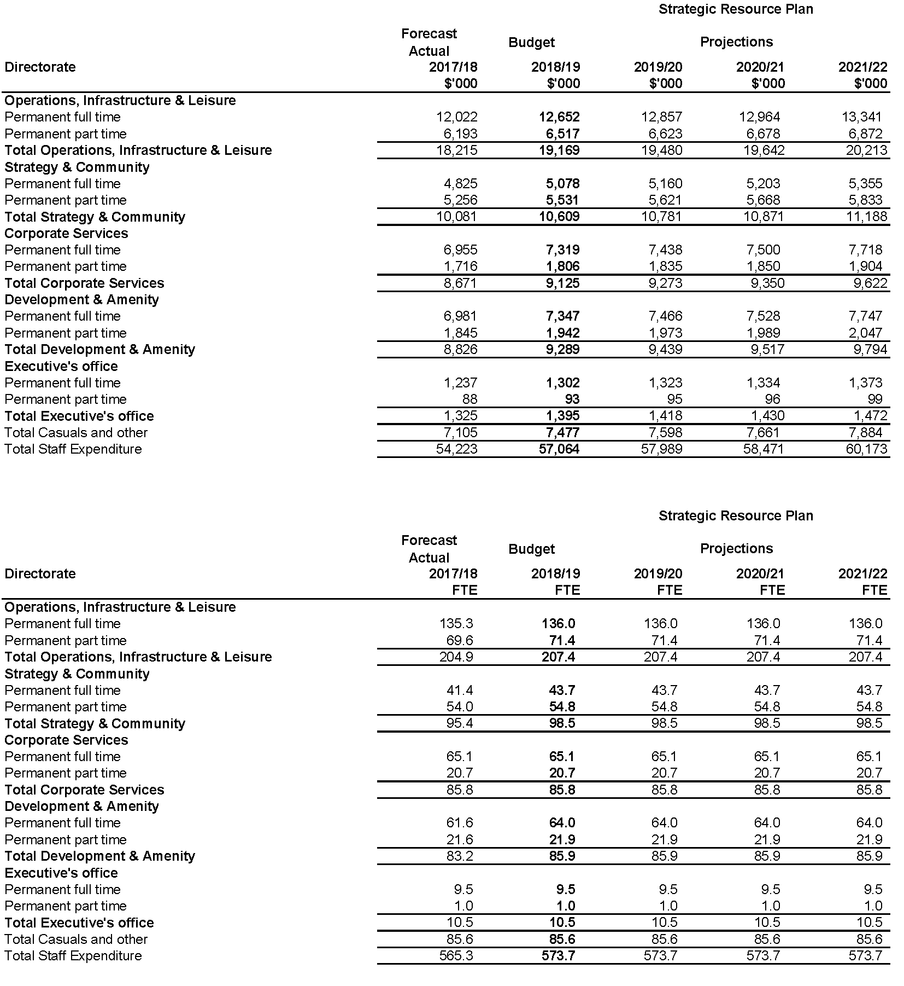

Glossary of terms

- Advisory committee: Specialist appointees who form a committee that provides advice and recommendations to Maroondah City Council on matters relating to the delivery of strategies, services and activities.
- Advocacy: To provide support to a cause or to make public recommendation on behalf of others.
- Annual Budget: The budget documents the financial and non financial resources required by Council to implement the outcome areas, key directions and priority actions identified in the Council Plan.
- Annual Report: A report on the activities of Council over the previous financial year. The report includes a report of operations, audited financial statements and an audited performance statement.
- Asset: An asset is an item of value that enables a service to be provided and has an economic life greater than 12 months.
- Asset expansion expenditure: Expenditure that extends the capacity of an existing asset to provide benefits to new users at the same standard as is provided to existing beneficiaries.
- Asset renewal and maintenance gap: The variance between what councils need to spend on their existing infrastructure to maintain or renew it to its original service potential or useful life, and what councils actually spend on renewal and maintenance.
- Asset renewal expenditure: Expenditure on an existing asset or on replacing an existing asset that returns the service capability of the asset to its original capability.
- Asset upgrade expenditure: Expenditure that either enhances an existing asset to provide a higher level of service or increases the life of the asset beyond its original life.
- Best practice: To adopt or develop standards, actions or processes for the provision of goods, services or facilities which are equal to or better than the best available on a state, national or international scale.
- Best value: An approach to Local Government service delivery which includes community input, effective service delivery and cost efficiency as key service outcomes. State Government legislation requires all Victorian Councils to review their services and adopt a model that considers six principles (see the Local Government Act 1989 for more details).
- Capital works: Projects undertaken to establish, renew, expand, upgrade and dispose assets owned by Maroondah City Council in the community.
- Capital works expenditure: Expenditure on non-current assets and includes new assets, asset renewal, asset expansion and asset upgrade.
- Charter of Human Rights and Responsibilities Act 2006: Legislation created to protect and promote human rights. It sets out freedoms, rights and responsibilities.
- Community engagement: The process of Council working with residents, businesses and community groups to address issues that impact their well-being. Council adopted principles regarding community engagement are outlined in the Community Engagement Policy.
- Community Satisfaction Survey: A State Government survey conducted once a year to obtain community feedback in order to gauge satisfaction levels with council services.
- Continuous improvement: The process that ensures review and improvement practices are built into operational activities.
- Corporate governance: Council’s responsibility for the economic and ethical performance of the municipality.
- Council: The collective group of nine Councillors that set the strategic direction for Maroondah City Council, monitor organisational performance, liaise with stakeholders and ensure operational compliance.
- Council Plan: A four year plan which provides the medium-term framework for Council operations by outlining the community’s preferred outcomes, the medium-term key directions to work toward these preferred outcomes and a set of priority actions for the forthcoming financial year. The Council Plan also includes a strategic resource plan that identifies the financial and non-financial resources required to achieve these preferred outcomes.
- Council Plan indicators: Performance measures that assist Council to monitor the progress toward achievement of long-term preferred outcome areas and four-year key directions (strategies). These indicators represent the strategic indicators for monitoring the achievement of outcome areas (strategic objectives) as required by section 125 of the Local Government Act 1989.
- Councillor: A member of the community elected in accordance with the Local Government Act 1989 to represent the residents of a ward within the municipality, as a member of Council.
- Current assets: Financial term assets where Council expects to receive the future economic benefit within the next 12 months unless the asset is restricted from being exchanged or used to settle a liability for at least 12 months after the reporting date.
- Current liabilities: Financial term liabilities where Council expects to fulfil its obligation within the next 12 months unless the Council does not have an unconditional right to defer settlement of the liability for at least 12 months after reporting date.
- Equity: The financial term residual interest in the assets of Council after deductions of its liabilities, which is made up of accumulated surplus and reserves. Total equity is also equal to net assets.
- Feasibility study: An analysis and evaluation of a proposed project to determine if it is technically possible, is worthwhile within the estimated costs, and will be valuable. Studies also often consider the potential impact of the project and discuss options.
- Financial resources: Includes income, expenditure, assets, liabilities, equity, cash and capital works required to deliver the services and initiatives in the annual budget.
- Governance: How Council operates as a decision-making body, its relationship with the administration and the ways that Council engages with their community.
- Home and community care: Council service which assists elderly and disabled residents with essential house cleaning and daily living tasks so that they can remain living independently in their own homes.
- Indigenous: Originating in a particular geographic region or environment and native to the area and/or relating to Aboriginal and Torres Strait Islander people.
- Infrastructure: Constructed assets required for the functioning of the community, such as roads, drains, footpaths, lighting, paths, play equipment, public buildings, signage, streetscapes and waste systems.
- Initiatives: Annual Budget initiatives are actions that are one-off in nature and/or lead to improvements in service. These are a sub-set of the Council Plan priority actions.
- Integrated Planning Framework: A hierarchy of strategic documents and processes that ensure all of Council’s activities and financial resources are aligned in order to meet the aspirations, needs and expectations of the Maroondah community. This framework includes the key statutory planning and reporting documents that are required to be prepared by councils to ensure accountability to local communities in the performance of functions and exercise of powers under the Local Government Act 1989.
- Key directions: High level strategies to achieve the Maroondah 2040 Community Vision preferred outcomes over the four-year term of the Council Plan. These directions guide Council service delivery and inform priority actions for each financial year. These key directions represent the ‘strategies’ for achieving the objectives (outcome areas) of Council over the 2017-2021 period in accordance with section 125 of the Local Government Act 1989.
- Liabilities: Financial term future sacrifices of economic benefits that Council is presently obliged to make to other entities as a result of past transactions or other past events.
- Local laws: The laws adopted by Council that prohibit, regulate and control activities, events, practices and behaviours within Maroondah.
- Local Government Act 1989: This Victorian Government legislation outlines the intention for Councils to provide a democratic and efficient system of local government in Victoria. It provides Councils with the authority to meet the needs of their communities and provides the basis for an accountable system of local governance in Victoria.
- Local Government Amendment (Performance Reporting and Accountability) Act 2014: Sets out the financial planning and reporting framework for local government.
- Local Government Performance Reporting Framework: A Victorian planning and reporting framework that seeks to provide a comprehensive picture of Council performance. The framework comprises four indicator sets: service performance, financial performance, sustainable capacity and governance & management.
- Local Government (Planning and Reporting) Regulations 2014: Supports the operation of the Local Government Performance Reporting Framework for Councils under the Local Government Act 1989.
- Long Term Financial Strategy: This strategy takes the outcome areas and key directions as specified in the Council Plan and expresses them in financial terms over a rolling 10 year period
- Major Initiatives: Annual Budget major initiatives are significant activities of Council that will directly contribute to the achievement of the Council Plan during a given financial year and have a major focus in the budget. They are determined on an annual basis and represent a sub-set of the Council Plan priority actions for the financial year.
- Maroondah 2040 Community Vision: The long term community and Council vision for the City of Maroondah developed after an extensive community engagement process. The Vision identifies the preferred future outcome areas and key directions for Maroondah looking ahead to the year 2040.
- Maroondah Health and Wellbeing Plan: A Council strategy that provides directions and guidelines for working towards an optimal state of health, safety and wellbeing for the people of Maroondah. This strategy incorporates the Municipal Public Health Plan.
- Municipal Emergency Management Plan: Addresses the prevention of, response to and recovery from emergencies within the municipality of Maroondah.
- Municipal Strategic Statement (MSS): Outlines the key land use and development objectives and strategies for the municipality. The MSS provides the basis for zones, overlays and particular provisions. Council will review the MSS every three years.
- Municipal Public Health Plan: Sets the broad mission, goals and priorities to promote municipal public health and wellbeing; and inform the operational processes of Council and local organisations. In Maroondah, this Plan is incorporated within the Community Wellbeing Plan.
- Municipality: A geographical area that is delineated for the purpose of local government.
- Net assets: The financial term difference between total assets and total liabilities, which represents Council’s net worth. Net assets are also equal to total equity.
- New asset expenditure: Expenditure that creates a new asset that provides a service that does not currently exist.
- Our mission: A shared understanding of the purpose of the organisation that articulates how Council will work towards the achievement of the Maroondah 2040 Community Vision in conjunction with the community.
- Our values: Represent attitudes and beliefs within Council that underpin organisational practices, processes, and behaviours.
- Our vision: A statement of the preferred direction for the City of Maroondah that defines the aspirations of the community and serves to guide all Council activities.
- Outcome Areas: Key areas of future opportunity and challenge as identified by the community in the Maroondah 2040 Community Vision. They describe the ideal future for Maroondah in very broad terms. These outcome areas represent the ‘strategic objectives’ of Council in accordance with section 125 of the Local Government Act 1989.
- Performance statement: A statement including the results of the prescribed service outcome indicators, financial performance indicators and sustainable capacity indicators for the financial year and included in the Annual Report.
- Policy: A set of principles intended to influence and provide direction for Council decisions, actions, programs and activities.
- Priority actions: Initiatives to be undertaken by Council that will significantly contribute to the achievement of the four-year Council Plan key directions (strategies). These actions include the major initiatives of Council for each financial year as identified within the Annual Budget in accordance with section 127 of the Local Government Act 1989.
- Risk management: A discipline for developing appropriate procedures to minimise or eliminate the risk of adverse effects resulting from future events and activities. Principles for managing risk are set out in the Australian Standards for risk management AS/NZS ISO 31000:2009
- Service Delivery Plan: A detailed four-year work plan to guide how a particular Council service area will support the achievement of relevant Maroondah 2040 Community Vision preferred outcome areas and key directions as outlined in the Council Plan.
- Statement of capital works: A statement which shows all capital expenditure of a Council in relation to non-current assets and asset expenditure type
- Statement of human resources: A statement which shows all council staff expenditure and numbers of full time equivalent council staff
- Statements of non-financial resources: A statement which describes the non-financial resources including human resources.
- Strategic Resource Plan: A medium-term plan of the financial and non-financial resources for at least the next four years required to achieve the outcome areas identified in the Council Plan. This plan is prepared in accordance with section 126 of the Local Government Act 1989.
- Strategic indicators: See Council Plan indicators.
- Strategic objectives: See outcome areas.
- Strategies: See key directions.
- Summary of planned human resources expenditure: A summary of permanent Council staff expenditure and numbers of full time equivalent Council staff categorised according to the organisational structure of the Council.
- Summary of planned capital works expenditure: A summary of capital expenditure in relation to non-current assets classified according to the model statement of capital works in the Local Government Financial Report, by asset expenditure type and funding source.
- Supporting strategies and plans: A long term systematic plan of action to achieve defined outcomes in an area of Council activity or responsibility.
- Sustainability: The principle of providing for the needs of the present community without compromising the ability of future generations to meet their own needs. The principle seeks to achieve long-term health and well-being across social, economic, environmental and cultural domains.
- Wards: A geographical area which provides a fair and equitable division of a local government area. The City of Maroondah is divided into three wards, each with three elected Council representatives.

To contact Council
- phone 1300 88 22 33 or (03) 9298 4598
- visit our website at www.maroondah.vic.gov.au
- email maroondah@maroondah.vic.gov.au

Translating and Interpreter Service
13 14 50

National Relay Service (NRS)
13 36 77

 MaroondahCityCouncil
@CityofMaroondah
 CityofMaroondah
 Maroondah City Council

