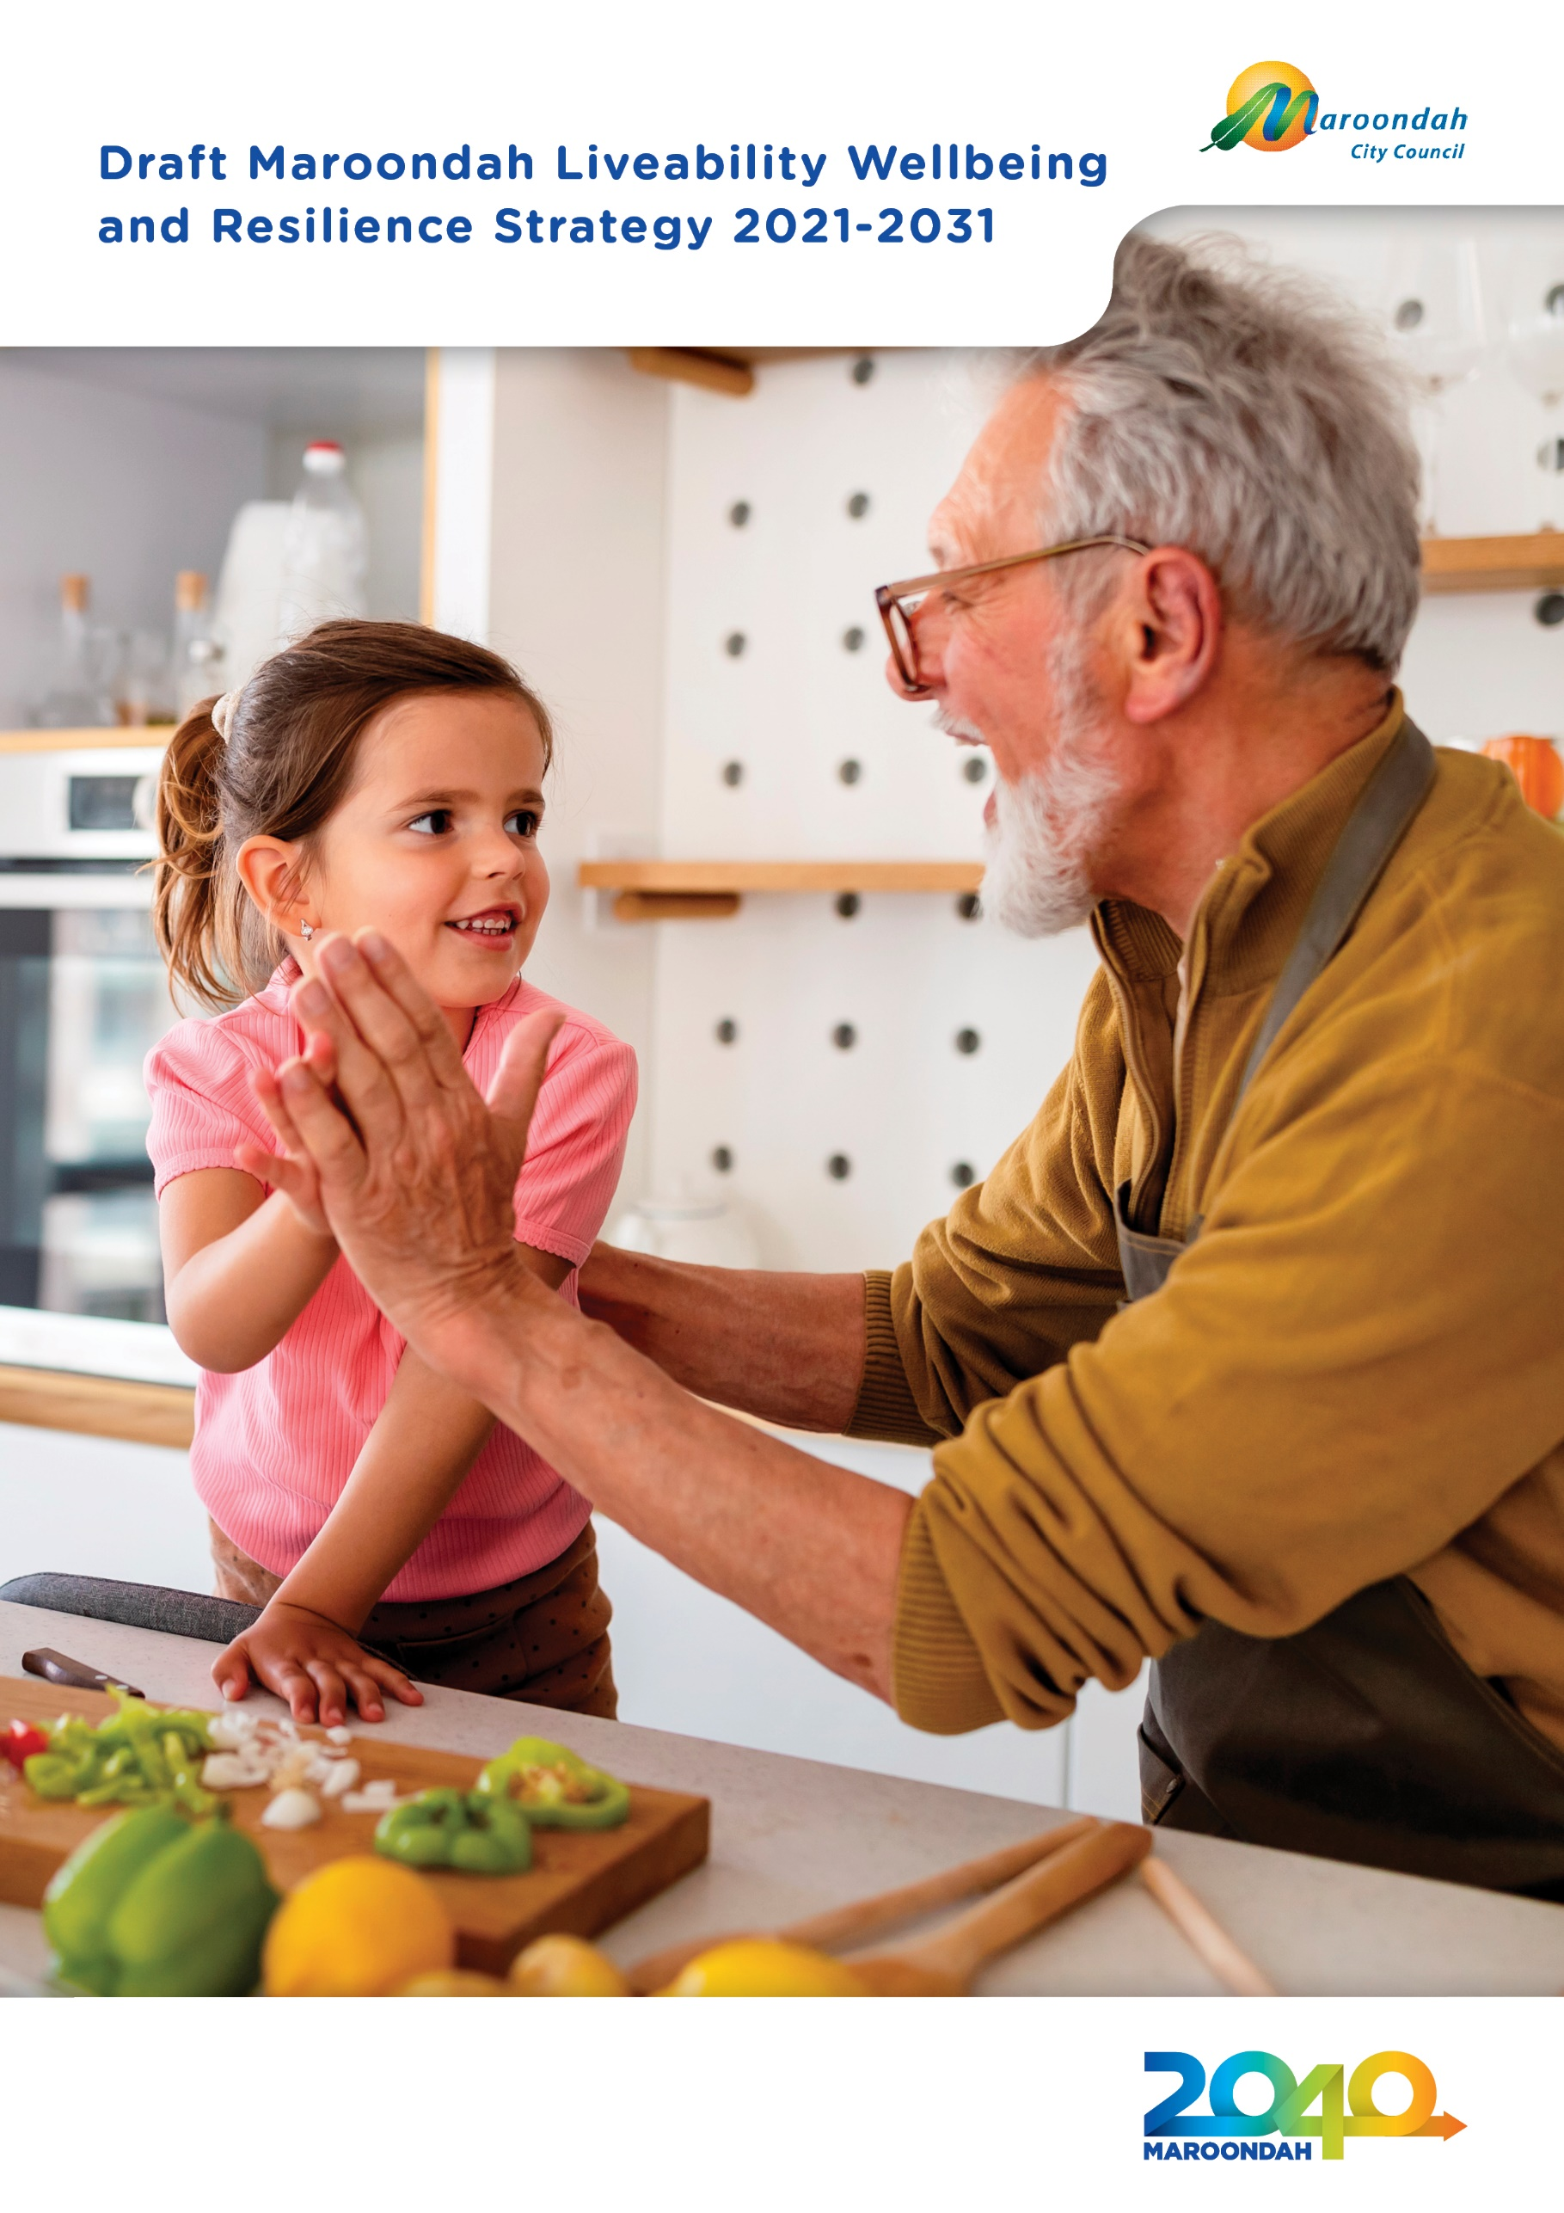

Community feedback sought on draft Strategy

The Draft Liveability Wellbeing and Resilience Strategy 2021-2031 has been placed on public exhibition for community feedback.

To have your say please visit: www.yoursay.maroondah.vic.gov.au/lwrs

Consultation closes 5pm Monday 6 September 2021.

If you would like more information on this Strategy, please contact Integrated Planning on 9298 4598 or 1300 88 22 33.

Contents

Mayor’s message | 3
Working towards community liveability, wellbeing and resilience in Maroondah | 4
Background | 7
Our city | 7
Strategic Context | 8
Guiding principles | 12
Guiding frameworks | 13
Developing the strategy | 17
What the evidence tells us | 18
What the community told us | 25
A strategy for liveability, wellbeing and resilience in Maroondah | 31
Healthy lifestyles | 32
Liveable neighbourhoods | 35
Safe communities | 38
Social inclusion | 41
Embracing diversity | 44
Social harms | 47
Making it happen | 49
Measuring our progress | 50
Glossary | 51
References | 60

Acknowledgement of Country

We, in the spirit of Reconciliation, acknowledge the Wurundjeri People of the Kulin Nation as traditional custodians of the land now known as the City of Maroondah, where Indigenous Australians have performed age-old ceremonies. We acknowledge and respect their unique ability to care for Country and their deep spiritual connection to it. We pay our respects to their Elders, past, present and emerging.

Mayor’s message

On behalf of Council, I am are pleased to present the Maroondah Liveability Wellbeing and Resilience Strategy 2021-2031.

The Maroondah Liveability Wellbeing and Resilience Strategy 2021-2031 is Council’s key social environment strategic plan that describes how Council and partners will work towards achieving enhanced community wellbeing, liveability and resilience over the next 10 years. In 2031, Maroondah will be a liveable, healthy and resilient community where everyone can belong, thrive and grow.

The Strategy is guided by the community vision for Maroondah as outlined in Maroondah 2040 - Our future together. The Maroondah 2040 Community Vision was first adopted in 2014 following extensive community and stakeholder consultation, and more recently refreshed to ensure ongoing alignment with emerging trends, community needs and aspirations. The Vision is the foundation from which Council shapes all of its long-term plans for the municipality.

The Maroondah Liveability Wellbeing and Resilience Strategy 2021-2031 has been developed through extensive community engagement, stakeholder consultation, and analysis of factors that influence the health, wellbeing, liveability and resilience of the Maroondah community.

The past 18 months has seen significant impacts of the global coronavirus (COVID-19) pandemic on the Maroondah community, including social impacts affecting community health and wellbeing. This Strategy seeks to incorporate long-term directions for community recovery, building upon the COVID19 Recovery Plan adopted in early 2021.

Council’s contribution to delivery of this Maroondah Liveability Wellbeing and Resilience Strategy 2021-2031 will be highlighted in a range of supporting action plans, including those with a focus on health and wellbeing, disability, and active and healthy ageing. These action plans will be revised periodically to enable adaptation to emerging community needs and aspirations over the lifespan of the Strategy.

Through the implementation of this Strategy and associated action plans, Council will continue to take a lead role in ensuring our City remains a great place to live, work, play and visit.

Cr Kylie Spears
Mayor

Working towards community liveability, wellbeing and resilience in Maroondah

The Maroondah Liveability Wellbeing and Resilience Strategy 2021-2031 is Council’s key social environment strategic plan that describes how Council and partners will work towards achieving enhanced community wellbeing, liveability and resilience over the next 10 years.

The Strategy outlines a vision for the future social environment of the municipality supporting the desired outcomes and key directions within Maroondah 2040: Our future together. Through this Strategy and supporting action plans, Council and its partners will work towards a common agenda that is evidence informed and community driven.

In addition, Council also has a range of other supporting strategic documents that guide service delivery for particular population cohorts, age groups, enabling activities and community issues. These include strategic documents in relation to children and families, youth, ageing residents, people with a disability, gender equity, arts and culture, reconciliation, physical activity, affordable housing and gambling.

In accordance with the Public Health and Wellbeing Act 2008, Council must prepare a health and wellbeing
planning document every four years, within 12 months of general council elections. The Maroondah Liveability Wellbeing and Resilience Strategy 2021-2031 meets these statutory requirements and replaces the previous Maroondah Health and Wellbeing Plan 2017-2021.

The Maroondah Liveability Wellbeing and Resilience Strategy 2021-2031 has been developed through extensive community engagement, stakeholder consultation, and background research. This work has helped to inform areas of population health that are key priorities to address, community aspirations and needs and gaps in service provision and support within our community. The impacts of the global coronavirus (COVID-19) pandemic on the Maroondah community have also been considered to incorporate long-term directions for community recovery. Details on the background research findings and community engagement input can be found in the Background Report - Liveability, Wellbeing and Resilience in Maroondah - July 2021.

The background research and community engagement has led to a broadened perspective of community health that incorporates three broad community outcomes of: community liveability, wellbeing and resilience. These three outcomes are heavily inter-related with interventions or issues in one outcome area having corresponding impacts on the others

To support the efforts towards these three inter-related community outcomes, a set of six focus areas are identified: healthy lifestyles, liveable neighbourhoods, safe communities, social inclusion, embracing diversity and social harms.

Council will continue to play a key role in leading work on each of the six focus areas and partnering with and supporting the community to achieve the vision statements identified over the next 10 years. Partnerships between a wide range of community service agencies, community organisations and groups, and community members will be vital in implementing the Maroondah Liveability Wellbeing and Resilience Strategy 2021-2031.

To articulate the specific actions of Council in working towards the key directions in this Strategy, a number of integrated action plans will be developed/reviewed and implemented. These associated action plans will highlight the short-medium priorities of Council in working towards the Strategy and be reviewed regularly during the lifespan of the Strategy to ensure they are responsive to community needs.
The Maroondah Liveability Wellbeing and Resilience Strategy 2021 provides a clear framework and common agenda for Council and its partners to collectively work towards over the next 10 years to enhance the liveability, wellbeing and resilience of our community. The framework is shown below:

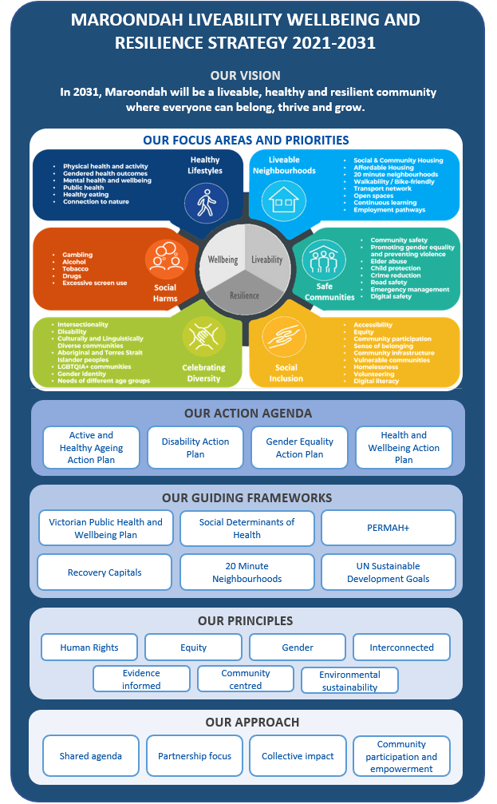
Figure 1. Maroondah Liveability, Wellbeing and Resilience Strategy 2021-2031 Framework

Background

Our city

The City of Maroondah covers a land area of 61.4 square kilometres in Melbourne’s outer east, 22 kilometres from the Central Business District. The area is a substantially urban residential municipality, with an estimated population of 119,401 residents and 47,021 households with an average of 2.54 people per household.

The first settlers to the area prior to European colonisation were the Wurundjeri People of the
Kulin nation approximately 60,000 years ago. The Wurundjeri People have a deep spiritual connection to the land and a unique ability to care for Country.

The City of Maroondah includes the suburbs of Bayswater North, Croydon, Croydon Hills, Croydon North, Croydon South, Heathmont, Kilsyth South, Ringwood, Ringwood East, Ringwood North and Warranwood.
The City also includes small sections of Kilsyth, Park Orchards, Vermont and Wonga Park.

Maroondah has four activity centres at Croydon, Ringwood, Heathmont and Ringwood East. Ringwood is one of the largest in Melbourne. In addition, a range of key service and retail precincts are clustered along the Maroondah Highway corridor and 31 neighbourhood, community and local shopping centres are spread throughout the municipality.

Almost 9,700 businesses operate within the City, with over 97% of these being small businesses
employing less than 20 people. The majority of businesses are in the construction, property and business
services; finance and insurance; retail trade; and manufacturing sectors.

Compared with metropolitan Melbourne, Maroondah has a slightly higher proportion of residents aged 50 and over and a lower proportion of residents aged between 20 to 34 years. Maroondah is an increasingly culturally and linguistically diverse community. Nearly one in four Maroondah residents were born overseas. The most common countries of birth for overseas residents are England, China, India, Myanmar and New Zealand.

With little remaining land available for greenfield residential development, future population growth will be mainly stimulated by housing consolidation.

Maroondah has the strategic advantage of being located at the north-eastern junction of the Eastern Freeway - EastLink corridor. There are two train lines and a large number of bus routes linking the City with other regions. Our sustainable transport links continue to expand, with on-road cycling paths and 40km of shared trails, including the Mullum Mullum Creek Trail, the EastLink Trail, the Tarralla Creek Trail and the Dandenong Creek Trail.

Strategic context

About the Maroondah Liveability Wellbeing and Resilience Strategy

The Maroondah Liveability Wellbeing and Resilience Strategy 2021-2031 is a long term strategic plan that holistically outlines a vision for the future social environment of the municipality supporting the desired outcomes and key directions within Maroondah 2040: Our future together. Through this Strategy and supporting action plans, Council and its partners will continue to strive towards enhancing the liveability, wellbeing and resilience of our community.

The Strategy, along with the supporting Health and Wellbeing Action Plan 2021-2023 is also a statutory document that has been prepared in accordance with requirements set out in the Public Health and Wellbeing Act 2008 (the Act). This Act requires Council to prepare a health and wellbeing planning document every four years, within 12 months of general council elections.

The Act requires that this document describes how Council and its partners will work towards achieving maximum health and wellbeing for our community over the next four years.

The Act requires that the plan must:
- Include an examination of the data about health status and health determinants in the municipal district.
- Identify goals and strategies based on evidence for creating a local community in which people can achieve maximum health.
- Provide for involvement of people in the local community in the development, implementation and evaluation of the public health plan.
- Specify how Council will work in partnership with the Department of Health and other agencies undertaking public health initiatives, projects, and programs to achieve the goals identified in the plan.
- Be consistent with the Council Plan and the Municipal Strategic Statement.

The Maroondah Liveability Wellbeing and Resilience Strategy 2021-2031, along with the supporting Health and Wellbeing Action Plan 2021-2023 meet these statutory requirements and replace the previous Maroondah Health and Wellbeing Plan 2017-2021.

What we mean by community wellbeing, liveability and resilience

A key purpose of this key social environment strategy is to integrate and align the broad domains of community health, wellbeing, liveability and resilience. Whilst historical health planning in local government has focused primarily on the social determinants of health, it is increasingly recognised that wellbeing, liveability and resilience all play key interrelated roles in enabling people to live their best lives.

Wellbeing

Wellbeing is a concept that encompasses how social, economic, environmental, cultural, and political conditions are key for people to flourish and fulfil their potential. Whilst there are many definitions and models of wellbeing, the World Health Organisation (WHO) considers wellbeing as a state in which every individual realizes their potential, can cope with normal stresses of life, can work productively and fruitfully and is able to make a contribution to their community.

Wellbeing has been measured both subjectively and objectively. Subjective wellbeing is based on how an individual evaluates their life and is determined by their measurement of domains such as standard of living, personal health, achievements in life, personal relationships, personal safety, community connectedness, future security, and spirituality/religion. Objective wellbeing focuses more on measuring the observable conditions that affect an individual’s life such as life expectancy, income, nutrition, employment, education and democratic participation.

Wellbeing can be considered a state of equilibrium that balances physical wellbeing, resources, psychological wellbeing, good relationships, and freedom and effectiveness in action. This ‘state of equilibrium’ or balance can be affected by life events and challenges. Stable wellbeing is achieved when individuals have the psychological, social and physical resources they need to meet a particular psychological, social and/or physical challenge. In more recent years, wellbeing has been considered and measured across age group cohorts, different geographic scales and population groups.

Council’s background research, data analysis and community engagement highlighted five key wellbeing areas of focus in Maroondah: community safety, healthy lifestyles, social inclusive communities, open space, and environmental sustainability.

Liveability

Liveability links the importance of place to community health and wellbeing, sustainability and productivity through consideration of how natural and built environments, including availability and access to amenities, can support people living their best life. The concept of ‘liveability’ is experienced differently by various population groups and liveability varies over time. At an individual level, liveability can be the extent to which we enjoy the quality of life afforded by the place we reside; whilst at a community level it can reflect the degree to which a city offers the opportunities or groups to enjoy its attributes.

Council’s research for this Strategy has identified the key factors that contribute to the liveability of a community. These include: the shared physical features of the natural built and economic environment; the availability of healthy environments for home, work and play; the services provided to support people in their daily lives; the socio-cultural features of a place including social cohesion and safety; and the perceived reputation of an area. Examples of key contributors to community liveability include: employment, food, housing, public open space, transport, walkability, and social infrastructure.

The liveability of a place contributes to the desirability and attractiveness of that place and has both a direct and indirect influence on community health and wellbeing. Liveable communities create conditions that can optimise health and wellbeing outcomes for people by influencing the social determinants of health. The Australian Prevention Partnership Centre identifies the following domains of liveability that contribute to the health and wellbeing of a community: crime and safety; education; employment and income; health and social services; housing; leisure and culture; local food and other goods; natural environments; public open space; transport; and social cohesion and local democracy.

Examples include the provision of supportive infrastructure; creating a ‘sense of community’ and social support; reducing crime rates and fear of crime; facilitating education opportunities and providing access to open space.

Council’s background research, data analysis and community engagement highlighted six key liveability areas of focus for Maroondah: alcohol environments, food environments, community connectedness, employment, open space and housing.

Resilience

Resilience is a concept that has emerged increasingly over the last decade to describe a desired state to cope effectively with challenging events for individuals, households, communities and organisations. Individual resilience refers to the ability to cope with whatever life throws at you; whilst collective community resilience relates to how you can adapt, survive and thrive no matter what kind of chronic stresses and acute shocks are experienced.

Resilience is a concept that can help us to understand how people and communities cope in the face of change and uncertainty. It is referred to as a strength or quality that can be learned and developed in order to respond or behave in a certain way. It can be measured against seven community resilience characteristics of being: safe and well; connected, included and empowered; a dynamic and diverse local economy; sustainable built and natural environment, culturally rich and vibrant; democratic and engaged; and reflective and aware. Communities that are resilient typically have a strong economy, good access to services and infrastructure, ample quality open space environments, low rates of crime, positive social interaction and inclusion, strong institutions and governance, and positive leadership.

Resilience can be built by reducing vulnerability and exposure, and empowering people so they are resourced and enabled. Strengthening our wellbeing (e.g. physical and mental health), connection (e.g. personal networks and relationships to the neighbourhood), knowledge (e.g. local and shared knowledge) and security (e.g. adequate shelter and personal safety) can increase our resilience.

Council’s background research, data analysis and community engagement highlighted a broad range of social, built, natural and economic environment areas of focus to enhance community resilience in Maroondah. Some examples include: ensuring construction is well designed and accessible; maintaining opportunities for social inclusion and connection; and nurturing vibrant local businesses.

Relationship between wellbeing, liveability and resilience

The three concepts of wellbeing, liveability and resilience are heavily inter-related with interventions or issues in one area having corresponding impacts on the others.

For the purpose of this strategy:
- Wellbeing is considered to have a more individual focus on physical, mental and emotional health with an emphasis on how we as people respond to external influences on our lives;
- Liveability is a more outwardly focused way of considering how we collectively relate to our physical and social spaces where we live; and
- Resilience-building is the process of developing both wellbeing and liveability, and therefore becoming more adaptable to our changing lives and world

The role of local government in facilitating community wellbeing, liveability and resilience

Local government is uniquely placed and plays a particularly important role in enhancing community health and wellbeing, liveability and resilience.

Historically local governments have had responsibility for delivering community services such as immunisation, early years and childcare services, youth and aged care services; regulating behaviour in public places and the handling of food; disposing of waste; building community facilities; and maintaining our public places and spaces.

These roles are increasingly more dynamic and require Councils to work collaboratively with partner agencies to collectively shape community wellbeing, liveability and resilience at individual, neighbourhood, municipal and regional levels.

Through integrated strategic planning, agile and responsive service delivery; building partnerships with local stakeholders; and empowering community members; local government can work to build social capital, create community capacity, address the social determinants of health, and enhance the places and spaces where people live work and play.

In accordance with the Public Health and Wellbeing Act 2008, the function of local government, in regard to health and wellbeing, is to seek to protect, improve and promote public health and wellbeing within a municipality by:
- Creating an environment which supports the health of members of the local community and strengthens the capacity of the community and individuals to achieve better health initiating, supporting and managing public health planning processes at the local government level
- Developing and implementing public health policies and programs within the municipal district
- Developing and enforcing up-to-date public health standards and intervening if the health of people within the municipal district is affected
- Facilitating and supporting local agencies whose work has an impact on public health and wellbeing to improve public health and wellbeing in the local community
- Coordinating and providing immunisation services to children living or being educated within the municipal district
- Ensuring that the municipal district is maintained in a clean and sanitary condition.

A snapshot of just some of the services provided by Council to facilitate and enhance community wellbeing, liveability and resilience are highlighted in the table below:

Wellbeing | Liveability | Resilience
- Providing access to sport and recreation facilities  - Delivering maternal and child health services  - Enabling early childhood education  - Providing services to aged and vulnerable residents through the Commonwealth Home Support Program  - Empowering and supporting youth and young adults  - Supporting vulnerable residents  - Promoting lifelong learning and social connection through community houses | - Enhancing and maintaining open space, bushland and reserves  - Providing and enhancing shared trails, footpaths and roads  - Planning for changes to land use  - Promoting and activating 20 minute neighbourhoods  - Supporting local businesses and shopping strips  - Facilitating community gardens  - Providing public art, access to galleries and community involvement in cultural activities  - Encouraging connection to indigenous culture | - Leading emergency management response, relief and recovery  - Providing community grants to support local groups and organisations  - Mitigating and adapting to the impacts of climate change  - Planning for the future housing needs of the community  - Ensuring a financially sustainable approach to service delivery

Guiding principles

In framing the Liveability Wellbeing and Resilience Strategy 2021-2031, the following guiding principles provide core underpinning values that guide future action, service delivery and decision-making.

Human Rights - Council recognises and protects the rights, interests and responsibilities of individuals, the community, and public bodies across the City of Maroondah in accordance with the Victorian Charter of Human Rights and Responsibilities. The Charter contains 20 basic rights that promote and protect the values of freedom, respect, equality and dignity. All of Council’s strategies, policies and decision-making procedures are compatible with the Victorian Charter, which reflects the United Nations Universal Declaration of Human Rights. Council aims to ensure that it pursues a human rights approach across all areas of Council activity.

Equity - is the process required to achieve equality, where everyone is treated the same or has the same life opportunities. We must first ensure equity before we can enjoy equality, which only works if everyone starts from the same place. By taking an equity stance, Council recognises that affirmative measures must be put in place for people of all ages, abilities and backgrounds, to overcome structural barriers and discrimination that prevent inclusion, participation and access to resources and opportunities.

Gender - Council recognises that within all communities, women, men and gender diverse people have different needs, benefits, access to power, resources and responsibilities. Council is committed to gender equity, that is, is the process of being fair to women, men and gender diverse individuals by recognising diversity and disadvantage and directing resources and services towards those most in need to ensure equal outcomes for all.

Evidence informed - Council is committed to using evidence to design, implement and improve planning, programs and service delivery. Learning from the successes and failures of previous actions and programs increases understanding of best practice. Evidence helps us to best meet the needs of our community, best focus our resources, choose the most effective approaches, continuously improve our efforts and services and provide successful and positive outcomes for our community.

Community engagement - Council is committed to engaging with the Maroondah community in a meaningful, accountable, responsive and equitable way. Our community and stakeholders play a vital role in shaping the City of Maroondah. Through community engagement, Council gains a strong understanding of our community’s wants and needs to ensure we are achieving the best possible outcomes for our community.

Environment sustainability - Council understands that environmental sustainability and the impacts of climate change are closely related to community health and wellbeing. The importance of building resilience in communities to reduce climate change impacts is particularly important.

Interconnected - It is recognised at the outset that all of the focus areas, topics, population groups and issues considered by this Strategy are interconnected, interdependent and have complex relationships with each other. The six focus areas identified in this Strategy are strongly interconnected and impact each on other. For example, Safe Communities influence Liveable Neighbourhoods, both of which can facilitate Healthy Lifestyles. Within each of the six focus areas, there are key topics. These also have strong connections and influence each other. For example, research demonstrates that problem gambling (topic area within Social Harms) is associated with family violence (topic area within Safe Communities).

Guiding frameworks

Throughout the development of this Maroondah Liveability, Wellbeing and Resilience Strategy 2021-2031, several frameworks have been drawn upon and help to shape the approach to enhancing liveability, wellbeing and resilience outcomes in the municipality. These include United Nations Sustainable Development Goals, Victorian Health and Wellbeing Plan 2019-2023, PERMA+ and Social Determinants of Health. Several frameworks have been drawn upon as no single framework includes and addresses all aspects of the Maroondah Liveability, Wellbeing and Resilience Strategy 2021-2031.

United Nations Sustainable Development Goals
These Sustainable Development Goals reflect an international call for action by all countries to promote prosperity while protecting the planet. They recognise that ending poverty must go hand-in-hand with strategies that build economic growth and address a range of social needs including education, health, social protection, and job opportunities, while tackling climate change and environmental protection.

This Framework plays a key role in a range of Council strategies including efforts to promote sustainability and action on climate change.

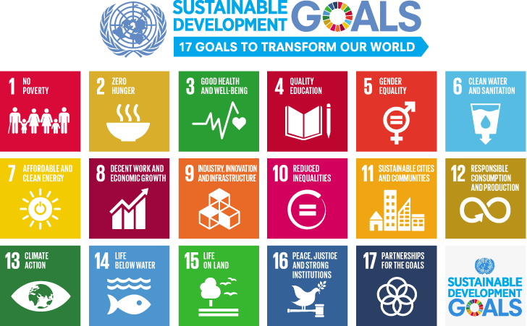

Figure 2. United Nations Sustainable Development Goals

Social determinants of health
The social conditions in which people are born, live and work are considered to be the single most important determinant of good health or ill health. The health advantages and disadvantages experienced by people are shaped by their broader social and economic conditions. The Framework suggests that inequalities in health appear in the form of a ‘social gradient of health’ that relates a person’s socioeconomic position to their overall health and wellbeing outcomes.
Factors such as income, education, conditions of employment, power and social support act to strengthen or undermine the health of individuals and communities. Because of their potent and underlying effects, these health-determining factors are known as the ‘social determinants of health’. The World Health Organisation (WHO) has described social determinants as the circumstances in which people grow, live, work, and age, and the systems put in place to deal with illness. The conditions in which people live and die are, in turn, shaped by political, social, and economic forces.
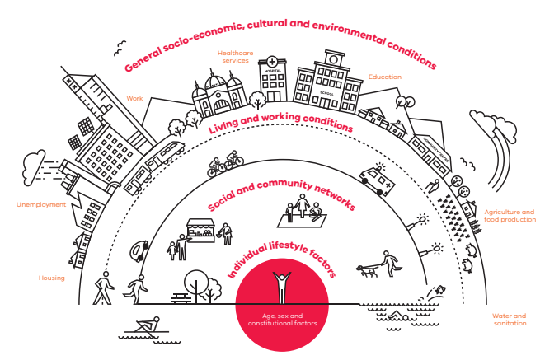
Figure 3. Social determinants model of health

PERMA+
Whilst the identification and treatment of mental health problems is critically important for those facing mental illness, it provides an incomplete picture of mental health. Positive psychology is a complementary approach that shifts the focus from what is clinically wrong, to the promotion of wellbeing and the creation of a satisfying life filled with meaning, pleasure, engagement, positive relationships, accomplishment and health. Positive Psychology is the scientific study of human flourishing, and an applied approach to optimal functioning. It has also been defined as the study of the strengths and virtues that enable individuals, communities and organisations to thrive.

The components of PERMA+ (Positive Emotion, Engagement, Relationships, Meaning, and Accomplishment PLUS Optimism, Physical Activity, Nutrition, and Sleep) provide a framework to understand and cultivate wellbeing. When introduced effectively, positive psychology provides strong scientific evidence about what works to improve well-being at both an individual and community level.

The PERMA+ model has been central to Council’s partnership with Communities of Wellbeing Inc. over recent years. Established in 2015 in response to the Maroondah 2040 Community Vision, Communities of Wellbeing Inc works with local stakeholders across a range of settings to build capability, wellbeing literacy and social connections to enable communities to flourish. Communities of Wellbeing Inc. works across five key areas of impact in Maroondah: home and family life, financial life, learning and education, work life, and social and public life. One key area of impact has involved the Maroondah Positive Education Network which has seen teachers and students embed wellbeing into the curriculum and culture of local schools.

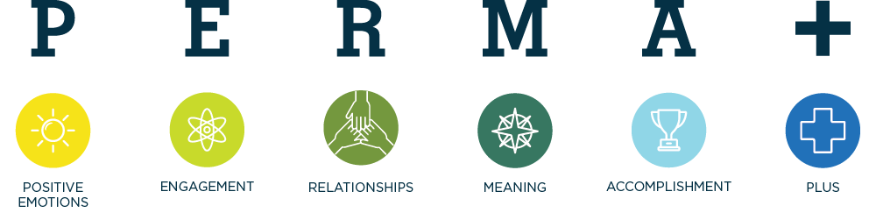

Figure 4. PERMA+ model

Recovery Capitals Framework
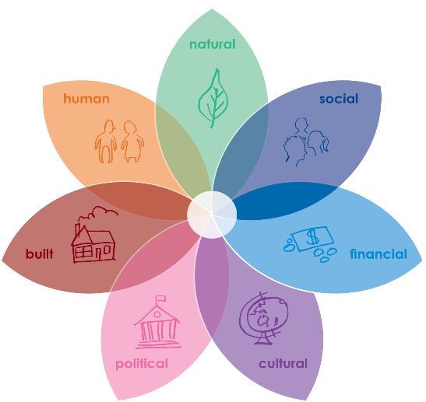
The Recovery Capitals Framework is recovery focussed. The concept of ‘capitals’ illustrates the ways that many factors interact and influence recovery from disasters, and how resources and strengths already existing in our community, can be identified and drawn upon to support community wellbeing. It helps us to identify the aspects of community life that are strong, and that when mobilised and developed can strengthen individual and community wellbeing.

As a holistic approach, the Recovery Capitals Framework is central to Council’s community recovery approach, forming the basis for the Maroondah COVID-19 Recovery Plan, adopted in March 2021. This Plan highlights the key activities and adjusted services being delivered by Council in partnership with the community to support community recovery from the global coronavirus (COVID-19) pandemic.
Figure 5. Recovery Capitals - Supporting wellbeing after disasters

20-Minute Neighbourhoods
Plan Melbourne 2017-2050 is a long-term Victorian Government planning document to accommodate Melbourne’s future growth in population. The 20-minute neighbourhood concept is a key element of the Plan. The 20-Minute Neighbourhood is all about ‘living locally’ - giving people the ability to meet most of their daily needs within a 20-minute return walk from home, with access to safe cycling and local transport options. Liveable communities should have access to the features shown in Figure 5.

Council has embraced the concept of 20-Minute Neighbourhoods with the support of Victorian Government funding through staged implementation in the Croydon South neighbourhood activity centre. It is envisaged the model will inform Council’s community, asset, infrastructure, landuse and recreation planning into the future.
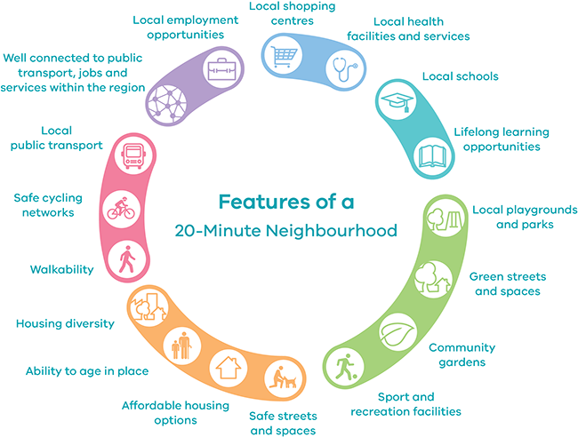

Figure 6. Features of a 20-minute Neighbourhood

Victorian Public Health and Wellbeing Plan 2019-2023
In Victoria, the Public Health and Wellbeing Act 2008 gives state and local government specific responsibilities to plan for and contribute to protecting and improving health and wellbeing. The Act requires a State public health and wellbeing plan and municipal public health and wellbeing plans to be prepared sequentially every four years. These plans inform each other and provide the basis for an integrated planning approach in Victoria.
The Victorian Public Health and Wellbeing Plan 2019-2023 identified ten priority areas with four of these as key focus areas. The four key focus areas are tackling climate change and its impact on health, increasing healthy eating, increasing active living and reducing tobacco-related harm. The remaining six priority areas are reducing injury in the community, preventing all forms of violence, decreasing the risk of drug-resistant infections in the community, improving mental wellbeing, improving sexual and reproductive health as well as reducing harmful alcohol and drug use. The Plan recognises key links between a number of these priority areas, including recognition that many actions to increase active living and healthy eating can contribute to reducing climate change.
Where relevant to its role and local community needs, Council will seek to work in partnership with other agencies to support the areas of priority and focus highlighted in the Victorian Public Health and Wellbeing Plan 2019-2023.
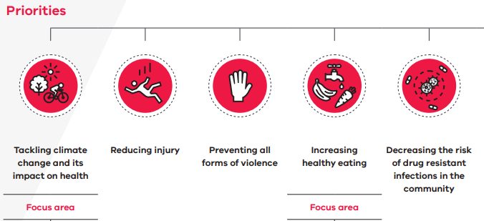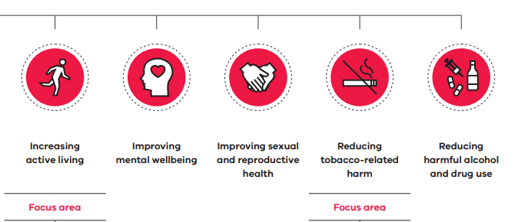
Figure 7. Victorian Public Health and Wellbeing Plan 2019-2023 priorities

Developing the strategy
The Maroondah Liveability Wellbeing and Resilience Strategy 2021-2031 was developed on the basis of considerable background research and accompanying analysis as well as engagement input from Maroondah community members, local partners and agencies. This involved a number of stages:

Stage 1 - Seeking input from the Maroondah community and stakeholders
The first stage involved a range of community engagement activities to seek the views of community members and key stakeholders on community health, wellbeing and liveability needs and aspirations in Maroondah. This included consideration of how Council and its partners could leverage strengths, address issues, and work in partnership to enhance outcomes for the community.

Stage 2 – Building an evidence base
Concurrently with Stage 1, Council prepared a number of background research reports designed to build an evidence base to support strategy actions. These activities included the development of an Issues Papers on key health and wellbeing matters, Outcome Papers on wellbeing, liveability and resilience and a Social Profile of the Maroondah community.

Stage 3 - Adjustment to consider the COVID-19 pandemic
The presence of coronavirus (COVID-19) pandemic was first confirmed in Australia in late January 2020.The onset of this pandemic in Australia resulted in considerable challenges for the Maroondah community. A rise in cases, a declared State of Emergency and subsequent staged restrictions disrupted our social infrastructure, economic livelihoods, normal routines and community activities.

Whilst this stage of the project was unplanned, it has helped to significantly shape the key directions of the Strategy, embed resilience as a key pillar of focus, and identify short-medium term priorities to support community recovery from the impacts of coronavirus (COVID-19) pandemic in Maroondah.

Stage 4 - Consideration of issues and options
During this phase, Council distilled the key messages and priorities arising from the background research, community engagement and coronavirus (COVID-19) pandemic inputs to identify key themes and future strategic directions to be included in the Strategy.

Stage 5 - Development of the Strategy
The draft Strategy was prepared based on the strategic framework established during Stage 4 and the identified priorities for future action and partnership work. Following development of the draft Strategy, it was released to the Maroondah community for public exhibition and community feedback.

Stage 6 - Adoption of the Strategy
Following consideration of feedback received during the public exhibition phase, the final Maroondah Liveability Wellbeing and Resilience Strategy will be presented for Council adoption, sent to the Victorian Government in accordance with requirements of the Public Health and Wellbeing Act 2008.

Stage 7 - Implementation of the Strategy
This stage involves implementing the key directions in the Strategy and the actions included in associated action plans, many of which involve partnerships and collaboration with other community service organisations, agencies and local groups, along with other levels of government. A report on implementation activities will be presented to Council on an annual basis.

What the evidence tells us

This section provides a summary of the evidence base gathered by Council to inform the strategy development process. More detail on the background research is provided in Background Report - Liveability, Wellbeing and Resilience in Maroondah - July 2021. Where comparative data is available, Maroondah has often been compared with averages for either Victoria, Metropolitan Melbourne or the Eastern Metropolitan Region (EMR). The EMR consists of seven eastern metropolitan Melbourne Councils: Boroondara, Knox, Manningham, Maroondah, Monash, Whitehorse and Yarra Ranges.

Healthy lifestyles

Healthy lifestyles play an important part in our wellbeing. They refer to positive outcomes achieved through our decision making, choices, participation and behaviours. When we focus on our holistic health, we reduce the risk of chronic illness and disease and improve our overall physical and mental wellbeing. Healthy lifestyles can help to improve happiness and satisfaction in our lives, reduce our risk of chronic illness and disease, improve our life expectancy and assist with maintaining good mental health. Healthy lifestyles are directly influenced by our physical health, personal and mental wellbeing, activity and social interaction, along with consumption of food and drinks. ​Our personal wellbeing, and the choices we make, can improve or lower our physical health, mental health, eating behaviours and overall public health.

Our health is dependent on the health of our environment. Spending time in nature has been shown to have many positive effects on physical, social and mental health. Visual and physical contact with nature helps reduce stress, anxiety, blood pressure and muscle tension and improves self-esteem. However, our changing climate has significant consequences for the environment and for public health, wellbeing and safety. The direct and indirect impacts of climate change are exacerbating existing public health risks and presenting a high risk to human health. At present, drug resistant infections also known as antimicrobial resistance (AMR), are a major public health issue. AMR is the ability of certain bacteria, viruses and some parasites to develop resistance to antimicrobial medication making a disease or infection difficult to treat. The outcomes of AMR have serious health impacts on an individual including prolonged ill health, poorer quality of life and higher risk of spreading illness.

An individual’s physical health has a significant impact on their mental health, general health and overall wellbeing. Benefits from physical activity can include increased energy levels, facilitated social contact, improved mental health and wellbeing, improved musculoskeletal health and reduced risk of developing Type 2 diabetes, cancer and cardiovascular disease. However, 42% of Maroondah residents are not meeting daily physical activity guidelines. Healthy eating also plays an important contributing factor to an individual’s health and wellbeing. Only 5% of Maroondah residents met vegetable daily consumption guidelines and 13% consume sugar-sweetened soft drinks daily. These findings could contribute to Maroondah’s obesity rates, with 62% of men and 43% of women being overweight or obese.

The importance of recognising and responding to the differences in gendered health outcomes is identified nationally. Men die at younger ages than females, in greater numbers from almost every type of non-gender specific health problem and more often die from suicide and preventable causes. Intimate partner violence is the leading cause of death, disability and illness in Australian women aged 18-44 years. Women are overrepresented in incontinence and dementia. Mental health and general physical health are poorer for Victorian LGBTIQA+ adults compared with non-LGBTIQ+ adults, with higher rates of multiple chronic illnesses, smoking daily, psychological distress as well as anxiety or depression.

Nearly half of all Australians will develop a mental illness at some point in their lives. Poor mental health typically presents a significant impact on the health, wellbeing and resilience of an individual and community resulting in an increased risk of mental and chronic illness. There is a strong association between mental and physical health, as well as the use of alcohol, tobacco and illicit drugs and mental illnesses. In Maroondah, males are less likely to have sought professional help for a mental health problem (7%), compared to females (22%). Comparative statistics for males in the outer east metropolitan area are 16% and 14% for males in Victoria.

Whilst the identification and treatment of mental health problems is critically important for those facing mental illness, positive psychology is an approach that shifts the focus to the promotion of mental wellbeing. Research has shown that there are some preventative strategies and skills that allow people to navigate the challenges of life more effectively and enjoy life despite the upsets. Participating in arts and cultural activities also has multiple benefits for health and wellbeing including strengthening community connection, reducing social isolation, providing platforms for less prominent voices, and opportunities for bringing people together to develop creative solutions to health promotion challenges.

Liveable neighbourhoods

Liveable neighbourhoods can shape the way we live, feel, enjoy and experience our community and are important for health and wellbeing. Liveable neighbourhoods are safe, attractive, socially inclusive and environmentally sustainable. Key elements of a liveable neighbourhood include: affordable and diverse housing, employment, education, public open space, vibrant local activity centres, health and community services, leisure and cultural opportunities, convenient public transport, along with walking and cycling infrastructure. 20-Minute Neighbourhoods are about ‘living locally’ - giving people the ability to meet most of their everyday needs within a 20-minute walk from home, with access to safe cycling and local public transport options. Features of 20-Minute Neighbourhoods include local health facilities and schools, employment opportunities, green streets and spaces and affordable housing options. Local neighbourhood design influences physical activity, health outcomes, social connectedness and sustainability.

Protection and enjoyment of our natural environment is directly linked to health and wellbeing outcomes, with the direct and indirect impacts of climate change having a significant role. Open space is a vital component of liveability, providing opportunities to enhance health and wellbeing through exercise, recreation, reflection and connection with nature, family and friends. Living within walking distance of parks and green public open space is linked to greater use of these areas and positive health outcomes. 72% of Maroondah dwellings are estimated to be within 400 metres of public open space, which is higher than both Knox (69%) and Yarra Ranges (53%).
Access to a transport network is also key for liveability and reduces private vehicle use, road congestion and car emissions. Using public transport encourages active transport, which involves walking, cycling, scooting or other active ways of getting to a destination. Active travel has strong connections to health outcomes. People who live within 400m of public transport are more likely to use it, and in turn achieve daily recommended exercise targets. An estimated 49% of dwellings in Maroondah are located within 400 metres of regular public transport, compared to 38% in Knox and 13% in Yarra Ranges. However, the use of public transport is also influenced by comfort, cost, as well as service route and frequency.

Two-thirds (67%) of working Australians experienced a change to their employment due to the coronavirus (COVID-19) pandemic. Women have been significantly impacted by the pandemic, experiencing a higher number of job losses and taking on additional carer and home-schooling responsibilities. Employment loss and increases in unemployment was greatest for those aged 20-34 years. Working arrangements have also been significantly affected during the coronavirus (COVID-19) pandemic, with working from home the most significant change to employment patterns. Research has indicated it could up to ten years of public transport use to return to pre-COVID-19 levels. Maroondah working residents primarily commuted to work in 2016 by driving themselves (67%) and catching the train (11%). 1 in 4 both lived and worked in Maroondah. With the changes arising from the coronavirus (COVID-19) pandemic, the results from the Census 2021 are expected to illustrate that more people now work from home, and live and work locally.

Continuous learning, also referred to as life-long learning, has been defined as all purposeful, planned education, formal or informal, from early childhood to old age. For a community to embrace and practice continuous learning; new skills, knowledge and understanding is sought through proactive learning via different methods for all people, at all ages. Learning across the lifespan in Maroondah is supported by childcare and early education centres, kindergartens, government and non-government schools at both primary and secondary levels, trade and higher education offered by Swinburne University, Maroondah’s five community houses/centres, and two U3A centres.

A lack of affordable housing can have a detrimental impact on liveability, affordability, homelessness and wellbeing. Private rental affordability rates in Maroondah have declined from 27% in 2000 to just 3% in 2020. In 2016, 1 in 10 Maroondah households were experiencing housing stress, spending more than 30% of their gross household income on rent or mortgage repayments. Higher proportions of housing stress were found in the Ringwood Metropolitan Activity Centre (20%) and Croydon Major Activity Centre (18%). Affordability is also influenced by housing diversity. A diverse range of housing which leads to varying prices can enable affordability, support community members to age in place within their local community and provide for all life stages, income levels and population groups. Single person households are projected to grow at nearly three times the rate of other households in Maroondah over the next 20 years. This will result in a greater need for diverse housing options in new developments.

Social housing represents a subset of affordable housing and is owned by the Victorian Government or registered not-for-profit community housing providers and is permanently dedicated to affordable rental. Maroondah has been identified as needing a greater supply of social housing with very high waiting lists in place. Maroondah’s level of social housing stock is 2.5%, far below the 5% average across Victorian and well below the 10% target.

Safe communities

Safety is a fundamental component of wellbeing, liveability and resilience. The degree to which someone feels safe within a home, workplace or community has a significant impact on how and where they live, work and play. Feeling safe and secure within a home, neighbourhood, workplace and community can affect one’s sense of freedom, levels of stress and overall mental health, physical health, trust, social habits and lifestyle behaviours, social connections, work and study productivity, and participation in leisure, community and physical activities.

Emergency management assists the community to prepare for, respond to, and recover from emergency events. Preparedness focuses on ensuring the local community are aware of their risks and the potential consequences of a resulting emergency event, and to inform and equip them with tools to implement resilience strategies for their homes and families. Climate change has caused more frequent and intense extreme weather events such as bushfires and floods, and significant impacts from more gradual changes. The greatest related risks to Maroondah include: heatwaves, floods, storms, bushfires, gas and electricity service disruptions, residential fires, and epidemics / pandemics. The impact of extreme weather events has been significantly exacerbated by the coronavirus (COVID-19) pandemic with additional strain placed on emergency relief and recovery systems. Vulnerable groups, including the elderly, children, people on low incomes, people experiencing homelessness, recent arrivals and those with pre-existing medical conditions, are disproportionately affected by the impacts of climate change.

A community’s perception of safety will influence how people go about their daily lives and how they engage within their local community. ​A sense of safety and security is strongly influenced by factors including vandalism and cleanliness, surveillance and lighting, human presence and activity, public and open spaces, finance and job security as well as social and anti-social behaviours. Principles for safer design include: maximising visibility and natural surveillance of the public environment, maximising activity in public spaces, and managing public spaces to ensure they are attractive and well used.

Road safety and crime rates also have a significant influence on community safety and perceptions of safety. The harm associated with crime includes economic loss, physical and psychological injury and distress, as well as trauma and grief. In 2020, Maroondah crime rates were lower than the Victorian rate (4826.4 per 100,000, compared to 6019.7). Most incidents occurred in Ringwood and Croydon, and the major locations where incidents occurred were in homes and streets / lanes / footpaths. In 2019, 266 people lost their lives on Victoria’s roads, around 8,000 Victorians were hospitalised with serious injuries and 12,000 were injured. Survivors and families affected by road crashes have a range of physical, psychological and legal needs. Road safety can be improved through safer vehicles, safer travel speeds, infrastructure improvements, innovation and technology as well as education programs.

Family, domestic and sexual violence are all major health and welfare issues that stem from a range of underlying issues, often centred around gender inequality. Since the age of 15, one in three (34%) Australian women has experienced physical and/or sexual violence perpetrated by a man. On average in Australia, one woman a week is murdered by her current or former partner. Maroondah has the equal second highest rate of family violence incidents in the EMR. During the coronavirus (COVID-19) pandemic, research and agency reports revealed an increased risk of violence against women in current domestic relationships.

To protect children from harm, Victorian organisations that provide services or facilities for children are required by law to implement Child Safe Standards. These aim to promote the safety of children, prevent child abuse and ensure organisations and businesses have effective processes in place to respond to and report all allegations of child abuse. Older Australians are also at risk of abuse. Elder abuse often occurs via family members, friends or professionals who are known by the victim. It has physical and psychological effects, including anxiety, loneliness and loss of dignity, trust and hope. Elder abuse is under-reported, as victims may fear retaliation, shame or embarrassment, or have mental incapacity.

Safety extends to staying safe online. There are a range of harms that are associated with the internet such as online harmful sexual behaviours, sextortion, cyber bullying, unwanted or unsafe contact, fake news, illegal content, harmful interactions or influences on social media, and online scams. Digital safety involves building community awareness to ensure individuals are protecting themselves and others from online harms and risks which may jeopardise their personal information, lead to unsafe communications or impact their mental health and wellbeing.

Social Inclusion

A socially inclusive community enables all members of the community to fully participate and contribute to social, economic and cultural life in a welcoming and safe manner. Being socially included means that people have the resources, opportunities and capabilities they need to participate in education and training (learn); participate in employment, unpaid or voluntary work including family and carer responsibilities (work); connect with people, use local services and participate in local, cultural, civic and recreational activities (engage); and influence decisions that affect them (have a voice). Being socially inclusive is about the deliberate actions taken to remove or reduce barriers to inclusion and to create opportunities that facilitate and encourage full participation.

Research has found that social connection and participation can assist with good mental health, reduce psychological distress and help to maintain overall health and wellbeing. Those people who are living alone, not in a relationship, are young adults and/or males tend to report higher levels of loneliness. Recently separated men experience higher levels of loneliness than married men, and single parents also experience higher levels of loneliness than singles adults without children, or couples with or without children. Lone person households comprise one in four Maroondah households (23%) and one parent families make up 11%.

People have a strong desire to belong and social connection and belonging is necessary for our survival. Belonging comes from a perception of quality, meaning and satisfaction with social connections. Belonging is essential for our psychological and physical health and can play a role in the way we think and interact with the world. Community connection occurs when individuals are connected with, contribute to, feel included in and valued by their community beyond their family and friends. An important aspect of this relationship is reciprocity, where people both give to and receive from the community. Volunteering provides an opportunity for new social experiences and connections, and the opportunity to practice and develop social skills. Research shows volunteering can promote better physical and mental health. Volunteering is also an important pathway to employment and can provide the opportunity to gain work experience, transferable skills and build professional networks. Well located, activated and fit-for-purpose community infrastructure can provide the spaces and places for people to connect and belong.

Certain population groups such as people with a disability, women, and people from low socioeconomic groups are differently impacted by societal norms, practices and structures. Equality means everyone is treated the same or has the same life opportunities. However, equality can only be achieved if people start from the same position. Equity is the process required to achieve equality, by ensuring affirmative measures are put in place to overcome structural barriers and discrimination that prevent inclusion, participation and access to resources and opportunities.

Homelessness goes beyond ‘rooflessness’ and includes vulnerable people living in refuges, crisis accommodation or in temporary housing. Homelessness can be the result of limited access to affordable and available housing, lack of adequate income, family and domestic violence, mental health, disability, trauma, and substance misuse. The most recent data indicates that the highest number of homeless persons in Maroondah are in suburbs of Ringwood, Ringwood East and Croydon.

Contact between people of different groups is important for building social inclusion. Vulnerable groups in Australia’s population, routinely experience forms of discrimination and exclusion as they go about their daily lives. Research shows that prejudice in Australia has been generally highest against religious minorities, racial minorities, Aboriginal and Torres Strait Islander people, and the LGBTIQ+ community. One in five (20%) Australians report having experienced a major form of discrimination in the last 2 years. The groups that report experiencing the most discrimination are young people (aged 18 to 24), Aboriginal and Torres Strait Islander Australians, LGBTIQ+ people, religious minorities, and people with disability.

Accessibility refers to providing an individual ability to access a place or type of infrastructure, providing mobility access to people with disability, enabling people to engage or fully participate in community activities, supporting engagement in the digital environment, and empowering people to achieve their full potential. Accessibility minimises inequalities, promotes social participation and helps in achieving social inclusion through greater equity, fairness and justice. Digital literacy means having the skills you need to live, learn, and work in a society where communication and access to information is increasingly through digital technologies. Australians with lower levels of income, employment, and education are significantly less digitally included. Low levels of digital inclusion for older Australians increase the risks of social isolation and loneliness. Older people, families without adequate internet access, and vulnerable Australians have been especially isolated during the coronavirus (COVID-19) pandemic through lack of digital access, affordability and ability.

Embracing diversity

Diversity plays a major contributing factor on liveability, health, and wellbeing. Diversity can be defined as understanding what makes each person unique. Diversity relates to different characteristics that can include race, ethnicity, gender, sexual orientation, socio-economic status, age, physical abilities, religious beliefs, or other ideologies. Embracing diversity is the exploration and respect of these differences in a safe, positive, and fostering environment, moving beyond simple tolerance and embracing and understanding the rich dimensions of diversity within everyone.

Intersectionality describes how different parts of a person’s identity or circumstances – such as age, race, culture, disability, gender, socioeconomic status or religion – intersect and combine to shape people’s life experiences, including unequal outcomes, privilege and discrimination.

The disability population is diverse and encompasses people with varying types and levels of disability. Around one in eight Australians aged 15-64 have some level of disability, rising to one in two for those aged 65 and over. In line with the EMR, 5% of Maroondah’s population need help in their day-to-day lives due to a disability. This rises to one in two Maroondah residents aged over 85 (48%). People with disabilities are considered one of the greatest at-risk groups in relation to violence, as 47% adults with a disability experience violence after the age of 15, compared with 36% of adults without a disability.

Embracing and respecting cultural and linguistically diverse communities allows for positive interactions between multicultural groups, increased tolerance and challenging cultural stereotypes. In Maroondah, cultural diversity continues to increase over time. In 2016, 17% in Maroondah indicated that they speak a language other than English at home compared to 13% in 2011. Myanmar had the highest proportion of recent overseas arrivals in Maroondah (22% of total recent overseas arrivals, compared to 1% in Greater Melbourne).

Reconciliation is about unity and respect for Aboriginal and Torres Strait Islander heritage and valuing justice and equity for all Australians. In 2016, 560 Maroondah residents identified as Aboriginal and Torres Strait Islander peoples, an increase from 413 in 2011. Colonisation has led to many negative impacts on the health and wellbeing of Aboriginal and Torres Strait Islanders, including discrimination, loss of identity, language, culture and land. Aboriginal and Torres Strait Islander Australians have a life expectancy that is 10-17 years shorter than other Australians and the suicide rate is twice that of their non-Indigenous counterparts.

Mental health and general physical health outcomes are poorer for Victorian LGBTIQA+ adults compared with non-LGBTIQA+ adults. The discrimination and societal stigma experienced by people identifying as LGBTIQA+ can have a significant impact on their mental health, with significantly higher rates of suicide than the rest of the population. People identifying as LGBTIQA+ also have higher rates of illicit drug use and risky drinking.

Individuals in various age groups have different experiences and needs. The life experiences and circumstances of a child and young person impacts significantly on how the brain develops and impacts their health, social and education outcomes. Central to healthy brain development are supportive family relationships and positive learning experiences, along with universal access to services, and additional support where families are faced with stressful circumstances and lower levels of resilience. Young people have been significantly impacted by the coronavirus (COVID-19) pandemic, with employment prospects, housing security, mental health and connection to others affected. Research shows that suicide is the leading cause of death for Australians between the ages of 15 and 44.

In 2016, almost half of Maroondah residents were aged between 25-59 (48% compared to 49% of Greater Melbourne residents). However, between 2016 and 2031, the age structure forecasts for Maroondah indicate a 30% increase in the retirement age population. Key attributes of Victorians ageing well include: a positive attitude, a purposeful and meaningful life, being respected and respectful, being connected to family, friends and society, in touch with a changing world, safe and secure at home and financially, being able to manage health issues including mental health, and being able to get around.

Social harms

There are a range of social behaviours that can result in disruptive and negative impacts on individual and community wellbeing. Lifestyle behaviours such as tobacco, drug, alcohol abuse, problem gambling and excessive screen use are acknowledged as contributing factors to poor mental and physical health.

Harmful levels of alcohol consumption present major health issues as they are associated with an increased risk of chronic disease, injury and premature death. Australian males (54%) are more likely to exceed the single occasion risk guidelines of four standard drinks than women (31%). Young adult males (aged 18-24 years) were most likely to engage in risky drinking (67%). In terms of lifetime risk of an alcohol related disease or injury, 1 in 4 Australian men and 1 in 10 women consume an average of more than two standard drinks per day. Data gathered for this Strategy indicates that Maroondah has the highest rate of alcohol assaults during high alcohol consumption hours (Friday & Saturday 8pm -6am) in the eastern metropolitan region (EMR).

Illicit drug use has both short-term and long-term health effects, which can be severe, including poisoning, heart damage, mental illness, self-harm, suicide and death. More than two in five Australians aged 14 and over have illicitly used a drug in their life and 16% have used one in the past 12 months. The most recently available data shows that Maroondah has highest levels of illicit drug use and highest levels of hospital admissions due to illicit drugs and antidepressants in the EMR.

Smoking tobacco is considered the single most important preventable cause of ill health and death in Australia. Longitudinal data shows that there is a downward trend in national tobacco consumption, with the proportion of persons aged 14 or older smoking daily halved from 24% in 1991 to 12% in 2019. In Maroondah, 14% of the adult population smoke daily. Nationally, more people are choosing to never take up smoking (63% in 2019, up from 29% in 1991).

Excessive screen use can lead to broad-ranging harms with significant physical, mental, social, and economic costs for individuals and communities. The relationship between technology and addictions has many implications including for neuropsychological and cognitive impairments, sleep disruptions, poor mental health, financial wellbeing, child and youth development.

Harms associated with gambling are understood to often result in decreased health or wellbeing of an individual, family unit, community or population. Problem gambling has been linked to poor employment outcomes, higher rates of diabetes, poor mental wellbeing and suicide ideation as well as family violence. Maroondah currently has the maximum legal cap of Electronic Gaming Machines (EGMs) located at venues, and more than $45 million was spent on pokies in Maroondah during 2019/20. Maroondah EGMs are in East Ringwood, Bayswater North, Ringwood, Croydon and Kilsyth, some of which are in the more disadvantaged areas in Maroondah.

What the community told us

The Maroondah Liveability Wellbeing and Resilience Strategy 2021-2031 was developed on the basis of considerable and comprehensive engagement input from Maroondah community members, local partners and community agencies. Engagement activities were conducted face-to-face, via telephone and online. More detail on the engagement findings is provided in Background Report - Liveability, Wellbeing and Resilience in Maroondah - July 2021.

Seeking input from the Maroondah community and stakeholders
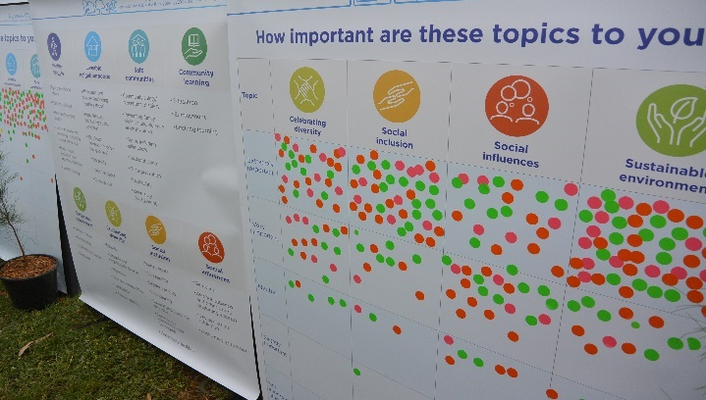
The first stage of the process involved a range of engagement activities to seek the views of community members and key stakeholders on community health, wellbeing and liveability needs and aspirations in Maroondah. This included consideration of how Council and its partners could leverage strengths, address issues, and work in partnership to enhance outcomes for the community. Activities included:
- An online community survey with more than 1,000 responses;
- An Appreciative Inquiry Workshop delivered in partnership with Communities of Wellbeing Inc;
Figure 8: Community input at the Maroondah Festival
- Face-to-face engagement activities at the Maroondah Festival in Croydon, Realm in Ringwood, local Farmers Markets and Celebrating Maroondah events; and
- Engagement with five Council advisory committees.

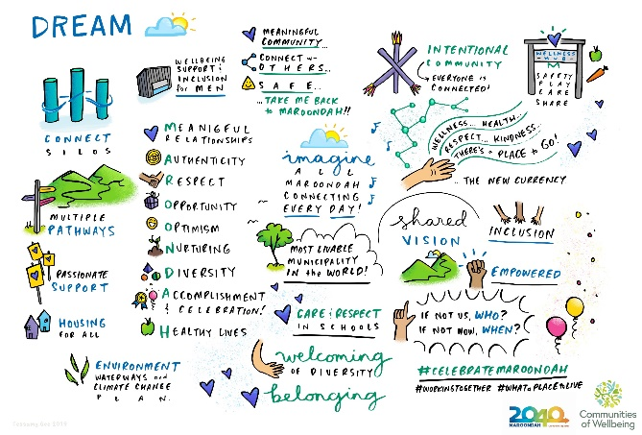

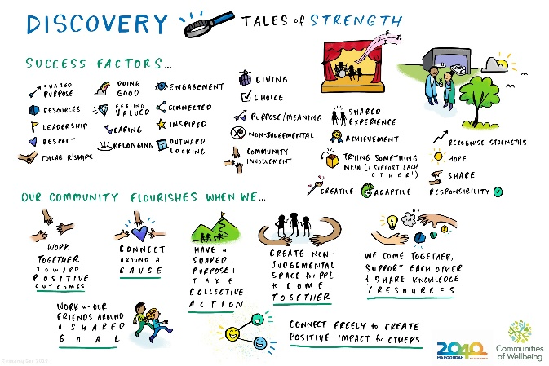

Figure 9: Outcomes from an appreciative inquiry workshop on enhancing wellbeing in Maroondah

Adjustment to consider the COVID-19 pandemic
The presence of COVID-19 was first confirmed in Australia in late January 2020. The onset of this pandemic in Australia resulted in considerable challenges for the Maroondah community. A rise in cases, a declared State of Emergency and subsequent staged restrictions disrupted our social infrastructure, economic livelihoods, normal routines and community activities. During this period, activities included:
- undertaking research to understand the social impacts on the Maroondah community
- engaging over 3000 people within the Maroondah community via an online survey
- engaging with a wide range of key stakeholders to understand community impacts and local needs
- engaging with volunteer led organisations and groups to understand local needs and impacts
- delivering a broad range of emergency response, relief and community recovery activities to meet local needs, as articulated in the Maroondah COVID-19 Recovery Plan.

While this stage of the project was unforeseen, it has significantly shaped the key directions of the strategy, embedded resilience as a key pillar of focus, and informed short-medium term priorities and Council service delivery responses to support community recovery from the impacts of the coronavirus (COVID-19) pandemic in Maroondah.

Consideration of issues and options
During this phase, Council sought to distil the key messages and priorities arising from the background research, community engagement and coronavirus (COVID-19) pandemic inputs to identify key themes and future strategic directions to be included in the strategy. Activities during this phase included:

- engaging with five Council Advisory Committees to seek their input
- engaging with Council service areas to identify services, priority projects and potential new initiatives for inclusion in the strategy action plan
- considering input from a deliberative engagement Community Panel that provided input on healthy lifestyles, safe communities, social inclusion, liveable communities and the natural environment
- formulating the strategic framework for the Liveability Wellbeing and Resilience Strategy.
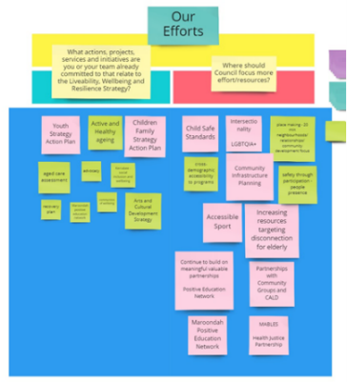
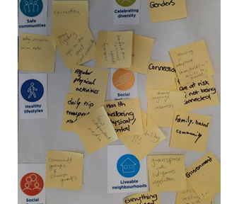

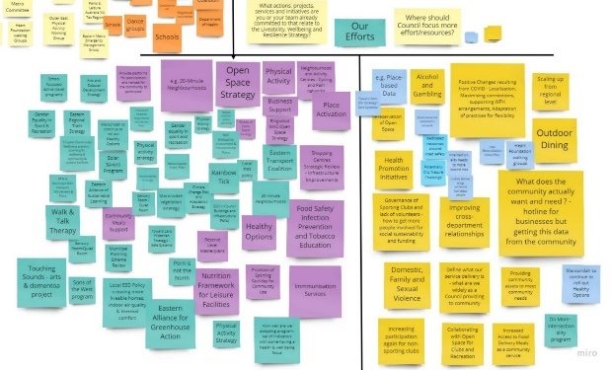

Figure 10: Outputs from a range of stakeholder engagement activities undertaken in 2020

Key findings arising from the community and stakeholder engagement process are highlighted below aligned to the key focus areas of the Maroondah Liveability, Wellbeing and Resilience Strategy:

Healthy lifestyles

Our community strongly value exercise, healthy eating, access to health services, mental health and have an understanding that healthy lifestyles lead to improved wellbeing and reduced illness. Feedback highlighted the relationship between physical and mental health and the opportunities to facilitate and support social connection. Opportunities to connect with nature were highly valued and seen to provide multiple benefits. Connection to nature to support wellbeing has been a particularly important aspect for community members during the coronavirus (COVID-19) pandemic.

Mental health and wellbeing are an increasing challenge especially in response to the coronavirus (COVID-19) pandemic. Respondents called for a greater focus on mental health in Council’s future service delivery, programs and events. More affordable community facilities, free outdoor recreation options as well as active and passive activities that promote health and wellbeing for all were also highly valued.

Health and wellbeing facilities, spaces, services, programs and events provided by Council, and its partners, are highly regarded. It was highlighted that Council needs to increasingly raise awareness of these offerings within the Maroondah community to enhance the health and wellbeing of local people. The community expressed that programs should be co-designed with user groups and relevant community organisations for suitability and success. Further partnering with community groups could increase funding opportunities, greater advocacy and enable greater delivery of initiatives.

Liveable neighbourhoods

Our community value the liveability of Maroondah and are supportive of the development of 20-Minute Neighbourhoods within Maroondah. Strong relationships between liveability, safety and sustainability were identified. Facilities and community services, parks and playgrounds, shops and businesses, accessibility and amenities, open space and green space, public transport, walkability, all contribute to liveability in Maroondah.

During coronavirus (COVID-19) pandemic restrictions, Maroondah residents spent more time in their local neighbourhood, with increased community connection to places and spaces, opportunities for exercise, socialising, outdoor activities, and provided the potential for a greater understanding of living within a 20-minute neighbourhood where everyone can live, work, and play. There is a desire to foster local community and create inviting places of belonging within neighbourhoods. Our community would like to see the creation and activation of local innovative spaces and places that provide the potential for passive recreation and social connections.

Our community understand the impacts of climate change and recognise the importance of collective action for our future, with a strong sense that green spaces and Maroondah’s special natural environment needs to be further protected. There is a desire for stronger action to address climate change and advancing community behaviour change to reduce negative environmental impacts.

The community would like to see greater efforts to preserve and expand green and open space, make public spaces and places safer after dark, provide more adequate and appropriate parking, improve public transport frequency and connectivity as well as walkability/active transport. Some felt liveability was being challenged by high density developments, however, it was also acknowledged that urban growth will be needed in the future and should be well planned. Increases in population, without adequate supporting infrastructure, was considered to have impacts on transport congestion and loss of open space. There was a strong desire to protect and enhance green open space, native vegetation and bushland reserves, especially with increased housing density and greater demand for affordable housing.

Engaging with vulnerable groups to support cost of living pressures, access affordable housing, address homelessness, and promote access to services and safety, was seen as important to improving liveability for all in Maroondah. Our community also want to see proactive partnerships with organisations to boost employment opportunities, particularly for young people and people with disability. Supporting and promoting small businesses was also considered to be particularly important.

Safe communities

Our community view safety as the foundation of liveability. It was identified that people presence through activated places and space helps lead to increased perceived safety and a sense of identity. There is a desire for Council to continue to work with community safety partners, such as Victoria Police, to promote community safety and provide an expanded police response and presence. Council’s role in eeducating the community on family violence was also considered important as was supporting those at risk of family violence, along with identifying ways for people to discretely seek assistance when in harmful situations. Our community are also aware of the need for increased education around safe use of the Internet, appropriate levels of screen use and the potential safety implications posed by digital environments.

To further improve safety in Maroondah, our community recommend improving infrastructure in the community that impacts people’s perceptions of safety. This includes: street lighting, creating safe public places and spaces, building design as well as maintenance of footpaths. A strong desire to address alcohol and drug use in particular at-risk communities was also expressed. Our community also emphasised the importance of using innovative methods to engage vulnerable people and young people in the design of spaces, places and buildings to improve liveability and safety for all.

Respondents validated Council’s role in supporting residents during emergencies. It was acknowledged that climate change is likely to increase these severe weather events in the future. It was noted that responsiveness and reaction times are crucial to supporting local people (particularly vulnerable residents) during emergencies. The community also see value in learning from the experiences of coronavirus (COVID-19) pandemic and extreme weather events in emergency planning and management.

Social inclusion

The City of Maroondah is seen as a friendly and inclusive community. Community understanding of social inclusion recognised the associated health and wellbeing benefits, as well as a focus on rights of individuals, not just their needs. Social Inclusion supports health and wellbeing needs in the community through acceptance, connection opportunities, belonging and support. Specifically, social inclusion is supported and isolation reduced by having connection to friends in the, contact with people with similar interests and values, feeling valued and appreciated, and volunteering with local organisations and groups. Social relationships were understood to be important in preventing family violence and critical to survival in an emergency, as people who aren’t connected are more vulnerable. The coronavirus (COVID-19) pandemic has seen the need for social inclusion prioritised by the community. Key areas of need included: support for elderly and people with a disability, increasing community connectedness and support for people who are vulnerable or living alone.

The role of Council and its partners in promoting and facilitating social inclusion within the community was generally commended. Some respondents noted that social inclusion does not need to have ‘its own program’ but be facilitated through initiatives, activities, programs and events, including volunteering, that bring people together and provide the opportunity for social connection and community participation. It was suggested that Council is well placed to promote opportunities for community involvement, support community leaders to act as community connectors, create opportunities for volunteers and support local volunteer-led organisations.

There was an acknowledgement that the community would benefit from an increased awareness of the importance and benefits of inclusion and that this education would ideally commence at a young age. The community also expressed the importance of bringing people together to create a shared purpose, foster community connection and create networks using inviting places and spaces that create a sense of belonging. There is a strong desire to ensure that all community members have access to services, facilities and community connection opportunities where everyone can feel valued and empowered. Council could increasingly learn from the lived experiences of community groups and further embed this input into planning and service delivery.

The benefits of diversifying methods of communication to the community were highlighted including the use of social media, printed material and translation services, to ensure all people have access to information. It was noted that technology is a suitable platform to gain social connection amongst some population groups, but not all.

Embracing diversity

Our community value the celebration of diversity, with an expectation that it can increase community harmony and promote acceptance. With increasing diversity of all ages, abilities and backgrounds, there is a continued desire to see this diversity celebrated and embraced. There was a focus to support specific groups, including the LGBTIQA+ community, people with a disability and their carers, people who are experiencing socio-economic disadvantage, young people, children, seniors, people from CALD backgrounds as well as Aboriginal and Torres Strait Islander peoples.

It was noted that Council is well placed to continue to lead by example by ensuring that diversity is visible, normalised and celebrated in Council services and activities. Embracing diversity should continue to be framed positively using strength-based language with Council well placed to promote community groups, initiatives and community inclusion champions. Feedback suggested that community leaders of diverse groups should increasingly be engaged in Council service planning and delivery. Educating the community about embracing diversity and learnings about diverse groups was also considered to be of importance. This includes embracing cultural understanding and wisdom from Aboriginal and Torres Strait Islander people on the natural environment, wellbeing and belonging. Our community also see the importance of welcoming environments for diverse groups, such as cultural references and gender-neutral changerooms. Council is considered to be a key player to ensure community information needs and communication channels reach all diverse groups in Maroondah.

Social harms

The community highlighted that there is a continued need to proactively address safety issues around gambling, alcohol, tobacco, drugs and excessive screen use. It was stressed that addressing these issues will strengthen the community wellbeing of Maroondah. Our community are aware of the need to promote positive coping mechanisms and healthier alternatives to drugs and alcohol. Respondents also highlighted the importance of positive social connections. It was acknowledged that further work needs to be done to change unhealthy and harmful attitudes surrounding alcohol and other drugs, particularly in community sport. Educating the community on how alcohol, drugs and problem gambling are linked to family violence was also seen as important.

A strategy for liveability, wellbeing and resilience in Maroondah

Our vision
From the background research, community engagement and stakeholder input, the long term vision for community wellbeing liveability and resilience in Maroondah is:

In 2031, Maroondah will be a liveable, healthy and resilient community where everyone can belong, thrive and grow.

Our key focus areas

To deliver this vision and support the overall vision of Maroondah 2040: Our future together, six focus areas have been developed that will create a framework for key directions and priority actions that Council will undertake to achieve this vision.

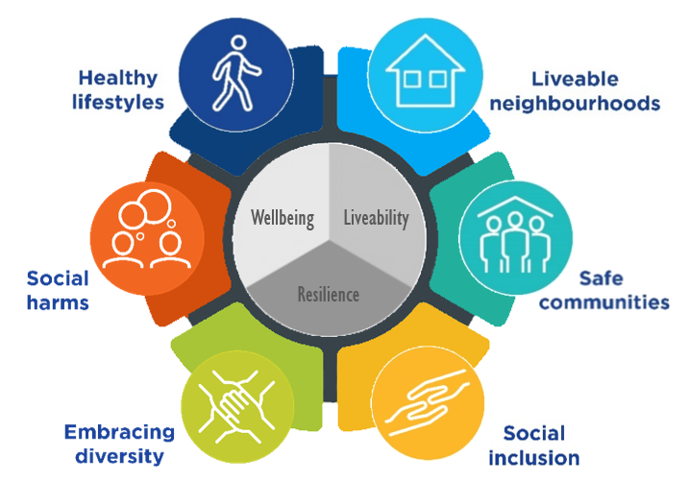
Healthy Lifestyles

Our vision

In 2031, Maroondah will be a healthy and active community where all people are physically and mentally well.
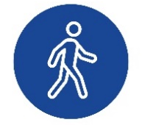

Healthy lifestyles

The research tells us

Healthy lifestyles refer to positive outcomes that are achieved through decision making, choice, participation and behaviours that promote holistic health; including reducing the risk of chronic illness and disease and improving overall physical and mental wellbeing. Healthy lifestyles can help to improve happiness and satisfaction in life, reduce our risk of chronic illness and disease, improve life expectancy and maintain good mental health. Healthy lifestyles are directly influenced by physical health, personal and mental wellbeing, activity and social interaction, along with consumption of food and drinks. ​Our personal wellbeing and the choices we make can help to improve or lower our physical health, mental health, eating behaviours and overall public health.

Our health is dependent on the health of our environment. Spending time in nature has been shown to have many positive effects on physical, social and mental health. However, our changing climate has significant consequences for the environment and for public health, wellbeing and safety. The direct and indirect impacts of climate change are likely to exacerbate existing public health risks and represent a high risk to human health.

52% of Maroondah adults are overweight or obese, with males (62%) more likely to be than females (43%). | Males in Maroondah are less likely to have sought professional help for a mental health problem (7%), compared to females in Maroondah (22%) and males in Victoria (14%).

Our community said
“People are living older and improving people's mental and physical health should be a financial and social benefit to community.”
Croydon Hills, 18-34, Male

Our community values exercise, healthy eating, access to health services and good mental wellbeing. They have an understanding that healthy lifestyles lead to improved wellbeing and reduced illness. Our community highlighted the relationship between physical and mental health and the opportunities to facilitate and support social connection. Opportunities to connect with nature were highly valued and seen to provide benefits to mental wellbeing, physical health and social connection. Mental health within the community has been particularly impacted by the coronavirus (COVID-19) pandemic and the community desire a greater focus on mental health in Council’s service delivery, programs and events. The community would also appreciate more affordable facilities, free outdoor recreation options as well as active and passive activities that promote health and wellbeing for all.

Health and wellbeing facilities, spaces, services, programs and events provided by Council, and its partners, are highly regarded. It was highlighted that Council has an opportunity to further raise awareness of what is on offer within the Maroondah community to enhance resident health and wellbeing. The community suggested that programs should be co-designed with user groups and relevant community organisations for suitability and success. Partnering with community groups could increase funding opportunities, strengthen advocacy and enable greater delivery of initiatives.

We will work towards healthy lifestyles in Maroondah by prioritising:

Physical health and activity | - Work in partnership to promote physical health, through the delivery of accessible initiatives, programs and services.  - Provide and enhance accessible active and passive open spaces, active travel infrastructure, sporting precincts and integrated recreation facilities, to increase opportunities for and participation in physical activity.  - Work in partnership to provide safe, inclusive and accessible environments and opportunities for all community members to undertake physical activity.
Gendered health outcomes | - Work in partnership to provide services and initiatives that support gendered health outcomes including known health risks, heart disease, cancer, physical activity, maternal health, parenting, healthy masculinities, reducing stigma and supporting those experiencing vulnerability.
Mental health and wellbeing | - Work in partnership to promote awareness of mental health, build the capacity of the community to navigate mental health challenges, and advocate for and support at-risk community members to access services.  - Work in partnership to promote awareness of mental wellbeing and using prevention and strength-based approaches to build the resilience of the community and enhance their wellbeing.
Public health | - Work in partnership to implement a preventative approach to addressing current and emerging public health issues, including communicable diseases and drug-resistant infections, and chronic diseases.  - Work in partnership to advocate for and support the community to minimise the health impacts of climate change, with a focus on vulnerable groups.
Healthy eating | - Provide leadership in healthy eating through the promotion of healthier food and drink options for Council facilities, events, spaces and places.  - Work in partnership to promote healthy eating through community education, initiatives and service delivery.  - Encourage thriving volunteer-led community gardens that promote sustainably grown local produce, enhanced food security and facilitate social inclusion.
Connection to nature | - Enhance Maroondah’s canopy vegetation, habitat corridors, parklands, bushlands and waterways to promote mental wellbeing, facilitate physical activity and encourage social connection.
Cultural participation | - Work in partnership to curate arts and cultural activities, installations and activations to promote health and wellbeing, encourage social connection, provide platforms for less prominent voices and opportunities for creative solutions to health promotion challenges.

Indicators of progress

Self-reported health
Percent of Maroondah residents reporting their health as very good or excellent

Subjective wellbeing
Subjective Wellbeing Index for Maroondah residents Maroondah resident satisfaction with life as a whole

Physical activity
Percent of Maroondah residents who are sufficiently physically active

Healthy eating
Percent of Maroondah residents who meet daily consumption guidelines for fruit and vegetables

Alignment to Maroondah 2040 Outcomes

- A safe, healthy and active community
- A clean green and sustainable community

Alignment to Victorian Public Health and Wellbeing Plan 2019-2023 priorities

- Increasing healthy eating
- Decreasing the risk of drug resistant infections in the community
- Increasing active living
- Improving mental wellbeing

Related Council documents

- Maroondah 2040 Community Vision
- Council Plan 2021-2025
- Active & Healthy Ageing Initiative 2015
- Children’s and Families Strategy 2020
- Maroondah COVID-19 Recovery Plan 2021
- Disability Policy and Action Plan 2019-2021
- Equally Active Strategy 2019
- Gender Equity Policy 2018
- Habitat Corridors Strategy (under development)
- Open Space Strategy 2016
- Physical Activity Strategy 2015-2020
- Sustainability Strategy 2016-2020
- Maroondah Vegetation Strategy 2020-2030
- Youth Strategy 2017

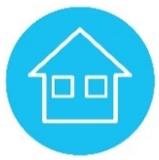
Liveable neighbourhoods

Our vision

In 2031, Maroondah will be a network of liveable neighbourhoods with a range of opportunities to live, work and play locally.

Liveable neighbourhoods

The research tells us
Liveable neighbourhoods can shape the way we live, feel, enjoy and experience our community and are important for health and wellbeing. Liveable neighbourhoods are safe, attractive, socially inclusive and environmentally sustainable. Key elements of a liveable neighbourhood include affordable and diverse housing, employment, education, public open space, local shops, health and community services, and leisure and cultural opportunities; via convenient public transport, walking and cycling infrastructure.

20-Minute Neighbourhoods are about ‘living locally’ - giving people the ability to meet most of their everyday needs within a 20-minute walk from home, with access to safe cycling and local public transport options. Features of 20-Minute Neighbourhoods include local health families and schools, employment opportunities, green streets and spaces and affordable housing options. Local neighbourhood design influences physical activity, health outcomes, social connectedness and sustainability.

26% of Maroondah residents both live and work locally. This is expected to increase in line with changes to working arrangements since COVID-19 | 72% of Maroondah dwellings are estimated to be within 400m of public open space, which is higher than Knox (69%) and Yarra Ranges (53%). | 10% of the Maroondah population experienced housing stress in 2016. This is particularly evident in Ringwood MAC (20%) and Croydon MAC (18%) | An estimated 49% of dwellings in Maroondah are located within 400m of regular public transport, compared to 38% in Knox and 13% in Yarra Ranges

Our community said
“Liveable neighbourhood involve a balance between housing, green corridors, sporting facilities, schools and community facilities.” Warranwood, 60+, Female
Our community value the liveability of Maroondah and are supportive of the development of 20-Minute Neighbourhoods within Maroondah. Facilities and community services, parks and playgrounds, shops and businesses, accessibility and amenities, open space and green space, public transport and walkability all contribute to liveability in Maroondah.
One of the positive outcomes of the coronavirus (COVID-19) pandemic was the reconnection of community members to their local neighbourhoods and the opportunities they provide.

There is a desire to foster local community and create inviting places of belonging within neighbourhoods. Our community would like to see the creation and activation of local innovative spaces and places that provide the potential for passive recreation and social connections. Our community understand the impacts of climate change and recognise the importance of action for our future, with a strong sense that the green space and environment in Maroondah needs to be protected. There is a desire for stronger action to address climate change and encouraging community behaviour change to reduce environmental impact.

We will work towards liveable neighbourhoods in Maroondah by prioritising:

Social and Community Housing | Work in partnership to increase investment in accessible, safe and well-located social and community housing.
Affordable Housing | Advocate and promote a diverse range of innovative and affordable housing options to meet the needs of all income levels and life-stage requirements.
20 minute neighbourhoods | Facilitate an integrated network of thriving local neighbourhoods across Maroondah that facilitate a sense of belonging, enable access to key services and amenities, and education and employment opportunities, and create places of connection.
Walkability / Bike-friendly | Work in partnership to facilitate local neighbourhood networks that are walkable and bike-friendly, and promote active travel of all ages, abilities and backgrounds.
Transport network | Work in partnerships to enable an integrated network of safe, accessible and efficient transport options that meet the needs of people of all ages, abilities and backgrounds.
Open spaces | Promote and enhance Maroondah’s active and passive open spaces to provide opportunities for connection, exercise, play and enjoyment for all people.
Continuous learning | Plan, advocate and facilitate improved access and opportunities for continuous learning for people of all ages, abilities and backgrounds.
Employment pathways | Work in partnership to facilitate local employment pathways with a focus on young people, people with a disability, along with people experiencing mid-career transition and seeking to re-enter the workforce.
Climate change | Foster liveable places and spaces for our community that are capable of adapting to climate change and responding to current and future risks.

Indicators of progress

Attractive open space
Public open space in Maroondah (hectares)

Household stress
Percent of Maroondah households in the lowest 40% of incomes who are paying more than 30% of their usual gross weekly income on housing costs

Transport proximity
Percent of Maroondah households that are within 200 metres of a bicycle facility and/or 400 metres of a bus stop and/or 800 metres of a train station

Environmental leadership
Community perception of Council’s performance in relation to environmental sustainability

Alignment to Maroondah 2040 Outcomes

- A safe, healthy and active community
- A prosperous and learning community
- A clean green and sustainable community
- An accessible and connected community
- An attractive thriving and well built community
- An inclusive and diverse community

Alignment to Victorian Public Health and Wellbeing Plan 2019-2023 priorities

- Tackling climate change and its impact on health
- Increasing healthy eating
- Increasing active living
- Improving mental wellbeing

Related Council documents

- Maroondah 2040 Community Vision
- Council Plan 2021-2025
- Affordable and Social Housing Policy 2018
- Arts and Cultural Development Strategy 2020-2025
- Asset Plan (under development)
- Climate Change Risk Adaptation and Mitigation Strategy 2018/19 to 2021/22
- Croydon Structure Plan (under review)
- Disability Policy and Action Plan 2019-2021
- Heathmont Structure Plan 2012
- Housing Strategy 2016
- Maroondah COVID-19 Recovery Plan 2021
- Open Space Strategy 2016
- Ringwood MAC Masterplan 2018
- Ringwood East Structure Plan 2012
- Road Management Plan 2021-2025
- Sustainability Strategy 2016-2020

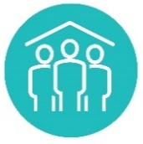
Safe communities

Our vision

In 2031, Maroondah will be an accountable community where all people feel and are safe.

Safe communities

The research tells us

Safety is a fundamental component of wellbeing, liveability and resilience. The degree to which someone feels safe within a home, workplace or community has a significant impact on how and where they live, work and play. Feeling safe and secure within a home, neighbourhood, workplace, digital settings and community can affect one’s sense of freedom, levels of stress and overall mental health, physical health, trust, social habits and lifestyle behaviours, social connections, work and study productivity, and participation in leisure, community and physical activities.

Maroondah has the equal second highest rate of family violence incidents in the EMR. | In 2020, the Maroondah criminal incident rate was lower than the Victorian rate (4826.4 per 100,000, compared to 6019.7). Most incidents occurred in Ringwood and Croydon, and the major locations were in homes and streets / lanes / footpaths.

Our community said
“We should all feel safe to go about our business, regardless of the hour of the day or day of the week. We should be able to walk the streets at night or early morning without fear or trepidation.”
Ringwood, 35-59, Female

Our community view safety as the foundation of liveability. To further improve safety in Maroondah, our community recommend addressing and improving infrastructure in the community that impacts perceptions of safety. There is a desire for Council to partner with organisations to promote community safety, positive cultures in community sport, digital safety awareness and behaviours, provide family violence education and support those at risk of family violence.

Our community would also like to see young people engaged in the design of places, spaces and buildings; address high levels of alcohol consumption; and provide create approaches opportunities to deter undesirable behaviour.

There is a desire for Council to continue supporting residents during emergencies and an understanding that climate change is likely to increase these events. Responsiveness and reaction time are crucial to support residents (particularly vulnerable residents) during emergencies. The community also see value in learning from the experiences of the coronavirus (COVID-19) pandemic and extreme weather events in emergency planning and management.

We will work towards safe communities in Maroondah by prioritising:

Community safety | Work in partnership to promote community safety and implement initiatives and practices aimed at improving the actual and perceived safety of the community.  Plan and advocate for the application of community safety principles that facilitate safe places and spaces.  Promote and facilitate safer cultures, spaces and settings relating to issues of gambling, alcohol and other drugs.
Promoting gender equality and preventing violence | Work in partnership to promote gender equity and inclusion in Maroondah to facilitate fairness of opportunity, safe environments and respectful relationships that reduce all forms of gender-based violence and discrimination.
Elder abuse | Advocate and support initiatives for the prevention of all forms of elder abuse.
Child protection | Promote a culture of child safety that is prevention focussed and proactive, encourages the empowerment of children and young people, and supports all people in the community safely disclose risks of harm to children and young people, and to respond effectively to allegations of child abuse.
Crime reduction | Work in partnership to proactively address the causes of crime to minimise harms across the community.
Road safety | Work in partnership to advocate for road safety infrastructure and promote road safety through education and training.
Emergency management | Work in partnership to utilise existing community resources and strengths to build resilience and preparedness and reduce vulnerability.  Provide leadership in community-centred response, relief, recovery and regeneration arising from crises and emergencies, including those resulting from climate change.
Digital safety | Work in partnership to raise awareness of digital safety to minimise harm and promote safe online behaviours and interactions.

Indicators of progress

Perceptions of safety
Percent of Maroondah residents who agree that they feel safe when walking alone at night

Crime

Offence rate per 100,000 population in Maroondah

Appearance of public areas
Community satisfaction with the appearance of public areas

Alignment to Maroondah 2040 Outcomes

- A safe, healthy and active community
- An attractive thriving and well built community
- An inclusive and diverse community

Alignment to Victorian Public Health and Wellbeing Plan 2019-2023 priorities

- Reducing injury
- Preventing all forms of violence
- Improving sexual and reproductive health

Related Council documents

- Maroondah 2040 Community Vision
- Council Plan 2021-2025
- Active & Healthy Ageing Initiative 2015
- Asset Plan (under development)
- Children and Families Strategy 2017
- Equally Active Strategy 2019
- Gender Equity Policy 2018
- Gender Equality Action Plan 2021
- Croydon Structure Plan (under review)
- Disability Policy & Action Plan 2019-2021
- Heathmont Structure Plan 2012
- Maroondah COVID-19 Recovery Plan 2021
- Municipal Emergency Management Plan
- Open Space Strategy 2016
- Ringwood Metropolitan Activity Centre Masterplan 2018
- Ringwood East Structure Plan 2012
- Youth Strategy 2017

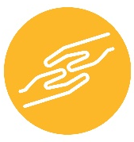
Social inclusion

Our vision

In 2031, Maroondah will be an inclusive, accessible and equitable community where all people can participate, feel connected and experience a sense of belonging.

Social inclusion

The research tells us
A socially inclusive community enables all members of the community to fully participate and contribute to social, economic and cultural life in a welcoming and safe manner. Being socially included means that: people have the resources, opportunities and capabilities they need to participate in education and training (learn); participate in employment, unpaid or voluntary work including family and carer responsibilities (work); connect with people, use local services and participate in local, cultural, civic and recreational activities (engage); and influence decisions have impact them (voice). Research shows that social connection and participation can assist with good mental health, reduce psychological distress and help to maintain overall health and wellbeing. Being inclusive involves deliberate actions taken to remove or reduce barriers to inclusion and to create opportunities that facilitate and encourage full participation.

Lone person households comprise one in four (23%) Maroondah households. This rate is higher In Croydon MAC (40%) and Ringwood MAC (34%). | One in five (20%) Australians report having experienced a major form of discrimination in the last 2 years. Young people (aged 18 to 24), Aboriginal and Torres Strait Islander Australians, LGBTIQ+ people, religious minorities, and people with disability, report the highest levels of discrimination.

Our community said
“it creates good people and strong communities when people "do things together with a common interest"
Croydon, 35-59, Female
Maroondah is seen as a friendly and inclusive community. Social inclusion is seen as currently supporting health and wellbeing needs in the community through available opportunities for acceptance, belonging and support. It is important for people to be part of a community with friendships, contact with people who are similar, environments where people feel valued and appreciated, and opportunities to volunteer. Social relationships were understood to be important in preventing family violence and critical to survival in an emergency, as people who aren’t connected are more vulnerable. The coronavirus (COVID-19) pandemic has seen the need for social inclusion prioritised by the community. Key areas of need included supporting and community members with a disability and elderly people, increasing community connection, addressing homelessness and supporting vulnerable people and those living alone.

Social inclusion is facilitated through initiatives, activities, programs and events, that bring people together and provide the opportunity for social connection and community participation. There is a role for Council to promote opportunities for community involvement, encourage local leaders to act as community connectors, create opportunities for volunteers and support local volunteer-led organisations. The importance of bringing people together to create a shared purpose, foster community connection and create networks using inviting places and spaces that create a sense of belonging was expressed. There is a strong desire to ensure that all community members have access to services, facilities and community connection opportunities where everyone can feel valued and empowered. Council can learn through lived experiences of community groups and embed this input into planning and service delivery.

We will work towards social inclusion in Maroondah by prioritising:

Accessibility | Promote, provide and improve community infrastructure, services and events that are accessible for all people.
Equity | Promote and create opportunities for equity across all abilities, ages, cultures, genders, languages, religions, sexualities and socio-economic groups.
Community participation | Work in partnership to create opportunities for community participation and social connection for all people.
Sense of belonging | Encourage and promote opportunities for all people to develop a strong sense of belonging to their local community.
Community Infrastructure | Provide and promote opportunities and places for social connection through community infrastructure and activation across Maroondah.
Vulnerable Communities | Work in partnership to advocate for and support vulnerable and disadvantaged communities and community members.
Homelessness | Work in partnership to support community members experiencing or at risk of homelessness and promote pathways out of homelessness.
Volunteering | Work in partnership to support, empower and connect organisations and groups that involve volunteers.  Promote diverse and attractive opportunities and empower local volunteers.
Digital literacy | Work in partnership to enable access to digital environments and build digital literacy.

Indicators of progress

Sense of community
Percent of Maroondah residents who agree people are willing to help in their neighbourhood
Percent of Maroondah residents who agree they live in a close-knit neighbourhood

Social connectedness
Percent of Maroondah residents who agree people in their neighbourhood can be trusted

Volunteerism
Percent of Maroondah residents who actively volunteer

Alignment to Maroondah 2040 Outcomes

- A safe, healthy and active community
- An attractive thriving and well built community
- An inclusive and diverse community

Alignment to Victorian Public Health and Wellbeing Plan 2019-2023 priorities

- Preventing all forms of violence
- Improving mental wellbeing

Related Council documents

- Maroondah 2040 Community Vision
- Council Plan 2021-2025
- Active and Healthy Ageing Initiative 2021-2025
- Asset Plan (under development)
- Children and Families Strategy 2017
- Disability Policy & Action Plan
- Equally Active Strategy 2019
- Gender Equity Policy 2018
- Gender Equality Action Plan 2021
- Maroondah COVID19 Recovery Plan 2021
- Open Space Strategy 2016
- Youth Strategy 2017


Embracing Diversity

Our vision

In 2031, Maroondah will be a harmonious community that celebrates and embraces diversity where all people are respected and valued.

Embracing Diversity

The research tells us

Diversity plays a major contributing factor towards community liveability, health, and wellbeing. Diversity can be defined as understanding and recognising individual differences. Differences can include race, ethnicity, gender, sexual orientation, socio-economic status, age, physical abilities, religious beliefs, or other ideologies. Embracing diversity is the exploration of these differences in a safe, positive, and fostering environment, moving beyond simple tolerance and embracing and understanding the rich dimensions of diversity within everyone.

Maroondah is home to a diverse range of communities including, but not limited to, people with disability, cultural and linguistic diverse (CALD) communities, Aboriginal and Torres Strait Islanders, people with a range of faiths, and community members with different gender and sexual identities.

In 2016, almost one in five (17%) Maroondah residents speak a language other than English at home. Compared to 13% in 2011. | 5% of Maroondah’s population needing help in their day-to-day lives due to a disability. This rises to one in two (48%) aged over 85. | 560 Maroondah residents identified as Aboriginal and Torres Strait Islander peoples in 2016, an increase from 413 in 2011.

Our community said
“As a person from a marginalised group, having diversity as something not only encouraged but celebrated is something I believe is actually needed. Without it, many people face significantly diminished quality of life and social rejection that can have severe consequences.”
Croydon, 18-34, Female
Our community value the celebration of diversity, with an expectation that it can increase community harmony and promote acceptance. With increasing diversity of all ages, abilities and backgrounds, there is continued desire to see this diversity celebrated and embraced.

Council has a role in leading by example and encouraging diversity be visible, normalised and celebrated in Council services and activities. Community leaders of diverse groups provide insights in the planning and delivery of services. The community also see the importance of educating the community about embracing diversity and learning from the wisdom of diverse groups, including Aboriginal and Torres Strait Islander. Our community also recognise the importance of creating welcoming environments and accessible services for diverse groups within Maroondah. Council has an opportunity to explore communication channels to effectively reach all diverse groups across Maroondah.

We will work towards embracing diversity in Maroondah by prioritising:

Intersectionality | Understand, respond to and advocate for intersectional needs of all communities, with a focus on reducing discrimination, promoting equity and respect, and inclusive service delivery.
Disability | Facilitate and advocate equal opportunity for people of all abilities, their families and their carers to actively and fully participate in the life of our community.
Culturally and Linguistically Diverse | Work in partnership to understand and support the needs of culturally and linguistically diverse communities to actively and fully participate in the life of our community, including refugees, new arrivals, migrants and interfaith communities.
Aboriginal and Torres Strait Islander peoples | Work collaboratively to celebrate, promote, recognise and integrate the culture of Aboriginal and Torres Strait Islander peoples to facilitate equity, respect, understanding and reconciliation.
LGBTQIA+ | Advocate and promote equity, safety, inclusion and wellbeing for community members of all sexualities and sex identities.
Gender identity | Advocate and promote equity, safety, inclusion and wellbeing for community members of all genders and gender identities.
Age groups | Facilitate the health and wellbeing of all children and their families through meaningful engagement, opportunities for participation and access to inclusive local services and spaces.  Work in partnership to support Maroondah’s young people to be healthy, connected, engaged and prepared to thrive.  Work in partnership to encourage active ageing by optimising opportunities for participation, health and security to enhance the quality of life as people age in our community.

Indicators of progress

Recent migrants
Number of migrants and refugees settling in Maroondah

Culturally and linguistically diverse communities
Language other than English
Proportion of residents who speak a language other than English at home

Alignment to Maroondah 2040 Outcomes

- A safe, healthy and active community
- A vibrant and culturally rich community
- An inclusive and diverse community
- A well governed and empowered community

Alignment to Victorian Public Health and Wellbeing Plan 2019-2023 priorities

- Preventing all forms of violence
- Improving mental wellbeing

Related Council documents
- Maroondah 2040 Community Vision
- Council Plan 2021-2025
- Active and Healthy Ageing Initiative 2015
- Arts and Cultural Development Strategy 2020-2025
- Children and Families Strategy 2020
- Disability Policy and Action Plan 2019-2021
- Equally Active Strategy 2019
- Gender Equity Policy 2018
- Gender Equality Action Plan 2021
- Maroondah COVID-19 Recovery Plan 2021
- Open Space Strategy 2016
- Reconciliation Action Plan 2018
- Youth Strategy 2017

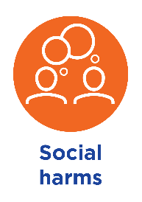
Social harms

Our vision

In 2031, Maroondah will be a socially responsible community that inspires positive choices and reduces impacts from harmful social behaviours.

Social harms

The research tells us
There are a range of social behaviours that can result in disruptive and negative impacts on individual and community wellbeing. Lifestyle behaviours such as tobacco, drug, alcohol abuse, problem gambling and excessive screen use are acknowledged as contributing factors to poor mental and physical health. Harmful levels of alcohol consumption present major health issues associated with increased risk of chronic disease, injury and premature death. Effects of Illicit drug use can be severe, including poisoning, heart damage, mental illness, self-harm, suicide and death. Tobacco smoking is the single most important preventable cause of ill health and death in Australia, and longitudinal data shows that there is a downward trend in national tobacco consumption.

Excessive screen use can lead to broad-ranging harms with significant physical, mental, social, and economic costs for individuals and communities. Gambling-related harm involves adverse consequences leading to health or wellbeing impacts on an individual, family unit, community or population. Problem gambling has been linked to poor employment outcomes, higher rates of diabetes, poor mental wellbeing and suicide ideation as well as family violence.

Maroondah has the highest rate of alcohol assaults during high alcohol consumption hours in the EMR | Maroondah has highest levels of illicit drug use and highest levels of hospital admissions due to illicit drugs and antidepressants in the EMR. | More than $45 million was spent on pokies in Maroondah during 2019/20.

Our community said
“Pokies are a blight on the outer suburbs and alcohol is too readily available, e.g. home delivery 24hrs a day.” Heathmont, 60+, Female
The community understand there is a continued need to proactively address safety issues around gambling, alcohol, tobacco, drugs and excessive screen use. It is viewed that addressing these characteristics will strengthen the community atmosphere of Maroondah. Our community are aware of the need to promote positive coping mechanisms and healthier alternatives to drugs and alcohol. The community also highlighted the importance of positive social connections. There is also a need to change unhealthy and harmful attitudes surrounding alcohol and other drugs, particularly in community sport. Educating the community on how alcohol, drugs and problem gambling are linked to family violence was seen as important.

We will work towards addressing social harms in Maroondah by prioritising:

Gambling | Work in partnership to prevent and minimise gambling-related harm in the community through collective advocacy, raising awareness and promoting safe gambling environments.
Alcohol | Work in partnership to prevent and minimise alcohol-related harm in the community through joint advocacy, education and promoting safer alcohol cultures and environments.
Tobacco | Work in partnership to de-normalise smoking behaviours and reduce smoking-related harm through education, regulation and increasing smoke-free public spaces.
Drugs | Work in partnership to minimise illicit drug-related harm in the community through advocacy, education, and facilitating safer cultures, spaces and places.
Excessive screen use | Work in partnership to raise awareness of the harms related to excessive screen use and promote safe and healthy screen behaviours and interactions.

Indicators of progress

Gambling
Reduction in EGM per person spend

Alcohol
Reduction in presentations of alcohol related incidents at emergency departments during high alcohol consumption hours

Drugs
Reduction in hospital presentations of drug related incidents

Tobacco
Reduction in daily smoking rate

Alignment to Maroondah 2040 Outcomes

- A safe, healthy and active community
- An inclusive and diverse community

Alignment to Victorian Public Health and Wellbeing Plan 2019-2023 priorities

- Reducing tobacco-related harm
- Reducing harmful alcohol and drug use
- Preventing all forms of violence
- Improving mental wellbeing

Related Council documents

- Maroondah 2040 Community Vision
- Council Plan 2021-2025
- Children and Families Strategy 2020
- Gambling Policy 2018
- Maroondah COVID-19 Recovery Plan 2021
- Youth Strategy 2017

Making it happen

Partnerships between a wide range of community service agencies, community organisations and groups, and community members will be vital in implementing the Maroondah Liveability Wellbeing and Resilience Strategy 2021-2031.

Council will continue to play a key role in leading work on each of the six focus areas and partnering with and supporting the community to achieve the vision statements identified over the next 10 years.

This Strategy 2021-2031 will form a key pillar within Council’s Integrated Planning Framework - taking direction from Maroondah 2040: Our future together and the Council Plan - but providing direction for a wide range of other strategies, social policies, Council services and programs, and projects.

The Strategy will help to shape where Council will focus its resources, energy and efforts - whilst acting as a catalyst for community partnerships and providing justification for seeking grant funding for other levels of government.

To articulate the specific actions of Council in working towards the key directions in this Strategy, a number of integrated action plans will be developed/reviewed and implemented. These associated action plans will highlight the short-medium priorities of Council in working towards the Strategy and be reviewed regularly during the lifespan of the Strategy to ensure they are responsive to community needs. These associated action plans, along with associated social policies and Council advisory Committees are shown in the diagram below.

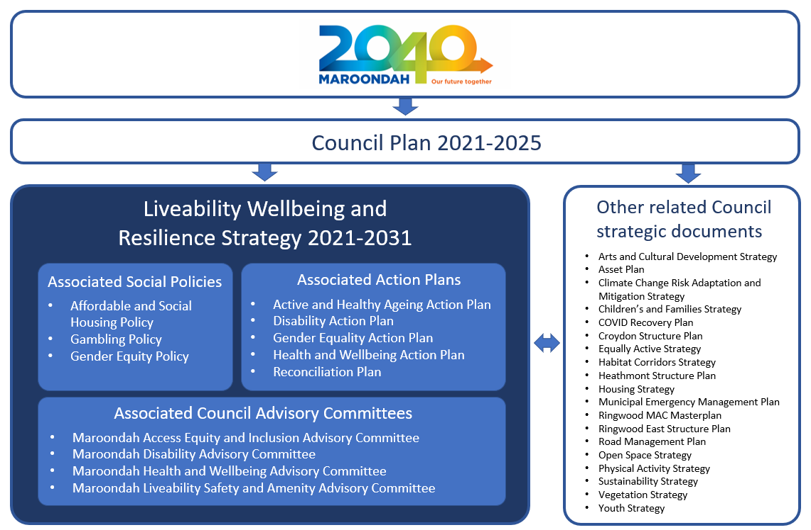

Measuring our progress

The Maroondah Liveability Wellbeing and Resilience Strategy 2021-2031 highlights a broad range of priorities for enhancing the health, wellbeing, liveability and resilience of the Maroondah community over the next 10 years. The associated action plans highlight the short-medium priorities of Council in working towards the priorities of the Strategy.

Significant change often occurs gradually and it is easy to overlook progress unless this is measured. To measure progress toward achieving the preferred future outcomes outlined in this Strategy, a number of key tactical outcome-based indicators have been selected linked to each of the six focus areas.

Over time, these indicators will be used to identify how successful the initiatives of Council and its community partners have been in working towards the future outcomes and key directions outlined in the Maroondah Liveability Wellbeing and Resilience Strategy. Council will periodically report on the broader outcomes achieved relating to these indicators along with some of the activities undertaken in progressing towards the overall vision statements highlighted in the Strategy. Council advisory committees will also be engaged to inform and provide direction on priorities in the Strategy, along with receiving regular reports on the implementation of initiatives.

In addition, Council will report on progress made on key action plans that are linked to Strategy on an annual basis. Service delivery activities to support the priorities of this Strategy will also be captured in Council’s Annual Report.

Achievements associated with this Strategy will be incorporated into the State of Maroondah Report that is currently prepared every two years. The State of Maroondah Report is intended to celebrate achievements, recognise efforts, monitor trends and identify areas for future improvement in working towards the Maroondah 2040 Community Vision.

An interim review of this strategy will be undertaken in 2024/25 and full review of this Strategy will be undertaken in 2029/30.

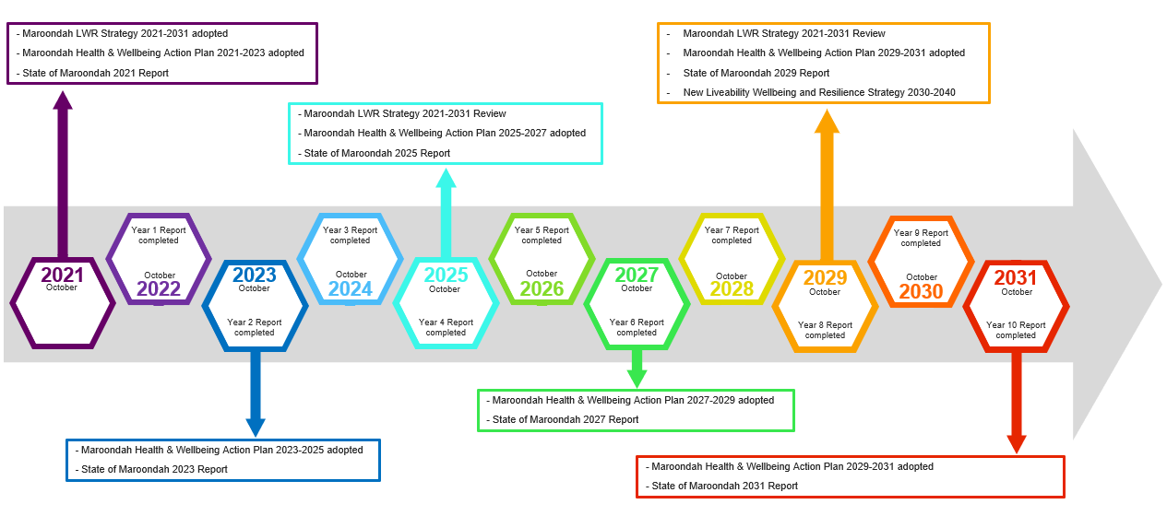

Glossary
Aboriginal or Torres Strait Islander (ATSI): A person of Aboriginal and/or Torres Strait Islander descent who identifies as an Aboriginal and/or Torres Strait Islander. See also Indigenous.

Activity Centre: Areas that provide a focus for services, employment, housing, transport and social interaction. They range in size and intensity of use from smaller neighbourhood centres to major suburban centres and larger metropolitan centres.

Active living: A way of life that integrates physical, social, mental, emotional and spiritual activities into daily routines.

Active travel: Any form of non-motorised transport, mostly walking and cycling; includes trips made for transport purposes (such as to work, school, shops and activities) or for purely recreational purposes. It does not include walking or cycling for competition.

Advocacy: To provide support to a cause or to make public recommendation on behalf of others. Local government have a role to advocate on behalf of local community needs to other levels of government.

Affordable housing: Housing where the cost (whether of mortgage repayments or rent) is no more than 30 per cent of the household’s income, for households in the bottom two quintiles (lowest 40%) of median incomes for a defined area.

Ageing in Place: A person living in the residence of their choice as they age for as long as they are able, incorporating responsive and flexible care in line with their changing needs.

Alcohol-related harm: Harmful physical and mental health issues, such as chronic disease, injury over a lifetime or premature death caused due to high-risk consumption of alcohol.

Annual Report: A report on the activities of Council over the previous financial year. The report includes a report of operations, audited financial statements and an audited performance statement.

Antimicrobial resistance: Occurs when microbials (bacteria, virus, fungi and parasites) change over time to become resistant to medicines and make infections harder to be treated. This resistance to antibodies and resulting increase of infections can cause disease and death.

Asset: An item of value that enables a service to be provided and has an economic life greater than 12 months.

Asylum seeker: An individual who is seeking international protection because they fear persecution, or they have experienced violence or human rights violations. An asylum seeker applies for protection through an application for refugee status. Once this status is granted, they become a ‘refugee’. Not every asylum seeker becomes a refugee, but every refugee starts out as an asylum seeker.

Best practice: To adopt or develop standards, actions or processes for the provision of goods, services or facilities which are equal to or better than the best available on a state, national or international scale.

Bike friendly: Provides infrastructure that supports cyclists and encourages people to use their bike for transportation and recreation. This can include dedicated bicycle lanes, well connected trail networks, shared user pathways, bicycle parking, bicycle repair stations and wayfinding signage.

Biodiversity: The term given to the variety of all forms of life. It is the variety within and between all species of plants, animals and micro-organisms and the ecosystems within which they live and interact. Biodiversity spans organisms from the smallest virus to the largest trees.

Canopy cover: The fraction of ground area covered by the vertical projection of tree crown perimeters.

Canopy vegetation: Mature trees that are at a height where the foliage covers a broad area.

Carbon Neutral Certification: Endorsement that entity that has meet the requirements of the National Carbon Neutral Standard.

Carer: A person who over an extended period of time provides regular care for another person who needs support with daily activities - often relating to support for a child, person who is unwell, elderly or person with a disability.

Charter of Human Rights and Responsibilities Act 2006: Victorian Government legislation created to protect and promote human rights. It sets out freedoms, rights and responsibilities.

Chronic disease: Persistent and long-lasting diseases that require ongoing medical attention and/or limit regular activities. Examples include heart disease, long last kidney or lung diseases, diabetes, dementia and cancer.

Climate change: Changes in the state of the climate, including an increase in extreme weather events, long-term changes in weather patterns and sea level rise, attributed directly or indirectly to human activity.

Climate vulnerability: The degree to which a system, sector or social group is susceptible to the adverse effects of climate change; vulnerability depends on the nature of the climate changes to which the system is exposed, its sensitivity to those changes and its adaptive capacity.

Communicable diseases: Diseases that are caused by infectious agents and can spread from person to person, e.g., common cold, flu, chicken pox, COVID19, hepatitis, polio, tetanus.

Community capacity building: An approach that enables community members to develop skills and competencies to enable self determination, become more involved in community, solve collective problems and/or make a positive contribution to community.

Community gardens: Generally not-for-profit groups of residents and volunteers that operate on designated open space land to grow fresh food, participate in sustainable urban practices, improve food literacy, learn horticultural skills, build community connections through shared activities, harvest and distribute crop yield.

Community engagement: Community engagement is a planned process that provides a range of opportunities for public involvement in Council’s decision-making, relationship building and community strengthening. Council’s approach to community engagement is outlined in the Maroondah Community Engagement Policy.

Community Engagement Policy: A formal expression of Council’s commitment to engaging with the Maroondah community and understanding the different views, experiences and expertise our community has to offer.

Community Satisfaction Survey: A Victorian Government survey conducted once a year to gauge community satisfaction levels with Council services.

Community Vision: Description of the municipal community’s aspirations for the future of the municipality for at least the next 10 financial years. The Maroondah 2040 Community Vision represents the strategic direction of Council as required by section 90 of the Local Government Act 2020. Also see Maroondah 2040 Community Vision.

Council: Democratically elected Councils are an essential tier of government established by the Victorian Constitution Act 1975 having the functions and powers that the Parliament considers are necessary to ensure the peace, order and good government of each municipal district.

Council Advisory Committee: Specialist appointees consisting of community representatives and/or agency stakeholders who provides advice and recommendations to Council on matters relating to the delivery of strategies, services and activities. There are eight Council advisory committees in operation in Maroondah.

Council Plan: A four-year plan which provides the medium-term framework for Council operations by outlining: the strategic direction of Council (Community Vision); strategic objectives for achieving the strategic direction (future outcomes); strategies for achieving the objectives for a period of at least the next four financial years (key directions); strategic indicators for monitoring the achievement of objectives (Council Plan indicators); and a description of Council’s initiatives and priorities for service, infrastructure and amenity (priority actions).

Councillor: A member of the community elected in accordance with the Local Government Act 2020 to participate in Council decision making, represent the interests of the municipal community and contribute to the strategic direction of Council. Councillors are responsible for the stewardship and governance of Council as the elected representatives of all residents and ratepayers across the City.

COVID-19 pandemic: A global pandemic caused by the transmission of a severe acute respiratory syndrome novel coronavirus known as COVID-19. The disease was first identified in humans during December 2019 and spread through close contact with an infectious person or contact with droplets from an infected person's cough or sneeze.

Culturally and Linguistically Diverse (CALD): A broad term used to describe communities with diverse languages, ethnic backgrounds, nationalities, traditions, societal structures and religions; widely used to refer to people born overseas, in non-English speaking countries.

Daily consumption guidelines (fruit and vegetables): Australian adult dietary guidelines for fruit and vegetable consumption to ensure a balanced diet. Guidelines are published by National Health and Medical Research Council of Australia.

Deliberative engagement: An approach which encourages community members to critically test, weigh up and consider a range of information, perspectives, inputs and evidence to reach a consensus or make recommendations.

Digital literacy: Having the skills you need to live, learn, and work in a society where communication and access to information is increasingly provided through digital technologies such as internet platforms, social media, and mobile devices.

Digital safety: Involves protecting and safeguarding the privacy of individuals in online settings, protecting people from predatory and harmful online behaviours such as cyberbullying, and preventing people being exposed to inappropriate content and material.

Drug resistant infection: Infections that are resistant to anti-bodies that can result in increased disease and death. See also Antimicrobial Resistance.

Elder abuse: A single or repeated act, or lack of action, which causes harm or distress to an older person and is carried out by someone they know and trust such as carers, family members or friends. Elder abuse can take various forms such as physical, psychological or emotional, sexual and financial abuse.

Equity: Providing impartiality, fairness and justice for all people. This involves recognising that each person has different circumstances and allocates the exact resources and opportunities needed to reach an equal outcome.

Environmentally Sustainable Design: Building design that seeks to improve building performance, reduce environmental impacts, resource use and waste and create healthy environments for occupants. The aim is to create comfortable and healthy indoor environments while reducing resource use (including energy and water consumption), waste, and operating costs.
Electronic Gambling Machines (EGMs): Computers utilising sophisticated techniques, designed to maximise spending and “time on device” per user.

Food security: All people, at all times, have physical, social, and economic access to sufficient, safe, and nutritious food that meets their food preferences and dietary needs for an active and healthy life.

Future outcomes: Key areas of future opportunity and challenge as identified by the community in the Maroondah 2040 Community Vision. They describe the ideal future for Maroondah in very broad terms. Each Council Plan priority action contributes to one or more future outcomes. The primary relationship is the future outcome area that the priority action makes a major contribution to. Secondary relationships are the future outcome areas that the priority action makes a supporting contribution to. These future outcomes represent the strategic objectives of Council in accordance with section 90 of the Local Government Act 2020.

Gambling harm: Any kind of harm or distress arising from, or caused or exacerbated by, a person’s gambling, a range of adverse consequences, including safety or wellbeing of gambling consumers and their family, extending to broader community; wide range of harmful behaviours and state such as use of alcohol or drugs and depression.

Gender-based violence: Refers to harassment, harmful or violent acts directed at an individual based on their sex or gender.

Gender Equality Action Plan: Strategies and measures for promoting gender equality in the workplace. Under the Gender Equality Act 2020, Council is required to develop a Gender Equality Action Plan every four years.

Gender identity: How one perceives their gender, show or express their gender to others and how one wants others to treat them. See also Sexual Identity.

Gendered health outcomes: There are different health and social needs experienced by specific genders. Consideration of a gender lens helps to address the health issues and challenges experienced by specific gender to overcome the health and wellbeing disparities experienced by different genders.

Governance: How Council operates as a decision-making body, its relationship with the administration and the ways that Council engages with their community.

Greenfield: Undeveloped land identified for future residential or industrial/commercial development, generally on the urban fringe of a metropolitan area.

Habitat corridor: A linear strip of vegetation that provides a continuous (or near continuous) pathway between two habitats where a species can find the food, shelter, protection, and mates for reproduction it needs.
Health promotion: Activities that help communities and individuals increase control over their health behaviours; focuses on addressing and preventing the root causes of ill health, rather than on treatment and cure.
Healthy eating: Involves making diverse, balanced and regulated food choices that meet an individual’s needs for nutrients and energy supporting the best possible physical, mental and emotional health.

Healthy ageing: The process of developing and maintaining the functional ability that enables wellbeing in older age.

Health masculinity: Involves men using their physical and emotional strengths to champion healthy behaviours and communities. It seeks to remove harmful behaviours associated with gendered stereotypes and focus on positive qualities without being restricted by gender expectations.
High alcohol consumption: Consumption of alcohol that is more than the recommended level. Guidelines recommend that men and women should drink no more than 10 standard drinks a week and no more than 4 standard drinks on any one day.

High alcohol consumption hours: Drinking of alcohol that occurs on Friday and Saturday nights.

Homelessness: When a person experiences a lack of suitable accommodation alternatives and their current living arrangement: is in a dwelling that is inadequate; has no tenure, or if their initial tenure is short and not extendable; or does not allow them to have control of, and access to space for social relations.

Household stress: Experienced when housing costs are high (more than 30%) relative to income and these housing costs are likely to reduce a household’s ability to afford other essential living costs such as food, clothing, transport and utilities.

Housing diversity: A mix of dwelling types (houses, town houses, apartments etc.), dwelling sizes (studios, one and two bedroom or large family homes with a back-yard) and dwelling costs that meet the needs of all people.

Human rights: The 20 basic rights identified in the United Nations Charter of Human Rights that promote and protect the values of freedom, respect, equality and dignity.

Illicit drugs: Illegal drugs, drugs and volatile substances used illicitly, and pharmaceuticals used for non-medical purposes (e.g., sleeping pills, steroids).

Inclusion: The principle that ensures all people feel valued, their differences are respected, and their basic needs are met so they can live in dignity and has the opportunity to participate fully in the society.

Indicators of progress: Selected indicators that will be used to identify how successful the initiatives of Council, businesses, community groups and individuals have been in working towards the future outcomes and key directions outlined in the Maroondah Liveability Wellbeing and Resilience Strategy 2021-2031.

Indigenous: Originating in a particular geographic region or environment and native to the area. An Indigenous Australian a person of Aboriginal or Torres Strait Islander descent who identifies as Aboriginal or Torres Strait Islander and is accepted as such by their community.

Infrastructure: Constructed assets required for the functioning of the community, such as roads, drains, footpaths, lighting, paths, play equipment, public buildings, signage, streetscapes and waste systems.

Initiatives: Actions that are generally one-off in nature and/or lead to improvements in service or support to the community.

Integrated Planning Framework: A hierarchy of strategic documents and processes that ensure all of Council’s activities and financial resources are aligned in order to meet the aspirations, needs and expectations of the Maroondah community. This framework includes the key statutory planning and reporting documents that are required to be prepared by Council to ensure accountability to the local community in the performance of functions and exercise of powers under the Local Government Act 2020.

Intersectionality: A theoretical approach that understands the interconnected nature of social factors – such as gender, sexual orientation, ethnicity, language, religion, class, socioeconomic status, gender identity, ability or age – which create overlapping and interdependent systems of discrimination or disadvantage for either an individual or group.

Key Directions: Strategies to achieve the vision for health, wellbeing and resilience in the Maroondah community. These directions inform and guide Council service delivery and inform priority actions associated with this Strategy.
Labour force: People within an identified geographic area over the age of 15 years who are fulfil requirements to be able to work. This consists of people who are employed, underemployed, unemployed or looking for work.

LGBTIQA+: Acronym used to refer to people associated with lesbian, gay, bisexual, transgender, intersex and queer people and other sexuality, gender and bodily diverse communities. There is no single LGBTIQA+ community, rather a plurality of identities and experiences.

Lifelong learning: Ongoing learning across the lifespan, where people are motivated to: engage in learning activities in formal and informal settings, have access to learning opportunities and have the necessary confidence and learning skills to participate.

Liveability: Links the importance of place to community health and wellbeing, sustainability and productivity through consideration of how natural and built environments, including availability and access to amenities, can support people living their best life. At an individual level, liveability can be the extent to which we enjoy the quality of life afforded by the place we reside; whilst at a community level it can reflect the degree to which a city offers the opportunities or groups to enjoy its attributes.

Major Activity Centre: A place that provides a suburban focal point for services, employment, housing, public transport and social interaction. Plan Melbourne identifies 121 existing and future Major Activity Centres across Melbourne, including Croydon.

Marginalised, disadvantaged and vulnerable groups: Individuals or groups of people who do not have access to the same opportunities, rights, tools and/or resources that are available to the majority of people in society.

Maroondah 2040: The long-term community and Council vision for the City of Maroondah, refreshed in 2019/20. The Vision identifies the future outcome areas and key directions for Maroondah looking ahead to the year 2040. Also see Community Vision.

Maroondah COVID-19 Recovery Plan: Provides a strategic overview of the intended community recovery outcomes within the Maroondah municipality in response to the global coronavirus (COVID-19) pandemic.

Medium density housing: A category of residential development that falls between detached housing and multi-story apartments. The category includes duplex, semi-detached, terrace and townhouse dwelling types.

Metropolitan Activity Centre: A higher-order centre intended to provide a diverse range of jobs, activities and housing for regional catchments that are well served by public transport. The centre plays a major service delivery role, including government, health, justice and education services, as well as retail and commercial opportunities. Plan Melbourne identifies nine existing and two future Metropolitan Activity Centres across Melbourne, including Ringwood.

Mid-career transition: The process of changing roles or career direction during the middle stage of an individual’s working life.

Migrant: A person born overseas, whose usual residence is Australia. Persons may have permanent resident status or temporary resident status (plan to stay in Australia for 12 months or more).

Municipal Emergency Management Plan: Addresses the prevention of, response to, and recovery from emergencies within the municipality of Maroondah.

Municipal Planning Strategy (MPS): The MPS is part of the Maroondah Planning Scheme. It sets out the vision for future use and development and provides an overview of important planning issues in Maroondah. It includes thematic strategic directions relating to how Maroondah is expected to change through the application of the policy and controls in the planning scheme. Council must take into account and give effect to the MPS when making planning decisions.
Municipal Public Health and Wellbeing Plan: Local government bodies in Victoria are required by the Public Health and Wellbeing Act 2008 to develop a Plan that sets out the broad mission, goals and priorities to promote municipal public health and wellbeing; and inform the operational processes of Council and local organisations. In Maroondah, this Plan is incorporated within the Maroondah Liveability, Wellbeing and Resilience Strategy 2021-2031.

Municipality: A geographical area that is delineated for the purpose of local government. Through the Local Government Act 2020, the Victorian Government formalises a Council’s legal status, purpose and objectives; delegates Council with specific functions and powers; and imposes Council with various duties.

Neighbourhood Centre: Local centres that provide access to local goods, services and employment opportunities and serve the needs of the surrounding community (i.e. Heathmont, Ringwood East).

Open Space: Any parcels of land within Maroondah managed by Council or other public authorities and is accessible to the public for the purpose of community outdoor use or environmental protection. Active open space provides for organised, structured recreational activities that may involve membership. Passive open space allows unstructured activity which may be undertaken either individually or with others.

Our Values: Represent attitudes and beliefs within Council that underpin organisational practices, processes, and behaviours.

Our Vision: A statement of the preferred direction for the City of Maroondah that defines the aspirations of the community and serves to guide all Council activities.

Outcome Areas: See future outcomes.

Perception of safety: The psychological feeling of safe and secure in all environments (home, outside, workplace and so on) under any circumstance (in daylight hours as well as non-daylight hours).

PERMA+: Framework for positive psychology that suggests that wellbeing is cultivated by the presence in our lives of positive emotion, engagement, relationships, meaning, and accomplishment and health.

Plan Melbourne: The metropolitan planning strategy prepared in 2016 by the Victorian Government to provide direction for the growth and future development of Greater Melbourne over the next 35 years. It sets the strategy for supporting jobs, housing, and transport, whilst building upon distinctiveness, liveability and sustainability.

Planning scheme: A legal document prepared by Council and approved by the Minister. It contains policies and provisions that control land use and development within a municipality.

Policy: A set of principles intended to influence and provide direction for Council decisions, actions, programs and activities.

Population health: An organised response to protect and promote health and to prevent illness, injury and disability. The focus is generally on the health outcomes of a particular population or subpopulations rather than individuals.

Positive Psychology: A scientific approach to studying human thoughts, feelings, and behaviour, with a focus on strengths instead of weaknesses. Positive psychology focuses on the positive events and influences in life to help people flourish and live their best lives.

Priority Actions: Initiatives to be undertaken by Council that will significantly contribute to the achievement of the key directions in this Maroondah Liveability Wellbeing and Resilience Strategy 2021-2031.

Psychological distress: Unpleasant feelings or emotions that affect a person’s level of functioning and interfere with the activities of daily living; can result in having negative views of the environment, others and oneself, and manifest as symptoms of mental illness, including anxiety and depression.
Public Health and Wellbeing Act 2008: Victorian Government legislation designed to promote and protect public health and wellbeing across the state. The Act requires Council to prepare a municipal health and wellbeing planning document every four years, within 12 months of general council elections.

Reconciliation: Involves strengthening relationships between Aboriginal and Torres Strait Islander peoples and non-Indigenous peoples, for the benefit of all Australians. Reconciliation cannot be seen as a single issue rather the inter-related dimensions of historical acceptance; race relations; equality and equity; institutional integrity and unity.

Recovery capitals: A set of evidence-based resources (natural, social, financial, cultural, political, built and human) designed to support strengths-based, holistic and inclusive recovery approaches for people and organisations.

Refugee: A person who has fled their country of origin and is unable or unwilling to return because of a well-founded fear of being persecuted because of their race, religion, nationality, membership of a particular social group or political opinion.

Related Council documents: The range of other Council strategic documents that will support key directions for a particular focus area within the Maroondah Liveability Wellbeing and Resilience Strategy 2021-2031.

Resilience: Describe a desired state to cope effectively with challenging events for individuals, households, communities and organisations. Resilience can be built by reducing vulnerability and exposure, and empowering people so they are resourced and enabled. Individual resilience refers to the ability of someone to cope with personal adversity and crisis; whilst collective community resilience relates to how a group of people can adapt, survive and thrive irrespective of the chronic stresses and acute shocks that are experienced.

Safer culture: An environment that is safe for people; where there is no assault, challenge or denial of their identity, of who they are and what they need. Safer cultures involve shared respect, shared meaning, shared knowledge and people being able to learn, live and working together with dignity.

Screen addiction: Harmful consequences or negative impacts arising from excessive use of digital devices and technologies, including smartphones, tablets, televisions, and computers.

Service Delivery Plan: A detailed four-year work plan to guide how a particular Council service area will support the achievement of relevant Maroondah 2040 Community Vision future outcomes and key directions as outlined in the Council Plan.

Sexual identity: How an individual sees and expresses themselves sexually, based on their sexual or romantic attraction to others. See also Gender Identity.

Social connection: Defined as the experience of belonging to a social relationship and the psychological bond that people feel in relation to being connected with other individuals and groups. Social connection can lower anxiety and depression, help us regulate our emotions, lead to higher self-esteem and empathy, and actually improve our immune systems.

Social determinants of health: The social conditions in which people are born, live and work are considered to be the single most important determinant of good health or ill health. These social factors (e.g., housing, living environment, socioeconomic status, social exclusion, work, unemployment, social support, addiction, food and transportation) that influence how likely we are to stay healthy or to become ill or injured.

Social housing: Short and long-term rental housing that is owned and run by the government or not-for-profit agencies. Social housing is an overarching term that covers both public housing (government managed) and community housing (not-for-profit housing association managed).
Socio-economic Advantage and Disadvantage: The relative level of people’s access to material and social resources, and their ability to participate in society.

State of Maroondah Report: A biennial report to the community that provides a snapshot of how the municipality is progressing towards the community vision identified in Maroondah 2040: Our future together.

Strengths-based approaches: A holistic outcome focused approach that seeks to build on an individuals’ strengths to improve wellbeing (including personal strengths and social networks) and not on addressing their deficits.

Structure Plan: A means to provide precinct-specific direction on the extent, form and location of land use and development.

Subjective wellbeing: Relates to an individual’s perspective on their own wellbeing along with how they experience and evaluate their lives. It is generally based on their self reported evaluation of quality of life, quality of relationships, meanings, achievements and individual values.

Subjective Wellbeing Index: Self reported ratings of personal wellbeing across the domains of: standard of living, health, achievements in life, community connection, personal relationships, safety, and future security; converted into an index score with a range of 0 (completely dissatisfied) to 100 (completely satisfied).

Sustainability: The principle of providing for the needs of the present community without compromising the ability of future generations to meet their own needs. The principle seeks to achieve long-term health and wellbeing across social, economic, environmental and cultural domains.

Underemployment: An employed person who wants, and is available for, more hours of work than they currently have.

Unemployment: A person who is not employed for more than one hour during a specified period, is actively seeking work, and is currently available for work.

United Nations Sustainable Development Goals: A set of 17 partnership goals adopted by the United Nations in 2015 as a universal call to action to end poverty, protect the planet, and ensure that by 2030 all people enjoy peace and prosperity. The goals demand transformation of the financial, economic and political systems that govern societies to guarantee the human rights of all people.

Victorian Health and Wellbeing Plan: The primary mechanism through which the Victorian Government works to achieve their vision of all Victorians enjoying the highest attainable standards of health, wellbeing and participation at every age. The Plan provides guidelines on priority areas that threaten the health and wellbeing of Victorians.
Walkability: Relates to the access to services and functions within a distance where the option to walk is desirable and outweighs the benefits of driving. Factors affecting walkability include: footpath quality, street connectivity, land use mix, residential density, trees and vegetation, sense of safety, places of interest, and destinations of interest.

Wards: A geographical area which provides a fair and equitable division of a local government area. There are nine Wards in Maroondah, with one elected Councillor per Ward.

Wellbeing: A state in which every individual realises their potential, can cope with normal stresses of life, can work productively, and is able to make a contribution to their community.

20-minute neighbourhood: Concept that all residents should have access to the places, services and facilities they use daily within a 20-minute journey from home. This includes local shops, schools, parks, jobs, recreation facilities, and a range of community services.

References

The list below is based on specific citations associated with this Strategy document. A full list of literature informing this Strategy can be found in the Background Report Liveability, Wellbeing and Resilience in Maroondah - July 2021.

Public Health and Wellbeing Act 2008 (Vic), s. 24.
Division for Sustainable Development Goals (DSDG), Sustainable Development – 17 Goals to Transform Our World, UN Department of Economic and Social Affairs, last accessed 09 July 2021, https://sdgs.un.org/goals
Australian Institute of Health and Welfare (AIHW) 2016, ‘Social determinants of health’, Australia’s health 2016, Australia’s health series no. 15, cat. no: AUS 199, last accessed on 9 July 2021, https://www.aihw.gov.au/reports/australias-health/australias-health-2016
Department of Health & Human Services (DHHS) Victoria 2019, Victorian public health and wellbeing plan 2019–2023, last accessed on 9 July 2021, https://www2.health.vic.gov.au/about/publications/policiesandguidelines/victorian-public-health-wellbeing-plan-2019-2023
Black Dog Institute Positive Psychology, last accessed on 9 July 2021, https://www.blackdoginstitute.org.au/wp-content/uploads/2020/04/4-positivepsychology.pdf
South Australian Health and Medical Research Institute (SAHMRI), PERMA+, The Wellbeing and Resilience Centre, last accessed on 9 July 2021, https://www.wellbeingandresilience.com/sites/swrc5/media/pdf/permaandcentreoverview.pdf
(Gable & Haidt, 2005, Sheldon & King, 2001).http://www.positivepsychologyinstitute.com.au/what_is_positive_psychology.html
PERMA+, South Australian Health and Medical Research Institute, The Wellbeing and Resilience Centre
Black Dog Institute, ‘Positive Psychology’
Supporting Well-Being Shipley School, PERMA+, last accessed on 9 July 2021, https://www.shipleyschool.org/academics/shipley-learns-online/supporting-well-being
Maroondah City Council 2021, Maroondah COVID-19 recovery plan, last accessed on 09 July 2021, https://www.maroondah.vic.gov.au/Community-support-business/COVID-19-Coronavirus/Maroondah-COVID-19-Recovery-Plan
Department of Environment, Land, Water and Planning (DELWP), State of Victoria, 20-Minute Neighbourhoods, last accessed on 9 July 2021, https://www.planning.vic.gov.au/policy-and-strategy/planning-for-melbourne/plan-melbourne/20-minute-neighbourhoods
Department of Environment, Land, Water and Planning (DELWP), State of Victoria, 20-Minute Neighbourhoods, last accessed on 9 July 2021, https://www.planning.vic.gov.au/policy-and-strategy/planning-for-melbourne/plan-melbourne/20-minute-neighbourhoods
Department of Health & Human Services (DHHS) Victoria 2019, Public health and wellbeing planning, last accessed on 22 July 2021, https://www2.health.vic.gov.au/about/health-strategies/public-health-wellbeing-plan
Department of Health & Human Services (DHHS) Victoria 2019, Victorian public health and wellbeing plan 2019–2023, last accessed on 9 July 2021, https://www2.health.vic.gov.au/about/publications/policiesandguidelines/victorian-public-health-wellbeing-plan-2019-2023
Department of Health & Human Services (DHHS) Victoria 2019, Victorian public health and wellbeing plan 2019–2023, last accessed on 9 July 2021, https://www2.health.vic.gov.au/about/publications/policiesandguidelines/victorian-public-health-wellbeing-plan-2019-2023 