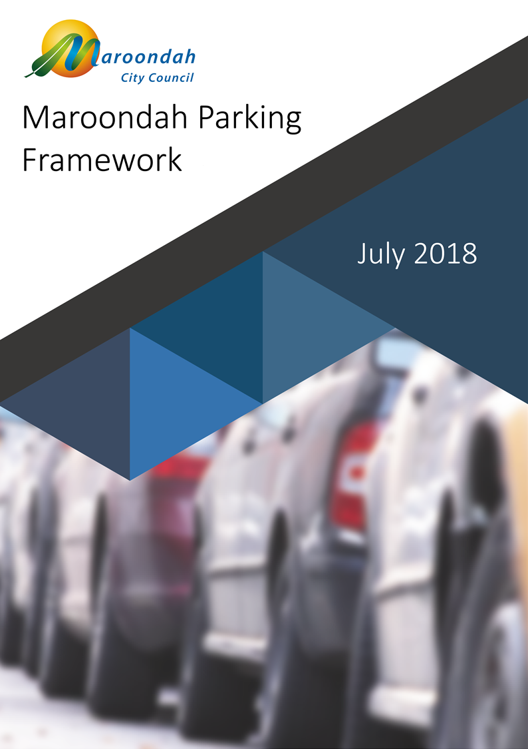

Contents
Introduction 2
The Parking Challenge 2
Parking in Maroondah 3
Our Vision for Maroondah 4
Our Vision for Parking in Maroondah 6
Guiding Principle 6
Key Directions 6
Achieving the Vision 7
General Approach to Local Parking Issues 7
Development & Planning Provisions 8
Parking Strategies 8
Parking Permits 8
Enforcement 9
Car Share 9
Paid Parking 9
Emerging Technologies 10
Planning Scheme Rates 10
Conclusion 10

Introduction
The Maroondah Parking Framework and Action Plan outlines how Council will manage and plan for our community’s future parking needs. It describes Council’s vision for the management of parking; identifies relevant policies and considerations that will inform decisions about parking; and establishes an action plan to help Council meet its objectives and responsibilities in relation to parking over the next four years. The framework responds to the community priorities expressed in Maroondah 2040 Community Vision and recognises the important contribution parking will make to the achievement of these objectives.

The Parking Challenge
Planning authorities have been grappling with parking-related challenges since the early 1950’s, when private vehicle ownership grew exponentially. In 1954, Melbourne’s first strategic planning scheme noted the “increasingly acute” problem of finding accommodation for parked cars in shopping strips; the solution to the parking problem was characterised as “one of the greatest challenges to city administrations the world over”.
Data captured by the Australian Bureau of Statistics (ABS) shows the magnitude of the problem confronting urban planners in 1955, at which time there were 153 passenger vehicles registered for every 1,000 Australian residents. By 2016, the rate of passenger vehicle ownership had risen to 579 per 1,000 people.,
In Maroondah, the rate of passenger vehicle ownership continues to grow. In 2011, Maroondah was home to 107,320 residents and nearly 64,150 cars; by 2026, it is expected that Maroondah’s population will reach 124,490 residents, who will own around 76,300 cars. If these forecasts are correct, Maroondah’s resident vehicle fleet will have grown by 19 percent over the 15 years between 2011 and 2026 – three percent faster than the forecast rate of population growth over the same period. Put simply, the number of cars in Maroondah is growing more rapidly than our population.
More recent data from the ABS confirms our growing preference for private vehicle ownership. As shown in Figure 1, the number of Maroondah households with at least one vehicle increased by 1,057 between the years 2006 and 2016; the number of households with two vehicles grew by 1,800; and households with three or more vehicles increased by 1,340. Over the ten-year period, the only category of vehicle ownership to decrease was car-free households, which fell in number by nearly 600 and now represents less than 4.8 percent of all households in Maroondah.
Figure 1 - City of Maroondah - Change in number of vehicles per household - 2006 to 2016

Parking in Maroondah
Other than clearways – for which VicRoads is the responsible authority – councils are generally responsible for managing parking in public spaces, as well as considering and setting parking requirements for new developments that incorporate parking on private land.
With population growth and increasing vehicle numbers, demand for parking space in Maroondah has never been greater. In many instances, parking demand already exceeds parking availability at peak times in and around activity centres. As the density of urban development increases – particularly in the Ringwood and Croydon activity centres – parking supply is likely to come under even greater pressure.
Parking needs and impacts vary according to the intensity and type of land use; often, parking associated with one land-use will spill over into adjacent areas, impacting nearby residents, businesses and other land users. Historically, the provision of adequate parking space has played a major role in shaping decisions about land use and amenity. Most often, this has occurred through the application of parking ratios in planning schemes that prescribe the number of parking spaces to accompany a development – an approach born in 1950’s America and adopted in the Melbourne Metropolitan Planning Scheme in 1954.
However, contemporary thinking is that this ‘planning scheme approach’ to parking may preference private vehicle accommodation over other planning considerations, such as accessibility, amenity and the use of alternative modes of transport. In the City of Maroondah, it is easy to see how the provision of more and more parking spaces at predetermined ratios could result in large parts of our activity centres being covered by asphalt as the density of development increases.
While our community sees the availability of public parking as important, it also recognises that it should not be the dominant factor in determining land use and amenity outcomes. Council must therefore consider how our parking resources can be managed in a manner that strikes an appropriate balance between diverse objectives and contributes to the realisation of our community’s vision for the municipality, as expressed in Maroondah 2040.
Given rapid advances in technology and on-demand convenient travel options, our approach to parking must also be capable of accommodating emerging disruptors – for example, the rapid uptake of plug-in electric vehicles; car-share services; and, potentially, self-drive vehicles. There are even some indications that younger generations may be moving away from car ownership altogether, toward a mobility framework in which transport is purchased just like any other service. Ultimately, the choices we make about parking provision in the City of Maroondah should be flexible enough to respond to these developments.

Our Vision for Maroondah
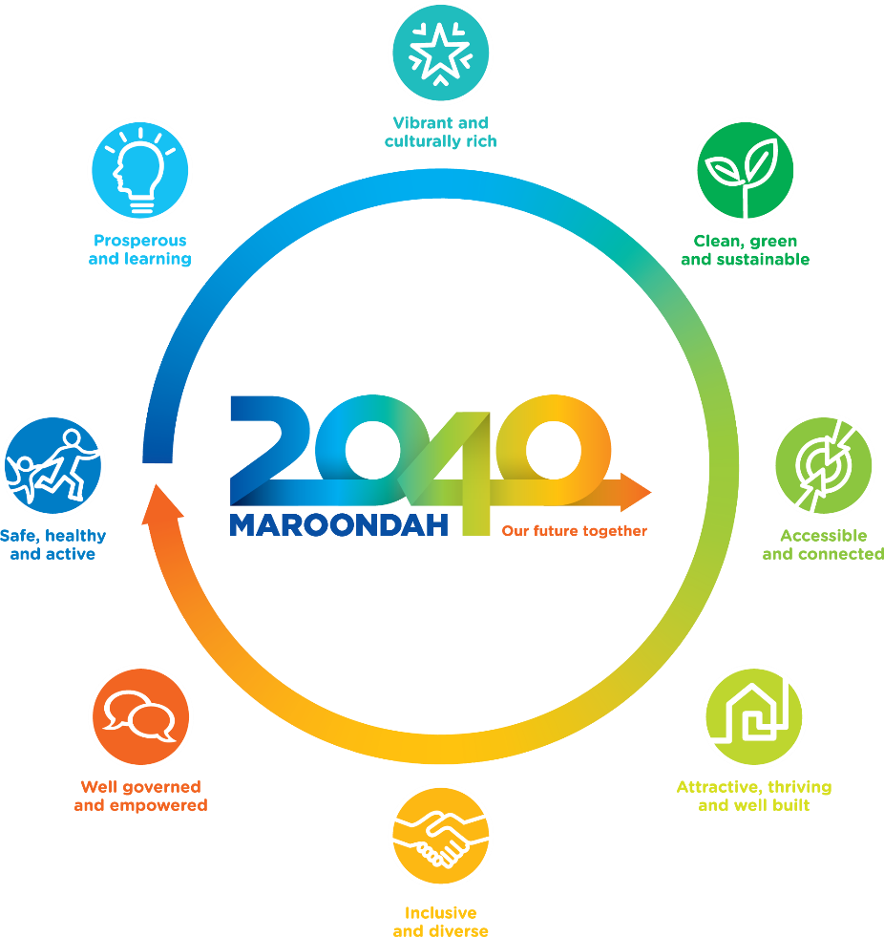
The Maroondah 2040 Community Vision is for “…a vibrant and diverse city with a healthy and active community, living in green leafy neighbourhoods which are connected to thriving and accessible activity centres contributing to a prosperous economy within a safe, inclusive and sustainable environment.” This vision is an expression of our community’s aspirations for the future of Maroondah, founded on eight future outcomes that reflect ideas and input from thousands of community members.
Figure 2 - Maroondah 2040 Community Vision is founded on eight future outcomes.
Maroondah 2040 is intended to serve as a roadmap to guide Council, members of our community and other levels of government as we work towards the future outcomes identified in the vision. It can be seen in Figure 3 how the achievement of these outcomes can be supported by effective parking strategies and management options.
Figure 3 - There are many ways that parking can contribute to our future outcomes.

 | “Maroondah is a safe, healthy & active community with local opportunities provided for people of all ages & abilities to have high levels of social, emotional & physical wellbeing.”  Appropriate & effective parking management, controls & enforcement strategies have a positive impact on accident rates and road safety.
 | “Maroondah is a thriving centre of economic activity & opportunity within the eastern region where the sustainability & growth of local businesses is supported. All community members, groups, education providers & local businesses have access to a wide range of quality learning resources & facilities.”  The application of good parking strategies supports economic activity by facilitating efficient vehicular access to businesses & service providers by customers, clients, suppliers & receivers.
 | “Maroondah is a creative cosmopolitan community recognised for its celebration & promotion of arts & culture. There are a broad range of engaging entertainment options, diverse cultural activities & the creation & display of traditional & contemporary forms of art.”  Well-designed parking infrastructure can be re-purposed for community uses at times of low demand.
 | “Maroondah is a green leafy community with high levels of waste diversion & sustainable approaches to infrastructure development, urban design & management of natural resources. Our community is resilient & has the knowledge, capacity & resources to make sustainable lifestyle choices.”  Appropriate parking strategies preserve open space, encourage use of more sustainable transport options & support the uptake of less polluting modes of personal transport.
 | “Maroondah is an accessible community for all ages & abilities with walkable neighbourhoods, effective on & off-road transport networks & access to a range of sustainable transport options.”  Well-designed & managed parking infrastructure is critical to an accessible city and integrated transport network.
 | “Maroondah is an attractive community with high quality residential & commercial areas incorporating infrastructure that meets the needs & aspirations of all ages & abilities. A diverse range of housing options are available & thriving activity centres provide a broad range of facilities & services to meet community needs.”  An appropriate supply of well-designed parking can ‘unlock’ valuable land for other uses, while smart management of parking space can ease congestion & facilitate access to activity centres.
 | “Maroondah is an inclusive community where social connections are strong across generations & diversity is embraced & celebrated.”  Contemporary parking strategies respond to individual differences in transport choices.
 | “Maroondah is an empowered community that is actively engaged in Council decision making through processes that consider the needs & aspirations of all ages & population groups. Council provides strong & responsive leadership, ensures transparency, while working with the community to advocate for & ‘champion’ local needs.”  Our parking strategies must be sound, with fair & effective enforcement processes that include appropriate mechanisms for review.

Our Vision for Parking in Maroondah
As the authority with primary responsibility for parking policy, allocation, management and enforcement in the City of Maroondah, it is important that the way Council manages our community’s parking resources keeps pace with changes in urban development trends and transport modes, as well as responding to diverse community needs. Council’s vision is that parking in Maroondah will be highly valued, well considered and carefully managed, contributing towards the achievement of the future outcomes that underpin Maroondah 2040.

Guiding Principle
Parking is a valuable resource that can deliver substantial public and private good when allocated effectively and efficiently. However, parking is only one of many factors that will play an important role in the future vibrancy and prosperity of Maroondah. In this context, parking will not be the determining factor for decisions about land-use across the municipality.

Key Directions
In managing parking in the City of Maroondah, Council will:
- ensure appropriate consideration of land use and amenity outcomes in the context of the overall objectives of Maroondah 2040;
- apply a balanced, transparent, contemporary approach that reflects best practice;
- support outcomes that enhance traffic safety, promote increased use of sustainable transport modes, and allow for emerging technologies and future trends;
- recognise that parking is a limited resource that has a value which – when warranted – should be reflected through appropriately priced paid parking or paid permit schemes in areas and times of high demand; and
- implement efficient and effective operational arrangements that support fair access to parking and enforce the strategic outcomes sought through parking management or permit schemes.

Achieving the Vision
As we work towards the future outcomes identified by our community in Maroondah 2040, Council acknowledges the need to rethink our approach to parking. While existing strategies and controls have served our community well for many years, the changing face of Maroondah presents new parking challenges for which we must seek new solutions.
As Figure 4 illustrates, the development of this parking framework has been influenced by issues such as parking supply and demand, ongoing changes in transport modes and the need for effective enforcement; and outlines options available to Council in response to these challenges. The framework will inform Council’s strategic response as it works towards the outcomes established in Maroondah 2040.

Informs
Parking Framework
Strategic Response
Supports

Figure 4 - The Parking Framework has been shaped by a wide range of issues & will inform Council's strategic response.

General Approach to Local Parking Issues
Council is frequently called upon to investigate and solve local parking problems. Hotspots for parking issues include areas near railway stations, activity centres, commercial hubs, schools, leisure precincts, industrial areas and hospitals. The following list gives a good indication of the breadth of parking-related issues managed by Council:
- Parking demand associated with land-use exceeding supply.
- Parking overspill from one land-use affecting neighbouring properties, public parking spaces, or roads.
- Nature strip and footpath parking.
- Parked vehicles obstructing driveways.
- Parked vehicles preventing rubbish collection.
- Safety of pedestrians and road users impacted by illegally parked vehicles – near intersections and pedestrian crossings, or obstructing roadways.
- Requests for new parking permit schemes.
- Parking permit regulation and fraud.
- Investigation of paid permit schemes.
- Review and enforcement of parking controls.
- Management and enforcement of private car parks.
- Installation and maintenance of parking signage.

In developing a response to parking-related problems, Council will have regard for the context in which the issue is occurring; the location of the problem within the municipality; likely causes of the problem; as well as our parking framework and vision for parking in Maroondah.

Development & Planning Provisions
While development size and type remain important factors in determining an appropriate amount of parking to be included in new developments, the availability of other parking options, access to alternative modes of transport and amenity outcomes should also be considered. Parking will not be the determining factor when considering land-use applications in Maroondah.

Parking Strategies
Council has previously endorsed high-level, area-specific strategies for the Ringwood Metropolitan Activity Centre and the Croydon Activity Centre. Both strategies have been instrumental in managing parking and setting parking requirements for new developments within our activity centres. Although still highly relevant, these strategies need updating to ensure that they align with the objectives of Maroondah 2040 and continue to be effective in managing future parking demand.

Parking Permits
Council currently operates both paid and free parking permit schemes that require relatively high levels of administration. There are paid schemes in place within activity centres and free permit schemes in other places of high demand within the municipality, such as the Maroondah Hospital precinct. More than 1,000 free permits are administered under these schemes, for which none of the administrative cost is recovered.
As the use of parking permits increases in line with demand, there is a need to ensure these schemes are effective; being used legitimately; and operate in a manner that sees the cost to administer and enforce the schemes transferred to those receiving the benefit. Accordingly, a full review of Council’s parking schemes is required, including a detailed assessment of the cost to run these schemes and appropriate rates of cost recovery.
In addition, Council will conduct a targeted review of parking arrangements within the Maroondah Hospital precinct, in the context of a planned future redevelopment of the hospital; existing residential parking restrictions; and the current parking permit scheme.

Enforcement
Council officers currently respond to more than 2,000 individual parking-related requests and issue over 12,000 parking infringements annually. Parking is a frequently searched item on Council’s website, with more than 2000 individual key searches registered per year.
Given the importance our community places on effective parking management, it is essential that restrictions, controls and permits are enforced – both reactively and proactively. It is also important for parking users to have confidence in the systems and processes that support enforcement practices.
Council will develop a car parking compliance and enforcement strategy, to improve the management of our parking resources through the application of best practice principles and explore opportunities to refine existing parking controls and enforcement procedures across the municipality. This strategy will be aimed at achieving an appropriate balance between proactive and reactive enforcement; education; and community outcomes.
Car Share
New transport modes and the growth of car share and ride share services are predicted to change travel behaviour in our cites over the next decade. Innovations in real-time public transport information, ride sourcing and car sharing are already important players in the transportation market in metropolitan Melbourne. These innovations are opportunities to diversify the mobility choices available to our community, offering a wider range of transport options to access employment, education, recreation and services.
Car share is expected to be one of the first ‘on-demand’ transportation services to extend to the City of Maroondah. Car share is an established low-cost alternative transport choice for residents and workers, which serves to fill a gap in city transport systems by allowing residents to access vehicles when they need them without owning a car. To help ensure the benefits of these programs extent to our community, Council will develop a position on the use of public spaces to support emerging transport options.

Paid Parking
In some parts of Maroondah, it is appropriate to consider the introduction of demand-based pricing for parking on Council land and paid permit schemes. This approach provides access to parking on fair terms, as well as producing revenue that can be used for improvements to roads and parking infrastructure. Drivers also recognise the value of parking – many motorists choose to pay to park their vehicles in privately run parking facilities, both in Maroondah and around metropolitan Melbourne.
The experience of cities around the world shows that direct management of access to parking through market-based mechanisms is one of the most efficient and effective ways to administer use of this limited resource., It is therefore appropriate to explore the introduction of paid parking as a mechanism to regulate access to parking in areas of high demand, such as in activity centres and near train stations.

Emerging Technologies
Advances in transport technology and new travel options must be anticipated and accommodated in our parking mix. The rapid uptake of plug-in electric cars and the development of self-driving vehicles are both examples of changes in private transport technology that will impact how we design, use and manage our parking resources.
At the same time, cities around the world are deploying intelligent parking platforms to improve parking management, user convenience and compliance. There is increasing interest in the real-time information this technology produces; the insights it offers into driver behaviour and parking space turnover; and how this data might be used to ease traffic congestion and benefit motorists by guiding drivers directly to a vacant parking space.
Our approach to parking design and allocation will be flexible and responsive to developments in transport and parking technology.

Planning Scheme Rates
Parking polices that set parking rates can have unintended consequences. If too much parking is required of a new development, valuable land may be ‘locked up’ and the cost for underutilised parking passed on to tenants and building occupants. Conversely, parking rates that are set too low for a new development may lead to problems with parking overspill, which can adversely impact amenity and accessibility in nearby streets and limit access to parking for existing users.
In built-up areas where demand for parking is high, or where access to alternative modes of transport is good, public parking responses can be market-driven, with pricing determined in the context of the value provided to nearby developments. Under these conditions, it may be reasonable to explore alternative solutions to the parking needs of new developments, such as developer contributions towards the cost of Council-provided public parking infrastructure or sustainable travel options in lieu of physical parking spaces.
Where access to parking and alternative transport options is poor, Council will advocate for developers to provide additional visitor and publicly accessible parking spaces as part of new developments.

Conclusion
Parking is a valuable resource that makes an important contribution to the achievement of the future outcomes our community has identified through Maroondah 2040. With population growth and more intensive development, we need to rethink the way we allocate, manage and price parking options, to help ensure our parking resources can continue to meet the needs of local road users, businesses and residents into the future. As well as ensuring parking controls remain up-to-date and well aligned to the needs of nearby land-uses, Council will continue to explore new mechanisms to address parking demand and provide fair and equitable access to parking space across the municipality.

Melbourne and Metropolitan Board of Works (MMBW), Melbourne Metropolitan Planning Scheme, Melbourne: MMBW, 1954, pp11 & 62.
ABS, Release 4102.0 - Australian Social Trends – Car Nation, July 2013.
ABS, Release 9309.0 - Motor Vehicle Census, Australia, Jan 2016.
Barber, H., 3 Million Cars – Motorisation in Melbourne, Phillip Boyle & Assoc., Melbourne, 2016.
MMBW, Melbourne Metropolitan Planning Scheme, 1954.
Consultation during the development of Maroondah Community Vision 2040 identified parking at railway stations and activity centres as a critical issue to be addressed.
Driver licensing rates among Victorians aged 18 to 30 years have been falling since 2001 in metropolitan areas. Source: Royal Automobile Club of Victoria (RACV), Young Adults Licensing Trends – 2017 Update, RACV, Melbourne, 2017.
Shoup, D., The High Cost of Free Parking, New York, Routledge, 2011.
Pierce, G., Willson, H. and Shoup, D., Optimizing the use of public garages: Pricing parking by demand. Transport Policy (44), 2015, pp.89-95.

