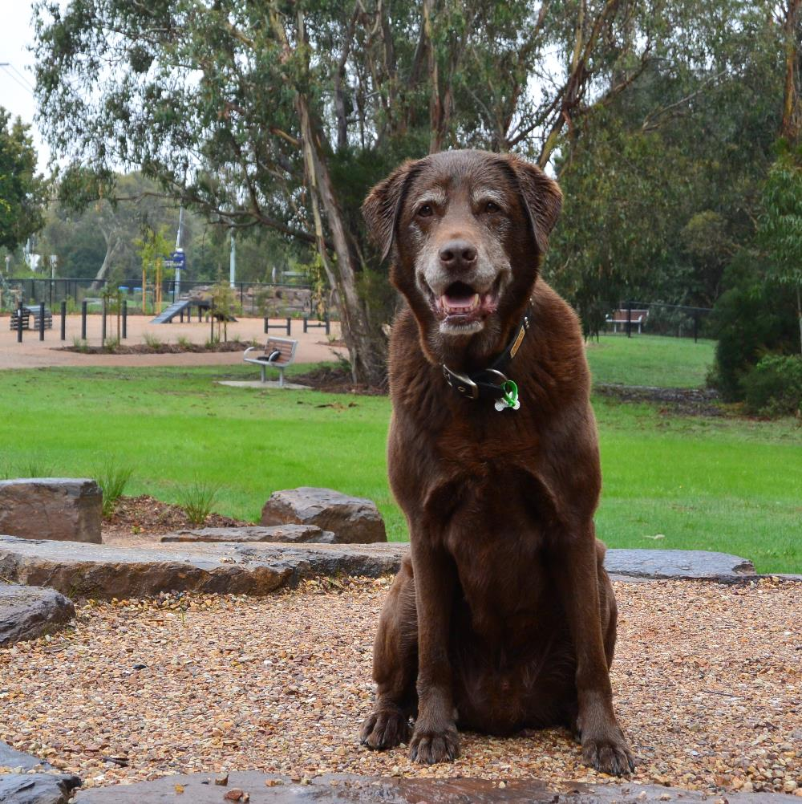
“Pets are a part of Community - not just something to be managed or controlled.”
DAMP survey respondent

“I have mental health issues and often struggle with social situations. But when there is a dog or other animal I'm a completely different person….. I can get out more and I feel like it helps me from being too isolated in my own home”
DAMP survey respondent

Executive Summary
The Maroondah Domestic Animal Management Plan identifies the ongoing and emerging issues that Council needs to consider and address over the next four years. It provides the service planning and delivery framework for animal management services. It also provides an overview of the ongoing compliance and education activities carried out by Council.
As of April 2017 there are 13,065 dogs and 5,033 cats on Council’s pet registration database.
Research tells us that pets are an important part of families, are considered as members of the family not ‘companion animals’ as in the past; are cherished because they give ‘unconditional love’, and are likely to be credited for giving an overwhelming majority of residents a ‘strong reason for living’.
The Domestic Animal Management Plan summarises the research carried out for the project and makes thirty nine recommendations on nine topics. The recommendations outlined in this plan will be addressed over the next four years.

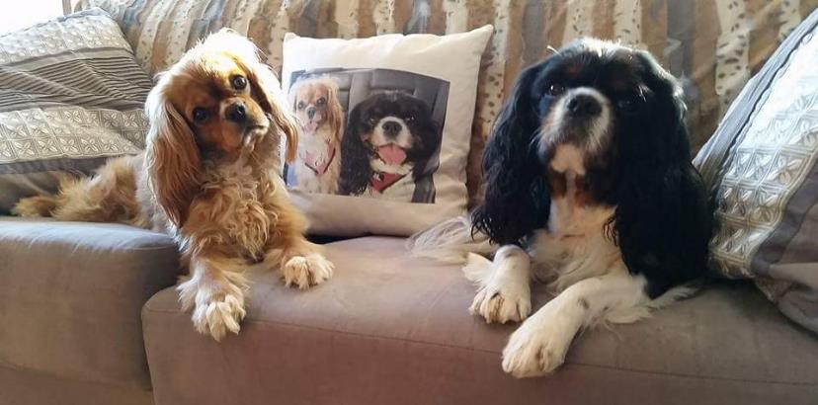

What We Aspire to Achieve
A community that embraces the important role pets play in the lives of many residents, where people and pets live in harmony with each other and where animals are treated with respect and compassion.

TABLE OF CONTENTS
Executive Summary .…3
Our Maroondah 2040 Community Vision………………………………………………………………………..6
1. Introduction 7
1.1 What is the purpose of the Domestic Animal Management Plan?..................................... 7
1.2 What are domestic animals?.................................................................................................... 7
1.3 Some key pet statistics / Pet Ownership 7
1.4 The importance of pets 8
1.5 The Victorian Domestic Animals Act 9
2. Maroondah Animal Management Service Achievements since 2012 10
3. Animal management services in Maroondah 10
3.1 Our Aspirations and principles 10
3.2 Our Team 11
3.3 Local Laws, 'Orders'………………………………………………………………………………....... 11
4. A strategic framework for animal management 13
4.1 Focus area one - Service Management including Training of ‘Authorised Officers’ 13
4.1.1 The key messages from our consultation and research 13
4.1.2 Additional Animal Management staff training 14
4.2 Focus area two - Registration and identification 15
4.2.1 The key findings from our consultation and research 15
4.2.2 Strategies to address new and emerging issues 16
4.3 Focus area three - Dealing with nuisance issues 17
4.3.1 The key findings from our consultation and research 17
4.3.2 Strategies to address new and emerging issues 18
4.4 Focus area four - Dog attacks 19
4.4.1 The key findings from our consultation and research 19
4.4.2 Strategies to address new and emerging issues 20
4.5 Focus area five - Managing dangerous, menacing and restricted breed dogs 21
4.5.1 The key findings from our consultation and research 21
4.5.2 Strategies to address new and emerging issues 21
4.6 Focus area six - Overpopulation (including euthanasia) and welfare of pets 22
4.6.1 The key findings from our consultation and research 22
4.6.2 Strategies to address new and emerging issues 23
4.7 Focus area seven - Domestic animal businesses 24
4.7.1 The key findings from our consultation and research 24
4.7.2 Strategies to address new and emerging issues 24
4.8 Focus area eight - Provision for dogs off leash 25
4.8.1 The key findings from our consultation and research 25
4.8.2 Strategies to address new and emerging issues 26
4.9 Focus area nine - Pets and People 27
4.9.1 The key findings from our consultation and research 27
4.9.2 Our plans to address priorities for the next four years 28
5. Consolidated Action Plan 29
6. Planning for pets and pet owners 35
6.1 How we prepared the Domestic Animal Management Plan 35
7. How we will implement the Domestic Animal Management Plan 35
7.1 Setting priorities for the next four years 35
7.2 Monitoring and reviewing the Domestic Animal Manangment Plan……………………… 35
7.3 Key Service Information 35
8. Appendices 36
Appendix 1 – The Domestic Animals Act requirement of Council 36
Appendix 2 – Key statistics 37
Appendix 3 – Operational Information 41
Appendix 4 - Glossary……………………………………………………………………..………….44

Our Maroondah 2040 Community Vision
In 2040, Maroondah will be a vibrant and diverse city with a healthy and active community, living in green leafy neighbourhoods which are connected to thriving and accessible activity centres contributing to a prosperous economy within a safe, inclusive and sustainable environment.

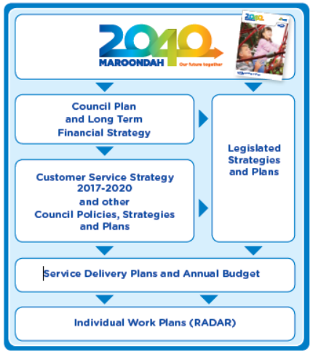

A safe, healthy and active community
Our community appreciates the family friendly atmosphere provided in Maroondah. The wide range of local parks, playgrounds, sporting and recreational facilities in Maroondah is strongly valued by the community. It is felt that enhancements to local leisure and recreational facilities in the future will help to ensure they cater for a broad range of age groups and abilities and recreation pursuits.

Our Mission
Maroondah City Council will be an effective and dynamic leader, working in partnership with the community, business and other spheres of government to foster quality, accessible and sustainable lifestyles for the community.

Introduction
  - What is the purpose of a Domestic Animal Management Plan?
A Domestic Animal Management Plan identifies the ongoing and emerging issues that Council needs to consider and address over the next four years. It provides the service planning and delivery framework for animal management services, and includes the timeframe during which Council will address priorities identified in the Plan.
The Plan also provides an overview of the ongoing compliance and education activities carried out by the Animal Management Officers in the Local Laws Department.

  - What are domestic animals?
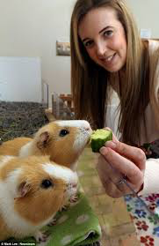
Domestic animals are generally those animals that reside as companions to people living in residential properties.
Pet owners told us that they consider many animals … other than cats and dogs to be ‘their pets’
While the Domestic Animals Act only makes requirements for the management of cats and dogs, Council recognises that residents have a large variety of other animal species as pets.
The Domestic Animal Management Plan also acknowledges those cats and dogs that are not currently living in a secure and caring home. These are the animals currently in shelters waiting to be adopted, and pets that may wander our neighbourhoods but for whom no one takes full responsibility.
The type and approximate number of pets in Australian households include:
Dogs – 4.8 million
Cats – 3.9 million
Fish – 8.7 million
Birds – 4.2 million
Small mammals (rodents, guinea pigs etc.) – 537,000
Reptiles – 415,000
Other pets – 1.6 million

Some key statistics on pet ownership
In Australia between 2013 and 2016, there was a 6.5% increase in cat ownership, a 2.8% increase in dog ownership, and a 10.8% increase in ownership of other pets including reptiles and rodents. In the same time, there has been a decrease in the ownership of fish (-21%) and birds (-8.6%). The number of households owning pets has remained fairly stable at 62% between 2013 and 2016.
In 2017 there are 13,065 dogs and 5,033 cats on Council’s pet registration database. This is 1,059 fewer dogs and only 2 more cats than on the database in 2012/13. The overall decrease in pets listed in the database is as a result of redundant listings having been removed.
Data released in 2016 indicates there could be up to 20 dogs and 16 cats for every 100 people in Australia. Actual cat and dog ownership rates might be more or less in some areas depending on household type, the level of urbanisation and socio-economic factors.

Table 1 – Cat and dog registrations
in Maroondah
Criteria | 2012/13 | 2016/17 | +/-
Cats | 5031 | 5033 | +2
Cats / 100 residents | 4.7 | 4.4
Dogs | 14124 | 13065 | -1059
Dogs / 100 residents | 13 | 11
For Maroondah this means there may well be a significant number of cats and dogs that are not registered. Compared to a number of nearby eastern Melbourne Councils, Maroondah would appear to have a slightly higher rate of registration for cats and a slightly lower rate of registration for dogs.
The suburb in Maroondah with the largest number of registered cats is Croydon: and the suburb with the largest number of registered dogs is also Croydon.
The Domestic Animals Act requires Council to collect data about cats and dogs and monitor trends that may require intervention. A full account of this data is provided in Appendix 2.

The importance of pets
Research conducted by Animal Medicines Australia shows a marked change in the role of dogs and cats in Australian households since 2013. Australians are disclosing that they have a far more personal relationship with their pets now, than in the past. This is indicated by the significant increase in the proportion of owners who see their pets as a member of the family rather than as merely companions.
Pets are important members of Maroondah and other outer eastern Melbourne metropolitan households, as indicated by community survey responses. These respondents told us :
- Pets are an important part of their family (M 90% / OEC Av. 91%)
- It is important for them to have an animal in their life (M 91% / OEC Av. 89%)
- Their pets are important because they give their owners unconditional affection (M 89% / OEC Av. 85%)
- They talk to more people because they have a pet (M 80% / OEC Av. 73%)
- They or their family exercise more because they have a pet (M 67%) / OEC AV. 68%)
The importance of pets is even further reflected by the 82% of Maroondah survey respondents who told us that their pets give them a ‘strong reason for living’ (OEC Av. 74%).
Research cited in a number of research publications now shows that pets greatly benefit the economy and provide far more than companionship for their owners.

‘Children reported strong relationships with their pets relative to their siblings, with lower levels of conflict and greater satisfaction in owners of dogs than other kinds of pets.’
Source ref/photo: Journal of Applied Developmental Psychology

- Pet owners are significantly more likely to get to know people in their neighbourhood than non-pet owners
- Around 40% of pet owners reported receiving one or more types of social support (i.e. emotional, informational, appraisal, instrumental) via people they met through their pet.
- Self-esteem has been shown to be higher in children or adolescents who have a pet
- People who own pets typically visit the doctor less and on average have lower cholesterol and lower blood pressure
- Having a companion animal is understood to decrease the likelihood of a heart attack by 3%
- Companion animals reduce the sense of loneliness in some population groups
- Australians now spend 35% more on their cats and 33% more on their dogs than they did in 2013, a spend that equates to $12.2 billion in 2016.

The Victorian Domestic Animals Act
The Victorian Domestic Animals Act requires all Victorian Councils to prepare a Domestic Animal Management Plan every four years. The purpose of the plan is to outline how they will address matters associated with cats and dogs. It does not make any requirements on Council in relation to other pets.
The Act stipulates a number of matters that Council must address as part of the plan. These matters relate to:
- Establishing the measures and processes for:
evaluating the effectiveness of the service and associated programs
reviewing local laws and orders
- Ensuring residents and Council comply with the Act, particularly in relation to:
the identification and registration of cats and dogs
the training of staff
minimising risk and nuisance associated with:
dogs, including dog attacks, barking dogs, wandering dogs, dogs defecating in public place, and dogs that are declared as ‘dangerous’
cats, including cats trespassing
- animal welfare including the high euthanasia rates associated with cats and dogs
- the management of animals in times of natural disasters.

Maroondah Animal Management Service achievements since 2012
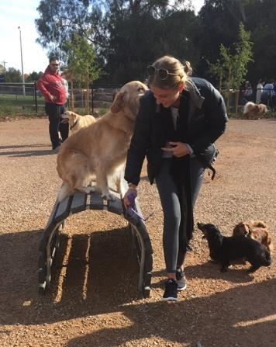
The primary responsibility for addressing the needs of the community in relation to pets is with Maroondah’s Animal Management Services team. However, the Domestic Animal Management Plan acknowledges that there are a number of Council service areas that contribute to achieving pet related outcomes for the community.
Love the new dog park - well done!
Ref: Survey respondent

These include Assets who are involved in the planning of open space opportunities and areas for dog owners; Community Services who work with families and their pets in times of family crisis; Operations who maintain parks, paths and dog park and Emergency Management Services who are required to provide for pets at evacuation centres in times of natural disaster.
The following highlights some of the achievements from the 2012-2016 Domestic Animal Management Plan
- Enhanced data collection and monitoring systems
- More highly skilled workforce and integrated service delivery processes
- Strengthened relationships with local veterinary surgeries regarding the return of lost pets to owners
- Construction of Eastfield Dog Park

Animal management services in Maroondah

Our aspirations and principles

What we aspire to achieve
A community that embraces the important role pets play in the lives of many residents; where people and pets live in harmony with each other; and where animals are treated with respect and compassion.

The principles that guide how we will achieve our aspirations
Principle 1 - Council seeks to strengthen our relationship with pet owners and the wider community to ensure the wellbeing of pets living in Maroondah.
What does this principle mean:
Council seeks to work in partnership with the community to assist pet owners and their pets in times of crisis
Council seeks support from the community to address the less positive behaviours and attitudes of some pet owners.
Council seeks to identify and support community groups, opportunities and initiatives associated with pets in our community

Principle 2 – Council is required by law to ensure our residents comply with Victorian Government legislation, but we also acknowledge the changing needs of our service and expectations of our community.
What does this principle mean:
Council has a primary obligation to ensure that pet owners comply with Victorian Government legislation, local laws and orders, and Council policies.
Council seeks to highlight the potential personal, social and economic benefits of pet ownership.
Council will advocate for the welfare of pets; and provide access to public spaces.

Principle 3 – By owning a pet, pet owners accept that:
they have an obligation to ensure the wellbeing of their pet.
they must comply with all relevant government legislation and policies relating to the ownership of their pet.
What does this principle mean:
Pet owners must ensure their pet is treated humanely and with compassion.

Principle 4 – Council understands that pets are important to many of our residents and visitors to Maroondah.
What does this principle mean:
Council has an obligation to manage its service in line with relevant legislation and policies.

Our Team
The Local Laws Service team are ‘Authorised Officers’ and trained across all aspects of Council’s local laws service. This provides Council with the flexibility to deal with animal management issues during time of high demand and in emergency situations.
Some of these situations include:
- Collection of contained and lost pets (daytime and after hours service)
- Administration including pet registrations, issuing of permits
- Ensuring state legislation and Council policies are enforced
- Monitoring of on leash and off leash areas in parks and reserves
- Providing advice to pet owners and relevant information to the wider community
- The inspection of animal businesses and animals with special registration requirements
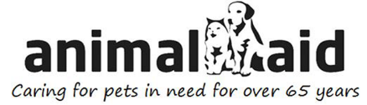
- Managing conflicting community attitudes and expectations relating to pets in places such as parks and along trails
Animal Aid works closely with Council’s animal management team as Maroondah’s prefered pound and animal shelter service.
- Addressing requests and complaints
- Managing the pound contract and associated programs
Council has a number of policies and procedures that underpin the operations of animal management services. These are listed in Appendix 3.

  - ‘Local Laws’, ‘Orders’
There are a number of ordinances that residents must comply with if they own or are responsible for the care of animals, or manage animal businesses or facilities. The following provides a summary of these ordinances:
Local Law 11, Section 43 – Provision of effective fencing to prevent animals from escaping
This local law requires the owner of the animal and the owner of the property to ensure that fencing is adequate.
Local Law 11, Section 41 – Removal of animal faeces
This local law specifies that a person in charge of an animal must:
remove the animal’s faeces from road reserves, Council land, or property owned or occupied by another person;
carry a device suitable for cleaning up animal faeces, and must be able to produce such a device;
Table 2 – Type and Number of animals that can be kept on properties in Maroondah 0.5 ha or less without a permit
Types of Animals | Number
Dogs | 2
Cats | 2
Domestic Birds | 20
Poultry (no roosters permitted) | 5
Pigeons | 20
Ferrets, Guinea Pigs, Rabbits or Rodents | 5
dispose of the animal’s faeces such that it is not hazardous or a nuisance.
Local law 11 Section 40 – limits on the number of animals kept
This local law specifies the number of animals residents can keep on Maroondah properties of half an acre or less without a permit. It also specifies that residents cannot keep any more than four different types of animals, and identifies the type of animals residents are not permitted to keep.
Animals that are not permitted on properties of half an acre or less are, roosters, large birds, horses, donkeys, cattle, sheep, alpacas, llamas, goats, pigs or any other type of agricultural animal.
Section 26 Order in Council – (February 20, 2012)
Section 1 - Restraint of dogs

This section:
stipulates how dogs must be controlled when in public places.
requires dogs to be on a leash when within 15 metres of a playground, public picnic facilities and barbecue, a sporting event.
Section 3 – Off leash areas
This section identifies 35 sites where dogs can be off leash.
Section 4 – Dogs and cats prohibited
This section identifies 10 sites where dogs and cats are not permitted
Section 5 – Confining of cats.
This section requires cats to be confined to owner’s property (either inside building or in a properly constructed enclosure) from sunset to sunrise each day.

A strategic framework for animal management.
This section provides an overview of the findings from consultation and research carried out for the DAMP, and provides a summary of new initiatives that will be considered over the next four years.
Ongoing compliance and educational activities that are carried out as standard practice are outlined in Appendix 3.

Focus area one - Service management including training of ‘Authorised Officers’
Objectives:
- Animal Management Services will:
be responsive to the changing needs and expectations of the service
be at the forefront of innovation in delivering the service
- Staff will be appropriately trained and experienced to deal with the requirements of the service, and encouraged to contribute original and effective ideas on how to deliver the service in the future.

The key findings from our consultation and research
- There is an increasing expectation from communities that animal management services will do more than managing animal related problems. That is, Councils should be raising awareness to address pet wellbeing issues.
- The Animal Management Services team wants the community to understand the passion the team has for the work they do, and to change the perception some members of the community have about the service.
- There are opportunities to use existing lines of communication more effectively to promote the service, provide information that explains the rationale for service protocols e.g. barking dog complaint process (current), and addressing issues associated with the semi-owned cat populations (future).
- Ensure information about impounded/surrendered animals is detailed enough to enable accurate analysis of issues and targeted strategies to address issues.
- There was only a small response to the community survey so only general comments should be made in relation to results. Where relevant, findings from surveys conducted by other LGAs the eastern metropolitan region have been noted.
The surveys indicated:
Those who have had contact with the Animal Management Services consider the team in a positive light. There is likely to be a large sector of the community that does not know of the work the service provides. As a result there may be public relations opportunities associated with ‘celebrating’ or promoting the good news stories associated with the service more effectively.
A major pet related event in the city would be well received.
67% (OEC Av. 70%) said Council’s website could have more information about caring for pets.
55% (OEC Av. 50%) said it would be good to know what dog obedience or dog activity groups they could join.
residents expect more than a compliance / punitive relationship with Council when it comes to pets.

Additional Animal Management staff training
OB | ACTION | RESPONSIBILITY COUNCIL ROLE | MEASURES | TIMEFRAME
 | Develop a plan for raising the profile and awareness of the scope of the service. | - Lead LL  - Support OERCs  - Role CL | - Plan developed  - Plan implemented as per agreed timelines | - 2018/19 Planning
 | Consider the merits of introducing a Pet based family event that has a focus on:  profiling the scope of the service  building community relationships to address key service issues e.g. control of dogs in off leash areas  profiling community support groups and agencies | - Lead LL  - Support OERCs  - Role CL | - Event scoped | - 2018/19 Planning
 | Animal Management Officers to undertake Common Risk Assessment Framework (CRAF)or similar training (Domestic Violence) | - Lead LL  - Support LL  - Role CL | - All staff to complete training over the next 4 years | - 2018/21
 | Review Council’s website and other communication channels with a view to:  Providing more relevant pet care/welfare information | - Lead LL  - Support OERCs  - Role CL | - Options investigated, documented & costed, timelines agreed  - Implementation of actions as per timelines | - 2018/21
 | Work with Animal Aid to ensure documenting of detailed information for all impounded and surrendered animals. Information should include:  At time of intake:  - Intake by species  - Intake type e.g. ranger pick-up, surrender, stray, trapped, involved in incident  - Address where animal came from/was collected from  - Approximate age of animal e.g. puppy/kitten vs. adult  - Sex and sex status i.e. desexed or entire  - If registered and microchipped at time of intake  - If surrendered, what are reasons  At time of outgoing:  - Reclaimed, adopted, transferred to other facility/rescue group  - If euthanised, the reason | - Lead LL  - Support LL  - Role CL | - Intake and outgoing information requirements implemented | - 2018
OB = Objective; CL=Council; LL=Local Laws; MAV=Municipal Association of Victoria; OERCs=Outer East Regional Councils * Lead Dept / agency

Focus area two - Registration and identification
Objectives:
- To optimise pet registrations.
- To maintain accurate animal registration and identification records.

Appendix 2 contains detailed information about cats and dogs in Maroondah. This information is used to set performance targets for the service, and importantly to identify any animal management and welfare trends that Council may need to address.

The key findings from our consultation and research
- All pet owners are required by law to register their cats and dogs with their local Council.
- Based on cat and dog registrations there would appear to be approximately 11 dogs and 4.4 cats for every 100 households in Maroondah.
- Compared to statistics reported in the previous DAMP (2012/13), there were approximately double the number of dogs and cats impounded in 2016/17. Of the 269 dogs and 155 cats impounded in 2016/17, 92% (246) of the dogs, but only 26% (40) of cats were claimed by an owner.
- Compared to a number of nearby Local Government Areas there are fewer entire dogs, as a percentage of registered dogs on Council’s registration database (9.6%). This does not necessarily mean that there are fewer entire dogs in Maroondah than elsewhere. It could also mean that fewer entire dogs are registered, or registered as entire.
- Council makes every effort to reunite pet owners with their pets as quickly as possible in order to minimise distress to the pet and the owner. Accurate and visible identification tags make this a less onerous process and may result in the pet being returned home rather than be taken to the pound. Pet owners will generally still be subject to the relevant penalties.
- Council recognises the industry research that indicates many residents do not see value for their pet registration, particularly cat owners, and understands there is a need to better inform the community as to the scope of the service. As with all community services, residents make a contribution regardless of the level of use of that service or benefit they may receive in any period of time
Table 3 – Number of cats and dogs in Maroondah
 | CATS | DOGS
2012/13 | 5031 | 14,124
2016/17 | 5033 | 13,065
- There are multiple microchip databases operating in Australia, which does not make it easy for pet owners to keep track of their pet’s information, or change it as required. Some databases are state specific and so when pets move interstate their information is not necessarily available via a national database. Multiple databases also make it difficult for local Councils to cross reference records and to find owners when pets are picked up outside their property.
- In recognition of the need for a national pet registration and identification system, the Municipal Association of Victoria (MAV) is seeking Federal Government support to develop a centralised pet management system. It is proposed that the system be fully integrated to include all information relating to the care and management of a pet.

Strategies to address new and emerging issues
OB | ACTION | RESPONSIBILITY COUNCIL ROLE | MEASURES | TIMEFRAME
 | Research successful strategies employed by other LGAs to increase compliance with registration requirements and consider how they might be applied in Maroondah. Consider strategies associated with:  - Targeted educational programs (e.g. localised programs)  - Social media | - Lead LL  - Support OERCs  - Role CL | - Strategies investigated/ researched  - Initiatives to increase rates of registration implemented | - 2018/21
 | Consider opportunities/further opportunities associated with:  - microchipping days/events  - low cost desexing initiatives | - Lead LL  - Support LL  - Role CL | - Opportunities/benefits considered  - Events/activities implemented (depending on above) | - 2019  - 2020
 | Update Council’s registration database including by:  - cleansing of all deceased / relocated pets etc.  - cross referencing with microchip databases | - Lead LL  - Support LL  - Role CL | - Updating of database undertaken | - 2018
 | Consider the development of ‘new resident’ Pet Ownership Pack | - Lead LL  - Support OERCs  - Role CL | - Action determined  - Pet ownership Pack developed (depending on above) | - 2019  - 2020
 | Support the MAV advocacy to the Federal Government for a single industry microchip and registration database, and funds to develop the database. | - Lead CL LL MAV  - Support OERCs  - Role CL | - Regional advocacy plan established | - 2018 - ongoing
 | Map cat and dog ownership on Council’s mapping system to identify areas of low registration and target as part of annual door knock | - Lead LL  - Support LL  - Role CL | - Door knock of low registration areas | - 2020
OB = Objective; CL=Council; LL=Local Laws; MAV=Municipal Association of Victoria; OERCs=Outer East Regional Councils * Lead Dept / agency


  - Focus area three - Dealing with nuisance issues
Objective:
- To minimise the number of complaints about pets.

The key findings from our consultation and research
- In 2016/17 there were 1,625 complaints relating to pets, an increase of 385 from the 2012/13 figures. As a proportion of the population, pet related complaints/requests increased 11.5 (2012/13) to 14.3 per 1,000 residents in 2016/17.
- The most significant increase in customer requests/complaints relate to:
Barking dogs – there were 233 complaints/customer requests relating to barking dogs in 2016/17, a fourfold increase on 2012/13 numbers (54).
Cat nuisance – there were 260 complaints/customer requests relating to nuisance cats in 2016/17, a threefold increase on 2012/13 numbers (92).

- As a percentage of all animal related customer requests/complaints, the following were the most common:
‘More education regarding up to date science based information on dog behaviour and training for dog owners.
… and engage qualified trainers and behaviourists to help resolve problem behaviour such as excessive barking and aggression.’

DAMP survey respondent

Ref: Milbemax ‘Dirty Dog’ study

Dog nuisance (16% of animal related complaints)
Cat nuisance (16% of animal related complaints)
Dog barking (14% of animal related complaints)
Dog wandering (9% of animal related complaints)
- There were 866 infringement notices issued in 2016/17 compared to 561 in 2012/13, an increase of 2.4 per 1,000 residents. The most significant increase in infringement notices related to dog and cat nuisance, a threefold increase from 95 in 2012/13 to 286 in 2016/17.
- The trends are similar to survey results from nearby LGAs in terms of the issues for residents over the past 12 months:
barking dogs.
cats not being confined at night.
cats wandering into gardens.
dog owners not picking up after their dogs.
- Only 56% of dog owners always clean up after their dog in public areas.
- 70% of dog owners over 65 are likely to pick up dog poo every time, but only 39% of 18 -24 olds are as diligent.

Strategies to address new and emerging issues
OB | ACTION | RESPONSIBILITY COUNCIL ROLE | MEASURES | TIMEFRAME
 | Investigate potential benefits of enlisting the help of an animal behaviourist as an intervention or to provide / develop literature for use by Council and owners in relation to barking dog complaints. | - Lead LL  - Support OERCs  - Role CL | - Options cost/benefit considered  - Implemented as determined | - 2019  - 2020 +
 | Consider developing a list of commercial providers that can work with residents to address:  - dog obedience/control issues that occur in public places  - barking dog issues | - Lead LL  - Support LL  - Role CL | - List developed / liaison with potential project/ promotional partners | - 2019  - 2020/21
 | Consider partnerships with commercial providers and community groups e.g. dog clubs | - Lead LL  - Support LL  - Role CL | - Promotion of providers/programs | - 2020/21
 | Consider a litter bag dispenser and bin policy that will determine where bins and dispensers should be provided | - Lead LL  - Support LL  - Role CL | - Policy scoped | - 2018
 | Review the schedule for the patrolling of parks, particularly addressing ‘high complaint’ parks | - Lead LL  - Support LL  - Role CL | - Schedule reviewed and implemented accordingly | - 2018
 | Purchase of additional cat trapping cages if demand continues | - Lead LL  - Support LL  - Role CL | - Cat traps acquired if demand warrants | - As required
 | Investigate successful industry/sector programs that have achieved reduced incidents of cat trespass/wandering | - Lead LL  - Support OERCs  - Role CL | - Investigation/research undertaken  - Initiatives considered for implementation | - 2019/20
 | Prepare information sheet/checklist for residents using cat traps e.g. humane treatment, safe operation of cages | - Lead LL  - Support OERCs  - Role CL | - Information sheet/checklist developed and made available | - 2018/20
 | Develop an information package for cat owners whose cats are the subject of cat trespass complaints | - Lead LL  - Support OERCs  - Role CL | - Information package prepared and made available | - 2018/20
OB = Objective; CL=Council; LL=Local Laws; MAV=Municipal Association of Victoria; OERCs=Outer East Regional Councils * Lead Dept / agency

Focus area four - Dog attacks
Objectives:
- To reduce the number of dog rushes and attacks
- To collect data on dog attacks that can better inform future community awareness initiatives
- To increase community awareness of the need to actively supervise dogs at all times, when in public and around children and vulnerable adults.

The key findings from our consultation and research
- In 2016/17 there were 54 customer requests/complaints involving reported dog attacks, representing 3% of all animal related complaints. This is significantly lower than the 84 complaints logged 2012/13 (13% of all animal related complaints)
- Council data differentiates dog ‘attacks’ from dog ‘rushes’ to better distinguish between extreme acts of aggression and other incidents
"Rushed" means that the dog has approached a person within three metres in a menacing manner, this includes displaying aggressive behaviour such as snarling, growling.
- About dog attacks
Dog bites and attacks in pubic places account for the minority of dog attacks. Most incidents of this nature occur in the home, and the victims are more likely to be young children than any other age group
Dog attacks and bites that occur in the home are generally not reported to any authority unless the incident is extreme. It is generally only dog attacks that occur in public places that are reported to Council. As a result, it is difficult to assess the actual number of dog attacks that occur in the community (including in the home), because families are reluctant to report an incident involving the family dog
Children are at least three times more likely to experience a dog bite needing medical attention than are adults


- The Australian Veterinary Association cautions against assuming that aggressive behaviour is specific to certain breeds. Instead the association reports that the tendency of a dog to bite is dependent on at least five interacting factors including heredity (genes, breed), early life experience, the type of socialisation and training a dog has been exposed to, the dog’s health, and the behaviour of the victim.
Dog bites or attacks on people generally occur as a result of human behaviour, and bites to children at home generally occur when there is no adult supervision

Strategies to address new and emerging issues
OB | ACTION | RESPONSIBILITY COUNCIL ROLE | MEASURES | TIMEFRAME
 | Investigate methods to reach target groups with information about:  - managing children around dogs  - education of children about the handling of dogs  Consider more targeted communications to promote awareness of appropriate handling of dogs | - Lead LL  - Support OERCs Animal Aid Local Media Schools  - Role CL  - Lead LL  - Support Animal Aid  - Role CL | - Opportunities through which to target information and relevant partnerships established  - Promotional strategies implemented | - 2019  - 2020/21  - 2019-21
 | Enhance the promotion/distribution of information that assists residents to make appropriate pet selection, particularly in relation to dogs. | - Lead LL  - Support Animal Aid  - Role CL | - Information more widely promoted in conjunction with promotional partners | - 2019/20
 | Review the data collected relating to dog attacks in order to identify if there are any patterns/trends that could be addressed via targeted strategies. | - Lead LL  - Support LL  - Role CL | - Data reviewed and additional data collected if required | - 2018
OB = Objective; CL=Council; LL=Local Laws; MAV=Municipal Association of Victoria; OERCs=Outer East Regional Councils * Lead Dept / agency

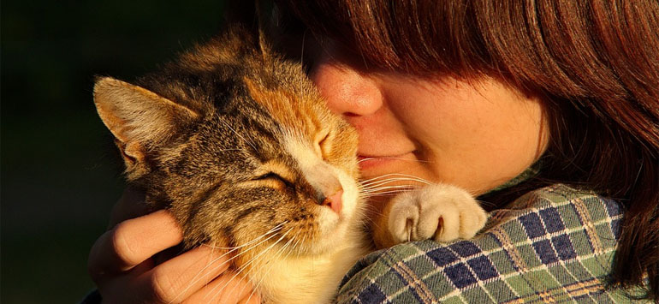

Focus area five - Managing dangerous, menacing and restricted breed dogs
Objectives
- To ensure all dog owners are aware of the potential for all dogs to exhibit dangerous and/or menacing behaviour, not just restricted breed dogs.
- To ensure owners of dangerous, menacing and restricted breed dogs:
- are aware of their obligations;
- comply with all legislated requirements for the keeping of these dogs.

The key findings from our consultation and research
- As of 2017 there are eight ‘declared’ dogs on Council’s pet registration database, which is four more than registered in 2012/13.
- Research cited by the Australian Veterinary Association shows that breed specific legislation is potentially causing complacency in relation to safety around dogs, and that breed specific legislation is not addressing the increase in dog attacks and bites that are being inflicted by dogs that are not of a ‘restricted breed’
- Definition of a ‘dangerous dog’: – Council can declare a dog as ‘dangerous’ if the dog has caused the death, of or serious injury to, a person or animal.
- Restricted breed dogs (Victoria) American Pit Bull Terrier (or Pit Bull Terrier), Perro de Presa Canario (or Presa Canario), Dogo Argentino, Japanese Tosa, or Fila Brasileiro
- The term ‘rushed’ refers to a dog that has aproached within 3 metres of a person in displaying aggressive behaviour such as snarling and growling

- Definition of a ‘menacing dog’: Council can declare a dog as ‘menacing’ if it has ‘rushed’ at or inflicted a non serious bite injury to a person or animal. "Rushed at" means that the dog has approached a person within three metres in a menacing manner, this includes displaying aggressive behaviour such as snarling, growling and raising the hackles.
- Dogs that are not appropriately trained, socialised and controlled can develop anti-social behaviours that can result in them being declared as a ‘menacing’ or ‘dangerous’ dog.
- The rate of Australians being attacked by dogs has
increased by almost 60 per cent from 2003 to 2013.

Strategies to address new and emerging issues
OB | ACTION | RESPONSIBILITY COUNCIL ROLE | MEASURES | TIMEFRAME
 | Review and enhance information for dog owners to ensure there is a clear understanding as to dog behaviour that may lead to their dog being ‘declared’ | - Lead LL  - Support LL  - Role CL | - Information reviewed and promoted more widely | - 2020
 | Review and distribute information to owners of dangerous, menacing and restricted breed dogs to ensure they are aware of current requirements | - Lead LL  - Support LL  - Role CL | - Information reviewed and circulated | - 2019
OB = Objective; CL=Council; LL=Local Laws; MAV=Municipal Association of Victoria; OERCs=Outer East Regional Councils * Lead Dept / agency

Focus area six - Overpopulation (including euthanasia) and welfare of pets
Objectives
- To fully understand the extent of the issues relating to the overpopulation of pets, in particular cats in Maroondah
- To develop a proactive strategy for addressing defined issues associated with pet overpopulation
- To raise awareness of opportunities for the community to address pet abandonment and overpopulation issues

The key findings from our consultation and research
- In 2016/17, 155 cats were impounded in Maroondah, of these 40 (26%) were claimed by an owner, 105 were rehomed (67%), and 10 (7%) euthanised.
- In excess of 100,000 cats and 76,000 dogs were euthanised in Australia in 2010. It is determined that up to 90% (138,523) of these animals were of good health and disposition and therefore appropriate for rehoming.
- Findings of a 2013 study found that:
Of cats admitted to a shelter:
over 71% of adult cats were euthanised, 21% were adopted and only a small percentage (6%) were reclaimed.
46% were adult cats (>3 months) and 54% were kittens (<3 months). The most common reason for admission was the animal being a stray (54%), followed by owner surrender (44%)
The financial burden of managing excess pets is estimated at over $260 million with local government in Australia spending an estimated $82 million and animal welfare agencies $180 million annually. This does not take into account the emotional and psychological stress of those working in a sector that is responsible for euthanising abandoned and unwanted pets.
“It would be good to share more information on how people can adopt animals in Maroondah.”

DAMP survey respondent

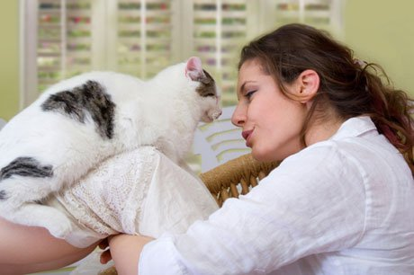
- Similar to nearby LGAs, survey respondents have a significant level of concern in relation to the high euthanasia rate of cats and kittens:
Addressing the overpopulation and the high euthanasia rates of cats requires a humane and whole of community approach
- 66% stated that this issue was ‘important’ or ‘very important’ to them.
- Survey results indicate that there is concern in communities about unowned cats that people are feeding but not taking full responsibility for. Many of these cats are not fully vaccinated, desexed, or contained at night. As a result these cats are potentially contributing to the cat overpopulation challenges, are a nuisance in local neighbourhoods, and are at risk of harm and disease.

Strategies to address new and emerging issues
OB | ACTION | RESPONSIBILITY COUNCIL ROLE | MEASURES | TIMEFRAME
 | Support community awareness programs:  - about the benefits of adopting from animal shelters  - to dismiss myths associated with animals that come from shelters | - Lead LL  - Support Animal Aid OERCs  - Role CL | - Information researched and in conjunction with relevant stakeholders  - Information prepared and promoted | - 2019  - 2020/21
 | Actively encourage the adoption of animals from animal shelters and promote adoption opportunities available to Maroondah residents | - Lead LL  - Support LL Animal Aid OERCs  - Role CL | - Promotion on Council’s website  - Material available at Council offices  - Media promotion | - 2018  - 2018  - 2019 - 21
 | Consider the introduction of a reduced registration fee for animals adopted from animal shelters  To be actioned by: LL, | - Lead LL  - Support LL  - Role CL | - Position/policy given consideration | - 2018
 | Work with ‘Getting to Zero’ (G2Z) and Animal Aid to:  - improve information to the community about managing and addressing the semi-owned cat populations.  - establish programs to address issues associated with the un-owned and semi-owned cat populations  - establish relevant key performance indicators for targeted and trial programs | - Lead LL  - Support G27 Animal Aid OERCs  - Role CL | - Partnership established with G2Z and Animal Aid  - Target programs established, including key performance measures | - 2019  - 2020/21
 | Work with other Councils in the region to develop a regional promotional and education strategy in relation to semi-owned cats | - Lead LL  - Support LL  - Role CL | - Potential strategies/program initiatives investigated  - Agreed initiatives implemented if relevant | - 2019
OB = Objective; CL=Council; LL=Local Laws; MAV=Municipal Association of Victoria; OERCs=Outer East Regional Councils * Lead Dept / agency


A national program sponsored by the Queensland Animal Welfare league that aims to increase responsibility for companion animals so that every community and municipality can achieve zero euthanasia of all healthy and treatable cats and dogs.

Focus area seven - Domestic animal businesses
Objective
- To ensure domestic animal businesses:
are aware of their obligations in relation to government legislation, policies; and relavant codes of practice
comply with all legislated requirements

The key findings from our consultation and research
- Council strongly encourages Domestic Animal Businesses (DABs) to source animals from reputable suppliers, particularly animal welfare agencies
- Similar to OERC, survey respondents state that the following were ‘important’ or ‘very important issues of concern:
unscrupulous breeders and puppy farms (approx. 87% of respondents)
the sale of animals through pet shops (approx. 81%)
- All DABs must be registered with Council and Council must in turn report these to the Victorian Government. Council will generally inspect DABs each year to ensure they comply with mandatory codes of practice and to offer any support and advice as may be necessary.
- DABs include:
An animal pound whether operated by Council or another agency. In the case of Maroondah, this is Animal Aid.
- At April 2017 there are 15 domestic animal businesses in Maroondah:
8 x Boarding establishments
2 x Training establishments
5 x Pet Shops

A dog and/or cat breeding or rearing business
A commercial dog training establishment
A pet shop
An animal shelter
A commercial cat or dog boarding establishment
An establishment that is rearing dogs or cats (where the business is run for profit).
- Over half of respondents were interested in knowing what dog obedience or activity groups were available in Maroondah.

Strategies to address new and emerging issues
OB | ACTION | RESPONSIBILITY COUNCIL ROLES | MEASURES | TIMEFRAME
 | Consider opportunities to profile dog obedience/training groups operating in Maroondah and recreation/social activities associated with pets. | - Lead LL  - Support Community Groups  - Role CL | Identification of groups and activities | - 2019/21
 | Identify opportunities to work with DABs to promote responsible pet ownership and initiatives that address the objectives of the Domestic Animal Management Plan. | - Lead LL  - Support LL  - Role CL | Initial discussions held as part of annual inspections and opportunities explored | - 2021
OB = Objective; CL=Council; LL=Local Laws; MAV=Municipal Association of Victoria; OERCs=Outer East Regional Councils * Lead Dept / agency

Focus area eight - Provision for dogs off leash
Objective:
- To plan and manage dog off leash areas in consideration of the needs of dog owners and other park users.
- To ensure dog owners are aware of their obligations in off leash areas and respect the rights of other park users
- To provide information that emphasises dog owner responsibilities in public places.

The key findings from our consultation and research
- Council’s Open Space Strategy makes a number of recommendations relating to dogs including:
The need to determine those open space areas where it is/is not appropriate to permit dogs/dogs off leash.
If and where it may be appropriate to considered fenced dog off leash areas
The need to ensure residents comply with dog on leash requirements, and responsibly manage their dogs in public places.
- As of April 2017 there are 35 areas in Maroondah where dogs are allowed off leash, and 10 areas where dogs are not permitted. In the remaining public areas, dogs are permitted but they must be on a leash.
- Respondents from the Maroondah survey and other local LGA DAMP surveys indicates:
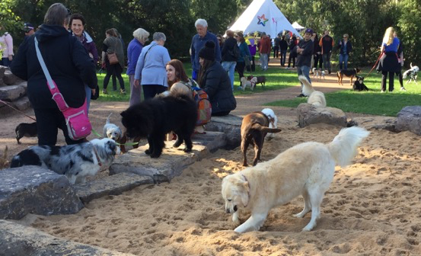
The greatest level of angst is generated by dog owners/walkers that do not pick up dog droppings (70-80% of respondents)
“We love the new Eastfield Dog Park….it is often very busy, so would be great to have another”
“Love the new dog park - well done!”
“Thank you for the park and I hope there are more in the future!”
“Some people bring inappropriate dogs …this needs to be managed”
Ref: DAMP Survey respondents

The next level of angst is generated by dog owners that allow their dogs annoy other people or other people’s dogs (approx. 40%)
- Around 15% of survey respondents were prepared to admit that their dog had run off from them in a park or reserve.
- There has been growing interest in additional fenced dog off-leash areas in Maroondah since the opening of the Eastfield Dog Park. Unfortunately some dog owners take inappropriate dogs (e.g. dogs with aggressive tendencies, timid dogs, entire dogs) into fenced dog parks. In addition, popular parks can become crowded which can trigger fearful behaviour in some dogs, and some dog owners do not actively supervise their dogs in these areas. As a result, often-avoidable dog fights can occasionally occur because some dog owners do not use the area responsibly.

Strategies to address new and emerging issues
OB | ACTION | RESPONSIBILITY COUNCIL ROLE | MEASURES | TIMEFRAME
 | Review the need for additional fenced dog parks and off lead areas to meet community needs and how these could be integrated into the overall provision for dog owners/dogs | - Lead LL  - Support LL  - Role CL | - Review undertaken, provision strategy determined | - 2018/19
 | Continue to provide information for users of fenced dog parks/confined off leash areas to raise awareness of:  - Dog behaviour/reactions that may be more prevalent in confined areas  - Additional dog owner responsibilities/ supervision requirements in confined areas  - Dog owner/dog etiquette | - Lead LL  - Support LL  - Role CL | - Information prepared and distributed | - 2018/19
OB = Objective; CL=Council; LL=Local Laws; MAV=Municipal Association of Victoria; OERCs=Outer East Regional Councils * Lead Dept / agency



Focus area nine - Pets and People
Objectives:
- To recognise and optimise health and wellbeing opportunities associated with pets.
- To strengthen networks that support pet owners and pets in crisis
- To improve the welfare of pets in Maroondah by supporting our residents to be responsible pet owners.

The key findings from our consultation and research
“I have mental health issues and often struggle with social situations, but when there is a dog or another animal I'm a completely different person. I can get out more and I feel like it helps me from being too isolated in my own home.”

In relation to Domestic violence situations … “It would be good if pets could have a safe place to go to till owners get their life back on track.”
DAMP Survey respondents
- Survey respondents stated that the following pet welfare issues were either ‘important’ or ‘very important’ to them
the high rate of abandonment of pets (approx. 91%)
the welfare of pets in domestic violence situations and making them safe (approx. 85%)
- 12% of regional survey respondents stated that animals subject to domestic violence was an issue for them now or had been in the past 12 months. The Maroondah survey respondents identified this as an issue (17%).
- A study conducted by Eastern Domestic Violence Service showed that 53% of women in violent relationships reported pets being hurt or killed, and 46% reported their pets had been threatened.
- 22% of regional survey respondents²⁷ stated that the welfare or treatment of an animal in their neighbourhood was an issue for them now or had been in the past 12 months.
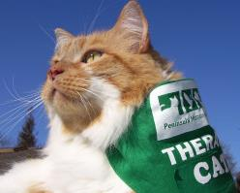
- As evidenced from natural disasters in the region over the last decade there is growing expectation that pets will be accommodated in Emergency Relief Centres. This highlights the need for Animal Emergency Management Plans to ensure centres have the capacity and networks in place to accommodate demand.
- There is a growing body of research that now highlights the physiological, emotional and social benefits of having animals.
- Newly released research indicates pets are an under-recognised conduit for building social capital particularly as associated with trust, reciprocity and involvement of more pet owners than non-pet owners in civic affairs.

Our plans to address priorities for the next four years

OB | ACTION | RESPONSIBILITY COUNCIL ROLES | MEASURES | TIMEFRAME
 | Identify and strengthen internal and external referral and support networks and protocols in relation to pets and domestic violence. | - Lead LL  - Support Animal Aid MAV OERCs  - Role CL | - Internal referral protocols developed  - Community networking and referral protocols developed and put in place | - 2018/19
 | Work with Outer Eastern Domestic Violence to identify opportunities to better inform the community about the impact of domestic violence on pets and how to make them safe | - Lead LL  - Support OERCs  - Role CL | - Preliminary discussions held and strategies developed  - Information / resources made available  - Procedures/networks established | - 2018/19  - 2018-21
 | Work with Animal Aid to identify strategies that address the root causes of animal abandonment | - Lead LL  - Support Animal Aid Vets OERCs  - Role CL | - Opportunities identified and implemented | - 2019-21
 | Work with Animal Aid and the RSPCA to raise awareness of the channels through which animal abuse can be reported. | - Lead LL  - Support Animal Aid RSPCA VETS AVA OERCs  - Role CL | - Awareness strategies developed and implemented | - 2019-21
 | Encourage other Council departments to optimise health and wellbeing and community networking opportunities associated with pets | - Lead LL  - Support LL  - Role CL | - Research findings information from the Domestic Animal Management Plan referred | - 2019-21
OB = Objective; CL=Council; LL=Local Laws; MAV=Municipal Association of Victoria; OERCs=Outer East Regional Councils * Lead Dept / agency

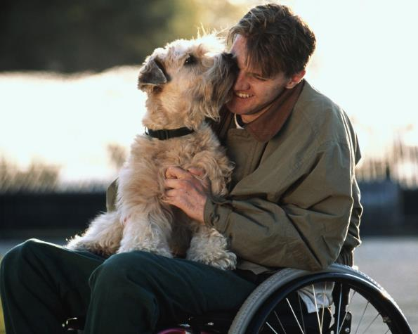

Consolidated Action Plan

OB | ACTION |  | RESPONSIBILITIES COUNCIL ROLES | MEASURES | TIMEFRAME
 |  | Service Management including Training of ‘Authorised Officers’
 | Develop a plan for raising the profile and awareness of the scope of the service. |  | - Lead LL  - Support OERCs  - Role CL | - Plan developed  - Plan implemented as per agreed timelines | - 2018/19 Planning
 | Consider the merits of introducing a Pet based family event that has a focus on:  profiling the scope of the service  building community relationships to address key service issues e.g. control of dogs in off leash areas  profiling community support groups and agencies |  | - Lead LL  - Support OERCs  - Role CL | - Event scoped | - 2018/19 Planning
 | Animal Management Officers to undertake Common Risk Assessment Framework (CRAF)or similar training (Domestic Violence) |  | - Lead LL  - Support LL  - Role CL | - All staff to complete training over the next 4 years | - 2018/21
 | Review Council’s website and other communication channels with a view to:  Providing more relevant pet care/welfare information |  | - Lead LL  - Support OERCs  - Role CL | - Options investigated, documented & costed, timelines agreed  - Implementation of actions as per timelines | - 2018/21
 | Work with Animal Aid to ensure detailed information for all impounded and surrendered animals. Information should include:  At time of intake:  - Intake by species  - Intake type e.g. ranger pick-up, surrender, stray, trapped, involved in incident  - Address where animal came from/was collected from  - Approximate age of animal e.g. puppy/kitten vs. adult  - Sex and sex status i.e. desexed or entire  - If registered and microchipped at time of intake  - If surrendered, what are reasons  At time of outgoing:  - Reclaimed, adopted, transferred to other facility/rescue group  - If euthanised, the reason |  | - Lead LL  - Support LL  - Role CL | - Intake and outgoing information requirements implemented | - 2018
 |  | Registration and identification
 | Research successful strategies employed by other LGAs to increase compliance with registration requirements and consider how they might be applied in Maroondah. Consider strategies associated with:  - Targeted educational programs (e.g. localised programs)  - Social media |  | - Lead LL  - Support OERCs  - Role CL | - Strategies investigated/ researched  - Initiatives to increase rates of registration implemented | - 2018/21
 | Consider opportunities/further opportunities associated with:  - microchipping days/events  - low cost desexing initiatives |  | - Lead LL  - Support LL  - Role CL | - Opportunities/benefits considered  - Events/activities implemented (depending on above) | - 2019  - 2020
 | Update Council’s registration database including by:  - cleansing of all deceased / relocated pets etc.  - cross referencing with microchip databases |  | - Lead LL  - Support LL  - Role CL | - Updating of database undertaken | - 2018
 | Consider the development of ‘new resident’ Pet Ownership Pack |  | - Lead LL  - Support OERCs  - Role CL | - Action determined  - Pet ownership Pack developed (depending on above) | - 2019  - 2020
 | Support the MAV advocacy to the Federal Government for a single industry microchip and registration database, and funds to develop the database. |  | - Lead CL LL MAV  - Support OERCs  - Role CL | - Regional advocacy plan established | - 2018 - ongoing
 | Map cat and dog ownership on Council’s mapping system to identify areas of low registration and target as part of annual door knock |  | - Lead LL  - Support LL  - Role CL | - Door knock of low registration areas | - 2020
 |  | Dealing with nuisance issues
 | Investigate potential benefits of enlisting the help of an animal behaviourist as an intervention or to provide / develop literature for use by Council and owners in relation to barking dog complaints. |  | - Lead LL  - Support OERCs  - Role CL | - Options cost/benefit considered  - Implemented as determined | - 2019  - 2020 +
 | Consider developing a list of commercial providers that can work with residents to address:  - dog obedience/control issues that occur in public places  - barking dog issues |  | - Lead LL  - Support LL  Role CL | - List developed / liaison with potential project/ promotional partners | - 2019  - 2020/21
 | Consider partnerships with commercial providers and community groups e.g. dog clubs |  | - Lead LL  - Support LL  - Role CL | - Promotion of providers/programs | - 2020/21
 | Consider a litter bag dispenser and bin policy that will determine where bins and dispensers should be provided |  | - Lead LL  - Support LL  - Role CL | - Policy scoped | - 2018
 | Review the schedule for the patrolling of parks, particularly addressing ‘high complaint’ parks |  | - Lead LL  - Support LL  - Role CL | - Schedule reviewed and implemented accordingly | - 2018
 | Purchase of additional cat trapping cages if demand continues |  | - Lead LL  - Support LL  - Role CL | - Cat traps acquired if demand warrants | - As required
 | Investigate successful industry/sector programs that have achieved reduced incidents of cat trespass/wandering |  | - Lead LL  - Support OERCs  - Role CL | - Investigation/research undertaken  - Initiatives considered for implementation | - 2019/20
 | Prepare information sheet/checklist for residents using cat traps e.g. humane treatment, safe operation of cages |  | - Lead LL  - Support OERCs  - Role CL | - Information sheet/checklist developed and made available | - 2018/20
 |  | Dog attacks
 | Develop an information package for cat owners whose cats are the subject of cat trespass complaints |  | - Lead LL  - Support OERCs  - Role CL | - Information package prepared and made available | - 2018/20
 | Investigate methods to reach target groups with information about:  - managing children around dogs  - education of children about the handling of dogs  Consider more targeted communications to promote awareness of appropriate handling of dogs |  | - Lead LL  - Support OERCs Animal Aid Local Media Schools  - Role CL  - Lead LL  - Support Animal Aid  - Role CL | - Opportunities through which to target information and relevant partnerships established  - Promotional strategies implemented | - 2019  - 2020/21  - 2019-21
 | Enhance the promotion/distribution of information that assists residents to make appropriate pet selection, particularly in relation to dogs. |  | - Lead LL  - Support Animal Aid  - Role CL | - Information more widely promoted in conjunction with promotional partners | - 2019/20
 |  | Managing dangerous, menacing and restricted breed dogs
 | Review the data collected relating to dog attacks in order to identify if there are any patterns/trends that could be addressed via targeted strategies. |  | - Lead LL  - Support LL  - Role CL | - Data reviewed and additional data collected if required | - 2018
 | Review and enhance information for dog owners to ensure there is a clear understanding as to dog behaviour that may lead to their dog being ‘declared’ |  | - Lead LL  - Support LL  - Role CL | - Information reviewed and promoted more widely | - 2020
 | Review and distribute information to owners of dangerous, menacing and restricted breed dogs to ensure they are aware of current requirements |  | - Lead LL  - Support LL  - Role CL | - Information reviewed and circulated | - 2019
 |  | Overpopulation (including euthanasia) and welfare of pets
 | Support community awareness programs:  - about the benefits of adopting from animal shelters  - to dismiss myths associated with animals that come from shelters |  | - Lead LL  - Support Animal Aid OERCs  - Role CL | - Information researched and in conjunction with relevant stakeholders  - Information prepared and promoted | - 2019  - 2020/21
 | Actively encourage the adoption of animals from animal shelters and promote adoption opportunities available to Maroondah residents |  | - Lead LL  - Support LL Animal Aid OERCs  - Role CL | - Promotion on Council’s website  - Material available at Council offices  - Media promotion | - 2018  - 2018  - 2019 - 21
 | Consider the introduction of a reduced registration fee for animals adopted from animal shelters  To be actioned by: LL, |  | - Lead LL  - Support LL  - Role CL | - Position/policy given consideration | - 2018
 | Work with ‘Getting to Zero’ (G2Z) and Animal Aid to:  - improve information to the community about managing and addressing the semi-owned cat populations.  - establish programs to address issues associated with the un-owned and semi-owned cat populations  - establish relevant key performance indicators for targeted and trial programs |  | - Lead LL  - Support G27 Animal Aid OERCs  - Role CL | - Partnership established with G2Z and Animal Aid  - Target programs established, including key performance measures | - 2019  - 2020/21
 | Work with other Councils in the region to develop a regional promotional and education strategy in relation to semi-owned cats |  | - Lead LL  - Support LL  - Role CL | - Potential strategies/program initiatives investigated  - Agreed initiatives implemented if relevant | - 2019
 |  | Domestic animal businesses
 | Consider opportunities to profile dog obedience/training groups operating in Maroondah and recreation/social activities associated with pets. |  | - Lead LL  - Support Community Groups  - Role CL | Identification of groups and activities | - 2019/21
 | Identify opportunities to work with DABs to promote responsible pet ownership and initiatives that address the objectives of the Domestic Animal Management Plan. |  | - Lead LL  - Support LL  - Role CL | - Initial discussions held as part of annual inspections and opportunities explored | - 2021
 | Provision for dogs off leash
 | Review the need for additional fenced dog parks and off lead areas to meet community needs and how these could be integrated into the overall provision for dog owners/dogs |  | - Lead LL  - Support LL  - Role CL | - Review undertaken, provision strategy determined | - 2018/19
 | Continue to provide information for users of fenced dog parks/confined off leash areas to raise awareness of:  - Dog behaviour/reactions that may be more prevalent in confined areas  - Additional dog owner responsibilities/ supervision requirements in confined areas  - Dog owner/dog etiquette |  | - Lead LL  - Support LL  - Role CL | - Information prepared and distributed | - 2018/19
 |  | Pets and People
 | Identify and strengthen internal and external referral and support networks and protocols in relation to pets and domestic violence. |  | - Lead LL  - Support Animal Aid MAV OERCs  - Role CL | - Internal referral protocols developed  - Community networking and referral protocols developed and put in place | - 2018/19
 | Work with Outer Eastern Domestic Violence to identify opportunities to better inform the community about the impact of domestic violence on pets and how to make them safe |  | - Lead LL  - Support OERCs  - Role CL | - Preliminary discussions held and strategies developed  - Information / resources made available  - Procedures/networks established | - 2018/19  - 2018-21
 | Work with Animal Aid to identify strategies that address the root causes of animal abandonment |  | - Lead LL  - Support Animal Aid Vets OERCs  - Role CL | - Opportunities identified and implemented | - 2019-21
 | Work with Animal Aid and the RSPCA to raise awareness of the channels through which animal abuse can be reported. |  | - Lead LL  - Support Animal Aid RSPCA VETS AVA OERCs  - Role CL | - Awareness strategies developed and implemented | - 2019-21
 | Encourage other Council departments to optimise health and wellbeing and community networking opportunities associated with pets |  | - Lead LL  - Support LL  - Role CL | - Research findings information from the Domestic Animal Management Plan referred | - 2019-21

Planning for pets and pet owners

How we prepared the Domestic Animal Management Plan
Research for the Domestic Animal Management Plan has taken into account the previous research and consultation carried out for other strategic plans, including Maroondah 2040 Council Plan 2017/21, the Maroondah Health and Wellbeing Plan, the Open Space Strategy and the Physical Activity Strategy.
It has also considered how the plan can help Council address the recommendations in those documents and the Maroondah 2040 Community Vision.
Consultation and community engagement carried out specifically for the Domestic Animal Management Plan involved:
- An online regional survey – Over 5,000 respondents - There was only a small response to the Maroondah based community survey so only general comments should be made in relation to results. Where relevant, findings from surveys conducted by other LGAs the eastern metropolitan region have been noted.
- 5 submissions.
- Council staff workshops and interviews, including with staff from disability, community services, economic development, infrastructure, environmental, and leisure services.
- Consultation with benchmarking Councils.
- Consultation with key industry groups including Getting to Zero (G2Z); Animal Aid and Australian Veterinary Association.

How we will implement the Domestic Animal Management Plan

Setting priorities for the next four years
Priorities in the Domestic Animal Management Plan may change over the life of the plan depending on changing service demands and priorities, available resources, partnership opportunities and external funding opportunities.

  - Monitoring and reviewing the Domestic Animal Management Plan
In line with the requirements of the Act:
- Council will review the Domestic Animal Management Plan annually to ensure actions and priorities are still relevant and can be completed within available resources.
- Council will undertake a major review of the Plan in 2020/21.

Key service information
Service issue | Service Details
Business hours services | Registrations, permits, complaints/customer requests, wandering/trespassing animals/nuisance complaints  Phone 1300 88 22 33 or 9298 4598  www.maroondah.vic.gov.au
After hours service | Dog attacks, dog contained  Operates Monday to Friday 4 pm to 10 pm  Saturday and Sunday 7am to 10 pm  Phone 1300 88 22 33
Dog attack / rush | Phone 1300 88 22 33 or 9298 4598
Dog wandering / off leash complaint | Contact Business Hours 1300 88 22 33
Pound Facilities | Animal Aid  35 Killara Road, Coldstream  8.30 am to 5 pm weekdays  Phone 03 9739 0300  www.animalaid.org.au

Appendices

Appendix 1 – The Domestic Animals Act requirement of Council
Under Section 68A of the Domestic Animals Act, every Council must prepare a Domestic Animal Management Plan, as follows:

68A Councils to prepare Domestic Animal Management Plans
(1) Every Council must, in consultation with the Secretary (of the Department of Primary Industries), prepare at 4 year intervals a Domestic Animal Management Plan.
(2) A Domestic Animal Management Plan prepared by a Council must—
(a) set out a method for evaluating whether the animal control services provided by the Council in its municipal district are adequate to give effect to the requirements of this Act and the regulations; and
(b) outline programs for the training of authorised officers to ensure that they can properly administer and enforce the requirements of this Act in the Council's municipal district; and
(c) outline programs, services and strategies, which the Council intends to pursue in its municipal district—
(i) to promote and encourage the responsible ownership of dogs and cats; and
(ii) to ensure that people comply with this Act, the regulations and any related legislation; and
(iii) to minimise the risk of attacks by dogs on people and animals; and
(iv) to address any over-population and high euthanasia rates for dogs and cats; and
(v) to encourage the registration and identification of dogs and cats; and
(vi) to minimise the potential for dogs and cats to create a nuisance; and
(vii) to effectively identify all dangerous dogs, menacing dogs and restricted breed dogs in that district and to ensure that those dogs are kept in compliance with this Act and the regulations; and
(d) provide for the review of existing orders made under this Act and local laws that relate to the Council's municipal district with a view to determining whether further orders or local laws dealing with the management of dogs and cats in the municipal district are desirable; and
(e) provide for the review of any other matters related to the management of dogs and cats in the Council's municipal district that it thinks necessary; and
(f) provide for the periodic evaluation of any program, service, strategy or review outlined under the plan.
(3) Every Council must—
(a) review its Domestic Animal Management Plan annually and, if appropriate, amend the plan; and
(b) provide the Secretary with a copy of the plan and any amendments to the plan; and
(c) publish an evaluation of its implementation of the plan in its annual report.

Appendix 2 – Key statistics
Table 5 – Key service statistics for Maroondah
Measure | 2012 / 13 DAMP | 2016/17
Resident population | 107,839 | 113,944
DOGS
Number of registered dogs | 14,124 | 13,065
Per 100 people |  | 11
Number of entire registered dogs | 2,458 | 1,244
As a % of registered dogs | 17% | 9.52%
Number of registered ‘declared’ dogs | 16 | 21
Number of impounded dogs | 139 | 269
As a % of registered dogs | 0.98% | 2.06%
Number of impounded dogs returned to owner |  | 246
As a % of impounded dogs |  | 91%
Number of dogs rehoused |  | 21
As a % of impounded dogs |  | 7.81%
Number of dogs euthanised |  | 2
As a % of impounded dogs |  | 0.74%
Number dogs not registered when impound | NK | NK
As a % of impounded dogs
CATS
Number of registered cats | 5,031 | 5,033
Per 100 people | 4,909 | 4.4
Estimated total cat population (registered and unregistered) | 97.58%
Number of entire registered cats | 122 | 62
As a % of registered cats | 2.42%
Number of impounded cats | 75 | 155
As a % of registered cats | 1.49% | 3.08
Number of impounded cats returned to owner |  | 40
As a % of impounded cats |  | 25.81%
Number of cats rehomed |  | 101
As a % of impounded cats |  | 65.16%
Number of cats euthanised |  | 10
As a % of impounded cats | 0.00% | 6.45%
CUSTOMER SERVICE REQUESTS/COMPLAINTS
Animal litter
Dog nuisance | 206 | 263
% of total requests | 16.60% | 16.18%
Dog attack | 84 | 54
% of total requests | 6.77% | 3.32%
Dog rush | 45 | 56
% of total requests |  | 3.45%
Dog – barking | 54 | 233
% of total requests | 4.35% | 14.34%
Dog - Contained for collection | 580 | 493
Dog – Contained (No/% of total requests/complaints) | 78.24 | 30.81
Dog – off leash | Not classified | Not Classified
% of total requests
Dog – wandering | 180 | 152
% of total requests |  | 9.35%
Cat nuisance | 92 | 260
% of total requests | 7.41% | 16.00%
Cat Cage |  | 114
% of total requests) | - | 7.02%
TOTAL Animal (Customer service requests/complaints | 1,241 | 1,625
TOTAL All - (Customer service requests/complaints) | 6392 | 6422
% of TOTAL (Customer service requests/complaints | 0.2 | 0.3
(Animal - Customer service requests/complaints/per 1,000 residents | 11.5 | 14.3

Appendix 3 – Operational Information
1. Ongoing service compliance and education activities
The following provides a list of all the ongoing compliance and education activities associated with animal management services.
ACTIONS | FREQUENCY
Training of Authorised Officers and Service Management
Operational/Compliance activities
Review Animal Management staff training requirements in line with operational requirements | Annual
Attendance at conferences, regional networking meetings, training and information workshops | Annual
Maintain accurate staff training register | Ongoing
Identify additional training requirements in response to changing service demands | Annual
Review policies and procedures | As required
Review Emergency Animal Management Plan | As required
Registration and identification
Information/Education activities
Information on Council’s website updated | Annual / as required
Information sent to new residents as part of welcome kit | monthly
Operational/Compliance activities
Annual registration door knock | Annual
Annual cat and dog registration renewals including follow up notifications, media coverage etc. | Annual
Cross referencing of microchip databases with Council’s animal registration database | Bi annual
Dealing with nuisance issues
Information/Education activities
Promotion of information available in relation to nuisance issues and how they can be addressed – Council’s website, Council Customer Service Centres | Ongoing
Barking dogs – Information provided to relevant dog owners | Ongoing
Operational/Compliance activities
Review of procedures for dealing with ‘barking dog’ complaints | Ongoing
Patrols of public places such as reserves, retail precincts, trails etc., particularly during high use times such as community events | Ongoing as per schedule
Monitor the effectiveness of ‘Barking Dog’ complaint process | Ongoing
Provide cat traps to confine trespassing cats | Ongoing
Collection of wandering dogs/’dogs at large’ | Ongoing
Management of animal related nuisance complaints | Ongoing
Issuing of warnings and infringement notices | Ongoing
Dog attacks
Information/Education activities
Information available at Council offices and on Council’s website:  about minimising opportunity for dog attacks  understanding triggers for dog attacks  reporting dog attacks  owner responsibilities for managing dogs | Ongoing – Council service centres, Council website
Continue to review processes for investigating dog attacks to ensure an efficient and timely process | Annual
Community awareness programs and information to improve awareness/ understanding of the nature of dog attacks and rushes and how to report | Ongoing e.g. via website update, direct contact and direct mail
Operational/Compliance activities
Investigate complaints, issue cautions and infringement notices, and prosecute as required | Ongoing
Proactive and unscheduled patrols conducted as required. | As required
Managing dangerous, menacing and restricted breed dogs
Information/Education activities
Information provided on Council website as to:  the appropriate housing of ‘dangerous’, ‘menacing’ and/or a ‘restricted breed’ dog  appropriate selection of dogs for the family and community environment | Ongoing – Council service centres, Council website
Operational/Compliance activities
Maintaining of records relating to dangerous, menacing and restricted breed dogs | Annual
Inspection of all industrial properties for dogs housed or kept as guard dogs | Annual
Inspection of all registered restricted breed, menacing and dangerous dogs and associated properties to ensure compliance with requirements; and consultation with owners | Annual
Overpopulation (including euthanasia) and abandonment of pets
Information/Education activities
Information on Council website promoting the benefits of desexing pets, particularly cats | Ongoing
Operational/Compliance activities
All impounded animals transferred to Animal Aid shelter for rehoming | Ongoing
Cat trapping cages available | Ongoing
Investigate cat complaints | Ongoing
Domestic animal businesses
Information/Education activities
Information on Council’s website to assist DABs to understand their obligations in relation to relevant legislation and best practice | Ongoing
Operational/Compliance activities
Inspection/auditing of ‘domestic animal businesses’ | Annual
Investigate complaints | Annual
Provision for dogs off leash
Information/Education activities
Monitoring of dog off leash areas for compliance | Ongoing
Monitoring of community events and high use areas | As required
Pets and people
Making provision for pets at Emergency Evacuation/Relief Centres | Annual Checks
Co-ordination of crisis care e.g. in times of domestic violence, traffic accidents, house fires etc. | Annual MEMP

2. Authorised Officers and Civic Compliance Officer training requirements
QUALIFICATION / TRAINING | No. of Officers with Qualification | Frequency (if relevant)
Certificate IV in Animal Control and Regulation | 13 | NR
Certificate IV in Animal Welfare  Unit RUV4203A Identify & Respond to Animal Behavior | 13 | NR
Animal Handling Behavior and Animal Assessment | 13 | Bi-Annual
Case reporting/investigation including:  - statement taking  - prosecution procedures/handling  - Certificate 4 in Government Investigations | 13 | Bi-Annual
Customer service / OH&S training  - conflict resolution  - dealing with aggressive customers  - public speaking | 13 | Annual
Municipal Association of Victoria and Local Government Professionals – training and information days | 13 | Annual
Australian Institute of Animal Management Annual Conference | 4 | Annual
Breed identification | 13 | Bi-Annual
NEW  CRAF (Common Risk Assessment Framework) or similar training (Domestic Violence) | New | Programmed for introduction in 2018

3. Procedures
Documented procedures relating to the following are in place and will be reviewed in Years 1-4:
- Impound of animals
- Animal registration and renewal
- Barking dogs
- Dog attack
- Seizing of dogs
- Prosecutions
- Injured animals
- Issuing infringements
- Appeals
- Additional animal permits
- Deceased animals
- Surrender of animals
- Restricted breed – dangerous / menacing
- Cat trap hire

3. Service Plans
Animal Emergency Management Plan

GLOSSARY OF TERMS
Term | Definition for the purpose of  this document
AMOs | (Council) Animal Management Officers
Local Laws/ Orders | Ordinances put in place by Council under various Acts of state government
LGAs | Local Government Authorities
MCC/Council | Maroondah City Council
Community survey | Survey conducted as part of the research carried out for the DAMP
Authorised Officer | Person authorised by Council under section 224 of the Local Government Act to administer/enforce any Act
DAA | Domestic Animals Act, 1994
LGA | Local Government Act
OERCs | Outer eastern Melbourne Councils who surveyed residents for DAM Plans – Knox, Yarra Ranges, Nillumbik, Maroondah
Appendix 4 - Glossary

DAMP survey / regional LGAs survey
DAMP Appendix 3
Victorian Domestic Animals Act 1994
Pet Ownership in Australia in 2016, p9
Pet Ownership in Australia in 2016
4.4 cats and 11 dogs for every 100 Maroondah residents compared to an average of 4 cats and 12.2 dogs across adjoining LGAs
Pet Ownership in Australia; 2016; p49
Recognises the small number of Maroondah survey respondents
% of DAMP survey respondents who selected ‘very important’ or ‘important’
OEC Average of survey responses for 4 outer eastern Melbourne metro Council areas
http://journals.plos.org/plosone/article?id=10.1371/journal.pone.0122085
The Power of Pets: The benefits of companion animal ownership, Australian Companion Animal Council, 2009
Pet Ownership in Australia; 2016; p31
Domestic Animals Act, section 68A, Victorian State Government.
Victorian Domestic Animals Act, 1994
Yarra Ranges, Monash, Casey, Nillumbik, Knox average of 20.9%
Australian Veterinary Association; ‘Dangerous dogs – a sensible solution’
Australian Veterinary Association, ‘Dangerous Dogs; A Sensible Solution’ p9
Victorian Department of Agriculture http://agriculture.vic.gov.au/pets/dogs/dog-attacks-dangerous-and-menacing-dogs
University of Tasmania’s Menzies Institute for Medical Research
Getting to Zero (G2Z)
Cat Admissions to RSPCA Shelters in Queensland, Australia: Description of Cats and Risk Factors for Euthanasia After Entry; Australian Veterinary Journal © 2013 Australian Veterinary Association
Nillumbik, Yarra Ranges, and Knox LGAs
http://www.g2z.org.au /
Nillumbik, Yarra Ranges, and Knox LGAs
Department of Economic Development, Jobs, Transport, and Resources
Nillumbik, Yarra Ranges and Knox LGAs
Royal Commission Into Family Violence Submission: The Link Between Domestic Violence and Animal Abuse, Judy Johnson OAM
habricentral.org; Latrobe University, Melb / Anthropological Studies; waltham.com/waltham-research
The pet connection: Pets as a conduit for social capital? Social Science & Medicine 61 (2005) 1159–1173
http://www.g2z.org.au /

