Working towards a safe, healthy and active community
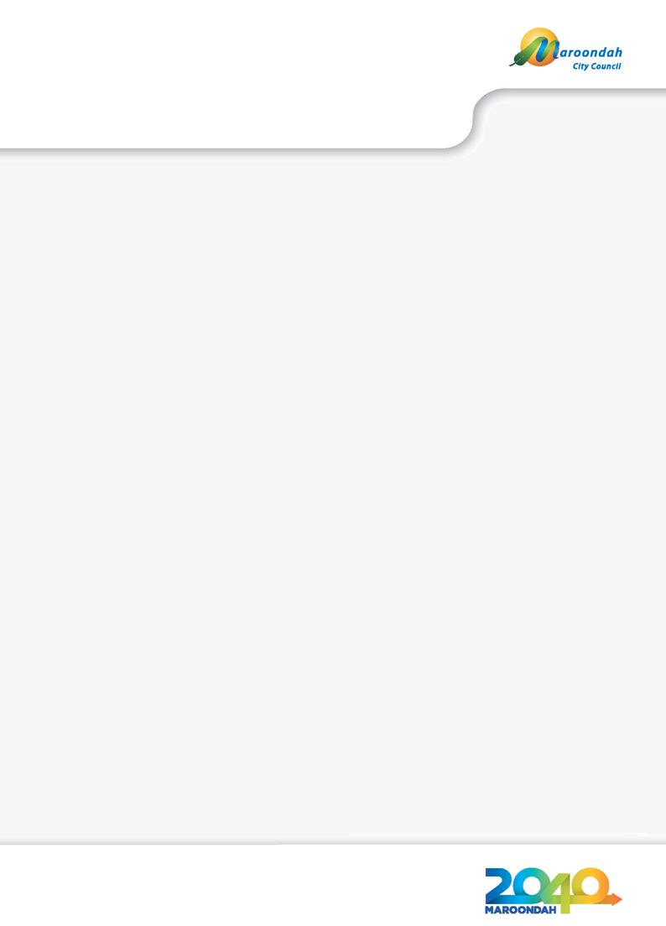
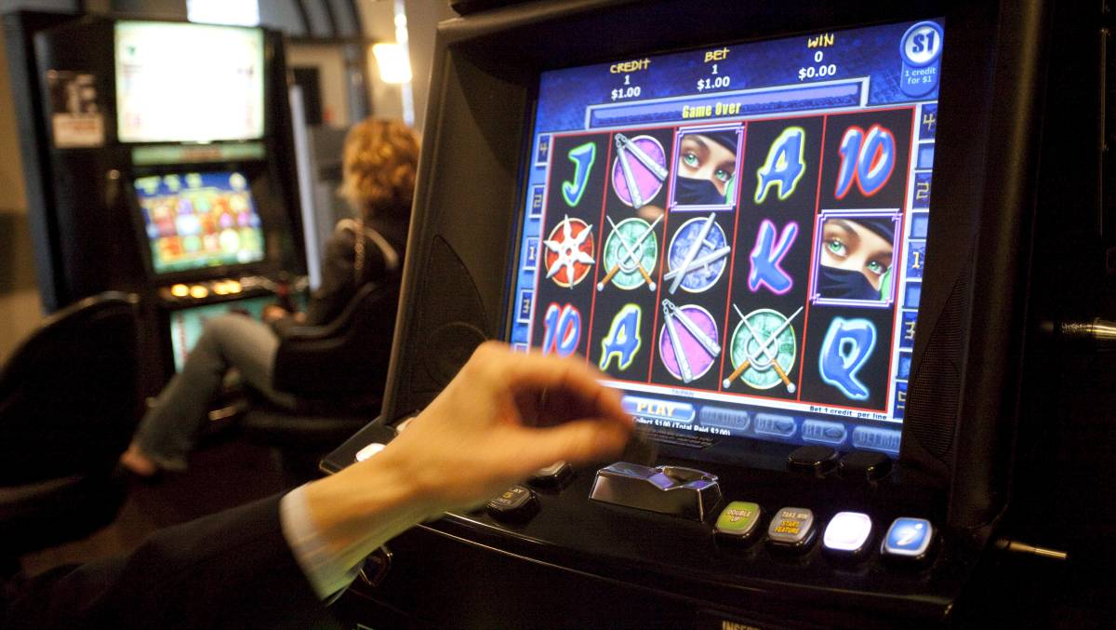
Draft Maroondah Gambling Policy
Working towards a safe, healthy and active community

Policy Title  Maroondah Gambling Policy 2018 (draft) |  | Policy No  IP-002 | Policy type  Council Policy
Policy creation date  April 2018 | Current version adopted  N/A | Current version number  01 | Policy review date  June 2022
Parent policy  None | Child policy/policies  None | Policy responsibility  Manager Integrated Planning | eCLIP record number  N/A


Working towards a safe, healthy and active community

Contents

What is the purpose of this Policy? | 4
How was this Policy prepared? | 4
What are we seeking to achieve through this Policy? | 5
How does this Policy align with the statutory and strategic framework? | 6
What is the City of Maroondah’s gambling context? | 8
What is gambling-related harm? | 11
What is our role in preventing and minimising gambling-related harms? | 12
What is our strategic response? | 13
References | 17

What is the purpose of this Policy?

The Maroondah Gambling Policy 2018 (the Policy) is a ‘whole of Council’ approach to preventing and minimising gambling-related harm in the community. It describes Council’s policy position on gambling in the municipality and describes three key priorities relating to service provision, advocacy and Council’s statutory, strategic and regulatory roles.
The Policy is relevant to all gambling activities that take place in the municipality. Its primary focus is on electronic gaming machines (EGMs) and gaming venues as this is the form of gambling over which Council has direct influence through its statutory roles and decision-making processes.
The Policy replaces the Maroondah Gaming Policy and Statement of Practice, 2007 and integrates recent changes to the statutory and regulatory framework within which gambling takes place in the municipality. It also responds to principles that have emerged from recent decisions that have been made on applications for gaming licences and planning permits, both within the City of Maroondah and relevant Victorian municipalities.
The Policy will guide the review of Clause 22.12 Gaming Machines and the schedules to Clause 52.28 Gaming in the Maroondah Planning Scheme. It will also inform Council’s submissions to the Victorian Commission for Gambling and Liquor Regulation (VCGLR) in response to applications for a new gaming licence or amendment to an existing gaming licence and the assessment of applications considered under the relevant clauses of the Maroondah Planning Scheme.

How was this Policy prepared?

The Policy was informed by a stakeholder engagement and community consultation process, environmental scan and document review (refer to Figure 1):
Figure 1 – Sources of information

What are we seeking to achieve through this Policy?

The Policy’s objectives are to:
- transparently articulate Council’s position on gambling and gaming to the gambling industry, service providers, other local governments and the community
- provide clarity and consistency in relation to Council’s commitments and approach to preventing gambling-related harms in the municipality
- ensure that Council’s actions and initiatives align with the contemporary statutory, strategic and decision-making framework within which gambling takes place in the municipality
- effectively and efficiently respond to emerging gambling patterns, behaviours and impacts
- demonstrate Council’s commitment to protecting those most at risk of gambling-related harms through its various statutory roles and responsibilities
- strengthen Council’s capacity to effectively guide the location and operation of electronic gaming machines (EGMs) by providing the framework for the review of the Maroondah Planning Scheme
- effectively engage with stakeholders and the community when fulfilling its statutory roles

How does this Policy align with the statutory and strategic framework?

Council’s mission and values

Council’s vision, as outlined in Maroondah 2040: Our future together and the Council Plan 2017-2021, is that:
Maroondah will be a vibrant and diverse city with a healthy and active community, living in green and leafy neighbourhoods which are connected to thriving and accessible activity centres contributing to a prosperous economy within a safe, inclusive and sustainable environment.
Key direction 1.3 of within Maroondah 2040 and the Council Plan 2017-2021 is to promote and facilitate safer cultures relating to issues of alcohol, drugs, tobacco gambling, child abuse and family violence.
The Maroondah Gambling Policy 2018 supports the mission and values by enabling Council to demonstrate best practice in managing gambling activities on Council owned land, implementing measures to promote and facilitate safer cultures relating to issues of gambling, advocating for necessary reforms in the legislative process and fulfilling its statutory role in effectively managing gambling-related activities.

Maroondah 2040 Our future together

Relevant outcomes of the Maroondah 2040 Our future together are that Maroondah will be a safe, healthy and active community; an inclusive and diverse community; and a well governed and empowered community. These outcomes will seek to ensure that:
- People of ages and abilities have opportunities to have high levels of social, emotional and physical wellbeing.
- The Maroondah community is effectively empowered through active engagement in Council decision-making processes.
- Council provides strong and responsive leadership, ensuring transparent processes and working with the community to advocate and champion their needs.
A key direction within the Maroondah 2040 Our future together is promoting and facilitating safer cultures relating to gambling.

Related Council policies, strategies, procedures and guidelines

The Maroondah community is concerned with the social, health and wellbeing impacts of gambling-related harms. This issue is one of the focus areas in the Maroondah 2040: Our future together under the ‘Safe Healthy and Active Community’ outcome and is identified as one of the priorities in the Council Plan 2017-2021. Key Direction 2.3 of the Maroondah Health and Wellbeing Plan 2017-2021 is to seek to foster an environment that minimises harm from gambling.
The Maroondah Planning Scheme provides Council with the statutory authority to manage the location and operation of gaming venues and EGMs in the municipality. The Maroondah Gambling Policy 2018 also provides the framework guiding the review of Clause 22.12 Gaming Premises.
The relationship between the Maroondah Gambling Policy 2018 and other Council strategic documents is illustrated in the Integrated Planning Framework in Figure 4.
Figure 4 – Integrated Planning Framework
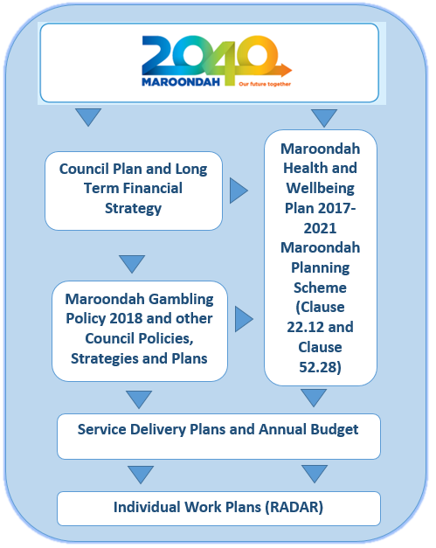

Related legislation

Gambling is a legal activity in Victoria that is regulated at the national, state and local government level.
The Gambling Regulation Act 2003 entitles Council to make a submission to the Victorian Commission for Gambling and Liquor Regulation (VCGLR) representing the community in regards the potential social and economic impacts of gaming applications. The Maroondah Planning Scheme enables Council to manage the location and operation of gaming venues. Several harm minimisation measures in relation to gaming, which are outside the scope of the planning system, are implemented by the Gambling Regulation Act 2003.
Since August 2012, gaming venue operators, including hotels and clubs, have been responsible for the ownership and operation of EGMs, giving them control over the way they operate their gaming venue and the services they offer. Venue operators have been allocated EGM entitlements which operate for a period of 10 years from August 2012.
The Interactive Gambling Act 2001 regulates access to and operation of interactive (online) gambling services to Australians.
Under Victorian legislation, the establishment and operation of gaming venues and use and installation of EGMs requires two permissions or ‘approvals’, namely a gaming licence under the Gambling Regulation Act 2003 and a planning permit under the Planning and Environment Act 1987 (refer to Figure 5).

What is the City of Maroondah’s gambling context?

Gambling has historically been a feature of Australian culture with 39 per cent of Australian adults gambling in a typical month. Gambling in Australia is categorised into three main groups, namely racing (bookmaker, totalisator and TAB), gaming (EGMs, lotteries, interactive gaming, keno, lotto and pools) and sports betting.
In the Financial Year 2015/16:
- Gaming turnover accounted for 90 per cent of all gambling turnover in Victoria.
- Per capita EGM turnover was $6,028 which accounted for nearly two thirds (64 per cent) of all per capita turnover on all forms of gambling ($9,435).
- Per capita EGM expenditure (losses) on EGMs was $557.61 which accounted for more than half (52 per cent) of all per capita expenditure on all forms of gambling.
In recent years there has been a significantly larger increase in expenditure on online forms of gambling, including sports betting compared with gaming (refer to Figure 2).

Figure 2 – Percentage change in gambling expenditure 2010/11 to 2015/16

Source: Australian Gambling Statistics, 33rd Edition, 2016

Although EGMs are one of the most important sources of enjoyment for gamblers, they also pose the greatest risks to existing and potential problem gamblers.
Between 2010/11 and 2015/16 the growth in expenditure on EGMs in Victoria (13.2 per cent) was above the growth in expenditure on all forms of gambling (10.8 per cent).

A study of gambling in Victoria in 2014 found that:
- Lotto, Powerball or the Pools; raffles, sweeps and other competitions and race betting were the forms of gambling in which most people participated.
- The most popular location for sports betting was over the internet the followed by TAB outlets.
- An increasing number of Victorian gamblers are gambling in pubs or hotels, rather than in club. Pubs or hotels were the most common location of play for gaming machines.
- Although participation in online gambling is relatively low compared with in venue gambling, the rapid increase in online gambling needs to be addressed.
- In recent years, participation in EGMs has decreased but there has been a growth in internet sports and event betting, and track sports betting participation.
- Participation in wagering has increased, particularly among women.
- There has been an increase in low risk gambling and decrease in non-problem gamblers.
- Those at higher risk (moderate risk and problem gamblers) may be gambling at greater intensity across a variety of products.
It is illegal for children under the age of 18 years to gamble. Nevertheless, research indicates that between 60 and 80 per cent of children gamble, predominantly on scratchies, lotto of card games, 20 per cent of whom participated in sports betting, racing and EGMs. Several socialisation factors shape gambling attitudes, behaviours and consumption intentions among children. These include the perceived popularity of different products through family activities, the media and the alignment of gambling products with sport; and the gambling events and activities valued by family members and the broader community. These factors highlight the need for effective policies to reduce children’s exposure to gambling products and initiatives that protect children from the harms associated with gambling.
The City of Maroondah has ten gaming venues, six of which are clubs and four of which are hotels. The municipality has 790 EGM licences and 749 attached EGM entitlements (operating EGMs). In September 2017, the Minister for Gaming and Liquor Regulation replaced the municipal cap with a regional cap which is applicable across the City of Maroondah. Whereas the previous municipal cap was set at a maximum of ten EGMs per 1,000 adults (and therefore rises with population increase), the regional cap is set at a maximum of 759 EGMs which represents the number of EGMs operating in the municipality on this date.
The community of Maroondah has good access to use EGMs due to the number of gaming venues within the municipality and close to the municipal boundary in adjoining municipalities.

In the Financial Year 2015/16, compared with the metropolitan and state averages, the City of Maroondah had:
  - a significantly higher density of EGMs per 1,000 adults
  - a significantly higher EGM expenditure per adult
  - more venues per adult
In this Financial Year, compared with the four adjoining municipalities, the City of Maroondah had:
  - the highest:
    - density of EGMs per 1,000 adults
    - EGM expenditure per adult
    - Number of venues per adult
  - the second highest (after the City of Knox):
    - total EGM expenditure
    - number of EGM entitlements, EGM licences and number of venues
In 2016/17 Maroondah had the highest density of EGMs per 1,000 adults of all metropolitan municipalities in Victoria. It also had the fifth highest expenditure per adults and seventh lowest number of adults per venue of all metropolitan municipalities.
Total expenditure and expenditure per EGM in the municipality’s hotels is typically high relative to its clubs, metropolitan hotels and hotels in Victoria. The municipality’s hotels are also large relative to its clubs and metropolitan hotels. In the City of Maroondah, there is typically a relationship between expenditure per attached EGM entitlement and the size of the venue (i.e. larger venues are associated with higher expenditure per EGM) and the type of venue (i.e. expenditure is higher in hotels compared with clubs).
Gaming expenditure is also typically higher in the second half of the year (July to December) than in the first half of the year. The higher expenditure months coincide with the colder months of the year, and the lowest expenditure months coincide with the warmer months of the year.
It is estimated that there were 114,979 people living in the City of Maroondah in 2017. Between 2016 and 2031 the greatest population increase is projected to be in the suburbs of Croydon (+6,027 people, 21.5 per cent) and Ringwood (+6,488 people, 34.7 per cent). The growth in population may result an increase in demand for additional EGMs in these suburbs.
The suburbs of Bayswater North, Ringwood, Croydon, Ringwood East and Kilsyth display several indicators of vulnerability to gambling-related harms Bayswater North, Ringwood East, Croydon, Ringwood and Kilsyth also contain all the municipalities gaming venues.

What is gambling-related harm?

Gambling-related harm is understood to be initial or exacerbated adverse consequences due to an engagement with gambling that leads to a decrement to the health or wellbeing of an individual, family unit, community or population. To cause harm, losses must exceed the individual’s personal threshold of affordability, either in respect to time money or time.
In Victoria, harm from gambling is comprised of 50 per cent low risk gambling, 35 per cent moderate risk gambling and 15 per cent problem gambling. Although harm from problem gambling is the most severe, harm from low-risk and moderate-risk gambling causes a greater burden on the community because the number of people affected is much greater. Research has found that approximately 2.79 per cent of Victorian adults reported experiencing problems because of someone’s gambling in the previous 12 months. It is estimated that for each person with a gambling problem, between seven and ten other people such as family, friends and employers, are affected. It is also estimated that gamblers who had problems (i.e., the combined low-risk, moderate-risk and problem gamblers), who represented 17 per cent of regular gamblers, accounted more than half of all expenditure by regular gamblers across EGMs, race betting, sports betting, casino table games and private betting (59-69 per cent).
Those who experienced problems were generally more likely to be young, single, unemployed or not employed (excluding retirees and full-time students), Indigenous, men, living in rental accommodation, in a low socioeconomic area, and were more likely to draw their income from welfare payments than those who had no problems. Other determinants of gambling-related harms include having a personal income in the medium highest and medium lowest quartiles or being employed as a salesworker, machinery operator or driver and labourer. In addition, people experiencing a recent trauma, loneliness and boredom are also at risk of gambling-related harms as they are vulnerable to social isolation. Research indicates that demographic groups such as males and females aged 55+ contribute substantially to the ‘burden of harm’ experienced by Victorians. It also demonstrates that Physical features of the gambling environment and product that increase the risk of gambling-related harms include a high density of EGMs per 1,000 adults, poorly designed and operated gaming venues and poor access to non-gambling social, leisure, recreation and entertainment activities and facilities.
Public health impacts associated with gambling include social (e.g. family and relationship breakdown), economic (e.g. financial hardship and job losses) and physical and mental wellbeing (e.g. anxiety, chronic disease and intimate partner violence). Gambling problems are a social and health issue on a similar order of magnitude to major depressive disorder and alcohol misuse and dependence. These health impacts impose direct and indirect costs on the public sector associated with treatment service, and expenditure programs and policies focussing on addressing gambling related harms.

What is our role in preventing and minimising gambling-related harms?

Council acknowledges that access to non-gambling social, leisure, entertainment and recreation uses is an important protective factor against the harms associated with gambling. However, the responsibility for achieving this is within the scope of other Council Plans and strategies such as the Maroondah Health and Wellbeing Plan 2017-2021, the Maroondah Youth Strategy, the Maroondah Physical Activity Strategy 2015-2020 and the Maroondah Active & Healthy Ageing Initiative 2015-2020.
Council also acknowledges the importance of equitable access to services supporting people directly and indirectly affected by gambling-related harms. However, the provision of access to these specialist services is the responsibility of external agencies and service providers, and is therefore also outside the scope of Council’s core responsibilities.
The effective application of the specific processes outlined in this policy is the responsibility of the following Council service areas:
- Regulation and enforcement of planning permit conditions– Statutory Planning
- Planning Scheme Amendments, including the revised local planning policy for electronic gaming – Integrated Planning (Strategic Planning and Sustainability)
- Assessment of planning permit applications under the Maroondah Planning Scheme and Planning and Environment Act 1987 – Statutory Planning
- Assessment of gaming licences under the Gambling Regulation Act 2003 – Integrated Planning (Council and Community Planning)
- Advocacy, partnerships and facilitation – Integrated Planning (Council and Community Planning)

Our strategic response

Policy framework

The framework underpinning the Policy is founded on three primary priorities that reflect Councils statutory roles, namely partnerships; advocacy; and planning, regulation and enforcement. Each priority is supported by an objective and related Council activities (refer to Figure 3).

Figure 3 – Maroondah Gambling Policy 2018 Action Plan Framework
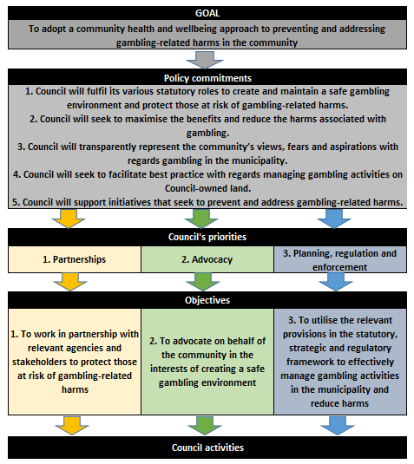

Policy principles

The Policy is founded on a public health approach to gambling-related harm. This approach acknowledges a shared responsibility for improving the health of population groups and subgroups rather than just the health of individuals. Two key principles underpin the public health approach to gambling-related harms:
- A range of social, economic and environmental factors affect a person’s mental and physical health and wellbeing.
- It is important to implement an appropriate mix of actions to achieve improved health outcomes.

Our commitments

Maroondah City Council acknowledges that gambling is a legal activity in Victoria associated with benefits to the individual, the gambling industry and the public sector. However, Council is concerned with the social, economic and health impacts resulting from gambling-related harms affecting the individual, their families and the community.
Council adopts a public health approach to preventing and minimising gambling-related harms within the community by addressing the social, economic, physical and environmental determinants of these harms.
Council will consider each application for a gaming application for a new or varied gaming licence and a planning permit to install or use electronic gaming machines on merit, based on the potential socio-economic and health impacts of the proposal on the community in general and groups within the community at an elevated risk of gambling-related harms.
Maroondah City Council adopts the following policy commitments which reflect Council’s statutory roles in preventing and addressing gambling-related harm in the community.
- Council will fulfil its various statutory roles to create and maintain a safe gambling environment and protect those at risk of gambling-related harms.
- Council will seek to maximise the benefits and reduce the harms associated with gambling.
- Council will transparently represent the community’s views, fears and aspirations with regards gambling in the municipality.
- Council will implement best practice with regards the operation of gambling activities on Council-owned land.
- Council will support initiatives that seek to prevent and address gambling-related harms.

Our priorities

Our three priorities are partnerships; advocacy; and planning, regulation and enforcement.

Priority 1 – Partnerships

Objective 1: To work in partnership with relevant agencies and stakeholders to protect those at risk of gambling-related harms.
Council activities
1.1 Work in partnership to support relevant organisations, providers and agencies in their initiatives to increase access to services that address the impacts of gambling-related harms.
1.2 Endorse efforts of the gambling industry and relevant organisations that increase access to non-gambling social, leisure, recreational and entertainment activities in the municipality.
1.3 Identify opportunities to increase non-gambling social, leisure, entertainment and recreation opportunities in facilities that incorporate EGM’s.
1.4 Identify opportunities for the gambling industry to increase access to welfare and support services that are directed at addressing gambling-related harms in the community.
1.5 Discourage gambling proposals that do not result in benefits to the community.
1.6 Support initiatives that reduce gaming operators’ reliance on revenue from EGMs.

Priority 2 – Advocacy

Objective 2: To advocate on behalf of the community on issues relating to the safety of the gambling environment.
Council activities
2.1 Support local government research and advocacy campaigns that focus on necessary amendments to the regulatory, statutory and strategic framework.
2.2 Support industry and community groups, service providers and agencies in their efforts to advocate for necessary changes to the regulatory, statutory and strategic framework.
2.3 Consider applications for additional funding to support advocacy efforts in the municipality.
2.4 Support advocacy efforts that increase transparency, efficiency and equity in the regulatory and decision-making processes.
2.5 Inform the community of Council’s advocacy role and activities in relation to preventing and addressing gambling-related harms.

Priority 3 – Planning, regulation and enforcement

Objective 3: To effectively manage gambling in the municipality through relevant provisions in the statutory, strategic and regulatory framework.
Council activities
3.1 Consider the potential social and economic impacts of applications for new or amended gaming licences or applications to install or use EGMs.
3.2 Discourage an increase in EGM density per 1,000 adults and EGM expenditure in communities and local neighbourhoods in the municipality at an elevated risk of gambling-related harms.
3.3 Acknowledge the social, economic and health impacts of gambling-related harms in Council’s plans, strategies, policies and action plans (where appropriate).
3.4 Make relevant amendments to the Maroondah Planning Scheme to strengthen Council’s capacity to manage and influence the location and operation of EGMs in the municipality through the planning process.
3.5 Require that applications for planning permits to install or use EGMs, or new or amended gaming licences are accompanied by rigorous and transparent social and economic impact assessments.
3.6 Support adjoining local governments’ statutory and strategic initiatives to prevent and address gambling -related harms in their respective communities.
3.7 Maximise the opportunity for the community and relevant stakeholders to provide their input into Council’s strategic, regulatory and decision-making processes relating to gaming applications.

Monitoring and review
The following outcomes may be used to monitor the effectiveness of the Policy:
- A reduction in the prevalence, incidence and extent of gambling-related harms in the community.
- The extent to which the Policy effectively informs Council’s advocacy, strategic, statutory, regulatory and decision-making processes.
- The capacity for the Policy to effectively manage the location and operation of gambling and gaming premises.
- The availability of facilities and services that provide non-gambling social, leisure, entertainment and recreation activities and support those affected by gambling-related harms.
This Policy will be subject to review by June 2022.

References

Armstrong, A., & Carroll, M. (2017). Gambling activity in Australia. Melbourne: Australian Gambling Research Centre, Australian Institute of Family Studies.
Source: Australian Gambling Statistics 33rd Edition, 2017
Australian Government Productivity Commission (2010) p5.22
Australian Gambling Statistics 2014/15 32nd Edition
Hare, S. (2015) Study of Gambling and Health in Victoria, Victoria, Australia: Victorian Responsible Gambling Foundation and Victorian Department of Justice and Regulation.
Phillips, T (2013) Discussion Paper - Gambling and young people: impacts, challenges and responses Victorian Responsible Gambling Foundation
Pitt, H et al (2017) “Factors that influence children’s gambling attitudes and consumption intentions: lessons for gambling harm prevention research, policies and advocacy strategies” Harm Reduction Journal 14.:11 sourced from http://www.vcglr.vic.gov.au/utility/about+us/news/gambling+defined+and+offences+consolidated+from+1+july+2015
Id consulting
Browne, M, Langham, E, Rawat, V, Greer, N, Li, E, Rose, J, Rockloff, M, Donaldson, P, Thorne, H, Goodwin, B, Bryden, G & Best, T 2016, Assessing gambling-related harm in Victoria: a public health perspective, Victorian Responsible Gambling Foundation, Melbourne.
Blaszczynski, A. et al (2015) Gambling Harm Minimisation Report NSW Government Department of Trade and Investment; Office of Liquor, Gambling and Racing
Miller, H (2017) Hidden Harm: Low-risk and moderate-risk gambling Victorian Responsible Gambling Foundation
Hare, S. (2015) Study of Gambling and Health in Victoria, Victoria, Australia: Victorian Responsible Gambling Foundation and Victorian Department of Justice and Regulation.
Victorian Responsible Gambling Foundation (2015) Background Paper Using a Public Health Approach in the Prevention of Gambling-Related Harm
Wilkins, R (2017) The Household, Income and Labour Dynamics in Australia Survey: Selected Findings from Waves 1 to 15
Armstrong, A., & Carroll, M. (2017). Gambling activity in Australia. Melbourne: Australian Gambling Research Centre, Australian Institute of Family Studies.
Browne, M, Langham, E, Rawat, V, Greer, N, Li, E, Rose, J, Rockloff, M, Donaldson, P, Thorne, H, Goodwin, B, Bryden, G & Best, T 2016, Assessing gambling-related harm in Victoria: a public health perspective, Victorian Responsible Gambling Foundation, Melbourne.
Browne, M, Langham, E, Rawat, V, Greer, N, Li, E, Rose, J, Rockloff, M, Donaldson, P, Thorne, H, Goodwin, B, Bryden, G & Best, T 2016, Assessing gambling-related harm in Victoria: a public health perspective, Victorian Responsible Gambling Foundation, Melbourne.
Victorian Responsible Gambling Foundation (2015) Background Paper Using a Public Health Approach in the Prevention of Gambling-Related Harm
Browne, M, Langham, E, Rawat, V, Greer, N, Li, E, Rose, J, Rockloff, M, Donaldson, P, Thorne, H, Goodwin, B, Bryden, G & Best, T 2016, Assessing gambling-related harm in Victoria: a public health perspective, Victorian Responsible Gambling Foundation, Melbourne. 