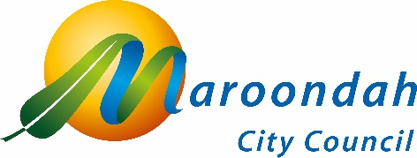

Public Toilet Policy consultation
Community Consultation Report
13 May 2024 to 7 June 2024
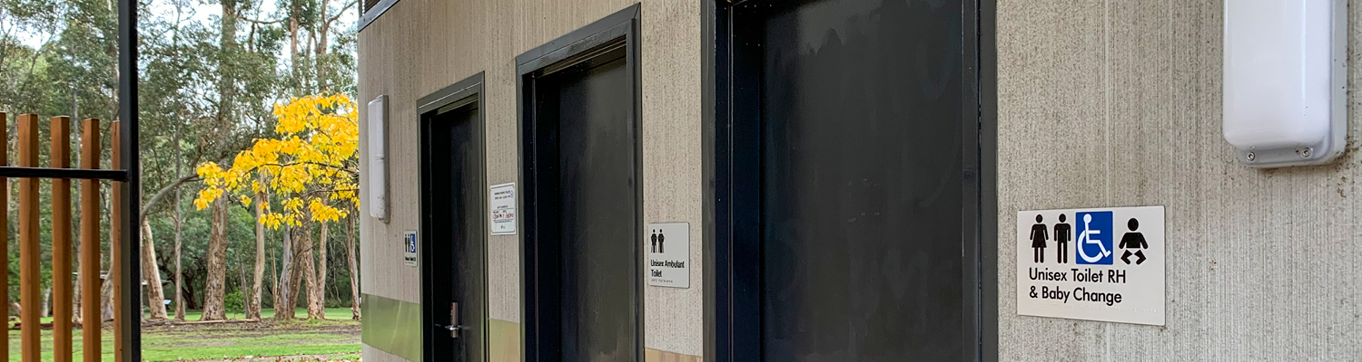

Contents

1. Background 2
2. Community consultation 2
2.1 Digital campaign reports 3
2.2 Online submissions 4
3. Conclusion 5
3.1 Community consultation 2023 5
3.2 Community consultation 2024 5
4. Next steps 6
5. Policy adopted 6

Background

It’s something many of us don’t give a lot of thought to until we need them, but public toilets play an important role in a wide range of community activities outside of our homes. The availability of modern, clean, safe and accessible public toilets can have a positive influence on the way community spaces are utilised throughout the municipality.

In Maroondah, Council currently provides and maintains 27 public toilet facilities in open space reserves and retail precincts to support a variety of activities. The public toilet facilities provided by Council are generally well distributed, however there is a need for greater consistency, clearer service levels and a planned approach to the provision of these facilities to ensure these assets continue to meet the future needs of the community.

The development of the Maroondah public toilet policy was identified as being required to clearly articulate Council’s role in the provision of these assets, along with the development of guiding principles and key considerations, to ensure these assets meet the future needs of the community. The guiding principles outlined in the policy enable consistent decision making for the provision of public toilet assets throughout the municipality, to ensure future community needs are met.

In October 2023, Council asked our community for their feedback on public toilets in Maroondah. The process involved a range of engagement activities to seek the views of community members and key stakeholders on the importance of previously identified themes associated with public toilets.

This feedback has helped Council develop the draft Public Toilet Policy, which establishes a structured and consistent approach for the provision of Council-owned public toilets across the municipality. In May 2024, again Council asked our community for their feedback on Maroondah’s draft public toilet policy to understand the level of support from the community.

Community consultation

A range of communications channels were used to promote the consultation opportunities including social media, various eNewsletters and emails to Your Say users.

Digital campaign reports
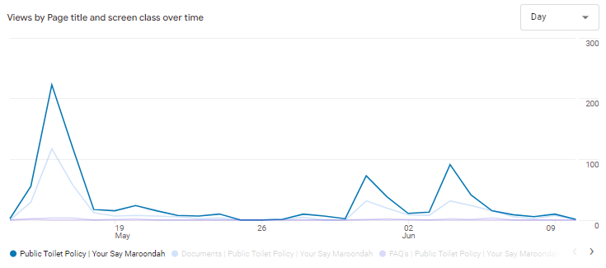
Consultation traffic
Traffic source | Views | % | Users | %
Digital campaign | 493 | 60.1 | 363 | 62.5
(direct) | 63 | 7.7 | 49 | 8.4
(organic) | 24 | 2.9 | 14 | 2.4
(referral) | 234 | 28.5 | 151 | 26.0
Not captured | 6 | 0.7 | 0 | 0.0
Total | 820 |  | 581

Digital campaign
Session source / medium | Views | % | Users | % | Benchmark
Maroondah eNews | 306 | 62.1 | 218 | 60.1 | 172.5
Targeted emails | 122 | 24.7 | 104 | 28.7 | 226.3
Maroondah News (quarterly) | 46 | 9.3 | 30 | 8.3 | 57.0
Consultation banner | 15 | 3.0 | 8 | 2.2 | 11.3
Facebook (paid) | 4 | 0.8 | 3 | 0.8 | 232.5

(organic) traffic
Session source / medium | Views | % | Users | %
Google | 23 | 95.8 | 13 | 92.9
Bing | 1 | 4.2 | 1 | 7.1

(referral) traffic
Session source / medium | Views | % | Users | %
Facebook (referral) | 230 | 98.3 | 149 | 98.7
Issuu | 3 | 1.3 | 1 | 0.7
Youtube | 1 | 0.4 | 1 | 0.7

Online submissions

A total of 150 people visited the Public Toilet Policy consultation page on the Your Say Maroondah engagement website between 5 May and 18 June 2024. The below image is a summary of visitors to the page during the four-week period, with a total of 41 responses received.
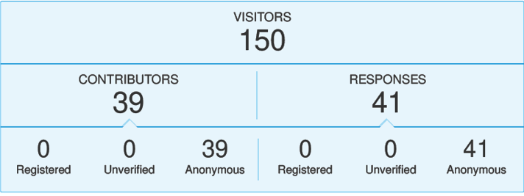
Respondents were asked to answer the following questions:
- Does the draft Public Toilet Policy meet your needs as a community member in relation to public toilets in Maroondah?
  - 25 responded YES (61%)
  - 16 responded NO (39%)
- Please provide any comments on the draft Public Toilet Policy below.
  - 41 responses
Overall Survey Themes | Respondents | % | Action
Design Focus | 10 | 24% | To be covered as part of Council’s Infrastructure (Public Toilet) Design Guidelines
Positive Feedback | 10 | 24% | Supports Policy
Provision Gap | 15 | 37% | To be covered as part of Council’s:  - Community Facilities (Public Toilet) Asset Management Plan (AMP)  - Long term capital works program
Other (e.g. community facilities, changing places, shopping precincts) | 6 | 15% | Outside the scope of the public toilet framework. To be considered as part of Council’s other Council Plan strategic priorities.
Total | 41 | 100%

Conclusion

Council has completed extensive discussions with the community and relevant stakeholders and has undertaken two (2) rounds of community consultation, to facilitate the development of the Public Toilet Policy.

Community consultation 2023
Feedback was received from a broad cross-section of the Maroondah community who rated the importance of previously identified five (5) key themes that relate to the provision of public toilet facilities: Cleanliness, safety, availability, inclusivity and accessibility and uniformity. Respondents were also asked whether there were other considerations that were more important for public toilet provision by Council.
Respondents confirmed that these key themes continue to be the most important considerations for public toilet provision by Council. Community feedback emphasised the importance placed on clean and safe public toilets, as well as the need to ensure toilets are available in key locations. Respondents also identified the need to ensure toilets were adequately stocked with consumables – soap and toilet paper – and reinforced the importance of regular cleaning, safety considerations, adequate opening hours and the provision of additional public toilets in strategic locations, such as at local shopping centres and in busy recreational precincts.
A comprehensive review of the feedback received was used to help clarify Council’s role in the provision of public toilet facilities. As a result, five (5) principles were established to guide decision making and shape the approach Council will take to the delivery and management of public toilet facilities in Maroondah.
These principles, reflect the outcomes of a detailed service assessment, community consultation, contemporary approaches to the provision of public toilet facilities and Council’s broader strategic objectives.

Community consultation 2024
The methods of engagement included targeted electronic direct mail (eDM) to previous contributors, online promotion via Council’s website and social media platforms, Your Say survey and targeted engagement with relevant stakeholders.
Council received a total of 41 responses to the Your Say survey. The draft policy received support from the community with 24% of responses indicating satisfaction with the policy. The remaining feedback received related to design principles (24%), provision gaps (37%) and other relating to other community facility infrastructure (15%). The feedback will be addressed as part of other documents within the public toilet framework shown in figure 3 within the policy. As a result, no further changes were made to this iteration of the policy.

Next steps
The Public Toilet Policy has been developed based on significant feedback received from key stakeholders and the community. It establishes guiding principles that will allow consistent decision-making about the provision of public toilets in Maroondah.
The Public Toilet Policy aims to establish a consistent approach to how public toilet facilities are provided in Maroondah.
As Maroondah’s population grows, demand for public toilets in public open spaces and community facilities is expected to increase. With this in mind, the Public Toilet Policy aims to establish clearer service levels and a consistent, planned approach to how public toilet facilities are provided in Maroondah, so that these facilities can continue to meet the needs of the community into the future.

Policy adopted
Council adopted the Public Toilet Policy 2024-2029 at its July 2024 meeting.
The policy will help to ensure Council’s management of public toilet facilities responds to current and future community needs, reflects best practice approaches, and aligns with Council’s strategic priorities.
Learn more about the Public Toilet Policy 2024-2029

